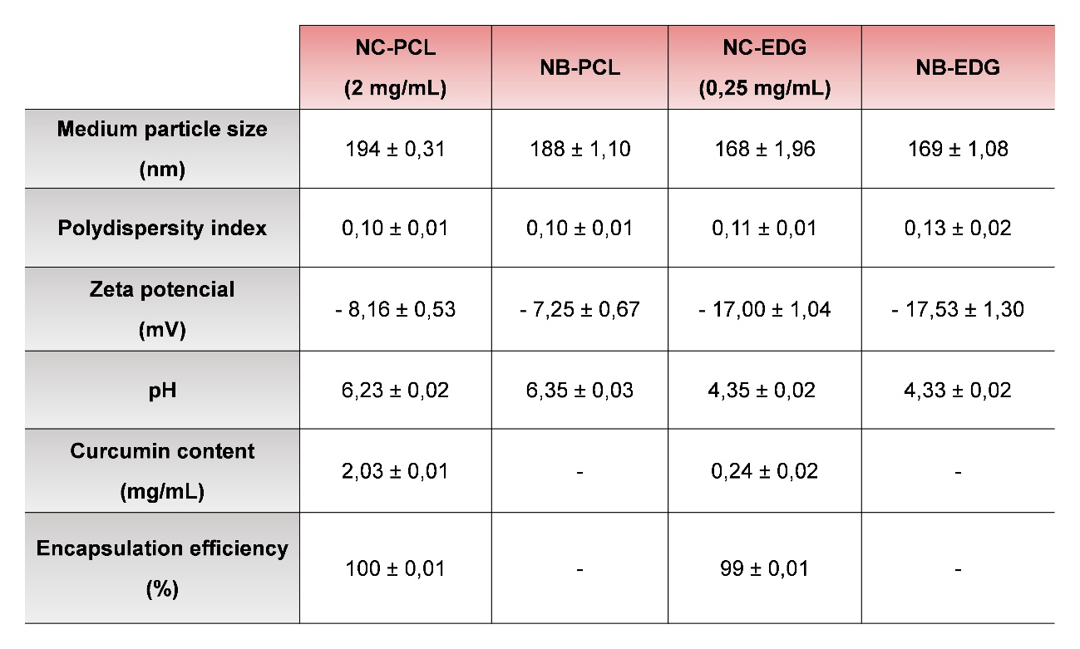
Table 1 Physio-chemical characteristics of curcumin nanocapsules and nanocapsules without curcumin. NC-PCL: nanocapsule of PCL with curcumin; NB-PCL: nanocapsule of PCL without curcumin; NC-EDG: nanocapsule of EDG with curcumin; NB-EDG: nanocapsule of EDG without curcumin.

