Potential use of distinct biomarkers (trace metals, micronuclei and nuclear abnormalities) in a heterogeneous sample of birds in southern Brazil.

Environmental Science and Pollution Research

Authors: Joana Tomazelli¹, Gabriela Zimmermann Prado Rodrigues¹, Danielle Franco², Mateus Santos de Souza³, Jorge Henrique Burghausen¹, Jenifer Panizzon¹, Juliana Machado Kayser⁴, Márcia Regina Loiko⁵, Anelise Schneider ⁶, Rafael Linden⁴, Gunther Gehlen¹

¹ Programa de Pós-graduação em Qualidade Ambiental, Universidade Feevale, RS 239, 2755, Novo Hamburgo, RS CEP 93352-000, Brasil
² Programa de Pós-graduação em Biologia Animal, Universidade Federal do Rio Grande do Sul, Porto Alegre, Brasil
³ Mestre em Biologia Animal, Universidade Federal do Rio Grande do Sul, Porto Alegre, Brasil
⁴ Programa de Pós-graduação em Toxicologia e Análises Toxicológicas, Universidade Feevale, RS 239, 2755, Novo Hamburgo, RS CEP 93352-000, Brasil
⁵ Programa de Pós-graduação em Virologia, Universidade Feevale, RS 239, 2755, NovoHamburgo, RS CEP 93352-000, Brasil
⁶ Estudante de Farmácia, Universidade Feevale, RS 239, 2755, NovoHamburgo, RS CEP 93352-000, Brasil

E-mail addresses: joanatomazelli1@gmail.com (J. Tomazelli) and guntherg@feevale.br (G. Gehlen).

ONLINE RESOURCES

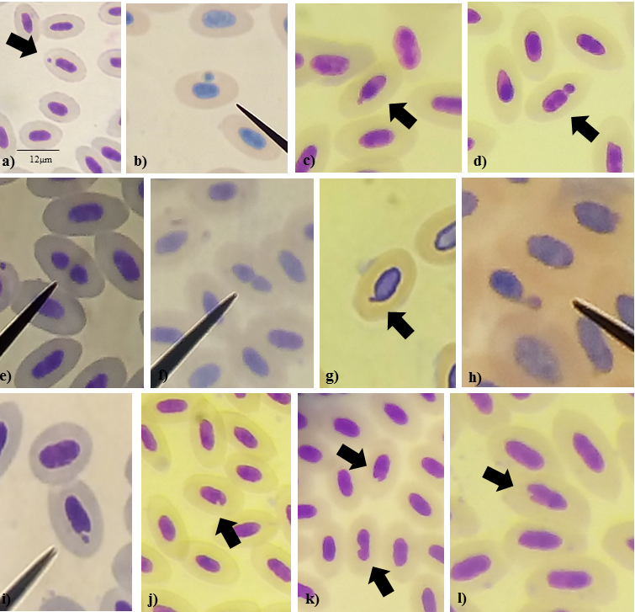
Online Resource 1, Figure. Micronuclei (a - b) and nuclear abnormalities observed in the erythrocytes of birds. c - d Nuclear bud. e - f Binucleated. g Nuclear tail. h- i Nucleoplasmic bridges. j - different morphologies of notched nuclei.

Online Resource 2, Table. List of species of birds, grouped by family and trophic guilds, captured at the three sampling sites in the Sinos River Hydrographic Basin, RS, Brazil.
Family | Species of bird | Common name | Trophic guild | S1 | S2 | S3
 |  |  |  | n | n | n
Columbidae | Leptotila verreauxi | White-tipped Dove | Herbivore/granivore |  | 1
Columbidae | Leptotila rufaxilla | Gray-fronted Dove | Herbivore/granivore |  |  | 1
 | Piaya cayana | Squirrel Cuckoo | Omnivore |  | 1
Cuculidae | Dromococcyx pavoninus | Pavonine Cuckoo | Insectivore |  |  | 1
Picidae | Veniliornis spilogaster | White-spotted Woodpecker | Insectivore |  | 1
Thamnophilidae | Thamnophilus caerulescens | Variable Antshrike | Insectivore | 1 | 1
Conopophagidae | Conopophaga lineata | Rufous Gnateater | Insectivore | 2 | 1
Scleruridae | Sclerurus scansor | Rufous-breasted Leaftosser | Insectivore |  |  | 1
Dendrocolaptidae | Sittasomus griseicapillus | Olivaceous Woodcreeper | Insectivore | 1
Dendrocolaptidae | Xiphorynchus fuscus | Lesser Woodcreeper | Insectivore | 1 | 1
Furnariidae | Lochmias nematura | Sharp-tailed Streamcreeper | Insectivore | 1
Furnariidae | Phyildor rufum | Buff-fronted Foliage-gleaner | Insectivore | 1
Furnariidae | Syndactytla rufosuperciliata | uff-browed Foliage-gleaner | Insectivore | 1
Pipridae | Chiroxiphia caudata | Swallow-tailed Manakin | Omnivore | 6
Rhynchocyclidae | Mionectes rufiventris | Gray-hooded Flycatcher | Omnivore | 1
Tyrannidae | Pitangus sulphuratus | Great Kiskadee | Omnivore |  | 1
Vireonidae | Ciclarhis gujanensis | Rufous-browed Peppershrike | Omnivore |  |  | 1
Turdidae | Turdus rufiventris | Rufous-bellied Thrush | Omnivore | 2 | 6 | 28
Turdidae | Turdus albicollis | White-necked Thrush | Omnivore | 4 | 5 | 4
Passerellidae | Zonotrichia capensis | Rufous-collared Sparrow | Herbívoro/granívoro |  | 2
Parulidae | Myiothlypis leucoblephara | White-browed Warbler | Insectivore | 2 | 1 | 4
Thraupidae | Trichothraupis melanops | Black-goggled Tanager | Insectivore | 2
Thraupidae | Tachyphonus coronatus | Ruby-crowned Tanager | Insectivore | 4
Thraupidae | Saltator similis | Green-winged Saltator | Insectivore | 1 | 2 | 1
Cardinalidae | Habia rubica | ed-crowned Ant-Tanager | Insectivore | 3 | 11
Total number of birds caught |  |  |  | 33 | 34 | 41

Online Resource 3, Figure. Number of birds categorized into age class (juvenile, adult and undetermined) and trophic guilds (insectivore, herbivore / granivore and omnivore) and number of micronuclei (MN) and nuclear abnormalities (NA) at each sampling site.

Online Resource 4, Table. Concentrations (µg / g) of the analyzed metals (mean ± standard deviation) in the feathers of birds captured at the three sampling sites and p value.
Metals | S1 | S2 | S3 | p value
Cr | 1.16 ± 1.40 | 0.58 ± 0,78 | 0.99 ± 1.23 | p = 0.40
Mn | 33.11 ± 18.33 | 26.15 ± 15.72 | 31.20 ± 18.40 | p = 0.22
Cu | 8.77 ± 5.16 | 7.61 ± 4.40 | 7.22 ± 4.14 | p = 0.43
Zn | 442.48 ± 196.21 | 397.11 ± 190.72 | 374.50 ± 173.88 | p = 0.28
* Significance of p ≤ 0.05, using the Kruskall-Wallis test for comparison

Online Resource 5, Figure. A) Zinc concentrations (µg / g) (mean ± standard deviation) in the feathers, separated by trophic guilds (grey bars) and age classes (black bars). B) Concentrations (µg / g) of copper (mean ± standard deviation) in the feathers, separated by trophic guilds (grey bars) and age classes (black bars).

