Supplementary Figures for “Identifying the multiple drivers of Cactus diversification”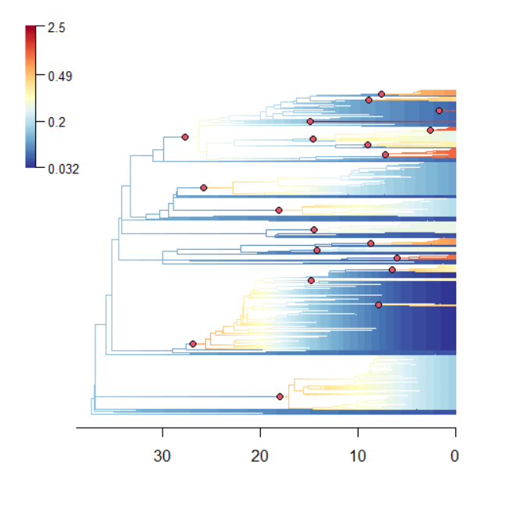
Supplementary figure 1: The maximum a posteriori rate shift configuration estimated by BAMM, with branches coloured by speciation rate, and rate shifts (red circles).
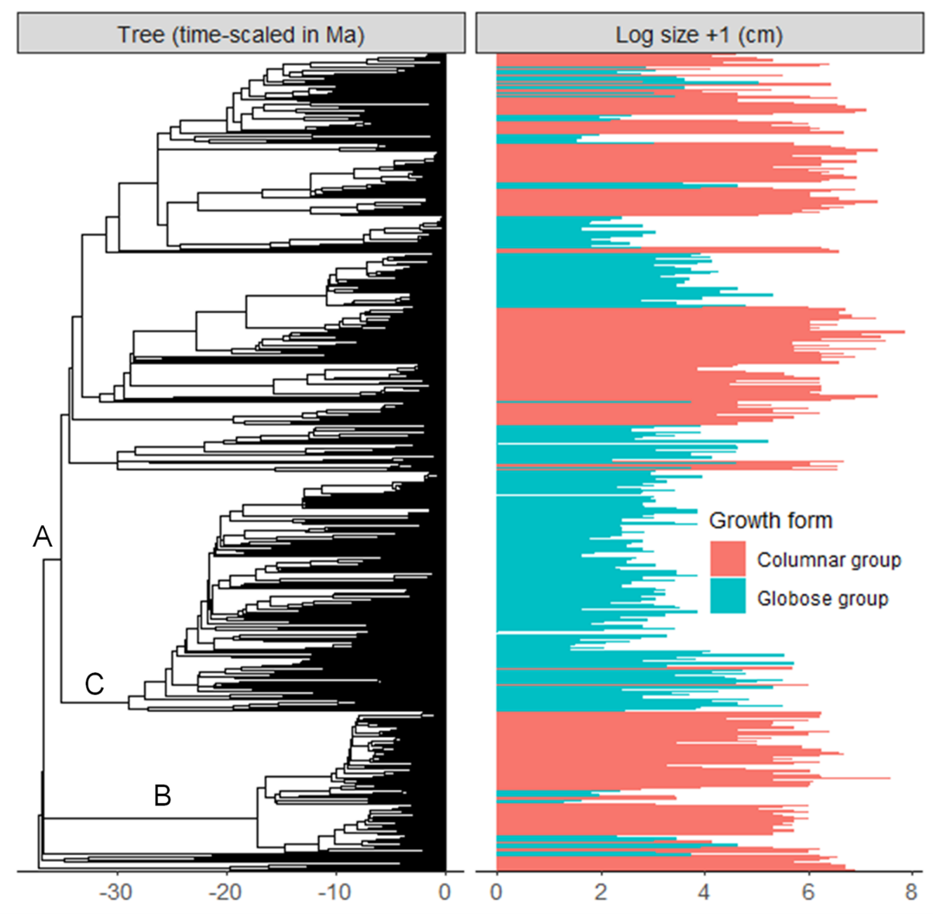
Supplementary figure 2: The phylogenetic distribution of plant size (height or length, log cm+1) and growth form. Major branches are indicated: subfamily Cactoideae (A), subfamily Opuntioideae (B) and the Mammillaria complex.

