Acupuncture Ameliorates Depression-like Behaviors through Modulating the Neuroinflammation Mediated by TLR4 Signaling Pathway in Rats Exposed to Chronic Restraint Stress

Huili Jiang,^{1,2*} Xianqi Long,³ Yu Wang,⁴ Xuhui Zhang,⁵ Lu Chen,^{1,2} Xinjing Yang,⁶ Bingcong Zhao,⁷ Ye Zhang,⁸ Yemao Chai,¹ Tuya Bao^{1,2*}

Dear editors and professors,
This is the corresponding author Huili Jiang, having submitted the manuscript entitled "Acupuncture Ameliorates Depression-like Behaviors Through Modulating the Neuroinflammation Mediated by TLR4 Signaling Pathway in Rats Exposed to Chronic Restraint Stress", which we wish to be considered for publication in the Molecular Neurobiology.
Thanks for all your kindly help and consideration. Acupuncture intervention in the present study was conducted as follows: Rats in acupuncture group were acupunctured at Baihui (GV 20) and Yintang (GV 26) compatibly with our previous described procedures. Acupuncture was conducted 1 hour before CRS procedures, 20 minutes per session, and 1 session daily for 21 days. During the acupuncture procedure, the rats were gently immobilized in the palm by the operator's left hand and the acupoint area was quietly kept fully exposed for acupuncture intervention. Following disinfection of the acupoint sites with 75% alcohol, the acupuncture needles (0.3㎜ in diameter and 25㎜ long; Suzhou Acupuncture & Moxibustion Appliance Co., Ltd., Jiangsu, China) were inserted transversely (keeping the angle between the needle and the skin sueface at 15 angle) into Baihui (GV 20) and Yintang (GV 29) to a depth of 5㎜. Acupoints coordinates [GV 20, located at the bregma, or on the junction of coronal suture and sagittal suture; GV 29, midway between the medial ends of the two eyebrows] were under the guidance as described previously [25, 35]. When rats in acupuncture group were exposed to acupuncture stimulation, rats were placed in separated room and under the conditions of free activities.
During the therapeutic cycle, rats were exposed to be rotated the needle twice per second for 1 minute every 10 min after the rats were gently immobilized in the palm by the operator's left hand. After acupuncture intervention, the needles were slightly removed and rats had access ad libitum to standard rat chow and tap water. When acupuncture intervention was conducted, additional stress was strictly avoided during each procedure. Due to the operation of being immobilized in the palm by the operator's left hand for 3 times during acupuncture treatment, rats in other group received grasping intervention once per day to ensure the principle of balance among groups.
The details of the feasibility of acupuncture interwention were presented as follows in figures.
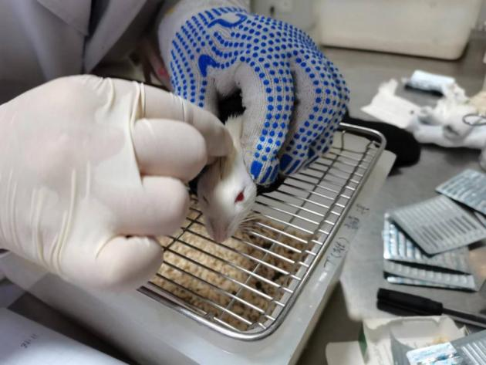 | 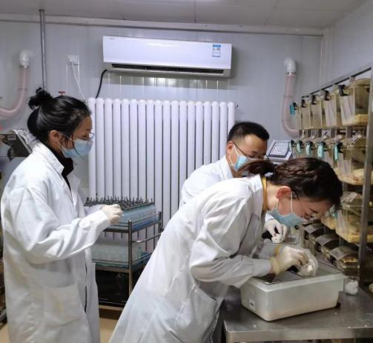
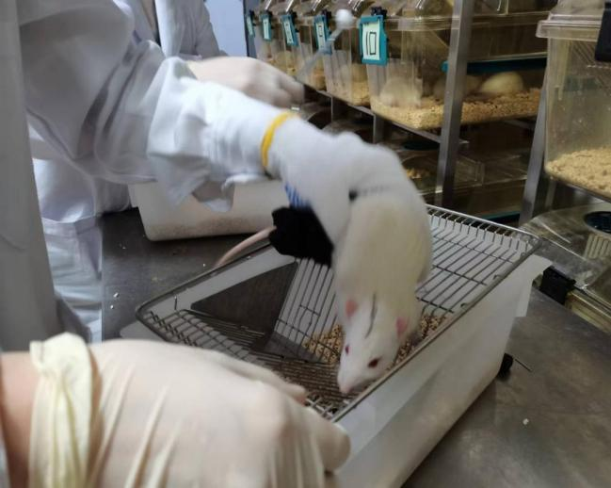 | 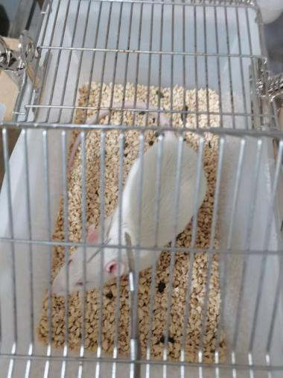
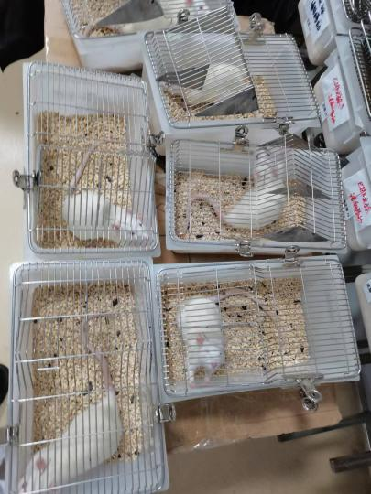
Rats in acupuncture group were acupunctured at Baihui (GV 20) and Yintang (GV 26) compatibly with our previous described procedures [25, 35]. Acupuncture was conducted 1 hour before CRS procedures, 20 minutes per session, and 1 session daily for 21 days. During the acupuncture procedure, the rats were gently immobilized in the palm by the operator's left hand and the acupoint area was quietly kept fully exposed for acupuncture intervention. Following disinfection of the acupoint sites with 75% alcohol, the acupuncture needles (0.3㎜ in diameter and 25㎜ long; Suzhou Acupuncture & Moxibustion Appliance Co., Ltd., Jiangsu, China) were inserted transversely (keeping the angle between the needle and the skin sueface at 15 angle) into Baihui (GV 20) and Yintang (GV 29) to a depth of 5㎜. Acupoints coordinates [GV 20, located at the bregma, or on the junction of coronal suture and sagittal suture; GV 29, midway between the medial ends of the two eyebrows] were under the guidance as described previously]. When rats in acupuncture group were exposed to acupuncture stimulation, rats were placed in separated room and under the conditions of free activities.
Collectively, I really thank you on behalf of all the co-authors for your kindly consideration. The Journal of Molecular Neurobiology have provided a large number of high-quality literature for our previous studies. We hope the present study will be published and make a little contribution to Molecular Neurobiology. Thanks for all your kindly consideration.

Corresponding Author: Huili Jiang, 20150941188@bucm.edu.cn.

