Supplementary Figures
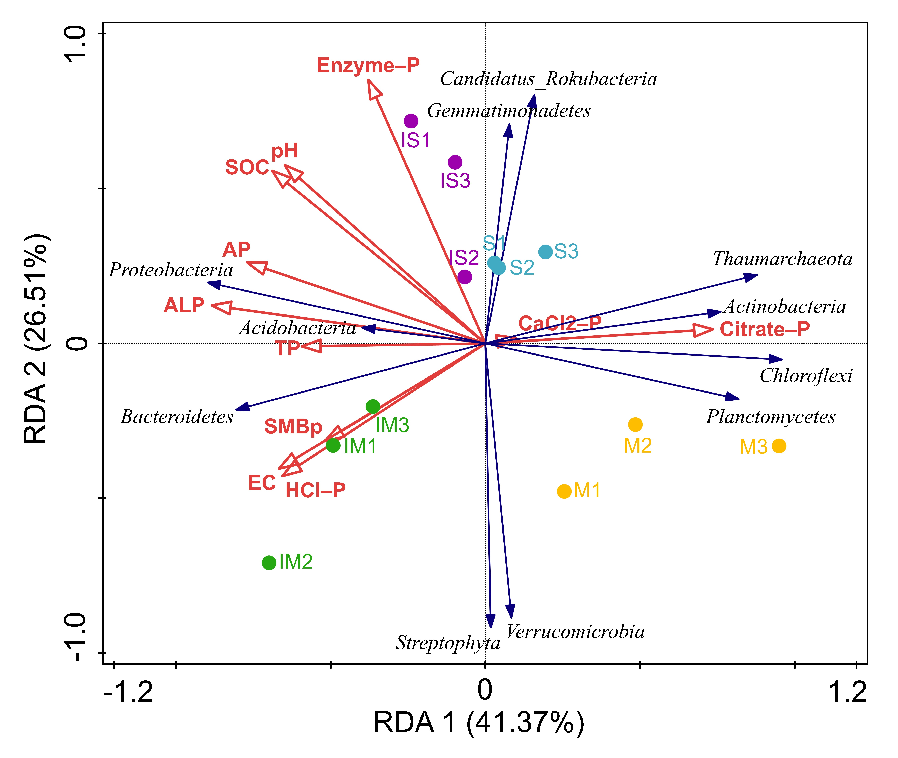
Fig. S1. Redundant analysis (RDA) of rhizosphere soil microbial community (at the phylum) and soil properties.

