SUPPLEMENTARY DATA

Accession | Description | Score | Coverage | # Proteins | # Unique Peptides | # Peptides | MW (kDa)
Q9D6F4 | GBRA4_MOUSE | 309,37 | 33,70 | 1 | 16 | 17 | 60,8
Sample | Peptide sequence | Modifications | phoSite Probab | q-Value | MH+ (Da) | ΔM (ppm) | RT (min)
ATP | TSAVQESSEATPK |  |  | 0,002 | 1334,64 | -1,09 | 15,99
ATP | TSAVQESSEAtPK | T11(Phospho) | T(11): 100,0 | 0,012 | 1414,61 | -1,91 | 15,92
ATP | AHLASSPNPFSR |  |  | 0,038 | 1283,64 | -3,28 | 19,81
ATP | AHLASsPNPFSR | S6(Phospho) | S(6): 98,3 | 0,131 | 1363,61 | -5,17 | 20,50
no ATP | TSAVQESSEATPK |  |  | 0,0000 | 1334,64 | -0,91 | 16,33
no ATP | AHLASSPNPFSR |  |  | 0,0000 | 1283,64 | -3,57 | 20,01

Supplementary Table 1. The α4 subunit of GABA_{A} receptors is phosphorylated at T423 and S431 by Ccnd1·Cdk4. The GST-Ct-α4 wild type was used in an in vitro kinase assay with Ccnd1·Cdk4, in the presence or absence of ATP (no ATP), and the Chymotryptic peptide molecular masses were analyzed by liquid chromatography-mass spectrometry. MH+: proton adduct; ΔM: mass difference; RT: retention time; q-value: adjusted p-value. Both T423 and S431 of α4 subunit (highlighted in red) were found to be phosphorylated by Ccnd1·Cdk4.

Supplementary Figure 1. Ccnd1 interacts with the α4 subunit of GABA_{A} receptors. HEK-293T cells were transfected with the C terminus of α4 subunit (354-552aa, tagged with HA: HA-Ct-α4) and Ccnd1 (tagged with Flag: Flag-Ccnd1). At 24 hours after transfection, Flag-Ccnd1 was precipitated using αFlag agarose beads (Sigma). Input (IN) and immunoprecipitation (IP) samples were analyzed by western blot using anti-HA and anti-Flag antibodies, to detect co-IP of the C terminus of α4 with Ccnd1.

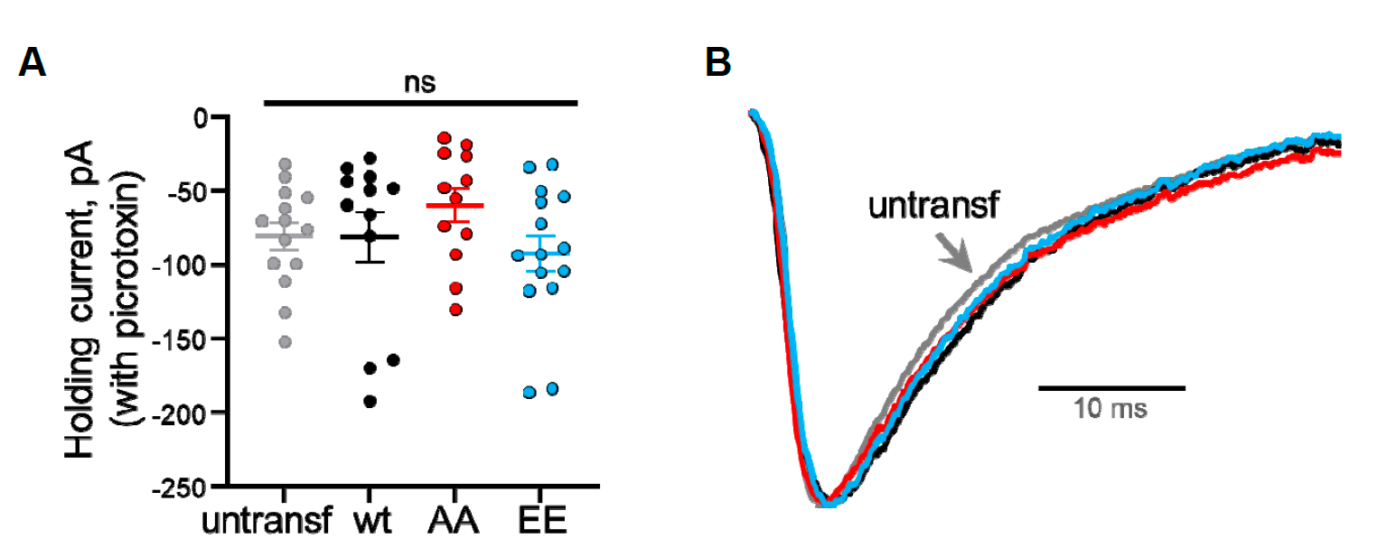
Supplementary Figure 2. Expression of recombinant α4 in culture hippocampal slices does not change non-GABA_{A} receptor currents and alters mIPSC kinetics. A) Quantification of absolute values for holding current after picrotoxin addition, from neurons plotted in Fig. 6, A and B. B) Scaled average mIPSCs from neurons plotted in Fig. 6 C and D, to compare the kinetics of the responses for each condition. For all panels, wild-type α4 is represented with black symbols, T423A/S431A (AA) α4 with red symbols, T423E/S431E (EE) α4 with blue symbols and untransfected neurons with grey symbols.

