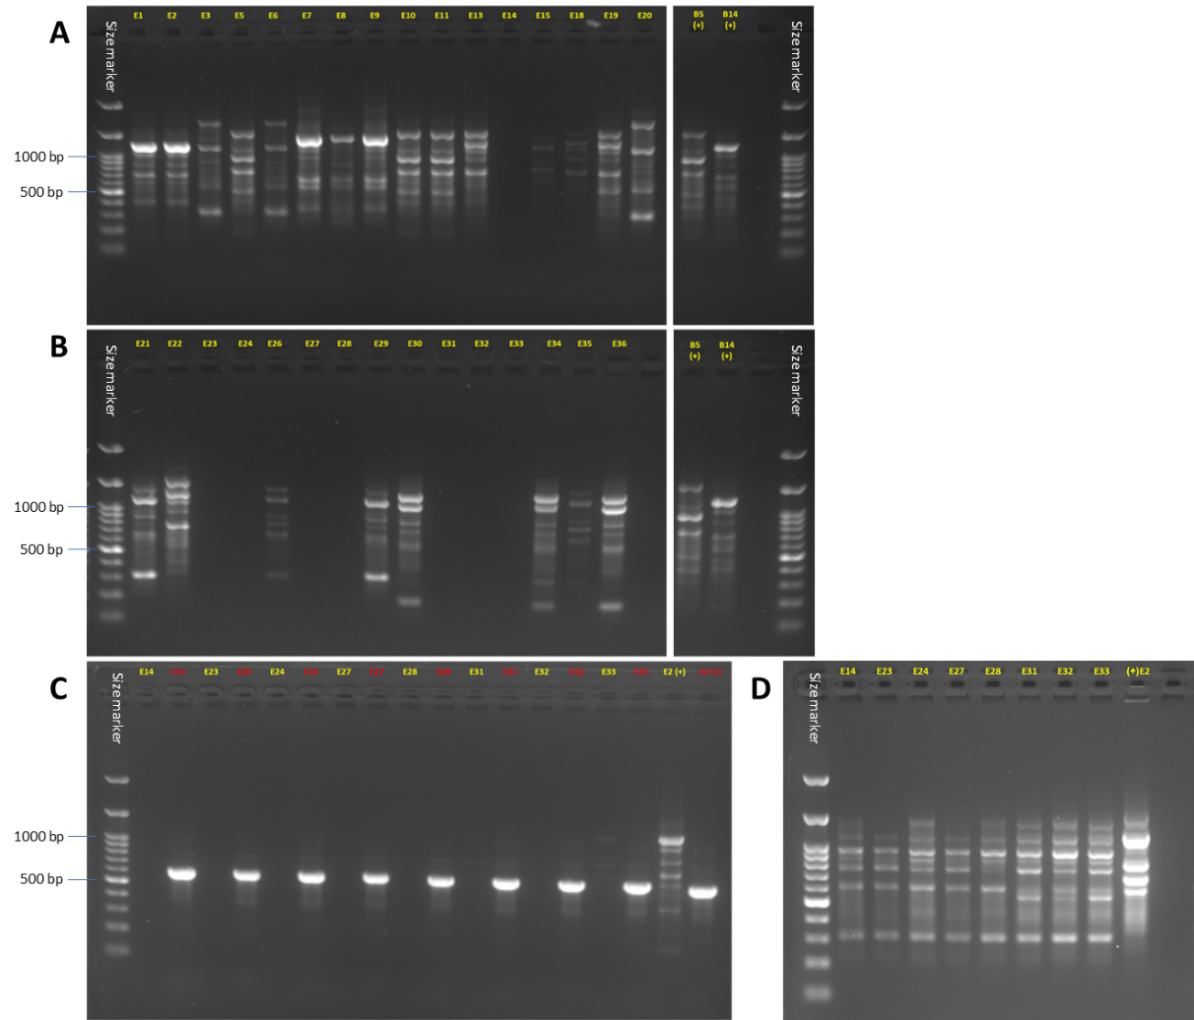
Figure S2. Full-length gels for the Fusarium isolates' DNA fingerprinting which are shown in Figure 7. A, B. The complex band profile was generated using the inter simple sequence repeat (ISSR)-PCR molecular method. The ISSR primers are listed in Table 1. The PCR reaction for ISSR amplification was conducted with the following parameters: an initial denaturation step at 95°C for 2 minutes; followed by 40 cycles of denaturation at 95°C for 15 seconds, annealing at 50°C for 15 seconds, and extension at 72°C for 30 seconds. The F. acutatum (isolate B15) and the F. oxysporum f. sp. cepae (isolate B14) were used as a positive control. C. The same PCR reaction conditions as in A and B to the undetected PCR products, with the addition of positive control, the universal internal transcribed spacer (ITS, highlighted in red) gene product (according to Kalman et al. 2020). Isolate E2 (F. oxysporum f. sp. cepae) was another positive control. D. A molecular PCR repetition to the undetected products in A and B, with the following changes: annealing at 43°C and the DNA template was diluted x2.

