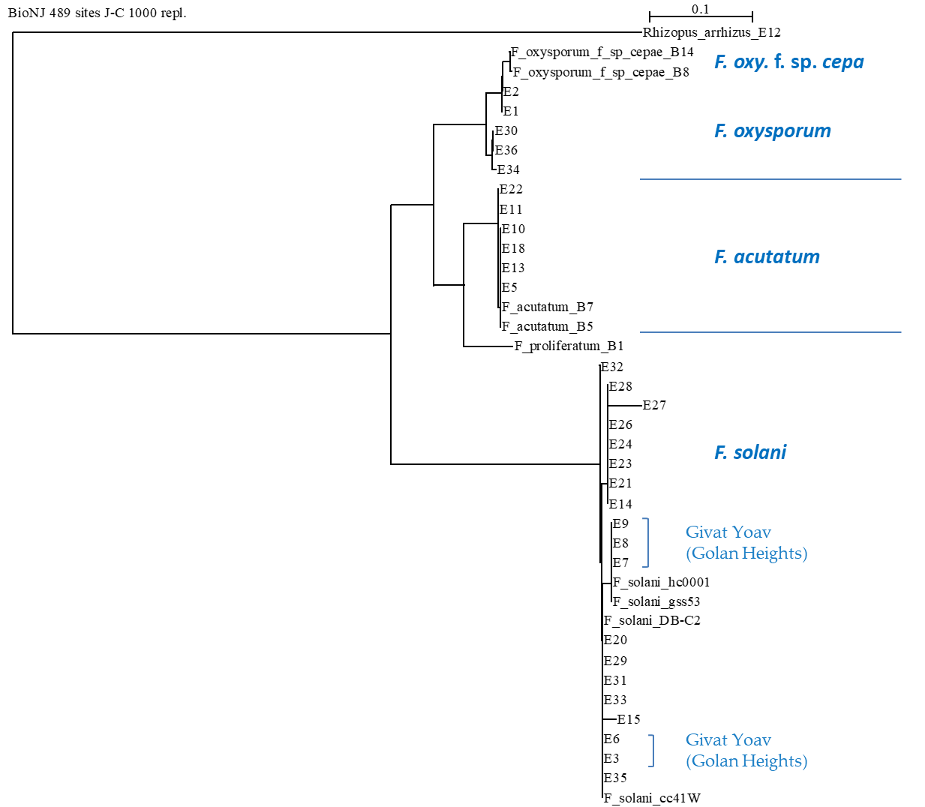
Figure S3. Phylogenetic analysis of the TEF1 gene of the Fusarium isolates. The phylogenetic tree was performed twice, once with the forward TEF1- Fusarium-specific (E1E2) primes (shown in Figure 8) and once with the reverse primers (presented here). Similar results were obtained in both analyses.

