Supplementary file
Supplement Table1. Baseline characteristics
Training and test set
 | Normal control (n=74) | Alcoholic hepatitis (n=60) | Alcoholic cirrhosis (n=81) | Alcoholic HCC  (n=48) | Normal control (n=77) | Nonalcoholic hepatitis (n=124)
Male (n, [%]) | 36 (48) | 39 (75) | 51 (64) | 29 (63) | 39 (51) | 62 (50)
Age | 61 (7) | 51 (12) | 54 (11) | 62 (13) | 63 (8) | 57 (12)
AST | 25 (10) | 85 (96) | 111 (152) | 103 (145) | 24 (8) | 47 (61)
ALT | 25 (16) | 61 (46) | 39 (44) | 63 (100) | 24 (17) | 54 (38)
γGT | 44 (49) | 325 (474) | 437 (775) | 235 (252) | 32 (36) | 57 (53)
Creatinine | 0.9 (0.8) | 0.9 (0.7) | 0.8 (0.7) | 0.8 (0.9) | 0.7 (0.7) | 0.9 (1.0)
Cholesterol | 180 (36) | 170 (53) | 137 (54) | 128 (53) | 167 (37) | 178 (38)
BMI | 25 (3) | 24 (4) | 24 (3) | 24 (4) | 24 (4) | 25 (4)
Validation set
 | Normal control (n=26) | Alcoholic hepatitis (n=24) | Alcoholic cirrhosis (n=59) | Alcoholic HCC  (n=17) | Normal control (n=22) | Nonalcoholic hepatitis (n=62)
Male (n, [%]) | 14 (54) | 18 (75) | 34 (58) | 10 (59) | 12 (55) | 30 (48)
Age | 57 (11) | 54 (9) | 56 (10) | 63 (8) | 65 (11) | 59 (10)
AST | 37 (10) | 85 (96) | 130 (122) | 112 (72) | 30 (9) | 55 (41)
ALT | 30 (16) | 71 (40) | 49 (43) | 53 (92) | 30 (17) | 54 (38)
γGT | 44 (49) | 325 (474) | 437 (775) | 235 (252) | 32 (36) | 59 (50)
Creatinine | 0.9 (0.8) | 0.9 (0.7) | 0.9 (0.7) | 0.9 (0.9) | 0.8 (0.7) | 0.8 (1.0)
Cholesterol | 177 (30) | 179 (53) | 140 (52) | 130 (59) | 167 (37) | 199 (30)
BMI | 23 (3) | 22 (4) | 23 (3) | 24 (4) | 23 (4) | 24 (4)
n, number; BMI, body mass index; AST, aspartate aminotransferase; ALT, alanine aminotransferase; γGT, gamma glutamyl transpeptidase

Supplement Table2. Taxonomical features of alcoholic liver disease groups with a LDA score > 2.0
Feature | Group | LDA score | p-value
Bacteria.Proteobacteria | HCC | 4.98029 | 0.000468
Bacteria.Actinobacteria.Actinobacteria.Bifidobacteriales.Bifidobacteriaceae.Bifidobacterium.bifidum | HCC | 2.936097 | 0.002065
Bacteria.Bacteroidetes.Bacteroidia.Bacteroidales._Paraprevotellaceae_ | HCC | 3.095678 | 0.003835
Bacteria.Firmicutes.Bacilli.Bacillales.Bacillaceae.Bacillus | HCC | 3.340567 | 0.035208
Bacteria.Firmicutes.Bacilli.Lactobacillales.Lactobacillaceae | HCC | 3.352703 | 2.50E-07
Bacteria.Firmicutes.Bacilli.Lactobacillales.Lactobacillaceae.Lactobacillus.hamsteri | HCC | 4.331152 | 5.56E-08
Bacteria.Firmicutes.Bacilli.Lactobacillales.Streptococcaceae | HCC | 4.053847 | 2.32E-09
Bacteria.Firmicutes.Bacilli.Lactobacillales.Streptococcaceae.Streptococcus | HCC | 3.926088 | 1.62E-10
Bacteria.Proteobacteria.Betaproteobacteria | HCC | 3.381573 | 0.006841
Bacteria.Proteobacteria.Gammaproteobacteria | HCC | 4.976148 | 3.25E-05
Bacteria.Proteobacteria.Gammaproteobacteria.Enterobacteriales | HCC | 4.950695 | 0.00016
Bacteria.Proteobacteria.Gammaproteobacteria.Enterobacteriales.Enterobacteriaceae | HCC | 4.948545 | 0.00016
Bacteria.Actinobacteria.Coriobacteriia | Cirrhosis | 3.846128 | 0.013704
Bacteria.Actinobacteria.Coriobacteriia.Coriobacteriales | Cirrhosis | 3.618718 | 0.013704
Bacteria.Actinobacteria.Coriobacteriia.Coriobacteriales.Coriobacteriaceae.Collinsella | Cirrhosis | 3.691356 | 0.037725
Bacteria.Actinobacteria.Coriobacteriia.Coriobacteriales.Coriobacteriaceae.Collinsella. | Cirrhosis | 3.67206 | 0.037725
Bacteria.Firmicutes | Cirrhosis | 3.582376 | 4.07E-07
Bacteria.Firmicutes.Bacilli.Lactobacillales.Aerococcaceae | Cirrhosis | 3.525972 | 1.36E-06
Bacteria.Firmicutes.Bacilli.Lactobacillales.Aerococcaceae.Granulicatella | Cirrhosis | 3.786091 | 4.68E-06
Bacteria.Firmicutes.Bacilli.Lactobacillales.Aerococcaceae.Granulicatella.balaenopterae | Cirrhosis | 3.742738 | 4.68E-06
Bacteria.Firmicutes.Bacilli.Lactobacillales.Lactobacillaceae.Lactobacillus.paraplantarum | Cirrhosis | 3.527659 | 0.000141
Bacteria.Firmicutes.Clostridia.Clostridiales.Lachnospiraceae.Clostridium.bolteae | Cirrhosis | 3.114784 | 0.000437
Bacteria.Firmicutes.Clostridia.Clostridiales.Veillonellaceae.Anaerosinus | Cirrhosis | 4.522358 | 1.18E-08
Bacteria.Firmicutes.Clostridia.Clostridiales.Veillonellaceae.Anaerosinus.glycerini | Cirrhosis | 4.522358 | 1.18E-08
Bacteria.Firmicutes.Erysipelotrichi.Erysipelotrichales.Erysipelotrichaceae.Clostridium | Cirrhosis | 3.016167 | 3.03E-08
Bacteria.Firmicutes.Erysipelotrichi.Erysipelotrichales.Erysipelotrichaceae.Clostridium.spiroforme | Cirrhosis | 3.463909 | 0.002096
Bacteria.Bacteroidetes.Bacteroidia.Bacteroidales._Odoribacteraceae_.Butyricimonas | Hepatitis | 3.604114 | 0.000251
Bacteria.Bacteroidetes.Bacteroidia.Bacteroidales.Bacteroidaceae | Hepatitis | 4.86534 | 0.020975
Bacteria.Bacteroidetes.Bacteroidia.Bacteroidales.Bacteroidaceae.Bacteroides | Hepatitis | 4.829277 | 0.012311
Bacteria.Firmicutes.Bacilli.Lactobacillales.Streptococcaceae.Streptococcus.equi | Hepatitis | 3.741788 | 0.000142
Bacteria.Firmicutes.Erysipelotrichi | Hepatitis | 3.15235 | 0.008669
Bacteria.Firmicutes.Erysipelotrichi.Erysipelotrichales | Hepatitis | 3.15235 | 0.008669
Bacteria. | Control | 3.035608 | 0.003041
Bacteria.Bacteroidetes.Bacteroidia.Bacteroidales | Control | 3.229782 | 0.002949
Bacteria.Bacteroidetes.Bacteroidia.Bacteroidales._Odoribacteraceae_ | Control | 3.62275 | 6.30E-06
Bacteria.Bacteroidetes.Bacteroidia.Bacteroidales._Odoribacteraceae_.Odoribacter | Control | 3.539695 | 2.97E-05
Bacteria.Bacteroidetes.Bacteroidia.Bacteroidales._Paraprevotellaceae_.Paraprevotella | Control | 3.397106 | 1.60E-06
Bacteria.Bacteroidetes.Bacteroidia.Bacteroidales.Rikenellaceae.Alistipes | Control | 3.089576 | 1.18E-05
Bacteria.Bacteroidetes.Bacteroidia.Bacteroidales.Rikenellaceae.Alistipes.finegoldii | Control | 3.258005 | 3.20E-07
Bacteria.Bacteroidetes.Bacteroidia.Bacteroidales.Rikenellaceae.Alistipes.putredinis | Control | 3.853025 | 1.33E-05
Bacteria.Bacteroidetes.Bacteroidia.Bacteroidales.S24_7 | Control | 3.333313 | 2.80E-07
Bacteria.Firmicutes.Clostridia.Clostridiales | Control | 3.201171 | 4.19E-05
Bacteria.Firmicutes.Clostridia.Clostridiales.Lachnospiraceae | Control | 3.762187 | 8.06E-12
Bacteria.Firmicutes.Clostridia.Clostridiales.Lachnospiraceae.Clostridium | Control | 3.033402 | 7.11E-05
Bacteria.Firmicutes.Clostridia.Clostridiales.Lachnospiraceae.Roseburia | Control | 3.760318 | 1.33E-12
Bacteria.Firmicutes.Clostridia.Clostridiales.Lachnospiraceae.Roseburia.inulinivorans | Control | 3.757443 | 1.33E-12
Bacteria.Firmicutes.Clostridia.Clostridiales.Lachnospiraceae.Ruminococcus.lactaris | Control | 3.234862 | 5.18E-09
Bacteria.Firmicutes.Clostridia.Clostridiales.Ruminococcaceae | Control | 3.60827 | 1.04E-07
Bacteria.Firmicutes.Clostridia.Clostridiales.Ruminococcaceae.Clostridium.islandicum | Control | 2.975613 | 0.000145
Bacteria.Firmicutes.Clostridia.Clostridiales.Ruminococcaceae.Faecalibacterium | Control | 3.484471 | 3.57E-06
Bacteria.Firmicutes.Clostridia.Clostridiales.Ruminococcaceae.Gemmiger | Control | 3.733309 | 4.28E-16
Bacteria.Firmicutes.Clostridia.Clostridiales.Ruminococcaceae.Gemmiger.formicilis | Control | 3.732198 | 4.28E-16
Bacteria.Firmicutes.Erysipelotrichi.Erysipelotrichales.Erysipelotrichaceae | Control | 2.835949 | 0.001467
Bacteria.Proteobacteria.Betaproteobacteria.Burkholderiales | Control | 3.479398 | 0.006892
Bacteria.Proteobacteria.Deltaproteobacteria | Control | 3.366494 | 0.000316
Bacteria.Proteobacteria.Deltaproteobacteria.Desulfovibrionales.Desulfovibrionaceae | Control | 3.224232 | 6.34E-05

Supplement Table 3. Taxonomical features of non-alcoholic fatty liver disease groups with a LDA score>2.0
Feature | Group | LDA score | pvalue
Bacteria.Actinobacteria | Hepatitis | 3.442449 | 0.01728
Bacteria.Actinobacteria.Actinobacteria | Hepatitis | 3.348942 | 0.033073
Bacteria.Actinobacteria.Actinobacteria.Bifidobacteriales | Hepatitis | 3.172292 | 0.043287
Bacteria.Actinobacteria.Actinobacteria.Bifidobacteriales.Bifidobacteriaceae | Hepatitis | 3.172292 | 0.043287
Bacteria.Actinobacteria.Coriobacteriia | Hepatitis | 2.948305 | 0.001026
Bacteria.Actinobacteria.Coriobacteriia.Coriobacteriales | Hepatitis | 3.00883 | 0.001026
Bacteria.Actinobacteria.Coriobacteriia.Coriobacteriales.Coriobacteriaceae.Collinsella | Hepatitis | 2.819818 | 0.002107
Bacteria.Actinobacteria.Coriobacteriia.Coriobacteriales.Coriobacteriaceae.Collinsella. | Hepatitis | 2.830713 | 0.002107
Bacteria.Bacteroidetes.Bacteroidia.Bacteroidales.Bacteroidaceae.Bacteroides.coprophilus | Hepatitis | 3.086635 | 0.043848
Bacteria.Bacteroidetes.Bacteroidia.Bacteroidales.Rikenellaceae.Alistipes.indistinctus | Hepatitis | 2.650614 | 0.027185
Bacteria.Firmicutes | Hepatitis | 3.819271 | 0.00023
Bacteria.Firmicutes.Bacilli | Hepatitis | 4.283469 | 0.007615
Bacteria.Firmicutes.Bacilli.Lactobacillales.Aerococcaceae | Hepatitis | 2.304982 | 0.000132
Bacteria.Firmicutes.Bacilli.Lactobacillales.Aerococcaceae.Granulicatella | Hepatitis | 2.769129 | 0.000288
Bacteria.Firmicutes.Bacilli.Lactobacillales.Aerococcaceae.Granulicatella.balaenopterae | Hepatitis | 2.787935 | 0.000288
Bacteria.Firmicutes.Bacilli.Lactobacillales.Lactobacillaceae | Hepatitis | 2.125523 | 0.009002
Bacteria.Firmicutes.Bacilli.Lactobacillales.Leuconostocaceae.Weissella | Hepatitis | 2.519355 | 0.004535
Bacteria.Firmicutes.Bacilli.Lactobacillales.Leuconostocaceae.Weissella.hellenica | Hepatitis | 2.516458 | 0.004535
Bacteria.Firmicutes.Bacilli.Lactobacillales.Streptococcaceae | Hepatitis | 3.912715 | 5.29E-06
Bacteria.Firmicutes.Bacilli.Lactobacillales.Streptococcaceae.Streptococcus | Hepatitis | 3.263277 | 2.50E-05
Bacteria.Firmicutes.Bacilli.Lactobacillales.Streptococcaceae.Streptococcus.equi | Hepatitis | 3.804053 | 4.92E-06
Bacteria.Firmicutes.Clostridia.Clostridiales.Lachnospiraceae.Clostridium.bolteae | Hepatitis | 2.614449 | 0.045096
Bacteria.Firmicutes.Clostridia.Clostridiales.Ruminococcaceae.Butyricicoccus | Hepatitis | 2.521415 | 0.013539
Bacteria.Firmicutes.Clostridia.Clostridiales.Ruminococcaceae.Butyricicoccus.pullicaecorum | Hepatitis | 2.528662 | 0.013539
Bacteria.Firmicutes.Clostridia.Clostridiales.Ruminococcaceae.Subdoligranulum | Hepatitis | 2.713045 | 0.01038
Bacteria.Firmicutes.Clostridia.Clostridiales.Ruminococcaceae.Subdoligranulum.variabile | Hepatitis | 2.708402 | 0.01038
Bacteria.Firmicutes.Clostridia.Clostridiales.Veillonellaceae.Anaerosinus | Hepatitis | 3.906862 | 0.009653
Bacteria.Firmicutes.Clostridia.Clostridiales.Veillonellaceae.Anaerosinus.glycerini | Hepatitis | 3.906862 | 0.009653
Bacteria.Firmicutes.Clostridia.Clostridiales.Veillonellaceae.Succinispira | Hepatitis | 4.032886 | 0.045854
Bacteria.Firmicutes.Clostridia.Clostridiales.Veillonellaceae.Succinispira.mobilis | Hepatitis | 4.032886 | 0.045854
Bacteria.Firmicutes.Erysipelotrichi | Hepatitis | 3.588245 | 0.007313
Bacteria.Firmicutes.Erysipelotrichi.Erysipelotrichales | Hepatitis | 3.588245 | 0.007313
Bacteria.Firmicutes.Erysipelotrichi.Erysipelotrichales.Erysipelotrichaceae._Eubacterium_.biforme | Hepatitis | 3.080602 | 0.004719
Bacteria.Firmicutes.Erysipelotrichi.Erysipelotrichales.Erysipelotrichaceae.Catenibacterium | Hepatitis | 3.282876 | 0.017044
Bacteria.Firmicutes.Erysipelotrichi.Erysipelotrichales.Erysipelotrichaceae.Catenibacterium.mitsuokai | Hepatitis | 3.302578 | 0.017044
Bacteria.Firmicutes.Erysipelotrichi.Erysipelotrichales.Erysipelotrichaceae.Holdemania | Hepatitis | 2.137383 | 0.048915
Bacteria.TM7 | Hepatitis | 3.294099 | 0.023312
Bacteria.TM7.TM7_3 | Hepatitis | 3.305751 | 0.023312
Bacteria.Bacteroidetes.Bacteroidia | Control | 4.834159 | 0.000115
Bacteria.Bacteroidetes.Bacteroidia.Bacteroidales.Bacteroidaceae | Control | 4.68532 | 0.005846
Bacteria.Bacteroidetes.Bacteroidia.Bacteroidales.Bacteroidaceae.Bacteroides | Control | 4.52123 | 0.011842
Bacteria.Firmicutes.Bacilli.Lactobacillales.Lactobacillaceae.Lactobacillus.hamsteri | Control | 2.134249 | 0.034482
Bacteria.Firmicutes.Erysipelotrichi.Erysipelotrichales.Erysipelotrichaceae.Clostridium | Control | 2.350757 | 0.036871
Bacteria.Proteobacteria.Betaproteobacteria | Control | 2.493839 | 0.022642
Bacteria.Proteobacteria.Deltaproteobacteria.Desulfovibrionales | Control | 2.243218 | 0.027175
Bacteria.Proteobacteria.Deltaproteobacteria.Desulfovibrionales.Desulfovibrionaceae.Desulfovibrio.D168 | Control | 2.434182 | 0.014964

Supplement Table 4. Performance measures of CNN model using the top 20, 40, 60, 80 highly contributing features reduced from PCA model for ALD datasets
Group 1 | Group 2 | Performance
Group 1 | Group 2 | No. of Features | AUC | ACC | Recall | Precision | F1
Control | Hepatitis | 20 | 0.92±0.08 | 0.93±0.08 | 0.94±0.08 | 0.89±0.13 | 0.91±0.10
Control | Hepatitis | 40 | 0.95±0.08 | 0.95±0.09 | 0.95±0.09 | 0.94±0.12 | 0.94±0.10
Control | Hepatitis | 60 | 0.94±0.09 | 0.94±0.08 | 0.96±0.07 | 0.92±0.13 | 0.93±0.10
Control | Hepatitis | 80 | 0.94±0.10 | 0.95±0.10 | 0.96±0.09 | 0.93±0.11 | 0.94±0.12
Control | Liver_cirrhosis | 20 | 0.95±0.08 | 0.95±0.09 | 0.96±0.06 | 0.94±0.14 | 0.95±0.1
Control | Liver_cirrhosis | 40 | 0.96±0.07 | 0.96±0.07 | 0.98±0.04 | 0.95±0.12 | 0.96±0.08
Control | Liver_cirrhosis | 60 | 0.97±0.06 | 0.97±0.07 | 0.98±0.03 | 0.96±0.11 | 0.97±0.07
Control | Liver_cirrhosis | 80 | 0.96±0.07 | 0.96±0.08 | 0.98±0.05 | 0.96±0.11 | 0.96±0.08
Control | Liver cancer | 20 | 0.97±0.07 | 0.98±0.06 | 0.98±0.06 | 0.96±0.11 | 0.97±0.08
Control | Liver cancer | 40 | 0.96±0.08 | 0.97±0.07 | 0.96±0.09 | 0.96±0.13 | 0.95±0.11
Control | Liver cancer | 60 | 0.96±0.09 | 0.97±0.07 | 0.96±0.10 | 0.94±0.15 | 0.95±0.12
Control | Liver cancer | 80 | 0.96±0.08 | 0.97±0.07 | 0.97±0.05 | 0.95±0.13 | 0.95±0.11
Normal+  Hepatitis | Liver_cirrhosis+  Liver cancer | 20 | 0.96±0.07 | 0.96±0.07 | 0.97±0.06 | 0.95±0.08 | 0.96±0.07
Normal+  Hepatitis | Liver_cirrhosis+  Liver cancer | 40 | 0.96±0.07 | 0.97±0.07 | 0.97±0.06 | 0.96±0.10 | 0.96±0.08
Normal+  Hepatitis | Liver_cirrhosis+  Liver cancer | 60 | 0.96±0.07 | 0.96±0.07 | 0.96±0.07 | 0.96±0.10 | 0.96±0.08
Normal+  Hepatitis | Liver_cirrhosis+  Liver cancer | 80 | 0.95±0.07 | 0.96±0.07 | 0.96±0.06 | 0.95±0.10 | 0.95±0.09
Hepatitis | Liver_cirrhosis | 20 | 0.93±0.11 | 0.94±0.10 | 0.95±0.09 | 0.94±0.09 | 0.94±0.09
Hepatitis | Liver_cirrhosis | 40 | 0.94±0.12 | 0.95±0.11 | 0.96±0.11 | 0.95±0.09 | 0.95±0.09
Hepatitis | Liver_cirrhosis | 60 | 0.93±0.13 | 0.94±0.12 | 0.94±0.12 | 0.96±0.08 | 0.95±0.10
Hepatitis | Liver_cirrhosis | 80 | 0.93±0.14 | 0.93±0.14 | 0.94±0.13 | 0.97±0.05 | 0.95±0.09
Hepatitis | Liver cancer | 20 | 0.95±0.08 | 0.96±0.07 | 0.99±0.03 | 0.94±0.12 | 0.95±0.09
Hepatitis | Liver cancer | 40 | 0.96±0.07 | 0.97±0.07 | 0.99±0.03 | 0.96±0.09 | 0.96±0.08
Hepatitis | Liver cancer | 60 | 0.97±0.06 | 0.98±0.06 | 0.98±0.08 | 0.96±0.09 | 0.97±0.07
Hepatitis | Liver cancer | 80 | 0.97±0.05 | 0.98±0.05 | 0.99±0.02 | 0.96±0.07 | 0.97±0.06
Liver_cirrhosis | Liver cancer | 20 | 0.93±0.12 | 0.94±0.12 | 0.95±0.16 | 0.9±0.17 | 0.91±0.17
Liver_cirrhosis | Liver cancer | 40 | 0.93±0.11 | 0.94±0.10 | 0.95±0.11 | 0.91±0.16 | 0.92±0.14
Liver_cirrhosis | Liver cancer | 60 | 0.93±0.12 | 0.94±0.11 | 0.96±0.12 | 0.88±0.20 | 0.91±0.16
Liver_cirrhosis | Liver cancer | 80 | 0.92±0.13 | 0.94±0.11 | 0.95±0.12 | 0.88±0.22 | 0.90±0.18

Supplement Table 5. Performance measures of CNN model using the top 20, 40, 60, 80 highly contributing features reduced from PCA model for NAFLD datasets
Group 1 | Group 2 | Performance
Group 1 | Group 2 | Number of features | AUC | ACC | Recall | Precision | F1
Normal | Hepatitis | 20 | 0.91±0.12 | 0.92±0.11 | 0.93±0.09 | 0.94±0.10 | 0.93±0.09
Normal | Hepatitis | 40 | 0.93±0.11 | 0.94±0.11 | 0.95±0.09 | 0.95±0.05 | 0.95±0.10
Normal | Hepatitis | 60 | 0.94±0.13 | 0.95±0.12 | 0.95±0.10 | 0.97±0.04 | 0.96±0.09
Normal | Hepatitis | 80 | 0.95±0.10 | 0.96±0.09 | 0.96±0.09 | 0.98±0.05 | 0.97±0.07

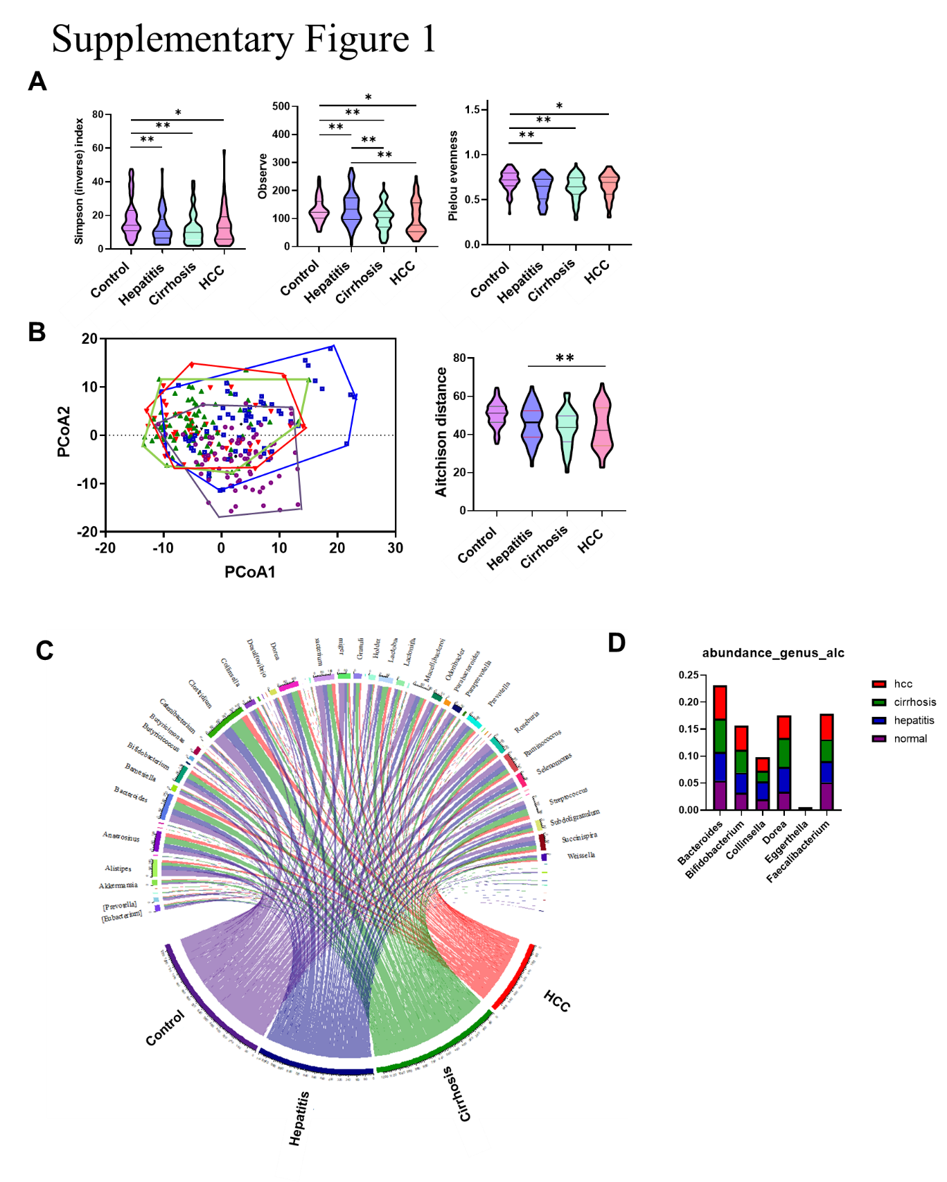
Supplementary Figure 1. Differences in alcoholic liver disease group. α diversity (A). β diversity (B). The inter-microbiome and disease correlation networks (C). Abundance of genus (D).

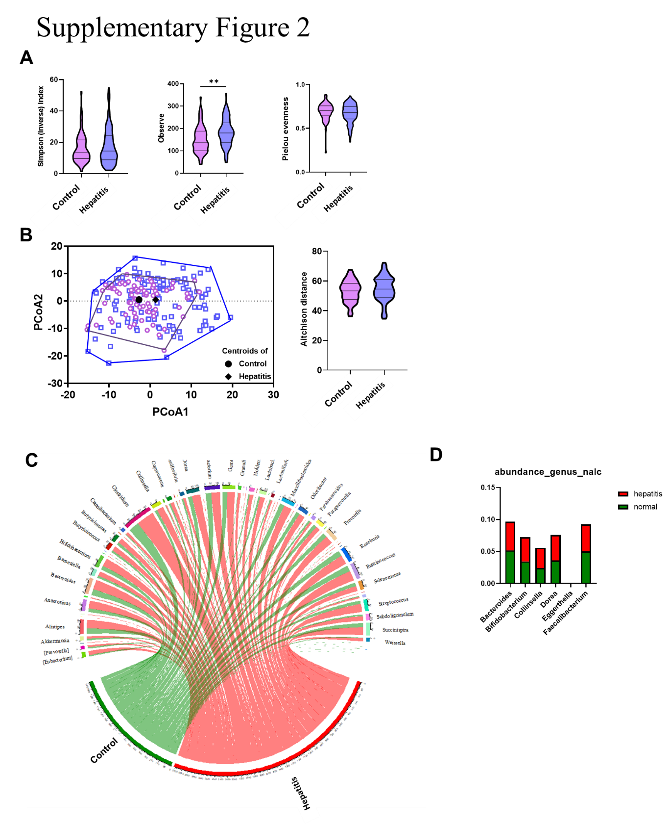
Supplementary Figure 2. Differences in nonalcoholic fatty liver disease group. α diversity (A). β diversity (B). The inter-microbiome and disease correlation networks (C). Abundance of genus (D).

