Supplementary Information
Quantifying electronic structure and geometric effects on the activity of Pt/CeO₂ catalysts for the water-gas shift reaction
Xiansheng Li^{1,2}, Xing Wang³, Arik Beck^{1,2}, Mikalai Artsiusheuski^{1,2}, Qianyu Liu⁴, Qiang Liu², Frank Krumeich¹, Ulrich Aschauer³, Jeroen Anton van Bokhoven^{1,2,*}, Luca Artiglia^{2,*}
¹Institute for Chemical and Bioengineering, ETH Zurich, 8092 Zurich, Switzerland
²Paul Scherrer Institute, 5232 Villigen, Switzerland
³Department of Chemistry, Biochemistry and Pharmaceutical Sciences, University of Bern, 3012 Bern, Switzerland
⁴Institute of Informatics, University of Zurich, 8050 Zurich, Switzerland
*Corresponding author Email: jeroen.vanbokhoven@chem.ethz.ch; luca.artiglia@psi.ch

The file includes:

Methods
Supplementary Text
Supplementary Figures S1 to S28
Supplementary Tables S1 to S13

S1. Methods
S1.1 Material synthesis
The catalysts (1 wt% Pt/CeO₂) were prepared by incipient wetness impregnation(IWI). Table S1 lists the designation and the methods of preparation of the samples in this work. The cerium(III) nitrate hexahydrate (99.9%, abcr Swiss) was heated in air at 350 °C for 2 h to obtain the bare ceria support. The required amount of the platinum precursor chloroplatinic acid, 99.9% (Alfa Aesar) for AD_0 ^{40,51} and tetraammineplatinum(II) nitrate (Alfa Aesar) for NP_0 ^{52,53}) was dissolved in deionized (DI) water and the solution was added drop-wise to the ceria during grinding. The powder was then dried overnight at 100°C in air. After drying the powder for AD_0, it was heated to 800 °C at a rate of 5 °C/min, kept at 800 °C for 12 h, and cooled (1 °C/min) to 500 °C at then cooled further to room temperature (RT) in flowing air. The powder for NP_0 was calcined at 500 °C for 5h in flowing air and then cooled to RT.
The sodium was add to the AD_0 and NP_0 samples by the IWI method. An appropriate amount of sodium nitrate was dissolved in DI water and the solution was added drop-wise to the fresh catalyst during grinding. The powder was then dried at 100 °C overnight, followed by calcination at 500 °C for 5 h in flowing air and then cooled.
S1.2 WGS performance
The WGS reaction was conducted in a Hiden CATLAB plug-flow reactor and the reaction products were analyzed by means of a Pfeiffer Omnistar quadrupole mass spectrometer. Two milligrams of catalyst, diluted with 0.2 g of inert SiC powder, were used to prevent temperature gradients. The main text mentions three types of reactions: light-off curve, fast measurements simulating conditions in an APXPS chamber and Arrhenius measurements. For the light-off curve measurements, the reaction temperature was increased from 50 °C to 500 °C and then decreased to 50 °C in steps of 50 °C. The flow mixture was 100 ppm CO, 300 ppm H₂O and argon to balance, at a total flow rate of 100 ml/min. This gas feed corresponds to a partial pressures of 0.1 mbar CO and 0.3 mbar H₂O during APXPS measurements. For fast measurements, the reaction temperatures were 100 °C, 250 °C, 300 °C, 250 °C and 100 °C, using the same catalyst mass and gas feed. For Arrhenius measurements, the gas feed was 100 ppm CO, 300 ppm H₂O, 500 ppm H₂, 100 ppm CO₂ and argon to balance, at a total flow rate of 100 ml/min. Samples used for Arrhenius measurements were initially treated in 100 ppm CO+ 300 ppm H₂O at 500 °C for 30 min for activation. The steady-state temperature steps are given in the main text. Water was dosed by means of a temperature-regulated saturator. CO was purified by flowing it through a copper mesh trap at 300 °C (to remove nickel carbonyls). DI water in the saturator was purified by boiling and bubbling helium through it for 1 h. The error bar of E_{a} is the standard deviation during linear fitting.
The standard gas feed for reaction order test was the same to the Arrhenius test. We worked in the temperature region where the CO conversion is lower than 10% (kinetically controlled regime). In general, to determine the reaction order of a compound, its concentration is varied while keeping the concentrations of other components constant. Four concentrations were varied over the ranges 0.0053 – 0.0206 % CO, 0.002 – 0.01 % CO₂, 0.013 – 0.148 % H₂O, and 0.022 – 0.078% H₂. Three different temperatures (260, 270, 310 ºC) were used for AD_0, AD_1 and AD_5 respectively.
S1.3 STEM and EDXS
Scanning TEM (STEM) at 200 kV, with high-angle annular dark field (HAADF) imaging, was performed with a Hitachi HD 2700 electron microscope, equipped with a Cs-corrector, at the Scientific Center for Optical and Electron Microscopy (ScopeM) of the ETH Zurich. Electron microscopy was done ex situ in vacuum (10⁻⁶ mbar pressure range). Due to the rather small difference in the Z contrast of Pt and Ce, the detection of AD species in STEM is challenging compared to the detection of small NPs (~1 nm). Therefore, the absence of detectable NPs in STEM is often interpreted as the sole presence of AD Pt and small clusters. Energy dispersive X-ray spectroscopy (EDXS) was done at U_{acc}= 200 kV on a HD2700CS instrument (Hitachi; FEG) equipped with an EDX spectrometer (EDAX (Ametec)). The fresh and used samples were transported in common sample vials in air. The fresh samples were measured right after synthesis and the used samples were measured after the fast WGS measurements. The error bar is the standard deviation calculated from the data in Table S2.
S1.4 APXPS
Ambient pressure XPS (APXPS) measurements were carried out at the X07DB In Situ Spectroscopy Beamline at the Swiss Light Source (SLS) synchrotron. The catalyst powders were ground and pressed (1.5 ton) onto a silver mesh. The silver mesh was fixed to a manipulator and introduced into the solid–gas interface endstation, which allows for precise dosing of gas/gas mixtures under flow conditions^{54,55}. Water was introduced into the chamber from a saturator, the temperature of which was controlled to regulate the equilibrium water vapor pressure. Gas mixtures were dosed and controlled by means of mass flow controllers and pumped away with a tunable diaphragm valve connected to a root pump. This allows for the dosing of relevant gas flows and precise control of the pressure during the experiments. The pressure was monitored by means of Baratron measurement heads. The samples were heated using a tunable IR laser hitting the back of the sample holder, and the temperature was monitored by means of a Pt100 sensor. After alignment, the sample was investigated by acquiring all the photoemission peaks in sequence, while being exposed to a specific gas at different temperatures. The samples were exposed to a mixture of 0.1 mbar CO and 0.3 mbar H₂O at 100, 250, 300, 250 and 100 °C. Linearly polarized light was used throughout the experiments. Pt 4f peaks were acquired with hν = 620 eV, corresponding to a kinetic energy of ∼540 eV. This value was chosen to maintain a high energy resolution, and sufficient photon flux. At this kinetic energy, the mean escape depth (defined as λ*cos(θ), where λ is the inelastic mean free path of photoelectrons in the solid and θ = 30°) of Pt 4f photoelectrons is ∼7 Å. The binding energy (BE) scale was aligned by means of the reference Ce 4d peak acquired at the same excitation energy. During ramp-up at 100 °C, the spectra display differential charging; the results are not given to avoid possible misinterpretation. After subtraction of the Shirley background, the photoemission peaks were fitted by Voigt-shaped functions. An asymmetric Doniach-Sunjic line shape⁵⁶, the parameters of which were evaluated from the fitting of the reference platinum metallic foil, was used to deconvolve the bulk platinum peak⁹. Ce 3d spectra were collected under the same reaction conditions used for Pt 4f, but with an excitation energy of 1200 eV. The Ce 3d spectra of CeAlO₃ were measured as a reference for Ce³⁺; as a reference for Ce⁴⁺, we measured the spectrum of CeO₂ in O₂ at 300ºC. The reference spectra were fitted using the peak positions found in a previous study³⁹. The parameters (BE, FWHM, G/L ratio, v⁰/v^{I} ratio and v/v^{II}/v^{III} ratio) were then applied to the peak fitting of all the Ce 3d spectra. Table S8 lists the parameters for the Ce 3d fitting and Figure S16 gives the fitting details for all the Ce 3d spectra in this work. The error bars associated with the area of different components obtained from the deconvolution of the spectra is the standard deviation calculated by repeating the fitting on a statistically relevant sample of spectra collected under the same reaction conditions.
S1.5 Density Functional Theory (DFT) calculations
DFT calculations were performed with the Quickstep code⁵⁷ within the CP2K package, using a mixed Gaussian and plane waves basis set, the Goedecker, Teter, and Hutter (GTH) pseudopotentials⁵⁸, and a GGA-PBE-D3⁵⁹ exchange-correlation functional ⁶⁰. We used a plane-wave basis-set energy cutoff of 1000 Ry and the Γ point to sample the Brillouin-zone. The DFT+U method was used to describe the Ce 4f electrons. A U value of 4.5 eV was taken to obtain a balanced description of the different properties of ceria, in line with previous work with typical U values in the range of 3.0 to 5.5 eV^{61,62}. Based on our previous calculations⁴⁵, the CeO₂ (223) stepped surface has a high stability and provides surface sites that can easily trap platinum species. Therefore, this surface and the step sites on it were considered. The sodium atom is placed on the step site and, in order to keep the whole system neutral, an OH group is attached to the sodium atom to form one NaOH species. The single-atom platinum species PtO_{x} (x=0, 1, 2) are then placed on step sites that neighbour the NaOH species. The positions of the two bottom layers of the CeO₂ surface are fixed. Optimizations are considered complete when atomic forces reach 0.02 eV/Å.
In this study, the adsorption energy was calculated as follows:

 | Eads = Eslab+PtOx− Eslab − EPt – x/2 EO2 | (1)

where Eslab+ptox, Eslab, EPt and EO2 are the calculated electronic energies of adsorbed species on the surface, a CeO2 (223) surface with or without NaOH species, a bulk platinum and a gas-phase O2 molecule, respectively.
S1.6 Ex situ X-ray Diffraction (XRD)
The ex situ XRD measurements were carried out in the 2θ range of 20–65° on Bruker D8 advance with Cu K_{α} radiation (λ = 0.15406 nm) as the X-ray source. A thin layer of fine-ground catalyst powder was dispersed on a zero-background silicon wafer, placed in a sample holder and scanned with an increment step of 0.05° by keeping a time/step of 5 s.

S2. Supplementary Text
S2.1 Peak fitting of Pt 4f photoelectron spectroscopy
The proposed peak fitting strategy is based on the following assumptions:
1) Platinum on the catalyst surface consists of AD Pt²⁺ and Pt NPs.
2) The platinum nanoparticle consists of atoms at the bulk, terrace, edge and corner positions. Their fraction can be determined by geometric effect as a function of the NP diameter. The BE values of these sites are in line with the values in ref⁹.
Although it may seem as though 5-6 peaks were employed to fit Pt 4f spectra, it is imperative to note that their parameters are constrained (position, shape, and full width at half-maximum, see Table S3), ultimately resulting in only two components being utilized for the fitting, namely AD Pt²⁺ and Pt⁰ NP.
We established theoretical platinum NP models supported on ceria with different platinum atom numbers and, thus, different diameters (Table S4). Even though the shape of the platinum nanoparticles is impacted by many factors, including synthesis techniques and reaction conditions ^{35,37,63}, the variation in the platinum sites with size shows a similar trend for most shapes (e.g. octahedral, icosahedral, cuboctahedra) in the literature. Figure S10 (A) confirms a typical truncated octahedral shape in the STEM image. Therefore, in this study, the platinum nanoparticles are modeled by a truncated octahedral shape, bound by <111> and <100> facets with the two lowest surface energies according to the DFT calculation ^{64,65}. The supported nanoparticles are then modeled by the upper half of the truncated octahedral. The fractions are displayed as a function of the NP diameter in Figure S10 (B), thus enabling the extraction of the specific ratio of those species at the average NP sizes obtained from the STEM images in Table S5. Therefore, the parameters can be constrained accordingly during peak fittings of the Pt 4f. Figure S11 shows an example of fitting. The average size of the STEM statistics can be used as a guide to identify the correct model. The shape of the NPs could also affect the fitting parameters. In practical situations, for example when AD starts to sinter into assembles of a few atoms, it is difficult to identify and account for these smaller clusters by electron microscopy. The proportion of small clusters may be higher, which leads to a higher proportion of corners. Therefore, we added the component “corner2” to fit the potential corners from smaller clusters. It has the same BE, FWHM, G/L ratio and asymmetry as “corner1”, but the area is not constrained. “Corner2” makes no contribution when there are large platinum particles, but it becomes prominent during the structural evolutions, e.g. AD_1 at 250°C during ramp-up (Figure S12(B)). The corner sites will eventually be the sum of “corner1” and “corner2”. Figures S12 and S13 give the fitting details for all the Pt 4f spectra in this work. All the spectra can be fitted well by means of this strategy.

S2.2 DFT calculation of the effect of sodium on the structure evolution of platinum
Figure S8 shows the differences in structures and adsorption energy of PtO_{x} species on the CeO₂ (223) surface with and without NaOH species. On the CeO₂ surface without NaOH species, the platinum atoms adsorb on the bridge site between two surface oxygen atoms. Platinum in the PtO and PtO₂ species are coordinated by four oxygen atoms, forming stable square planar [PtO₄] units⁴⁵. In the case of PtO, one oxygen atom in the [PtO4] unit originates from a neighboring surface O site, leaving an oxygen vacancy site on the surface. In the presence of NaOH species, the structures of PtO_{x} species on CeO₂ surfaces do not change. PtO and PtO₂ interact with NaOH by forming a Na-O bond. In the oxidizing environment, platinum exists in the form of PtO and PtO₂ species. DFT calculations show that these species are more stable (0.45 eV for PtO and 0.57 eV for PtO₂) on the CeO₂ surface in the presence of NaOH species. NaOH will thus promote the dispersion of nanoparticles to form AD platinum under oxidative conditions, in agreement with the experimental findings. In the WGSR environment, the PtO and PtO₂ species will be reduced to atomic Pt species. The experimental results show that sodium species promote the sintering of AD platinum, forming larger platinum nanoparticles. However, the DFT calculations show that the NaOH species has a negligible influence on the adsorption of reduced platinum species. This implies that the sintering process cannot be explained simply by thermodynamic stability, but instead that other kinetic factors may play an important role in the sintering process.

S2.3 Different theoretical models of Pt NPs
Platinum NPs may have different shapes, depending on their size, position, interaction with the support, etc. This will lead to different fractions assigned to the corner atoms. On the other hand, the participation of ceria in WGS will place more emphasis on the role of the sites at the interface. We, therefore, also took into account the fraction of perimeter atoms, and two new theoretical physical models of the NP were established: "pancake" and "diamond". Figure S14 (A) and (B) show the two models and the fraction of species as a function of size. The pancake model is flatter compared to the truncated octahedron due to the stronger Pt-CeO₂ interaction; in contrast, the diamond model represents the case of the weaker interaction, with a shape close to a diamond or a truncated bipyramid^{66,67}. Figure S14 (C) presents a comparison of the size dependence of the calculated corner ratios combining both models together with the truncated octahedron model. The corner site shows similar fractions in the three models. Figure S14 (D) shows that the fractions of the perimeter site are different in the three models, but none of them has a drastic drop as the size of the nanoparticle decreases. Thus, difference in NP shape has a minor effect on the rate of decay of the corner atoms; the fraction of perimeter atoms also cannot provide a faster drop.

S2.4 APXPS investigations of Ce 3d during the WGS reaction
The Ce 3d spectra in Figure S16 were collected under the same reaction conditions as for Pt 4f spectra; and Figure S17 displays the structural evolution with temperature, in CO+H₂O on different samples. In addition to the six samples loaded with platinum, the bare ceria support, prepared according to the method described in S1.1, was also tested as a reference. CeO₂ is reduced to a different extent on all samples. The bar plots of all samples show a consistent pattern during cooling: The fraction of Ce³⁺ is higher at lower temperatures. According to the activity test results, the catalyst has no WGS activity at 100°C; at 300°C, when high conversion is measured, a decrease in Ce³⁺ indicates that oxidation state of ceria surface has relevant modifications upon WGS reaction. Such a difference at 100°C and 300°C suggests that the WGS reaction involves the participation of ceria. This result can be verified further by the behavior of the AD_0 sample. AD_0 fresh is almost inactive and shows the lowest percentage of Ce³⁺ at low temperatures (100 and 250°C). As soon as AD Pt²⁺ sites sinter at 300°C, the fraction of Ce³⁺ increases and becomes comparable to that observed in the other catalysts. Metallic platinum boosts the local reduction of ceria, creating Ce³⁺ active sites for the reaction. The affinity of the reactants for different surface sites, i.e., CO always adsorbs on Pt while water adsorbs on ceria, places more emphasis on the importance of the Pt-ceria interface for WGS^{47,48}.
As suggested by the dashed line in Figure S17, at 100°C, when there is no observable conversion, the samples show a decreasing amount of Ce³⁺ from NP_0 to NP_5 and from AD_0 to AD_5, with bare-CeO₂ having the lowest percentage. To explain this, the Ce³⁺ fraction was plotted as a function of the size of Pt NPs (Figure S18): As the size of NPs increases, the fraction of Ce³⁺ decreases. This may be related to the different magnitude of Pt-CeO₂ electron transfer^{6,46}. Small Pt clusters transfer more charge to the support, resulting in a greater reduction in CeO₂. However, several factors affect the CeO₂ valence state: Pt-CeO₂ charge transfer, reaction conditions, Na-loading and even the grain size of CeO₂. Moreover, the high (20-26%) Ce³⁺ fraction also indicates that 1 wt% Pt cannot provide so much charge. Therefore, we assume qualitatively that the lower Ce³⁺ percentage observed with the larger Pt NP is attributed, in part, to the weaker EMSI, which is consistent with the literature⁶ and with the shift of Pt 4f to lower BEs.
S2.5 Mathematical expression of the kinetic model
The model assumes that two types of active sites, namely AC₁ and AC₂, possessing different activation energies E₁ and E₂, are dispersed on the surface of a catalyst. The proportion of AC₁ is x and the proportion of AC₂ is (1-x).
Overall activation energy is not the mere sum of E₁ and E₂; the reaction rate must be taken into consideration.
Arrhenius equation:
 | k = A·exp(-E_{a}/RT) | (2)
where
- k is the rate constant,
- A is the pre-exponential factor,
- E_{a} is the activation energy,
- T is the absolute temperature (in Kelvin),
- R is the universal gas constant.
Differential form of Arrhenius equation:
 | $$E_{a}=RT^{2}\frac{dlnk}{dT}$$ | (3)
 | $$\frac{dk}{dT}=A·exp\left(-\frac{E_{a}}{RT}\right)∙\frac{E_{a}}{{RT}^{2}}=\frac{{kE}_{a}}{{RT}^{2}}$$ | (4)
Rate of AC₁ for WGS: the amount of CO converted from AC₁ in unit time
 | r₁ = k₁ · [CO]^{O1}· [H₂O]^{O2}· [H₂]^{O3}· [CO₂]^{O4} | (5)
Rate of AC₂ for WGS: the amount of CO converted from AC₂ in unit time
 | r₂ = k₂ · [CO]^{O1}· [H₂O]^{O2}· [H₂]^{O3}· [CO₂]^{O4} | (6)
where
- r is the WGS reaction rate,
- O is the reaction orders of reactants and products,
- Assuming that the reaction orders for AC₁ and AC₂ are identical.
The overall rate r_{eff} of AC₁ and AC₂ for the WGS reaction is:
 | r_{eff} = x · r₁ +(1-x) · r₂ | (7)
 | r_{eff} = (x·k₁ - x·k₂ + k₂) · [CO]^{O1}· [H₂O]^{O2}· [H₂]^{O3}· [CO₂]^{O4} | (8)

Overall rate constant k_{eff}
 | k_{eff} = x·k₁ - x·k₂ + k₂ | (9)
 | k_{eff} = x·(k₁ - k₂ )+ k₂ | (10)
 | ln k_{eff} = ln [x·(k₁ - k₂ )+ k₂] | (11)
 | $$\frac{dlnk_{eff}}{dT}=\frac{1}{x\left(k_{1}-k_{2}\right)+k_{2}}∙\frac{d}{dT}\left[x\left(k_{1}-k_{2}\right)+k_{2}\right]$$ | (12)
 | $$\frac{dlnk_{eff}}{dT}=\frac{1}{k_{eff}}∙[x\left(\frac{dk_{1}}{dT}-\frac{dk_{2}}{dT}\right)+\frac{dk_{2}}{dT}]$$ | (13)
 | $$\frac{dlnk_{eff}}{dT}=\frac{1}{k_{eff}}∙[x\left(\frac{k_{1}∙E_{1}}{{RT}^{2}}-\frac{k_{2}∙E_{2}}{{RT}^{2}}\right)+\frac{k_{2}∙E_{2}}{{RT}^{2}}]$$ | (14)
The expression for the overall activation energy E_{eff} is
 | $$E_{eff}=RT^{2}\frac{dlnk}{dT}$$ | (15)
 | $$E_{eff}=\frac{1}{k_{eff}}∙\left[x\left(k_{1}∙E_{1}-k_{2}∙E_{2}\right)+k_{2}∙E_{2}\right]$$ | (16)
 | $$E_{eff}=\frac{x\left(k_{1}∙E_{1}-k_{2}∙E_{2}\right)+k_{2}∙E_{2}}{x·\left(k_{1} - k_{2} \right)+ k_{2}}$$ | (17)
 | $$E_{eff}=\frac{x\left(r_{1}∙E_{1}-r_{2}∙E_{2}\right)+r_{2}∙E_{2}}{x·\left(r_{1} - r_{2} \right)+ r_{2}}$$ | (18)
Equation (18) does not adequately describe the experimental activation energy data on the basis of the measured WGS rates (not shown here). The reason is that r₁ and r₂ are the function of temperature but our Arrhenius data were collected at different temperature ranges.
We therefore used a unified kinetic model that makes use of all the available kinetic data with a full range of temperatures and based on equation (8):
 | r_{eff} =[ x · k₁ +(1-x) · k₂] · [CO]^{O1}· [H₂O]^{O2}· [H₂]^{O3}· [CO₂]^{O4}  r_{eff} =x · A₁ exp(-E₁/RT) + (1-x) · A₂ exp(-E₂/RT) | (8)  (19)
- Assuming that [CO]^{O1}· [H₂O]^{O2}· [H₂]^{O3}· [CO₂]^{O4} is a constant and merge it into the pre-exponential factor A₁ and A₂.
- Assuming that the structure of the platinum no longer changes in the Arrhenius test.
The experimental data r_{eff}, x and T (Table S9) are substituted in the above equation to estimate A₁, A₂, E₁ and E₂. Experimental data were fitted in OriginPro using the Orthogonal Distance Regression(ODR) Algorithm. To cross-check, we also carried out a least-squares minimization in python using the scipy.optimize.curve_fit function. Both fitting results (Table S10) are close, indicating that the fittings are reliable. By means of the fitted results, we calculated r₁ and r₂ at 250 and 300°C, respectively.
The activity difference of r₁ and r₂ is about 1380 fold at 250°C; hence CPS contributes almost all the conversion at low temperature. At 300°C, the gap narrows to about 410 fold, when the contribution of other sites to the activity starts to become significant, which is also the reason why E_{a} differs on different samples. The activity values calculated according to this model were compared with the measured results as a function of temperature (see Figure S20). Because the fitting results by python and by OriginPro are close, only the results fitted by python are shown. We then took the average temperature in the Arrhenius plot for each sample in Figure 2(A) and 2(B) and estimated the activation energy at those specific temperatures by equation(18).
The calculated results are listed in Table S11, and the predicted values of E_{a} are compared with the measured values in Figure 3(C).

S2.6 Sodium-induced support modification
O 1s spectra and kinetic reaction order tests were used to demonstrate the Na-CeO₂ interaction, as well as its contribution to the WGS activity. Figure S21(A) compares the H₂O and H₂ orders for AD_x samples, with detailed kinetic order test results shown in Figure S22. The positive (H₂O) and negative (H₂) reaction orders indicate the promotion and inhibition effects of H₂O and H₂ towards WGS. Upon sodium addition, the H₂O order slightly decreases (form 0.9 to 0.7-0.8), while the H₂ order significantly increases (from -0.8 to -0.3), indicating that sodium can mitigate the inhibitory effect of H₂ on WGS¹⁶. Moreover, the small amount of sodium addition (AD_1) and large amount of sodium addition (AD_5) have the same effect on the reaction order of H₂, in line with the results for Na-Pt/rutile in ref. ¹⁵, implying that:
1. The effect of sodium on the reaction order is independent on the Pt NP size. Despite a consistent increase in NP size from AD_0 to AD_5, the reaction order experiences only minimal alteration from AD_1 to AD_5. In ref. ¹⁵, platinum remains in metallic state throughout the WGS process in both Na-free and Na-load samples, and the changes in reaction orders are only attributed to the modifications made to the support properties.
2. A relatively low loading of Na (Pt: Na = 1:1 in AD_1) is sufficient to alter the reaction order, while excess sodium (AD_5) does not contribute to further changes. Sodium preferentially occupies the most relevant locations on active sites, i.e., CPS at the Pt-CeO₂ interface; excess sodium migrates to the support but has no effect on the reaction order.
O 1s raw spectra in Figure S21(B) show the effect of sodium on ceria measured on AD_x samples. Such spectra were acquired together with Pt 4f and Ce 3d, with a photon energy of 825 eV, and were normalized to the main peak intensity, using C 1s (Figure S23) as a reference to align the BE scale. The lattice peak⁶⁸ of CeO₂ (AD_0 at 529.6 eV) shifts towards lower binding energy by 0.4 eV upon sodium addition (AD_5 at 529.2 eV). This small but convincing shift supports the formation of the Ce-O-Na structure, and is due to the electronegativity difference between sodium and cerium: when the O-Na structure forms, the electron cloud density on O is larger than that of O-Ce, leading negative BE shift of the lattice oxygen peak. The metal-O-alkali structure has already been reported in the literature⁶⁹⁻⁷¹. It is important to highlight that the lattice oxygen peak of O 1s undergoes a shift, rather than broadening. This observation strongly suggests a homogeneous structure of Ce-O-Na within the probing depth of XPS. The O 1s spectrum was acquired at a kinetic energy of approximately 300 eV, corresponding to an inelastic mean free path of approximately 7.7 Å on ceria. Accounting for the XPS acquisition geometry, the mean escape depth is estimated as 6.6 Å, which is less than two unit cells of ceria. Nearly 80% of the photoemission signal originates from this depth, with the remainder from 2x and 3x this value. This indicates a homogeneous sodium distribution within the first two layers of the support. The STEM analysis depicted in Figure S5 shows no agglomeration of sodium, and the negligible signal of sodium in energy dispersive spectrometry (Figure S24) further confirms its highly dispersed nature. Additionally, the absence of any peaks in the diffraction pattern in Figure S25, beyond those of pure ceria, implies the lack of a distinct sodium-containing phase. These findings align well with those previously reported literature^{32,70,72}. Although surface hydroxyls (OHs) are considered significant intermediates in the WGS reaction^{17,18,21,47} and alkali metals influence their fraction¹⁷⁻¹⁹, the intensities of OH-related peaks (531-532 eV) ⁶⁸ in Figure S21(B) exhibit negligible differences. This lessens their importance as a descriptor of WGS activity. Hence, at lower Na-loadings (Pt:Na=1:1), Na initially migrates to the metal-support interface and forms Na-O-Ce structure, as evidenced by the slight shift of the O 1s main peak for AD_1. Such modification of ceria promotes WGS by mitigating the inhibition effect of H₂, in line with the literature¹⁶. By increasing Na-loading (Pt:Na=1:5), the ceria surface is completely covered with homogeneous Na-O-Ce layer, but this does not further alter the reaction order.
The above results contribute to a comprehensive understanding of the sodium effect: on one hand, sodium inhibits WGS by promoting the sintering of platinum; on the other hand, sodium enhances WGS through support modification. The overall effect of sodium on WGS is inhibition, implying that the contributions from the modification of the platinum structure overwhelms those from the support modification. Assuming that the support-modification have a significant impact on the activity, the proportional relationship between activity and platinum structure is the result of compensating for support-modification. Considering that activity is proportional to the number of active sites, the support-modification and activity should also have a proportional relationship. However, it is evident that when the activity changes significantly (AD_1 vs AD_5), the changes in reaction order caused by the support-modification are not as apparent, indicating no proportional relationship. This justifies why the contribution of support-modification to the activity is negligible in the proportional correlation between activity and Pt structure. A parallel comparison of AD_x and NP_x supports a similar conclusion, as the addition of the same amount of sodium to AD_0 and NP_0 results in markedly different activities. The strong correlation between WGS activity and platinum structure suggests that the platinum structure is the predominant descriptor for WGS activity.

S2.7 Compatibility analysis of APXPS data with activity tests by flow reactor to allow an operando analysis
Below is a discussion of the following three compatibility issues.
1) Activities in the APXPS chamber versus in the flow reactor
Figure S26 compares the results of a fast activity test (S1.2) performed in the flow reactor with the hydrogen signal by means of MS during the APXPS experiment. The XPS cell is not a flow reactor; the catalyst pellet is different for each catalyst in terms of the amount of sample and pellet thickness (not a catalytic bed). However, the reaction can be followed quantitatively by following the production of hydrogen. Therefore, it is possible to make only qualitative comparisons across the samples.
On the other hand, it is relevant to compare the hydrogen signals for the same sample at different temperatures. As the temperature increases to the working temperature window of the catalyst, the hydrogen signal increases, indicating that the catalyst is functioning; the hydrogen signal at 300 °C is higher than that at 250 °C, in line with the results measured by the flow reactor. The red and black curves indicate good agreement. For example, they show the activation behavior of the AD_0 sample at 300 °C and the low CO conversion, reflected by the low H₂ production of the AD_5 sample at 300 °C.
Based on the equivalence of partial pressure levels experienced by the samples in both the XPS chamber and the flow reactor, as well as the strong correlation observed in the conversion and production data, we put forth the suggestion that this combination provides a viable means for conducting operando analyses.
2) Pt structures during operando XPS in CO+H₂O versus in CO+H₂O+H₂+CO₂ during Arrhenius measurement
APXPS experiments were carried out in CO+H₂O, while the Arrhenius data were acquired by co-dosing reagents and products (CO+H₂O+CO₂+H₂). The pretreatment of the samples is also different: Before data acquisition in CO+H₂O, the samples were heated in 0.1 mbar CO + 0.3 mbar H₂O up to 300 °C then cooled down to 250 °C before measurement. In the case of CO+H₂O+CO₂+H₂, the samples were heated in 0.1 mbar CO + 0.3 mbar H₂O up to 500 °C then cooled down to 250 °C and measured after switching to CO+H₂O+CO₂+H₂. To evaluate whether the spectroscopic data can be directly compared to the results of the Arrhenius tests, we compared the Pt 4f spectra of NP_0 and NP_5 samples acquired at 250 °C in 0.1 mbar CO + 0.3 mbar H₂O and 0.1 mbar CO + 0.3 mbar H₂O + 0.1 mbar CO₂+ 0.5 mbar H₂. Figures S27-28 give Pt 4f spectra and Table S13 lists the results of fitting. The differences between the two experimental conditions are minor, indicating that XPS data can describe the structural information of samples in their working state; thus the correlation of Arrhenius plots with spectroscopy data is relevant.
3) Industrial relevance of this work
To remove relatively low CO concentrations from a reformate gas, WGS is a chemical method that can be used as an alternative to preferential oxidation (PROX) and methanation. Typically, a WGS reactor is used in series with a PROX reactor to achieve CO concentrations lower than 10 ppm for hydrogen fuel cell applications⁴¹, which are susceptible to carbon monoxide poisoning. Unfortunately, the commercial WGS catalysts are unsuitable for fuel cell applications. The development of water gas shift catalysts for the application in fuel cell technology is of current interest due to the demand for clean fuel and the critical role of the water gas shift reaction in hydrogen fuel cells. Therefore, the conditions we applied in the flow reactor (100 ppm CO+ 300 ppm H₂O) and in the APXPS (0.1 mbar CO+ 0.3 mbar H₂O) are industrially relevant. A comprehensive understanding of the structure-activity relationship under such conditions will finally enable the rational design of WGS catalysts.

S2.8 Discussion of contrasting results in the literature with regard to identification of the active site
Our results provide a complete characterization of the structure-activity relationship, based on interface-sensitive spectroscopy and reactivity data, with the support of NPs model simulations. The following points summarize the main disagreements with regard to previously reported data, in an attempt to highlight the novelty and strength of this work.
1) As suggested by APXPS, the corner/CPS sites represent low fractions among the platinum species. This weak feature is hard to estimate by bulk-sensitive techniques such as X-ray Absorption Spectroscopy (XAS). Previous studies support this claim, showing that samples consisting exclusively of AD species and those with coexisting AD and small clusters showed qualitatively similar XAS features ^{73,74}.
2) Due to final state effects, the EMSI and electron transfer from Pt 5d to the CO molecule upon adsorption, the Pt 4f component assigned to corner sites is at a higher binding energy than that of a platinum foil reference. The binding energy is close to that of oxidized platinum and can be confused with AD (Pt²⁺); for that reason some research groups describe it by the term Pt^{δ+} ^{6,75}.
3) AD Pt²⁺ may behave as a precursor for smaller clusters, formed upon sintering during the reaction (as demonstrated by our microscopy and XPS results), which possess more CPS sites and, thus, lower activation energy according to our prediction. This may explain why AD catalysts are usually considered more active than large NP catalysts.

S2.9 Discussion of the WGS performance of progressively deposited Pt on CeO₂(111)
Our results elucidate the exceptional WGS activity behavior observed in the model Pt/CeO₂(111) catalyst⁴⁶. As platinum is progressively deposited onto the initially inactive CeO₂(111) surface, the WGS activity exhibits a volcano-shaped curve in correlation with Pt coverage, initially increasing and then decreasing. The peak activity occurs in catalysts containing Pt particles ranging from 1-2 nm in size. This phenomenon can be rationalized by our findings: as Pt is deposited, AD species initially form on the CeO₂(111) surface, contributing minimally to the WGS activity. However, when the fraction of small Pt clusters (<1.25 nm) emerges, the WGS conversion rate starts to increase, peaking with the maximum number of small clusters (<1.25 nm). Continued increases in Pt only promote the formation and increase of larger particles at the expense of smaller clusters (<1.25 nm), while the larger NPs contribute little activity due to the dramatic change in electronic structure effects. The absence of activity change for Pt coverages between 0.8 and 2.4 monolayers is likely attributed to the persistence of the main active sites, i.e., the few small clusters (<1.25 nm), while additional larger particles contribute marginally to the activity. This suggests that merely increasing the Pt loading (augmenting the number of clusters and sites) without controlling the size fails to enhance the number of active sites. Our conclusions also align with results obtained for gold (Au) deposited on Mo(112)-(8 × 2)-TiOx in the context of CO oxidation⁷⁶.

Figure S1. WGS reaction rate of fresh/used AD_0 samples at 250°C calculated by the light-off conversion. Feeding: 100 ppm CO + 300 ppm H₂O, total flow=100 ml/min. Sample mass: 2mg catalyst and 200mg SiC.
Figure S2. Light-off curve of AD_0 and NP_0 at 100-500°C during ramp-up and ramp-down. Feeding: 100 ppm CO + 300 ppm H₂O, total flow=100 ml/min. Sample mass: 2mg catalyst and 200mg SiC.

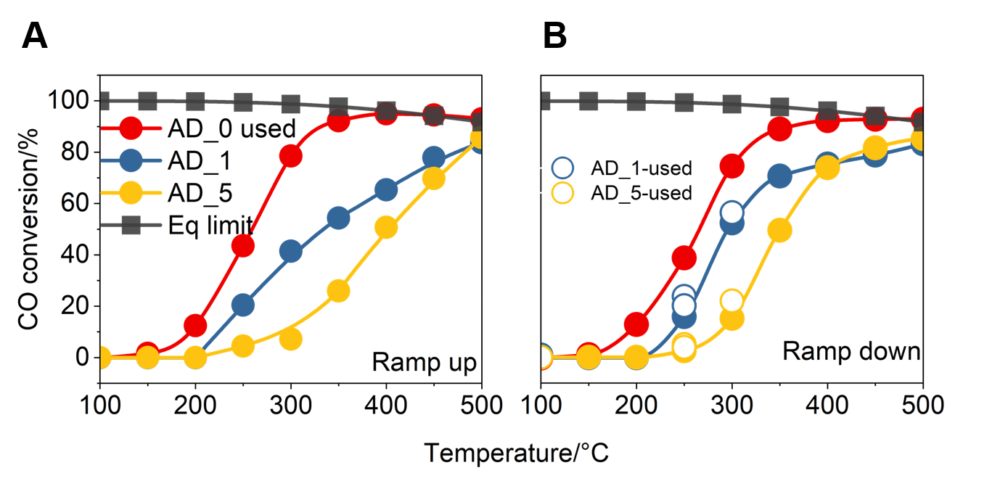
Figure S3. Light-off curve of AD_x catalysts loaded with various amount of sodium at 100-500°C during (A) ramp-up and (B) ramp-down. To compare the activity of used AD_0 and AD_1/AD_5 samples, fast activity test results for the used AD_x samples after cool down are shown in empty circles in (B). Feeding: 100 ppm CO + 300 ppm H₂O, total flow=100 ml/min. Sample mass: 2mg catalyst and 200mg SiC.

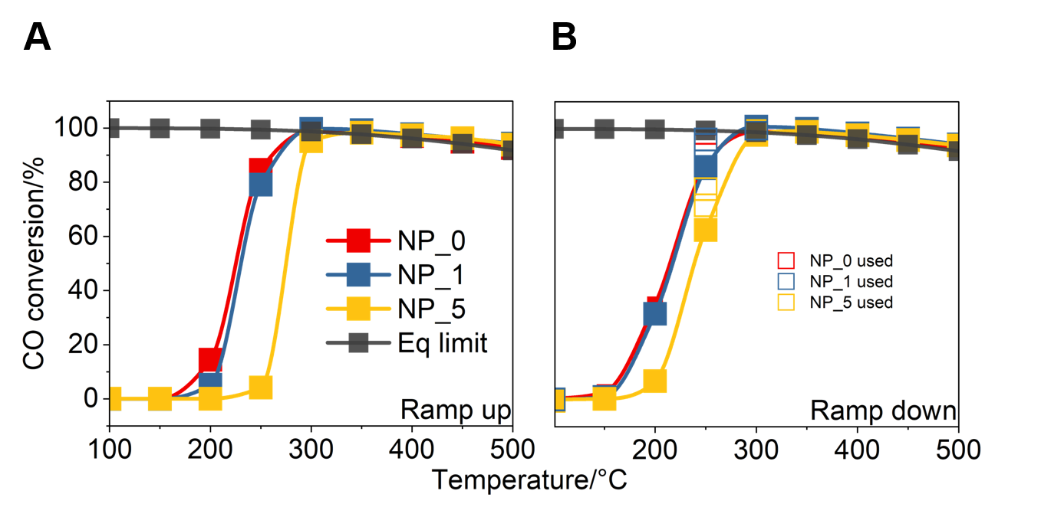
Figure S4. Light-off curve of NP_x catalysts loaded with various amount of sodium at 100‒500°C during (A) ramp-up and (B) ramp-down. To compare the activity of used NP_x samples, fast activity test results for the used NP_x samples after cool down are shown in empty squares in (B). Feeding: 100 ppm CO + 300 ppm H₂O, total flow=100 ml/min. Sample mass: 2mg catalyst and 200mg SiC.

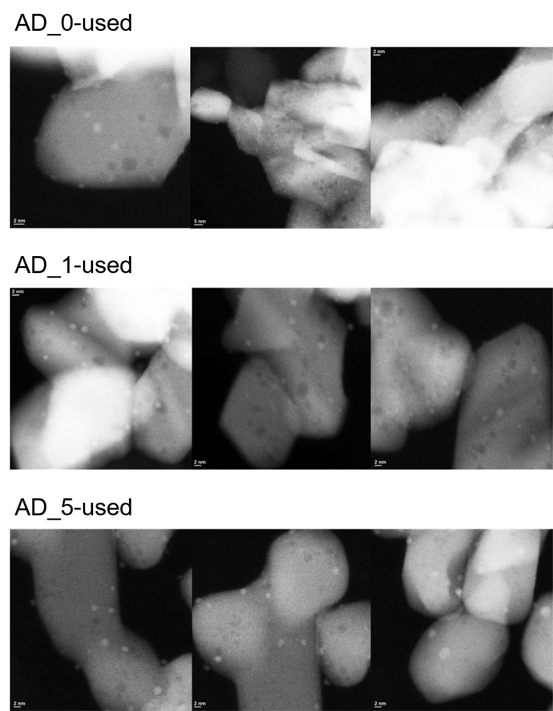
Figure S5. Representative STEM images of the AD_x catalysts after WGS reaction.

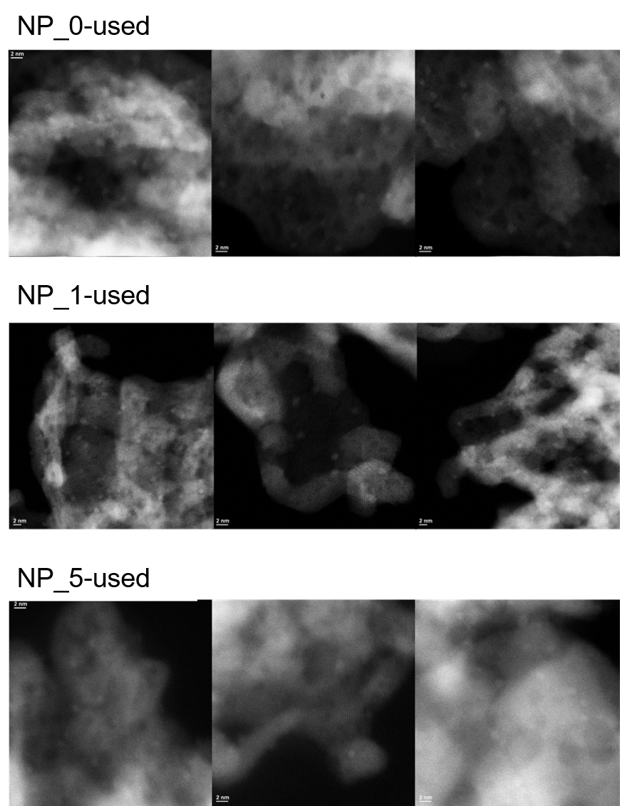
Figure S6. Representative STEM images of the NP_x catalysts after WGS reaction.

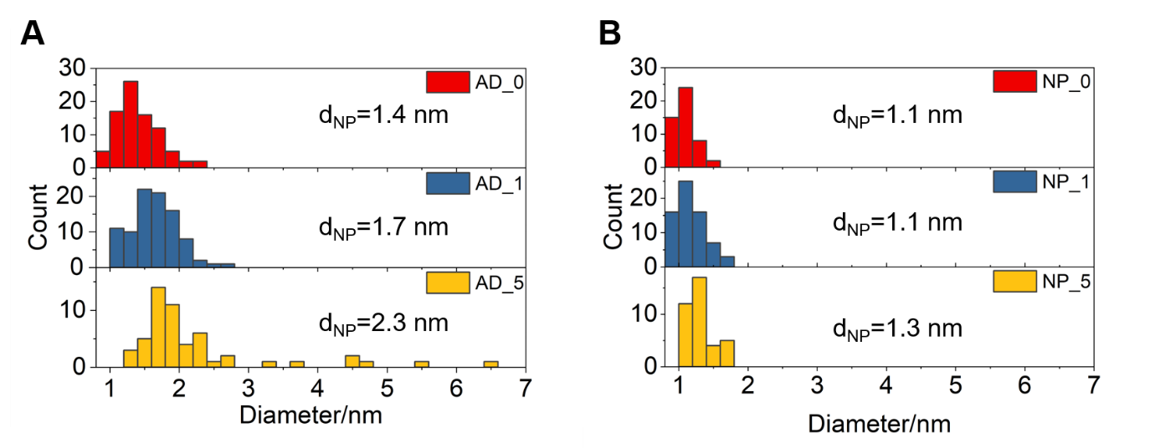
Figure S7. Particle size distribution of the platinum nanoparticles on used AD_x samples (A) and used NP_x samples (B) obtained from the STEM images.

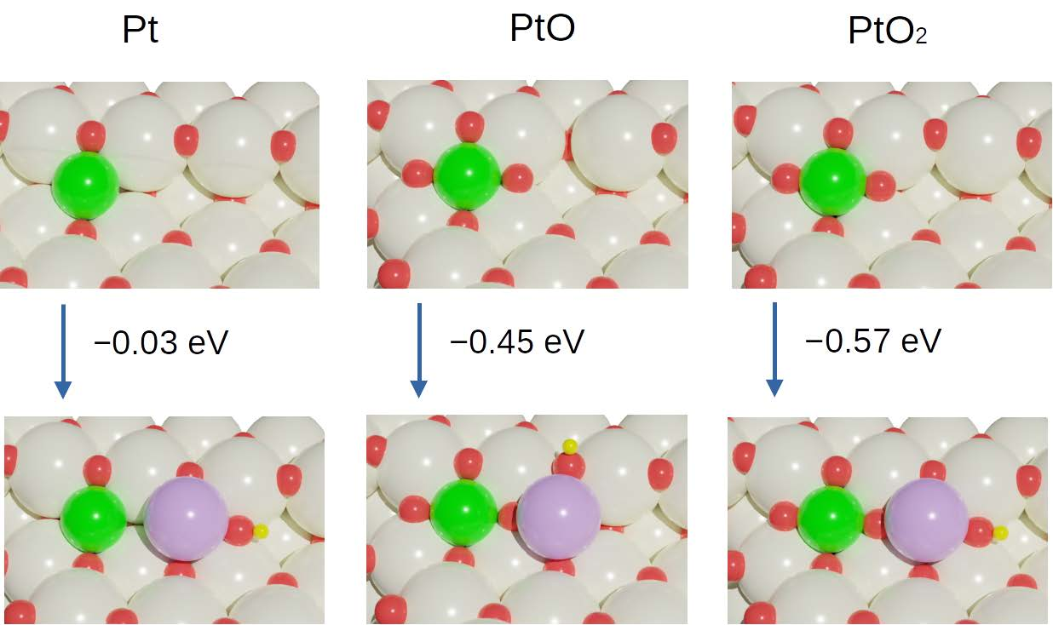
Figure S8. Structures of PtOx species on CeO₂ (223) surface without and with NaOH species. Ce, O, Pt, Na and H atoms are shown as grey, red, green, purple and yellow spheres, respectively. The adsorption energy difference of PtOx species on CeO₂ (223) surface with and without NaOH species are also shown. Adsorption energies are calculated using Eq. (1).

Figure S9. Comparison of raw Pt 4f XP spectra collected at 250ºC in CO+H₂O (0.1+0.3 mbar) for AD_x and NP_x samples.

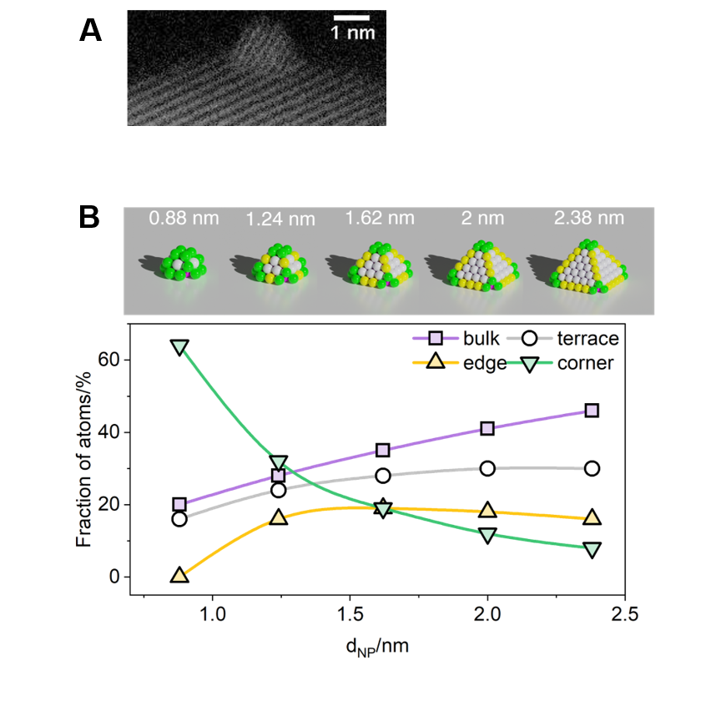
Figure S10. (A) Typical STEM image of Pt NP for determining the particle shape in the model. (B)Illustrations of supported NP models (truncated octahedron) and atom fractions at different sites as a function of the NP model diameter.

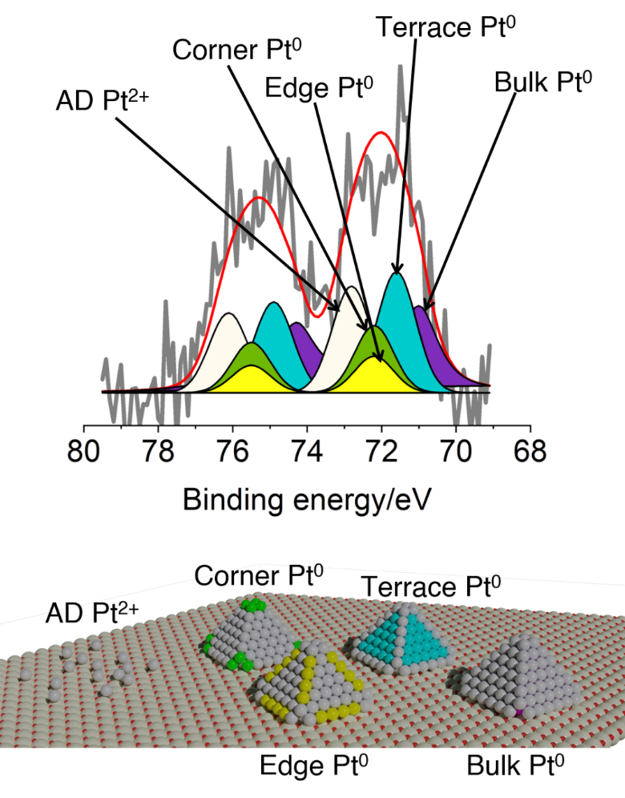
Figure S11. An example of Pt 4f fitting details and the corresponding sites are highlighted with the same colors. Bulk Pt⁰ atoms are in purple color but covered by the atoms on surface.

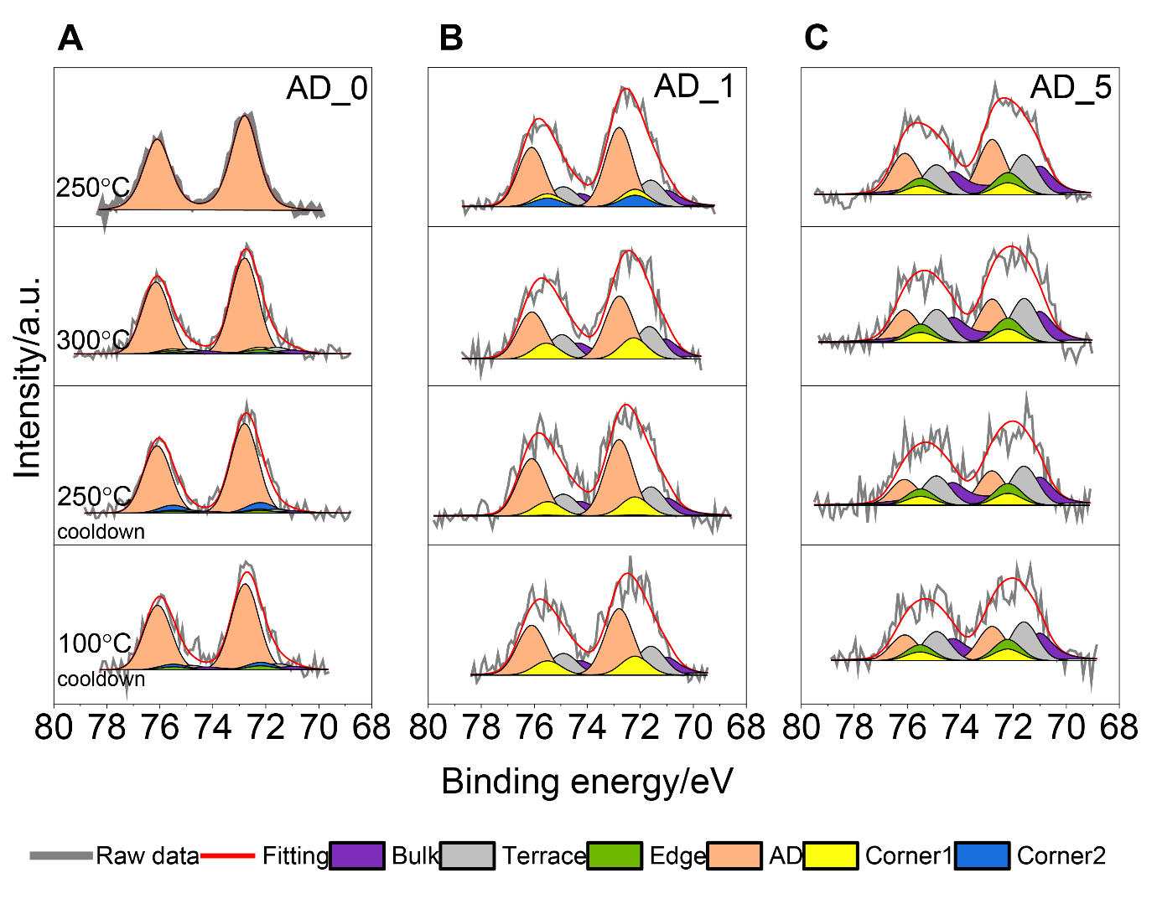
Figure S12. Experimental X-ray photoelectron spectra and peak fitting of the Pt 4f region over AD_0 (A), AD_1 (B) and AD_5 (C) samples obtained in 0.1 mbar CO + 0.3 mbar H₂O, during ramp-up at 250-300°C and cool-down at 300-100°C, using 620 eV of photon energy.

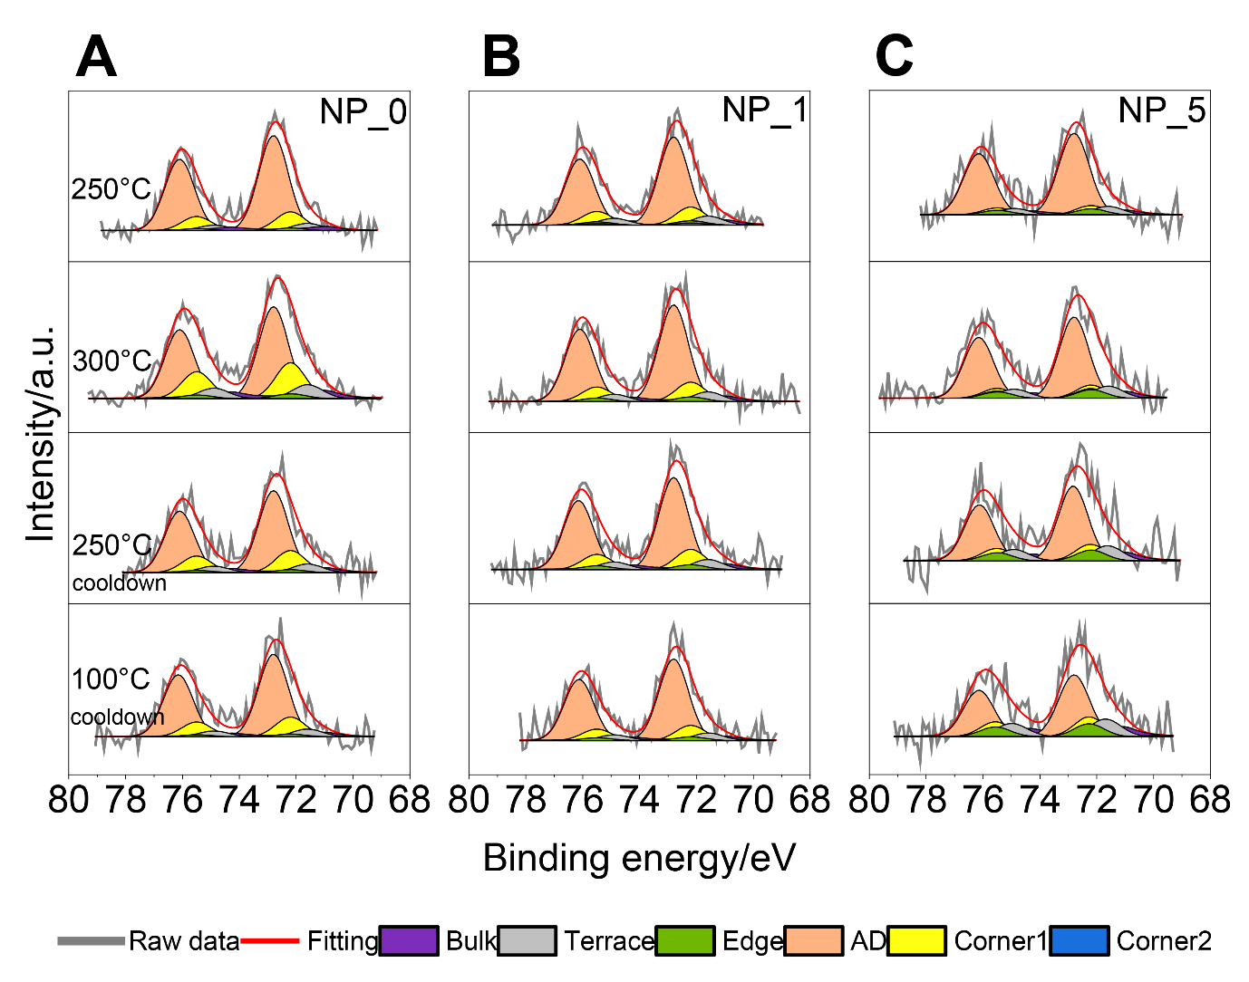
Figure S13. Experimental X-ray photoelectron spectra and peak fitting of the Pt 4f region over NP_0 (A), NP_1 (B) and NP_5 (C) samples obtained in 0.1 mbar CO + 0.3 mbar H₂O, during ramp-up at 250-300°C and cool-down at 300-100°C, using 620 eV of photon energy.

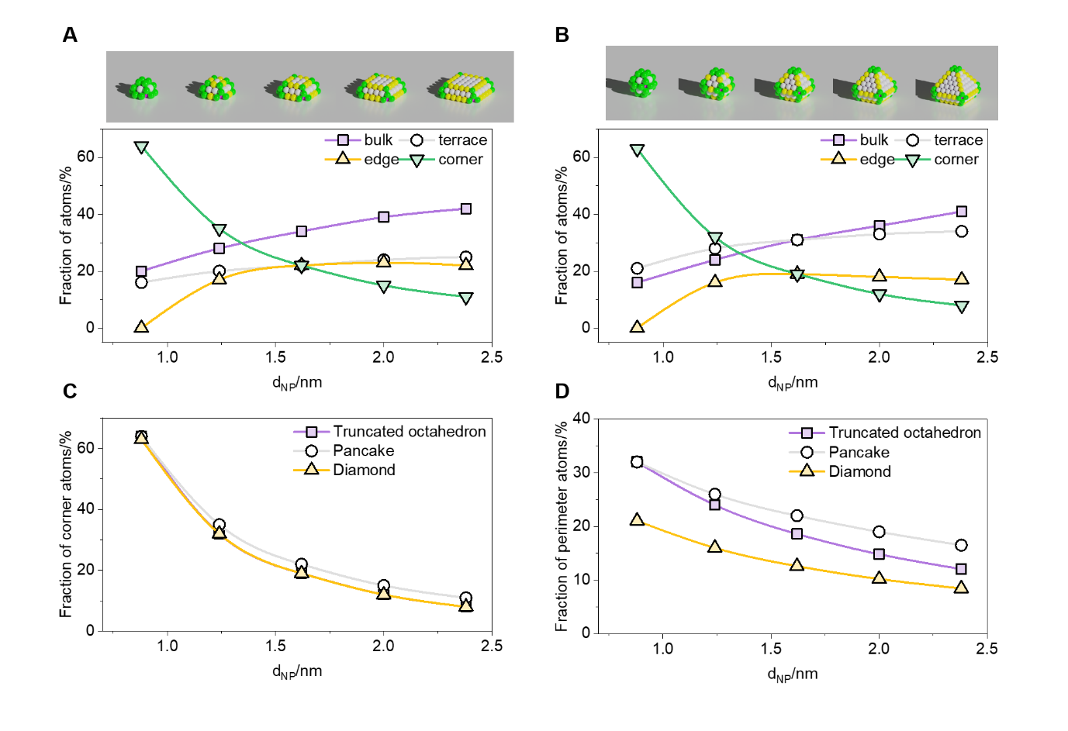
Figure S14. Illustrations of supported NP models and atom fractions at different sites as a function of the NP model diameter. (A) “Pancake” and (B) “Diamond”. Atom fractions of (C) corner and (D) perimeter sites as a function of the NP model diameter.

Figure S15. Correlation between WGS activity and fraction of corner atoms on small NPs using different threshold (1.2, 1.25, 1.3, 1.4 and 1.5nm) to divide “smaller” and “larger” Pt NPs.

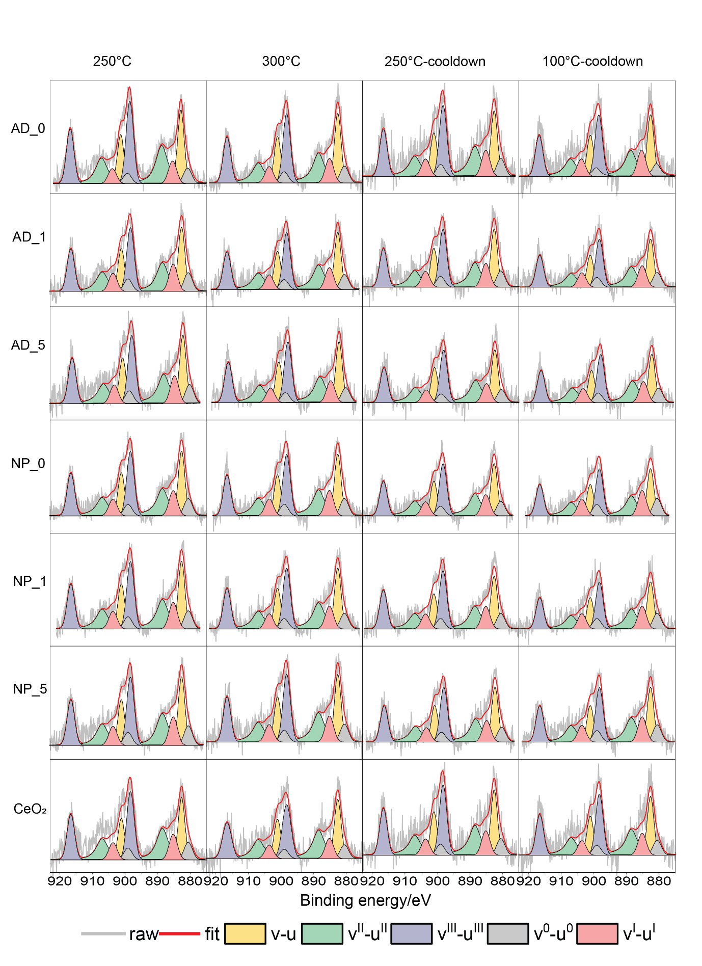
Figure S16. Experimental X-ray photoelectron spectra and peak fitting of the Ce 3d region over all the samples obtained in 0.1 mbar CO + 0.3 mbar H₂O, during ramp-up at 250-300°C and cool-down at 300-100°C, using 1200 eV of photon energy.
Figure S17. Stacked bar plot showing the evolution of Ce 3d species on all samples at different temperatures in a 0.1 mbar CO + 0.3 mbar H₂O reaction environment.

Figure S18. Fraction of Ce³⁺ in CO+H₂O at 100°C during cool-down as a function of Pt NP size.

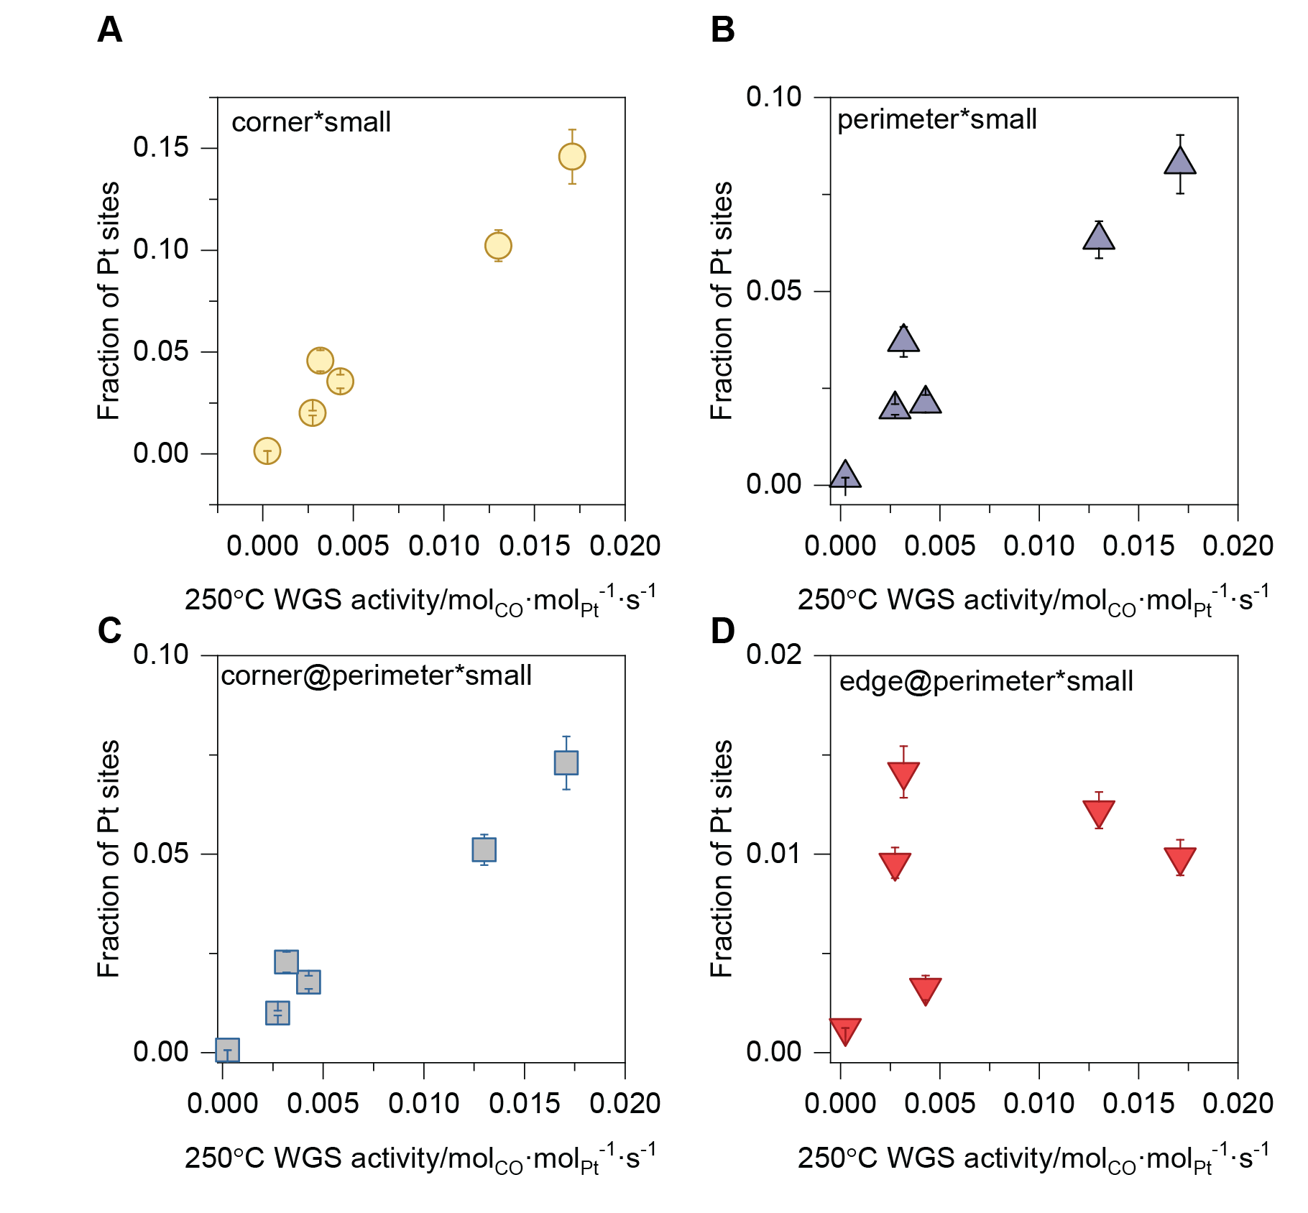
Figure S19. Correlation of the fraction of different platinum sites with WGS activity at 250°C.

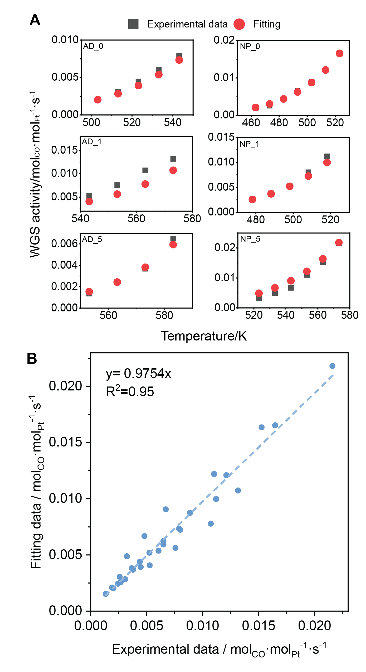
Figure S20. (A) Comparison of measured activity data and the fitting by kinetic model as a function of temperature. (B) Overall correlation plot of the fitted data with experimental data.
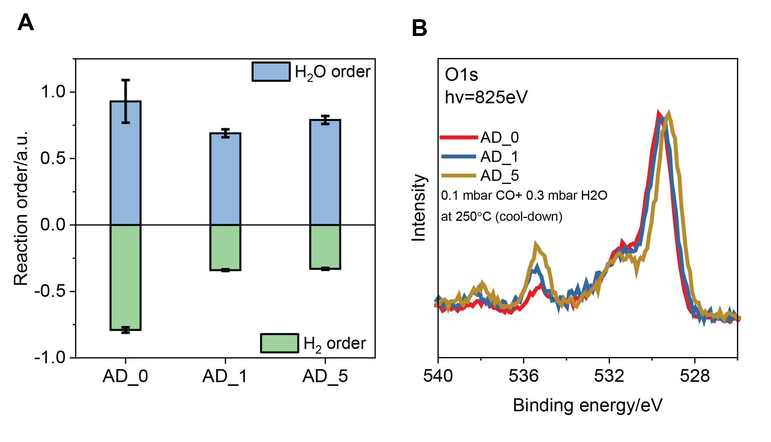
Figure S21. (A) Comparison of the reaction orders of H₂ and H₂O for AD_x samples. (B) O 1s spectra of AD_x samples in 0.1 mbar CO + 0.3 mbar H₂O at 250 °C during cool-down. The intensity was normalized using lattice oxygen peak intensity.

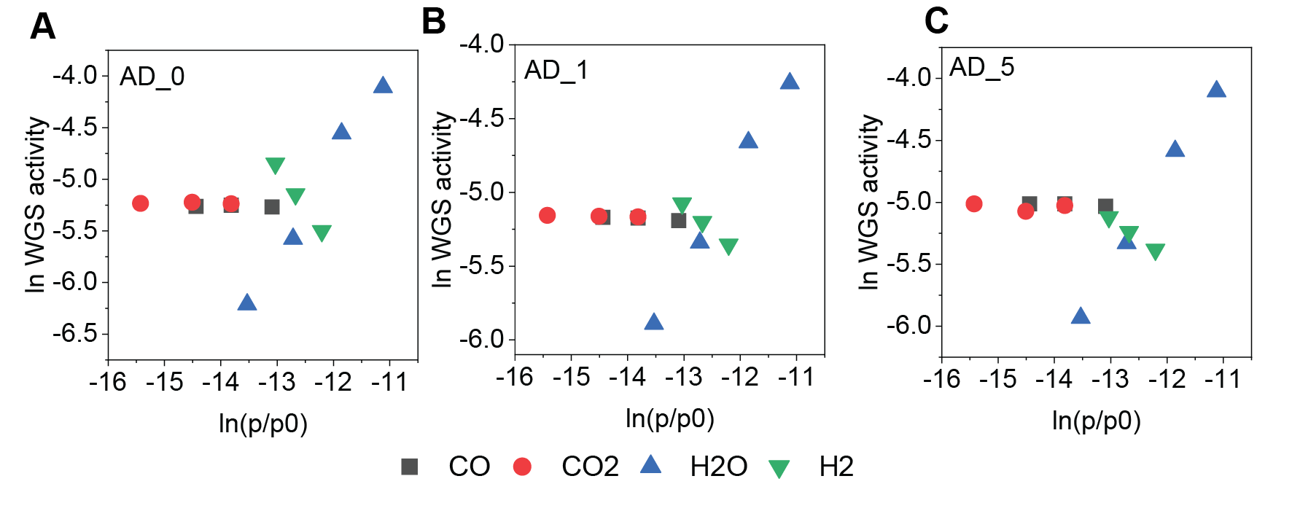
Figure S22. Apparent reaction orders for CO, CO₂, H₂, and H₂O for (A) AD_0, (B) AD_1 and (C) AD_5 over WGS reaction. Standard conditions were 0.01% CO, 0.01% CO₂,0.03% H₂O, 0.05% H₂ and balance Ar. Order determination at standard conditions with each component varying in the range of 0.0053 – 0.0206 % for CO, 0.002 – 0.01 % for CO₂, 0.022 – 0.078% for H₂, and 0.013 – 0.148 %for H₂O.

Figure S23. C 1s spectra of AD_x samples acquired under the same conditions and photon energy with O 1s for energy alignment. The intensity was normalized using adventitious carbon peak intensity.

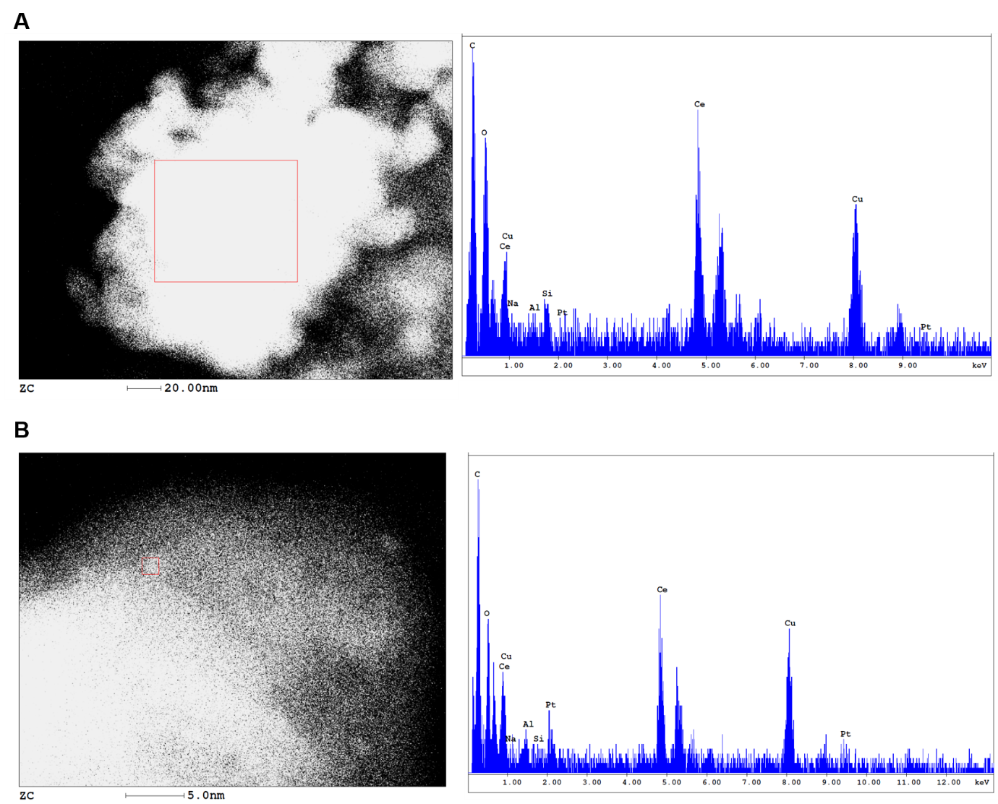
Figure S24. STEM and EDXS images of used AD_1. Two typical regions containing Ce and Ce+Pt are presented, but little Na signal was detected.

Figure S25. ex-situ XRD patterns of used AD_x samples after WGS in air at RT.

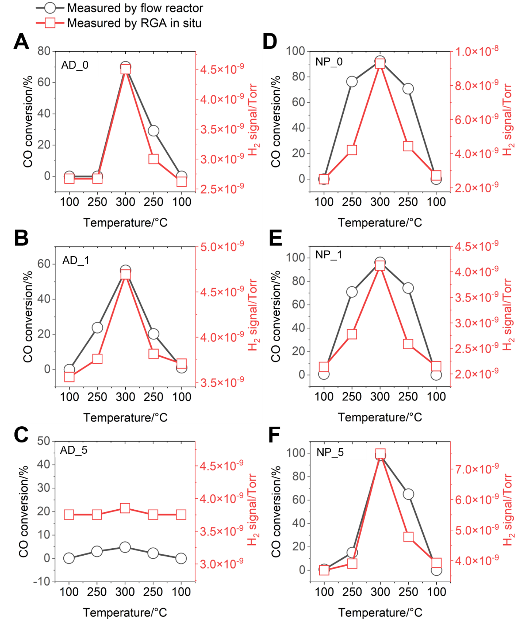
Figure S26. WGS performance of all the samples measured during APXPS by mass spectrometer in terms of H₂ production and the CO conversion in flow reactors when fast ramp-up and cool-down at 100-300-100°C in 100 ppm CO + 300 ppm H₂O.

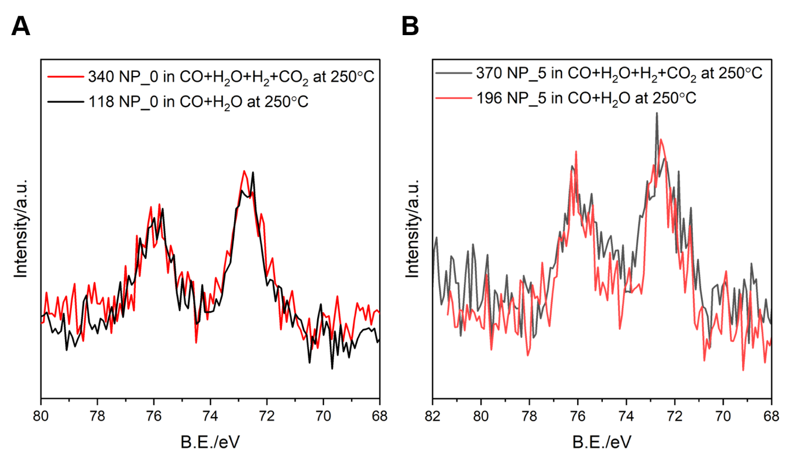
Figure S27. Comparison of raw Pt 4f XP spectra collected at 250ºC in (A) CO+H₂O (0.1+0.3 mbar) and (B) CO+H₂O+CO₂+H₂ (0.1+0.3+0.1+0.5 mbar) for NP_0 and NP_5.

Figure S28. Comparison of Pt 4f species proportion in XP spectra collected in CO+H₂O and CO+H₂O+CO₂+H₂ for NP_0 and NP_5.

Table S1. Sample names and preparation methods in this work.
Sample name | Pt loading/ wt% | Platinum precursor | Atomic ratio of Na: Pt | Surface Pt species in STEM
AD_0 | 1 | H₂PtCl₆ | 0 | AD
AD_1 | 1 | H₂PtCl₆ | 1 | AD
AD_5 | 1 | H₂PtCl₆ | 5 | AD
NP_0 | 1 | Pt(NH₃)₄](NO₃)₂ | 0 | NP+AD
NP_1 | 1 | Pt(NH₃)₄](NO₃)₂ | 1 | AD
NP_5 | 1 | Pt(NH₃)₄](NO₃)₂ | 5 | AD

Table S2. Platinum particle diameters(nm) of used samples as determined from STEM images.
AD_0-used | AD_1-used | AD_5-used | NP_0-used | NP_1-used | NP_5-used
2.18 | 1.68 | 1.78 | 0.89 | 0.96 | 1.29
2.03 | 2.08 | 1.68 | 0.92 | 0.91 | 1.35
1.68 | 1.39 | 1.98 | 0.99 | 0.91 | 1.39
1.58 | 1.44 | 2.23 | 0.79 | 1.14 | 1.25
1.83 | 2.62 | 1.88 | 1.22 | 0.88 | 1.39
2.33 | 2.23 | 2.18 | 0.96 | 1.10 | 1.06
1.49 | 1.19 | 1.73 | 1.09 | 1.58 | 1.06
1.29 | 1.24 | 2.33 | 0.96 | 1.06 | 0.92
1.54 | 1.78 | 1.88 | 0.99 | 0.99 | 1.06
1.58 | 1.58 | 1.58 | 1.06 | 1.02 | 1.49
1.34 | 1.98 | 1.78 | 1.06 | 1.06 | 1.39
1.29 | 1.54 | 1.68 | 1.12 | 1.19 | 1.06
1.14 | 2.03 | 1.39 | 0.83 | 1.19 | 1.03
1.68 | 1.78 | 1.78 | 1.35 | 1.29 | 1.49
1.58 | 1.68 | 1.63 | 1.06 | 1.22 | 1.34
1.78 | 1.88 | 1.83 | 1.06 | 0.72 | 1.75
1.39 | 1.83 | 1.88 | 1.13 | 1.49 | 1.29
1.63 | 1.58 | 1.93 | 0.79 | 1.04 | 1.32
1.19 | 1.78 | 1.49 | 0.77 | 1.14 | 1.25
1.19 | 1.83 | 1.78 | 0.85 | 0.89 | 1.62
1.58 | 1.58 | 1.98 | 1.11 | 1.02 | 1.32
1.09 | 1.68 | 1.88 | 0.86 | 0.89 | 1.39
1.29 | 1.14 | 2.13 | 1.06 | 0.83 | 1.09
1.39 | 2.08 | 1.98 | 0.89 | 1.12 | 1.32
1.63 | 1.58 | 1.63 | 0.96 | 1.27 | 1.42
0.84 | 1.78 | 2.53 | 1.02 | 1.11 | 1.12
1.19 | 1.93 | 1.39 | 0.99 | 0.89 | 1.39
1.39 | 1.78 | 1.68 | 1.12 | 1.46 | 1.63
2.28 | 2.33 | 2.33 | 1.45 | 1.26 | 1.54
1.63 | 1.83 | 2.13 | 1.19 | 1.78 | 1.19
1.39 | 1.83 | 1.44 | 1.31 | 0.69 | 1.25
1.68 | 2.15 | 2.62 | 1.19 | 1.04 | 1.32
1.34 | 1.58 | 3.37 | 1.12 | 1.14 | 1.06
1.45 | 1.75 | 2.38 | 0.79 | 1.29 | 1.22
1.32 | 1.49 | 2.23 | 1.06 | 1.19 | 1.19
1.22 | 1.52 | 5.41 | 1.06 | 1.39 | 1.19
1.88 | 1.54 | 4.56 | 1.52 | 1.19 | 1.68
1.73 | 1.88 | 6.40 | 1.35 | 0.84 | 1.68
1.54 | 1.98 | 1.85 | 1.25 | 1.29 | 1.11
1.09 | 1.63 | 1.68 | 0.99 | 1.34
1.39 | 2.48 | 1.55 | 1.29 | 1.09
0.89 | 1.09 | 1.73 | 1.09 | 1.14
1.04 | 1.24 | 1.63 | 1.12 | 1.49
1.93 | 1.19 | 2.67 | 1.12 | 1.24
1.83 | 1.24 | 1.24 | 1.09 | 0.99
1.14 | 1.24 | 1.83 | 1.19 | 0.87
1.78 | 1.98 | 1.68 | 1.29 | 0.99
1.19 | 1.83 | 1.58 | 1.09 | 1.09
1.19 | 2.18 | 4.65 | 1.39 | 0.67
1.09 | 1.29 | 2.38 | 1.02 | 0.99
1.09 | 1.58 | 4.46 | 1.12 | 0.89
1.14 | 1.63 | 3.76 | 0.86 | 1.22
1.39 | 1.78 | 2.18 | 0.89 | 1.25
1.39 | 1.44 |  |  | 1.09
1.14 | 1.54 |  |  | 1.19
1.58 | 1.58 |  |  | 0.63
1.58 | 1.44 |  |  | 1.25
1.34 | 1.24 |  |  | 1.24
1.98 | 1.54 |  |  | 1.44
1.54 | 1.98 |  |  | 1.14
1.73 | 1.34 |  |  | 1.14
1.39 | 1.73 |  |  | 0.99
1.39 | 2.18 |  |  | 1.34
1.68 | 2.08 |  |  | 1.63
1.39 | 1.68 |  |  | 1.78
1.44 | 1.93 |  |  | 1.24
1.34 | 1.78 |  |  | 1.49
1.34 | 1.63 |  |  | 1.19
1.58 | 2.03 |  |  | 1.56
1.44 | 1.19 |  |  | 1.34
1.14 | 1.78 |  |  | 1.04
1.29 | 1.78
1.29 | 1.49
1.24 | 1.78
1.45 | 1.88
1.25 | 1.83
1.62 | 1.78
0.92 | 1.58
0.89 | 1.25
1.25 | 1.16
1.19 | 1.68
1.45 | 1.85
1.12 | 1.19
0.96 | 1.58
1.39 | 1.42
 | 1.19
 | 1.42
 | 1.22
 | 1.55
 | 1.19
 | 1.02
 | 1.12

Table S3. Peak Fitting Parameters (Position, FWHM, Lorentzian/Gaussian ratio and Asymmetry parameters) of Pt 4f Photoemission Spectra.
Pt species | Position/eV | FWHM/eV | Lorentzian/Gaussian ratio | Asymmetry parameters
 |  |  |  | TS | TL
Bulk Pt⁰ | 71.0±0.05 | 1.22±0.05 | 80 | 0.3 | 110
Terrace Pt⁰ | 71.6±0.05 | 1.22±0.05 | 0 | 0 | 1
Edge Pt⁰ | 72.2±0.05 | 1.22±0.05 | 0 | 0 | 1
Corner Pt⁰ | 72.2±0.05 | 1.22±0.05 | 0 | 0 | 1
AD Pt²⁺ | 72.8±0.1 | 1.22±0.05 | 0 | 0 | 1

Table S4. Number of atoms at different sites of NP models in the 0.88-2.38 nm size.
d_{NP}(nm) | Number of atoms | Bulk atoms | Terrace atoms | Edge atoms | Corner atoms
0.88 | 25 | 5 | 4 | 0 | 16
1.24 | 50 | 14 | 12 | 8 | 16
1.62 | 86 | 30 | 24 | 16 | 16
2 | 135 | 55 | 40 | 24 | 16
2.38 | 199 | 91 | 60 | 32 | 16

Table S5. Fitting parameters used for Pt 4f photoemission spectra peak fitting
Sample | d_{NP}(nm) | Bulk/terrace ratio | Terrace/ terrace ratio | Edge/ terrace ratio | Corner/ terrace ratio
AD_0 | 1.43 | 1.206 | 1 | 0.671 | 1
AD_1 | 1.65 | 1.259 | 1 | 0.654 | 0.654
AD_5 | 2.25 | 1.473 | 1 | 0.555 | 0.302
NP_0 | 1.07 | 1.206 | 1 | 0.348 | 2.582
NP_1 | 1.15 | 1.183 | 1 | 0.478 | 2
NP_5 | 1.30 | 1.171 | 1 | 0.708 | 1.091

Table S6. Number and proportion of platinum particles smaller than 1.25 nm in the STEM images and their average diameters together with the corresponding proportion of terrace and corner atoms on small NPs.
Sample name | Number of particles smaller than 1.25 nm | Proportion of particles smaller than 1.25 nm(%) | Average diameter of particles smaller than 1.25nm (nm) | Proportion of terrace atoms in particles smaller than 1.25 nm(%) | Proportion of corner atoms in particles smaller than 1.25 nm(%)
AD_0 | 24 | 28 | 1.11 | 27.4 | 42.0
AD_1 | 17 | 18 | 1.19 | 29.6 | 35.0
AD_5 | 1 | 1.9 | 1.24 | 30.1 | 32.8
NP_0 | 44 | 83 | 1.02 | 25.7 | 48.2
NP_1 | 50 | 70 | 1.04 | 25.7 | 48.2
NP_5 | 14 | 36 | 1.12 | 27.6 | 40.2

Table S7. Multi-linear regression results of WGS rate with bulk, terrace, edge and corner sites on small NPs (<1.25 nm).
Site | Coefficient* | R²
Bulk | 0 | 0.974
Terrace | 0 | 0.974
Edge | 0 | 0.974
Corner | 0.1204 | 0.974
*sklearn.linear_model.LinearRegression⁷⁷ in Python was employed to fit the raw data. Parameter “positive=True” was applied to constrain the coefficients no smaller than 0.

Table S8. Peak Fitting Parameters (Position, FWHM, Lorentzian/Gaussian ratio and Asymmetry parameters) of Ce 3d Photoemission Spectra.
Ce 3d peak | Position/eV | FWHM/eV | Lorentzian/Gaussian ratio | Area constraints
 |  |  |  | v^{i}/v⁰ | v^{i}/v
v⁰ | 880.56±0.05 | 3.0±0.05 | 0 | 1 | -
v^{I} | 885.16±0.05 | 3.0±0.05 | 0 | 1.46 | -
v | 882.6±0.05 | 2.4±0.05 | 0 | - | 1
v^{II} | 888.5±0.05 | 4.3±0.05 | 90±10 | - | 1.11
v^{III} | 898.3±0.05 | 2.7±0.05 | 0 | - | 1.13

Table S9. Experimental data used for the kinetic model fitting
T in K | r_{eff} | x(CPS fraction) | 1-x | sample name
503.15 | 0.002036934 | 0.01074 | 0.98926 | AD_0
513.15 | 0.003088254 | 0.01074 | 0.98926 | AD_0
523.15 | 0.004468112 | 0.01074 | 0.98926 | AD_0
533.15 | 0.00606152 | 0.01074 | 0.98926 | AD_0
543.15 | 0.007901331 | 0.01074 | 0.98926 | AD_0
543.15 | 0.005269697 | 0.00542 | 0.99458 | AD_1
553.15 | 0.007574491 | 0.00542 | 0.99458 | AD_1
563.15 | 0.010729596 | 0.00542 | 0.99458 | AD_1
573.15 | 0.013168649 | 0.00542 | 0.99458 | AD_1
553.15 | 0.00135777 | 0.000353 | 0.9996 | AD_5
563.15 | 0.002441097 | 0.000353 | 0.9996 | AD_5
573.15 | 0.003683312 | 0.000353 | 0.9996 | AD_5
583.15 | 0.006499962 | 0.000353 | 0.9996 | AD_5
463.15 | 0.001921033 | 0.0476 | 0.9524 | NP_0
473.15 | 0.002589466 | 0.0476 | 0.9524 | NP_0
483.15 | 0.004389794 | 0.0476 | 0.9524 | NP_0
493.15 | 0.006498717 | 0.0476 | 0.9524 | NP_0
503.15 | 0.008871824 | 0.0476 | 0.9524 | NP_0
513.15 | 0.012119474 | 0.0476 | 0.9524 | NP_0
523.15 | 0.016481939 | 0.0476 | 0.9524 | NP_0
478.15 | 0.002689474 | 0.03334 | 0.96666 | NP_1
488.15 | 0.003788387 | 0.03334 | 0.96666 | NP_1
498.15 | 0.005253229 | 0.03334 | 0.96666 | NP_1
508.15 | 0.008005562 | 0.03334 | 0.96666 | NP_1
518.15 | 0.011206889 | 0.03334 | 0.96666 | NP_1
523.15 | 0.003241946 | 0.01354 | 0.98646 | NP_5
533.15 | 0.004807024 | 0.01354 | 0.98646 | NP_5
543.15 | 0.006707476 | 0.01354 | 0.98646 | NP_5
553.15 | 0.011022618 | 0.01354 | 0.98646 | NP_5
563.15 | 0.015270686 | 0.01354 | 0.98646 | NP_5
573.15 | 0.021598071 | 0.01354 | 0.98646 | NP_5

Table S10. Fitting results using ODR function in OriginPro and Curve_fit function in Python.

Method | Results fitted by ODR in OriginPro | Results fitted by Curve_fit in Python
E₁/J·mol⁻¹ | 68919.00354 | 69072.97
E₂/J·mol⁻¹ | 129792.0744 | 129547.27
A₁/ mol_{CO}·mol_{Pt}⁻¹·s⁻¹ | 2624410.781 | 2701723.16
A₂/ mol_{CO}·mol_{Pt}⁻¹·s⁻¹ | 2270780000 | 2138681180.00
r₁ at 250°C / mol_{CO}·mol_{CPS}⁻¹·s⁻¹ | 0.344722342 | 0.342535102
r₂ at 250°C/ mol_{CO}·mol_{other}⁻¹·s⁻¹ | 0.000249136 | 0.000248228
r₁/r₂ at 250 °C | 1384 | 1380
r₁ at 300°C/ mol_{CO}·mol_{CPS}⁻¹·s⁻¹ | 1.373401925 | 1.368908544
r₂ at 300°C/ mol_{CO}·mol_{other}⁻¹·s⁻¹ | 0.003365177 | 0.003336491
r₁/r₂ at 300 °C | 408 | 410

Table S11. Estimation of E_{a} using the fitted results at the Arrhenius measurement

Sample name | AD_0 | AD_1 | AD_5 | NP_0 | NP_1 | NP_5
Temperature for estimation/°C | 250 | 285 | 295 | 220 | 225 | 275
Calculated r₁ by ODR / mol_{CO}·mol_{CPS}⁻¹·s⁻¹ | 0.3447 | 0.9311 | 1.2093 | 0.1315 | 0.1556 | 0.7101
Calculated r₂ by ODR / mol_{CO}·mol_{other}⁻¹·s⁻¹ | 0.00025 | 0.00162 | 0.00265 | 0.00004 | 0.00006 | 0.00097
Calculated E_{a} by ODR /kJ·mol⁻¹ | 72.72 | 83.64 | 121.34 | 69.29 | 69.54 | 74.44
Calculated r₁ by Curve_fit / mol_{CO}·mol_{CPS}⁻¹·s⁻¹ | 0.3425 | 0.9272 | 1.2050 | 0.1304 | 0.1544 | 0.7067
Calculated r₂ by Curve_fit / mol_{CO}·mol_{other}⁻¹·s⁻¹ | 0.00025 | 0.00161 | 0.00263 | 0.00004 | 0.00006 | 0.00097
Calculated E_{a} by Curve_fit /kJ·mol⁻¹ | 72.86 | 83.66 | 121.12 | 69.45 | 69.70 | 74.55

Table S12. Previously reported activation energy for WGS reaction over platinum catalysts.
Catalysts | Ea (kJ/mol) | Reference
1%Pt/CeO₂ | 78.4 | Ref⁷⁸
1%Pt/Al₂O₃ | 68 | Ref¹⁵
1%Pt/Al₂O₃ | 84 | Ref¹⁵
1.66%Pt/Al₂O₃ | 81 | Ref¹⁵
1%Pt/CeO₂ | 75 | Ref¹⁵
1%Pt/CeO₂ | 91 | Ref⁷⁹
1%Pt/CeO₂ | 90 | Ref⁷⁹
Pt/CeO₂/Al₂O₃ | 76.8 | Ref⁸⁰
Pt/CeO₂/Al₂O₃ | 78.2 | Ref⁸⁰
Pt | 80 | Ref⁸¹
Pt/CeO₂ | 80 | Ref⁸¹
2%Pt-1%Re/CeO₂–ZrO₂ | 71 | Ref⁸²
2%Pt/Al₂O₃ | 82 | Ref⁸³
1%Pt/CeO₂ | 46 | Ref⁸⁴
0.4%Pt/Al₂O₃ | 39 | Ref⁸⁵
1.4%Pt-8.3%CeO₂/Al₂O₃ | 86 | Ref⁸⁶
0.74%Pt/CeO₂ | 82 | Ref⁸⁷
1.15%Pt/VO_{x}-CeO₂ | 86 | Ref⁸⁸
4.15%Pt/Ce(La)O_{x} | 75 | Ref²⁹
1wt% Pt₁Na₆/SiO₂(full gas) | 65 | Ref¹⁹
1wt% Pt₁Na₆/1000-2h-C_{N}(full gas) | 105 | Ref¹⁹
1 wt% Pt/CZO | 85 | Ref⁸⁹
2 wt% Pt/CZO | 71 | Ref⁸⁹
3 wt% Pt/CZO | 81 | Ref⁸⁹
Pt/CeO₂ | 54 | Ref⁹⁰
Pt/Ce_{0.8}Zr_{0.2}O₂ | 56 | Ref⁹⁰
Pt/Ce_{0.6}Zr_{0.4}O₂ | 58 | Ref⁹⁰
Pt/Ce_{0.4}Zr_{0.6}O₂ | 64 | Ref⁹⁰
Pt/Ce_{0.2}Zr_{0.8}O₂ | 71 | Ref⁹⁰
Pt/ZrO₂ | 83 | Ref⁹⁰
Pt(SAs)/CeO₂ | 84 | Ref⁷⁵
Pt(NCs)/CeO₂ | 79 | Ref⁷⁵
Pt(S-NPs)/CeO₂ | 73 | Ref⁷⁵
Pt(M-NPs)/CeO₂ | 66 | Ref⁷⁵
Pt(L-NPs)/CeO₂ | 66 | Ref⁷⁵
0.5Pt/CeO₂ | 79.9 | Ref⁹¹
0.5Pt/1Ce-10Ti | 77.7 | Ref⁹¹
0.5Pt/3Ce-10Ti | 74.5 | Ref⁹¹
0.5Pt/5Ce-10Ti | 78.6 | Ref⁹¹
0.5Pt/TiO₂ | 67.5 | Ref⁹¹
0.5Pt/MgO | 88.1 | Ref⁹²
0.5Pt–1CeO_{2–δ}/MgO | 70.6 | Ref⁹²
0.5Pt–2CeO_{2−δ}/MgO | 59.4 | Ref⁹²
0.5Pt–5CeO_{2−δ}/MgO | 40.0 | Ref⁹²
0.5Pt–10CeO_{2−δ}/MgO | 34.5 | Ref⁹²
0.5Pt–20CeO_{2−δ}/MgO | 28.8 | Ref⁹²
0.5Pt/CeO₂ | 18.4 | Ref⁹²

Table S13. Peak fitting results of XP spectra collected in CO+H₂O and CO+H₂O+CO₂+H₂ at 250 °C.
Sample name | Pt 4f species proportion
Sample name | Bulk | Terrace | Edge | AD | Corner
NP_0-CO+H₂O | 0.082 | 0.068 | 0.024 | 0.650 | 0.176
NP_0-CO+H₂O+CO₂+H₂ | 0.079 | 0.065 | 0.023 | 0.661 | 0.172
NP_5-CO+H₂O | 0.130 | 0.111 | 0.079 | 0.552 | 0.127
NP_5- CO+H₂O+CO₂+H₂ | 0.140 | 0.119 | 0.084 | 0.527 | 0.130

