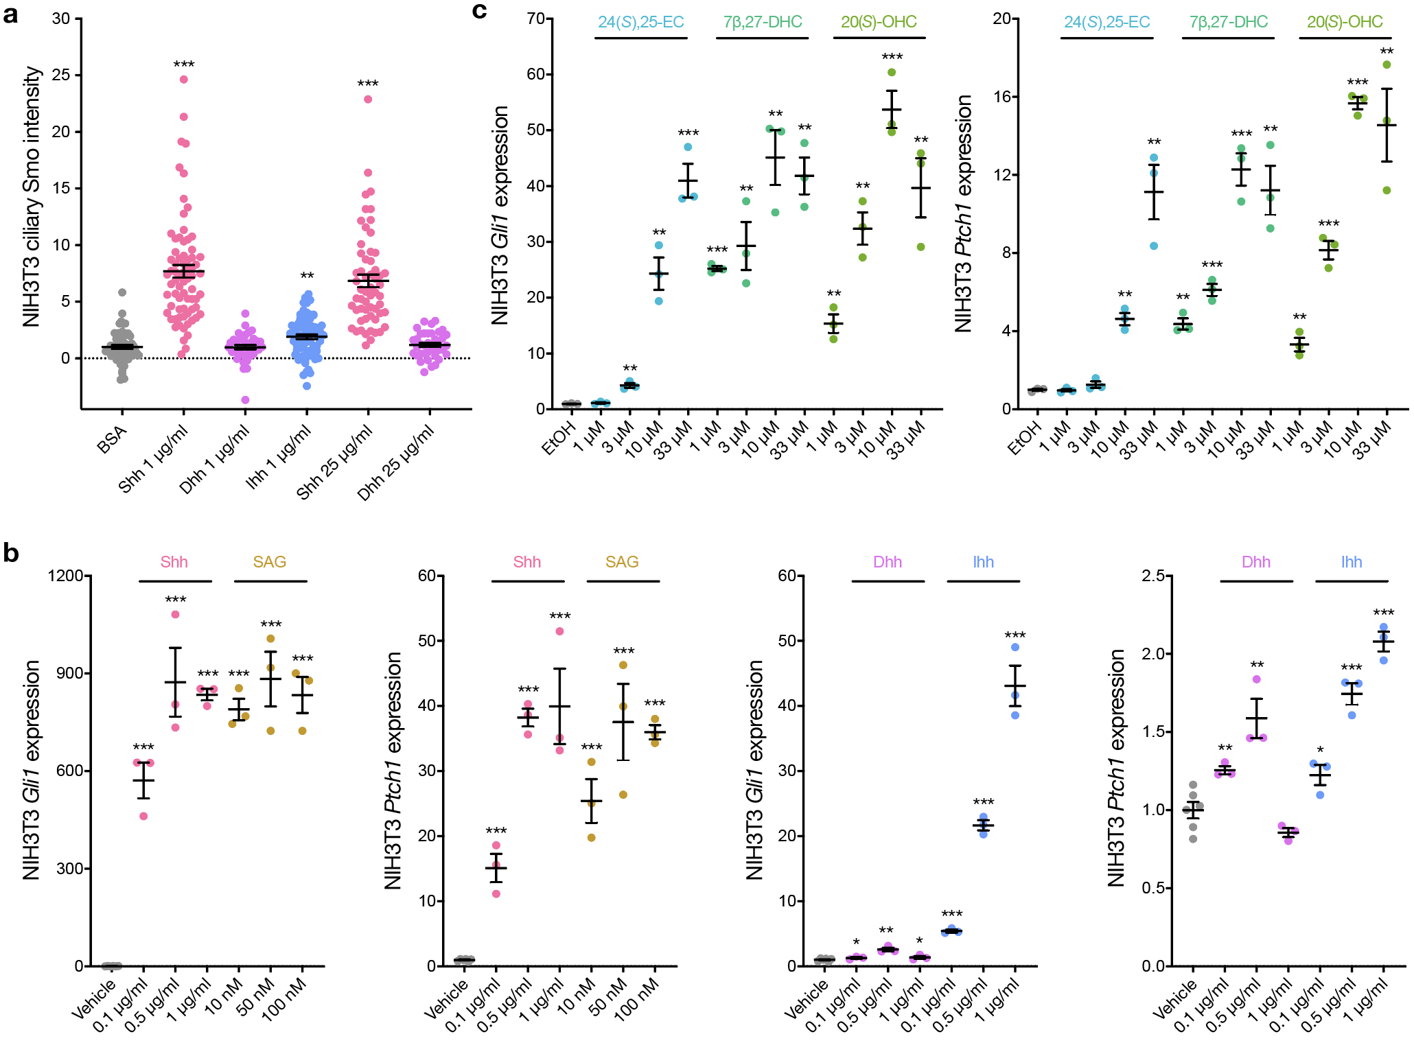Extended Data Fig. 1. Dose-response ligand activation of the Hedgehog pathway. a, Quantitative immunofluorescence microscopy for ciliary Smo in NIH3T3 cells ± 1µg/mL Shh, Dhh, or Ihh, or 25µg/mL of Shh or Dhh. The EC50 of these recombinant ligands are 0.1-0.4µg/mL for Shh, <20µg/mL for Dhh, and 3-12µg/mL for Ihh. b, QPCR assessment of the Hh target genes Gli1 or Ptch1 in NIH3T3 cells ± 0-1µg/mL Shh, Dhh, or Ihh, or 0-100nM SAG (EC50 3nm). c, QPCR assessment of Gli1 or Ptch1 in NIH3T3 cells ± 0-33µM 7β,27-DHC, 24(S),25-EC, and 20(S)-OHC. Lines represent means and error bars represent standard error of the means. Student’s t-tests, *p≤0.05, **p≤0.01, ***p≤0.0001.

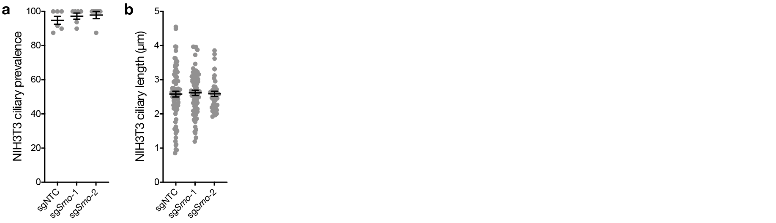Extended Data Fig. 2. Smoothened knockout does not change NIH3T3 ciliary architecture. Quantification immunofluorescence microscopy of ciliary prevalence (a) or ciliary length (b) in NIH3T3 wildtype or Smo^{-/-} cells after transduction of 2 independent sgRNAs targeting Smo (sgSmo) or a non-targeted control sgRNA (sgNTC). Primary cilia were labeled for these analyses using immunofluorescence microscopy for the ciliary marker Arl13b. Lines represent means and error bars represent standard error of the means.

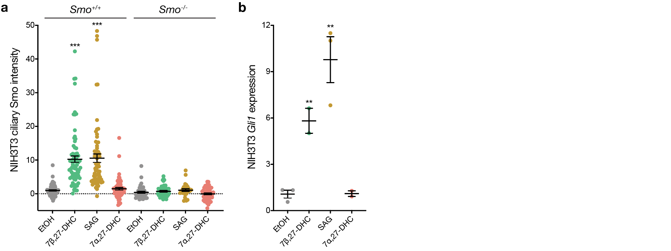Extended Data Fig. 3. 7α,27-dihydroxycholesterol does not activate the Hedgehog pathway. a, Quantitative immunofluorescence microscopy for ciliary Smo in NIH3T3 wildtype or Smo^{-/-} cells ± 33µM 7β,27-DHC or 7α,27-DHC, or 50nM SAG as a positive control. b, QPCR assessment of the Hh target gene Gli1 in NIH3T3 wildtype or Smo^{-/-} cells ± 33µM of 7β,27-DHC or 7α,27-DHC, or 50nM SAG as a positive control. Lines represent means and error bars represent standard error of the means. Student’s t-tests, **p≤0.01, ***p≤0.0001.

