Methods
The study was conducted in five patches of riparian forest (hereafter referred to as sampling units) in the region of the reservoir of the Volta Grande hydroelectric power plant (HPP) located on the Rio Grande river that forms the border between Minas Gerais and São Paulo states, Brazil (20°01'54" S / 48°13'17" W) (Table S1).

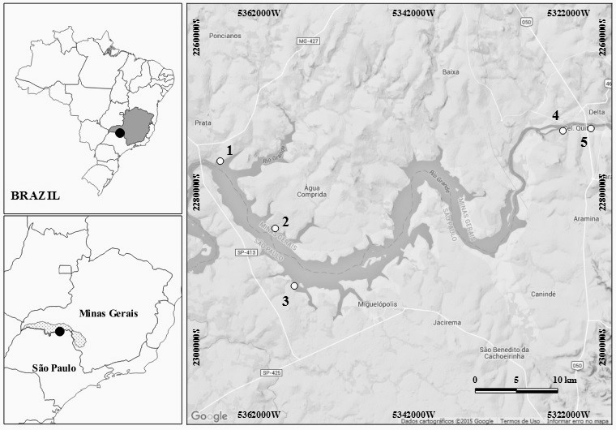
Supplementary Figure 1: Grande River basin, located in the border of Minas Gerais and São Paulo States, southeastern Brazil. The five riparian forest patches are shown, being areas 1 and 2 located in Minas Gerais State and areas 3, 4 and 5 located in São Paulo State.

Suplementary Table 1: Location (UTM) and characteristics of the five riparian forest fragments studied.
Area | Vegetation | UTM | Location | Municipality | Age (y) | Width (m)
1 | Native | 22k | 791531/7783262 | Conceição das Alagoas/MG | 30 | 400
2 | Reforestation | 22k | 798082/7775015 | Água Comprida/MG | 10 | 30
3 | Reforestation | 22k | 800294/7768027 | Miguelópolis/SP | 20 | 30
4 | Reforestation | 23k | 205429/7786874 | Igarapava/SP | 10 | 100
5 | Reforestation | 23k | 208838/7787209 | Igarapava/SP | 20 | 100
MG = Minas Gerais State; SP = São Paulo State; y = year; m = meters.

Table 2. Units for each variable used in the models
Variable | Unit
Richness | S
Abundance | N
Tree_High | meters
Tree_Density | n individuals/m2
Tree_DBH | cm
Decomposition | Remaining mass (X1)
Leaf_Litter_Prod | mg ha−1
Other_Litter_Prod | mg ha−1
N_Lit | Concentration
P_Lit | Concentration
pH | absolute value
P | Concentration
Litterfertility_Index | True value
SoilFertility_index | True value
Age | Years
Width | Meters

Plant sampling
In each plot floristic analysis was used to obtain the richness and abundance of trees with diameter at breast height or 1.30 m (DBH) > 10 cm. To describe tree community structure, the traditional quantitative parameters proposed by Mueller-Dombois and Ellenberg (1974) were calculated per plot: absolute density (AD. ind/m²); three high (m) and DBH (cm). Vouchers of the plants studied can be found in the herbarium OUPR, Ouro Preto, Minas Gerais. Brazil.

Syndromes of pollination
Among the plants with DBH < 10 cm, only flowering plants were recorded for identification of the pollination syndrome. All flowering plants found in the plots were classified by their syndromes, following Faegri & van der Pijl (1979) including lianas, shrubs and herbaceous plants.

Seed rain and seedling settlement
Seed rain was sampled using mesh with PVC support. This commonly used trap design in tropical rain forests consists of a frame of PVC tubing that supports a net (Harms et al. 2000. Muller-Landau et al. 2002. Wright et al. 1999). We used a trap with a collection area of 1 m² with a polyester net bag, with holes of less than 1 mm, which was supported by 4 PVC tubes at 0.8 m from the ground. For each sampling site were installed four sampling plots with 3 sampling bags in each plot. Each sampling plot was separated by 100 metros distance. Seed rain was sampled monthly. Seeds collected in traps were counted and identified to the lowest taxonomic level possible to obtain values of richness and abundance.
Vertebrate sampling
Small mammal’s, amphibians and reptiles
Pitfall traps were used to collect small mammals (Corn 1994; Cechin and Martins 2000), amphibians (frogs ) and reptiles (lizards and snakes). Thirty 60-l buckets were disposed in three linear transects of 50m; 10 buckets, 5m equidistant, were disposed in each transect. Pitfall traps stood opened for four nights per month in each area. Nine months of field work were carried out (March 2013 to January 2014), being four months during the dry season and five months during the rainy season.
Capture and individual manipulation were carried out according to the guidelines of the Commitee of Animal Care and Use of the American Society of Mammalogists (Sikes et al. 2011). Some specimens were collected, sacrificed and deposited in the vertebrate collection of the Laboratory of Vertebrate Zoology of the Federal University of OuroPreto (LZV-UFOP). The study was approved by the Brazilian System of Authorization and Information on Biodiversity (SISBIO license n° 37067-1) and by the Animal Ethics Committee of the Federal University of OuroPreto (protocol n° 2012/55). Richness and abundance of each group was used for the construction of the models.

Birds
Birds were quantitatively (point count method; Vielliard et al. 2010) and qualitatively (ad libitum observations) sampled in the five riparian forests studied sites. Each site was sampled once per month. from April 2013 to January 2014.
Three points, separated by 350 m, were set in each riparian forest site (Ralph et al. 1995; Vielliard et al. 2010). The researchers remained in each point for 20 minutes, recording all bird species that were observed or heard. The sampling order was determined using the Latin square method (Bailey 1996) and the surveys occurred only in the mornings (between 06:00 to 09:00 h). Ad libitum observations were conducted in each site between 06:00 to 11:00 and 13:00 to 18:00 hours, resulting in a sampling effort of 10h/day (400 h in total for all five sites).
Piacintini et al. (2015) was used for birds’ nomenclature. Birds were identified visually with binoculars, by photography (Canon PowerShot SX50 HS) or audibly. A Sony ICDPX312 recorder was used to document vocalizations.

Invertebrates sampling
Soil Invertebrate Pitfall traps were also used to sample terrestrial invertebrates (Holway 2005). Ten 400ml plastic cups, filled with a mixture of alcohol 70% and detergent, were disposed laterally to the small mammal pitfall trap transects. As done for small mammals sampling, pitfall traps stood opened for four nights per month in each area. Nine months of field work were carried out (March 2013 to January 2014). Samples were analyzed in laboratory, and the richness (morphospecies) and abundance of each invertebrate order was determined. Invertebrate sampling was approved by the Brazilian System of Authorization and Information on Biodiversity (SISBIO license n° 37067-1).
Ants
In each plot three trees were arbitrarily selected, and the ants were collected using one baited pitfall trap per tree (radius = 7 cm; height = 9 cm). The pitfall traps were tied to the trees as close as possible to the crown. and baited with sardine (DF) or sardine and honey (PP). The pitfall traps remained on the trees for 48 h. Ants were identified to the higher possible taxonomic level using specific taxonomic keys.

Trap-nesting bees and wasps
In each of the five sampling units, 12 plots of 100 m² were installed. In each plot were installed two woodblocks placed 1.5 meters high in the most central tree, forming a plot, totaling 90 blocks of trap-nests, and 5.400 nesting sites total. Trap nests were black cardboard tubes inside inserted in holes drilled into wood blocks with a total of 45 holes arranged linearly (Camilo et al 1995). Trap nests were uniform in length (150 mm) but varied in their inner diameters (6–16 mm). Traps nests were horizontally tied to tree trunks. about 1.8 m above the soil surface. Occupied cardboard, those closed with soil or plant materials, indicating completed nest construction (Krombein 1967), were collected and taken to the laboratory. New empty cardboards were used to replace those collected. In the laboratory, cardboards brought from the field were kept in a glass assay tube plugged with a cotton wad were kept in the laboratory at room conditions (ca. 15–25 °C). Insects were identified and deposited with their nest material in the Entomological Collection of the Laboratório de Biodiversidade, of the Universidade Federal de Ouro Preto.

Functional Biodiversity
Recorded animals were separated into functional biodiversity. The selected functions are related more to feeding habits, or life forms. Vertebrates were classified as insectivores, carnivores, frugivores, omnivores, nectar eaters, granivores. Invertebrates were classified as herbivores, decomposers, insectivores and nectar eaters. Plants were classified as pioneer or secondary. We also classified plants in accordance with the floral syndrome.

Ecosystem functions
Soil content of Nitrogen, Phosphorus and pH.
In each plot three samples of soil (0–10 cm deep) were randomly collected and mixed for chemical and granulometric analyses. Soil content of nitrogen (mg/dm3) and phosphorus (mg/dm3), besides pH in H2O was determined following the procedures described by EMBRAPA (1997).

Litter and other litter production
Five 50 × 50 cm (0.25 m²) litter-fall traps were spaced in each sampling plot. Traps were placed 1 m above the ground, taking care to avoid placing traps directly below obvious understory obstructions. Trap contents at each site were monthly collected for 12 months and oven-dried at 50 °C for 3 days before being separated into four constituent parts – leaves and others (fruits, flowers, branches) – and weighed to the nearest 0.1 g. From this, we calculated the leaf litter and other production (g.m⁻².year⁻¹) per plot.
Litter decomposition
Twelve litter bags (representing four bags for each plot) were installed, coinciding with the location of the litter fall traps. Each litter bag was filled with 10 g of a previous homogenized litter fall sampling. Litterbags (10 cm × 10 cm) were made from 2 mm nylon mesh material. The bags were placed in the forest in the beginning of the dry season and one-quarter of the bags were collected within 44, 71, 228 and 374 days. Collected bags were oven-dried at 50 °C and weighed to the nearest 0.1 g after removing (and noting the presence of) fine root matter, termite runs and mud. The oven-dried litter samples were ground and sieved through a 0.5 mm mesh and analyzed for total N and P concentrations (g.kg-1). The remaining mass for each period (X1) was determined and compared to the initial mass values (X0) using the formula: X_{t}=X₀ e^{-kt}. As proposed by Olson (1963) and (Bockheim et al. 1991), the time required for 50% and 95% mass loss and nutrient release was calculated as t50% = 0.693/k and t95% = 3/k. With this was obtained the Coefficient of decomposition (K).

Litter and Soil Fertility index
Following Moran et al. (1998; 2000a,b) we used a soil fertility index (SFI) and litter Fertility Index to explore the relationship between soil and litter fertility with biodiversity. For this we used the equation SFI= pH + OM + P + K + Ca + Mg – Al for Soil Fertility and LFI= OM + P + K + Ca + Mg – Al for litter fertility.

References
Moran EF, Brondízio ES, Mausel PW, Wu Y. 1994. Integrating Amazonian vegetation, land use, and satellite data. Bioscience 44: 329–338.
Moran EF, Brondízio ES, Tucker JM, Da Silva-Forsberg MC, Falesi I, McCracken SD. 2000a. Strategies for Amazonian forest restoration: evidence for afforestation in five regions of the Brazilian Amazon. Amazonia at the Crossroads: The Challenge of Sustainable Development, Hall A (ed.). Institute for Latin American Studies, University of London: London; 129–149.
Moran EF, Brondízio ES, Tucker JM, Da Silva-Forsberg MC, McCracken SD, Falesi I. 2000b. Effects of soil fertility and land use on forest succession in Amazonia. Forest Ecology and Management 139: 93–108

