Supporting Information
Atomic Insights into the Unidirectional Alignment and Orientation-Pinning Behavior of h-BN Nucleation on Ir(111)

Jinliang Pan^{1,3,4}, Tongwei Wu^{2,4}, Chao Ma^{2,4}, Yangfan Wu^{1,3}, Yi Zheng^{1,3}, Kui Hu^{1,3}, Luye Sun^{1,3}, Sumei Ma¹, Mengxi Liu^{1,3}*, Yanning Zhang²* and Xiaohui Qiu^{1,3}*
¹CAS Key Laboratory of Standardization and Measurement for Nanotechnology, National Center for Nanoscience and Technology, Beijing, 100190, P. R. China
²Institute of Fundamental and Frontier Sciences, University of Electronic Science and Technology of China, Chengdu, Sichuan, 610054, P. R.China
³University of Chinese Academy of Sciences, Beijing 100049, P. R. China
⁴These authors contributed equally: Jinliang Pan, Tongwei Wu, Chao Ma.
*e-mail: liumx@nanoctr.cn; yanningz@uestc.edu.cn; xhqiu@nanoctr.cn

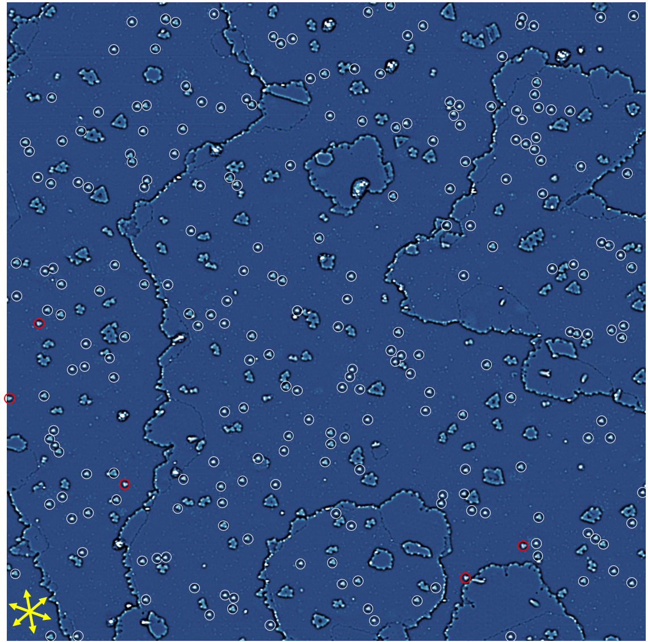
Figure S1 A representative large-scale STM image of h-BN nuclei formed on Ir(111) via TPG method at 700 K. The h-BN nanoclusters with inverse adsorption orientation are marked by white and red circles, respectively. The yellow arrows represent the three equivalent crystallographic directions of Ir(111). The image is processed by Laplace-filter, and the image size is 230 nm × 230 nm.
The analysis of 2097 nanoclusters in multiple samples exhibits that the dominant orientation of h-BN nuclei is approximately 91%. The N_{top}B_{hcp} atomic registration is the preferred oritation for all the samples, while the minority adopts N_{top}B_{fcc}. The energy differences ($∆E$) between h-BN nuclei for opposite orientations are calculated to be 0.14 eV, according to the Boltzmann factors. Among them, one sample exhibits an unexpected ultrahigh proportion of dominant orientaiton, up to 97 %. The reason for this anomaly is currently unclear and requires further investigation.

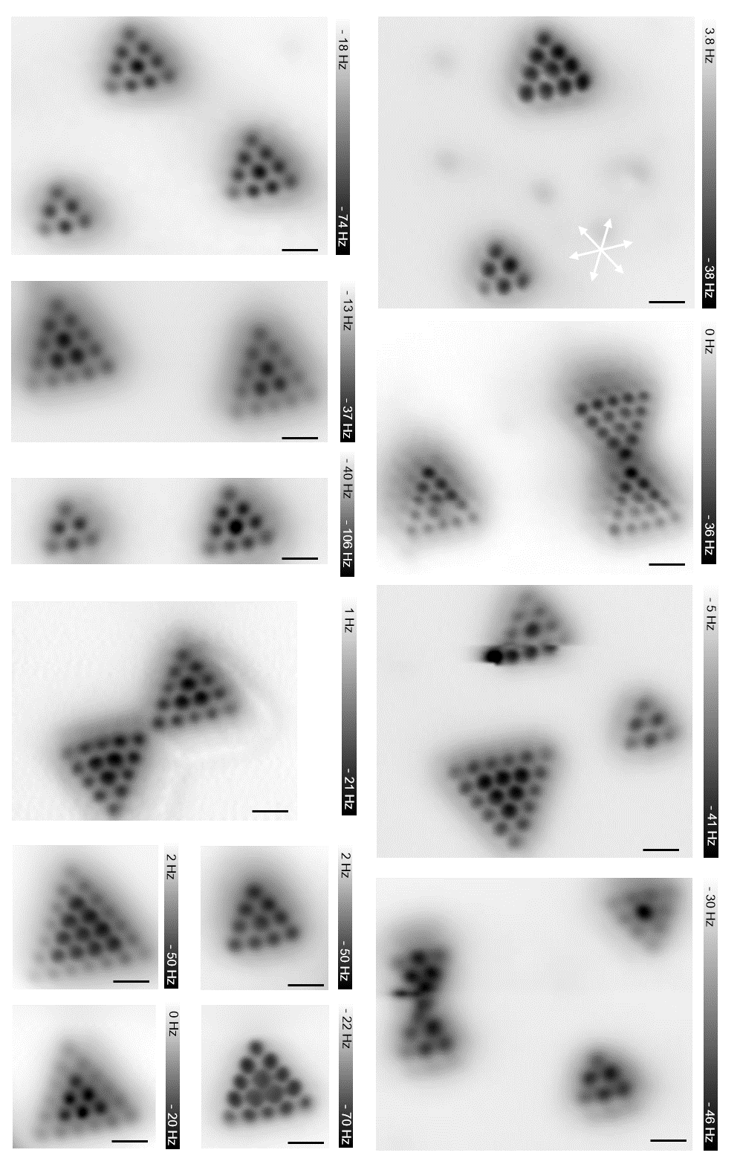
Figure S2 nc-AFM images showing that h-BN crystallization is strictly in registry with the substrate lattices. The white arrows represent the three equivalent crystallographic directions of Ir(111). Scale bars: 5 Å.
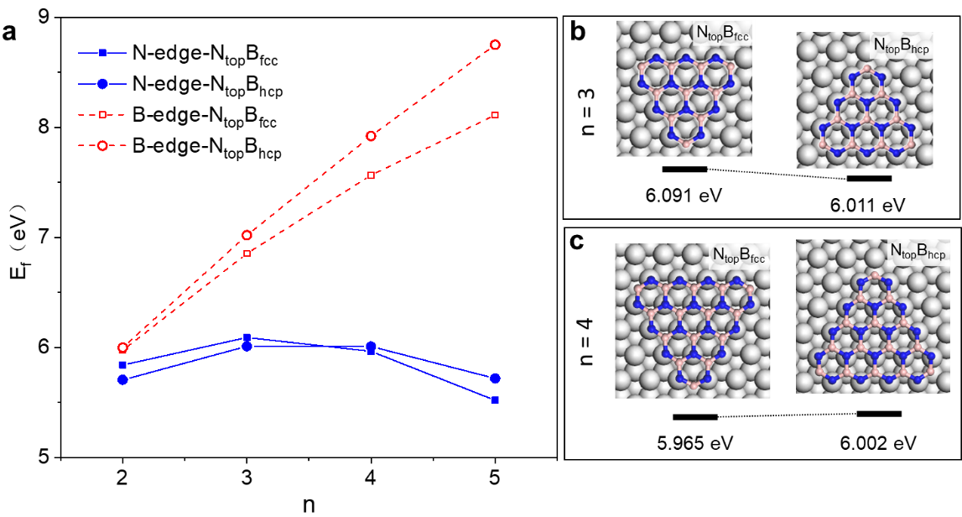
Figure S3. DFT calculation of h-BN nuclei with different adsorption configuration on Ir(111) (a) Formation energy (E_{f}) of N-terminated (blue) and B-terminated (red) h-BN nuclei (n = 2–5) with N_{top}-B_{fcc} (spuare) and N_{top}-B_{hcp} (circle) adsorption sites. The formation energies indicate that the h-BN nanoplate with N termination is more energetically favorable than that with B termination. (b) Atomic structures of h-BN nuclei with n = 3 and n = 4 (c), combined with their formation energies listed below the structures.

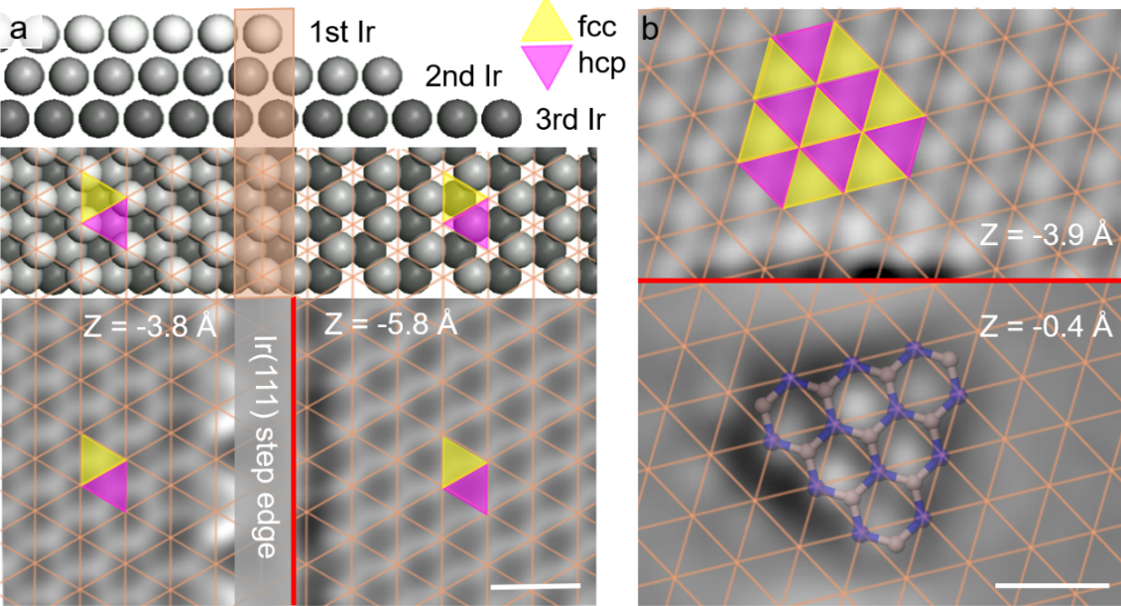
Figure S4. The determination of adsorption sites of h-BN on Ir(111) using adjusted constant-height AFM images method with CO-functionalized tip. (a) The schematic diagram and the nc-AFM imaging for the determination of fcc (yellow triangles) and hcp sites (magenta triangles) of Ir(111) surface. (b) The adsorption sites of an h-BN nanosheet on Ir(111). The tip height (z) change on the step edge of Ir(111) is marked by red lines. Crossings of orange lines mark the positon of the top-layer Ir atoms. Tip heights are given with respect to an STM conductance set point of G = 100 pS (a) and 20 pS (b). The image is rotated - 46° (a) and 30° (b) in clockwise direction. Scale bars: 5 Å.

