Supporting information for: Skin-effect-mediated magnetoionic control of charge transport in thick layers
V. Barough¹, L. Jamilpanah^{1,2}, M. Zare¹, M. Ghanaatshoar³, S.M. Mohseni^{1,*}
Department of Physics, Shahid Beheshti University, Tehran, 1983969411, Iran
Laboratory for High Performance Ceramics, Empa - Swiss Federal Laboratories for Materials Science and
Technology, Dubendorf, CH-8600 Switzerland
Laser and Plasma Research Institute, Shahid Beheshti University, Tehran, 1983969411, Iran
*Contact email: m-mohseni@sbu.ac.ir

1- Schematic of the skin effect-mediated magnetoionic characterization
The diagram of the experimental setup is visible in Figure S1. To conduct the electrochemical measurements, a conventional three-electrode electrochemical cell was employed, and the impedance of the cobalt-based amorphous ribbon (Co₆₀Fe₃Si₁₂B₂₅) was measured concurrently. The skin depth, which is approximately 100 nanometers[1], is demonstrated in the schematic.
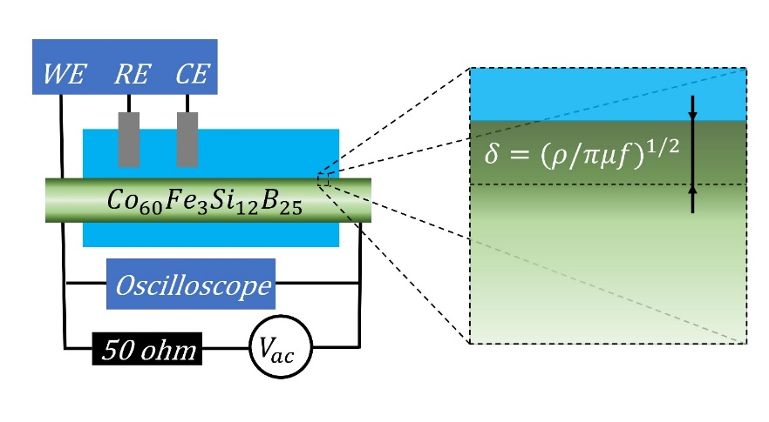
Figure S1: The schematic of the setupat the left with WE: working electrode, RE: reference electrode, CE: counter electrode and the zoom-in at the skin depth region at the right.

2- Impedance characterization
The raw data and smoothed curve of the impedance changes during the oxidation and reduction process at the sample's surface are depicted in Figure S2. Based on the results, it can be inferred that the impedance undergoes an increase and decrease of approximately 2 and 1 ohm, respectively, during the oxidation and reduction reactions.
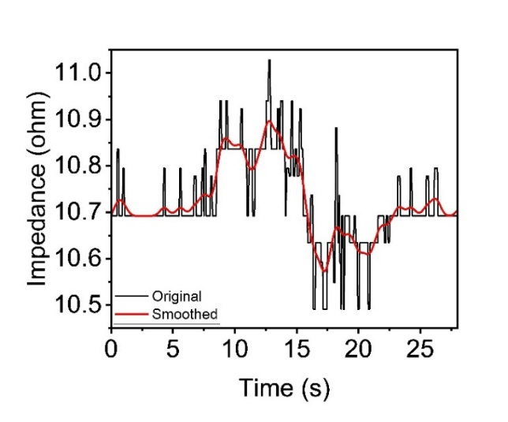
Figure S2: Raw data and smoothed curve of impedance changes in two oxidation and reduction states.

Figure S3 illustrates that while the impedance changes due to oxidation or reduction at the sample's surface, it remains unaffected by an increase in current density at the hydrogen evolution reaction region. This observation provides evidence that the impedance is solely influenced by electrochemical reactions occurring at the surface of the sample. This is the electronic portion of the magnetoionic interaction which is due to transformations in the chemical compositions at the sample’s surface. In reality, in the skin effect-mediated magnetoionic phenomenon, impedance could just be affected by manipulation in magnetic properties via electrochemical redox reactions.
Figure S3: The cyclic voltammetry test and impedance measurement that shows no effect on impedance in hydrogen evolution reaction region. Explain this too in the passage above. At higher voltage/current …. .

To demonstrate the surface limitation of the magnetoionic process, impedance measurements were taken at various frequencies, as shown in Figure S4. The results indicate that the impedance only changes at a frequency of 8 MHz, which corresponds to the smallest value of the skin depth. This finding suggests that a concentrated current at the surface is capable of detecting surface-limited changes in chemical compounds. As a consequence, the evolution of magnetic properties in a high permeability magnetic material could be detected in a skin effect-mediated magnetoionic approach.
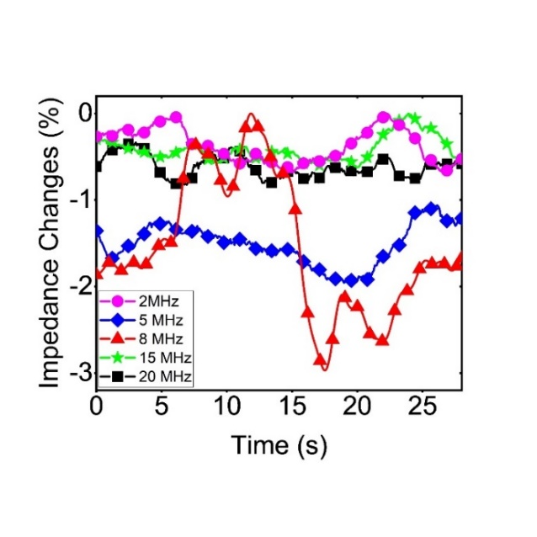
Figure S4: The impedance measurement at two oxidation and reduction states which has been done at different frequencies.

1. Hajiali, M., et al., Spin-orbit-torque driven magnetoimpedance in Pt-layer/magnetic-ribbon heterostructures. Applied Physics Letters, 2017. 111(19): p. 192405.

