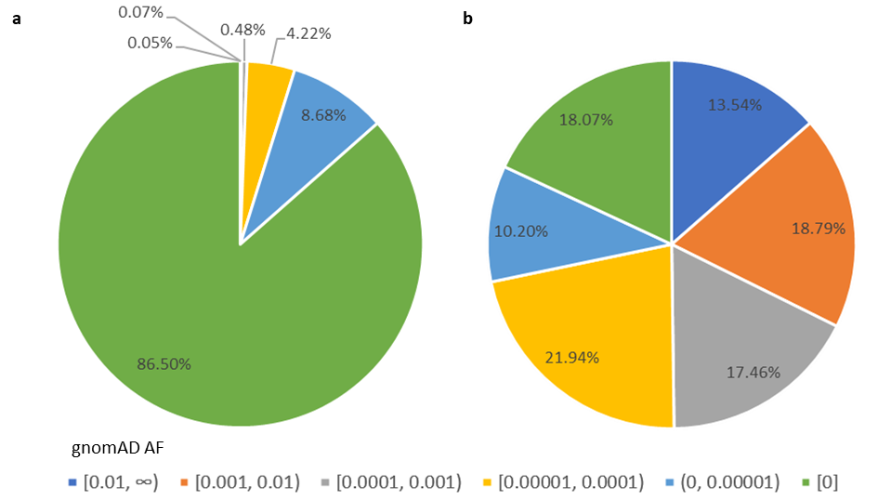
Supplementary Fig. 1: AF (Global AF in gnomAD) distributions in TCGA and GTEx data (a) TCGA variants. Most of the TCGA variants had an AF close to 0. (b) GTEx variants exhibited a relatively even distribution across AF ranges.

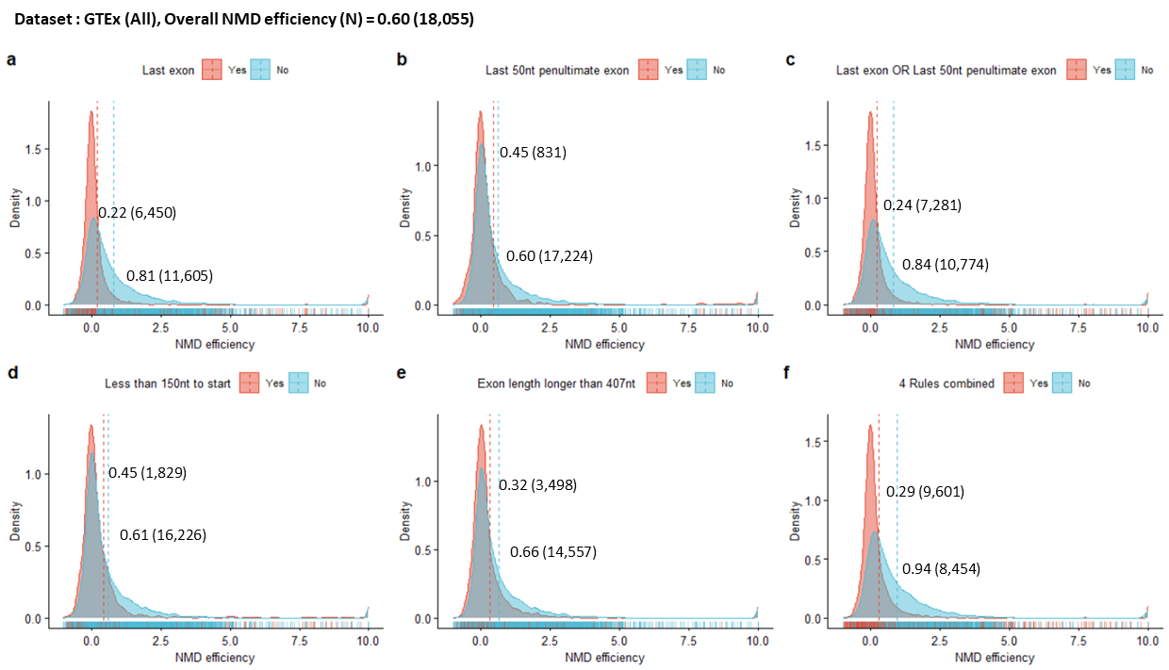
Supplementary Fig. 2: Distribution plots of NMD efficiency observed from GTEx (all nonsense variants). The mean NMD efficiency and number of variants in each distribution are noted on the plot. Each plot represents a NMD efficiency distribution of (a) last exon nonsense variants vs. other nonsense variants, (b) nonsense variants in the last 50nt of the penultimate exon vs. other nonsense variants, (c) nonsense variants located in the last exon or the last 50nt of the penultimate exon vs. other nonsense variants, (d) nonsense variants closer than 150nt from the start codon vs. other nonsense variants, (e) nonsense variants located in the exon longer than 407nt vs. other nonsense variants, (f) nonsense variants located in the last exon, in the last 50nt of the penultimate exon, closer than 150nt from the start codon, or in the exon longer than 407nt vs. other nonsense variants.

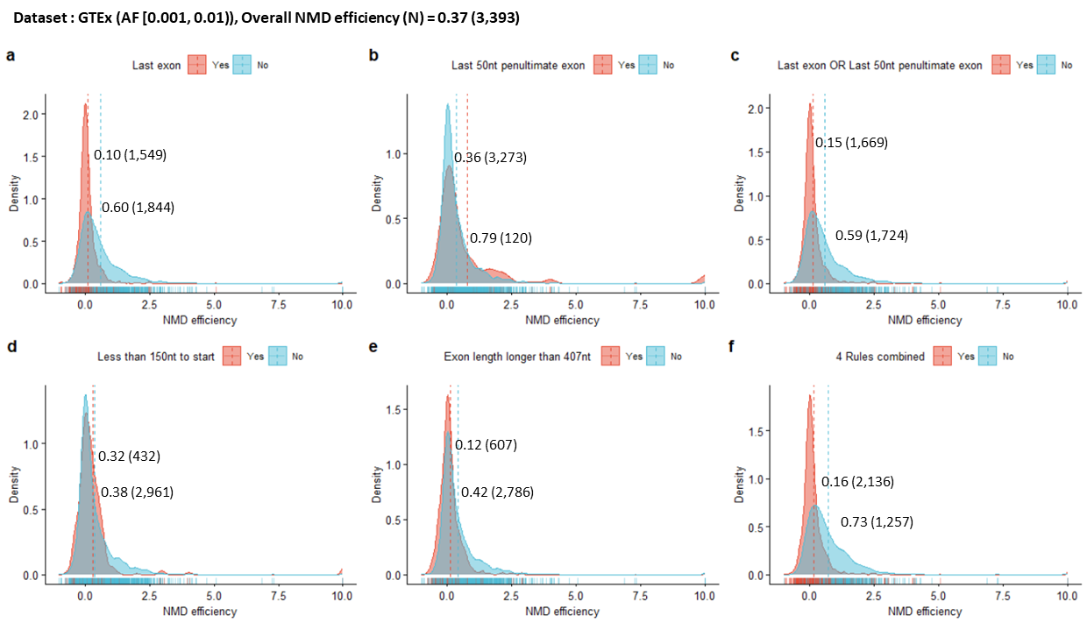
Supplementary Fig. 3: Distribution plots of NMD efficiency observed from GTEx (AF [0.001, 0.01)). The mean NMD efficiency and number of variants in each distribution are noted on the plot. Each plot represents a NMD efficiency distribution of (a) last exon nonsense variants vs. other nonsense variants, (b) nonsense variants in the last 50nt of the penultimate exon vs. other nonsense variants, (c) nonsense variants located in the last exon or the last 50nt of the penultimate exon vs. other nonsense variants, (d) nonsense variants closer than 150nt from the start codon vs. other nonsense variants, (e) nonsense variants located in the exon longer than 407nt vs. other nonsense variants, (f) nonsense variants located in the last exon, in the last 50nt of the penultimate exon, closer than 150nt from the start codon, or in the exon longer than 407nt vs. other nonsense variants.

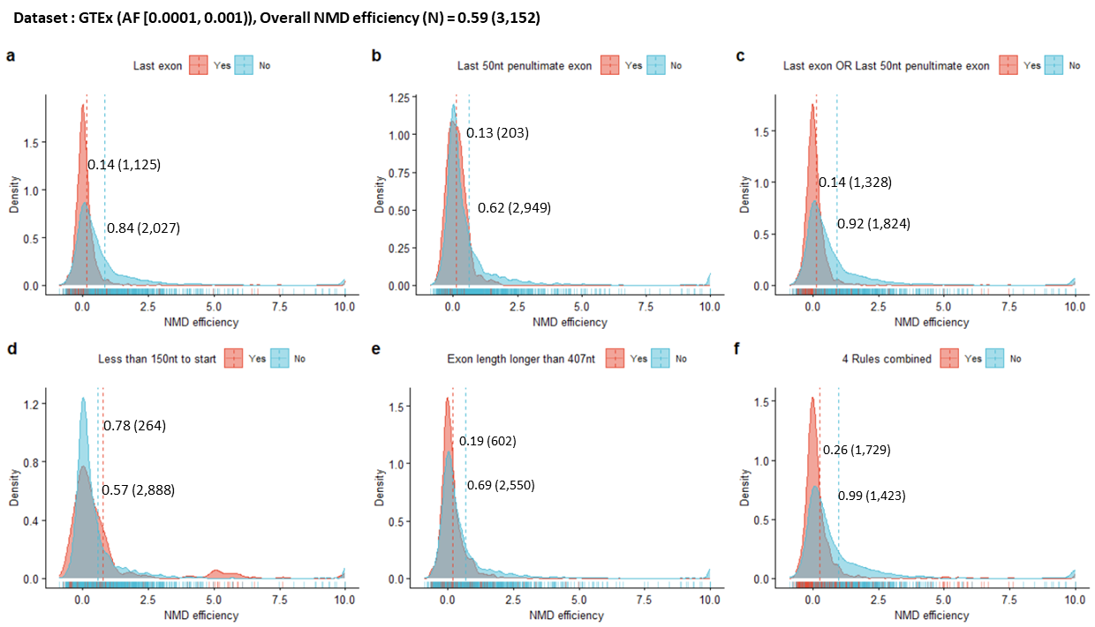
Supplementary Fig. 4: Distribution plots of NMD efficiency observed from GTEx (AF [0.0001, 0.001)). The mean NMD efficiency and number of variants in each distribution are noted on the plot. Each plot represents a NMD efficiency distribution of (a) last exon nonsense variants vs. other nonsense variants, (b) nonsense variants in the last 50nt of the penultimate exon vs. other nonsense variants, (c) nonsense variants located in the last exon or the last 50nt of the penultimate exon vs. other nonsense variants, (d) nonsense variants closer than 150nt from the start codon vs. other nonsense variants, (e) nonsense variants located in the exon longer than 407nt vs. other nonsense variants, (f) nonsense variants located in the last exon, in the last 50nt of the penultimate exon, closer than 150nt from the start codon, or in the exon longer than 407nt vs. other nonsense variants.

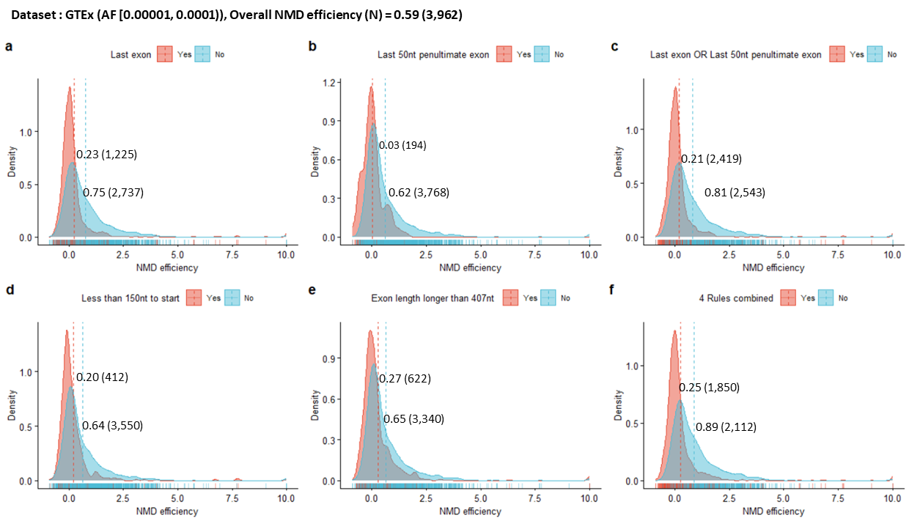
Supplementary Fig. 5: Distribution plots of NMD efficiency observed from GTEx (AF [0.00001, 0.0001)). The mean NMD efficiency and number of variants in each distribution are noted on the plot. Each plot represents a NMD efficiency distribution of (a) last exon nonsense variants vs. other nonsense variants, (b) nonsense variants in the last 50nt of the penultimate exon vs. other nonsense variants, (c) nonsense variants located in the last exon or the last 50nt of the penultimate exon vs. other nonsense variants, (d) nonsense variants closer than 150nt from the start codon vs. other nonsense variants, (e) nonsense variants located in the exon longer than 407nt vs. other nonsense variants, (f) nonsense variants located in the last exon, in the last 50nt of the penultimate exon, closer than 150nt from the start codon, or in the exon longer than 407nt vs. other nonsense variants.

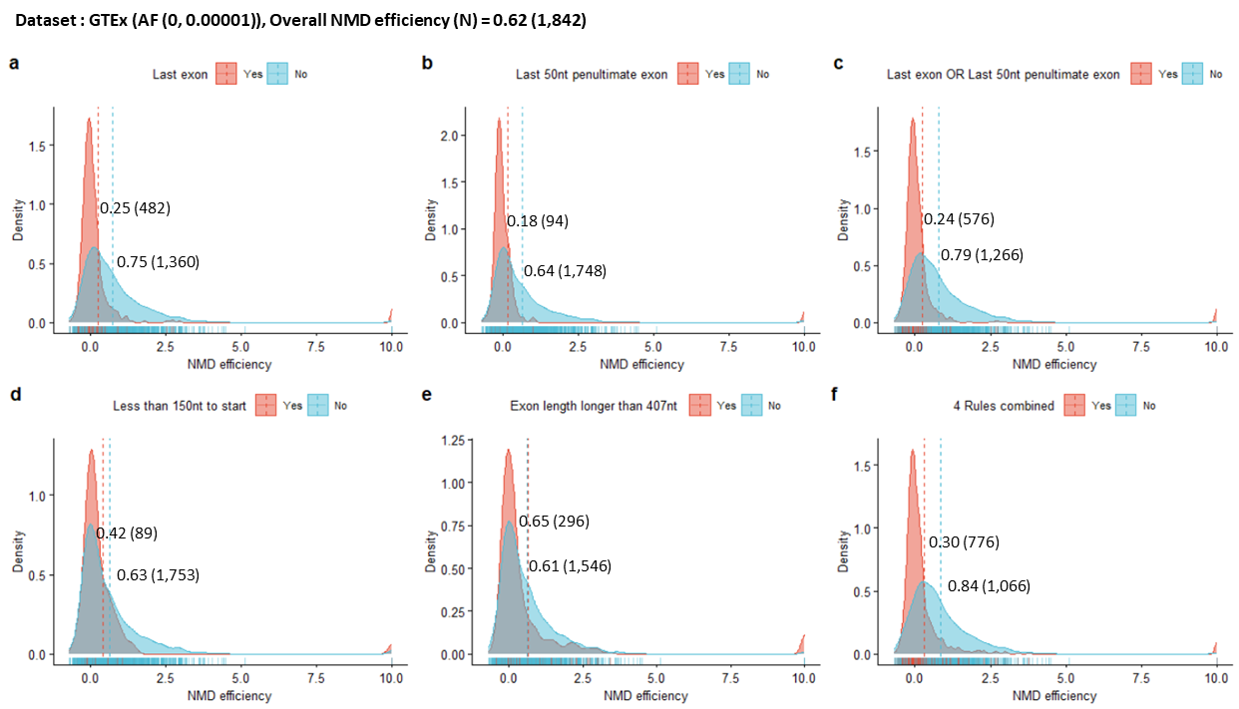
Supplementary Fig. 6: Distribution plots of NMD efficiency observed from GTEx (AF (0, 0.00001)). The mean NMD efficiency and number of variants in each distribution are noted on the plot. Each plot represents a NMD efficiency distribution of (a) last exon nonsense variants vs. other nonsense variants, (b) nonsense variants in the last 50nt of the penultimate exon vs. other nonsense variants, (c) nonsense variants located in the last exon or the last 50nt of the penultimate exon vs. other nonsense variants, (d) nonsense variants closer than 150nt from the start codon vs. other nonsense variants, (e) nonsense variants located in the exon longer than 407nt vs. other nonsense variants, (f) nonsense variants located in the last exon, in the last 50nt of the penultimate exon, closer than 150nt from the start codon, or in the exon longer than 407nt vs. other nonsense variants.

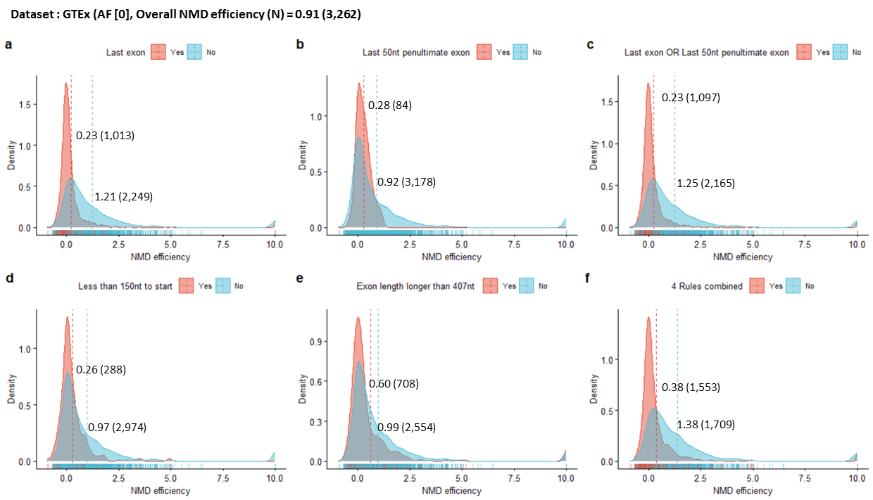
Supplementary Fig. 7: Distribution plots of NMD efficiency observed from GTEx (AF [0]). The mean NMD efficiency and number of variants in each distribution are noted on the plot. Each plot represents a NMD efficiency distribution of (a) last exon nonsense variants vs. other nonsense variants, (b) nonsense variants in the last 50nt of the penultimate exon vs. other nonsense variants, (c) nonsense variants located in the last exon or the last 50nt of the penultimate exon vs. other nonsense variants, (d) nonsense variants closer than 150nt from the start codon vs. other nonsense variants, (e) nonsense variants located in the exon longer than 407nt vs. other nonsense variants, (f) nonsense variants located in the last exon, in the last 50nt of the penultimate exon, closer than 150nt from the start codon, or in the exon longer than 407nt vs. other nonsense variants.

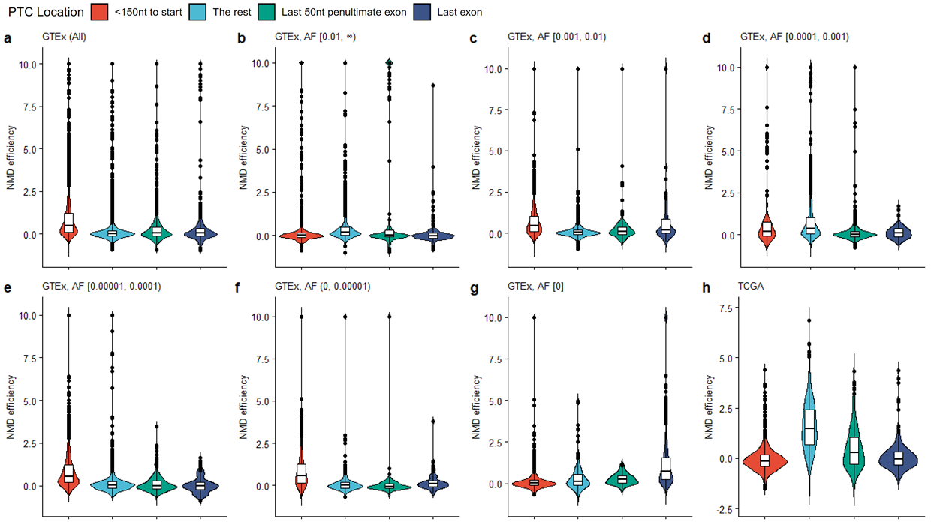
Supplementary Fig.8: NMD efficiency according to PTC locations. (a) All GTEx variants. (b)~(g) AF-stratified subsets of GTEx variants. (h) All TCGA variants. The expected differences in NMD efficiency according to the regions were evident only in the TCGA variants.
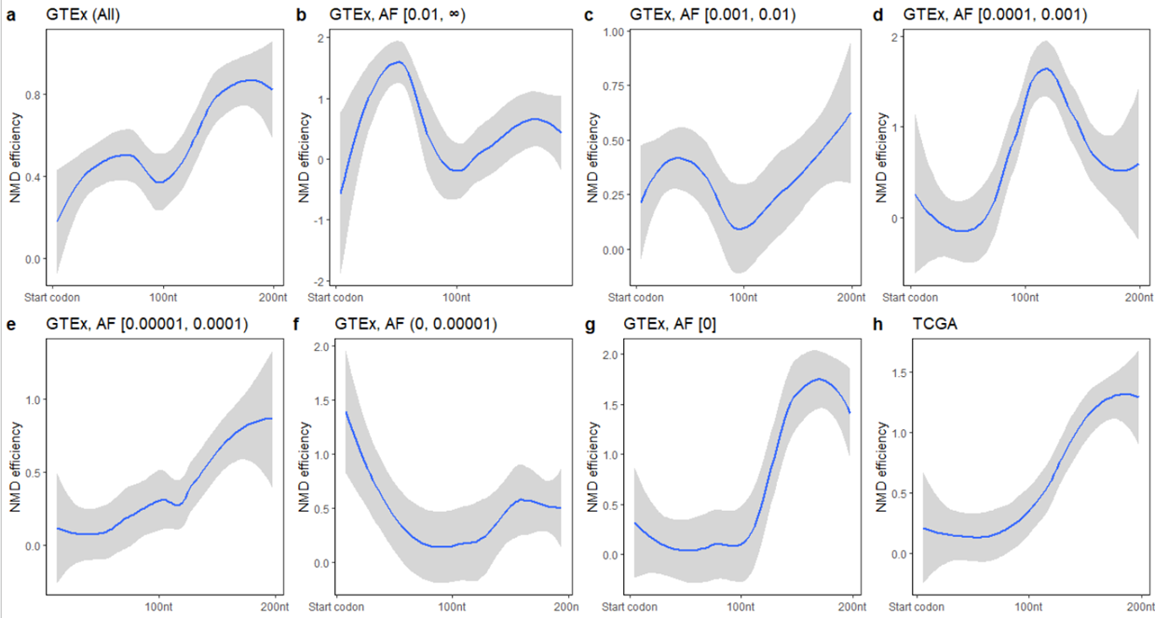
Supplementary Fig.9: NMD efficiency trends presented as loess fits with 95% confidence intervals (shaded regions) in the start proximal region. (a) All GTEx variants show an increasing tendency of NMD efficiency from the start codon to the 200th nucleotide. (b)~(g) AF-stratified subsets of GTEx variants. (h) All TCGA variants show a gradual increase of NMD efficiency from the start codon to the 200th nucleotide.
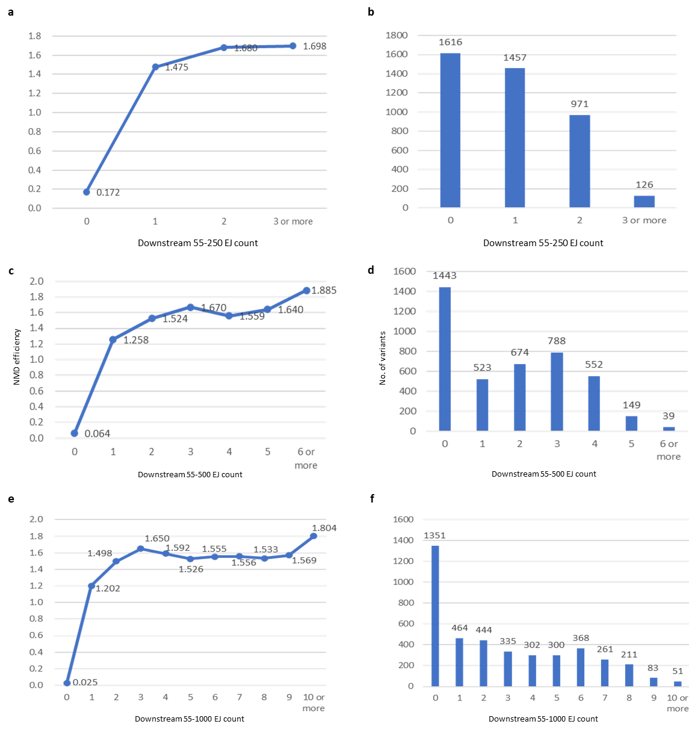
Supplementary Fig. 10: NMD efficiency of TCGA variants according to the number of exon junctions in the specified range the downstream of PTC (a) between 55nt and 250nt. The final model explained 38.4% of the total variance when this range was used. (b) The number of variants in each subset (c) between 55nt and 500nt. The final model explained 38.6% of the total variance when this range was used. (d) The number of variants in each subset (e) between 55nt and 1000nt. The final model explained 38.4% of the total variance when this range was used. (f) The number of variants in each subset.

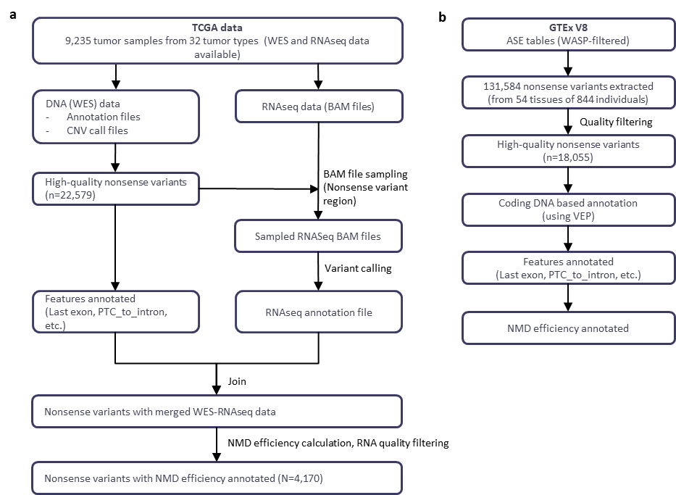
Supplementary Fig. 11: Flowchart of data preprocessing. The detailed procedure is described in Online Methods. (a) TCGA data. (b) GTEx data

