Supplementary Information for ‘Splitter of topological photonic waveguide in semiconductor platform.’

Sho Okada, Hibiki Kagami*, Nobuhiko Nishiyama, Tomohiro Amemiya
Department of Electrical and Electronic Engineering, Tokyo Institute of Technology, Tokyo 152-8550, Japan.
Xing-Xiang Wang, Xiao Hu
Research Center for Materials Nanoarchitectonics (MANA), National Institute for Materials Science (NIMS), Tsukuba 305-0044, Japan.
Graduate School of Science Technology, University of Tsukuba, Tsukuba 305-8571, Japan.
*Current address: NTT Device Technology Laboratories, Kanagawa-ken 243-0198, Japan.

Correspondence e-mail: okada.s.ah@m.titech.ac.jp, amemiya.t.ab@m.titech.ac.jp, HU.Xiao@nims.go.jp

Time-dependent propagation characteristics of the topological splitter

To discuss the change in the optical vortex mode inside the device, we investigated the change in the mode distribution near the input and output over time, as shown in Fig. 2c. Figure S1 shows the results. In any of the optical vortices propagating in the topological edge-state waveguide on the input and output sides, there was no change in the state of the optical vortex (p wave and d wave were equally mixed). This is because the bandgap centre wavelength of all the photonic structures that form this device is the same as that of the propagating light. At this time, the transition ratio of the electromagnetic mode (p±, d±) is the same, and the propagating optical vortex mode is maintained.

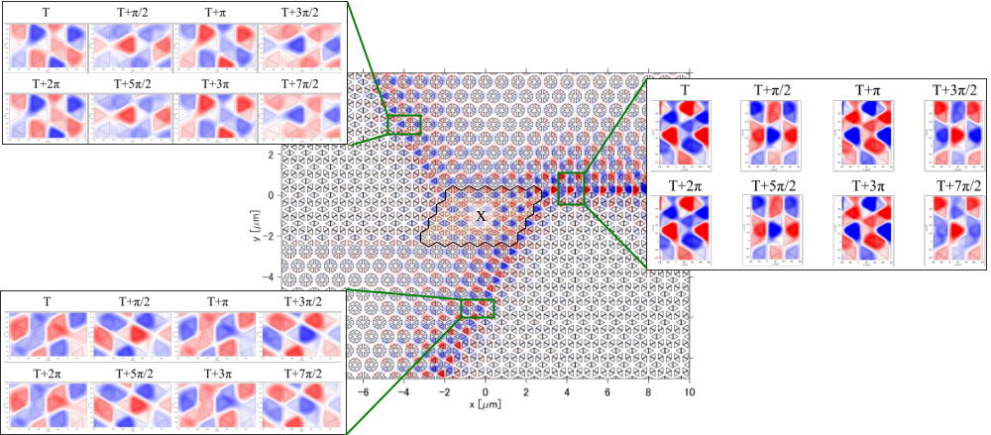
Figure S1. Time-dependent propagation characteristics of the topological splitter. A zero bandgap photonic structure was placed in the coupler/combiner domain.

Fabrication process of topological splitter using shape correction electron beam lithography

Figure S2a shows the topological splitter fabrication process. After coating ZEP520A (thickness: 500 nm) on an SOI substrate with a Si core thickness of 220 nm, PhC patterns were formed by electron beam lithography (JEOL JBX-6300UA, acceleration voltage: 50 kV, beam current: 100 pA, dose: 170 μC/cm²) and inductively coupled plasma-reactive ion etching with SF₆ mixed gas (Samco RIE-100iPH, ICP power: 160 W, bias power: 60 W, pressure: 0.05 Pa). ZEP520A, which was used as a mask, was finally removed via O₂ ashing (Samco RIE-101iPH, ICP power: 100 W, bias power: 0 W, pressure: 0.05 Pa), followed by treatments with piranha solution and high-performance liquid (Novec™ 7200).
Fabricated structures are usually different from computer-aided design (CAD) structures because of the spread of the electron beam inside the resist and the nonuniformity of the gas distribution derived from the surface shape during etching. This effect is particularly strong in acute-angled structures used in topological photonics, and rounded corners are unavoidable in fabricated structures. This generally has a significant effect on the appearance of the topological edge states. To realise an ideal triangular nanohole with an appropriate radius of curvature, shape correction (optical proximity correction, OPC) lithography was introduced based on empirical big-data processing. Figure S2b shows the shape-corrected triangular nanohole pattern. Specifically, the shape was such that the vicinity of the apex of the triangle was narrowed, and a circular pattern was placed at the centre of the apex. Figure S2c shows scanning electron microscopy images of the triangular nanoholes with and without shape correction. The shape-corrected nanoholes had relatively sharper angles, and their radii of curvature were less than 30 nm.

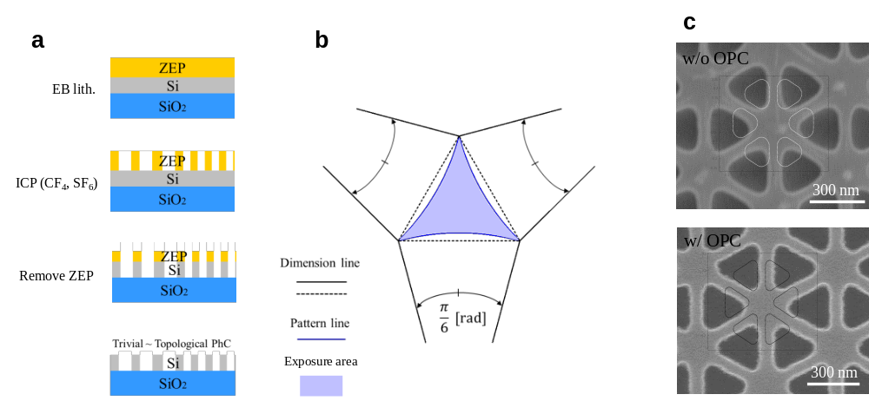
Figure S2. a, Fabrication process of topological splitter. b, Shape correction electron beam lithography pattern for triangular nanohole. c, Scanning electron microscopy images of the triangular nanoholes with and without shape correction.
Hyperspectral Fourier image spectroscopy for measuring topological photonic band

Figure S3a shows the configuration of the infrared hyperspectral Fourier image spectrometer. First, we obtained collimated light from a fibre-output wideband white light source (Bentham Ltd. WLS100) through a lens (4× Olympus Plan Achromat Objective, 0.10 NA). The sample was then irradiated with light using an objective lens (60× Olympus Plan Fluorite Objective, 0.9 NA) through a variable retarder/wave plate. The light scattered from the PhC was observed using an imaging element through a 4f optical system consisting of two achromatic lenses (f = 300 mm). A dichroic mirror was inserted in the middle of the 4f optical system path, and the visible wavelength component of a broad-range white light source was used to observe the real image of the sample. Additionally, a variable-wavelength filter (VariSpec LNIR) was placed in front of the infrared camera to obtain a Fourier image of the scattered light.
The photonic band diagram was obtained using the above configuration via the following procedure. First, the Fourier image of the light scattered from the structure was observed while changing the centre wavelength of the tunable filter. Next, for the obtained Fourier image, the intensity along a specified path was measured and converted into an intensity distribution of the specific energy in reciprocal lattice space. The photonic band diagram was reconstructed by performing the same operation for all wavelengths and arranging them in two-dimensional space, as shown in Figure S3b. Considering their high speed and versatility, the above operations were fully automated using software.

Figure S3. a, Configuration of infrared hyperspectral Fourier image spectroscopy. b, Fourier image as a function of light energy obtained by observing the Fourier image.
Layout of fabricated device

Figure S4 shows the layout of the fabricated device. The device consists of a topological region of the order of several 10 microns and a silicon thin-wire waveguide. The input waveguide end was separated from the topological splitter by 2 mm to eliminate stray light during measurement. The two output waveguide ends were separated by 600 µm.
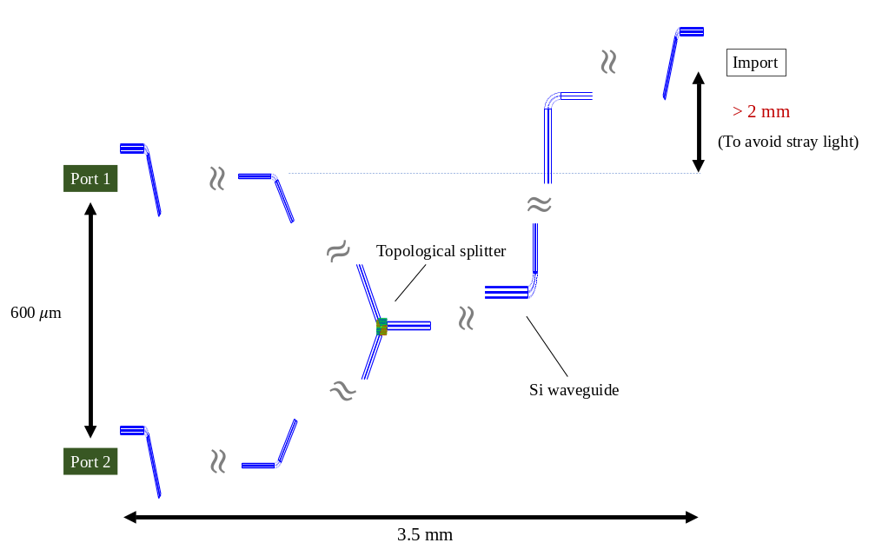
Figure S4. Layout of the fabricated device.

Experimental setup to measure transmission characteristics of the topological splitter

Figure S5 shows our experimental setup for measuring the propagation characteristics of the device for 1550-nm-band incident light (1480–1640 nm). The TE-mode light from a tunable laser (10 dBm) was transferred into and out of the device using a spherical lensed polarisation-maintaining fibre (PMF). The intensity of the output light from the device was measured using an optical spectrum analyser (Anritsu: MS9710C) and a power meter (ML9001). An infrared camera (Hamamatsu Photonics: C14041-10U) was used to simultaneously observe the upward-scattered light from the device.

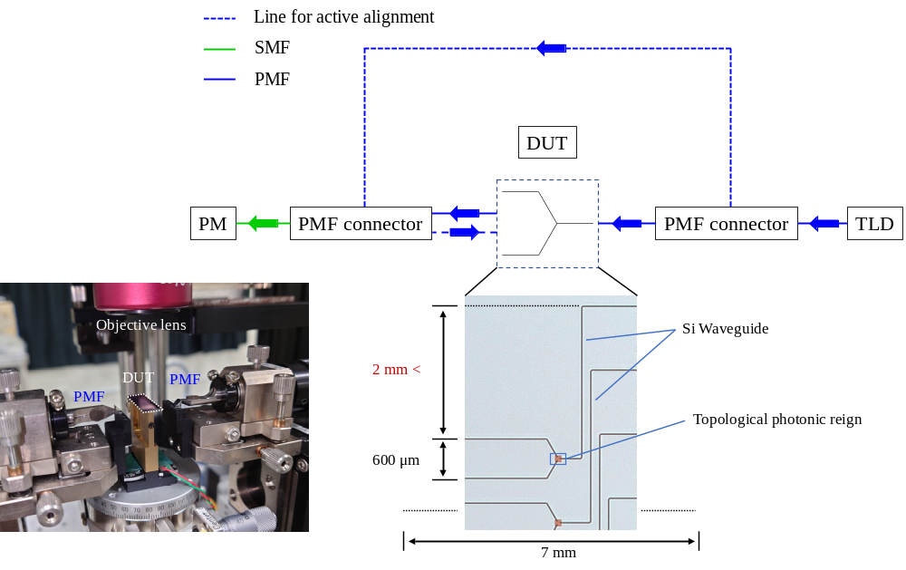
Figure S5. Experimental setup to measure transmission characteristics of the topological splitter.

Propagation characteristics of the topological splitter when switching input ports

Figure S6 shows the infrared camera images when switching the input ports ($\left|\left.1\right\rangle \right.$ or $\left|\left.2\right\rangle \right.$) for cases I and III in Fig. 3c (results when light was input from $\left|\left.0\right\rangle \right.$ are also shown). In both cases, the propagating light was emitted to the left through the topological waveguide created at the interface between the trivial and topological PhCs. From these results, it can be concluded that each photonic structure, which is a basic component of the topological splitter, was appropriately designed.

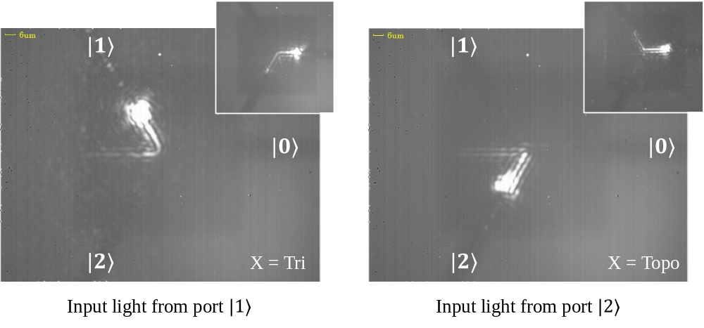
Figure S6. Propagation characteristics of the topological splitter when switching input ports.

