Supplementary Materials
Visualization of Latent Fingerprints Based on Composites of Dye-Doped Cellulose with Red Emissive Fluorescence
Zhan-Chao Li ^{1,#,*}, Da-Wu Li^{,2,3,#}, Zhao-Hui Liu ¹, Li-Ping Wu ¹, Xiao-Sen lv ^{2,3, *}
(1. Shenyang polytechnic college, Shenyang, 1100451. 2. College of Forensic Science, Criminal Investigation Police University of China, Shenyang, 110035, China; 3. Key Laboratory of Impression Evidence Examination and Identification Technology, Ministry of Public Security, Shenyang, 110035, China)
# The first three authors contributed equally to this paper
* Corresponding author
Email: lvxiaosen@126.com (X-S lv), and sylzc2023@163.com (Z Li)
Materials
All other reagents used which were of analytical grade, were obtained from Sinopharm Chemical Reagent Co., Shanghai, China, and used as received.
Characterization
The product obtained was characterized by FT-IR spectroscopy (model 5700, Nicolet, USA) was recorded using KBr pellets between 4000 and 400 cm⁻¹ with the resolution of 1 cm⁻¹, by scanning electron microscope (SEM, Shimadzu SS 550) operated at 12 kV equipped with an energy-dispersive X-ray (EDS) analyzer, and by X-ray diffraction using Cu Kα radiation (XRD, Almelo PW-3060, Netherland). The absorption and fluorescence spectral measurements were carried out using a Shimadzu UV-2550 UV Visible spectrophotometer and a Hitachi F-4500 fluorescence spectrometer, respectively.
Calculation of adsorptive amount
q = (C₀ − C_{t}) V/m (S1)
where q (mg g⁻¹) is the adsorptive amount, C₀ (mg L⁻¹) is the initial concentration of dyes, C_{t} (mg L⁻¹) is the remnant concentration of dyes, V (mL) is the volume of solution and m (g) is the mass of cellulose.
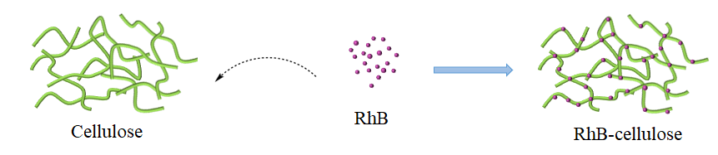
Scheme S1 General process for the preparation of the RhB-cellulose.
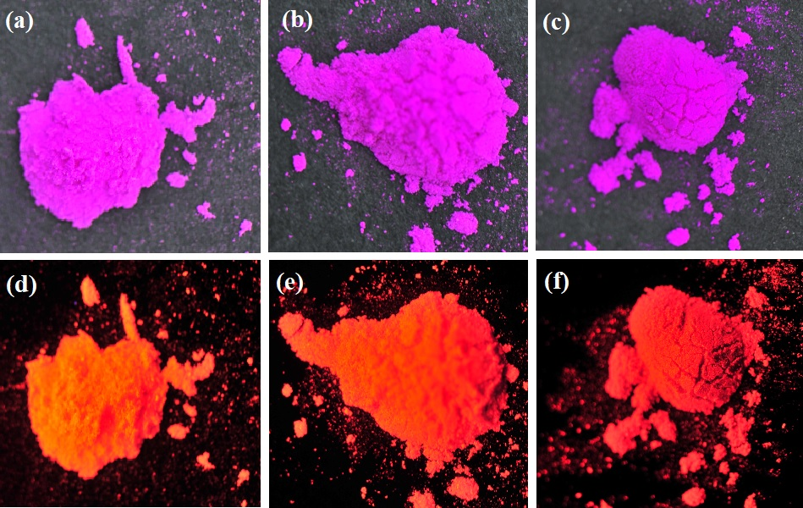
Figure S1 Appearance of (a) the RhB₅-cellulose, (b) RhB₁₀-cellulose, and (c) RhB₂₀-cellulose in daylight; Fluorescent appearance of (d) the RhB₅-cellulose, (e) RhB₁₀-cellulose, and (f) RhB₂₀-cellulose under 365 nm UV-light irradiation.
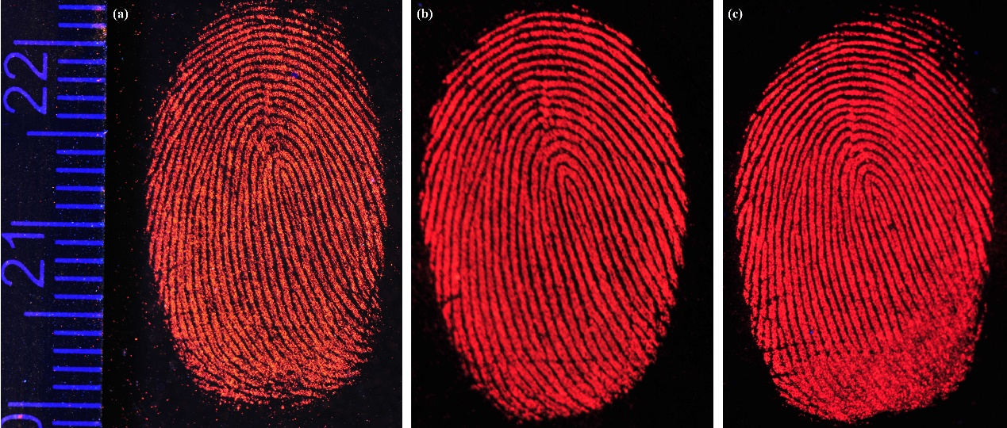
Figure S2 The fluorescent images of the LFPs based on (a) the RhB₅-cellulose, (b) RhB₁₀-cellulose, and (c) RhB₂₀-cellulose under 365 nm UV-light irradiation.

Table S1 Statistical table of ridge, Furrow and sweat hole size
Number | Ridge/mm | Furrow/mm | Sweat pore length/mm | Distance of  sweat pore/mm
1 | 0.227 | 0.291 | 0.085 | 0.283
2 | 0.271 | 0.199 | 0.095 | 0.248
3 | 0.301 | 0.183 | 0.122 | 0.309
4 | 0.358 | 0.223 | 0.064 | 0.337
5 | 0.388 | 0.257 | 0.126 | 0.375
6 | 0.259 | 0.215 | 0.124 | 0.256
7 | 0.252 | 0.268 | 0.08 | 0.395
8 | 0.299 | 0.195 | 0.093 | 0.335
9 | 0.267 | 0.270 | 0.080 | 0.398
10 | 0.232 | 0.220 | 0.071 | 0.227
11 | 0.217 | 0.245 | 0.134 | 0.311
12 | 0.257 | 0.274 | 0.088 | 0.433
13 | 0.232 | 0.347 | 0.118 | 0.268
14 | 0.217 | 0.199 | 0.144 | 0.225
15 | 0.257 | 0.306 | 0.125 | 0.311
16 | 0.232 | 0.126 | 0.089 | 0.433
17 | 0.271 | 0.151 | 0.134 | 0.267
18 | 0.233 | 0.189 | 0.126 | 0.301
19 | 0.262 | 0.180 | 0.063 | 0.249
20 | 0.257 | 0.119 | 0.085 | 0.332
21 | 0.232 | 0.145 | 0.068 | 0.298
22 | 0.27 | 0.205 | 0.072 | 0.289
23 | 0.233 | 0.121 | 0.068 | 0.234
24 | 0.262 | 0.146 | 0.068 | 0.255
25 | 0.299 | 0.183 | 0.144 | 0.284
26 | 0.202 | 0.203 | 0.063 | 0.309
27 | 0.158 | 0.163 | 0.108 | 0.297
28 | 0.183 | 0.192 | 0.072 | 0.69
29 | 0.193 | 0.188 | 0.085 | 0.248
30 | 0.196 | 0.171 | 0.109 | 0.278
31 | 0.197 | 0.176 | 0.084 | 0.314
32 | 0.158 | 0.145 | 0.109 | 0.280
33 | 0.233 | 0.214 | 0.107 | 0.354
34 | 0.197 | 0.163 | 0.072 | 0.401
35 | 0.223 | 0.203 | 0.112 | 0.442
Max | 0.388 | 0.306 | 0.134 | 0.433
Min | 0.158 | 0.119 | 0.063 | 0.225
Average | 0.24 | 0.20 | 0.09 | 0.32

