Optimizing the hydrolysis-acidification stage in municipal wastewater treatment: comparison of immobilized fillers and granular sludge

Xuyan Liu^{1,2}, Hong Yang³, Kai Yang^{4*}
¹Hebei GEO University, Shijiazhuang 050031, China;
²Hebei Province Collaborative Innovation Center for Sustainable Utilization of Water Resources and Optimization of Industrial Structure, Shijiazhuang 050031, China;
³Key Laboratory of Beijing Water Quality Science and Water Environment Recovery Engineering, Beijing University of Technology, No. 100, Pingleyuan, Chaoyang District, Beijing 100124, China;

⁴ Shijiazhuang University, Shijiazhuang 050031, China;

Corresponding author. E-mail address: ykaisjz@163.com

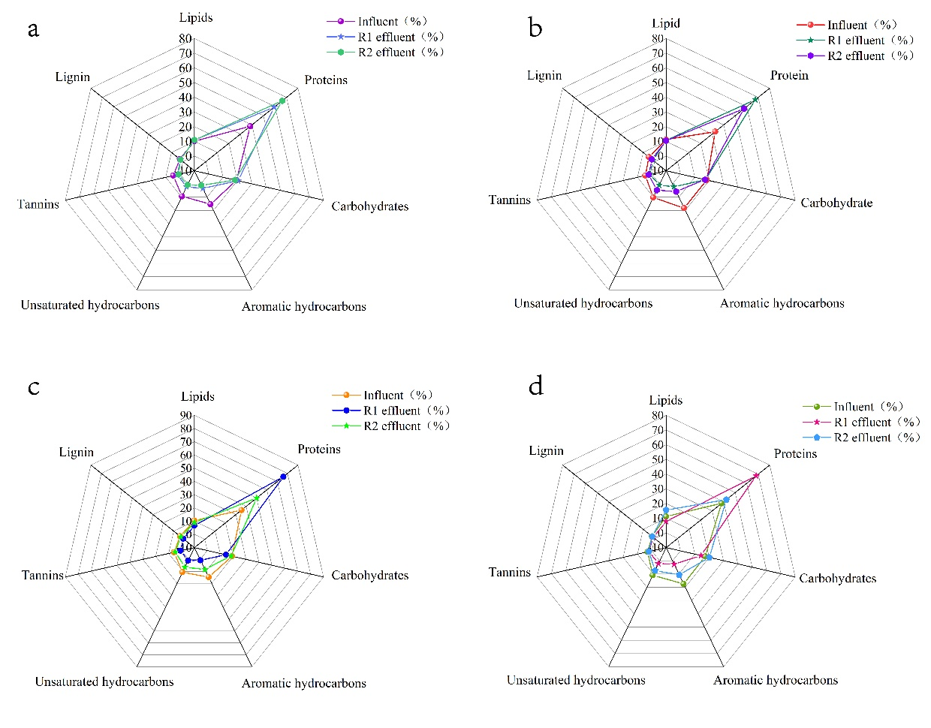
1. Organic matter molecule composition in reactor effluent
Fig.S1 Radar map of the DOM molecular composition of the influent and effluent of the reactor: (a) Sample on day 17th; (b) Sample on day 25th; (c) Sample on day 75th; (d) Sample on day 105th
Understanding the molecular features of reactor effluent can give crucial insights into the changes in hydrolysis and acidification characteristics of filler and granular sludge at various phases. Fourier transform ion cyclotron resonance-Mass Spectrometry (FTICR-MS) was used to detect the molecular characteristics of organic matter in the reactor, and the proportion of organic matter represented by different regions was then shown by radar map for better analysis (Valle et al., 2018).
Through analysis, it can be seen that the types of organic matter in and out of the water from R1 and R2 mainly include lipids, proteins, unsaturated hydrocarbons and aromatic hydrocarbons. Fig. S1 (a) shows the proportion of organic compounds in the samples on day 17. Protein accounts for the largest proportion of organic matter in the influent (38.57%), followed by carbohydrates (19.33%), aromatic hydrocarbons (15.27%), lipids (10.08%), and unsaturated hydrocarbons (9.32%), while tannin and lignin account for a relatively low proportion of 4.76% and 2.67%, respectively. Masiuk et al. (2008) found that the protein content in urban sewage is relatively high, usually ranging from 24% to 35%, followed by carbohydrates typically ranging from 17% to 30%, and lipids typically ranging from 5% to 11%. Aromatic hydrocarbons, tannic acid, and lignin are related to the local environment. At this stage, the proportion of protein in R1 and R2 effluent increased from 38.57% to 59.33% and 66.53% respectively, the proportion of aromatic hydrocarbons decreased from 15.27% to 3.33% and 1.06%, and the proportion of unsaturated hydrocarbons decreased from 9.32% to 2.11 and 0.77%, respectively. Based on the changes in these data, it can be seen that the proportion of protein in the effluent of R2 significantly increases compared to R1, and the residual amount of complex organic compounds (aromatic hydrocarbons and unsaturated hydrocarbons) is also less than R1, which is consistent with the three-dimensional fluorescence results. Therefore, it indicates that granular sludge at this stage has stronger hydrolysis and acidification performance compared to fillers, hydrolyzing most complex organic matter into small molecule organic matter.
Figure S1 (b) shows the proportion of organic matter in the sample on the 25th day. The proportion of organic compounds in the influent during this stage did not change significantly. Compared to the previous stage, the proportion of protein in R1 effluent increased from 59.33% to 67.56%. Aromatic hydrocarbons and unsaturated hydrocarbons further decreased, from 18.23% of influent to 2.11%, and 10.11% to 0.89%, respectively. At this point, the proportion of protein in R2 effluent decreased from 66.53% in the previous stage to 57.68%. Although it was higher than the proportion of protein in influent (32.68%), there was still a certain decrease in performance. From the remaining complex organic matter, it can also be seen that its proportion has increased from about 1% in the previous stage to 5%. This is consistent with molecular weight analysis and three-dimensional fluorescence results.
Figure S1 (c) shows the proportion of organic matter in the sample on the 75th day. At this stage, the organic composition in the influent water has not changed much compared to the previous two stages. At this time, the proportion of protein in R1 effluent further increased to 75.97%, while the proportion of aromatic hydrocarbons and unsaturated hydrocarbons decreased to below 1%, indicating that the hydrolysis performance of the filler is good at this time. The proportion of protein in R2 effluent continued to decrease to 50.11%, while the proportion of aromatic hydrocarbons and unsaturated hydrocarbons increased to 8.33% and 6.44%, respectively. At this time, tannic acid and lignin were not removed. Johnson et al (2001) found that tannic acid molecules contain sugar and aromatic acid groups, as well as carboxyl, methoxy, and carbonyl groups, just like humic acids. Tannic acid also belongs to the category of macromolecular organic compounds. Therefore, it indicates that the performance of granular sludge further decreases at this time. Based on the previous analysis, it is concluded that long-term low intensity operation has a significant impact on the hydrolysis and acidification performance of granular sludge, and the released SMPs increase the content of complex organic matter in the effluent. The filler can maintain a good anaerobic state in long-term low intensity polluted wastewater and has a certain protective effect on bacteria, so the hydrolysis and acidification performance can gradually increase and remain stable.
Figure S1 (d) shows the proportion of organic matter in the sample on the 105th day. This stage is a low-temperature operation period in winter, where the proportion of protein in R1 and R2 effluent decreases compared to the previous stage, while the proportion of aromatic hydrocarbons and unsaturated hydrocarbons increases to varying degrees. The protein content in R1 effluent decreased from 75.97% on the 75th day to 70.25%, and the proportion of aromatic hydrocarbons and unsaturated hydrocarbons increased from less than 1% in the previous stage to about 2%. At this time, the protein content in R2 effluent decreased to 42.33%, while the proportion of aromatic hydrocarbons and unsaturated hydrocarbons increased to 10.56% and 7.36%, respectively. Therefore, it can be seen that low temperature in winter has a certain impact on both the filler and granular sludge, while the filler has stronger resistance to low temperature and less performance degradation. At this time, the performance of granular sludge decreases significantly, not only producing less easily degradable organic matter, but also increasing the proportion of complex organic matter. The reason may be due to the dual effects of low strength and low temperature, which leads to a decrease in its performance and a greater generation of SMPs, this leads to an increase in the content of complex organic matter in the effluent.
2. Study on the Internal Structure of Typical Stage Fillers and Granular Sludge
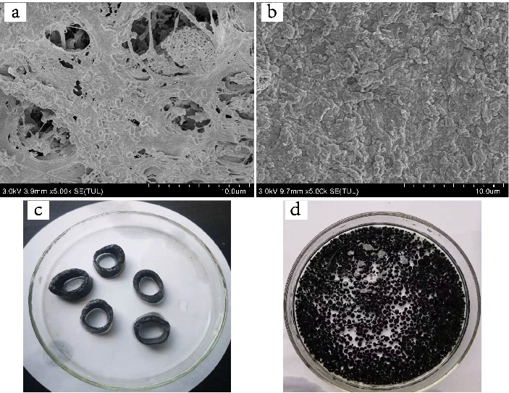

Fig. S2 Morphology of filler and granular sludge: (a) SEM image of filler magnified 5k times; (b) SEM image of granular sludge magnified 5k times; (c) actual image of filler; (d) actual image of granular sludge
Reference
Valle J, Gonsior M, Harir M, et al. Extensive processing of sediment pore water dissolved organic matter during anoxic incubation as observed by high-field mass spectrometry (FTICR-MS). Water Research, 2018, 129: 252-263.
Masiuk S, Rakoczy R, Kordas M. Statistical description of influence of biogenic compounds on process reduction of organic substance from municipal sewage in functioning treatment plant. Biochemical Engineering Journal, 2008, 40(1): 79-91.
Johnson A C, Sumpter J P. Removal of endocrine-disrupting chemicals in activated sludge treatment works [J]. Environ. Sci. Technol., 2001, 35(24): 4697-4703.

