The Implications of Ending Groundwater Overdraft for Global Food Security
Supplementary Material

Figure S1: Projected change in food demand in Business-As-Usual scenario (BAU) without climate change impacts
Source: Author’s calculations based on simulations from the IMPACT model, units in million metric tons

Table S1. Overdraft rates of top depleting water basins in 2020 (estimate) and 2050 (projection) under climate change scenarios
FPU | Basin | Country | Rate of Overdraft
FPU | Basin | Country | 2020 |  | 2050
 |  |  | billion cubic meters
GAN_IND | Ganges basin | India | 88.1 |  | 107.1
IND_PAK | Indus basin | Pakistan | 38.5 |  | 52.3
SAU_SAU | Saudi Arabia basin | Saudi Arabia | 18.1 |  | 21.3
YHE_CHM | Yili He basin | China | 13.2 |  | 16.8
MHN_IND | Mahanadi basin | India | 11.8 |  | 14.0
WAI_IRN | Western Asia Iran basin | Iran | 10.7 |  | 13.3
SAY_IND | Sahyada basin | India | 9.2 |  | 12.8
CHO_IND | Chota-Nagpui basin | India | 10.3 |  | 12.4
GOD_IND | Godavari basin | India | 9.5 |  | 12.1
JAP_JPN | Japan basin | Japan | 3.5 |  | 11.1
CAL_USA | California basin | United States | 10.1 |  | 9.7
HAI_CHM | Hail He basin | China | 9.1 |  | 9.1
KRI_IND | Krishna basin | India | 7.4 |  | 8.6
LUN_IND | Luni basin | India | 7.3 |  | 8.6
UME_MEX | Upper Mexico basin | Mexico | 4.4 |  | 7.6
LMO_CHM | Lower Mongolia basin | China | 7.3 |  | 7.5
MAT_IND | Mahi basin | India | 5.9 |  | 7.3
TIG_IRQ | Tigris basin | Iraq | 3.1 |  | 6.9
NLL_EGY | Nile basin | Egypt | 5.3 |  | 5.9
RAP_RAP | Rest of Arab Peninsula basin | Rest of Arab Peninsula |  | 4.7 | 5.3
NLL_SDN | Nile basin | Sudan | 1.3 |  | 4.3
BRT_BGD | Brahmaputra basin | Bangladesh | 3.5 |  | 4.2
GAN_BGD | Ganges basin | Bangladesh | 2.6 |  | 3.9
YEM_YEM | Yemen basin | Yemen | 2.6 |  | 3.7
TIG_IRN | Tigris basin | Iran | 2.1 |  | 3.6
EGH_IND | Eastern Ghats basin | India | 3.5 |  | 3.6
PRT_PRT | Portugal basin | Portugal | 2.9 |  | 3.5
NAC_EGY | North African Coast basin | Egypt | 3.5 |  | 3.5
OBB_CHM | Ob basin | China | 3.4 |  | 3.4
BOR_MYS | Borneo basin | Malaysia | 3.1 |  | 3.1
MEK_THA | Mekong basin | Thailand | 0.5 |  | 3.0
CHU_KGZ | Chu and Talas basin | Kazakhstan | 0.9 |  | 2.5
NWS_ECU | Northwest South America basin | Ecuador | 2.4 |  | 2.4
IEC_IND | India East Coast basin | India | 2.4 |  | 2.4
WGM_USA | Western Gulf of Mexico basin | the United States | 0.7 |  | 1.9
DAN_MDA | Danube basin | Moldova | 1.4 |  | 1.6
NAC_LBY | North African Coast basin | Libya | 1.1 |  | 1.3
NAC_TUN | North African Coast basin | Tunisia | 1.0 |  | 1.2
WAI_PAK | Western Asia Iran basin | Pakistan | 0.8 |  | 1.2
EME_EGY | Eastern Mediterranean basin | Egypt | 1.2 |  | 1.2
EME_ISR | Eastern Mediterranean basin | Israel | 1.0 |  | 1.1
WORLD |  |  | 319.1 |  | 406.3
Source: Authors’ estimates using IMPACT/Global Hydrology model.
Notes: Only FPUs with annual depletion greater than 1 billion cubic meters (bcm) per year are listed; GW overdraft/depletion is defined as the rate of withdrawal in excess of net recharge (recharge rate minus environmental flow requirements); Values are averages of GDFL, HEM, and IPSL simulation results.

Table S2 Projected over- and under withdrawal of groundwater, by Food Producing Units, by 2050, under climate change scenario.
Regions | Year |  |  | Year |  |  | Year
Regions | 2020 | 2050 |  | 2020 | 2050 |  | 2020 | 2050
 | billion cubic meters
 | Overwithdrawing FPUs |  |  | Rest of FPUs |  |  | All FPUs
GW Withdrawals
HICs | 74.5 | 87.7 |  | 79.5 | 93.5 |  | 154.1 | 181.2
LMICs | 447.3 | 521.9 |  | 254.9 | 296.0 |  | 702.1 | 817.9
World | 521.8 | 609.6 |  | 334.4 | 389.5 |  | 856.2¹ | 999.2
GW Recharge
HICs | 52.1 | 53.8 |  | 612.0 | 607.3 |  | 664.1 | 661.2
LMICs | 209.9 | 214.8 |  | 2,389.5 | 2,920.8 |  | 2,599.4 | 3,135.6
World | 262.0 | 268.7 |  | 3,001.5 | 3,528.1 |  | 3,263.5 | 3,796.8
Environmental Flow (contribution from GW)
HICs | 19.8 | 19.8 |  | 167.7 | 167.7 |  | 187.5 | 187.5
LMICs | 58.5 | 58.5 |  | 620.4 | 620.4 |  | 678.9 | 678.9
World | 78.3 | 78.3 |  | 788.1 | 788.1 |  | 866.4 | 866.4
Net GW Recharge
HICs | 32.3 | 34.0 |  | 444.3 | 439.7 |  | 476.6 | 473.7
LMICs | 151.4 | 156.3 |  | 1,769.1 | 2,300.4 |  | 1,920.5 | 2,456.7
World | 183.7 | 190.3 |  | 2,213.4 | 2,740.0 |  | 2,397.1 | 2,930.4
Net Withdrawals*
HICs | -42.3 | -53.7 |  | 364.8 | 346.2 |  | 322.5 | 292.5
LMICs | -295.9 | -365.6 |  | 1,514.3 | 2,004.3 |  | 1,218.4 | 1,638.8
World | -338.1 | -419.3 |  | 1,879.0 | 2,350.5 |  | 1,540.9 | 1,931.2
Number of FPUs | 78 |  |  | 238 |  |  | 316
% of total | 25 |  |  | 75 |  |  | 100
Withdrawals (bcm) | 522 | 610 |  | 334 | 390 |  | 856 | 999
% of total | 61 | 61 |  | 39 | 39 |  | 100 | 100
Source: Authors’ estimates using IGHM (IMPACT Global Hydrology Model) simulations.
Notes: FPUs are Food Producing Units in IMPACT that correspond to geographical watersheds or water basins; Rates of GW withdrawals are irrespective of use;¹ This estimated value is lower than the AQUASTAT estimate of 879 bcm for 2020; *Net withdrawals = Net GW Recharge less Withdrawals. Negative values mean rates of GW depletion, while positive values mean above “minimum sustainable” levels; HICs are high-income countries, and LMICs are low- and middle-income countries.

Table S2: Groundwater withdrawals by regions and use types across years until 2050.
Region | 2015 |  | 2030 |  | 2050
Region | Irrigated | Rainfed | Irrigated | Rainfed | Irrigated | Rainfed
East Asia and the Pacific | 144 | 165 | 150 | 173 | 155 | 180
South Asia | 118 | 111 | 131 | 105 | 147 | 93
Former Soviet Union | 13 | 95 | 14 | 98 | 15 | 99
Latin America and the Caribbean | 21 | 128 | 23 | 146 | 26 | 166
Middle East and North Africa | 26 | 46 | 28 | 48 | 30 | 50
Sub-Saharan Africa | 9 | 194 | 12 | 222 | 19 | 255
Developing countries | 324 | 727 | 352 | 778 | 386 | 829
Developed countries | 37 | 207 | 40 | 210 | 44 | 208
World Total | 361 | 934 | 391 | 988 | 430 | 1,037
Note: Authors’ calculations from IFPRI Impact Model, in km3 per year

Figure S2: Annual groundwater recharge in base year (2005) and relative change with climate change , from base year to 2050 under BAU.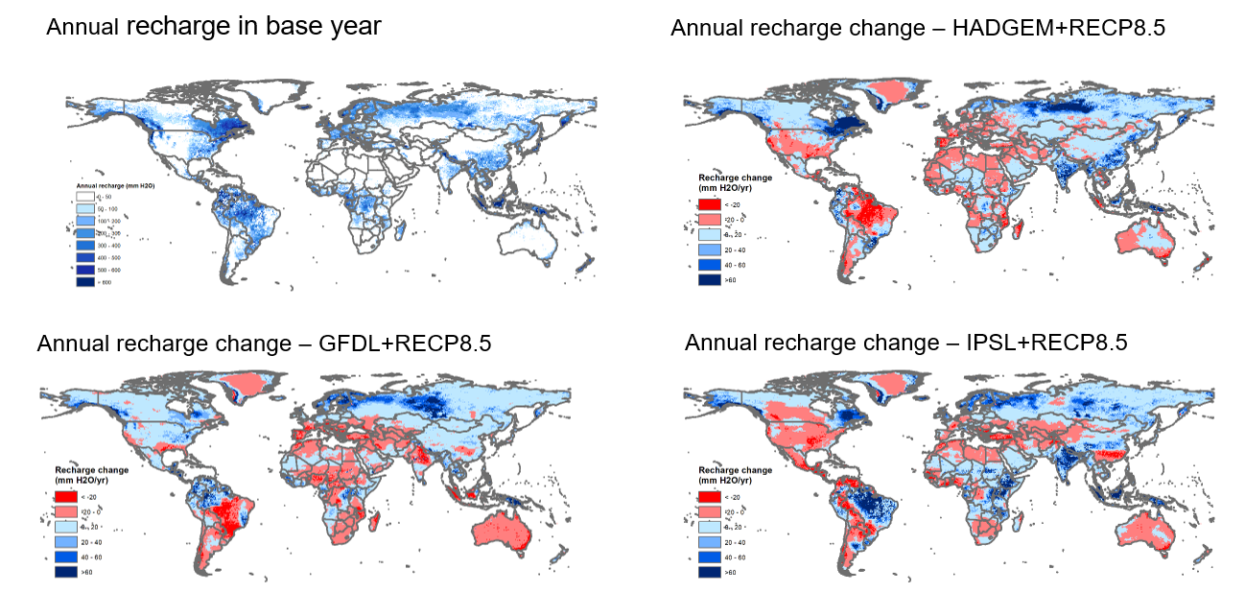
Source: Author’s calculations based on IFPRI IMPACT model

Figure S3: Representation of IMPACT model with the IGHM
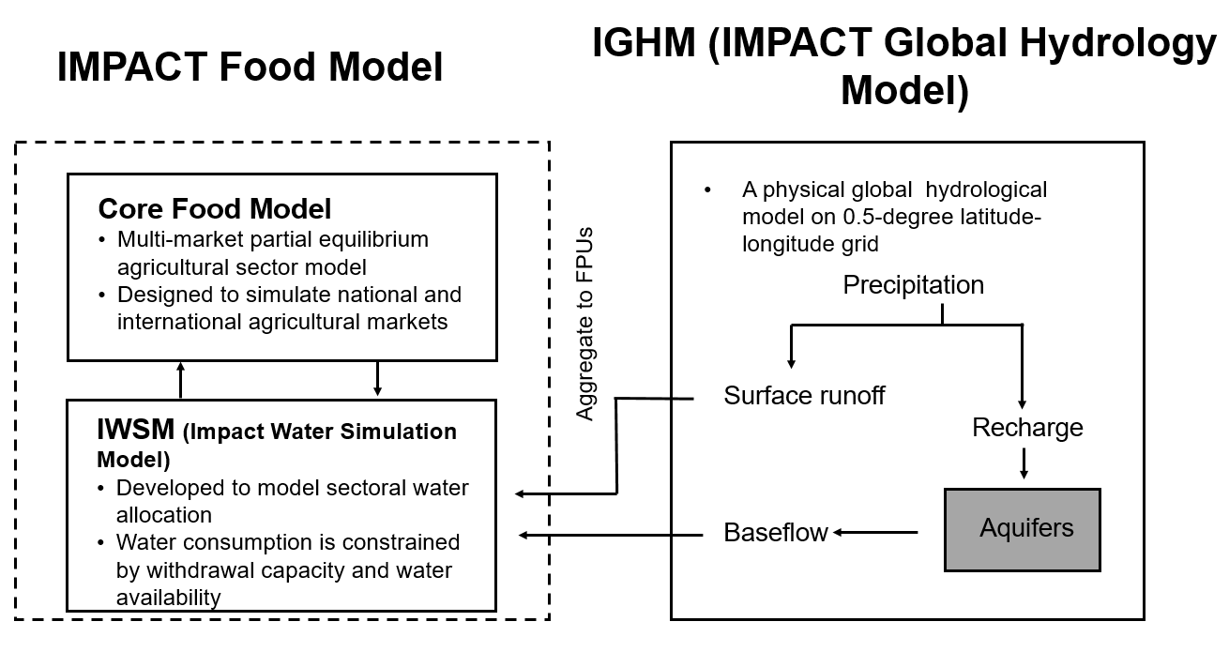
Source: IFPRI IMPACT model (Robinson et al. 2015).

Figure S4. Linking the groundwater module to the IMPACT model.
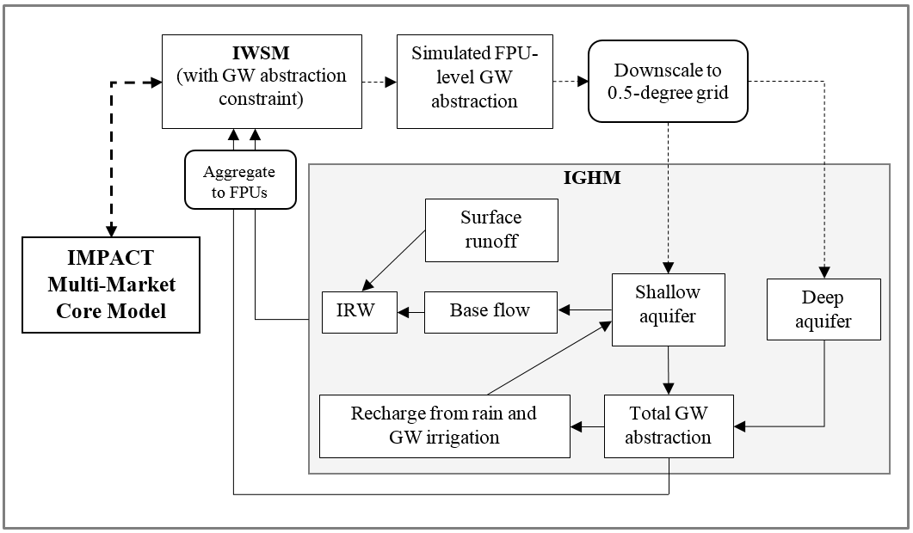
Note: Processes shown in the shaded rectangular area are simulated in the IGHM model with groundwater withdrawal, at the grid cell level. Real lines represent water flows; dotted lines represent demand for groundwater; thick dotted line refers to information exchange between IMPACT multi-market core model and the water module IWSM. GW denotes groundwater; IRW stands for internal renewable water resources.

Figure S5. Groundwater pumping rules and aquifer storage balance at the grid cell level
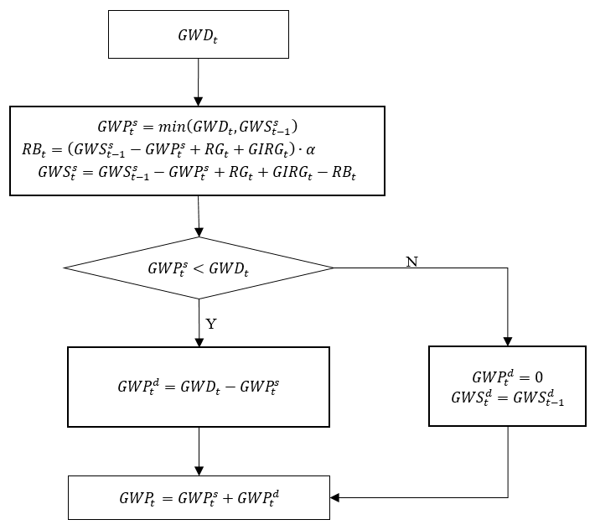
Note: ${GWD}_{t}$ refers to GW pumping demand; ${GWP}_{t}^{s}$ is GW pumping from a shallow aquifer; ${GWP}_{t}^{d}$ is GW pumping from a deep aquifer; ${GWP}_{t}$ is the total amount of GW pumped from both the shallow and deep aquifers; ${GWS}_{t}^{s}$ is shallow aquifer water storage; and ${GWS}_{t}^{d}$ is deep aquifer water storage; ${RG}_{t}$ is GW recharge from rainfall; G$I{RG}_{t}$ is GW recharge from irrigation that is sourced from GW.

Appendix 1: Downscaling of FPU groundwater withdrawal demand to grid cells
In the newly added groundwater module in IMPACT, groundwater withdrawal demands, simulated by the IWSM model at the FPU level, are downscaled to 0.5-degree grid cells so that groundwater withdrawal and its effects on baseflow can be simulated in the IGHM model. For any time period t and grid cell i in a FPU, the simulated groundwater withdrawal demand at the FPU level, ${GWD}_{t}^{FPU}$, is downscaled to grid cell i by multiplying a real grid cell-fraction ($f_{gwd,i}$) of total groundwater demand in the entire FPU, namely,
${{GWD}_{i,t}=GWD}_{t}^{FPU}∙f_{gwd,i}$
Groundwater withdrawal demand at FPU level is calculated using consumptive use demand of groundwater simulated by the IWSM model, of which water accounting is based on consumptive use, and a comprehensive depletion coefficient, namely:
$${GWD}_{t}^{FPU}={{GWCD}_{t}^{FPU}}/{ε_{t}^{FPU}}$$
where ${GWCD}_{t}^{FPU}$ is consumptive use groundwater demand in time period t, and $ε_{t}^{FPU}$ is comprehensive depletion coefficient in the FPU given by
$$ε_{t}^{FPU}=\frac{{WCDd}_{t}^{FPU}+{WCDn}_{t}^{FPU}+{WCDi}_{t}^{FPU}}{{WWDd}_{t}^{FPU}+{WWDn}_{t}^{FPU}+{WWDi}_{t}^{FPU}}$$
and ${WWDd}_{t}^{FPU}=\frac{{WCDd}_{t}^{FPU}}{ε_{d}^{FPU}}$, ${WWDd}_{t}^{FPU}=\frac{{WCDn}_{t}^{FPU}}{ε_{n}^{FPU}}$, and ${WWDd}_{t}^{FPU}=\frac{{WCDi}_{t}^{FPU}}{ε_{i}^{FPU}}$
where ${WCDd}_{t}^{FPU}$, ${WCDn}_{t}^{FPU}$, ${WCDi}_{t}^{FPU}$are consumptive use water demands of domestic, industrial and irrigation sectors at the FPU level in time period t; ${WWDd}_{t}^{FPU}$, ${WWDn}_{t}^{FPU}$, ${WWDi}_{t}^{FPU}$are withdrawal water demands of the domestic, industrial and irrigation sectors at the FPU level; and $ε_{d}^{FPU}$, $ε_{n}^{FPU}$, and $ε_{i}^{FPU}$ are FPU-specific depletion coefficients of domestic, industrial and irrigation sectors. Please note that we assume livestock water demand is met solely by surface water, as in (Döll et al., 2014).
The groundwater demand fraction in grid cell i, $f_{gwd,i}$, is approximated by the ratio of total water demand in the grid cell to that in the entire FPU, that is
$$f_{gwd,i}=\frac{{WWDd}_{i,t}+{WWDn}_{i,t}+{WWDi}_{i,t}}{{WWDd}_{t}^{FPU}+{WWDn}_{t}^{FPU}+{WWDi}_{t}^{FPU}}$$
where ${WWDd}_{i,t}$, ${WWDd}_{i,t}$, and ${WWDd}_{i,t}$ represent withdrawal water demands (groundwater and surface water) of the domestic, industrial and irrigation sectors in grid cell i and time period t, respectively.
Domestic and industrial groundwater demand at the grid cell level are assumed to be proportional to population, following Vörösmarty et al. (Vörösmarty et al., 2000), and are calculated as
${WWDd}_{i,t}={WWDd}_{t}^{FPU}∙\frac{{Pop}_{i,t}}{{Pop}_{FPU,t}}$ and ${WWDn}_{i,t}={WWDn}_{t}^{FPU}∙\frac{{Pop}_{i,t}}{{Pop}_{FPU,t}}$
in which ${Pop}_{i,t}$ and ${Pop}_{FPU,t}$ denote population in time period t in grid cell i and in the entire FPU, respectively. We use population projections in the SSP2 (Shared Socioeconomic Pathway 2) (O’Neill et al., 2015) downscaled to 0.5-degree global grid by (Murakami and Yamagata, 2016).
Irrigation groundwater demand in grid cell i is assumed to be proportional to the share of groundwater-irrigated area in total irrigated area, namely
$${WWDi}_{i,t}={WWDi}_{t}^{FPU}∙{fI}_{i}$$
in which ${fI}_{i}$ is share of groundwater irrigated area of grid cell i in that of the entire FPU, calculated using gridded irrigated area data from (Siebert et al., 2010).

References
Döll, P., Müller Schmied, H., Schuh, C., Portmann, F. T., & Eicker, A. (2014). Global-scale assessment of groundwater depletion and related groundwater abstractions: Combining hydrological modeling with information from well observations and GRACE satellites. Water Resources Research, 50, 1–23. https://doi.org/10.1002/2014WR015595
Murakami, D., & Yamagata, Y. (2016). Estimation of gridded population and GDP scenarios with spatially explicit statistical downscaling. ArXiv.
O’Neill, B. C., Kriegler, E., Ebi, K. L., Kemp-benedict, E., & Riahi, K. (2015). The Roads Ahead: Narratives for Shared Socioeconomic Pathways describing World Futures in the 21 st Century. Global Environmental Change, 1–48. https://doi.org/10.1016/j.gloenvcha.2015.01.004
Robinson, S., Mason-D’Croz, D., Dunston, S., Sulser, T., Robertson, R., Zhu, T., Gueneau, A., Pitois, G., & Rosegrant, M. (2015). The International Model for Policy Analysis of Agricultural Commodities and Trade (IMPACT): Model description for version 3. https://doi.org/10.13140/RG.2.1.4865.1607
Siebert, S., Burke, J., Faures, J. M., Frenken, K., Hoogeveen, J., Döll, P., & Portmann, F. T. (2010). Groundwater use for irrigation – a global inventory. Hydrology and Earth System Sciences, 14(10), 1863–1880. https://doi.org/10.5194/hess-14-1863-2010
Vörösmarty, C. J., Green, P., Salisbury, J., & Lammers, R. B. (2000). Global Water Resources: Vulnerability from Climate Change and Population Growth. Science, 289 (5477)(2000), 284–288. https://doi.org/10.1126/science.289.5477.284

