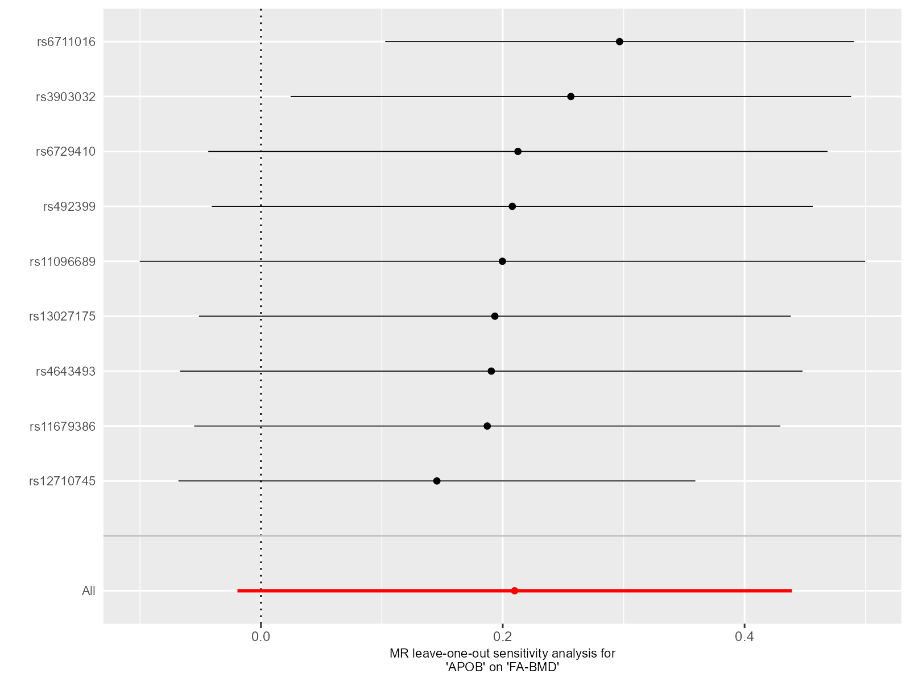Supplementary Figure 1. Leave-one-out plot for sensitivity analysis of single SNP effect on “APOB”-to-“FA-BMD” UVMR results.
Leave-one-out plot using IVW method by sequentially re-evaluating the causal estimate after discarding one SNP at a time, which helps determine whether the overall effect is driven by the specific genetic variant. The black point denotes the causal effect estimate after discarding a certain SNP, and the black line signifies the 95% CI of estimate. The red point symbolizes the causal effect estimate, and the red line indicates the 95% CI of the estimate.
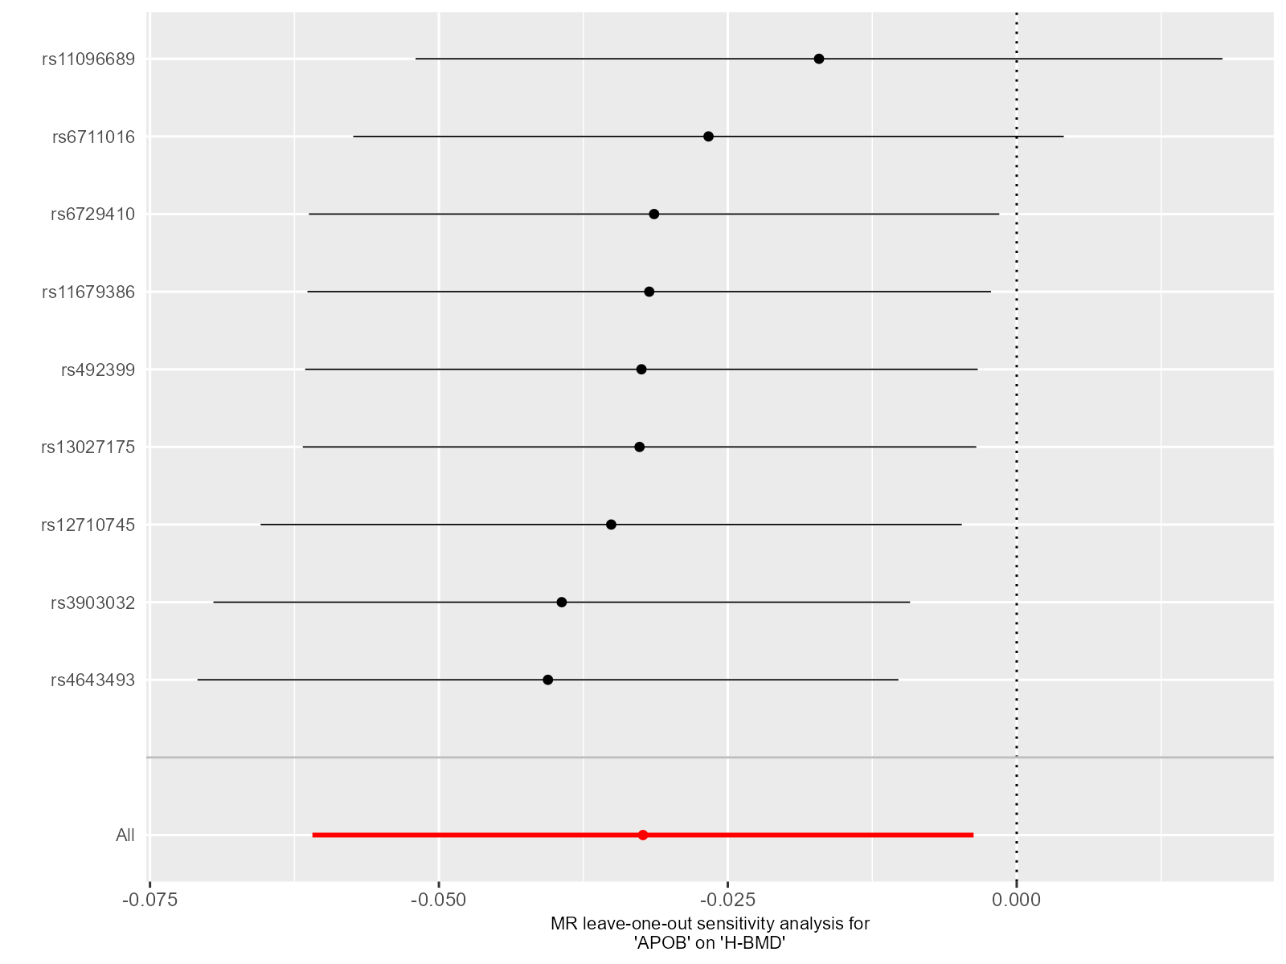Supplementary Figure 2. Leave-one-out plot for sensitivity analysis of single SNP effect on “APOB”-to-“H-BMD” UVMR results.
Leave-one-out plot using IVW method by sequentially re-evaluating the causal estimate after discarding one SNP at a time, which helps determine whether the overall effect is driven by the specific genetic variant. The black point denotes the causal effect estimate after discarding a certain SNP, and the black line signifies the 95% CI of estimate. The red point symbolizes the causal effect estimate, and the red line indicates the 95% CI of the estimate.
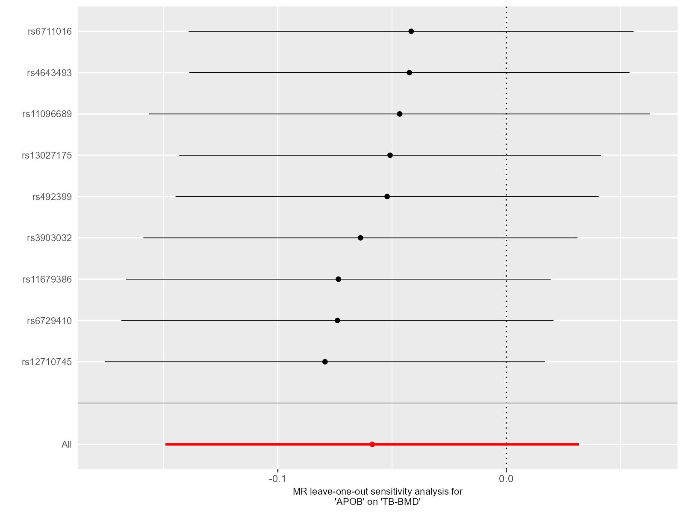Supplementary Figure 3. Leave-one-out plot for sensitivity analysis of single SNP effect on “APOB”-to-“TB-BMD” UVMR results.
Leave-one-out plot using IVW method by sequentially re-evaluating the causal estimate after discarding one SNP at a time, which helps determine whether the overall effect is driven by the specific genetic variant. The black point denotes the causal effect estimate after discarding a certain SNP, and the black line signifies the 95% CI of estimate. The red point symbolizes the causal effect estimate, and the red line indicates the 95% CI of the estimate.
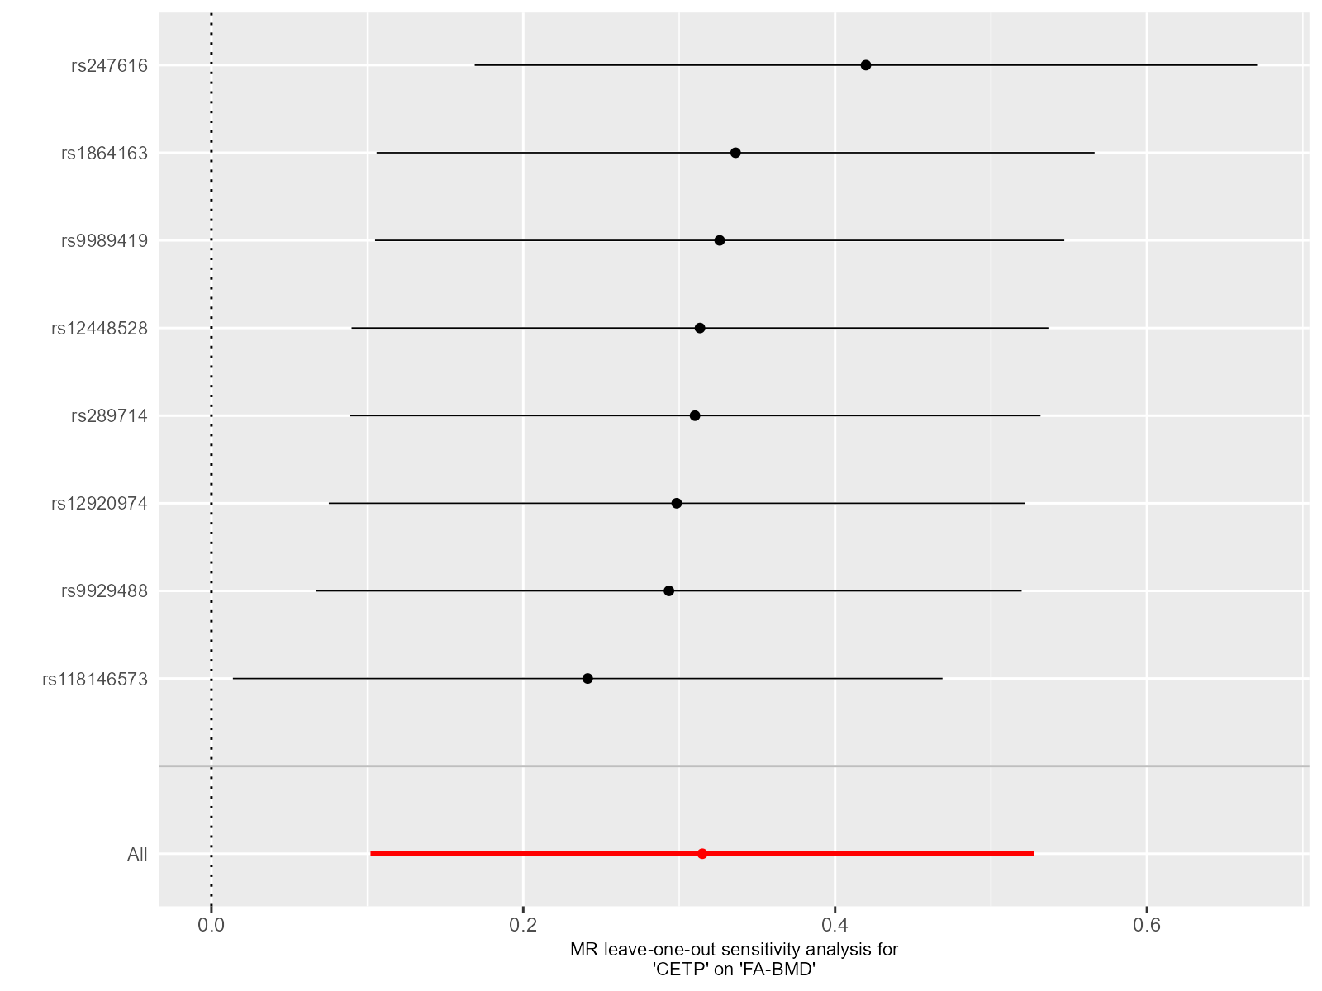Supplementary Figure 4. Leave-one-out plot for sensitivity analysis of single SNP effect on “CETP”-to-“FA-BMD” UVMR results.
Leave-one-out plot using IVW method by sequentially re-evaluating the causal estimate after discarding one SNP at a time, which helps determine whether the overall effect is driven by the specific genetic variant. The black point denotes the causal effect estimate after discarding a certain SNP, and the black line signifies the 95% CI of estimate. The red point symbolizes the causal effect estimate, and the red line indicates the 95% CI of the estimate.
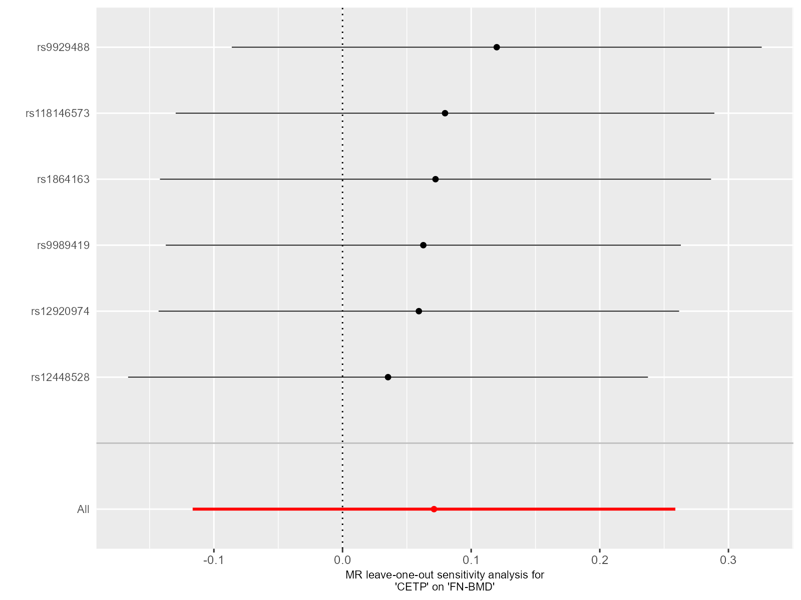Supplementary Figure 5. Leave-one-out plot for sensitivity analysis of single SNP effect on “CETP”-to-“FN-BMD” UVMR results.
Leave-one-out plot using IVW method by sequentially re-evaluating the causal estimate after discarding one SNP at a time, which helps determine whether the overall effect is driven by the specific genetic variant. The black point denotes the causal effect estimate after discarding a certain SNP, and the black line signifies the 95% CI of estimate. The red point symbolizes the causal effect estimate, and the red line indicates the 95% CI of the estimate.
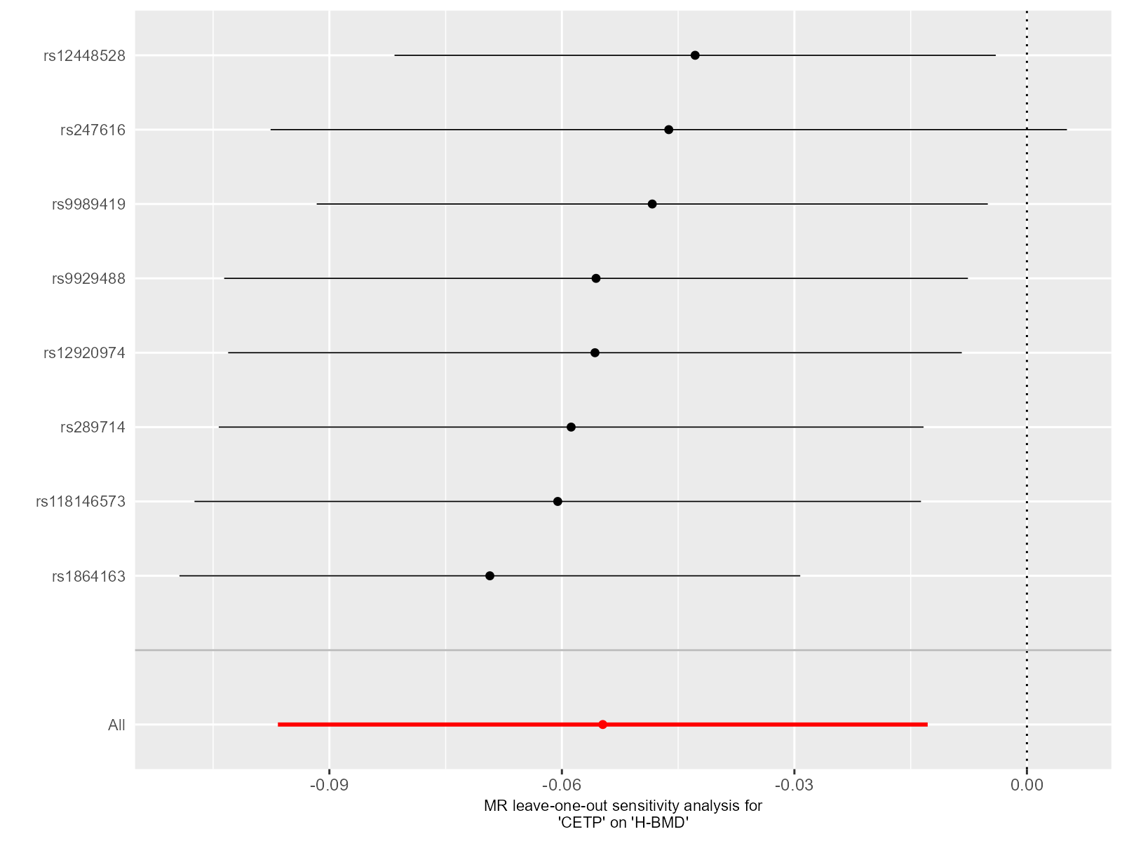Supplementary Figure 6. Leave-one-out plot for sensitivity analysis of single SNP effect on “CETP”-to-“H-BMD” UVMR results.
Leave-one-out plot using IVW method by sequentially re-evaluating the causal estimate after discarding one SNP at a time, which helps determine whether the overall effect is driven by the specific genetic variant. The black point denotes the causal effect estimate after discarding a certain SNP, and the black line signifies the 95% CI of estimate. The red point symbolizes the causal effect estimate, and the red line indicates the 95% CI of the estimate.
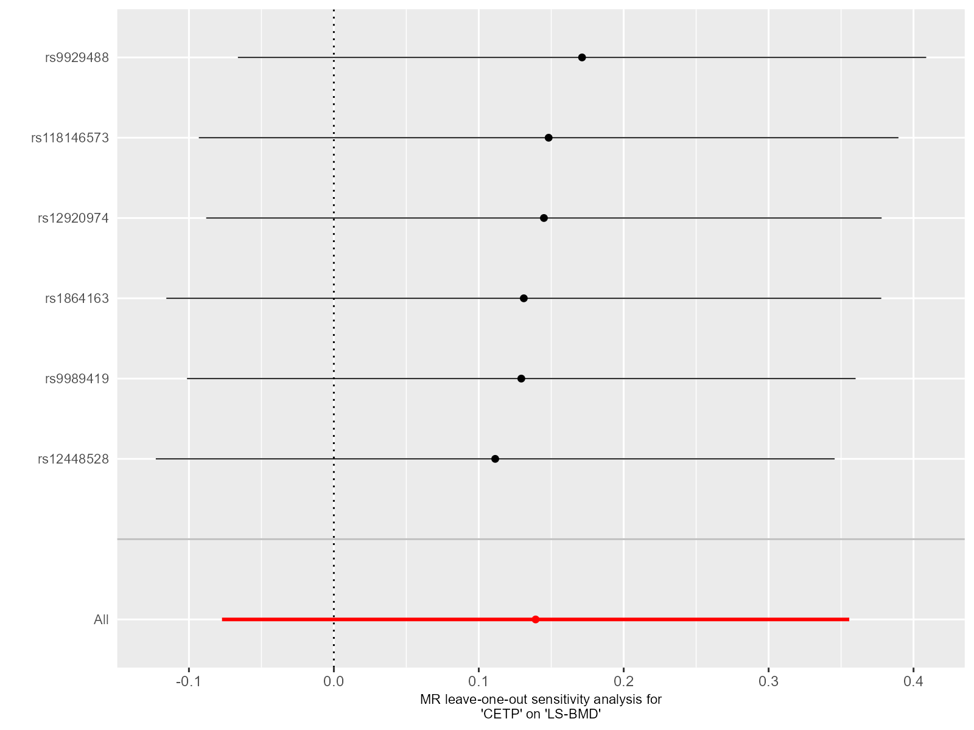Supplementary Figure 7. Leave-one-out plot for sensitivity analysis of single SNP effect on “CETP”-to-“LS-BMD” UVMR results.
Leave-one-out plot using IVW method by sequentially re-evaluating the causal estimate after discarding one SNP at a time, which helps determine whether the overall effect is driven by the specific genetic variant. The black point denotes the causal effect estimate after discarding a certain SNP, and the black line signifies the 95% CI of estimate. The red point symbolizes the causal effect estimate, and the red line indicates the 95% CI of the estimate.
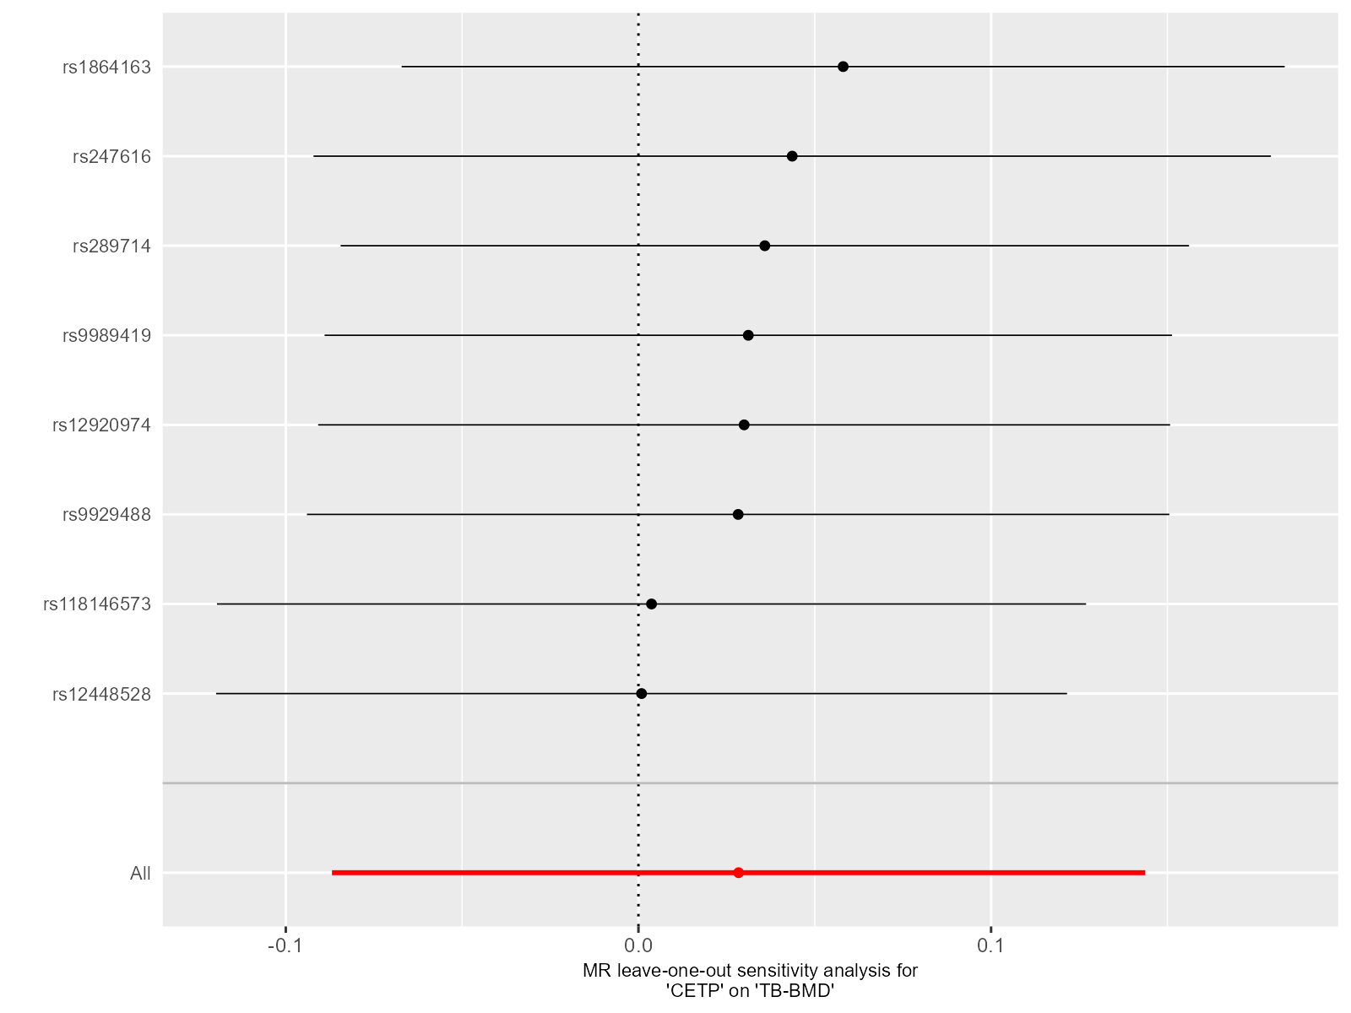Supplementary Figure 8. Leave-one-out plot for sensitivity analysis of single SNP effect on “CETP”-to-“TB-BMD” UVMR results.
Leave-one-out plot using IVW method by sequentially re-evaluating the causal estimate after discarding one SNP at a time, which helps determine whether the overall effect is driven by the specific genetic variant. The black point denotes the causal effect estimate after discarding a certain SNP, and the black line signifies the 95% CI of estimate. The red point symbolizes the causal effect estimate, and the red line indicates the 95% CI of the estimate.
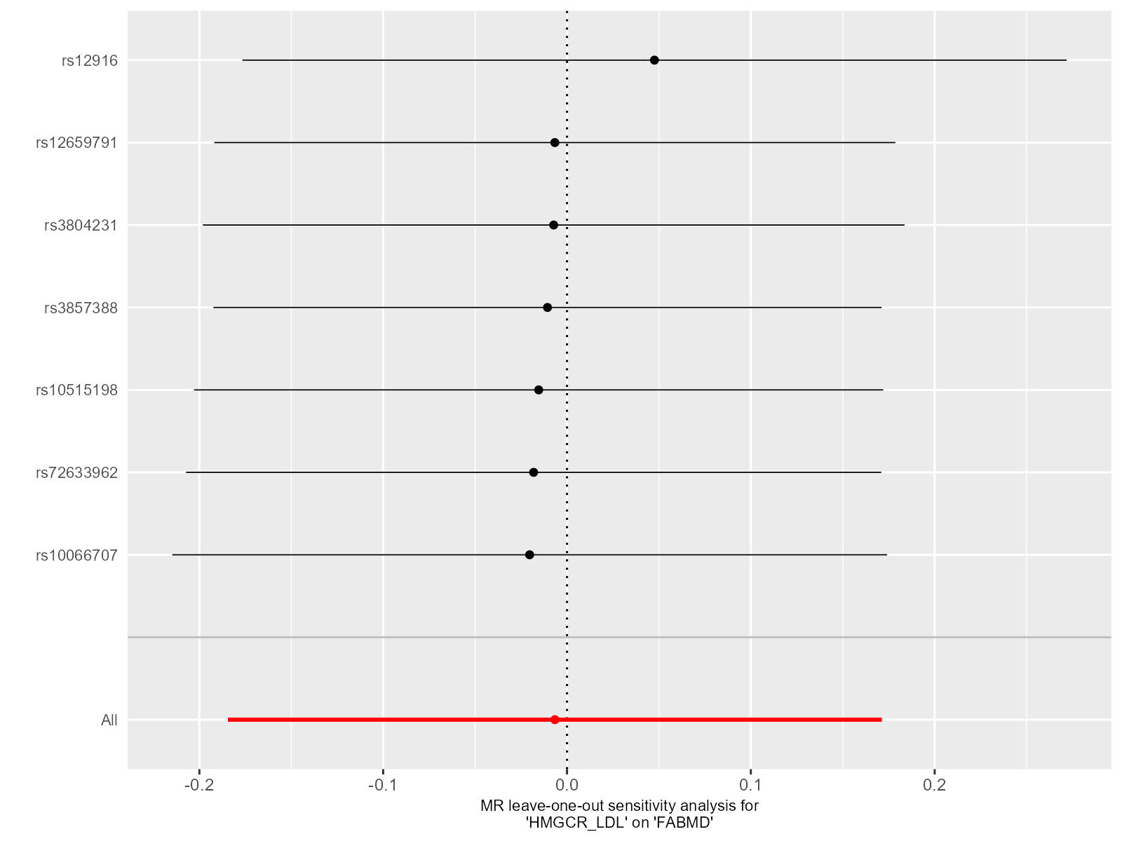Supplementary Figure 9. Leave-one-out plot for sensitivity analysis of single SNP effect on “HMGCR”-to-“FA-BMD” UVMR results.
Leave-one-out plot using IVW method by sequentially re-evaluating the causal estimate after discarding one SNP at a time, which helps determine whether the overall effect is driven by the specific genetic variant. The black point denotes the causal effect estimate after discarding a certain SNP, and the black line signifies the 95% CI of estimate. The red point symbolizes the causal effect estimate, and the red line indicates the 95% CI of the estimate.
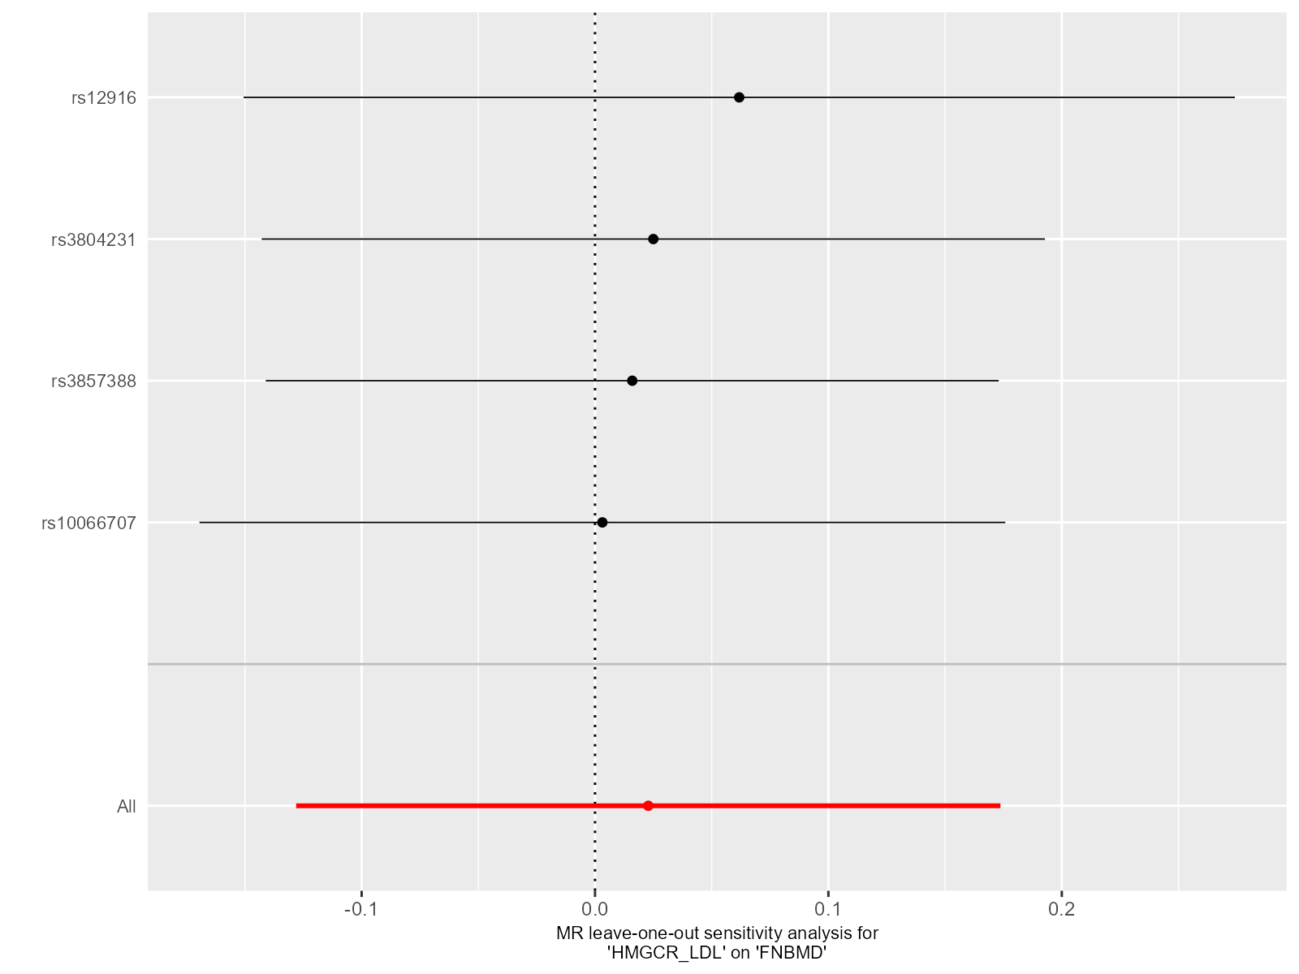Supplementary Figure 10. Leave-one-out plot for sensitivity analysis of single SNP effect on “HMGCR”-to-“FN-BMD” UVMR results.
Leave-one-out plot using IVW method by sequentially re-evaluating the causal estimate after discarding one SNP at a time, which helps determine whether the overall effect is driven by the specific genetic variant. The black point denotes the causal effect estimate after discarding a certain SNP, and the black line signifies the 95% CI of estimate. The red point symbolizes the causal effect estimate, and the red line indicates the 95% CI of the estimate.
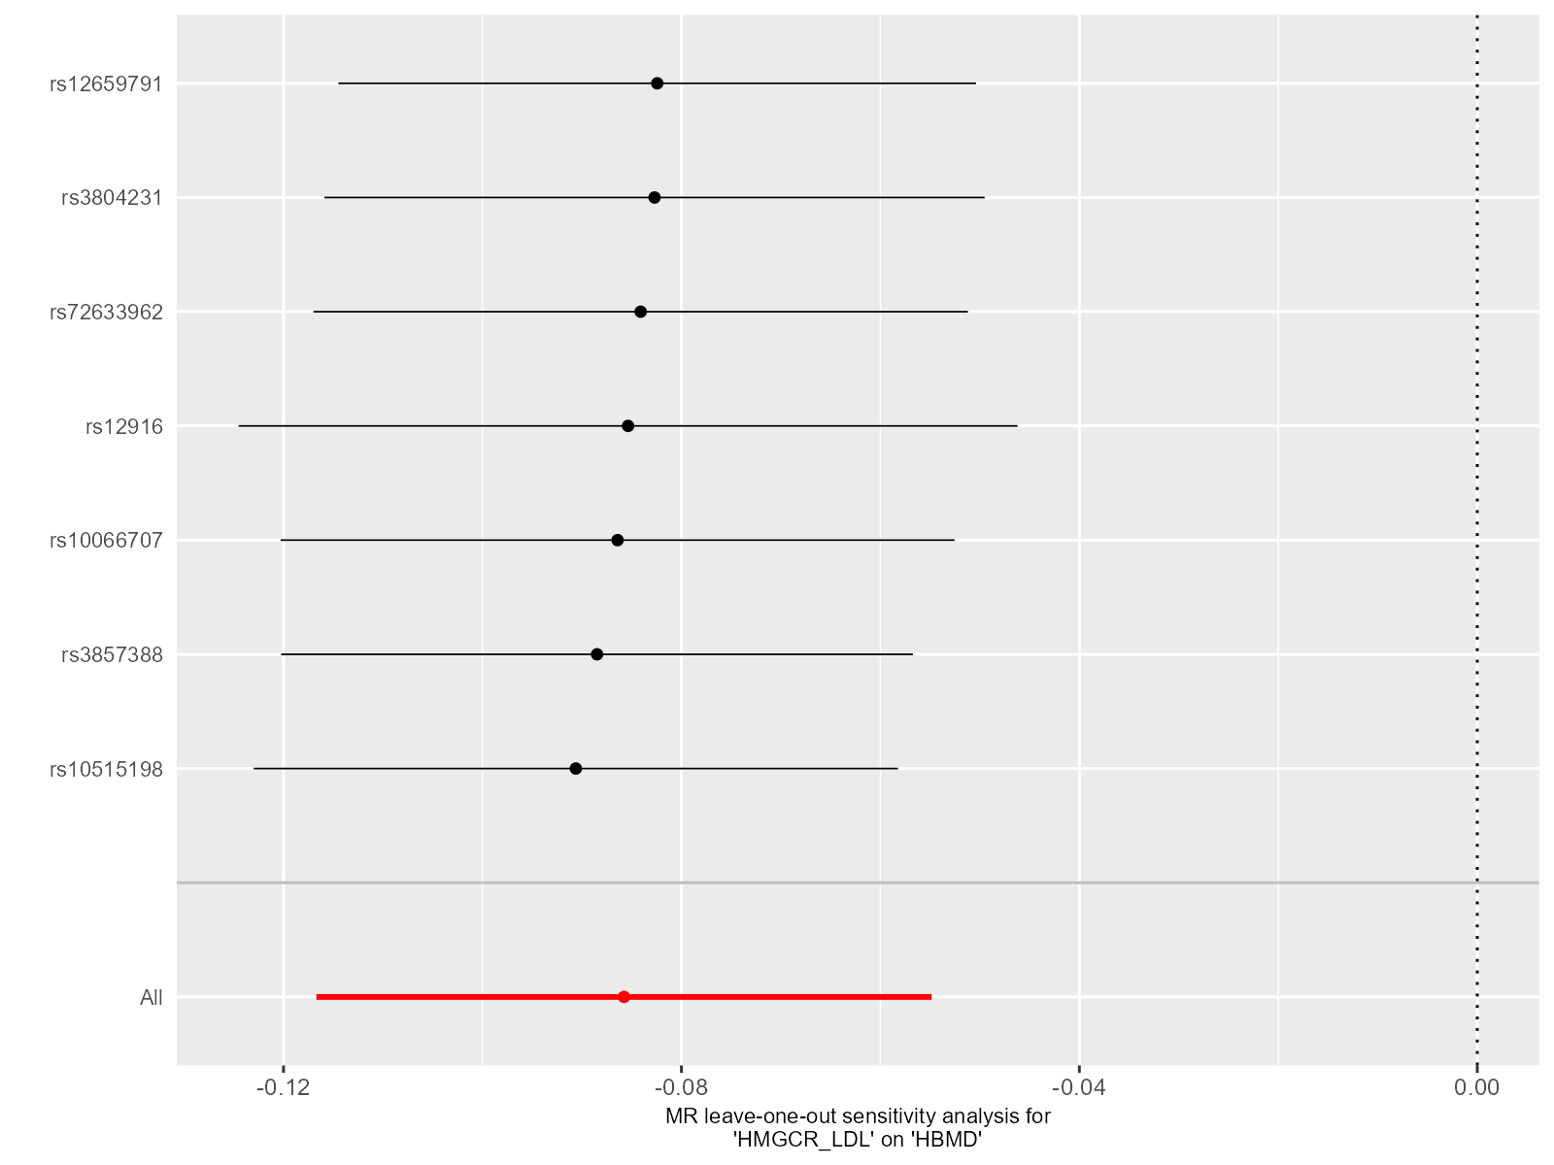Supplementary Figure 11. Leave-one-out plot for sensitivity analysis of single SNP effect on “HMGCR”-to-“H-BMD” UVMR results.
Leave-one-out plot using IVW method by sequentially re-evaluating the causal estimate after discarding one SNP at a time, which helps determine whether the overall effect is driven by the specific genetic variant. The black point denotes the causal effect estimate after discarding a certain SNP, and the black line signifies the 95% CI of estimate. The red point symbolizes the causal effect estimate, and the red line indicates the 95% CI of the estimate.
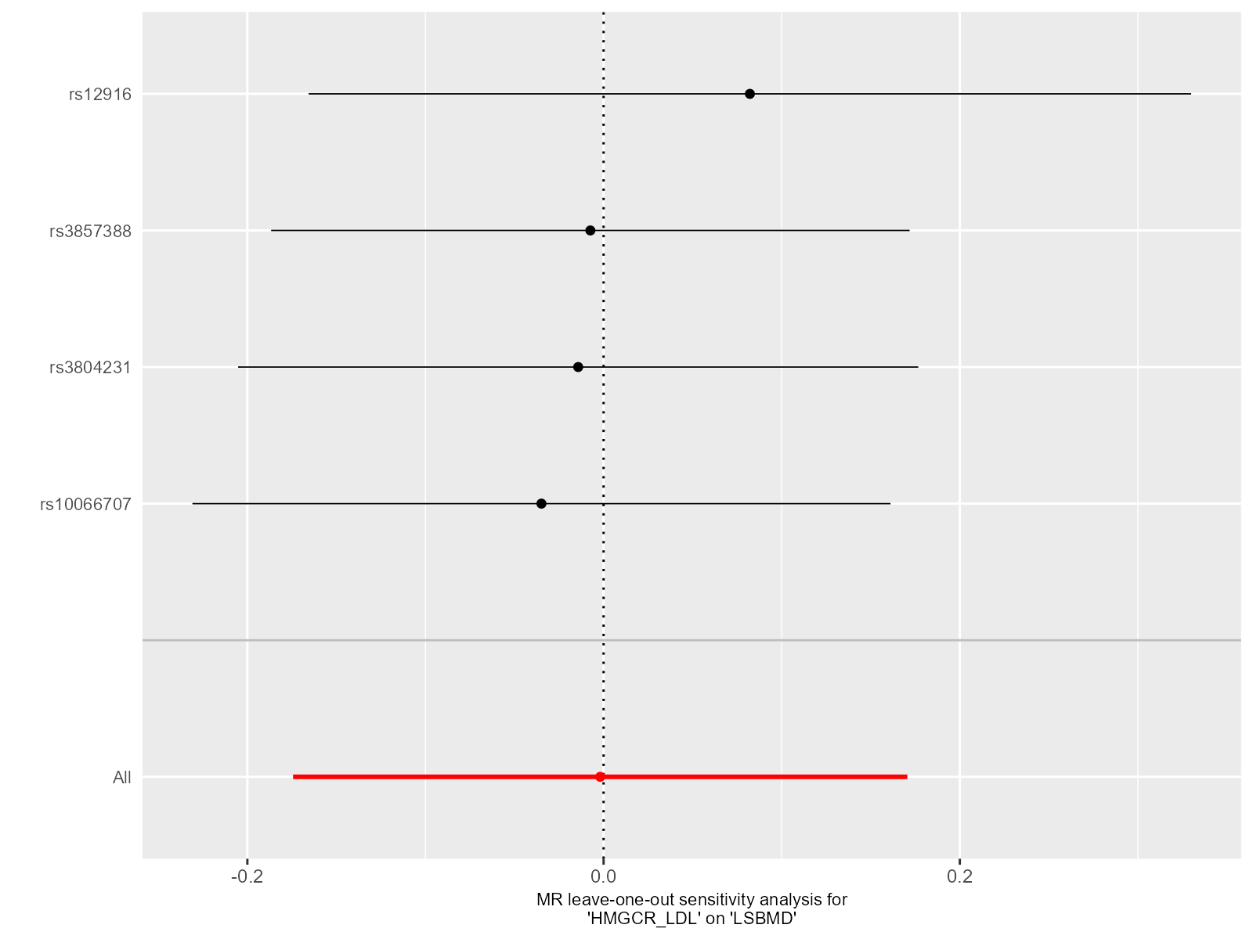Supplementary Figure 12. Leave-one-out plot for sensitivity analysis of single SNP effect on “HMGCR”-to-“LS-BMD” UVMR results.
Leave-one-out plot using IVW method by sequentially re-evaluating the causal estimate after discarding one SNP at a time, which helps determine whether the overall effect is driven by the specific genetic variant. The black point denotes the causal effect estimate after discarding a certain SNP, and the black line signifies the 95% CI of estimate. The red point symbolizes the causal effect estimate, and the red line indicates the 95% CI of the estimate.
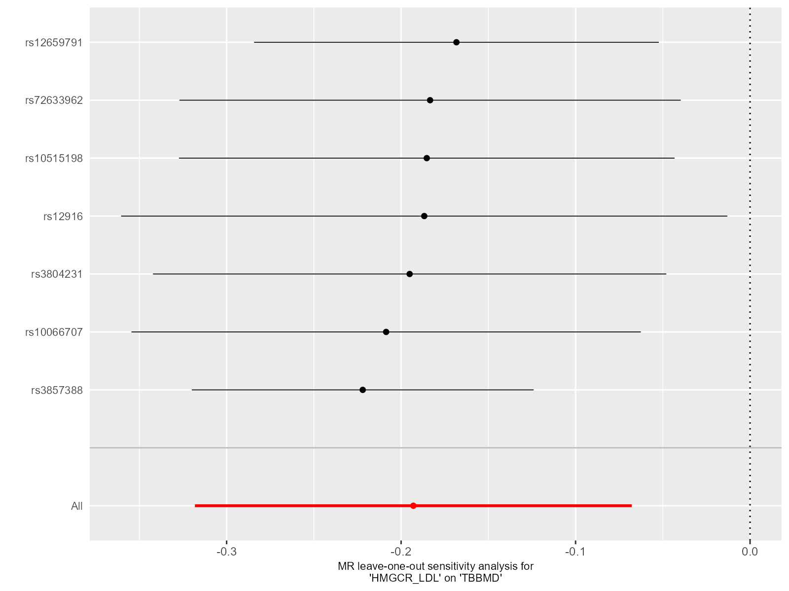Supplementary Figure 13. Leave-one-out plot for sensitivity analysis of single SNP effect on “HMGCR”-to-“TB-BMD” UVMR results.
Leave-one-out plot using IVW method by sequentially re-evaluating the causal estimate after discarding one SNP at a time, which helps determine whether the overall effect is driven by the specific genetic variant. The black point denotes the causal effect estimate after discarding a certain SNP, and the black line signifies the 95% CI of estimate. The red point symbolizes the causal effect estimate, and the red line indicates the 95% CI of the estimate.
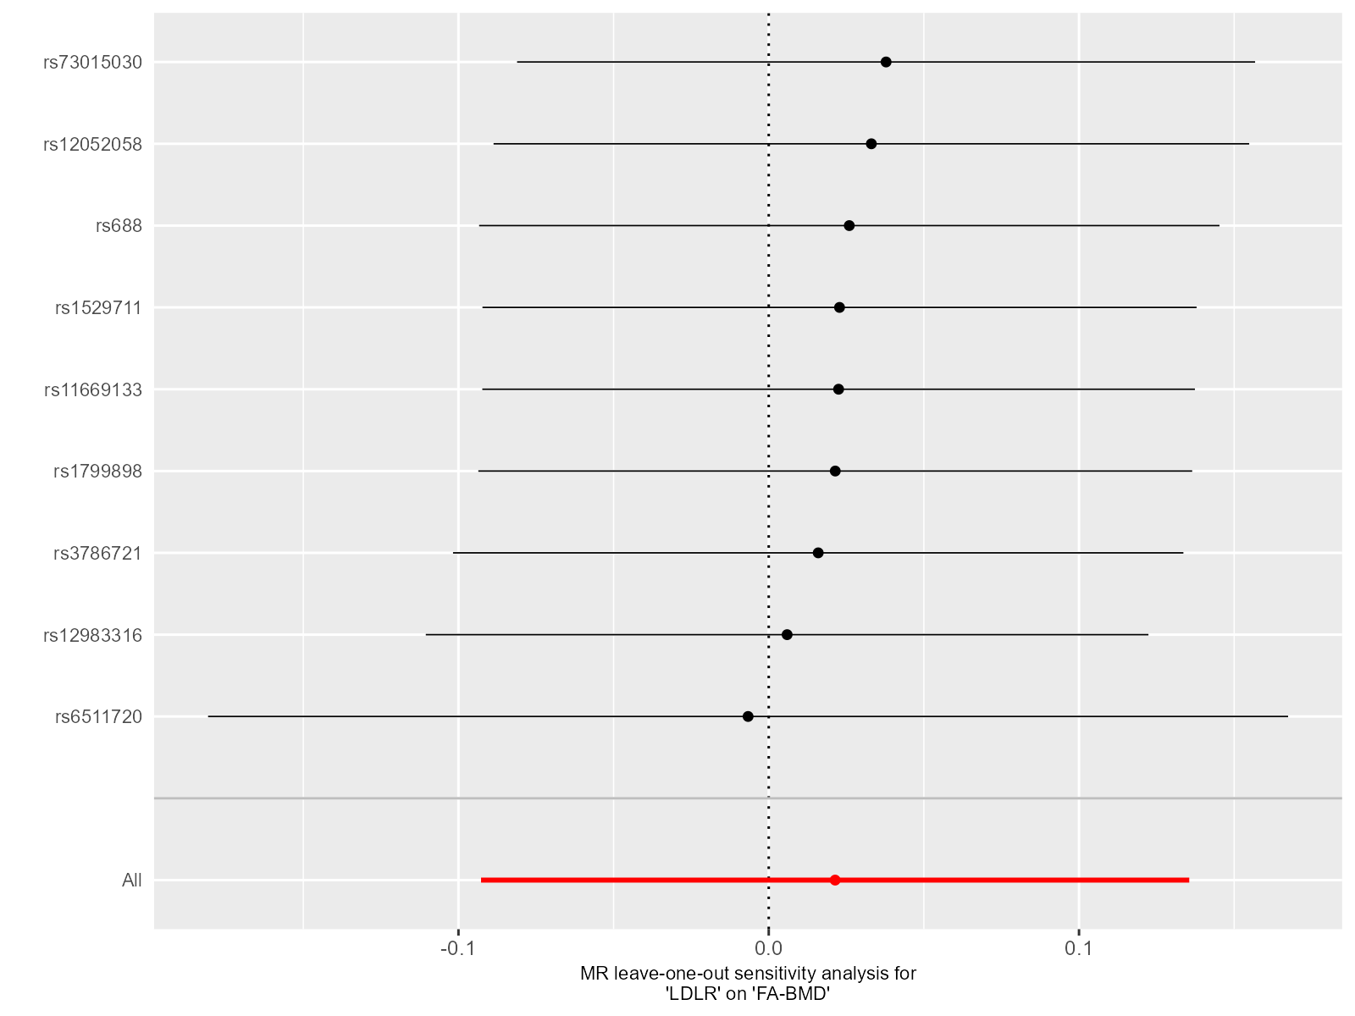Supplementary Figure 14. Leave-one-out plot for sensitivity analysis of single SNP effect on “LDLR”-to-“FA-BMD” UVMR results.
Leave-one-out plot using IVW method by sequentially re-evaluating the causal estimate after discarding one SNP at a time, which helps determine whether the overall effect is driven by the specific genetic variant. The black point denotes the causal effect estimate after discarding a certain SNP, and the black line signifies the 95% CI of estimate. The red point symbolizes the causal effect estimate, and the red line indicates the 95% CI of the estimate.
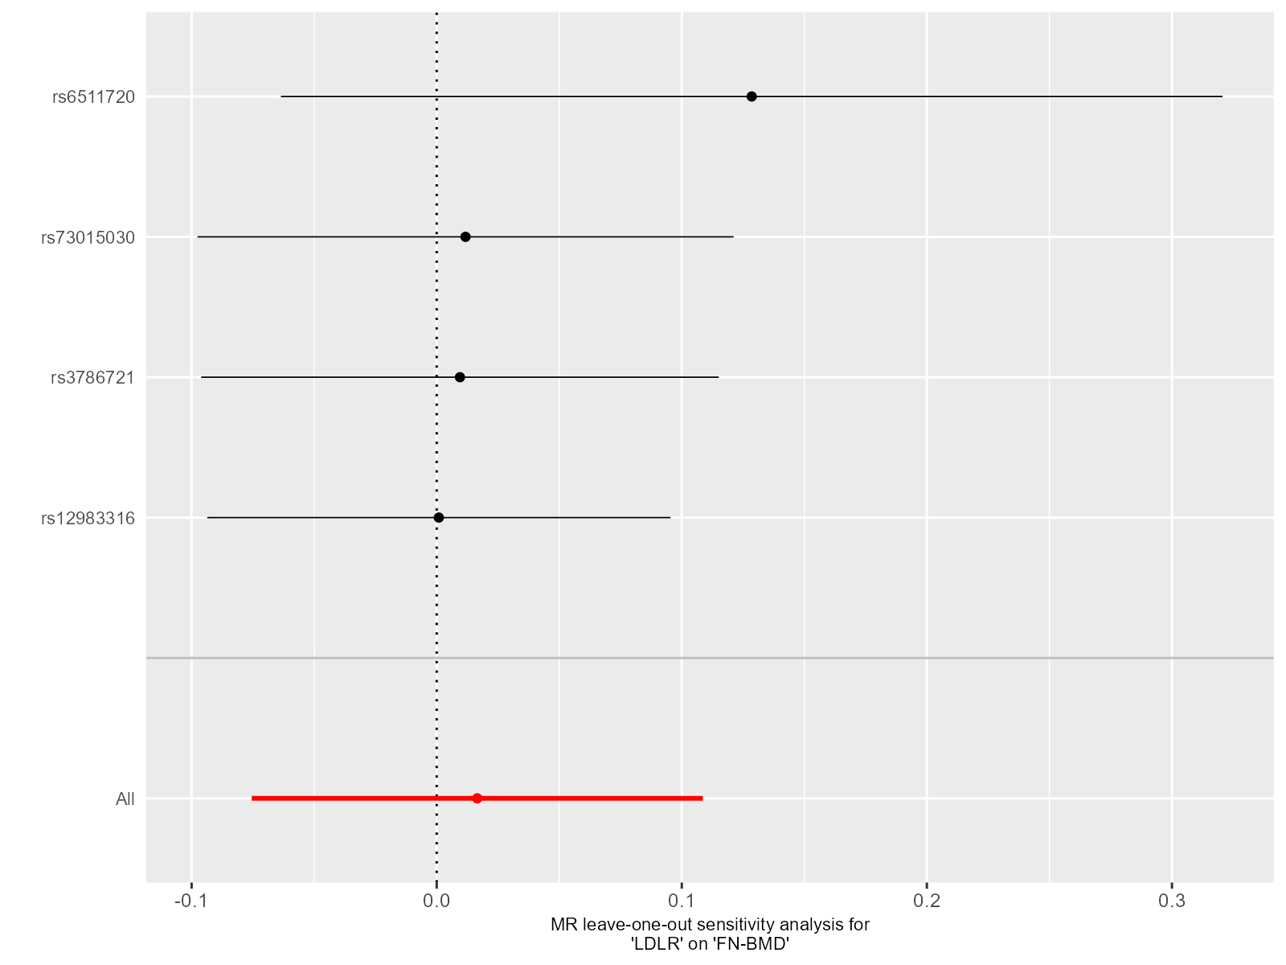Supplementary Figure 15. Leave-one-out plot for sensitivity analysis of single SNP effect on “LDLR”-to-“FN-BMD” UVMR results.
Leave-one-out plot using IVW method by sequentially re-evaluating the causal estimate after discarding one SNP at a time, which helps determine whether the overall effect is driven by the specific genetic variant. The black point denotes the causal effect estimate after discarding a certain SNP, and the black line signifies the 95% CI of estimate. The red point symbolizes the causal effect estimate, and the red line indicates the 95% CI of the estimate.
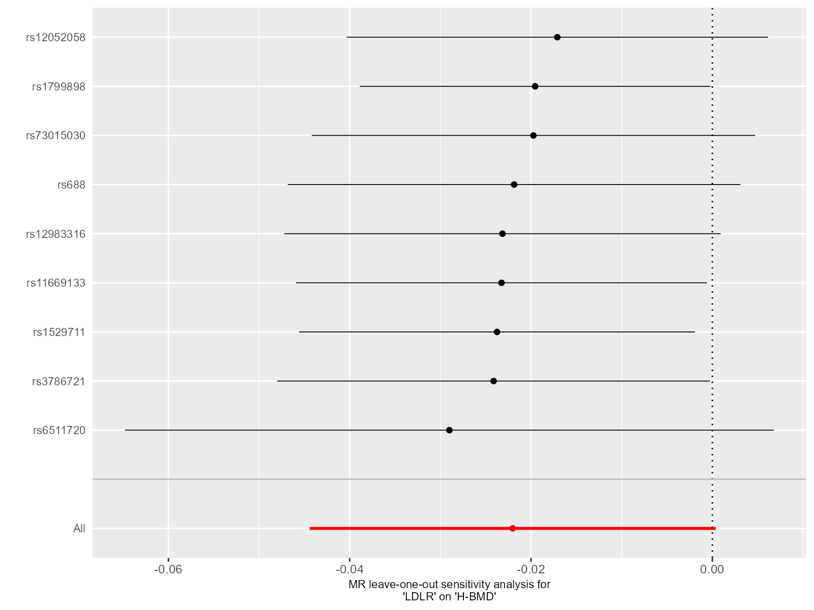Supplementary Figure 16. Leave-one-out plot for sensitivity analysis of single SNP effect on “LDLR”-to-“H-BMD” UVMR results.
Leave-one-out plot using IVW method by sequentially re-evaluating the causal estimate after discarding one SNP at a time, which helps determine whether the overall effect is driven by the specific genetic variant. The black point denotes the causal effect estimate after discarding a certain SNP, and the black line signifies the 95% CI of estimate. The red point symbolizes the causal effect estimate, and the red line indicates the 95% CI of the estimate.
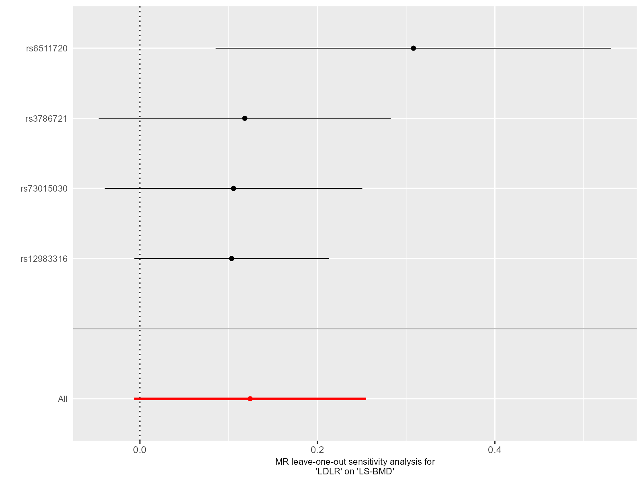Supplementary Figure 17. Leave-one-out plot for sensitivity analysis of single SNP effect on “LDLR”-to-“LS-BMD” UVMR results.
Leave-one-out plot using IVW method by sequentially re-evaluating the causal estimate after discarding one SNP at a time, which helps determine whether the overall effect is driven by the specific genetic variant. The black point denotes the causal effect estimate after discarding a certain SNP, and the black line signifies the 95% CI of estimate. The red point symbolizes the causal effect estimate, and the red line indicates the 95% CI of the estimate.
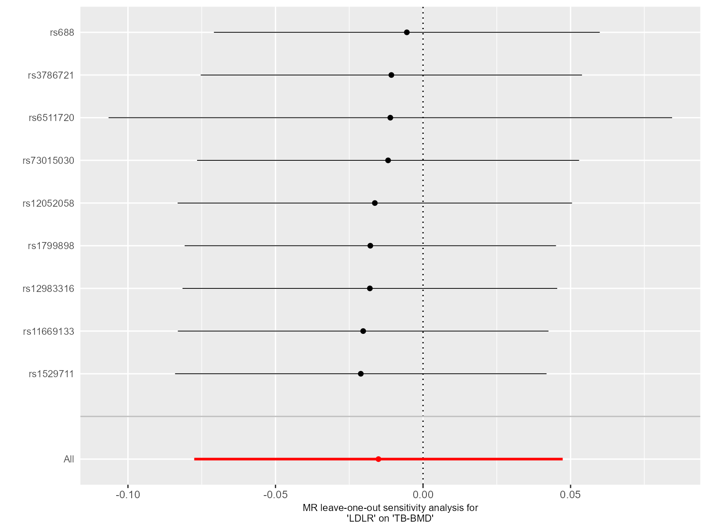Supplementary Figure 18. Leave-one-out plot for sensitivity analysis of single SNP effect on “LDLR”-to-“TB-BMD” UVMR results.
Leave-one-out plot using IVW method by sequentially re-evaluating the causal estimate after discarding one SNP at a time, which helps determine whether the overall effect is driven by the specific genetic variant. The black point denotes the causal effect estimate after discarding a certain SNP, and the black line signifies the 95% CI of estimate. The red point symbolizes the causal effect estimate, and the red line indicates the 95% CI of the estimate.
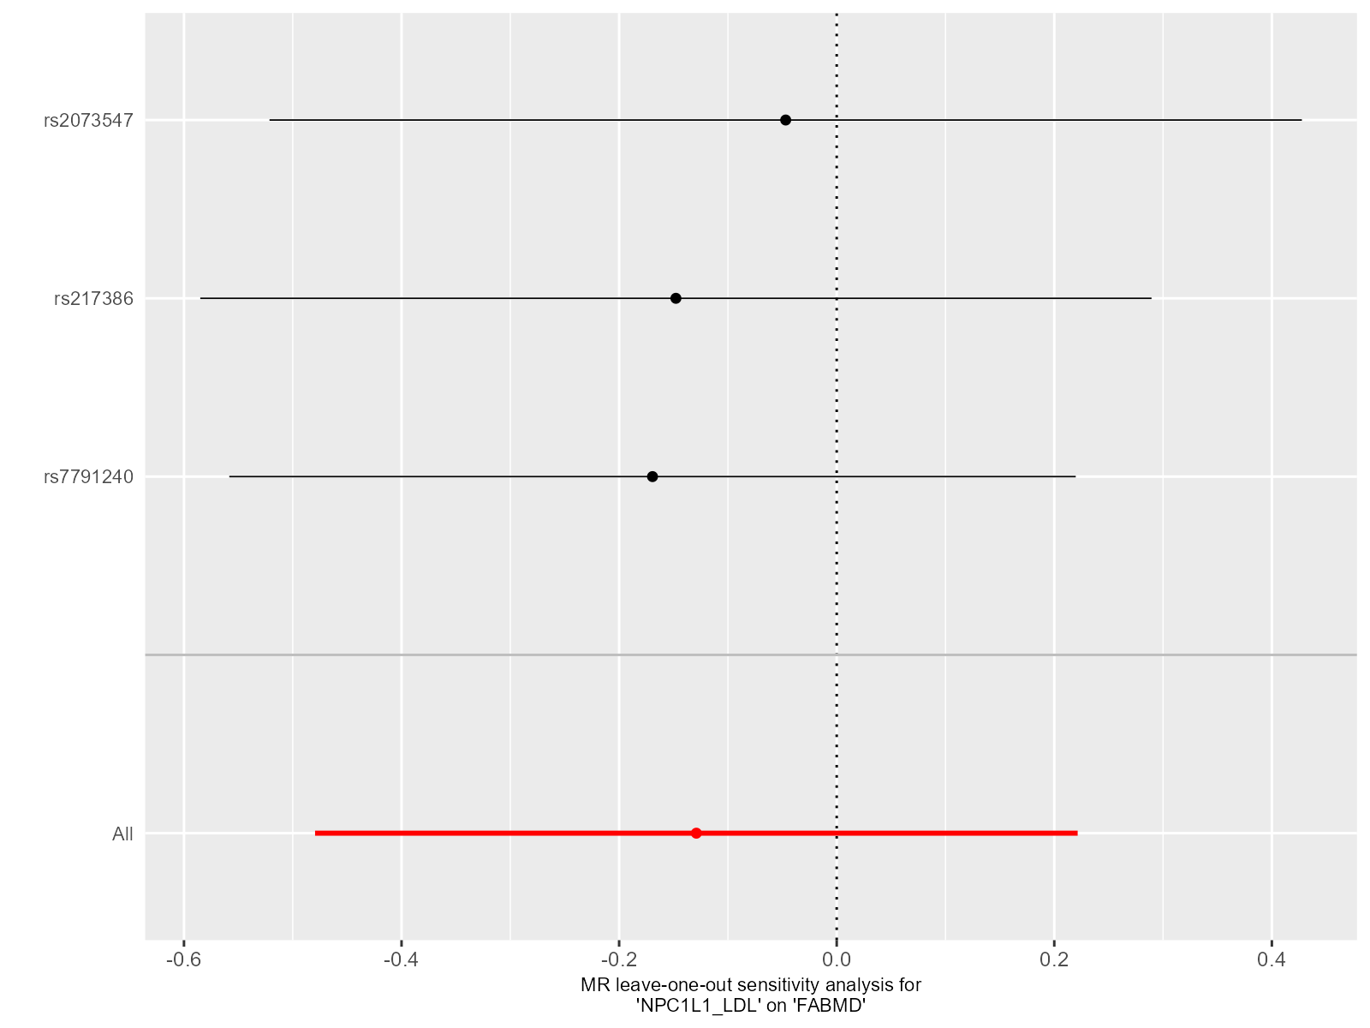Supplementary Figure 19. Leave-one-out plot for sensitivity analysis of single SNP effect on “NPC1L1”-to-“FA-BMD” UVMR results.
Leave-one-out plot using IVW method by sequentially re-evaluating the causal estimate after discarding one SNP at a time, which helps determine whether the overall effect is driven by the specific genetic variant. The black point denotes the causal effect estimate after discarding a certain SNP, and the black line signifies the 95% CI of estimate. The red point symbolizes the causal effect estimate, and the red line indicates the 95% CI of the estimate.
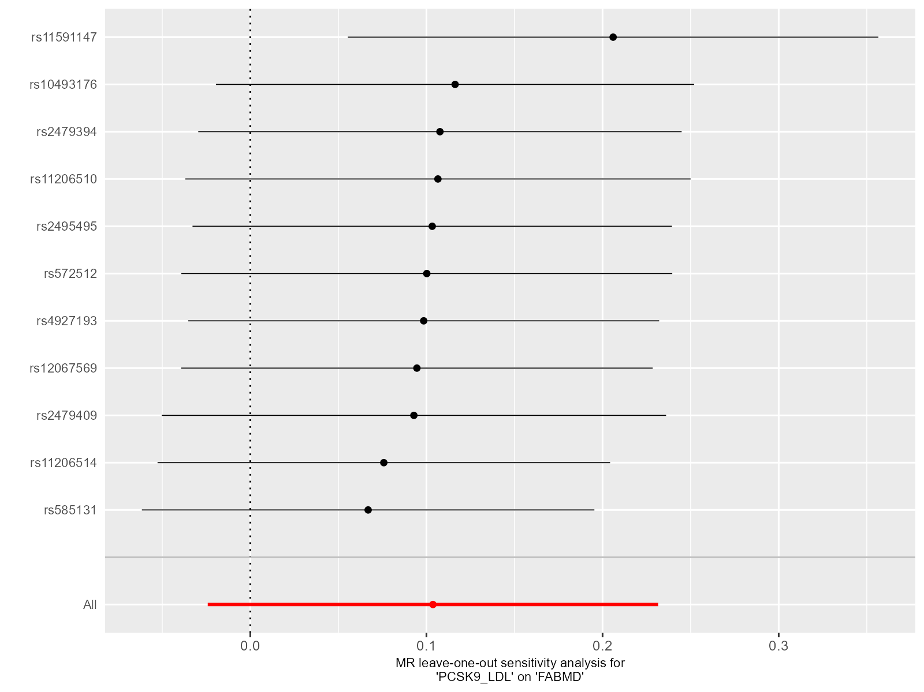Supplementary Figure 20. Leave-one-out plot for sensitivity analysis of single SNP effect on “PCSK9”-to-“FA-BMD” UVMR results.
Leave-one-out plot using IVW method by sequentially re-evaluating the causal estimate after discarding one SNP at a time, which helps determine whether the overall effect is driven by the specific genetic variant. The black point denotes the causal effect estimate after discarding a certain SNP, and the black line signifies the 95% CI of estimate. The red point symbolizes the causal effect estimate, and the red line indicates the 95% CI of the estimate.
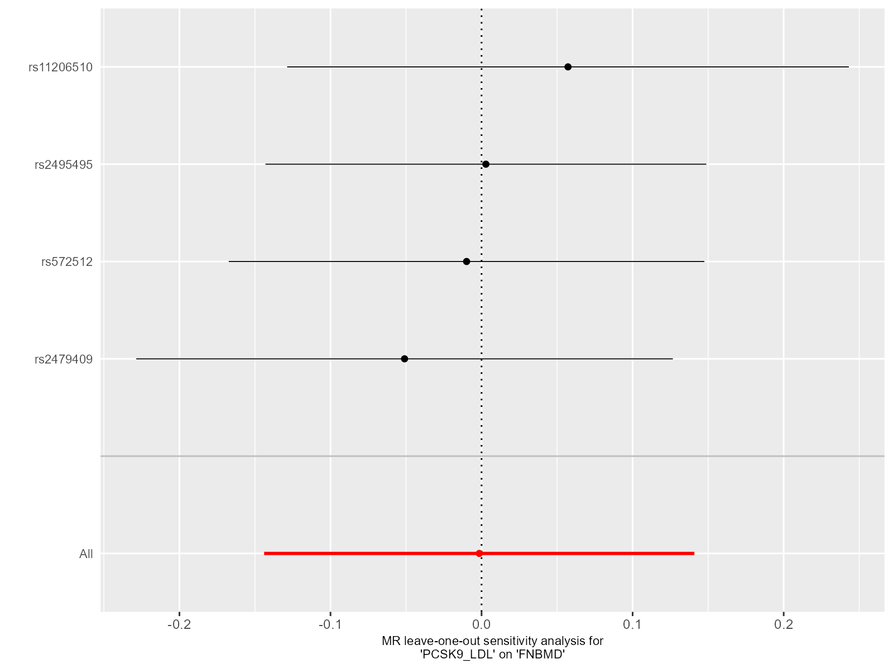Supplementary Figure 21. Leave-one-out plot for sensitivity analysis of single SNP effect on “PCSK9”-to-“FN-BMD” UVMR results.
Leave-one-out plot using IVW method by sequentially re-evaluating the causal estimate after discarding one SNP at a time, which helps determine whether the overall effect is driven by the specific genetic variant. The black point denotes the causal effect estimate after discarding a certain SNP, and the black line signifies the 95% CI of estimate. The red point symbolizes the causal effect estimate, and the red line indicates the 95% CI of the estimate.
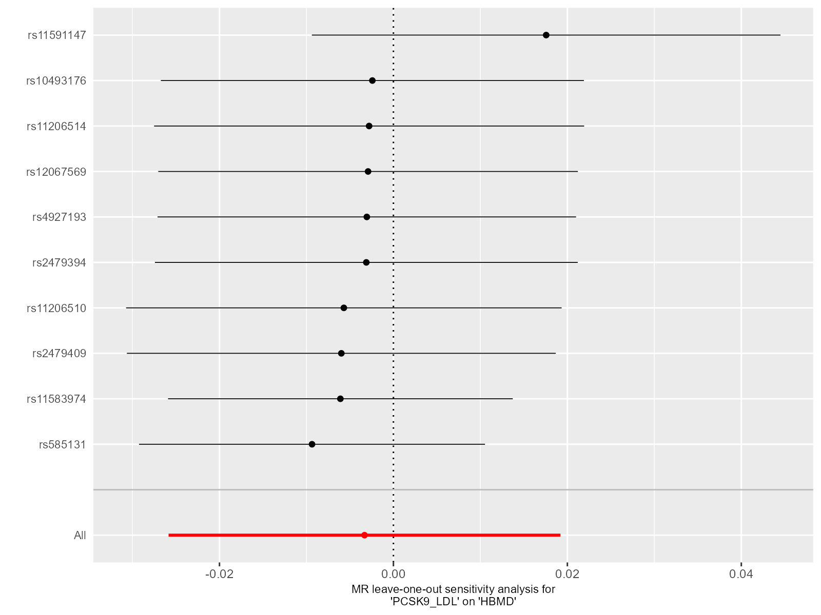Supplementary Figure 22. Leave-one-out plot for sensitivity analysis of single SNP effect on “PCSK9”-to-“H-BMD” UVMR results.
Leave-one-out plot using IVW method by sequentially re-evaluating the causal estimate after discarding one SNP at a time, which helps determine whether the overall effect is driven by the specific genetic variant. The black point denotes the causal effect estimate after discarding a certain SNP, and the black line signifies the 95% CI of estimate. The red point symbolizes the causal effect estimate, and the red line indicates the 95% CI of the estimate.
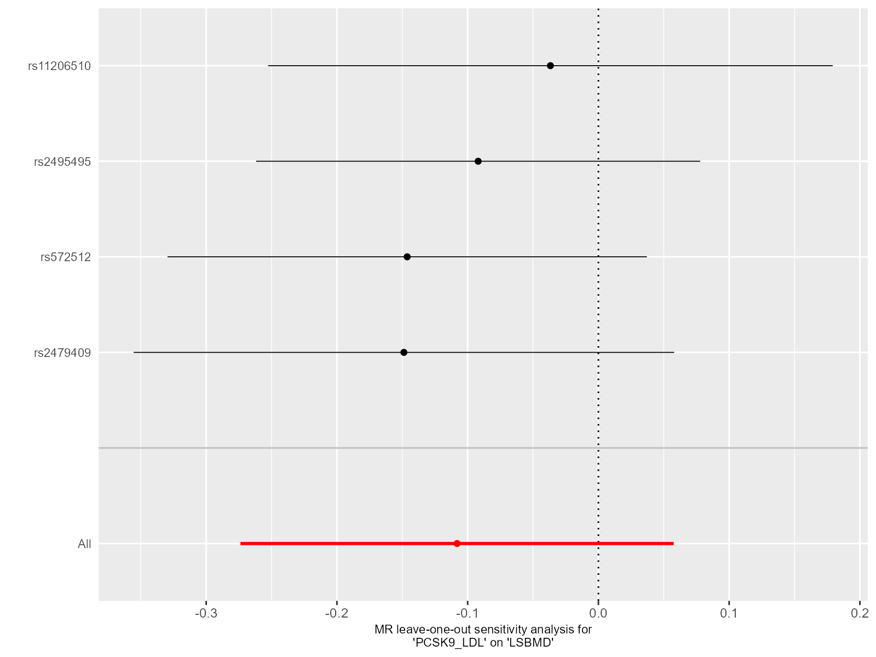Supplementary Figure 23. Leave-one-out plot for sensitivity analysis of single SNP effect on “PCSK9”-to-“LS-BMD” UVMR results.
Leave-one-out plot using IVW method by sequentially re-evaluating the causal estimate after discarding one SNP at a time, which helps determine whether the overall effect is driven by the specific genetic variant. The black point denotes the causal effect estimate after discarding a certain SNP, and the black line signifies the 95% CI of estimate. The red point symbolizes the causal effect estimate, and the red line indicates the 95% CI of the estimate.
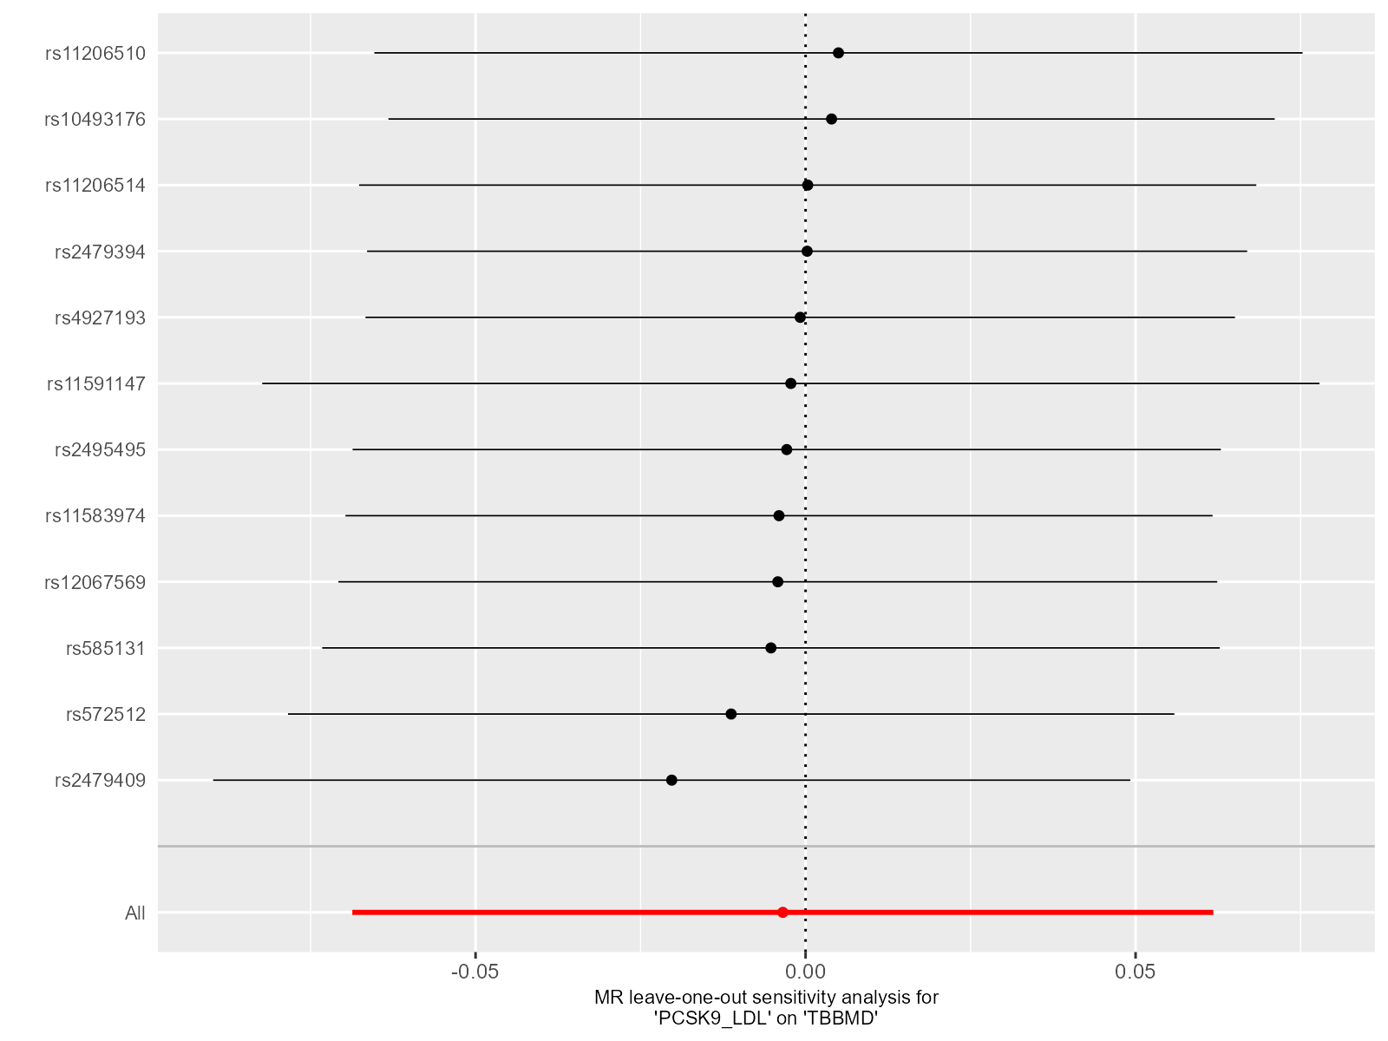Supplementary Figure 24. Leave-one-out plot for sensitivity analysis of single SNP effect on “PCSK9”-to-“TB-BMD” UVMR results.
Leave-one-out plot using IVW method by sequentially re-evaluating the causal estimate after discarding one SNP at a time, which helps determine whether the overall effect is driven by the specific genetic variant. The black point denotes the causal effect estimate after discarding a certain SNP, and the black line signifies the 95% CI of estimate. The red point symbolizes the causal effect estimate, and the red line indicates the 95% CI of the estimate.

