Table 6 Compounds with possible direct inhibitory effect on the ATP-dependent bacterial topoisomerases, identified in the mretabolic extract of Micromonospora sp. 65SH by LC-QTOF-MS-MS technique
No. | RT (min.) | Intensity | Mass (Da) | Adduct | m/z value (mass) | Molecular formula | InChI Key | PubChem CID | CAS Registry Number | HMDB ID | Chemspider ID | Identified compound | Chemical structure
2 | 0.51 | 85355 | 342.297 | [M+Na]⁺ | 365.1062 | C₁₂H₂₂O₁₁ | DLRVVLDZNNYCBX-ZZFZYMBESA-N | 440658 | 13299-20-2 | HMDB0000048 | 10974 | Melibiose | 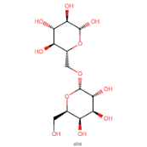
3 | 0.54 | 228 | 790.52311 | [M+H]⁺ | 791.53039 | C₄₅H₇₄O₁₁ | MNULEGDCPYONBU-WMBHJXFZSA-N | 5281899 | 579-13-5 | NA | 10308285 | Oligomycin A | 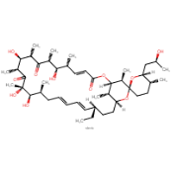
15 | 2.74 | 450 | 277.11749 | [M+H]⁺ | 278.12477 | C₁₂H₁₅N₅O₃ | WYROLENTHWJFLR-ACLDMZEESA-N | 135398670 | 72496-59-4 | HMDB0001495 | 102837 | Queuine | 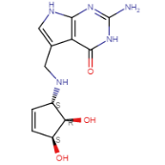
38 | 12.43 | 3699 | 267.09675 | [M+H]⁺ | 268.10403 | C₁₀H₁₃N₅O₄ | YKBGVTZYEHREMT-KVQBGUIXSA-N | 135398592 | 961-07-9 | HMDB0000085 | 163230 | 2-deoxyguanosine | 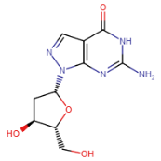
41 | 14.44 | 9296 | 222.24 | [M+H]⁺ | 223.0961 | C₁₂H₁₄O₄ | FLKPEMZONWLCSK-UHFFFAOYSA-N | 6781 | 84-66-2 | HMDB0094660 | 13837303 | Diethyl phthalate | 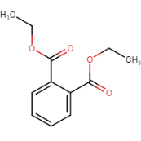
43 | 14.53 | 860 | 280.13107 | [M+H]⁺ | 280.13107 | C₁₅H₂₀O₅ | JESMSCGUTIEROV-RTWAVKEYSA-N | 10945834 | 57710-57-3 | NA | 9121060 | Heptelidic acid | 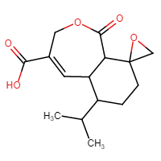

Table 7 Ligand-receptor interactions of the tested compounds towards the two proteins of antimicrobial activity; DNA Gyrase and Topoisomerase VI
Comp. | DNA Gyrase (1KZN) |  |  | Topoisomerase VI (1S14)
Co- crystallized ligand | 2 H-Bonds(HB) with Arg 136 and Asn 46 |  |  | 3 H-Bonds(HB) with Asn 1042, Arg 1132, and Asp 1068
Melibiose | -15.01  Kcal/mol | 3 HB with Asn 46 | -- | -13.24  Kcal/mol | 2 HB with Asn 1042 and Asp 1068 | --
Melibiose | 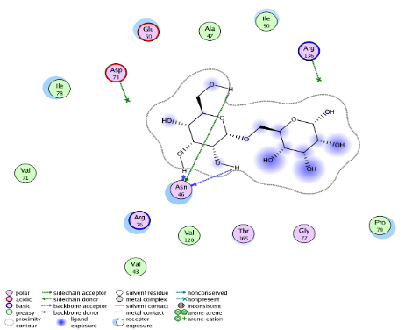 |  |  | 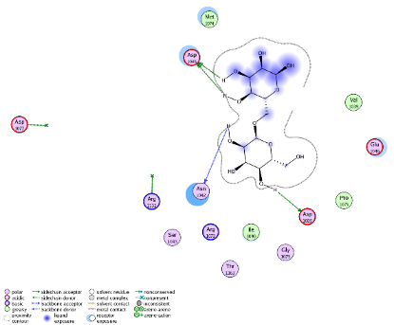
Oligomycin A | -15.23  Kcal/mol | 2HB with Arg 136 | -- | -10.6  Kcal/mol | 1 HB with Asn 1042 | --
Oligomycin A | 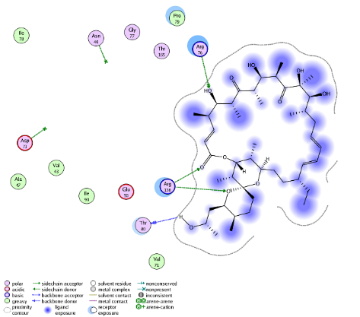 |  |  | 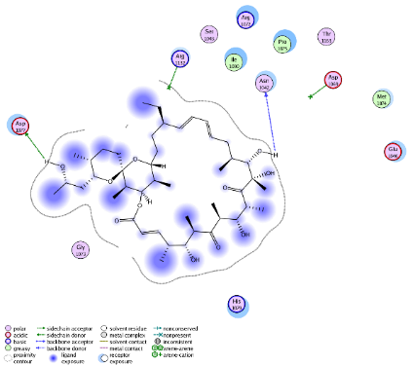
Queuine | -14.23  Kcal/mol | 1 HB with Asn 46 | One arene-cation with Arg 76 | -11.23  Kcal/mol | 1 HB with Asp 1069 | --
Queuine | 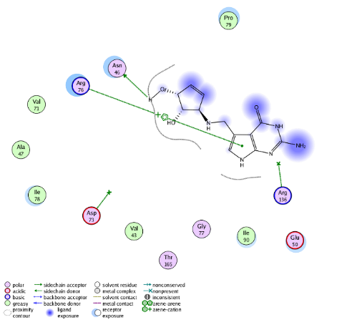 |  |  | 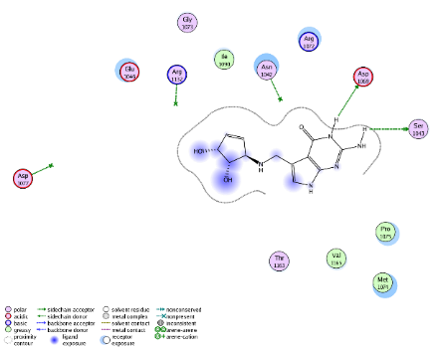
Heptelidic acid | -16.32  Kcal/mol | 1 HB with Asn 46 | -- | -10.67  Kcal/mol | 2 HB with Arg 1132 | --
Heptelidic acid | 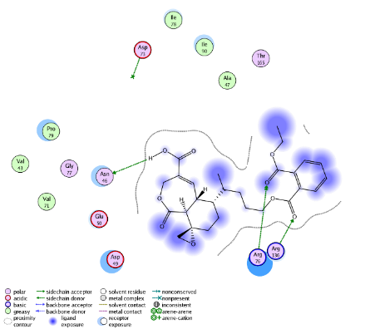 |  |  | 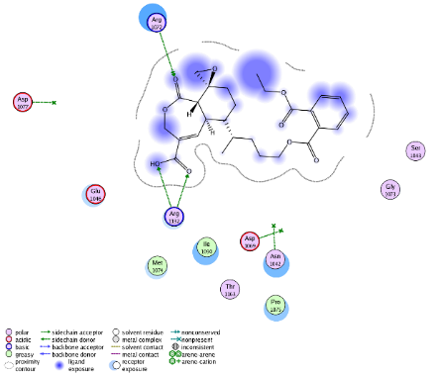
Diethyl phthalate | -17.56  Kcal/mol | -- | One arene-cation with Arg 76 | -14.6  Kcal/mol | - | --
Diethyl phthalate | 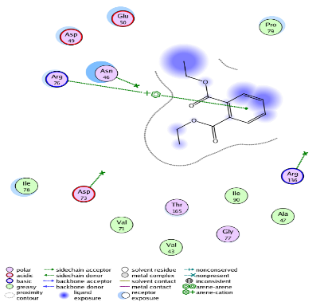 |  |  | ---
2'-Deoxyguanosine | -16.4  Kcal/mol | 3 HB with Asn 46 | -- | -12.8  Kcal/mol | 2 HB with Asp 1069 | --
2'-Deoxyguanosine | 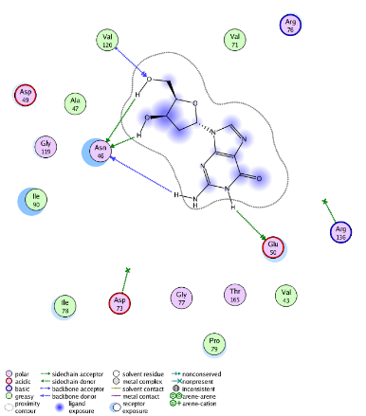 |  |  | 