Supplementary material.
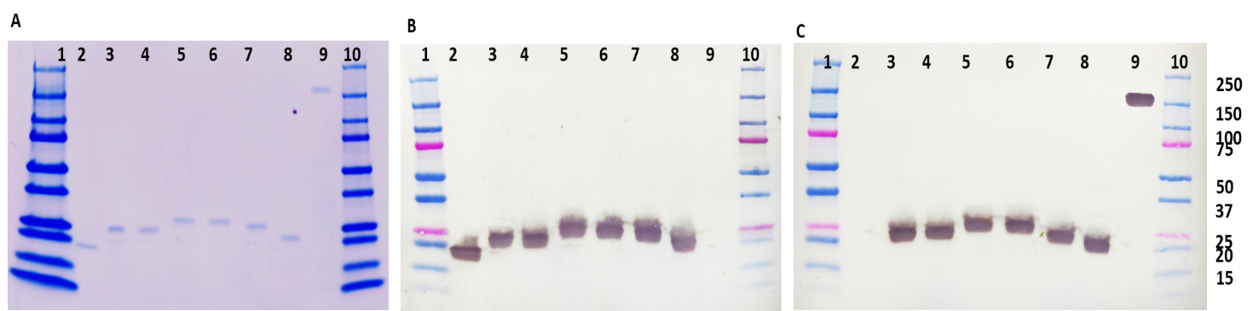
Figure S1: The images show analysis of the TMV-epitope constructs using SDS PAGE (A); western blots were carried out using either anti-TMV (B); or anti-SARS-CoV2 S (C) polyclonal antibody. The blots were loaded as follows: Lane 1: Prestained molecular weight marker (BioRad). Lane 2: TMV-A, Lane 3 TMV-D, Lane 4: TMV-F, Lane 5: TMV-H, Lane 6: TMV-H, Lane 7: TMV-L, Lane 8: TMV-S21P2, Lane 9: SARS-CoV2 spike protein, Lane 10:. Ladder

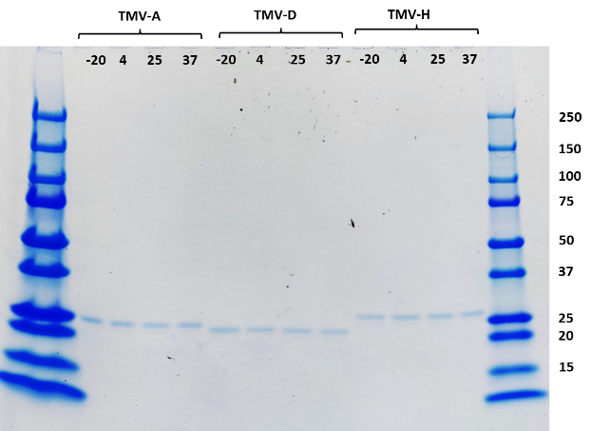
Figure S2: Coomassie-stained SDS PAGE showing the stability of the three TMV-epitope fusions that elicited neutralizing antibodies in mice after storage at -20°C, 4°C, 25°C and 37°C for 28°C days.

