Supplementary materials 2
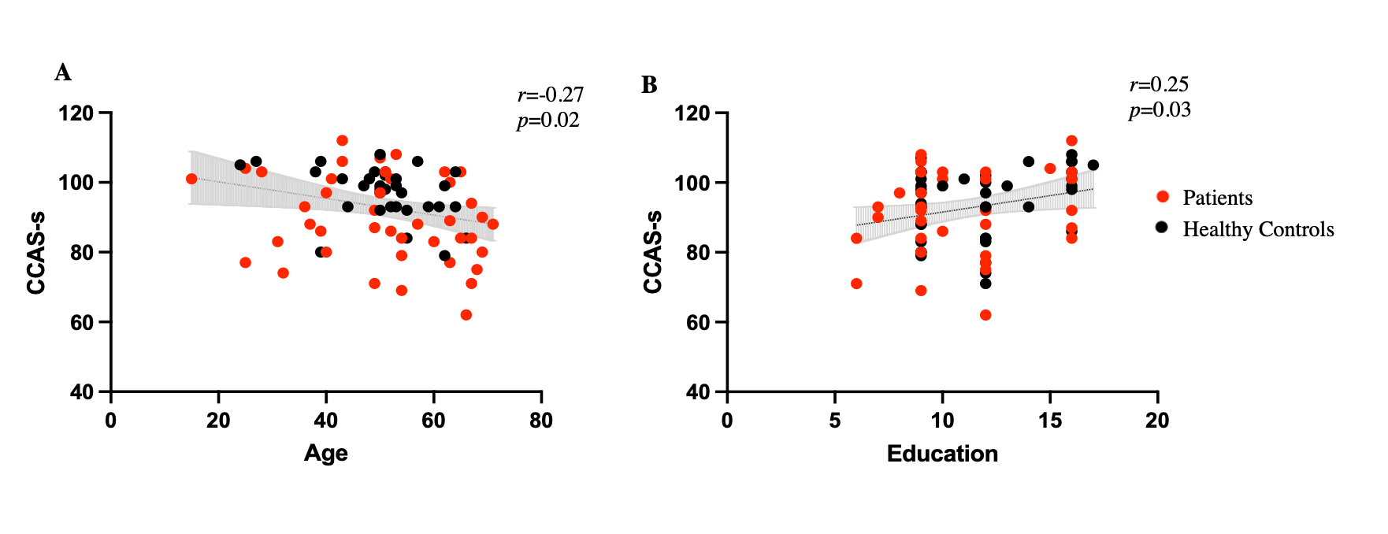
Supplementary Fig 1 The effect of age and education on the performance of the Chinese CCAS-s. The correlations in patients (red) and healthy controls (black) combined

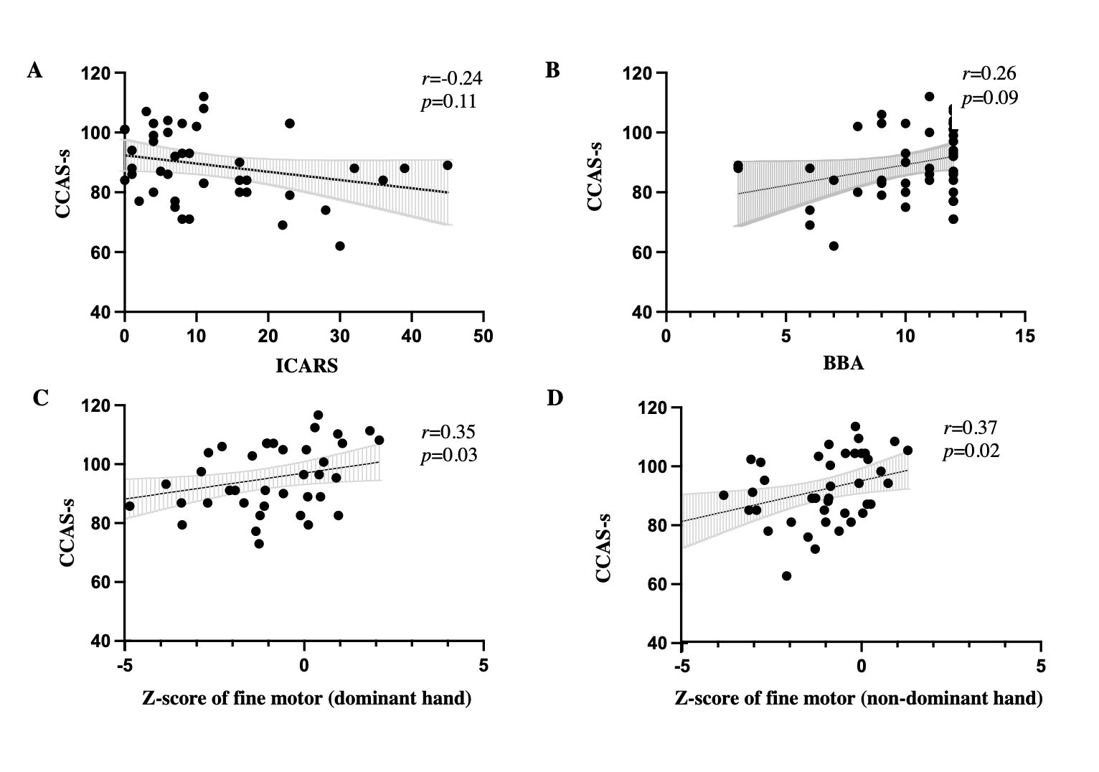
Supplementary Fig 2 Association between CCAS-s score and motor function in patients with cerebellar infarction. CCAS-s = Cerebellar cognitive affective syndrome-scale; ICARS = International Cooperative Ataxia Rating Scale; BBA = Brunel balance assessment

