Supplementary figures:
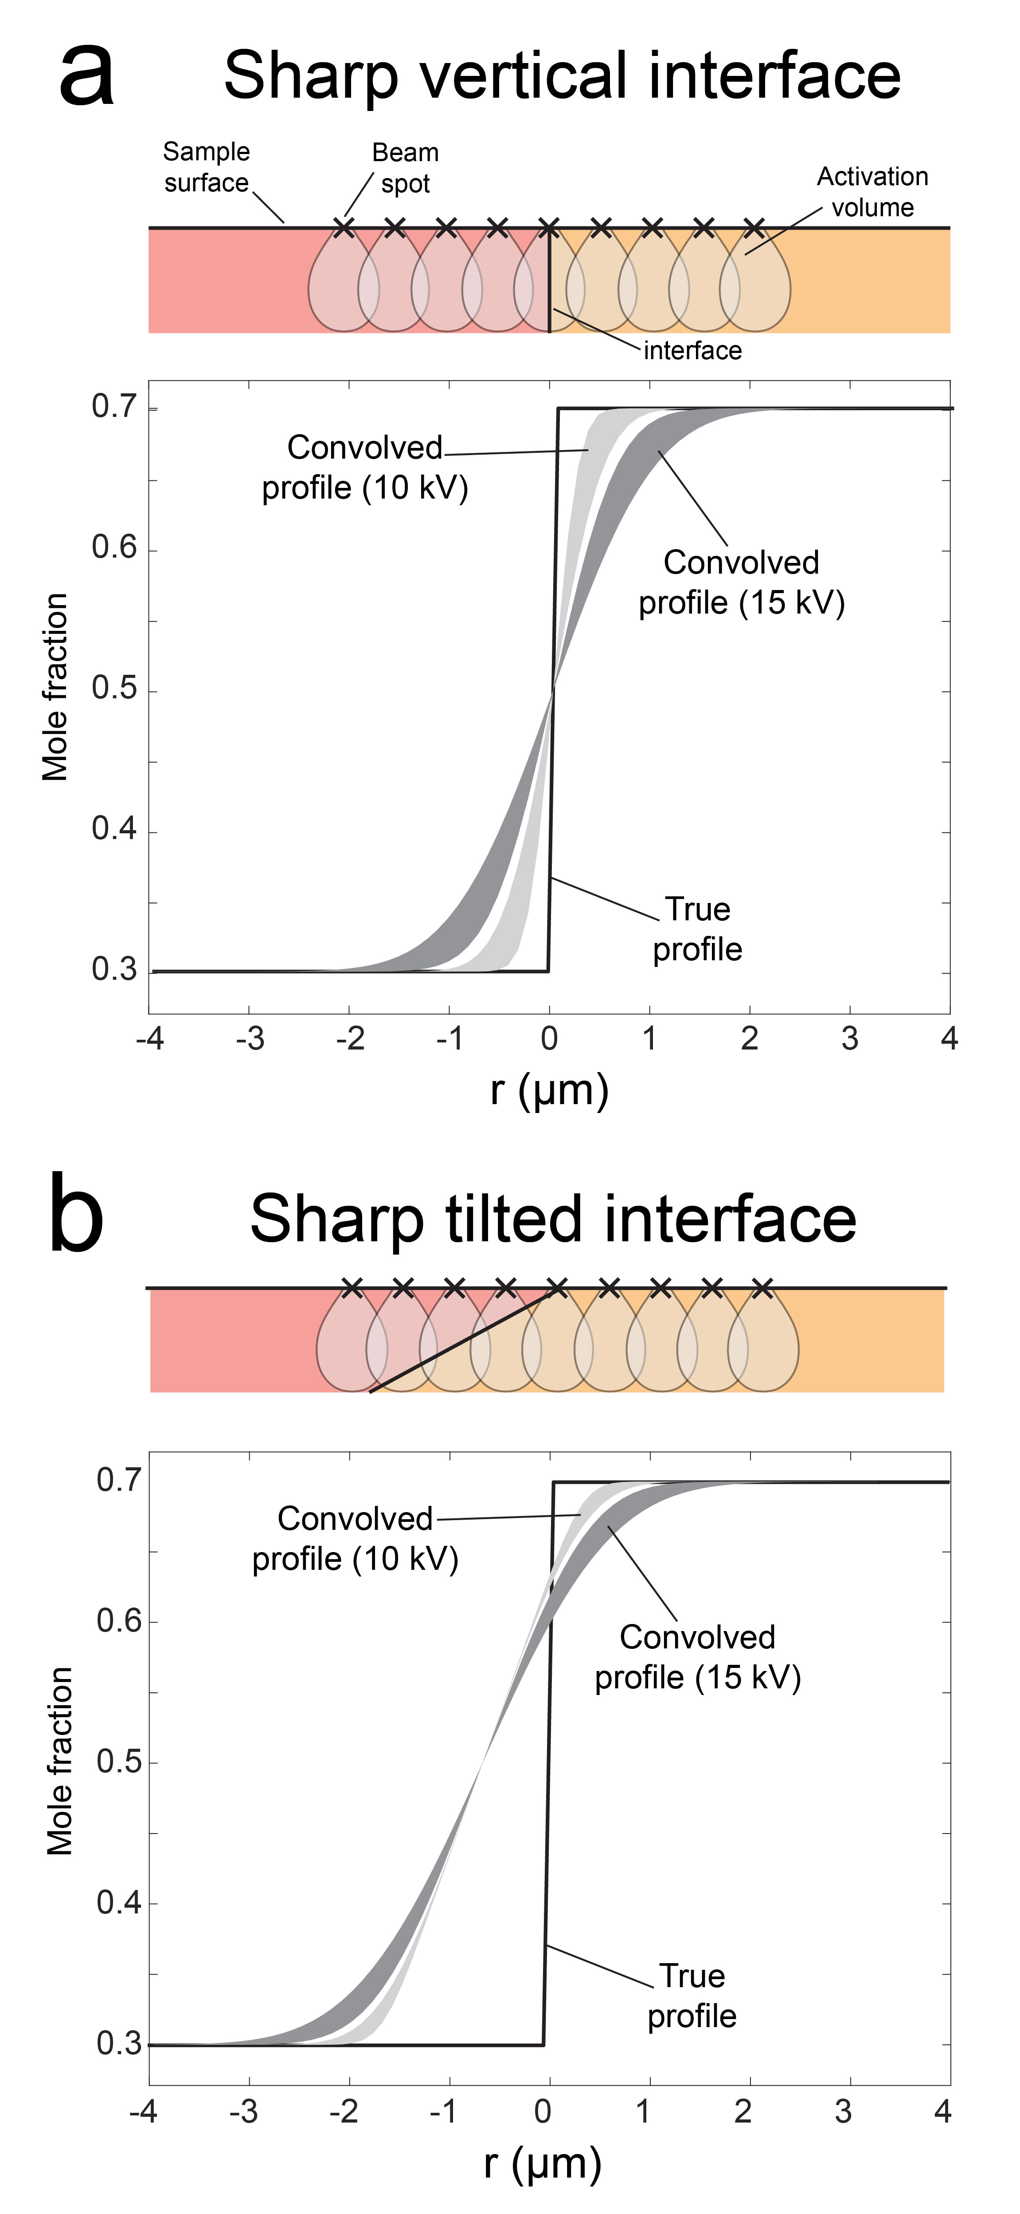
Figure S1 Modeled analytical convolution of sharp interfaces. a) Convolution of a sharp vertical interface. An electron microprobe beam excites a sample volume (the activation volume) that is larger than the beam spot. Due to convolution, the profile that is obtained will appear wider compared to the true profile. The amount of convolution depends largely on the accelerating voltage. A voltage of 10 kV has a smaller activation volume than 15 kV, leading to less convolution. The diameter of the activation volumes is determined following refs. 1 and 2 using a general Alm-rich garnet composition and the convolved profiles are calculated following ref. 3. b) If the sharp interface is tilted, then the amount of convolution will be greater than with a vertical interface, leading to an even wider apparent profile width.

Figure S2. Measured and best-fitting modeled composition profiles (solid lines) with corresponding initial conditions (dashed lines) for a diffusion timescale of 175 kyr. Initial conditions are bounded between the composition ranges of X_{Grs} = 0.05 to 0.175, X_{Grs} = 0.07 to 0.14, and X_{Grs} = 0.07 to 0.21 for Profiles 1, 3, and 6, respectively. The measured data points are represented by blue rectangles (heights are ± 2$σ$ uncertainty)
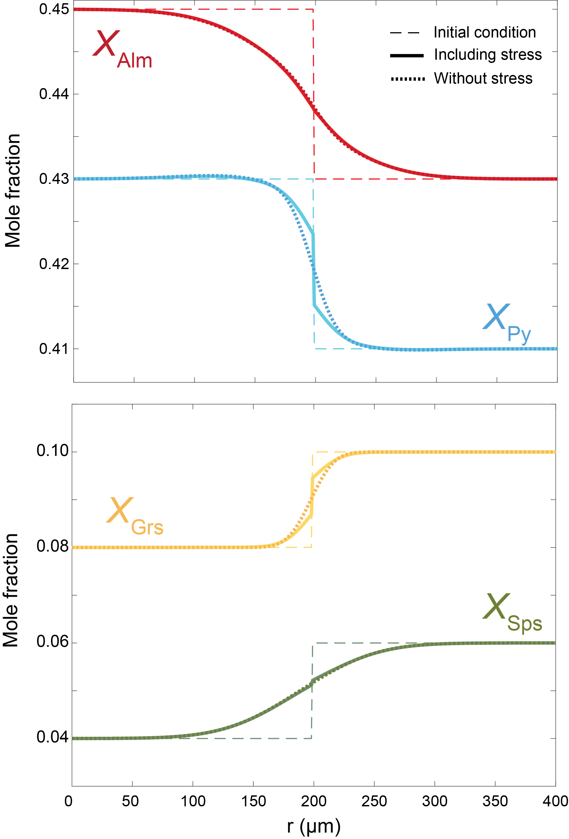
Figure S3. Comparison of diffusion rates between a diffusion treatment with (solid lines) and without (dotted lines) compositional stress for a hypothetical garnet profile at 700 ºC and 1 GPa after 1 Myr. Compositional stress alters the morphology of the composition curves, but it does not noticeably change the widths of the profiles. Thus, the endmember interdiffusion rates are not appreciably altered by stress for garnet.

Supplementary references:
- Merlet, C. & Llovet, X. "Uncertainty and capability of quantitative EPMA at low voltage–A review." In IOP Conference Series: Materials Science and Engineering (IOP Publshing, 2012), 32, p. 012016.
- Fournelle, J., Catheby, H., Pinard, P. T. & Richter, S. "Low voltage EPMA: experiments on a new frontier in microanalysis-analytical lateral resolution" In IOP Conference Series: Materials Science and Engineering (IOP Publishing, 2016), 109, p. 012003.
- Ganguly, J., Bhattacharya, R. N. & Chakraborty, S. Convolution effect in the determination of composition profiles and diffusion coefficients by microprobe step scans. Am. Mineral. 73, 901-909 (1988).

