Supplementary Materials: Oxidative stress mediated by pyrrolidine SS13 is involved in apoptosis and autophagy induction in colorectal cancer cells
Natália Nosálová¹, Monika Majirská¹, Alexandra Kešeľáková¹, Miroslava Martinková², Dominika Fábianová², Andrej Miroššay¹, Martina Bago Pilátová^{1*}, Martin Kello^{1*}
¹ Department of Pharmacology, Faculty of Medicine, P.J. Šafárik University, Košice, Slovak Republic; natalia.nosalova@student.upjs.sk (N.N.); monika.majirska@student.upjs.sk (M.M.); alexandra.macejova@student.upjs.sk (A.K.); martin.kello@upjs.sk (M.K.); martina.pilatova@upjs.sk (M.B.P.); andrej.mirossaj@upjs.sk (A.M.)
² Institute of Chemical Sciences, Department of Organic Chemistry, Faculty of Science, P.J. Šafárik University, Košice, Slovak Republic; miroslava.martinkova@upjs.sk (M.M.); dominika.jackova@gmail.com (D.F.)
* Correspondence: Dr. Martin Kello, Department of Pharmacology, Faculty of Medicine, Pavol Jozef Safarik University, Trieda SNP 1, 04011 Kosice, Slovak Republic. Tel/Fax: +421556428524, e-mail: martin.kello@upjs.sk
Assoc. prof. MVDr. Martina Bago Pilátová, Department of Pharmacology, Faculty of Medicine, Pavol Jozef Safarik University, Trieda SNP 1, 04011 Kosice, Slovak Republic. Tel/Fax: +421556428524, e-mail: martina.pilatova@upjs.sk

Densitometric analyses of Western blot
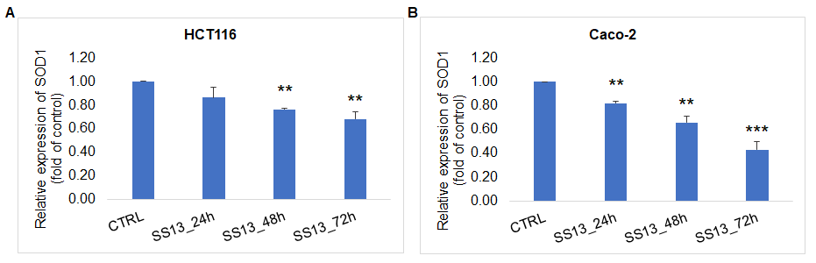
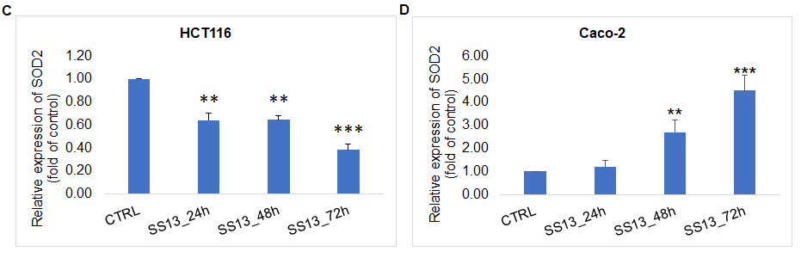
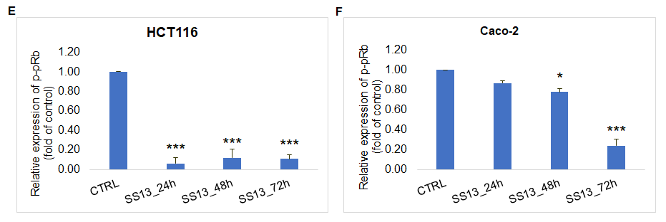
Figure S1. Densitometric analysis of Western blot assay: relative expression of SOD1 (A, B), SOD2 (C, D) and p-pRb (E, F) in HCT116 and Caco-2 cells after treatment with pyrrolidine SS13. Statistical significance: * p < 0.05, ** p < 0.01, *** p < 0.001 vs. untreated cells (control).

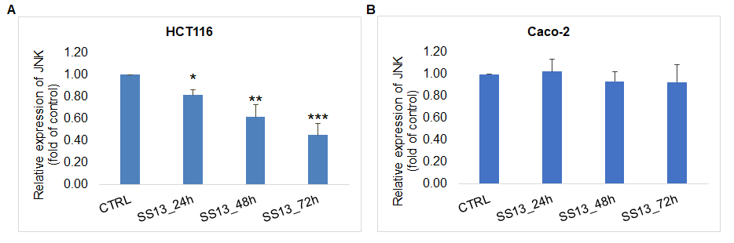
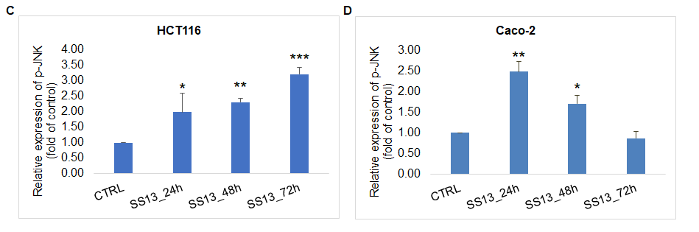
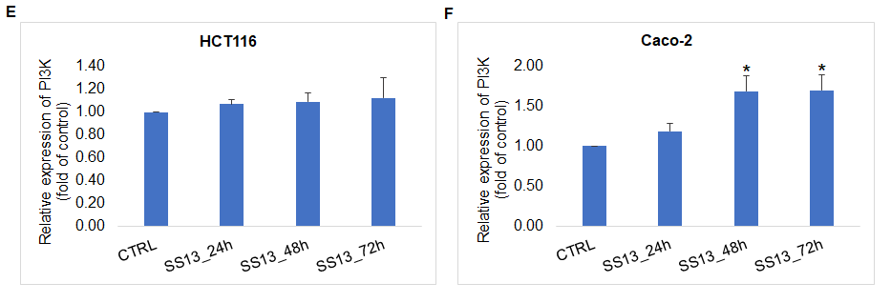
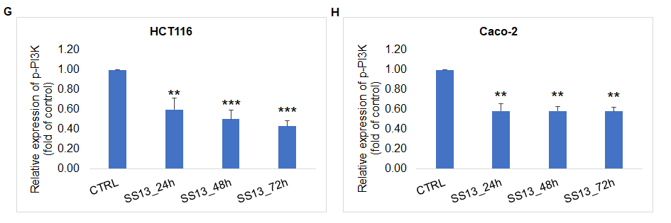
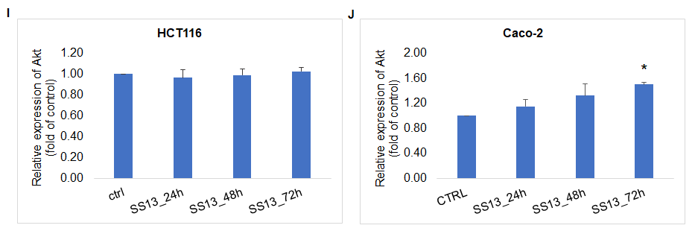
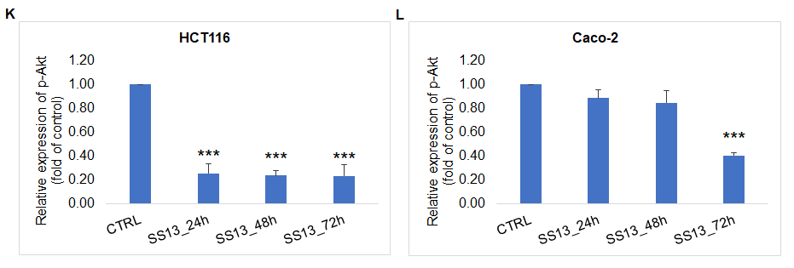
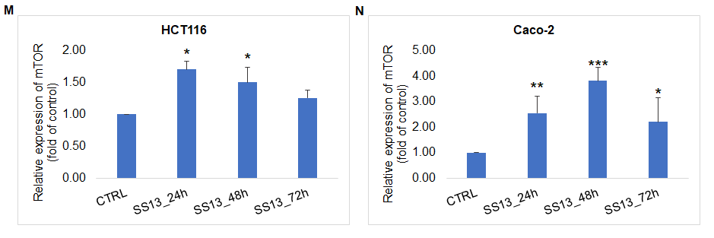
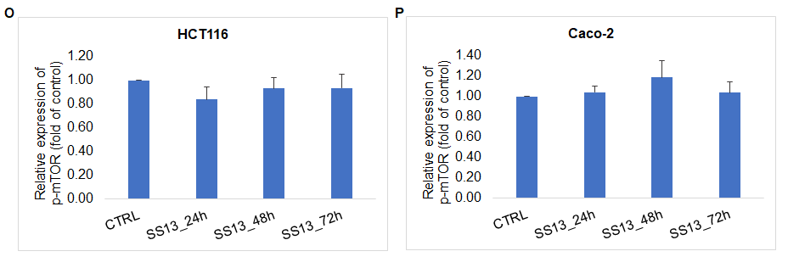
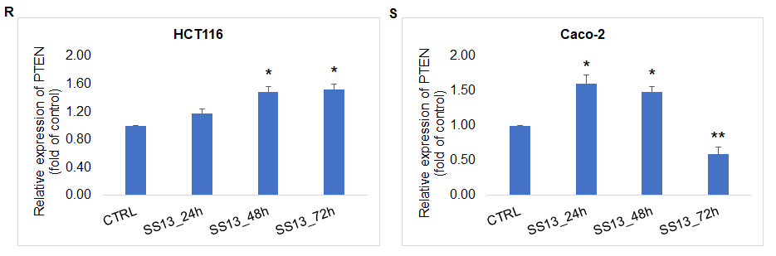
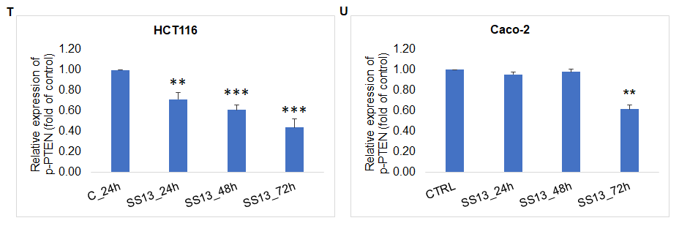
Figure S2. Densitometric analysis of Western blot assay: relative expression of JNK (A, B), p-JNK (C, D), PI3K (E, F), p-PI3K (G, H), Akt (I, J), p-Akt (K, L), mTOR (M, N), p-mTOR (O, P), PTEN (R, S) and p-PTEN (T, U) in HCT116 and Caco-2 cells after treatment with pyrrolidine SS13. Statistical significance: * p < 0.05, ** p < 0.01, *** p < 0.001 vs. untreated cells (control).

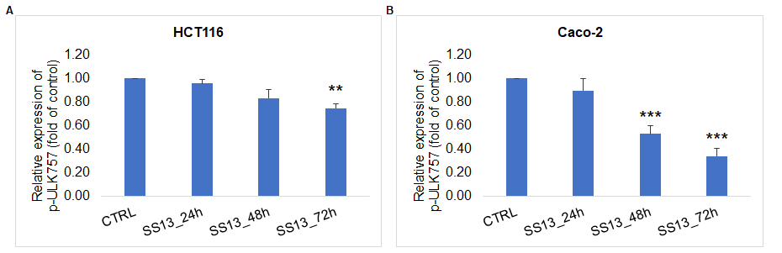
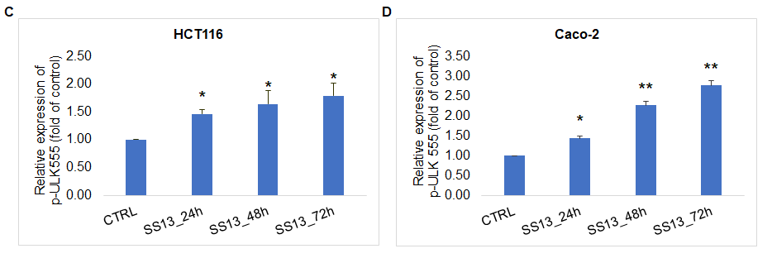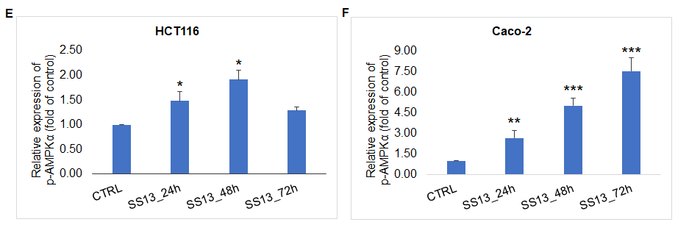

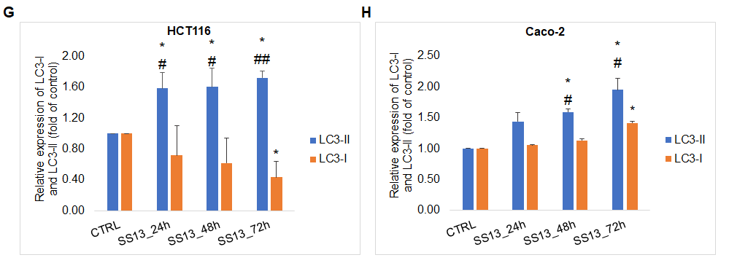
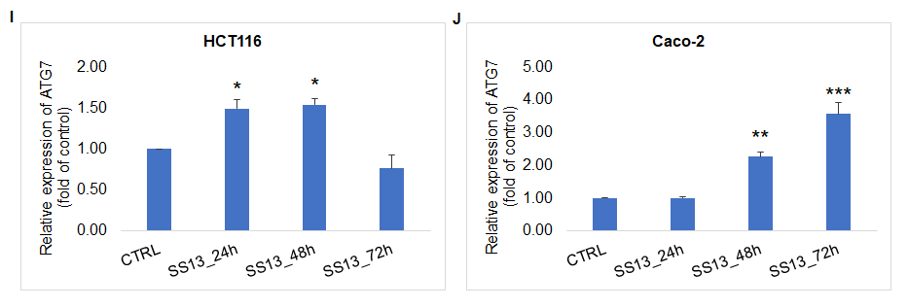
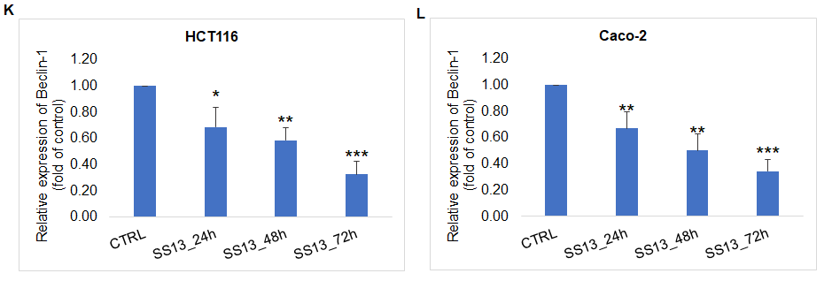
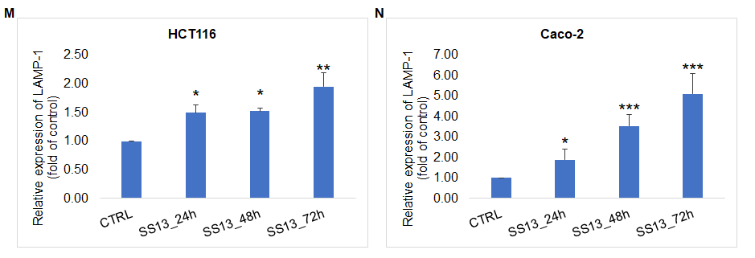
Figure S3. Densitometric analysis of Western blot assay: relative expression of p-ULK757 (A, B), p-ULK555 (C, D), p-AMPKα (E, F), LC3I and LC3II (G, H), ATG7 (I, J), Beclin-1 (K, L) and LAMP-1 (M, N) in HCT116 and Caco-2 cells after treatment with pyrrolidine SS13. Statistical significance: * p < 0.05, ** p < 0.01, *** p < 0.001 vs. untreated cells (control); # p < 0.05, ## p < 0.01 vs. LC3-I.

