Supplementary Information

Contents of this file

Text S1 to S3

Figures S1 to S3

Additional Supporting Information

Table S1

Text S1. Implication of a b-value over 1.5

The Gutenberg-Richter (G-R) law defines a log-linear relationship between the frequency of occurrence of earthquakes and their magnitude:

$logF\left(m\right)=a-bm$ (S1)

where F(m) is the incremental frequency of occurrence of earthquakes with magnitudes in the range $m±\frac{δm}{2}$ , with $δm$ corresponding to the bin width and $a$, b constants.

The implication of a b-value over 1.5 is explained as follows. One can express $F$ as a function of m_{min} and b, where m_{min} should be equal to or above the threshold magnitude for complete detection of events m_{C}, as follows:

$∆\left(logF\right)=logF-\log{F\left(m_{min}\right)}=\left(m-m_{min}\right)b ⇒ F=F(m_{min}){10}^{-b(m-m_{min})}$ (S2)

The magnitude (m) is a logarithmic measure of seismic moment (M):

$logM=cm+d$ (S3)

where it is commonly assumed that $c=\frac{3}{2}$ (Kanamori, 1978). The total moment in each bin is:

$FxM=F\left(m_{min}\right){10}^{-b\left(m-m_{min}\right)}{10}^{cm+d}=F\left(m_{min}\right){10}^{-m\left(c-b\right)+bm_{min}+d}$ (S4)

In the case of b = 1.5, c-b = 0, FM = constant, which suggests that each bin above m_{min} contributes equally to the moment sum. If b > 1.5, such as in our dataset, FxM is bigger for smaller events, which translates to smallest events contributing most to seismic strain – and conversely, if b < 1.5, FM is bigger for larger events (largest events contribute most).

Text S2. Accounting for undetectable seismicity in the seismic strain partition coefficient

Using the Brune (1970) model, we estimate the seismic moment as a function of the square of the seismic source radius:

$M=K_{1}∆σr^{2}$ (S5)

where r is the seismic source radius, K₁ is a constant, and Δσ is the stress drop.

Using (9), the ratio of maximum to minimum magnitude can be expressed as:

$\frac{M_{max}}{M_{min}}=\frac{{10}^{cm_{max}+d}}{{10}^{cm_{min}+d}}=\frac{r_{max}^{2}}{r_{min}^{2}}$ (S6)

$⇒ r_{min}=r_{max}{10}^{\frac{1}{2}c(m_{min}-m_{max})}$ (S7)

Here the term $K_{1}∆σ$ cancels on division, so the calibration is independent of the absolute stress drop. Next, we look at the seismic moment (M) sum over n individual entries i, which is related to the sum over q magnitude (m) bins:

$\sum_{i=1}^{n}{M_{i}=\sum_{j=1}^{q}{F\left(m_{j}\right)M\left(m_{j}\right)=\sum_{j=1}^{q}{{10}^{1-bm_{j}+cm_{j}+d}=K_{2}\sum_{j=1}^{q}{{10}^{(c-b)m_{j}}}}}}$ (S8)

where K₂ is a constant.

We now try two different threshold magnitudes, one being the magnitude of complete reporting (m_{C}), with n_{C} events and q_{c} bins, and one assuming the magnitude due to the smallest crack possible, with n_{max} events and q_{max} bins. By proportion:

$\frac{\sum_{i=1}^{n_{max}}{M_{i}}}{\sum_{i=1}^{n_{c}}{M_{i}}}=\frac{\sum_{j=1}^{q_{max}}{{10}^{(c-b)m_{j}}}}{\sum_{j=1}^{q_{c}}{{10}^{(c-b)m_{j}}}}$ (S9)

The total strain measured from the observed deformation is ε_{T}. The seismic strain ε_{S} is based on Kostrov (1974), and defined as:

$ε_{S}=K_{3}\sum_{i=1}^{n}{M_{i}}$ (S10)

with K₃ constant, while the seismic strain partition factor $χ=\frac{ε_{S}}{ε_{T}}$ for the two thresholds are similarly related by direct proportion:

$\frac{χ_{q_{max}}}{χ_{q_{C}}}=\frac{\sum_{j=1}^{q_{max}}{{10}^{(c-b)m_{j}}}}{\sum_{j=1}^{q_{C}}{{10}^{(c-b)m_{j}}}}$ (S11)

We further compute the reduction in radius implicit in reduction of magnitudes for neighbouring bins of thickness Δm = 0.1 as:

$r_{j-1}=r_{j}{10}^{-\frac{1}{2} c 0.1}=r_{j}{10}^{-\frac{1}{2} 1.5 0.1}=r_{j}{10}^{-0.075}$ (S12)

and extrapolate downwards the radii until we reach an acceptable lower limit for the seismic source radius. In addition, we compute the increase in strain partition factor from smaller magnitude AEs in neighbouring bins from eq. (S11) as:

$χ_{j}=χ_{j-1}{10}^{(c-b)(m_{j}-m_{j-1})}=χ_{j-1}{10}^{(1.5-b)(0.1)}$ (S13)

Text S3. Stress evolution in the strain softening regime under constant acoustic emission event rate feedback control
Charles’ law for subcritical crack growth takes the form
$V=V_{c}{(K/K_{c})}^{n}$ , (S14)
where $V$ is the crack growth velocity, $V_{c}$ is the critical crack growth (rupture) velocity at dynamic failure, limited by inertia to be slower than the Rayleigh wave on its surfaces, $K$ is the stress intensity factor, $K_{c}$ is a critical stress intensity factor known as the fracture toughness and the exponent $n>2$ is known as the stress corrosion index. A similar relationship is found for the acoustic emission event rate $\dot{N}$
$\dot{N}=\dot{N_{c}}{(K/K_{c})}^{n}$ , (S15)
where the exponent $n$ obtained by fitting (1) and (2) to the data are remarkably similar (Meredith & Atkinson, 1983). The stress intensity factor is the product of the stress $σ$, the square root of crack length $c$, and a dimensionless geometric factor $Y$ that depends on the experimental configuration
$K=Yσc^{1/2}$ . (S16)
Thus at constant event rate loading both $\dot{N}$ and $V$ are constant, but stress and crack lengths are functions of time
$σ=σ\left(t\right) ; c=c_{0}+Vt$ . (S17
From equations (S14)-(S17), we find
$K_{c}=Y{\left(\frac{V_{c}}{V}\right)}^{n}σ\left(t\right)\left(c_{0}+Vt \right)=A{σ\left(t\right)c_{o}^{1/2}(1+t/T)}^{1/2}$, (S18)
where $A= Y{\left(V_{c}/V\right)}^{n}$ is a dimensionless constant and $T=c_{0}/V$. For constant $K_{c}$
$σ\left(t\right)=\left[{K_{c}}/{(Ac_{o}^{1/2})}\right] {\left(1+t/T\right)}^{-1/2}=σ_{0}{\left(1+t/T\right)}^{-1/2}$ , (S19)
where $σ_{0}=σ(t=0) .$
Equation (S18) predicts $σ→0$ as $t→∞$. In compressional experiment it is more usual to find $σ→σ_{F}$ as $t→∞$, where $σ_{F}$ is the frictional sliding stress, i.e. the steady state after a contiguous fault has developed. With this boundary condition we have
$σ\left(t\right)=σ_{F}+(σ_{0}-σ_{F}){\left(1+t/T\right)}^{-1/2}$ . (S20)
In a mean field damage mechanics model for an ensemble of cracks, $c$ takes the role of a characteristic crack length, and the exponent in equation (S15) need not be ½ (Main 2000). In this more general case, for a generalised exponent $q$
$σ\left(t\right)=σ_{F}+(σ_{0}-σ_{F}){\left(1+t/T\right)}^{-q}$ . (S21)
For $q>0$, the medium is softening with time, i.e. $\dot{σ}≤0$, consistent with the observation of a shear band that relaxes the stress around it by self-organised en-echelon localization of tensile cracks, grain rolling, and grain boundary shear, as seen in our CT images (Cartwright-Taylor et al, 2022). In a conventional laboratory test under compressional load, this could only apply after peak stress $σ_{p}$ (the ultimate strength) is reached .
For $q<0$, $\dot{σ}≥0$, and the material hardens with time, most likely by the dilatant hardening mechanism caused by tensile micro-cracking in a compressive stress field, as also observed for this phase in our experiments in the CT images (Cartwright-Taylor et al, 2022) after yield. For the case $\dot{N}$ and $V$ are constant, we have for $σ_{y}≤σ_{0}<σ_{p}$ and $0≤t<t_{p}$
$σ\left(t\right)=σ_{0}{\left(1+t/T\right)}^{q}$ ; $q>0$ . (S22)
However, we also observe the co-existence of these microscopic processes during the transition, implying a gradual change from hardening to softening mechanisms, with a mixture of processes in between. A general mixture model for the two processes with a weighting function $w(t)$ can be expressed in the form
$σ\left(t\right)=σ_{0}\left[w(t){\left(1+t/T_{h}\right)}^{q_{h}}+{(1-w\left(t\right))\left(1+t/T_{s}\right)}^{-q_{s}}\right]$, (S23)
where subscripts $h, s$refer to the hardening/softening processes respectively. Consider a transient crossover, so that hardening dominates early and softening later on. The simplest model for this is an exponential transient
$w\left(t\right)=exp⁡(-\frac{t}{T_{w}}$) . (S24)

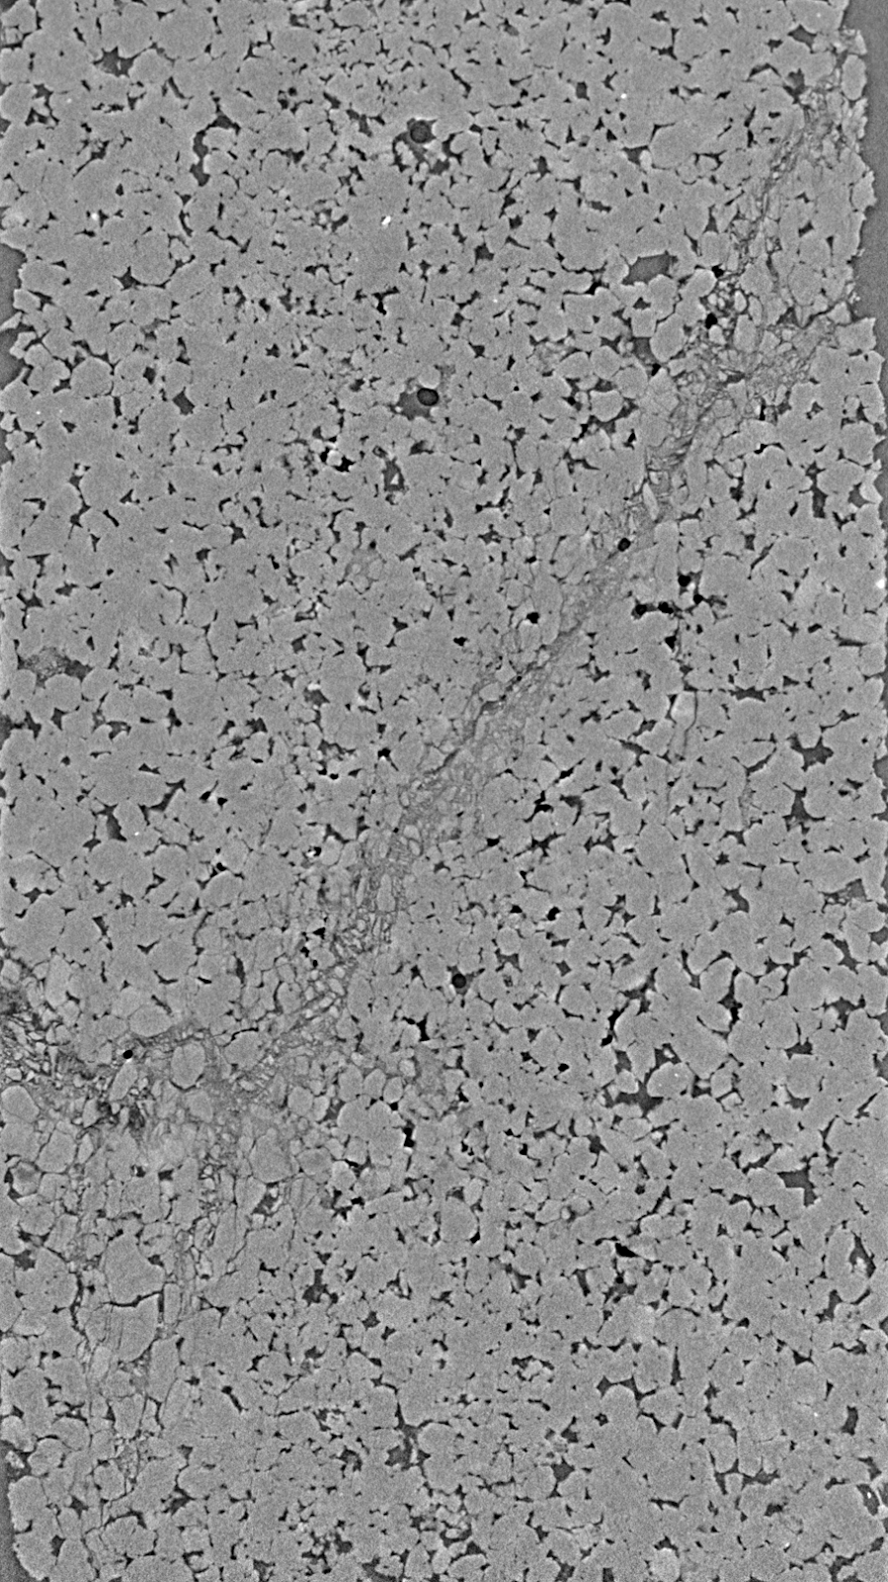

Figure S1. X-ray cross-section of failed sample for test A (diameter = 10mm).

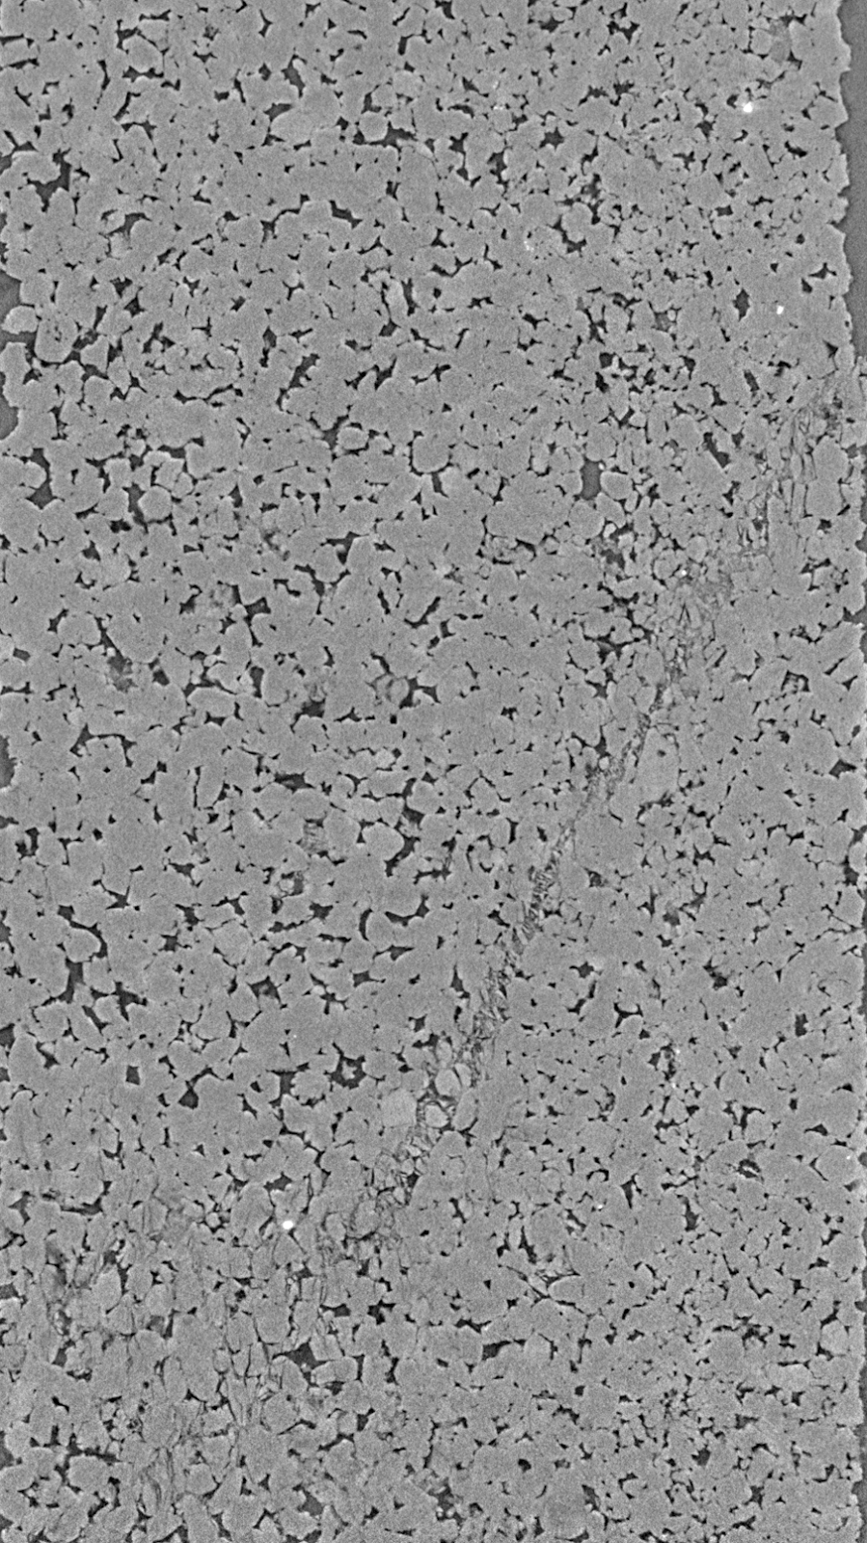

Figure S2. X-ray cross-section of failed sample for test B (diameter = 10mm).

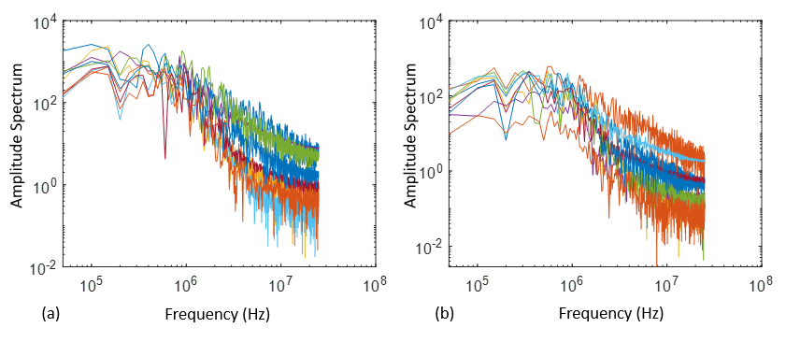

Figure S3. Amplitude spectra of ten largest events from AE dataset of test A (a) and B (b). Corner frequencies are fairly similar for all events.

Additional Supporting Information

Table S1. Temporal variation in b-values for Test A (top table) and B (bottom table).

