Supplementary Information

Distinct gut microbial communities and metabolic functions are associated with cachexia in lung cancer patients

Yueqiong Ni^{1#}, Zoltan Lohinai^{2#}, Yoshitaro Heshiki^{1,3}, Balazs Dome², Judit Moldvay², Edit Dulka⁴, Gabriella Gallfy⁴, Judit Berta², Glen J. Weiss⁵, Morten O. A. Sommer⁶, Gianni Panagiotou^{1,3,7,*}

# These authors contributed equally to this work
*Corresponding author. Email: Gianni.Panagiotou@hki-jena.de

This PDF file includes:

Figures. S1 to S10
Tables S1-S2

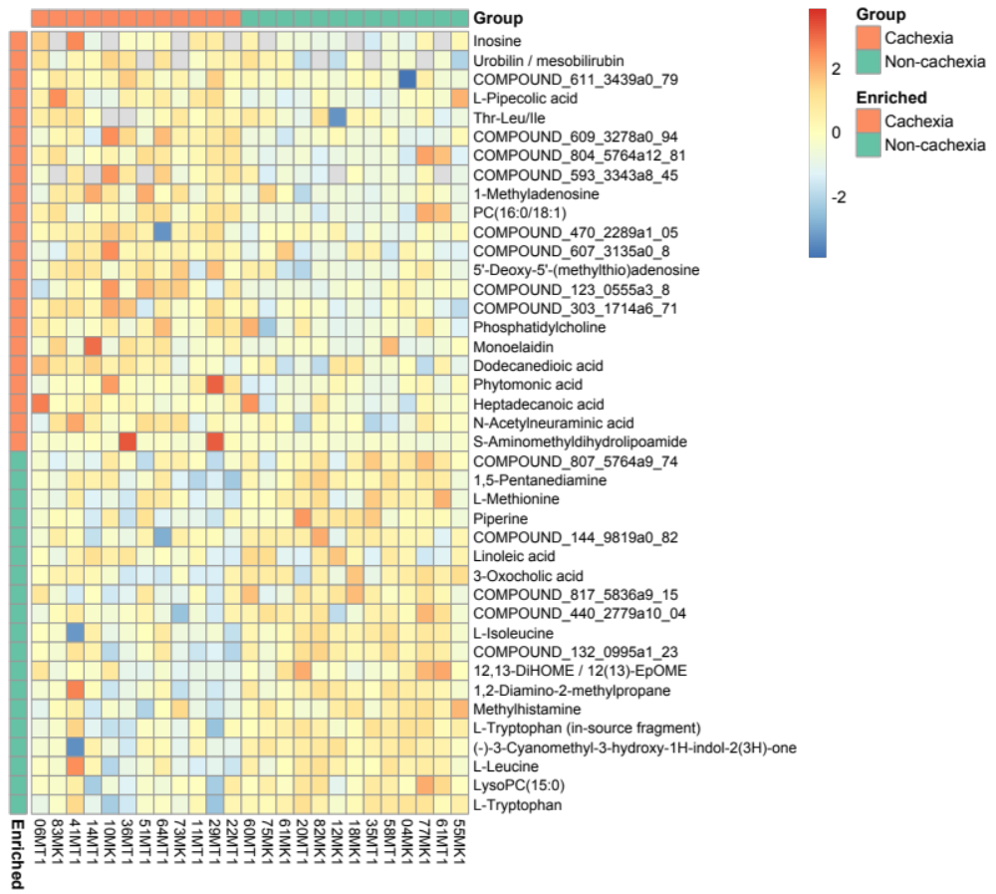
Fig. S1 Significantly differential abundant plasma metabolites in cachexia vs. non-cachexia group (p<0.05, Student’s t-test). Orange: higher in cachexia; green: higher in non-cachexia.

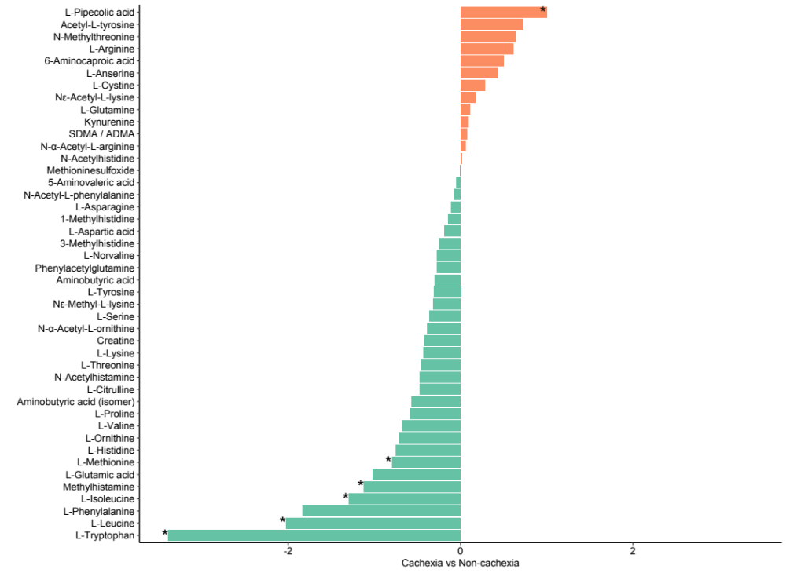
Fig. S2 Comparison of plasma amino acids in cachexia vs. non-cachexia group. Asterisks indicate significantly differential abundant metabolites (p<0.05, Student’s t-test). Orange: higher in cachexia; green: higher in non-cachexia.

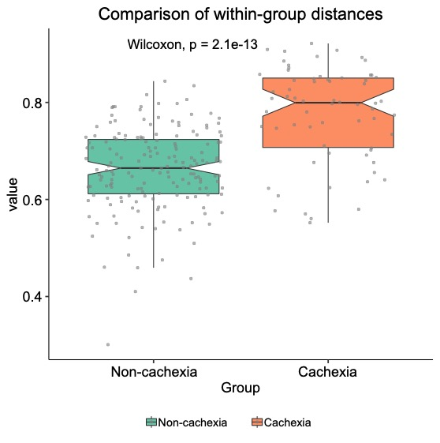
Fig. S3 Significantly higher variability of gut microbiota composition in cachexia than the non-cachexia group. Bray-Curtis dissimilarity based on gut microbial species profile was used as the distance metric.

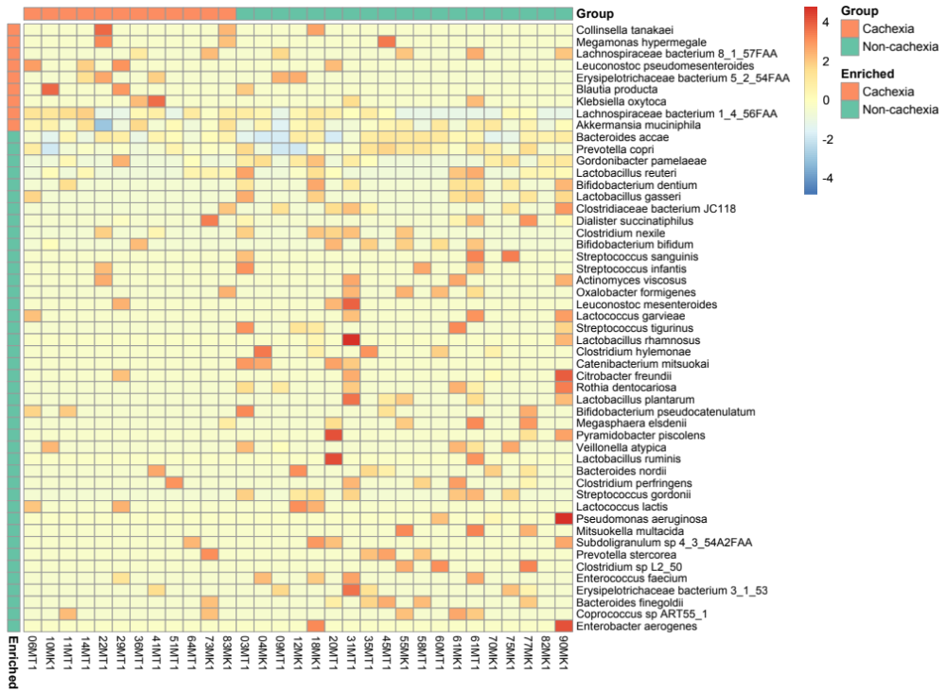
Fig. S4 Significantly differential abundant gut microbial species in cachexia vs. non-cachexia group using DESeq2 (p<0.05). Species annotated in orange: higher in cachexia; green: higher in non-cachexia.

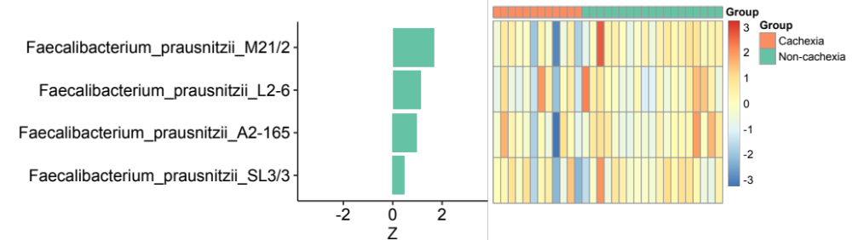
Fig. S5 The abundance comparison of Faecalibacterium prausnitzii strains between cachexia and non-cachexia patient groups.

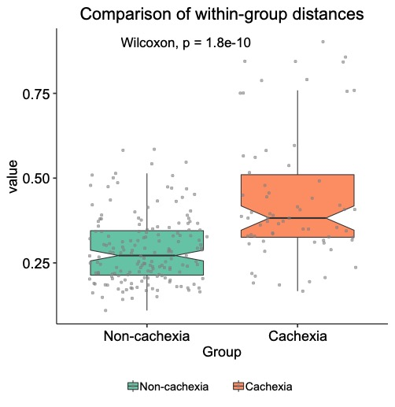
Fig. S6 Significantly higher variability of gut microbiota functionality in cachexia than the non-cachexia group. Bray-Curtis dissimilarity based on gut microbial genes (KEGG Ortholog groups) was used as the distance metric.

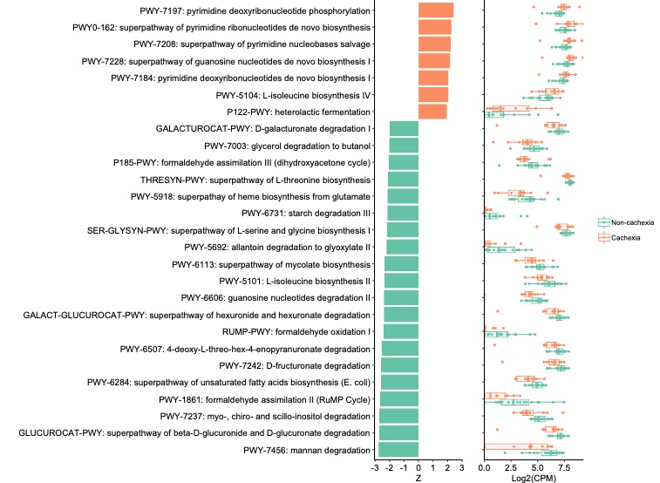
Fig. S7 Significantly differential abundant MetaCyc pathways in cachexia vs. non-cachexia group (p<0.05, Wilcoxon rank-sum test). Orange: higher in cachexia; green: higher in non-cachexia.
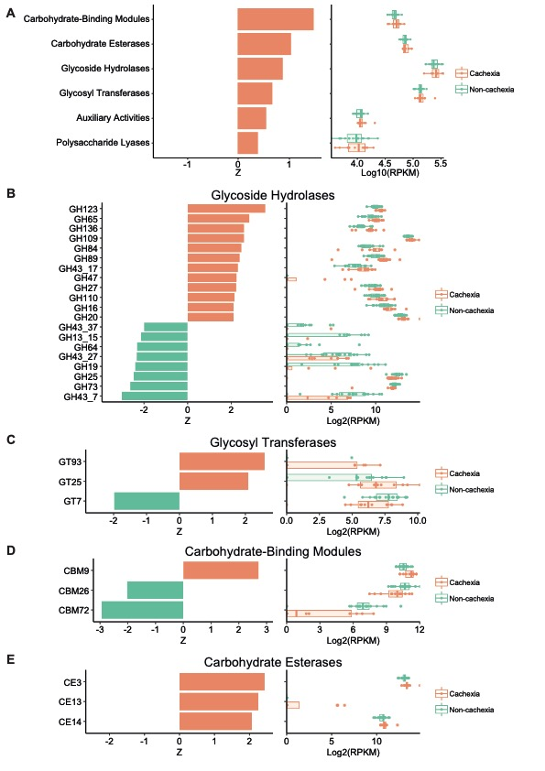
Fig. S8 Comparison of CAZy abundances in cachexia vs. non-cachexia group. (A) Overall comparison of CAZY class abundances. All CAZy classes were more abundant in the cachexia group, but none of them have significantly differences (p>0.05, Wilcoxon rank sum test). (B-E) Significantly differential abundant CAZy families within each CAZy class (p<0.05, Wilcoxon rank sum test). Orange: higher in cachexia; green: higher in non-cachexia.
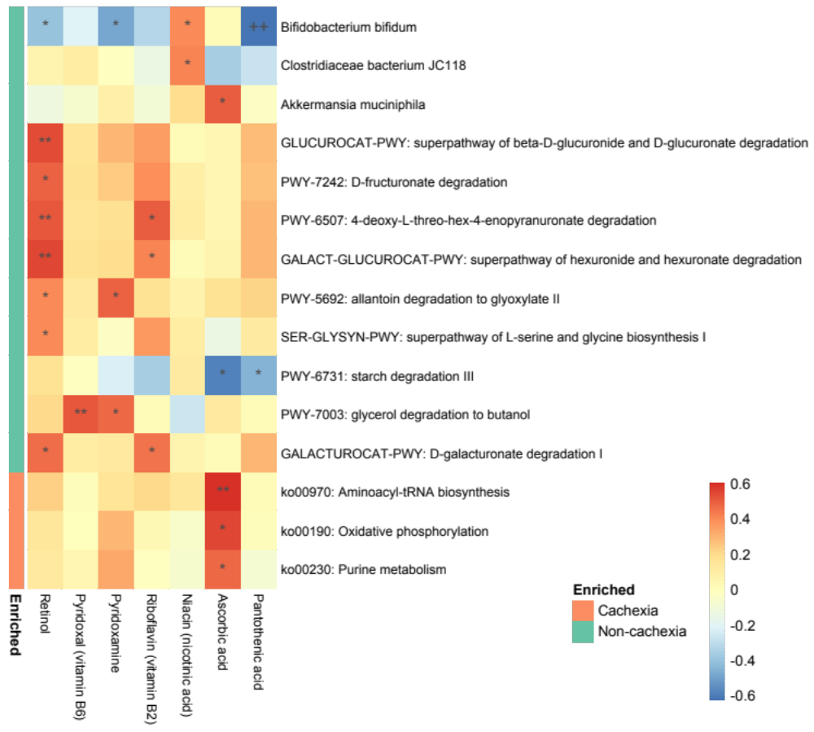
Fig. S9 Correlation between gut microbiota and plasma vitamins. Heatmap of Spearman’s rank correlation analysis between significant microbiota features and vitamins (*p<0.05, **p<0.01, ***p<0.001, +FDR<0.1, ++FDR<0.05, +++FDR<0.01, Spearman’s rank correlations). Microbiota-derived features used here include significant species from DESeq2, differentially abundant MetaCyc pathways and significant KEGG pathways from enrichment analysis. Orange: higher in cachexia; green: higher in non-cachexia.

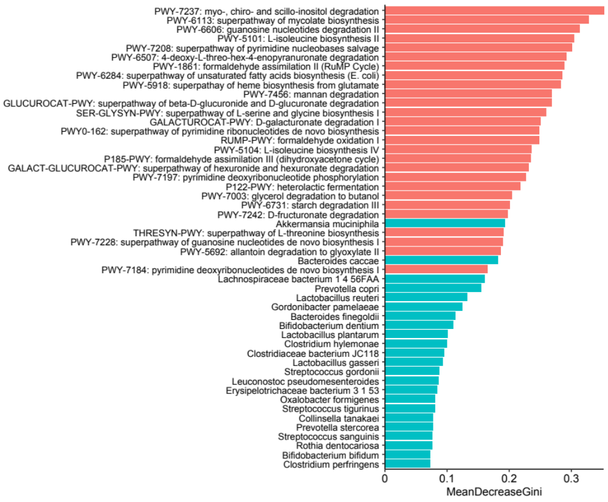
Fig. S10 List of top 50 feature importance for the random forest classifier using abundances of gut microbiota species (blue) and MetaCyc pathways (red).

Supplementary Table 1. Major clinicopathological characteristics of the EU/Hungarian patients cohort (n=31).

SampleID | Gender | Age | Stage* | Stage | Histology | Cachexia | SGA
03MT1 | M | 61 | NA | Advanced | ADC | Non-Cachexia | A
06MT1 | F | 63 | IVA | Advanced | ADC | Cachexia | B
14MT1 | F | 69 | IIIB | Advanced | SCC | Cachexia | B
18MK1 | M | 69 | IVA | Advanced | ADC | Non-Cachexia | A
22MT1 | M | 64 | IVA | Advanced | SCC | Cachexia | C
29MT1 | F | 60 | IB | Advanced | SCC | Cachexia | C
31MT1 | F | 70 | IVA | Advanced | ADC | Non-Cachexia | A
35MT1 | F | 51 | IIIB | Advanced | SCLC | Non-Cachexia | A
36MT1 | F | 60 | IVB | Advanced | NSCLC-NOS | Cachexia | B
41MT1 | M | 67 | IVA | Advanced | SCC | Cachexia | B
45MT1 | M | 65 | IIIA | Advanced | SCLC | Non-Cachexia | A
51MT1 | F | 67 | IA | Advanced | SCC | Cachexia | B
55MK1 | M | 67 | IIA | Advanced | ADC | Non-Cachexia | A
60MT1 | M | 64 | IVB | Advanced | SCC | Non-Cachexia | A
61MK1 | M | 64 | IIB | Advanced | SCLC | Non-Cachexia | A
61MT1 | M | 70 | IVC | Advanced | SCC | Non-Cachexia | A
64MT1 | M | 63 | IVA | Advanced | ADC | Cachexia | C
70MK1 | F | NA | IIIA | Advanced | SCC | Non-Cachexia | A
73MK1 | M | 64 | IIIB | Advanced | SCC | Cachexia | B
75MK1 | F | 63 | IVB | Advanced | SCLC | Non-Cachexia | A
77MK1 | M | 68 | IVA | Advanced | ADC | Non-Cachexia | A
83MK1 | M | 72 | IIIB | Advanced | ADC | Cachexia | C
90MK1 | M | 78 | IVA | Advanced | ADC | Non-Cachexia | A
04MK1 | M | 50 | IIIA | Resected | SCC | Non-Cachexia | A
09MT1 | M | 75 | IB | Resected | ADC | Non-Cachexia | A
10MK1 | F | 65 | IIA | Resected | ADC | Cachexia | B
11MT1 | F | 57 | IIA | Resected | ADC | Cachexia | B
12MK1 | M | 63 | IIA | Resected | ADC | Non-Cachexia | A
20MT1 | M | 57 | IB | Resected | ADC | Non-Cachexia | A
58MT1 | M | 68 | IVA | Resected | ADC | Non-Cachexia | A
82MK1 | F | 51 | IIB | Resected | ADC | Non-Cachexia | A
*according to the Union for International Cancer Control (8th edition)
adenocarcinoma (ADC), squamous cell carcinoma (SCC), non-small cell lung carcinoma not otherwise specified (NSCLC-NOS), small cell lung carcinoma (SCLC)

Supplementary Table 2. Major clinicopathological characteristics of the US patients cohort (n=7).
PatientID | Gender | Age | Race | Stage* | Stage | Histology | Cachexia | SGA
01A1 | F | 53 | Black | IV | Advanced | ADC | Non-Cachexia | A
05A1 | F | 54 | White | IV | Advanced | ADC | Cachexia | B
07A1 | M | 53 | White | IV | Advanced | ADC | Non-Cachexia | A
08A1 | F | 51 | White | IV | Advanced | ADC | Non-Cachexia | A
09A1 | F | 52 | White | IV | Advanced | ADC | Non-Cachexia | A
12A1 | M | 64 | Hispanic | IV | Advanced | ADC | Non-Cachexia | A
25A1 | M | 60 | White | IV | Advanced | SCLC | Cachexia | B
*according to the Union for International Cancer Control (8th edition)
adenocarcinoma (ADC), squamous cell carcinoma (SCC), non-small cell lung carcinoma not otherwise specified (NSCLC-NOS), small cell lung carcinoma (SCLC)

