Supplementary Information for

Climate action and gender equality matter most for China's sustainable development

Qiang Xing^{1,2}, Chaoyang Wu^{3,4}*, Fang Chen^{1,2,4}*, Jianguo Liu⁵, Prajal Pradhan^{6,7}, Brett A Bryan⁸, Thomas Schaubroeck⁹, L. Roman Carrasco¹⁰, Alemu Gonsamo¹¹, Yunkai Li¹², Xiuzhi Chen¹², Xiangzheng Deng^{3,4}, Andrea Albanese¹³, Yingjie Li^{5,14}, Zhenci Xu¹⁵

Correspondence to: wucy@igsnrr.ac.cn, chenfang@radi.ac.cn

This PDF file includes:

Figs. S1-S2
Table S1-S3
Text
Reference

Other Supplementary Information for this manuscript includes the following:

Data for the synergy and trade-off among indicators at national and provincial levels
Explanations on the associations between indicators

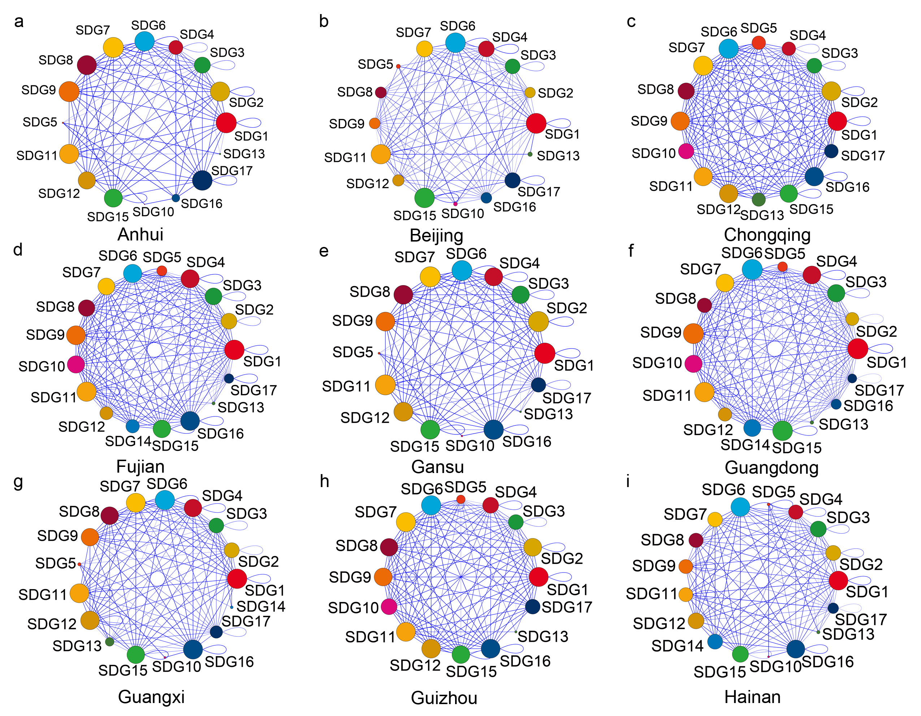

Fig. S1.
The thickness of the edges in the synergy network indicates the weighted edge between SDG Pairs. The thicker the lines are, the stronger the strengths are. The size of the circle suggests its importance as a central hub in the network. The larger the circle is, the more important the node as a central hub is. In the synergy network the edge lines is shown in blue. The background color of each node is consistent with the SDG icon of the United Nations (UN). The 31 synergy networks at sub-national level in alphabetical order, including Anhui (0.2-1), Beijing (0.18-1), Chongqing (0.4-1), Fujian (0.11-0.99), Gansu (0.1-1), Guangdong (0.14-0.99), Guangxi (0.22-1), Guizhou (0.15-1), Hainan (0.14-1), continued,

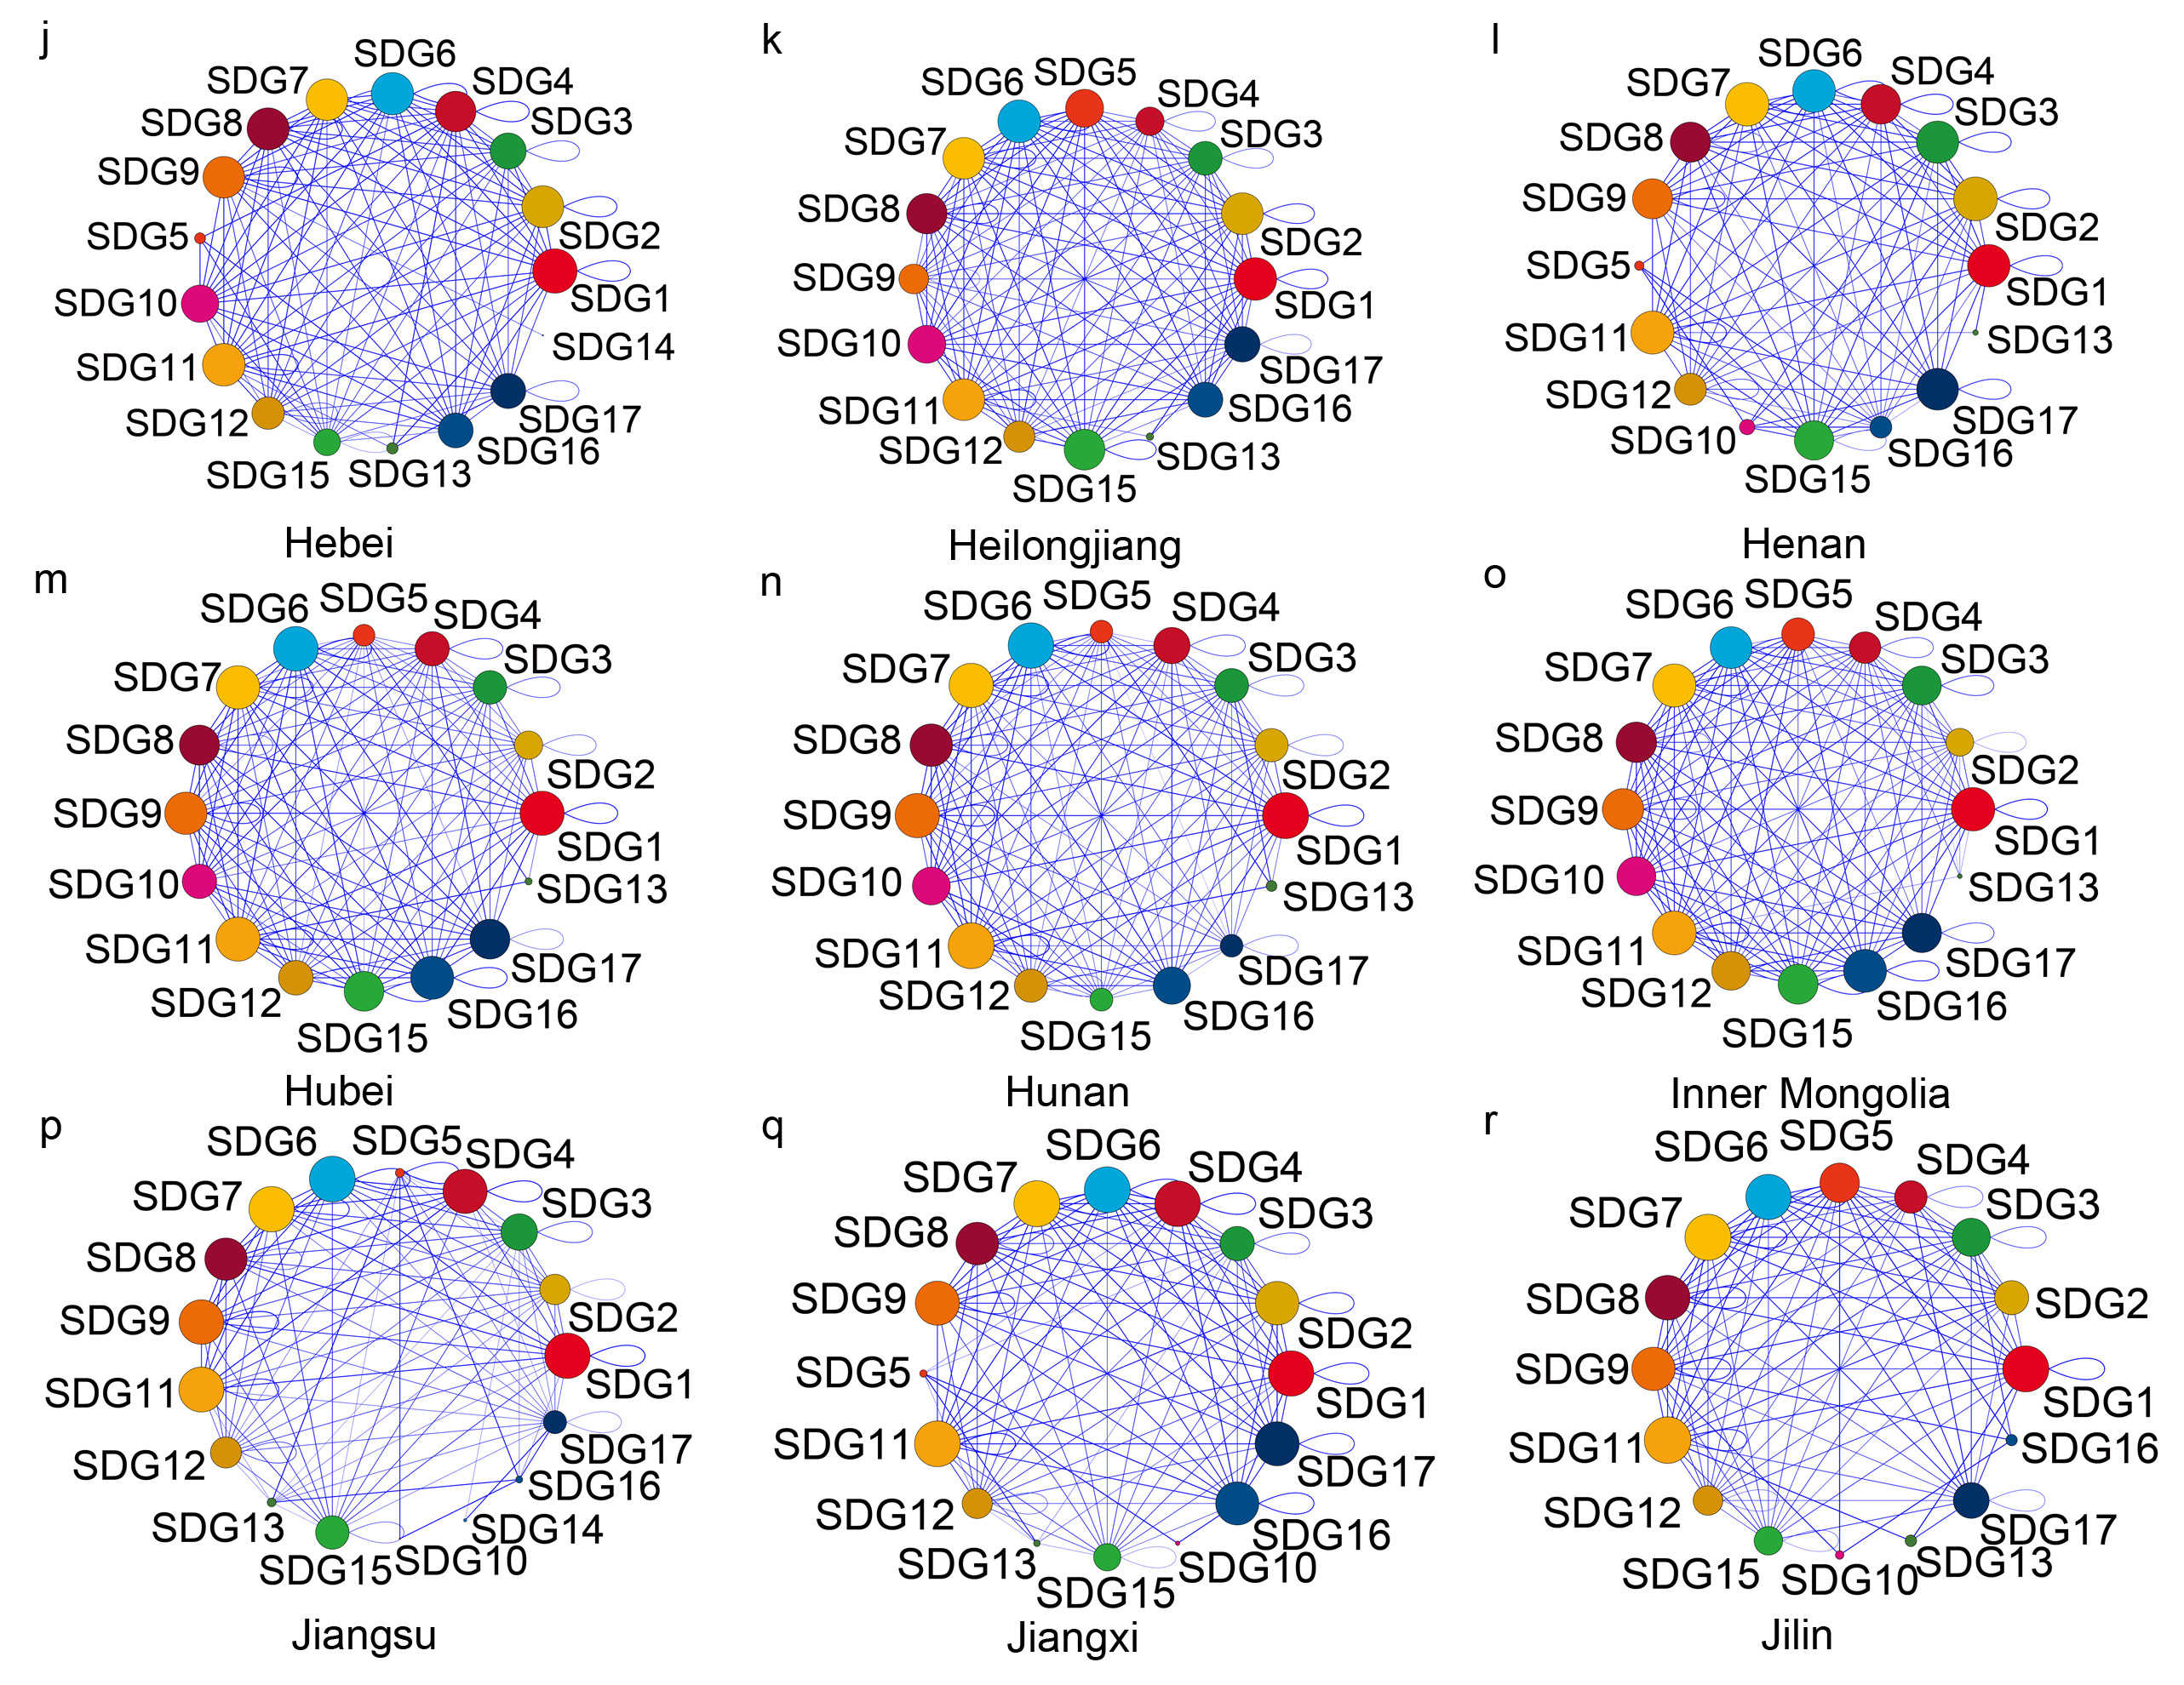
Hebei (0.3-1), Heilongjiang (0.3-1), Henan (0.29-1), Hubei (0.24-1), Hunan (0.14-1), Inner Mongolia (0.13-1), Jiangsu (0.14-1), Jiangxi (0.23-1), Jilin (0.3-1), continued,
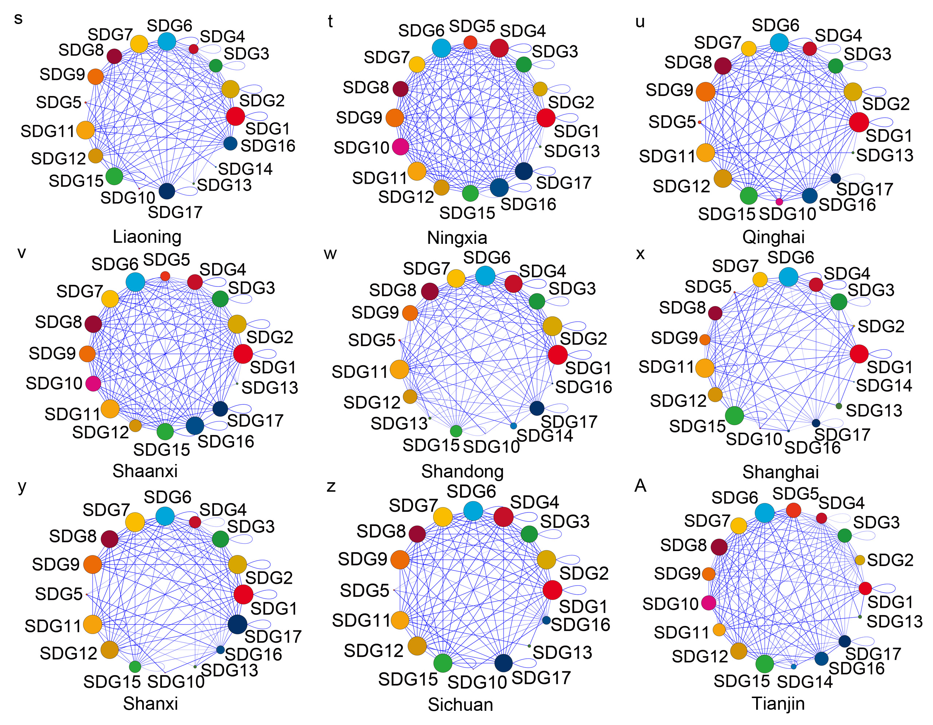
Liaoning (0.15-1), Ningxia (0.14-1), Qinghai (0.29-1), Shaanxi (0.1-1), Shandong (0.12-1), Shanghai (0.17-1), Shanxi (0.15-1), Sichuan (0.11-1), Tianjin (0.23-1), continued,
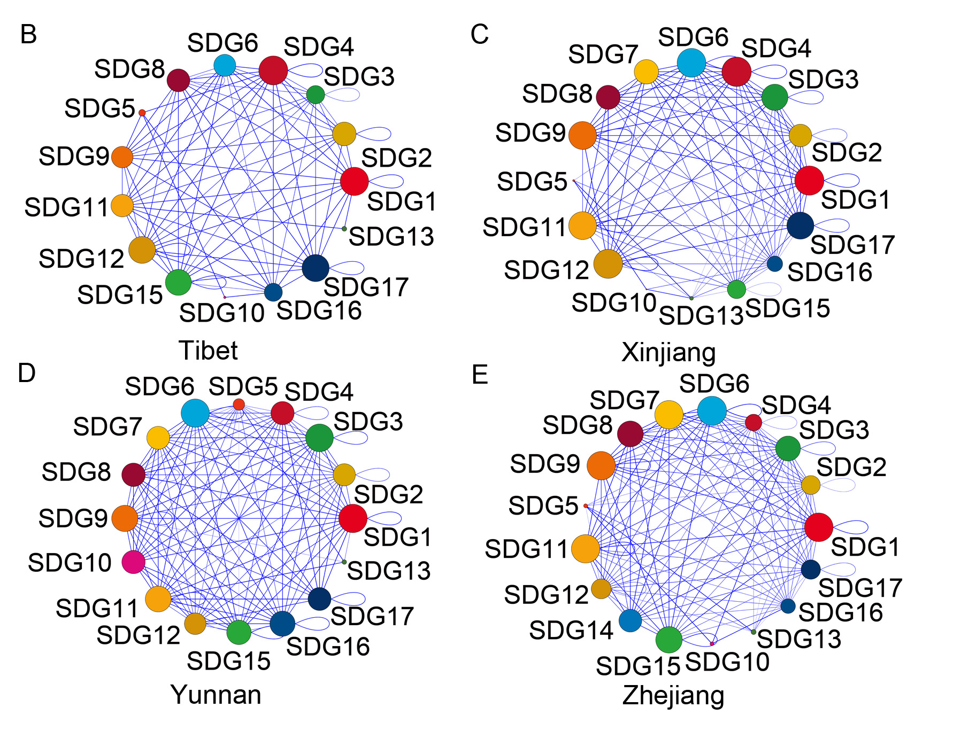
Tibet (0.46-1), Xinjiang (0.13-1), Yunnan (0.19-1) and Zhejiang (0.13-1).

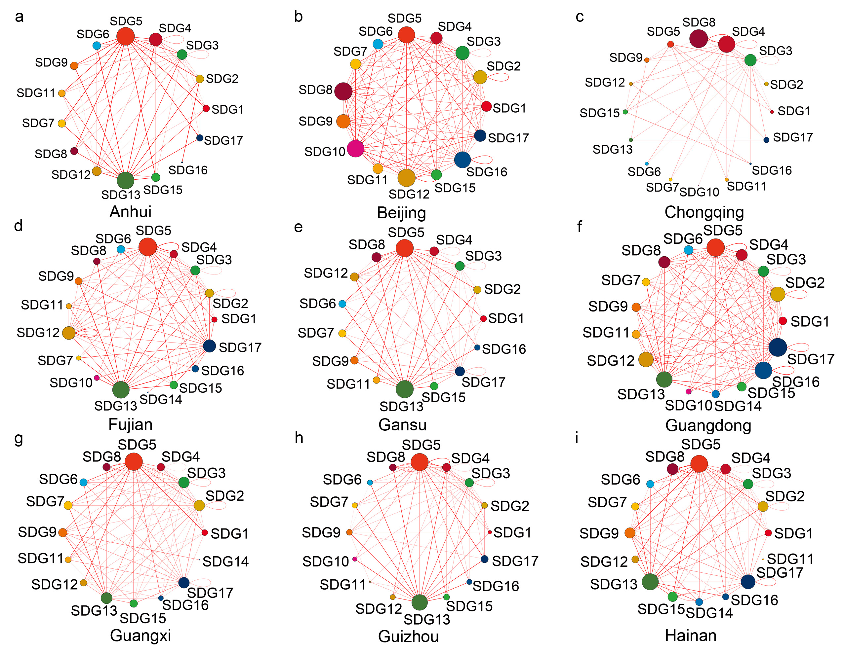

Fig. S2.
The thickness of the edge lines in the trade-off network indicates the weighted edge between SDG Pairs. The thicker the lines are, the stronger the strengths are. The size of the circle suggests its importance as a central hub in the network. The larger the circle is, the more important the node as a central hub is. In the trade-off network the edge lines is shown red. The background color of each node is consistent with the SDG icon of the United Nations (UN). The 31 trade-off networks at sub-national level in alphabetical order, including Anhui (0.05-1), Beijing (0.18-1), Chongqing (0.11-0.9), Fujian (0.09-0.97), Gansu (0.06-0.97), Guangdong (0.08-1), Guangxi (0.1-0.95), Guizhou (0.07-0.98), Hainan (0.07-0.99), continued,
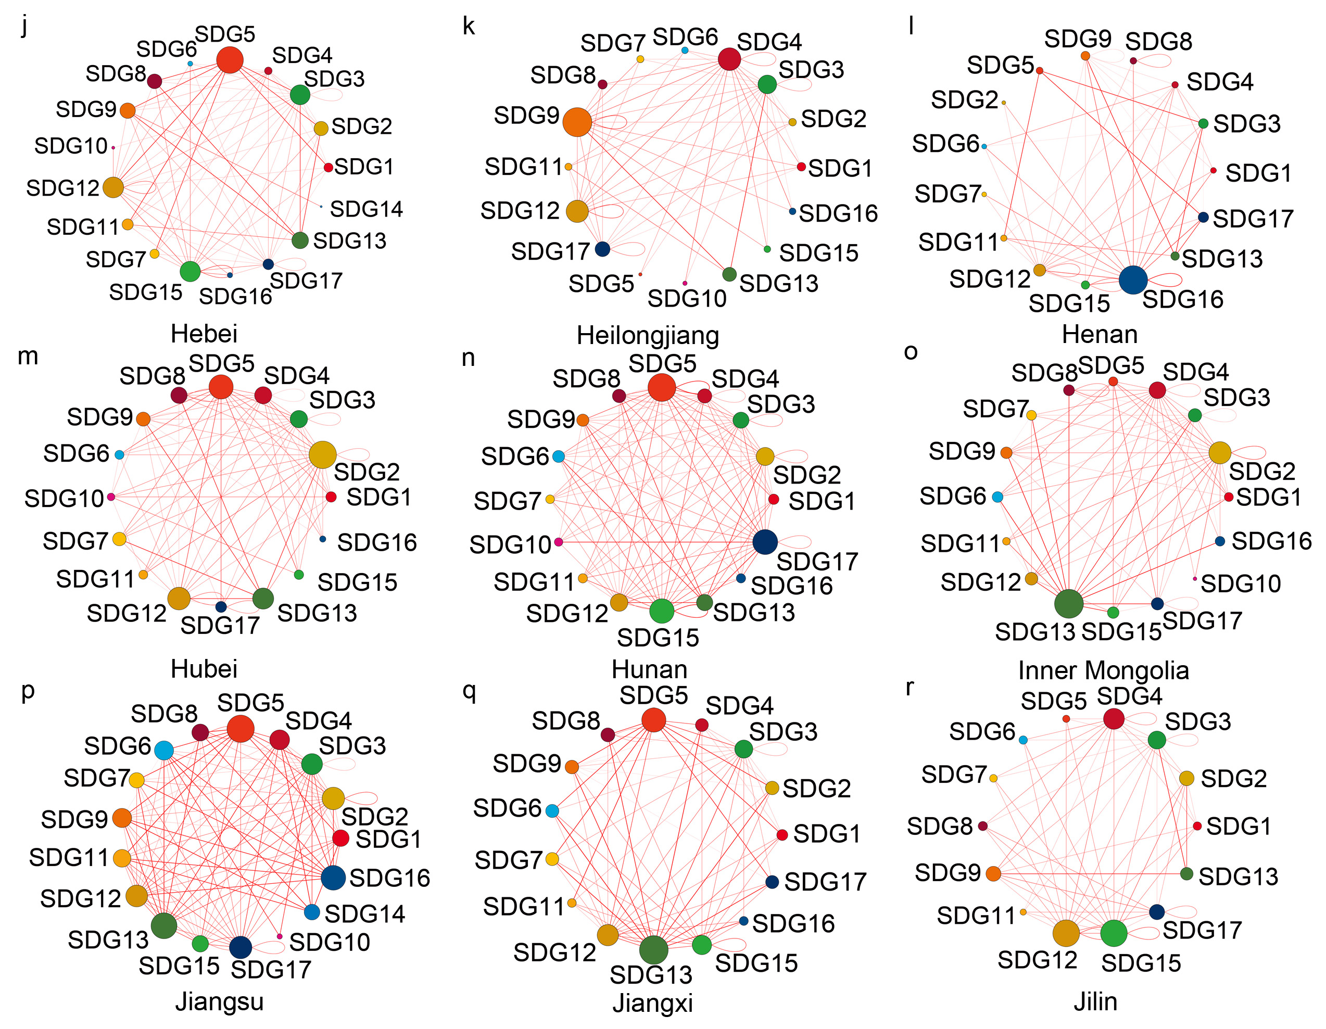
Hebei (0.08-0.91), Heilongjiang (0.12-0.87), Henan (0.04-0.93), Hubei (0.09-0.86), Hunan (0.12-0.94), Inner Mongolia (0.04-0.97), Jiangsu (0.08-1), Jiangxi (0.06-1), Jilin (0.11-0.93), continued,
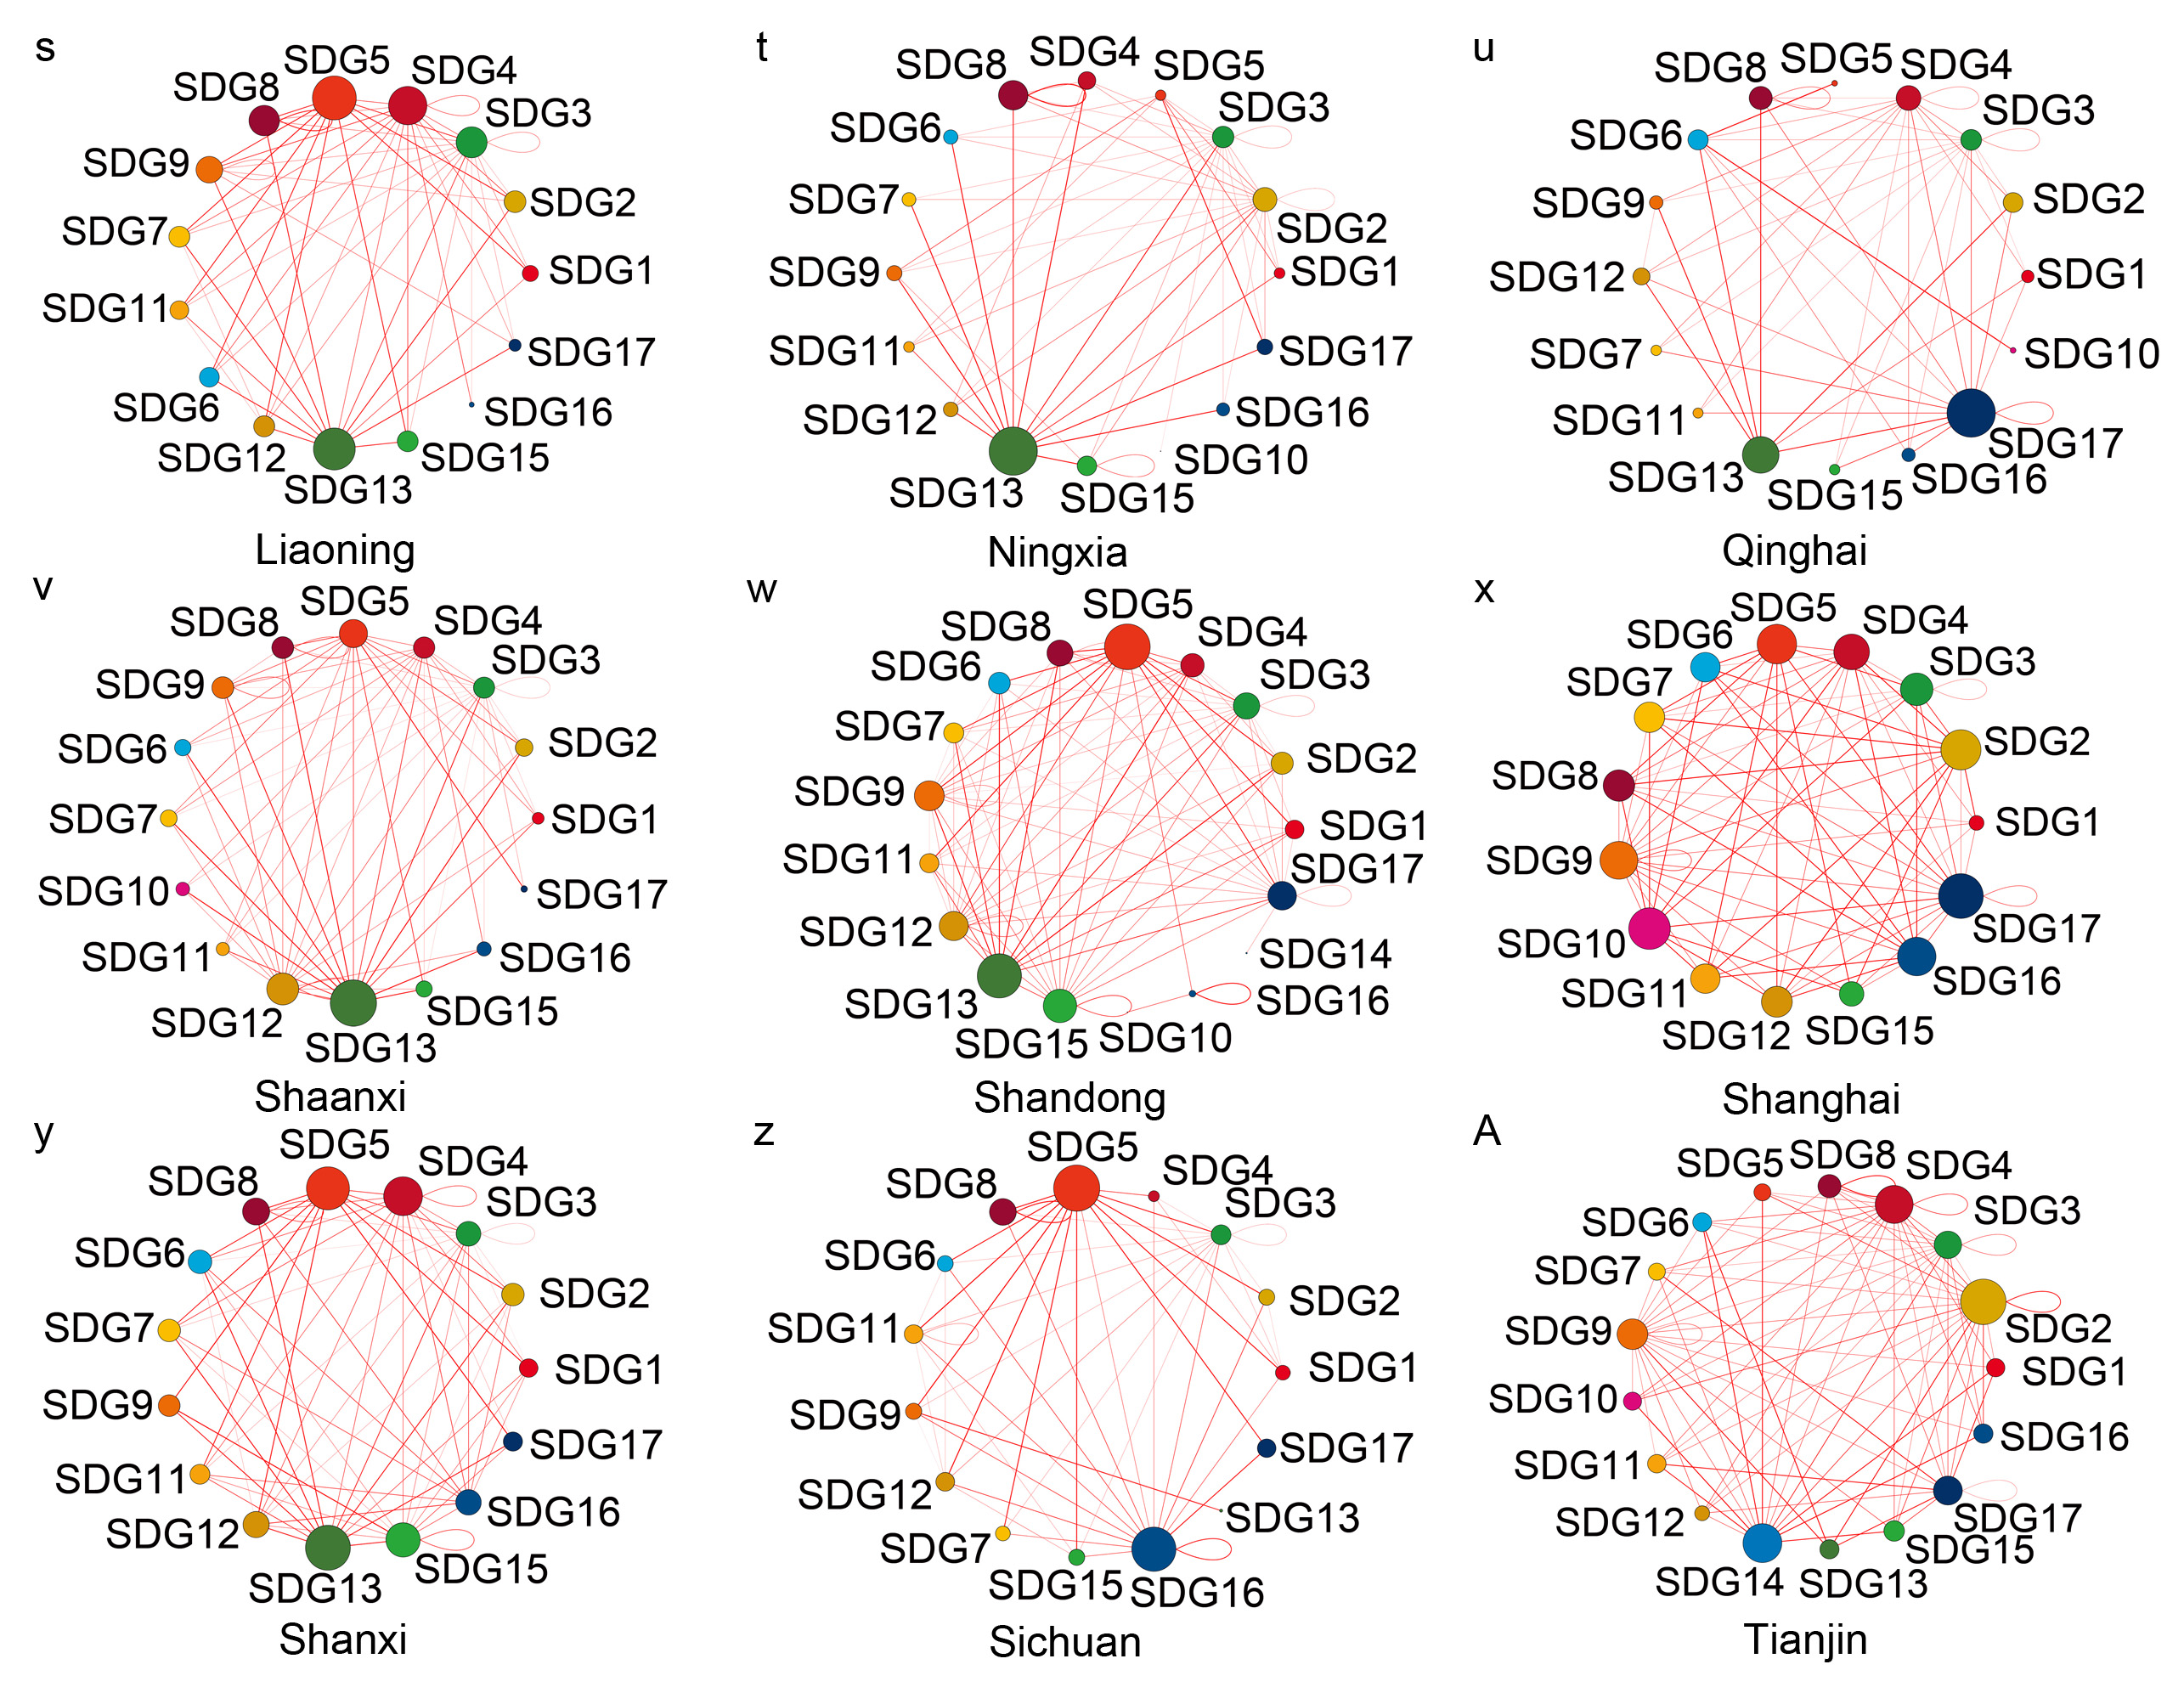
Liaoning (0.13-0.92), Ningxia (0.11-0.98), Qinghai (0.11-1), Shaanxi (0.09-0.97), Shandong (0.09-1), Shanghai (0.22-0.98), Shanxi (0.09-1), Sichuan (0.09-1), Tianjin (0.2-0.94), continued,
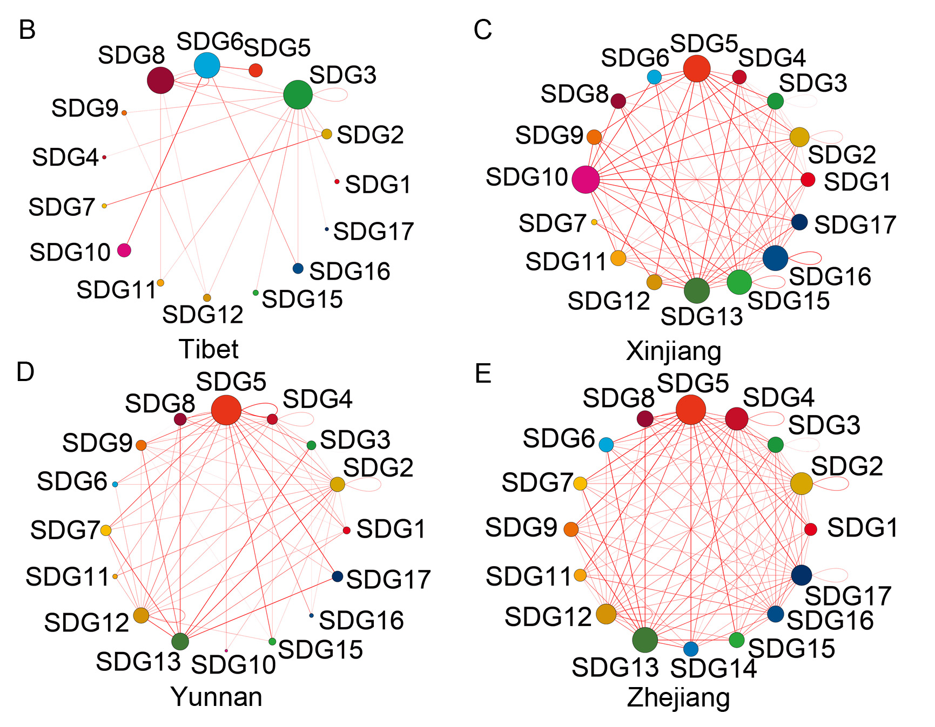
Tibet (0.14-1), Xinjiang (0.07-0.99), Yunnan (0.03-0.96) and Zhejiang (0.1-1).

Table S1.
The averaged correlation coefficient (R) and Number of indicator pairs (N) for synergy, weak synergy, trade-off and weak trade-off groups at the provincial level.

Provinces | Correlation coefficient (R) |  |  |  | Number of indicator pairs (N)
Provinces | Synergy | Weak Synergy | Trade-off | Weak Trade-off | Synergy | Weak Synergy | Trade-off | Weak Trade-off
Anhui | 0.94 | 0.50 | -0.93 | -0.43 | 872 | 2235 | 238 | 1206
Beijing | 0.94 | 0.40 | -0.93 | -0.38 | 251 | 2190 | 184 | 1886
Chongqing | 0.94 | 0.53 | -0.91 | -0.46 | 773 | 2144 | 126 | 1589
Fujian | 0.94 | 0.46 | -0.94 | -0.40 | 757 | 2264 | 235 | 1581
Gansu | 0.94 | 0.51 | -0.93 | -0.46 | 763 | 2197 | 171 | 1514
Guangdong | 0.94 | 0.49 | -0.94 | -0.46 | 660 | 2054 | 305 | 1819
Guangxi | 0.93 | 0.47 | -0.91 | -0.41 | 721 | 2270 | 242 | 1608
Guizhou | 0.94 | 0.48 | -0.93 | -0.42 | 748 | 2295 | 174 | 1412
Hainan | 0.93 | 0.47 | -0.91 | -0.42 | 438 | 2275 | 207 | 1822
Hebei | 0.96 | 0.48 | -0.92 | -0.40 | 794 | 2370 | 167 | 1607
Heilongjiang | 0.93 | 0.48 | -0.91 | -0.43 | 641 | 2167 | 147 | 1685
Henan | 0.94 | 0.49 | -0.90 | -0.43 | 677 | 2513 | 96 | 1360
Hubei | 0.94 | 0.49 | -0.91 | -0.39 | 710 | 2050 | 216 | 1666
Hunan | 0.95 | 0.50 | -0.92 | -0.46 | 820 | 2216 | 380 | 1136
Inner Mongolia | 0.93 | 0.49 | -0.93 | -0.42 | 768 | 2135 | 185 | 1560
Jiangsu | 0.94 | 0.55 | -0.94 | -0.48 | 524 | 2259 | 291 | 1760
Jiangxi | 0.95 | 0.52 | -0.94 | -0.45 | 674 | 2026 | 208 | 1644
Jilin | 0.93 | 0.43 | -0.93 | -0.42 | 476 | 2339 | 138 | 1689
Liaoning | 0.93 | 0.41 | -0.92 | -0.39 | 489 | 2562 | 202 | 1680
Ningxia | 0.94 | 0.50 | -0.92 | -0.42 | 567 | 2131 | 108 | 1743
Qinghai | 0.95 | 0.50 | -0.90 | -0.46 | 503 | 2442 | 154 | 1448
Shaanxi | 0.94 | 0.52 | -0.93 | -0.43 | 683 | 2229 | 179 | 1556
Shandong | 0.94 | 0.51 | -0.92 | -0.47 | 654 | 2217 | 247 | 1725
Shanghai | 0.93 | 0.44 | -0.91 | -0.42 | 244 | 2122 | 208 | 1957
Shanxi | 0.94 | 0.46 | -0.92 | -0.40 | 586 | 2070 | 213 | 1778
Sichuan | 0.94 | 0.52 | -0.94 | -0.44 | 721 | 2191 | 133 | 1604
Tianjin | 0.92 | 0.43 | -0.91 | -0.39 | 279 | 2283 | 174 | 1986
Tibet | 0.94 | 0.45 | -0.93 | -0.38 | 324 | 2127 | 62 | 1541
Xinjiang | 0.93 | 0.46 | -0.93 | -0.39 | 460 | 2237 | 168 | 1671
Yunnan | 0.95 | 0.49 | -0.92 | -0.40 | 789 | 2262 | 180 | 1417
Zhejiang | 0.94 | 0.50 | -0.93 | -0.48 | 680 | 2309 | 329 | 1397

Table S2.
Information about the indictors, targets and goals in the study. The name of the indicators is listed in the third column. For coding of the indicators, if the name of the indicator cannot be found in the official document of United Nations, the code of indicator is selected based on its closeness to the definition of the target and goal with the alphabet “L” added. The positive and negative sign in the fourth column refers to judging whether the higher the value of each indicator is, the better it is to promote sustainable development or the lower the value is, the better it is to promote sustainable development. The data source of every indicator is listed in the fifth column with the time range in the sixth column.

SDG | Target | Indicators | Positive or Negative | Data sources | Year
SDG1 No Poverty | 1.2 By 2030, reduce at least by half the proportion of men, women and children of all ages living in poverty in all its dimensions according to national definitions | 1.2.1 Rural poverty incidence rate | -1 | Poverty Monitoring Report of Rural China (2020)¹ | 2010-2019
SDG1 No Poverty | 1.3 Implement nationally appropriate social protection systems and measures for all, including floors, and by 2030 achieve substantial coverage of the poor and the vulnerable | 1.3.1 Proportion of population covered by insurance (endowment, unemployment, and medicare) | 1 | China Statistical Yearbook, Yearbook  of China’s Insurance ^{2,3} | 2000-2020
SDG1 No Poverty | 1.4 By 2030, ensure that all men and women, in particular the poor and the vulnerable, have equal rights to economic resources, as well as access to basic services, ownership and control over land and other forms of property, inheritance, natural resources, appropriate new technology and financial services, including microfinance | 1.4.1 Proportion of population with access to basic services such as education and insurance | 1 | China Statistical Yearbook, Yearbook  of China’s Insurance ^{2,3} | 2000-2020
SDG1 No Poverty | 1.5 By 2030, build the resilience of the poor and those in vulnerable situations and reduce their exposure and vulnerability to climate-related extreme events and other economic, social and environmental shocks and disasters | 1.5.1 Number of deaths, missing persons and directly affected persons attributed to disasters per persons attributed to disasters per 100,000 population | -1 | China Statistical Yearbook on  Environment, China Statistical  Yearbook^{2,4} | 2004-2020
SDG1 No Poverty |  | 1.5.2 Direct economic loss attributed to disasters in relation to global gross domestic product (GDP) | -1 | China Statistical Yearbook on  Environment, China Statistical  Yearbook^{2,4} | 2004-2020
SDG1 No Poverty |  | 1.5.4 Proportion of local governments that adopt and implement local disaster risk reduction strategies in line with national disaster risk reduction strategies | 1 | China Statistical Yearbook on  Environment⁵ | 2001-2020
SDG2 Zero Hunger | 2.1 By 2030, end hunger and ensure access by all people, in particular the poor and people in vulnerable situations, including infants, to safe, nutritious and sufficient food all year round | 2.1.2 Cereal yield (t/ha) | 1 | China Statistical Yearbook² | 2000-2020
SDG2 Zero Hunger | 2.2 By 2030, end all forms of malnutrition, including achieving, by 2025, the internationally agreed targets on stunting and wasting in children under 5 years of age, and address the nutritional needs of adolescent girls, pregnant and lactating women and older persons | 2.2.1 Percentage children born with low birth weight | -1 | China Health Statistical Yearbook ⁶ | 2002-2020
SDG2 Zero Hunger |  | 2.2.2 Prevalence of malnutrition among children under 5 years of age | -1 | China Health Statistical Yearbook ⁶ | 2002-2020
SDG2 Zero Hunger | 2.3 By 2030, double the agricultural productivity and incomes of small-scale food producers, in particular women, indigenous peoples, family farmers, pastoralists and fishers, including through secure and equal access to land, other productive resources and inputs, knowledge, financial services, markets and opportunities for value addition and non-farm employment | 2.3.1 Volume of production (farming/pastoral/forestry) per capita (rural population) | 1 | China Rural Statistical Yearbook,  China Population & employment  Statistics Yearbook ^{7,8} | 2000-2020
SDG2 Zero Hunger | 2.4 By 2030, ensure sustainable food production systems and implement resilient agricultural practices that increase productivity and production, that help maintain ecosystems, that strengthen capacity for adaptation to climate change, extreme weather, drought, flooding and other disasters and that progressively improve land and soil quality | 2.4.1 Proportion of agricultural area under productive and sustainable agriculture | 1 | China Statistical Yearbook² | 2000-2020
SDG2 Zero Hunger | 2.a Increase investment, including through enhanced international cooperation, in rural infrastructure, agricultural research and extension services, technology development and plant and livestock gene banks in order to enhance agricultural productive capacity in developing countries, in particular least developed countries | 2.a.L Number of agricultural extension workers per 1,000 farmers | 1 | China Statistical Yearbook on  Science and Technology, China  Population & employment Statistics  Yearbook^{7,9} | 2000-2017
SDG3 Good Health and Well-being | 3.1 By 2030, reduce the global maternal mortality ratio to less than 70 per 100,000 live births | 3.1.1 Maternal mortality ratio | -1 | China Health Statistical Yearbook ⁶ | 2002,  2005-2020
SDG3 Good Health and Well-being |  | 3.1.2 Proportion of births attended by skilled health personnel | 1 | China Health and Family Planning  Statistical Yearbook ¹⁰ | 2002-2020
SDG3 Good Health and Well-being | 3.2 By 2030, end preventable deaths of newborns and children under 5 years of age, with all countries aiming to reduce neonatal mortality to at least as low as 12 per 1,000 live births and under-5 mortality to at least as low as 25 per 1,000 live births | 3.2.1 Under-five child with low birth weight (%) | -1 | China Health Statistical Yearbook ⁶ | 2002-2020
SDG3 Good Health and Well-being |  | 3.2.2 Neonatal mortality rate (per 1,000 live births) | -1 | China Health Statistical Yearbook ⁶ | 2002-2020
SDG3 Good Health and Well-being | 3.3 By 2030, end the epidemics of AIDS, tuberculosis, malaria and neglected tropical diseases and combat hepatitis, water-borne diseases and other communicable diseases | 3.3.1 Number of new HIV infections per 100,000 uninfected population | -1 | China Health Statistical Yearbook ⁶ | 2002-2020
SDG3 Good Health and Well-being |  | 3.3.2 Tuberculosis incidence per 100,000 population | -1 | China Health Statistical Yearbook ⁶ | 2002-2020
SDG3 Good Health and Well-being |  | 3.3.3 Malaria incidence per 100,000 population | -1 | China Health Statistical Yearbook ⁶ | 2002-2020
SDG3 Good Health and Well-being |  | 3.3.4 Hepatitis B incidence per 100,000 population | -1 | China Health Statistical Yearbook ⁶ | 2002-2020
SDG3 Good Health and Well-being | 3.4 By 2030, reduce by one third premature mortality from non-communicable diseases through prevention and treatment and promote mental health and well-being | 3.4.L Annual consumption of vegetables by rural population (kg/year/person) | 1 | China Statistical Yearbook² | 2000-2012,  2015-2020
SDG3 Good Health and Well-being | 3.6 By 2020, halve the number of global deaths and injuries from road traffic accidents | 3.6.1 Death rate due to road traffic injuries (per 100,000 people) | -1 | China Statistical Yearbook² | 2000-2020
SDG3 Good Health and Well-being | 3.8 Achieve universal health coverage, including financial risk protection, access to quality essential health-care services and access to safe, effective, quality and affordable essential medicines and vaccines for all | 3.8.1 Percentage of population without effective financial protection for health care | -1 | China Statistical Yearbook² | 2002-2020
SDG3 Good Health and Well-being |  | 3.8.2 Expenditures on health as a share of total household income (urban population) | 1 | China Statistical Yearbook² | 2000-2020
SDG3 Good Health and Well-being | 3.9 By 2030, substantially reduce the number of deaths and illnesses from hazardous chemicals and air, water and soil pollution and contamination | 3.9.1 Keshan disease incidence per 100,000 population | -1 | China Health Statistical Yearbook ⁶ | 2002-2020
SDG3 Good Health and Well-being | 3.b Support the research and development of vaccines and medicines for the communicable and non-communicable diseases that primarily affect developing countries, provide access to affordable essential medicines and vaccines, in accordance with the Doha Declaration on the TRIPS Agreement and Public Health, which affirms the right of developing countries to use to the full the provisions in the Agreement on Trade-Related Aspects of Intellectual Property Rights regarding flexibilities to protect public health, and, in particular, provide access to medicines for all | 3.b.2 Total net official development assistance to medical research and basic health sectors as a proportion of government expenditure budget | 1 | Finance Yearbook of China¹¹ | 2000-2020
SDG3 Good Health and Well-being |  | 3.b.3 Percentage of health facilities meeting service specific readiness requirements (women and children care agencies) | 1 | China Health Statistical Yearbook ⁶ | 2002-2020
SDG3 Good Health and Well-being | 3.c Substantially increase health financing and the recruitment, development, training and retention of the health workforce in developing countries, especially in least developed countries and small island developing States | 3.c.1 Health worker density | 1 | China Health Statistical Yearbook ⁶ | 2002-2020
SDG4 Quality Education | 4.1 By 2030, ensure that all girls and boys complete free, equitable and quality primary and secondary education leading to relevant and effective learning outcomes | 4.1.1 Net primary enrolment rate (%) | 1 | Educational Statistics Yearbook of China¹² | 2002,  2010-2020
SDG4 Quality Education |  | 4.1.2 Completion rate (primary education, lower secondary education, upper secondary education) (%) | -1 | China Statistical Yearbook² | 2000-2020
SDG4 Quality Education | 4.3 By 2030, ensure equal access for all women and men to affordable and quality technical, vocational and tertiary education, including university | 4.3.1 Participation rate of youth and adults in formal education and training in the previous 12 months | 1 | Educational Statistics Yearbook of China¹²  China Statistical Yearbook² | 2004-2020
SDG4 Quality Education | 4.4 By 2030, substantially increase the number of youth and adults who have relevant skills, including technical and vocational skills, for employment, decent jobs and entrepreneurship | 4.4.1 Proportion of youth and adults with internet | 1 | China Statistical Yearbook² | 2011-2020
SDG4 Quality Education | 4.5 By 2030, eliminate gender disparities in education and ensure equal access to all levels of education and vocational training for the vulnerable, including persons with disabilities, indigenous peoples and children in vulnerable situations | 4.5.1 Ratio of female to male illiteracy rate | -1 | China Population & Employment  Statistic Yearbook⁷ | 2001-2020
SDG4 Quality Education | 4.6 By 2030, ensure that all youth and a substantial proportion of adults, both men and women, achieve literacy and numeracy | 4.6.1 Proportion of population achieving at least a fixed level of proficiency in functional literacy skills | 1 | Educational Statistics Yearbook of China¹²  China Statistical Yearbook² | 2000-2020
SDG4 Quality Education | 4.a Build and upgrade education facilities that are child, disability and gender sensitive and provide safe, non-violent, inclusive and effective learning environments for all | 4.a.L Number of computers per school: (a) primary; (b) lower secondary; and (c) upper secondary education | 1 | Educational Statistics Yearbook of China¹² | 2002-2019
SDG4 Quality Education | 4.b By 2020, substantially expand globally the number of scholarships available to developing countries, in particular least developed countries, small island developing States and African countries, for enrolment in higher education, including vocational training and information and communications technology, technical, engineering and scientific programmes, in developed countries and other developing countries | 4.b.L Government expenditure on education (% total government expenditure) | 1 | Finance Yearbook of China¹¹ | 2000-2020
SDG4 Quality Education | 4.c By 2030, substantially increase the supply of qualified teachers, including through international cooperation for teacher training in developing countries, especially least developed countries and small island developing States | 4.c.1 Proportion of teachers in: (a) preprimary; (b) primary; (c) lower secondary; and (d) upper secondary education who have got a bachelor degree or above | 1 | Educational Statistics Yearbook of China¹² | 2002-2019
SDG5 Gender Equality | 5.3 Eliminate all harmful practices, such as child, early and forced marriage and female genital mutilation | 5.3.2 Ratio of female to male sterilization rate | -1 | China Population & Employment  Statistic Yearbook⁷ | 2000-2017
SDG5 Gender Equality | 5.5 Ensure women’s full and effective participation and equal opportunities for leadership at all levels of decision-making in political, economic and public life | 5.5.1 Proportion of seats held by women in parliaments (national and provincial people’s congress in China) | 1 | the National People's Congress of the People's Republic of China¹³ | 2003-2017
SDG5 Gender Equality |  | 5.5.2L Ratio of male to female employment rate | -1 | China Population & Employment  Statistic Yearbook⁷ | 2001-2020
SDG5 Gender Equality | 5.a Undertake reforms to give women equal rights to economic resources, as well as access to ownership and control over land and other forms of property, financial services, inheritance and natural resources, in accordance with national laws | 5.a.1 Share of women among owners or rights-bearers of agricultural land | 1 | China Population & Employment  Statistic Yearbook⁷ | 2003-2020
SDG5 Gender Equality | 5.b Enhance the use of enabling technology, in particular information and communications technology, to promote the empowerment of women | 5.b.L Ratio of female to male illiteracy rate | -1 | China Population & Employment  Statistic Yearbook⁷ | 2001-2020
SDG6 Clean Water and Sanitation | 6.1 By 2030, achieve universal and equitable access to safe and affordable drinking water for all | 6.1.1 The proportion of the population benefiting from the treated water - Endemic fluorosis (water type) per 100,000 population | 1 | China Health Statistical Yearbook ⁶ | 2002-2020
SDG6 Clean Water and Sanitation | 6.2 By 2030, achieve access to adequate and equitable sanitation and hygiene for all and end open defecation, paying special attention to the needs of women and girls and those in vulnerable situations | 6.2.1 Popularity rate of sanitary toilet in rural area | 1 | China Rural Statistical Yearbook ⁸ | 2002-2017
SDG6 Clean Water and Sanitation | 6.3 By 2030, improve water quality by reducing pollution, eliminating dumping and minimizing release of hazardous chemicals and materials, halving the proportion of untreated wastewater and substantially increasing recycling and safe reuse globally | 6.3.1 Sewage treatment rate in cities (%) | 1 | China Urban Construction Statistical Yearbook ¹⁴ | 2002-2020
SDG6 Clean Water and Sanitation | 6.4 By 2030, substantially increase water-use efficiency across all sectors and ensure sustainable withdrawals and supply of freshwater to address water scarcity and substantially reduce the number of people suffering from water scarcity | 6.4.1 Water-use efficiency (Water consumption per GDP) | -1 | China Statistical Yearbook² | 2002-2020
SDG6 Clean Water and Sanitation |  | 6.4.2 Level of water stress: freshwater withdrawal as a proportion of available freshwater resources | -1 | China Statistical Yearbook² | 2002-2020
SDG6 Clean Water and Sanitation | 6.6 By 2020, protect and restore water-related ecosystems, including mountains, forests, wetlands, rivers, aquifers and lakes | 6.6.1 Wetland area as a proportion of total land area | 1 | China Statistical Yearbook on  Environment, China Statistical Yearbook ^{2,4} | 2004-2019
SDG7 Affordable and Clean Energy | 7.1 By 2030, ensure universal access to affordable, reliable and modern energy services | 7.1.2 Proportion of population with access to gas in cities (%) | 1 | China Statistical Yearbook² | 2001-2020
SDG7 Affordable and Clean Energy | 7.2 By 2030, increase substantially the share of renewable energy in the global energy mix | 7.2.1 Proportion of clean energy power generation to total power generation (%) | 1 | China Energy Statistical Yearbook ¹⁵ | 2000-2020
SDG7 Affordable and Clean Energy | 7.3 By 2030, double the global rate of improvement in energy efficiency | 7.3.1 Energy intensity measured in terms of primary energy and GDP | -1 | China Energy Statistical Yearbook,  China Statistical Yearbook^{2,15} | 2000-2019
SDG8 Decent Work and Economic Growth | 8.1 Sustain per capita economic growth in accordance with national circumstances and, in particular, at least 7 per cent gross domestic product growth per annum in the least developed countries | 8.1.1 Annual growth rate of real GDP per capita |  | China Statistical Yearbook² | 2001-2020
SDG8 Decent Work and Economic Growth | 8.2 Achieve higher levels of economic productivity through diversification, technological upgrading and innovation, including through a focus on high-value added and labour-intensive sectors | 8.2.1 Annual growth rate of real GDP per employed person | 1 | China Statistical Yearbook² | 2001-2020
SDG8 Decent Work and Economic Growth | 8.4 Improve progressively, through 2030, global resource efficiency in consumption and production and endeavour to decouple economic growth from environmental degradation, in accordance with the 10-Year Framework of Programmes on Sustainable Consumption and Production, with developed countries taking the lead | 8.4.2 Resource (water, energy) consumption per capita | -1 | China Energy Statistical Yearbook,  China Statistical Yearbook^{2,15} | 2000-2020
SDG8 Decent Work and Economic Growth | 8.8 Protect labour rights and promote safe and secure working environments for all workers, including migrant workers, in particular women migrants, and those in precarious employment | 8.8.1 Fatal and non-fatal occupational injuries treatment per 10,000 employed persons | 1 | China Statistical Yearbook² | 2000-2020
SDG8 Decent Work and Economic Growth | 8.9 By 2030, devise and implement policies to promote sustainable tourism that creates jobs and promotes local culture and products | 8.9.1 Tourism direct GDP as a proportion of total GDP | 1 | Yearbook of China Tourism  Statistics, China Statistical Yearbook  ^{2,16} | 2000-2020
SDG9 Industry, Innovation and Infrastructure | 9.1 Develop quality, reliable, sustainable and resilient infrastructure, including regional and transborder infrastructure, to support economic development and human well-being, with a focus on affordable and equitable access for all | 9.1.2 Passenger and freight volumes, by mode of transport (railway, highway, water transport) | 1 | Yearbook of China Transportation &  Communications, China Statistical  Yearbook^{2,17} | 2000-2020
SDG9 Industry, Innovation and Infrastructure | 9.2 Promote inclusive and sustainable industrialization and, by 2030, significantly raise industry’s share of employment and gross domestic product, in line with national circumstances, and double its share in least developed countries | 9.2.1 Manufacturing value added as a proportion of GDP | 1 | China Statistical Yearbook² | 2000-2020
SDG9 Industry, Innovation and Infrastructure |  | 9.2.2 Manufacturing employment as a proportion of total employment | 1 | China Population & Employment  Statistic Yearbook⁷ | 2000-2020
SDG9 Industry, Innovation and Infrastructure | 9.3 Increase the access of small-scale industrial and other enterprises, in particular in developing countries, to financial services, including affordable credit, and their integration into value chains and markets | 9.3.1 Proportion of small-scale industries in total industry value added | 1 | China Industry Statistical Yearbook  ¹⁸ | 2001-2003,  2005-2016,  2019-2020
SDG9 Industry, Innovation and Infrastructure | 9.4 By 2030, upgrade infrastructure and retrofit industries to make them sustainable, with increased resource-use efficiency and greater adoption of clean and environmentally sound technologies and industrial processes, with all countries taking action in accordance with their respective capabilities | 9.4.1 CO₂ emission per unit of value | -1 | China Statistical Yearbook, Shan. et  al., 2018, 2020, Guan et al. 2021 ^{2,19-21} | 2000-2019
SDG9 Industry, Innovation and Infrastructure | 9.5 Enhance scientific research, upgrade the technological capabilities of industrial sectors in all countries, in particular developing countries, including, by 2030, encouraging innovation and substantially increasing the number of research and development workers per 1 million people and public and private research and development spending | 9.5.1 Research and development expenditure as a proportion of GDP | 1 | China Statistical Yearbook on  Science and Technology, China  Statistical Yearbook ^{2,9} | 2000-2020
SDG9 Industry, Innovation and Infrastructure |  | 9.5.2 Researchers (in full-time equivalent) as a proportion of total population | 1 | China Statistical Yearbook on  Science and Technology, China  Statistical Yearbook ^{2,9} | 2000-2020
SDG9 Industry, Innovation and Infrastructure | 9.c Significantly increase access to information and communications technology and strive to provide universal and affordable access to the Internet in least developed countries by 2020 | 9.c.1 Proportion of population covered by a mobile network | 1 | China Statistical Yearbook² | 2014-2020
SDG10 Reduced Inequalities | 10.2 By 2030, empower and promote the social, economic and political inclusion of all, irrespective of age, sex, disability, race, ethnicity, origin, religion or economic or other status | 10.2.L Share of women among owners or rights-bearers of agricultural land | 1 | China Population & Employment  Statistic Yearbook⁷ | 2003-2020
SDG10 Reduced Inequalities | 10.3 Ensure equal opportunity and reduce inequalities of outcome, including by eliminating discriminatory laws, policies and practices and promoting appropriate legislation, policies and action in this regard | 10.3.L Proportion of seats held by women in parliaments (national and provincial people’s congress in China) | 1 | the National People's Congress of the People's Republic of China¹³ | 2003-2017
SDG10 Reduced Inequalities | 10.4 Adopt policies, especially fiscal, wage and social protection policies, and progressively achieve greater equality | 10.4.1 Wages as a proportion of GDP | 1 | China Statistical Yearbook² | 2002-2009,  2011-2020
SDG11 Sustainable cities and Communities | 11.1 By 2030, ensure access for all to adequate, safe and affordable housing and basic services and upgrade slums | 11.1.L Percentage of urban population below minimum living guarantee | -1 | China Statistical Yearbook² | 2000-2009,  2011-2020
SDG11 Sustainable cities and Communities | 11.2 By 2030, provide access to safe, affordable, accessible and sustainable transport systems for all, improving road safety, notably by expanding public transport, with special attention to the needs of those in vulnerable situations, women, children, persons with disabilities and older persons | 11.2.1 Passenger volumes (per capita) | 1 | China Statistical Yearbook² | 2002-2020
SDG11 Sustainable cities and Communities | 11.5 By 2030, significantly reduce the number of deaths and the number of people affected and substantially decrease the direct economic losses relative to global gross domestic product caused by disasters, including water-related disasters, with a focus on protecting the poor and people in vulnerable situations | 11.5.1 Number of deaths, missing persons and directly affected persons attributed to disasters per 100,000 population | -1 | China Statistical Yearbook on  Environment, China Statistical  Yearbook^{2,4} | 2004-2020
SDG11 Sustainable cities and Communities |  | 11.5.2 Direct economic loss in relation to global GDP, damage to critical infrastructure and number of disruptions to basic services, attributed to disasters (% GDP) | -1 | China Statistical Yearbook on  Environment, China Statistical  Yearbook^{2,4} | 2004-2020
SDG11 Sustainable cities and Communities |  | 11.5.3L Road traffic deaths per 100,000 population | -1 | China Statistical Yearbook, China  Civil Affairs’ Statistical Yearbook ^{2,22} | 2000-2020
SDG11 Sustainable cities and Communities | 11.6 By 2030, reduce the adverse per capita environmental impact of cities, including by paying special attention to air quality and municipal and other waste management | 11.6.1 Ratio of industrial solid waste generated to the waste regularly collected and utilized | -1 | China Statistical Yearbook² | 2000-2020
SDG11 Sustainable cities and Communities | 11.7 By 2030, provide universal access to safe, inclusive and accessible, green and public spaces, in particular for women and children, older persons and persons with disabilities | 11.7.1 Green area in park per capita (square meters per person) | 1 | China Statistical Yearbook² | 2001-2020
SDG12 Responsible Consumption and Production | 12.2 By 2030, achieve the sustainable management and efficient use of natural resources | 12.2.2 Resource (e.g., water, energy) consumption per capita | -1 | China Energy Statistical Yearbook,  China Statistical Yearbook^{2,15} | 2000-2020
SDG12 Responsible Consumption and Production | 12.4 By 2020, achieve the environmentally sound management of chemicals and all wastes throughout their life cycle, in accordance with agreed international frameworks, and significantly reduce their release to air, water and soil in order to minimize their adverse impacts on human health and the environment | 12.4.2 Hazardous waste generated per capita | -1 | China Statistical Yearbook on  Environment, China Statistical Yearbook ^{2,4} | 2000-2020
SDG12 Responsible Consumption and Production | 12.5 By 2030, substantially reduce waste generation through prevention, reduction, recycling and reuse | 12.5.1 Percentage of industrial solid waste recycled (%) | 1 | China Statistical Yearbook on  Environment, China Statistical Yearbook ^{2,4} | 2000-2020
SDG12 Responsible Consumption and Production | 12.a Support developing countries to strengthen their scientific and technological capacity to move towards more sustainable patterns of consumption and production | 12.a.1 Installed renewable energy-generating capacity in developing countries (in watts per capita) | 1 | China Energy Statistical Yearbook,  China Statistical Yearbook^{2,15} | 2000-2019
SDG12 Responsible Consumption and Production | 12.b Develop and implement tools to monitor sustainable development impacts for sustainable tourism that creates jobs and promotes local culture and products | 12.b.L Tourism direct GDP as a proportion of total GDP | 1 | Yearbook of China Tourism  Statistics, China Statistical Yearbook  ^{2,16} | 2000-2020
SDG13 Climate Action | 13.1 Strengthen resilience and adaptive capacity to climate-related hazards and natural disasters in all countries | 13.1.1 Number of deaths, missing persons and directly affected persons attributed to disasters per 100,000 population | -1 | China Statistical Yearbook on  Environment, China Statistical  Yearbook^{2,4} | 2004-2020
SDG13 Climate Action |  | 13.1.3 Proportion of local governments that adopt and implement local disaster risk reduction strategies in line with national disaster risk reduction strategies | 1 | China Statistical Yearbook on  Environment⁵ | 2001-2020
SDG13 Climate Action | 13.2 Integrate climate change measures into national policies, strategies and planning | 13.2.2 Total CO2 emissions per year (tCO2) | -1 | China Statistical Yearbook, Shan. et  al., 2018, 2020, Guan et al. 2021^{2,19-21} | 2000-2019
SDG14  Life below Water | 14.1 By 2025, prevent and significantly reduce marine pollution of all kinds, in particular from land-based activities, including marine debris and nutrient pollution | 14.1.L Ratio of wastewater discharged at ocean to marine areas with established rights | -1 | China Marine Statistical Yearbook ²³ | 2000-2015
SDG14  Life below Water | 14.5 By 2020, conserve at least 10 per cent of coastal and marine areas, consistent with national and international law and based on the best available scientific information | 14.5.1 Ratio of marine protected area to marine area with established rights | 1 | China Marine Statistical Yearbook ²³ | 2000-2018
SDG14  Life below Water | 14.a Increase scientific knowledge, develop research capacity and transfer marine technology, taking into account the Intergovernmental Oceanographic Commission Criteria and Guidelines on the Transfer of Marine Technology, in order to improve ocean health and to enhance the contribution of marine biodiversity to the development of developing countries, in particular small island developing States and least developed countries | 14.a.1 Personnel in R&D in the field of ocean study (per million inhabitants) | 1 | China Marine Statistical Yearbook ²³ | 2000-2018
SDG15  Life on Land | 15.1 By 2020, ensure the conservation, restoration and sustainable use of terrestrial and inland freshwater ecosystems and their services, in particular forests, wetlands, mountains and drylands, in line with obligations under international agreements | 15.1.1 Forest area as a proportion of total land area | 1 | China Forestry Statistical Yearbook,  ²⁴ | 2002-2020
SDG15  Life on Land |  | 15.1.2 Wetland area as a proportion of total land area | 1 | China Statistical Yearbook on Environment, China Statistical Yearbook ^{2,4} | 2004-2019
SDG15  Life on Land | 15.2 By 2020, promote the implementation of sustainable management of all types of forests, halt deforestation, restore degraded forests and substantially increase afforestation and reforestation globally | 15.2.1 Afforestation area as a percent of forest area | 1 | China Forestry Statistical Yearbook,  ²⁴ | 2002-2020
SDG15  Life on Land | 15.3 By 2030, combat desertification, restore degraded land and soil, including land affected by desertification, drought and floods, and strive to achieve a land degradation-neutral world | 15.3.1 Proportion of land that is degraded over total land area | -1 | China Statistical Yearbook on Environment⁴ | 2004-2020
SDG15  Life on Land | 15.a Mobilize and significantly increase financial resources from all sources to conserve and sustainably use biodiversity and ecosystems | 15.a.1 Official development assistance and public expenditure on conservation and sustainable use of biodiversity and ecosystems as a proportion of GDP | 1 | China Forestry Statistical Yearbook,  China Statistical Yearbook^{2,24} | 2002-2018
SDG15  Life on Land | 15.b Mobilize significant resources from all sources and at all levels to finance sustainable forest management and provide adequate incentives to developing countries to advance such management, including for conservation and reforestation | 15.b.1 Government expenditure on environmental pollution control as a proportion of GDP | 1 | China Statistical Yearbook on Environment,  China Statistical Yearbook^{2,4} | 2004-2017
SDG16 Peace, Justice and Strong Institutions | 16.6 Develop effective, accountable and transparent institutions at all levels | 16.6.1 Primary government expenditures as a proportion of original approved budget | 1 | Finance Yearbook of China¹¹ | 2000-2020
SDG16 Peace, Justice and Strong Institutions | 16.7 Ensure responsive, inclusive, participatory and representative decision-making at all levels | 16.7.1 Proportions of positions (population groups) in public institutions (national and local legislatures, public service, and judiciary) compared to national distributions | 1 | the National People's Congress of the People's Republic of China¹³ | 2003-2017
SDG16 Peace, Justice and Strong Institutions | 16.9 By 2030, provide legal identity for all, including birth registration | 16.9.L Proportion of children under 3 years of age whose births have been registered with a civil authority | 1 | China Health Statistical Yearbook ⁶ | 2002-2020
SDG16 Peace, Justice and Strong Institutions | 16.b Promote and enforce non-discriminatory laws and policies for sustainable development | 16.b.L Proportion of seats held by women in parliaments (national and provincial people’s congress in China) | 1 | the National People's Congress of the People's Republic of China¹³ | 2003-2017
SDG17 Partnerships for the Goals | 17.1 Strengthen domestic resource mobilization, including through international support to developing countries, to improve domestic capacity for tax and other revenue collection | 17.1.1 Total government revenue as a proportion of GDP | 1 | China Statistical Yearbook, Finance  Yearbook of China ^{2,11} | 2000-2020
SDG17 Partnerships for the Goals |  | 17.1.2 The percentage share of tax revenues in a country's gross domestic product (GDP) | 1 | Finance Yearbook of China, China  Statistical Yearbook ^{2,11} | 2003-2020
SDG17 Partnerships for the Goals | 17.3 Mobilize additional financial resources for developing countries from multiple sources | 17.3.1 Foreign direct investments (FDI) proportion of total domestic budget | 1 | Finance Yearbook of China, China  Statistical Yearbook ^{2,11} | 2000-2020
SDG17 Partnerships for the Goals |  | 17.3.2 Foreign direct investments (FDI) as a proportion of total GDP | 1 | Finance Yearbook of China, China  Statistical Yearbook ^{2,11} | 2000-2020
SDG17 Partnerships for the Goals | 17.8 Fully operationalize the technology bank and science, technology and innovation capacity-building mechanism for least developed countries by 2017 and enhance the use of enabling technology, in particular information and communications technology | 17.8.1 Proportion of individuals using the Internet | 1 | China  Statistical Yearbook ² | 2011-2020
SDG17 Partnerships for the Goals | 17.14 Enhance policy coherence for sustainable development | 17.14.L Government health and education spending (% GDP) | 1 | Finance Yearbook of China, China  Statistical Yearbook ^{2,11} | 2000-2020
SDG17 Partnerships for the Goals | 17.15 Respect each country’s policy space and leadership to establish and implement policies for poverty eradication and sustainable development | 17.15.L Expenditure on social security and employment (% total government expenditure) | 1 | Finance Yearbook of China, China  Statistical Yearbook ^{2,11} | 2000-2020

Table S3.
The regional division in China following Resource and Environment Science and Data Center, Chinese Academy of Science²⁵

Regions | Provinces
Southwest | Tibet, Sichuan, Chongqing, Guizhou, Yunnan
East | Shanghai, Jiangsu, Zhejiang, Anhui, Jiangxi, Shandong, Fujian
Central South | Henan, Hubei, Hunan, Guangxi, Guangdong, Hainan
North | Inner Mongolia, Beijing, Tianjin, Hebei, Shanxi
Northwest | Xinjiang, Gansu, Qinghai, Ningxia, Shaanxi
Northeast | Heilongjiang, Jilin, Liaoning

Supplementary text
Supplementary results on the priority of SDGs at the national level
We also found that China achieved great co-benefits on most of the SDGs at the national level, such as SDG1 (No Poverty), SDG2 (Zero Hunger), SDG3 (Good Health and Well-being), SDG4 (Quality Education), SDG6 (Clean Water and Sanitation), SDG7 (Affordable and Clean Energy), SDG8 (Decent Work and Economic Growth), SDG9 (Industry, Innovation and Infrastructure), SDG10 (Reduced Inequalities), SDG11 (Sustainable cities and Communities), and SDG15 (Life on Land).

Supplementary results on the priority of SDGs among provinces
Among the 19 provinces, 14 of them had the highest trade-off in SDG5 (Gender Equality) (Anhui, Fujian, Gansu, Guangxi, Guizhou, Hainan, Hebei, Hunan, Jiangsu, Liaoning, Shandong, Sichuan, Yunnan, and Zhejiang) and 5 of them had the highest trade-off in SDG13 (Climate Action) (Inner Mongolia, Jiangxi, Ningxia, Shaanxi, Shanxi).
The highest goal in trade-off differed among the other 12 provinces (Hubei and Tianjin: SDG2 (Zero Hunger); Tibet: SDG3 (Good Health and Well-being); Beijing and Chongqing: SDG8 (Decent Work and Economic Growth); Heilongjiang: SDG9 (Industry, Innovation and Infrastructure); Xinjiang: SDG10 (Reduced Inequalities); Jilin: SDG12 (Responsible Consumption and Production); Henan: SDG16 (Peace, Justice and Strong Institutions); Guangdong, Qinghai, Shanghai: SDG17 (Partnerships for the Goals)).

Among the 24 provinces, 14 of them had the highest synergy in SDG1 (No Poverty) (Anhui, Beijing, Fujian, Gansu, Guangdong, Guangxi, Hainan, Hebei, Hunan, Liaoning, Qinghai, Shaanxi, Shanxi, Yunnan) and 10 of them had the highest synergy in SDG6 (Clean Water and Sanitation) (Chongqing, Guizhou, Heilongjiang, Hubei, Jiangsu, Ningxia, Shandong, Shanghai, Tianjin, Zhejiang).
The highest goal in synergy differed among the other 7 provinces (Henan: SDG2 (Zero Hunger); Sichuan, Tibet, and Xinjiang: SDG4 (Quality Education); Inner Mongolia and Jilin: SDG11 (Sustainable cities and Communities); Jiangxi: SDG7 (Affordable and Clean Energy)).

Supplementary discussion on the availability of indicator data
Previous studies are based on the public SDG Index database at global and national levels, which may not be applicable at the sub-national level. Using indicators suitable for the sub-national level will be of great help in identifying the common but differentiated priorities among the 17 SDGs from synergy and trade-off perspectives. Nevertheless, it is indeed not easy to find suitable indicators available at the national and sub-national levels simultaneously. After massive efforts on data collection, our list of indicators included a total of 102 SDG indicators (118 original indicator and 102 after calculation), 81 targets, and 17 goals, at both the national level and sub-national level on a yearly basis, which is greater than the number of indicators in the 2022 SDG Index and Dashboards Report (which used 88 indicators to assess China's SDGs performances at the national level) ²⁶ and one previous study (which used 88 indicators, 71 targets, and 16 goals to calculate the score of 16 goals in China and analyze the SDGs interactions between 3 general categories using the score at the goal level)²⁷. Our understanding of the SDGs interaction networks in China at provincial, regional and national levels will evolve as more data become available.

Supplementary discussion on the high trade-off in SDG13 and SDG5
China needs to strengthen the top-level design of carbon peak and carbon neutral, propose a systematic, all-round plan for every sector, lead all-round green transformation to combat climate change (SDG13). On one side, it requires reductions in high carbon emissions from economic development (SDG8) ²¹, especially the industry (SDG9) and traditional energy sectors (SDG7)²¹, and from agriculture (SDG2)²⁸; on the other side, it requires reinforcing the carbon sink in China’s terrestrial ecosystems (SDG15)²⁹. Besides, it also needs reducing the threat to water supplies and sanitation services (SDG6)³⁰⁻³¹, quality education (SDG4)³²⁻³³, and human health (SDG3)³⁴⁻³⁵.
The central government should take the lead to strengthen the top-level design and launch a package of much stronger plans and measures in every sector in the short and long terms to promote the all-round development of women and girl. In particular, they should reduce gender gap in women’s employment rate and wage (SDG8 and SDG9)³⁶, participation in decision-making (SDG5)³⁷, healthcare (SDG3)³⁸, rural and secondary education (SDG4)^{37, 39}, poverty reduction (SDG1)⁴⁰, rights protection in agriculture, forestry and animal husbandry (SDG2 and SDG15)⁴¹, water and sanitation (SDG6)⁴², and building partnership (SDG17)⁴³.

Reference
- China Statistics Press, “Poverty Monitoring Report of Rural China” (Department of Household Surveys of the National Bureau of Statistics of China, 2020).
- China Statistics Press, “China Statistical Yearbook” (National Bureau of Statistics of the People's Republic of China, 2001-2021) [in Chinese].
- Press of Yearbook of China's Insurance, “Yearbook of China's Insurance” (China Insurance Regulatory Commission, 2001-2021).
- China Statistics Press, “China Statistical Yearbook on Environment” (National Bureau of Statistics & State Environmental Protection Administration of the People's Republic of China, 2001-2021) [in Chinese].
- Friends of Nature. China Environmental Yearbook (in Chinese). (Brill, 2001-2021).
- Pecking Union Medical College Press, “China Health Statistical Yearbook” (Ministry of Health of the People's Republic of China, 2001-2021) [in Chinese].
- China Statistics Press, “China Population & Employment Statistic Yearbook” (Department of Population and Employment Statistics of the National Bureau of Statistics of China, 2007-2021) [in Chinese].
- China Statistics Press, “China Rural Statistical Yearbook” (National Bureau of Statistics of the People's Republic of China, 2001-2021) [in Chinese].
- China Statistics Press, “China Statistical Yearbook on Science and Technology” (National Bureau of Statistics of the People's Republic of China & Ministry of Science and Technology of China, 2001-2021) [in Chinese].
- China Statistics Press, “China Health and Family Planning Statistical Yearbook” (National Bureau of Statistics of the People's Republic of China, 2001-2021) [in Chinese].
- China Financial & Economic Publishing House, “Finance Yearbook of China” (Ministry of Finance of the People's Republic of China, 2001-2021) [in Chinese].
- People's Education Press, “Educational Statistics Yearbook of China” (Ministry of Education of the People's Republic of China, 2001-2021) [in Chinese].
- The National People's Congress of the People's Republic of China, <http://www.npc.gov.cn> (2022).
- China Statistics Press, “China Urban Construction Statistical Yearbook” (Ministry of Housing Urban-Rural Development People’s Republic of China, 2003-2021) [in Chinese].
- China Statistics Press, “China Energy Statistical Yearbook” (National Bureau of Statistics of the People's Republic of China, 2001-2021) [in Chinese].
- China Tourism Press, “Yearbook of China Tourism Statistics” (National Tourism Administration of the People's Republic of China, 2001-2021) [in Chinese].
- China Communications Press, “Yearbook of China Transportation & Communications” (The National Development and Reform Commission of the People's Republic of China, 2001-2021) [in Chinese].
- China Statistics Press, “China Industry Statistical Yearbook” (National Bureau of Statistics of the People's Republic of China, 2001-2021) [in Chinese].
- Shan, Y. et al. China CO 2 emission accounts 1997–2015. Scientific Data 5, 170201 (2018).
- Shan, Y. et al. China CO 2 emission accounts 2016-2017. Scientific Data 5, 170201 (2020).
- Guan, D. et al. Assessment to China's Recent Emission Pattern Shifts. Earth's Future, 9 (11), e2021EF002241 (2021)
- China Statistics Press, “China Civil Affairs' Statistical Yearbook” (Ministry of Civil Affairs of the People's Republic of China, 2001-2021) [in Chinese].
- China Ocean Press, “China Marine Statistical Yearbook” (State Oceanic Administration of the People's Republic of China, 2001-2021) [in Chinese].
- Chinese Forestry Press, “China Forestry Statistical Yearbook” (State Forestry Administration of the People's Republic of China, 2001-2021) [in Chinese].
- The regional division in China, http://www.resdc.cn/data.aspx?DATAID=276, accessed on January 15th, 2023.
- Sachs, J., Lafortune, G., Kroll, C., Fuller, G., Woelm, F.. From Crisis to Sustainable Development: the SDGs as Roadmap to 2030 and Beyond. Sustainable Development Report 2022, Cambridge: Cambridge University Press, doi.org/10.1017/9781009210058 (2022).
- Zhang J, Wang S, Pradhan P, et al. Untangling the interactions among the Sustainable Development Goals in China. Sci. Bull. 67(9): 977-984 (2022).
- Liang, D., Lu, X., Zhuang, M., Shi, G., Hu, C., Wang, S., & Hao, J.. China’s greenhouse gas emissions for cropping systems from 1978–2016. Scientific Data, 8(1), 171 (2021).
- Piao, S., He, Y., Wang, X., & Chen, F.. Estimation of China’s terrestrial ecosystem carbon sink: Methods, progress and prospects. Science China Earth Sciences, 65(4), 641-651 (2022).
- How China Is Responding to Its Water Woes, https://thediplomat.com/2022/09/how-china-is-responding-to-its-water-woes/, accessed on March, 10, 2023
- Climate change adaptation and resilience and water, sanitation and hygiene: links between SDG 13 and SDG 6, Policy brief for the 2019 High Level Political Forum, https://washmatters.wateraid.org/sites/g/files/jkxoof256/files/climate-change-adaptation-and-resilience-and-water-sanitation-and-hygiene-links-between-sdg-13-and-sdg-6_0.pdf, accessed on April 8th, 2023.
- Education is under threat from climate change - especially for women and girls, https://www.ox.ac.uk/news/features/education-under-threat-climate-change-especially-women-and-girls, accessed on March 10th, 2023.
- United Nations International Children's Emergency Fund. It is getting hot: call for education systems to respond to the climate crisis. UNICEF East Asia and Pacific Regional Office (2019).
- Joint Global Change Research Institute and Battelle Memorial Institute, Pacific Northwest Division. China: The Impact of Climate Change to 2030 A Commissioned Research Report (2009).
- Patz, J., Campbell-Lendrum, D., Holloway, T. et al. Impact of regional climate change on human health. Nature 438, 310–317 (2005).
- Brussevich, M., Dabla-Norris, E., & Li, B. G.. China's Rebalancing and Gender Inequality (2021).
- Binli C., & Hailan H.. Falling behind the Rest? China and the Gender Gap Index. 8(2), 10–22 (2020).
- Zhou, M., Zhao, S. & Zhao, Z. Gender differences in health insurance coverage in China. Int J Equity Health 20, 52 (2021).
- Yuexuan L. Gender Inequality in Education in China. Advances in Social Science, Education and Humanities Research, volume 615 (2021).
- Women and poverty in China: what has been missed out in the poverty elimination campaign? https://alumni.ids.ac.uk/news/blogs-perspectives-provocations-initiatives/613/613-Women-and-poverty-in-China-what-has-been-missed-out-in-the-poverty-elimination-campaign, accessed on Feb. 20, 2023.
- Yan Z, Wei F, Deng X, Li C, He Q, Qi Y. Feminization of Agriculture: Do Female Farmers Have Higher Expectations for the Value of Their Farmland?—Empirical Evidence from China. Agriculture. 12(1):60 (2022).
- China Women’s Development Foundation, https://give2asia.org/cwdf/, accessed on Mar., 22, 2023.
- China’s companies giving more opportunities to women, https://asiapacific.unwomen.org/ en/news-and-events/stories/2021/03/chinas-companies-giving-more-opportunities-to-women, accessed on Apr., 24, 2023.

