Supplementary Information

Ultrasensitive touch sensor based on phase inversion with sacrificial template strategy for tactile/slip sensing

Yue Liu^{1, 2}, Juan Tao^{1, 2}, Yepei Mo^{1, 2}, Rongrong Bao^{1, 2, 3*}, Caofeng Pan^{1, 2, 3*}

Table of Contents

Supplementary Notes 1
Supplementary Note 1: Preparation principle and universality of sensitive layer 1
Supplementary Note 2: Interface analysis and performance of sensitive layer 5
Supplementary Note 3: Sensing performance of the touch-sensor 13
Supplementary Note 4: Analysis methods of the slip sensing 17
Supplementary Note 5: Influencing factors of slip sensing 21
Supplementary Note 6: Verification of slip sensing recognition accuracy 23
Supplementary References 24

Supplementary Notes

Supplementary Note 1: Preparation principle and universality of sensitive layer
Supplementary Equation 1 Analysis of the phase inversion process from a thermodynamic point.
From the point of thermodynamic properties, we can use the Flory -Huggins theory to draw a ternary phase diagram of the material system to study the phase separation mechanism of the film formation process¹. In this case, its free energy can be expressed as:
$\frac{∆G_{m}}{RT}=n_{1}\ln{Ф_{1}+n_{2}\ln{Ф_{2}}+n_{2}\ln{Ф_{3}+χ_{12}n_{1}Ф_{3}+χ_{23}n_{2}Ф_{3}}}$ (1-1)
Where, the subscripts 1, 2 and 3 are the non-solvent, solvent and polymer; ,are the gas constants and absolute temperatures; and are the moles and volume fractions of the components; are the interaction parameters between solvent and polymer, as a function; andare the non-solvent-solvent and non-solvent-polymer interaction parameters, respectively².
Supplementary Table 1 Interaction parameters of the ternary material systems
Polymer | Solvent | Non-solvent
TPU  TPU  TPU  TPU | DMF  DMF  DMF  DMF | water  MeOH  EtOH  IPA | 2.870  0.500  0.140  0.005 | 2.89  2.89  2.89  2.89 | 7.57  3.53  3.19  2.15
The polymers and solvents remain TPU and DMF, and the non-solvents are chosen as methanol (MeOH), ethanol (EtOH) and isopropanol (IPA), in addition to water. After reviewing the literature, it is known that the interaction parameters of the four systems are shown in Supplementary Table 1².
According to the analysis of thermodynamic properties, it is known that the tendency of phase separation of two components is related to their interaction parameters. When their interaction parameters are different, the tendency of phase separation will be more obvious due to the deterioration of the compatibility of two components. But water molecules with special structures are more different from theof alcohols, so the mechanism of phase separation is also more different.
In addition, it is known from the interaction parameters in the experiment that when the non-solvent is water, is the maximum value. The TPU solution is rapidly contracted by the epidermis when it meets water, and the phase separation phenomenon occurs, and the inhomogeneous porous structure is formed due to the coalescence of DMF solvent.
Supplementary Equation 2 Analysis of the phase inversion process from a kinetic point.
The apparent diffusion coefficient at 25 ℃ is obtained from Eq. (1-2):
(1-2)
Where, (cm²/s) is the diffusion coefficient of the solutein the solvent at low concentration; and(10⁻⁵ N/cm) is the surface tension ofand, respectively; (K) is the temperature; (mPa·s) is the viscosity of solvent; and(cm³/mol) is the molar volume of soluteand solventat normal boiling point³.
Since the theory of the spinodal curve is based on the overall motion of the macromolecule, while in the diffusion-permeation phase, the moving unit of the polymer can only be in the form of chain segments. Therefore, the spinodal curve is not valid at this time, which means that the surface composition of the membrane can enter the spinodal zone under equilibrium conditions and undergo phase separation⁴.

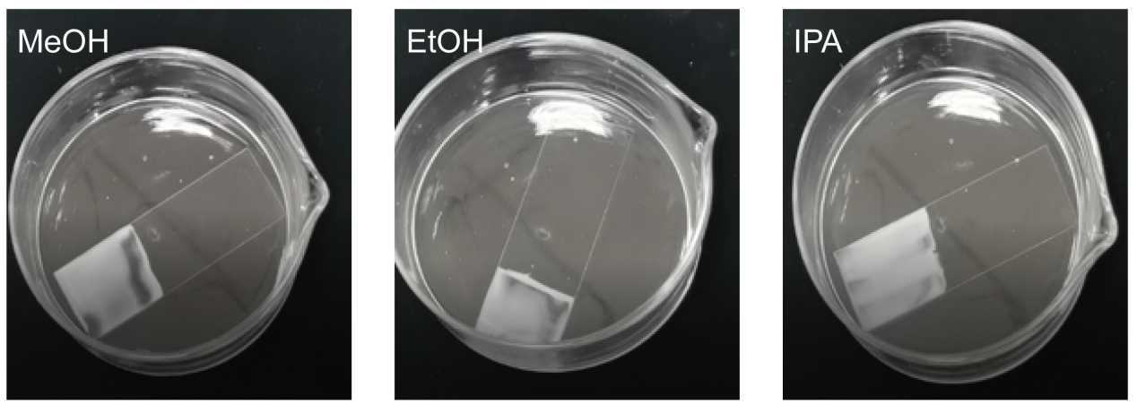
Supplementary Figure 1 | Optical photographs of TPU films prepared by different non-solvent systems.
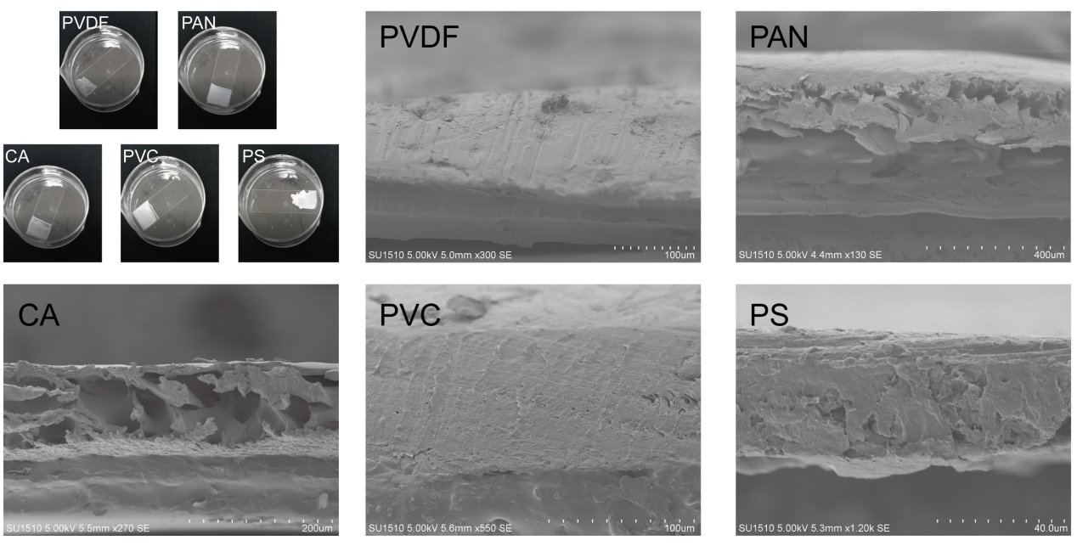
Supplementary Figure 2 | Experimental photos and SEM images of different ternary materials by phase inversion method.
In addition, to verify the generalizability of this strategy, we verified the film formation using the phase inversion method for different material systems with the polymer-solvent-non-solvent composition of PVDF-DMF-H₂O, PAN-DMF-H₂O, CA-DMF-H₂O, PVC-DMF-H₂O, and PS-DMF-H₂O. The SEM images of the five films are shown in Supplementary Fig. 3, demonstrating the feasibility of the phase inversion method for tactile sensor preparation.
Supplementary Table 2 Apparent diffusivity of different solvents and non-solvents
Solvent-Non-solvent system
DMF-water  DMF-MeOH  DMF-EtOH  DMF-IPA | 1.095  1.979  1.054  0.493 | 2.720  2.280  1.953  1.744 | 1.625  0.301  0.899  1.251
According to the kinetic property analysis, it can be seen that are greater than 0 in all the four systems, which indicates that all the four different ternary systems exhibit faster diffusion from solvent to non-solvent. Therefore, the experimentally obtained TPU films all show a certain degree of shrinkage. Among them, the phase separation of methanol and ethanol system is slower, and the phase separation of water system has an obvious trend³.

Supplementary Note 2: Interface analysis and performance of sensitive layer
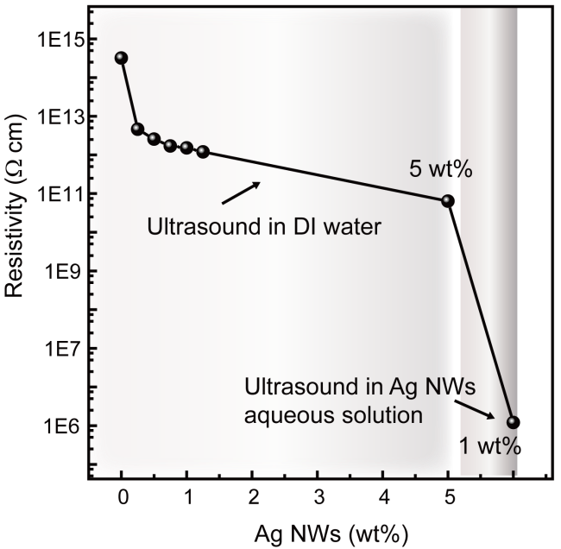
Supplementary Figure 3 | Volume resistance of TPU mixed films with different Ag NWs concentrations^{5,6}.
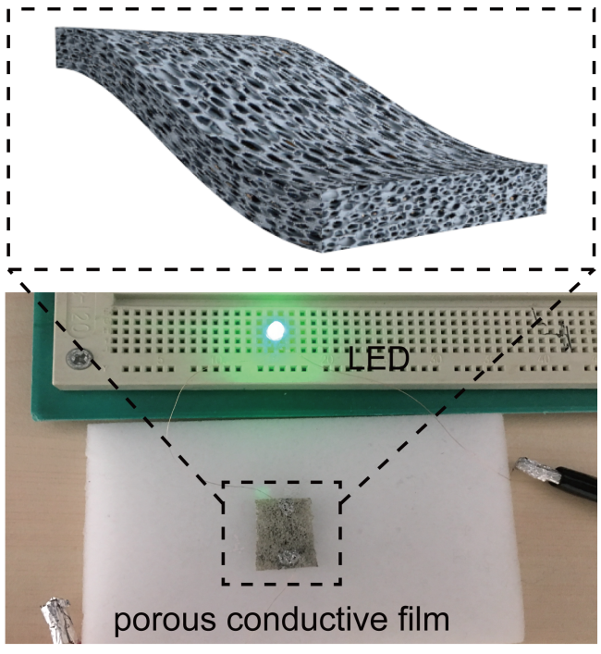
Supplementary Figure 4 | The photograph of a LED that still glows when the Ag NWs/TPU composite film is connected in series to a circuit without loading.
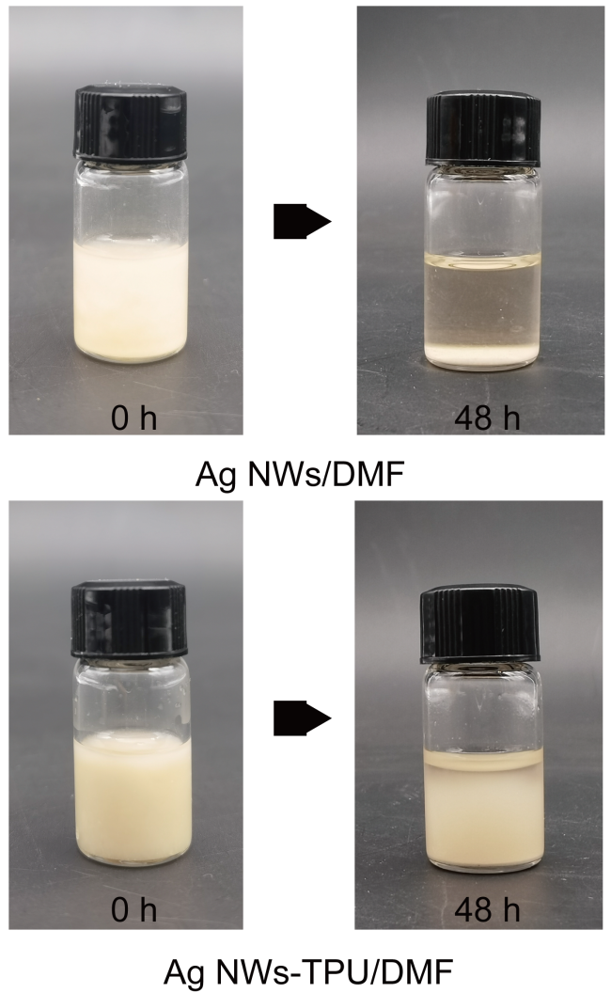
Supplementary Figure 5 | Stability test of Ag NWs mixed with TPU solution by resting for 48 hours⁷.
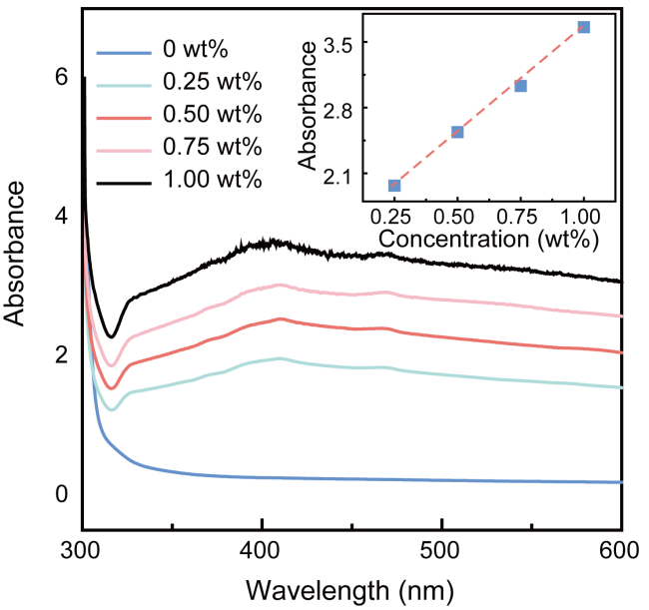
Supplementary Figure 6 | UV-Vis on TPU mixed solutions containing different Ag NWs concentrations.
The Ag NWs have a relatively obvious surface plasmon resonance peak (SPR) near the wavelength of 409 nm, which should be caused by the transverse plasmon resonance⁸. With the increase of concentration of Ag NWs, the value of the absorption peak also increases gradually. According to the Lambert-Beer law, when a beam of parallel monochromatic light vertically passes through a uniform non-scattering light-absorbing material, its absorbance ($A$) is proportional to the concentration ($c$) of the light-absorbing material and the thickness of the absorption layer ($d$), where $k$ is the proportional coefficient of light absorption, that is⁹:
(2-1)
So, from the roughly linear relationship between Ag NWs concentration and absorbance of composite solutions at the wavelength of 409 nm (the inset of Supplementary Fig. 7), good homogeneity of the composite solution can be verified.
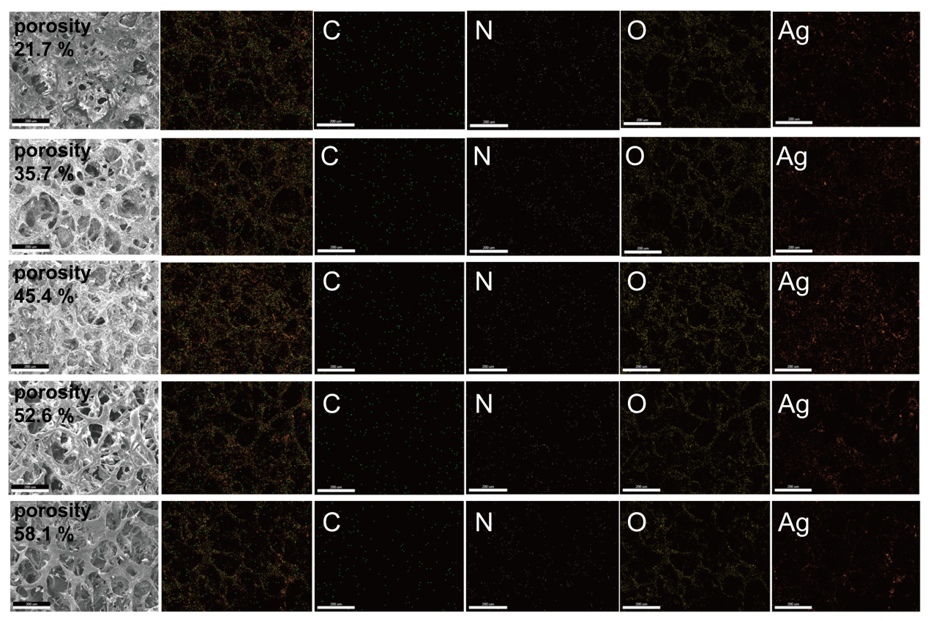
Supplementary Figure 7 | EDS element mapping energy spectrum of Ag NWs/TPU films with different porosity (Scale bars, 200 μm).

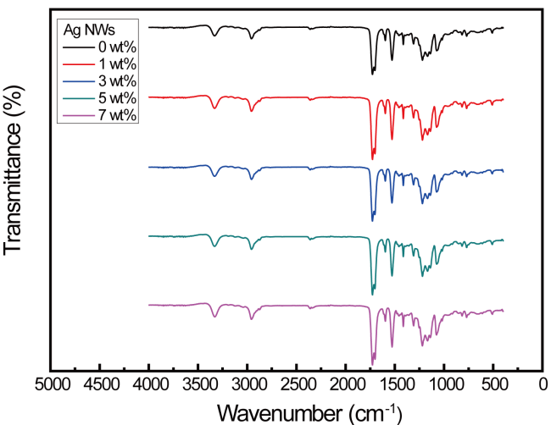
Supplementary Figure 8 | Fourier transform infrared spectra (FTIR) of Ag NWs-TPU films with different Ag NWs contents.
In order to verify the reason for good homogeneity of the Ag NWs-TPU mixed solution, we prepared it into an Ag NWs-TPU film, and further studied the interfacial interaction between Ag NWs and TPU. Firstly, the Ag NWs/TPU films are tested by Fourier transform infrared spectroscopy (FTIR). The peak positions of TPU films with different Ag NWs concentration are identical to those of pure TPU films, which indicates that no unknown organic matter is adsorbed on the surface of Ag NWs. Therefore, the high stability between Ag NWs and TPU is not due to the chemical combination of the two materials. Therefore, the better dispersion stability of Ag NWs in the TPU may be due to physical adsorption. Then, the interfacial interaction between TPU and Ag NWs are further verified by wetting theory and friction theory.
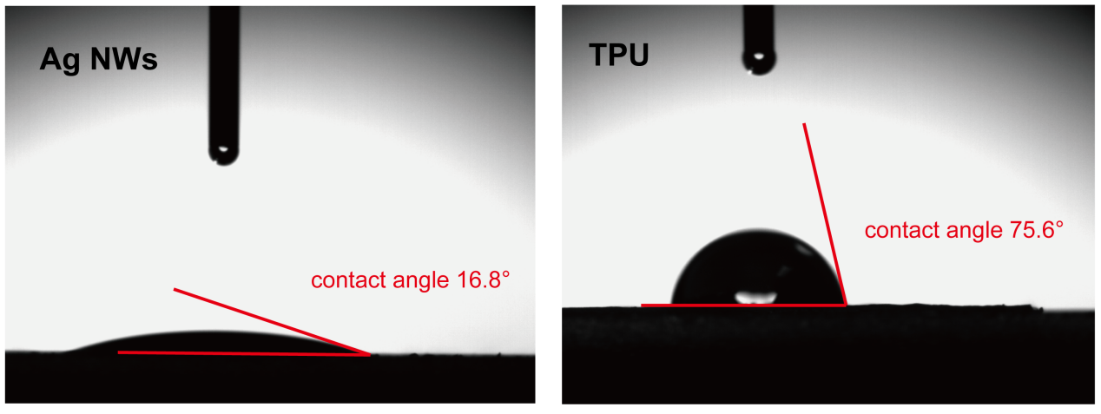
Supplementary Figure 9 | Verification of infiltration theory: Ag NWs and TPU contact angle test.
The wettability test shows that the contact angles of TPU and Ag NWs are 75.6˚ and 16.8˚, respectively. According to the method of evaluating the wettability of the solid surface, the higher the surface free energy of the solid, the better the wetting of water droplets on the surface of the solid, and the smaller the contact angle. While the lower the surface free energy of the solid, the water droplets on the surface of the solid can’t be well wetted, the contact angle is larger. Since the surface free energy of Ag NWs is higher than the cohesive energy density of TPU, so Ag NWs are active fillers. Under the action of interfacial force, the interfacial structure should be TPU/loose layer/dense layer/Ag NWs, and the cohesive strength of TPU is much smaller than its physical adsorption bond strength on the high-energy surface, so the Ag NWs/TPU mixed solution relatively more stable^{7,10}.
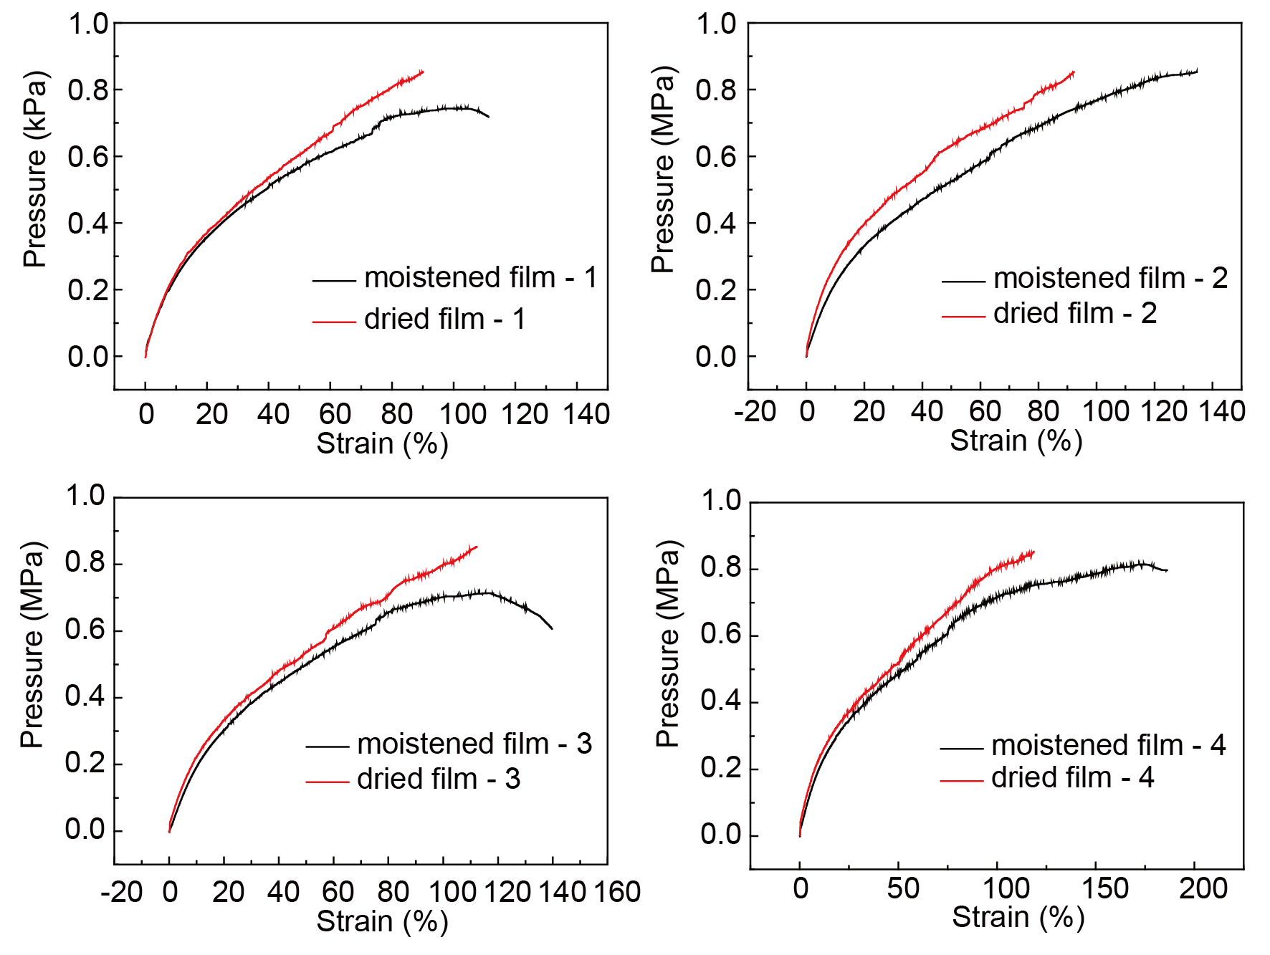
Supplementary Figure 10 | Verification of friction theory: stress-strain curves of dried and wetted samples.
Friction theory refers to the bonding of the interface between the matrix and the reinforcing material due to friction, and the strength of the composite is determined by the friction coefficient of the two phases^{7,10}.
There is a frictional effect in the bonding of the two-phase interface, which is shown by the fact that the strength of the composite decreases when low molecules such as water are immersed, but the strength can be partially recovered after drying. Friction may also exist between Ag NWs and TPU, so stress-strain tests are performed on the same films after drying and wetting, and four samples, numbered 1, 2, 3, 4 are tested separately. It can be seen from the test results that the film strength after drying is greater. This may be due to the fact that the friction coefficient between TPU and Ag NWs decreases after water immersion, which reduces the ability of the interface to transmit stress. While the friction coefficient between TPU and Ag NWs increases after drying, and the ability to transmit stress recovers get bigger. So, the prepared films are immersed into water and dried it, and it is known from the test results that the strength of the dried film is greater. This is because the coefficient of friction between TPU and Ag NWs decreases after water is immersed into the interface, and the ability of the interface to transfer stress is weakened, so the strength decreases. And after drying, the water in the interface decreases, the friction coefficient between TPU and Ag NWs increases, the ability to transfer stress increases, and the strength becomes larger.
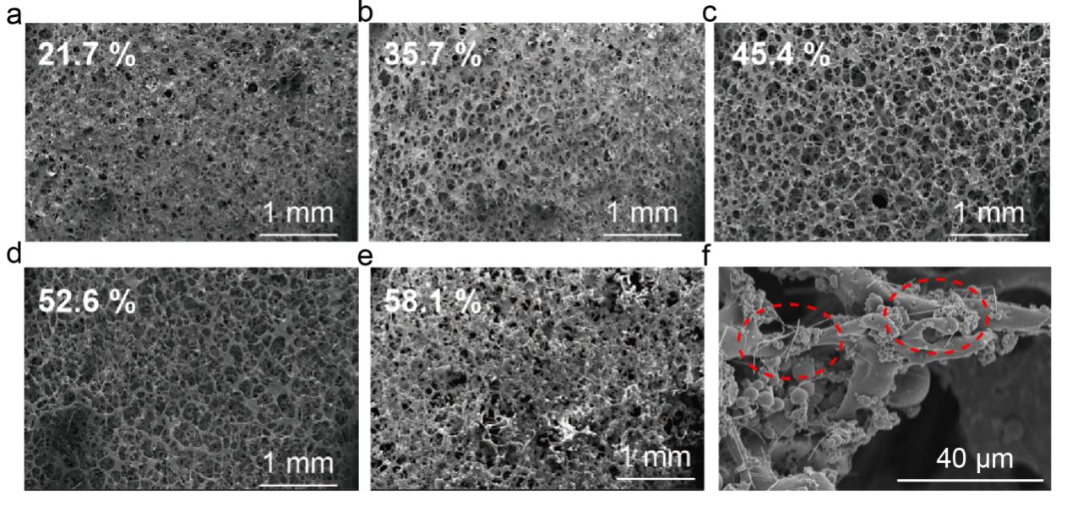
Supplementary Figure 11 | SEM images of Ag NWs/TPU films with different porosity. The porosity of the film is 21.7% (a), 35.7% (b), 45.4% (c), 52.6% (d), and 58.1% (e), respectively. (scale bars, 1 mm) (f) Local magnification of SEM image of porous film (scale bars, 40 μm). Ag NWs are clearly seen in the red circle.
The NaCl particles have been completely removed as templates, and the Ag NWs/TPU films all show a homogeneous porous structure with pore sizes ranging from 100 to 200 μm at different levels of NaCl particles. The distribution of Ag NWs on the TPU skeleton can be seen in the local magnification of SEM image.
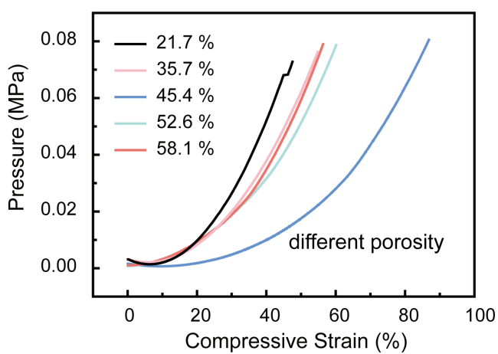
Supplementary Figure 12 | The pressure-compressive strain curves of Ag NWs/TPU films with different porosity.
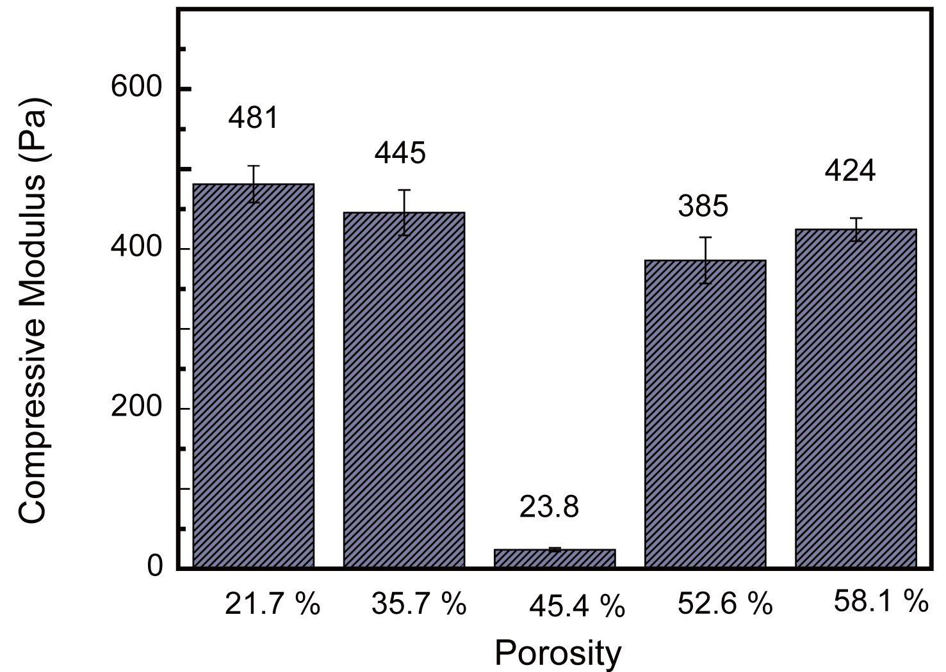
Supplementary Figure 13 | The calculated compressive modulus of Ag NWs/TPU films with different porosity.

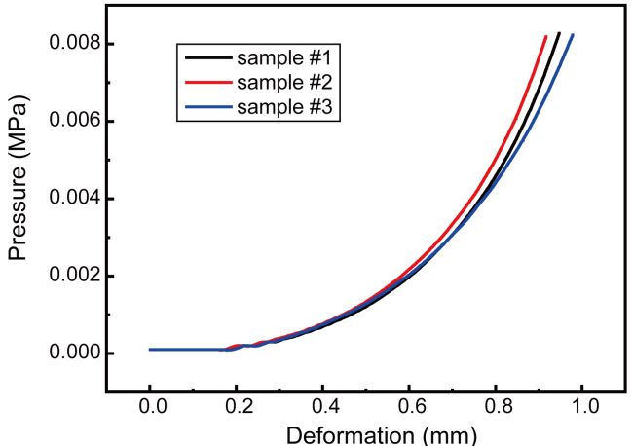
Supplementary Figure 14 | Relationship curves of compressive stress and distance of three composite film samples under the same parameters.

Supplementary Note 3: Sensing performance of the touch-sensor
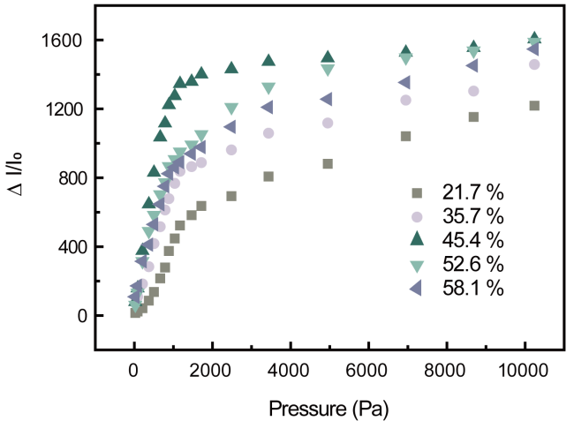
Supplementary Figure 15 | Sensing performance of devices with different porosity in sensing layer over 0-10000 Pa.

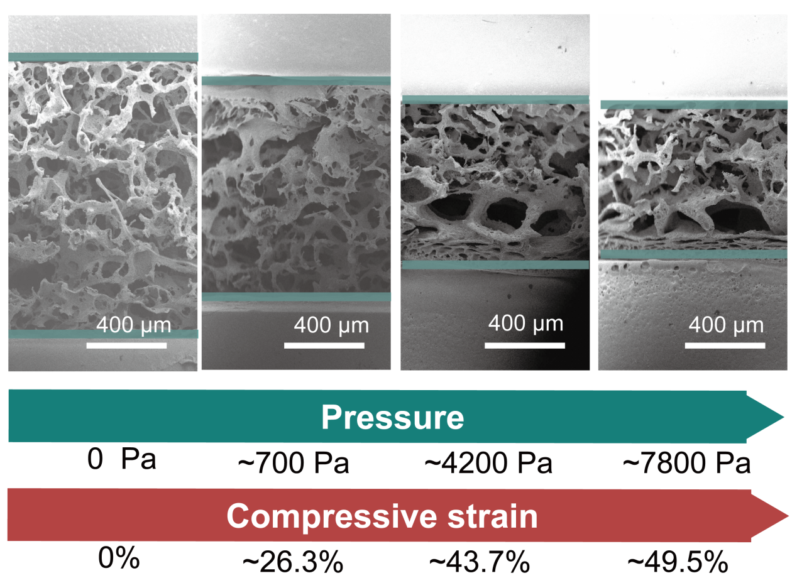
Supplementary Figure 16 | SEM images of deformation of the sensitive layer during compression.
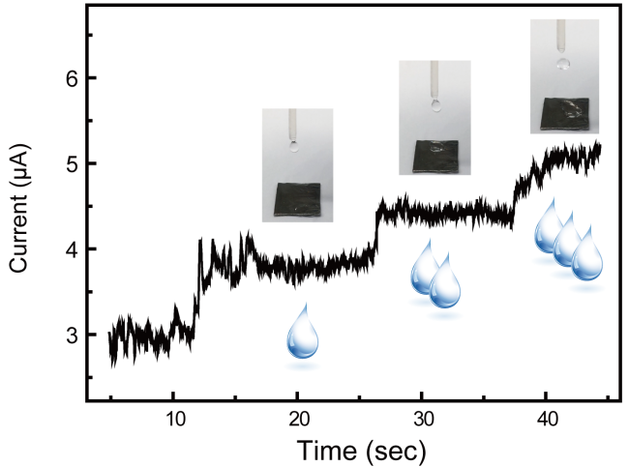
Supplementary Figure 17 | Monitoring of tiny dynamic pressure by the device. The stable response of the device to three drops falling continuously.
During the static process, it can be seen from the recorded electrical output signals that the device has a fast and stable response to small static pressures. Furthermore, since the outermost layer of the device is protected by PET encapsulation, it has good waterproof ability. The response of the device to three water droplets falling continuously has been shown. Due to the error caused by the volatilization and flow of water droplets, we control the falling time of each droplet to about 10 s. The different electrical signal response steps corresponding to the number of water droplets demonstrate the ability of the device to respond rapidly and steadily to dynamic tiny pressures.
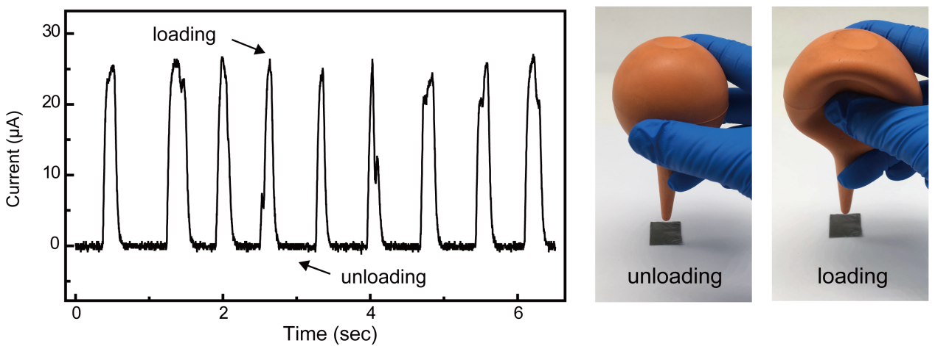
Supplementary Figure 18 | Monitoring of tiny dynamic pressure by the device. The stable response of the device to weak airflow.
The rubber suction bulb is placed at a vertical distance of 5 mm above the device and squeezed. And the device also shows obvious responsiveness to the weak airflow generated by it, and can be repeated many times. During the process, the speed and intensity of the device response can be basically kept stable. Moreover, compared with the pressure brought by static insect specimens, when the device senses the drop of water droplets and weak airflow, the current response is reduced from a change of several hundred microamps to a change of several microamps, which further proves that the detection of tiny pressure by the device shows more excellent sensing performance.

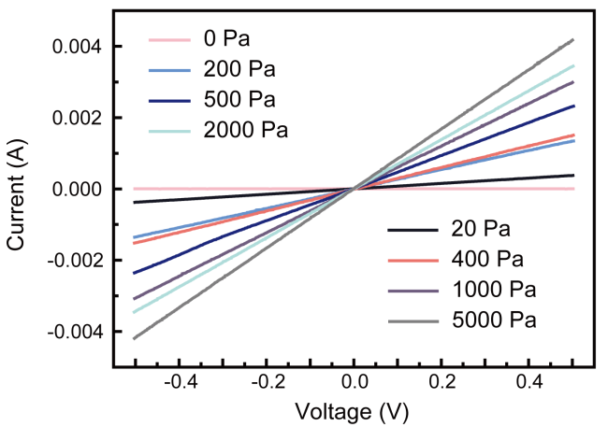
Supplementary Figure 19 | The current-voltage (I-V) response curve of the device.
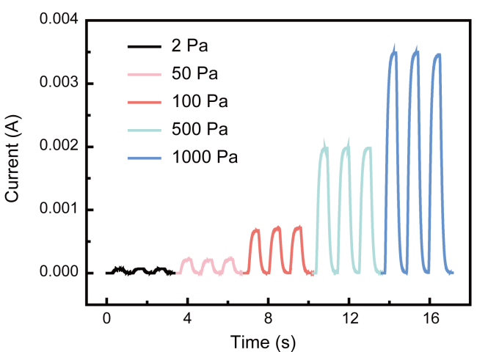
Supplementary Figure 20 | Dynamic response of the device under loading-unloading cycle.
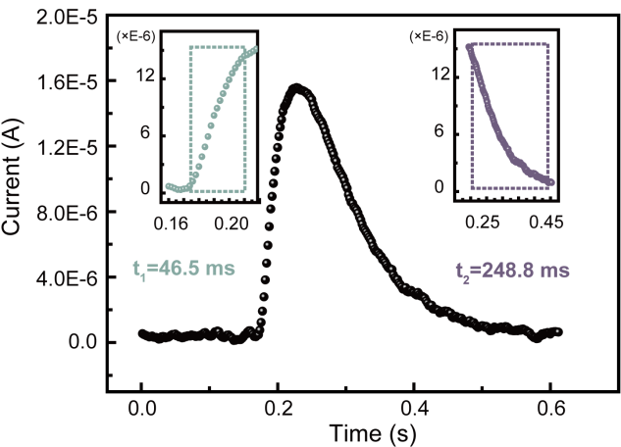
Supplementary Figure 21 | The response time and recovery time of the device are 46.5 ms and 248.8 ms, respectively.

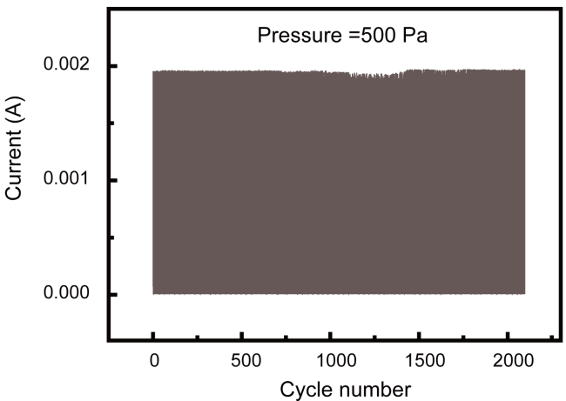
Supplementary Figure 22 | Cycling stability of the device under 500 Pa at 0.5 V.
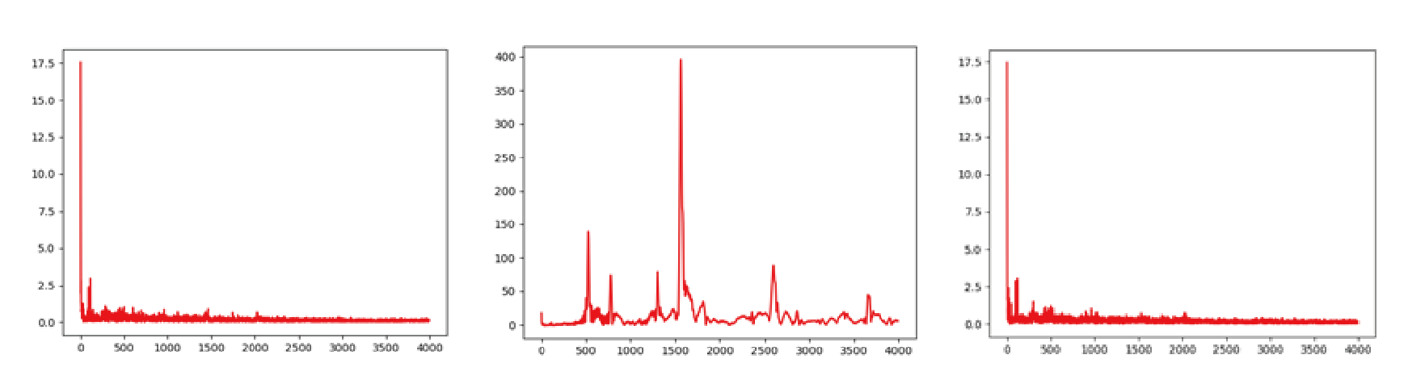
Supplementary Figure 23 | Frequency information of three ringtones obtained by short-time Fourier transform.

Supplementary Note 4: Analysis methods of the slip sensing
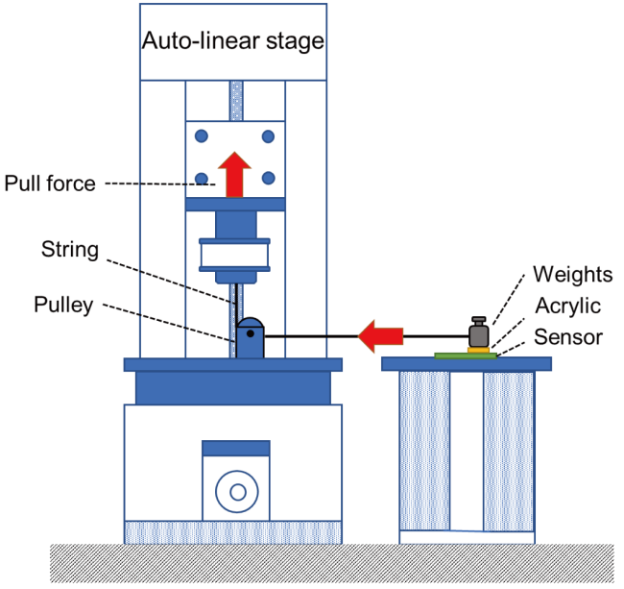
Supplementary Figure 24 | Schematic diagram of slip signal experimental apparatus.
The peeling force testing machine exerts a horizontal tensile force on the target object, combined with the low-noise current amplifier SR 570 and the comprehensive function generator DS 345 to record the current change during the physical movement of the target.
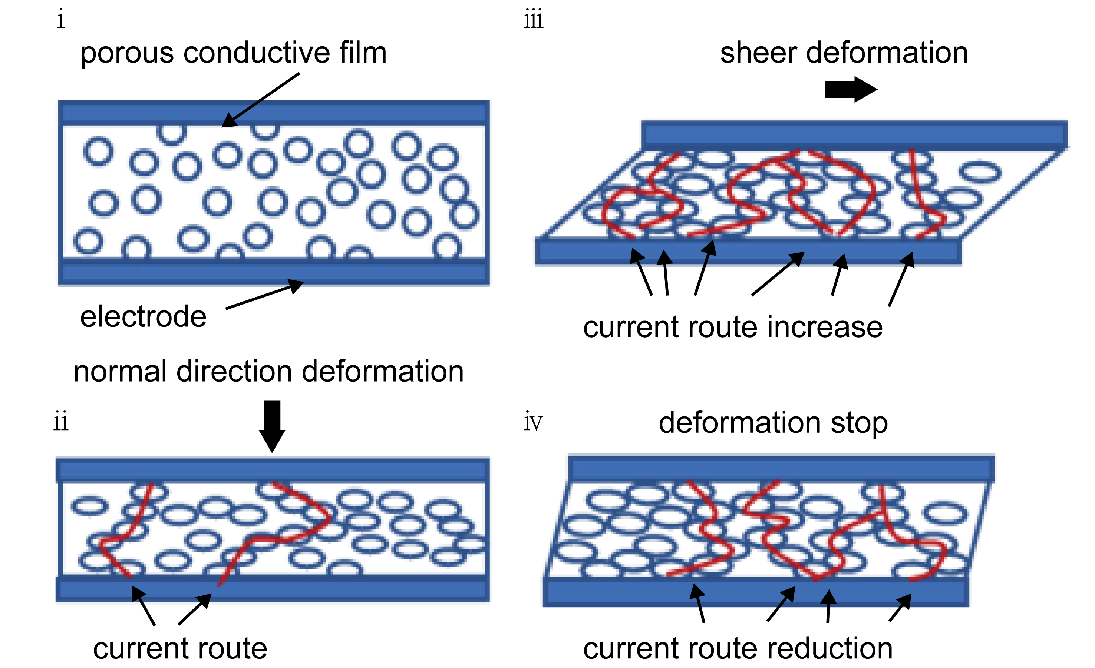
Supplementary Figure 25 | Sensing mechanism of the touch-sensor is based on piezoresistive effect.
- unloading state;
- when the object is placed at rest, the device is subjected to normal pressure to form a certain number of conductive channels;
- before the slipping of the object, tangential deformation of the device occurs due to the friction of the contact surface, and the number of conductive channels increases;
iv. when the object starts slipping, the tangential deformation of the device recovers and the number of conductive channels decreases due to the decrease of friction.
In the i-th stage, in the case of no loading, due to the high porosity of the interconnected porous structure in the sensitive layer, the formation of the conductive network between the conductive films is broken, and the resistance value is large, corresponding the current is small. For the tactile sensing mechanism, when there is only normal pressure in the ii-th stage, the change of the conduction path is shown as the change after the device is subjected to the normal pressure. When a fixed normal pressure is applied, the resistance has a definite decrease value and remains unchanged. For the slip sensing mechanism, firstly, the device will also be subjected to a fixed-size normal pressure from the object. At this time, the conductive paths increase to a certain number. Then, as shown in the iii-th stage, the object will slip instantaneously. Prior to this, due to the effect of the maximum static friction between the interfaces, the device is deformed in the horizontal direction due to the shear force, resulting in the increase of conductive paths again. In the iv-th stage, when the object overcomes the maximum static friction force and slips, as a result, the horizontal deformation of the device is slightly recovered, and the number of conductive paths is slightly reduced at this time.

The specific analysis process is to obtain the time information of the signal by translating the wavelet basis function, and to obtain the frequency characteristics of the signal by scaling the width of the wavelet¹¹. The detail coefficients can be calculated from the transform of the wavelet basis function, and the interrelationship between the wavelet and the local signal is characterized by the detail coefficients.
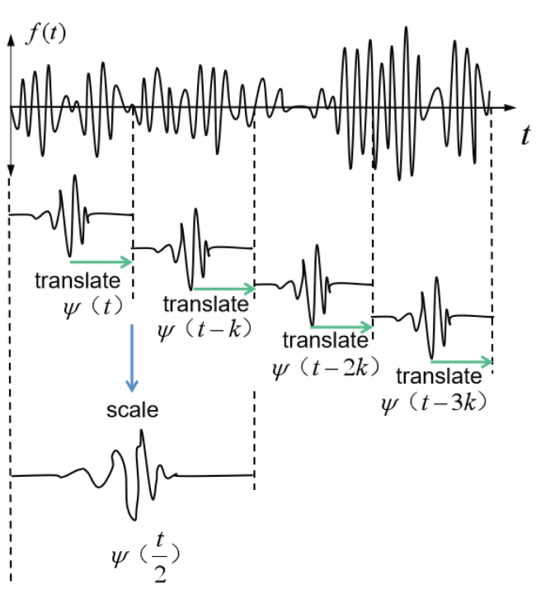
Supplementary Figure 26 | Schematic diagram of continuous wavelet transform (CWT) process.
The transformation process is as follows. Firstly, the matching wavelet basis function (our chosen wavelet basis function is mexh) and its scale a value is selected. After that, the wavelet basis function and the acquired signal are compared locally along the time axis from the initial position and the detail coefficients are calculated¹².
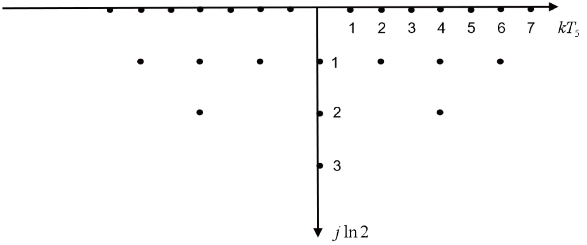
Supplementary Figure 27 | Schematic diagram of discrete wavelet transform (DWT) process.
In the process of signal analysis, the computational demand of the CWT is large, so some discrete points are limited to the wavelet basis function of a, to be taken. a andis generally chosen as a multiple of 2^{j}.
This work uses the wavelet transform toolkit of MATLAB R2021b for continuous and discrete wavelet transforms and writes a program to convert scale plots to time-frequency plots using MATLAB R2021b¹².

Supplementary Note 5: Influencing factors of slip sensing
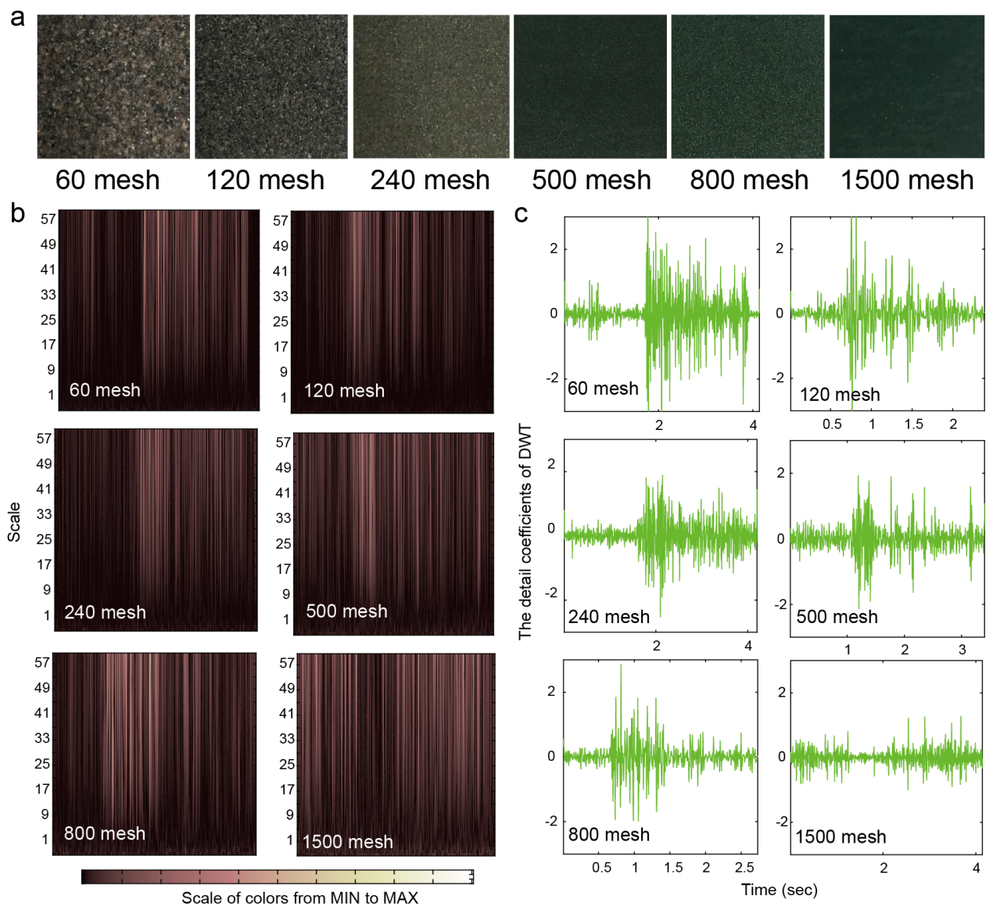
Supplementary Figure 28 | Slip signal analysis of objects with different surface roughness. (a) Optical photographs of sandpaper with different mesh sizes are 60, 120, 240, 500, 800, and 1500 meshes, respectively. CWT diagram (b) and DWT diagram (c) of the weights with different mesh sandpaper affixed at the bottom when they are relative to the device.
A weight of the same mass (100 g) has been selected, but the acrylic plate whose bottom in contact with the surface of the device is replaced with sandpapers of different roughnesses (60, 120, 240, 500, 800 and 1500 mesh). Similarly, the weight is moved from static to slip at a pulling speed of 5 mm/s, and the real-time current signal has been recorded. The corresponding CWT and DWT images are obtained by wavelet transformation of the original signal. Before the initial slip of the weight, the DWT detail coefficient of the device also exceeds the set threshold (±1), which proves that the device has the ability to judge whether the slipping occurs for objects with different contact surface roughness. Moreover, as the roughness of the contact surface decreases, the DWT detail coefficient also decreases gradually, which means that the larger surface roughness of the object, the stronger vibration caused by the change of its motion state, and the easier its slip state is to be detected.

Supplementary Note 6: Verification of slip sensing recognition accuracy
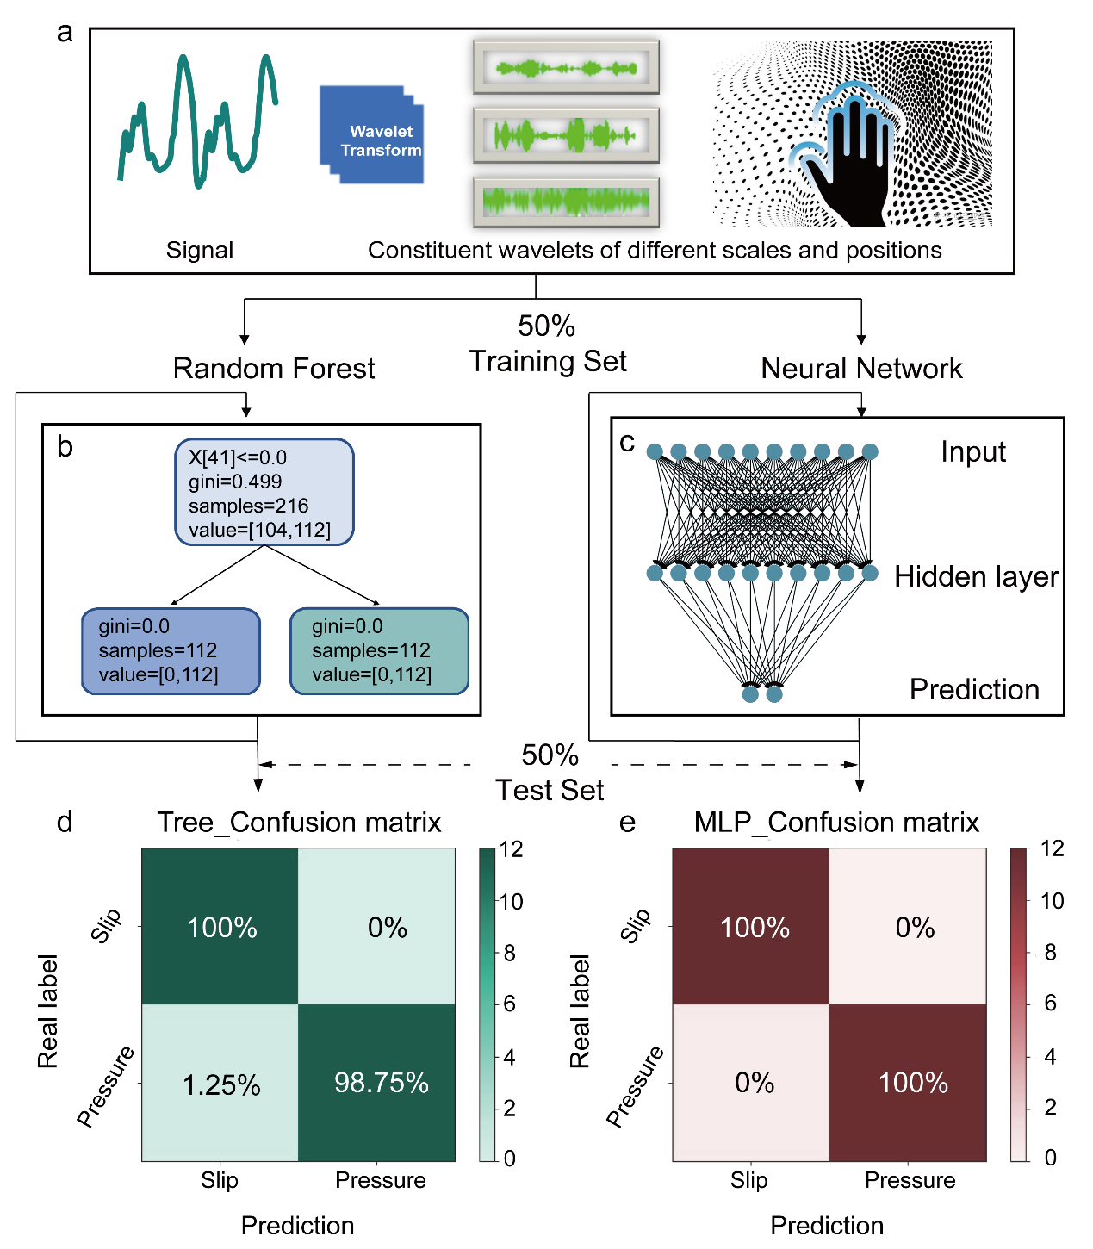
Supplementary Figure 29 | The distinction of contact force as tactile or slip perception with the assistance of the machine-learning algorithm. (a) Tactile/slip sensing mode with integrated deep learning-assisted data analytics. (b) The structure of the decision tree training model. (c) The confusion matrix based on decision tree for individual recognition of tactile/slip mode. (d) The structure of the multilayer perceptron (MLP) training model. (e) The confusion matrix based on MLP for individual recognition of tactile/slip mode.

Supplementary References
- Stropnik B., Kaiser V. Polymeric membranes preparation by wet phase separation: mechanisms and elementary processes. Desalination 145, 1-10 (2002).
- MIKAWA M., SEKI N., NAGAOKA S., KAWAKAMI H. Structure and gas permeability of asymmetric polyimide membranes made by dry–wet phase inversion: influence of alcohol as casting solution. J. Polym. Sci. B Polym. Phys. 45, 2739-2746 (2007).
- Van’t Hof J.A., Reuvers A.J., Boom R.M., Rolevink H.H.M., Smolders C.A. Preparation of asymmetric gas separation membranes with high selectivity by a dual-bath coagulation method. J. Membr. Sci. 70, 17-30 (1992).
- Khorasani M. T., Shorgashti S. Fabrication of microporous thermoplastic polyurethane for use as small-diameter vascular graft material. I. Phase-inversion method. J. Biomed. Mater. Res. B Appl. Biomater. 76, 41-48 (2006).
- White S. I., et al. Electrical percolation behavior in silver nanowire-polystyrene composites: simulation and experiment. Adv. Funct. Mater. 20, 2709-2716 (2010).
- Nagai T., Aoki N., Ochiai Y., Hoshino, K. Electric conductivity-tunable transparent flexible nanowire-filled polymer composites: orientation control of nanowires in a magnetic field. ACS Appl. Mater. Interfaces 3, 2341-2348 (2011).
- Shao L.-H., Qu X. D., Wang T. Y., Cui Z., Liu Y. X., Zhu Y. Interfacial shear stress transfer between elastoplastic fiber and elastic matrix. J. Mech. Phys. Solids 173, 105218 (2023).
- Sun Y., Gates B., Mayers B., Xia Y. Crystalline silver nanowires by soft solution processing. Nano Lett. 2, 165-168 (2002).
- Grossiord N., Regev O., Loos J., Meuldijk J., Koning C. E. Time-dependent study of the exfoliation process of carbon nanotubes in aqueous sispersions by using UV-visible spectroscopy. Anal. Chem. 77, 5135-5139 (2005).
- Zheng H., et al. Recent advances of interphases in carbon fiber-reinforced polymer composites: A review. Composites Part B 233, 109639 (2022).
- Meyer J., Lukowicz P., Troster, G. Textile pressure sensor for muscle activity and motion detection. IEEE 0, 121 (2006).
- Arts L. P. A., van den Broek E. L. The fast continuous wavelet transformation (fCWT) for real-time, high-quality, noise-resistant time–frequency analysis. Nat. Comput. Sci. 2, 47–58 (2022).

