Supporting Information
Dual-Wing Ligand Constructed Metal-Organic Framework Membranes with Finely Tuned Apertures for Natural Gas Separation
Yapeng Shiª, Zhenggong Wang^{ab,}*, Weikang Laiª, Yining Liaoª, Kuan Lu^{c}, Yang Liuª, Zheng Niuª, Jian Jin^{ab,}*
ªCollege of Chemistry, Chemical Engineering and Materials Science & Collaborative Innovation Center of Suzhou Nano Science and Technology & Innovation Center for Chemical Science and Suzhou key Laboratory of Macromolecular Design and Precision Synthesis, Soochow University, Suzhou, 215123, China.
^{b}Jiangsu Key Laboratory of Advanced Negative Carbon Technologies, Soochow University, Suzhou, 215123, China
^{c}State Key Laboratory of Coal Conversion, Institute of Coal Chemistry, Chinese Academy of Sciences, Taiyuan, 030001, China

Corresponding Author
* E-mail: zgwang2017@suda.edu.cn (Z. Wang)
* E-mail: jjin@suda.edu.cn (J. Jin)

- Supporting Materials and Methods
Materials
Zinc nitrate hexahydrate (98.0%, Sigma), 2-methylimidazole (mIm, 99.0%, Sigma), 2-chloromethylbenzimidazole (Clbim, 96%, Adamas), aniline (99.5%, Sinopharm), anhydrous methanol (99.5%, Sinopharm), ammonium hydroxide (28-30% aqueous solution, Sinopharm), perchloric acid (70.0-72.0%, Aladdin), benzimidazole (Bim, 98%, TCI), 2-methylbenzimidazole (Mbim, 98%, TCI), 2-ethylbenzimidazole (Ebim, 99%, Adamas) 2-phenylbenzimidazole (Pbim, 98%, Adamas), dimethyl sulfoxide-d₆ (DMSO‑d₆, 99.9%, Macklin), sulfuric acid-d₂ (D₂SO₄-d₂, 99.5%, Macklin), the polyethersulfone (PES) membrane (diameter of 47 mm, pore diameter of 0.22 µm, Haining Yibo Filter Equipment Factory of Zhejiang province, China).
Characterization
X-ray diffraction (XRD) patterns of the samples were detected under ambient conditions by a Bruker D8 instrument fitted with Cu Kα radiation of wavelength (λ) 1.54 Å. ¹H nuclear magnetic resonance (¹H NMR) spectra were recorded on a Bruker 400MHz spectrometer using sulfuric acid-d₂ solution and dimethyl sulfoxide-d₆ as solvent. The morphology of the Clbim_{x}/ZIF-8 membranes were observed by scanning electron microscope (SEM) using a Hitachi SU8010. FTIR spectra of the samples were recorded with a Nicolet 6700 spectrometer. A Quantachrome Autosorb-iQ2 instrument was used to measure N₂ sorption isotherms. Prior to measurement, the samples were regenerated at 120 °C under vacuum (∼1 × 10^{–5} bar) for ∼10 h, respectively.
Gas permeation measurement
The obtained membranes were sealed in a Wicke-Kallenbach cell to measure their separation performance (Supplementary Fig. 26)^{1,2}. To avoid direct contact of silicone O-ring with the measured membrane and thus damage the membrane, two aluminum tapes with 10 mm diameter holes were used to sandwich the membrane and then high vacuum grease was used to seal the aluminum tapes and the membrane. Single gas permeance experiment was performed using the steady-state gas of H₂, CO₂, N₂ and CH₄ at 25 °C. The feed flow rate was constant at 30 mL min^{–1}, regulated by mass flow controllers. Argon with flow rate of 10 mL min^{–1} was used as a sweep gas to minimize the influence of back diffusion of the sweeping gas to the feed side and simultaneously bring permeate into a gas chromatography (GC, Aglient Technologies 7820A) for composition analysis. There was no pressure drop between the sides of the membrane in order to prevent any damage on the membrane.
$P_{i}\text{ =}\frac{N_{i}}{\text{∆}P_{i}\text{ × A}}$ (1)
where N_{i} (mol·s^{–1}) is the molar flow rate of component i, ΔP_{i} (Pa) is the transmembrane pressure difference of component i, and A (m²) is the effective membrane area for testing. The ideal selectivity, S_{i/j}, is calculated from the relation between the permeance of component i and component j.
${\text{S}}_{{\text{i}}/{\text{j}}}\text{=}\frac{{\text{P}}_{\text{i}}}{{\text{P}}_{\text{j}}}$ (2)
For the mixed gas separation measurement, the prepared MOF membrane was fixed in a module sealed with O-rings. A 1:1 mixture of gas was applied to the feed side of the membrane, and the permeate gas was removed from the permeate side with the sweeping gas (Ar)³. The feed flow rate was kept constant with a total volumetric flow rate of 60 mL·min⁻¹ (each gas, 30 mL·min^{–1}). Pressures at both the feed side and permeate side were maintained at 1 bar. A calibrated gas chromatograph was used to measure the concentration of each gas on the permeate side. The separation factor, αi/j, of the gas pairs is defined as the molar ratios of the components (i, j) in the permeate side, divided by the quotient of the molar of the components (i, j) in the feed side:
${\text{α}}_{{\text{i}}/{\text{j}}}\text{=}\frac{{X_{i,perm}}/{X_{j,perm}}}{{X_{i,feed}}/{X_{i,feed}}}$ (3)

2. Supporting Figures and Tables
Supplementary Fig. 1. Molecular size of various types of imidazole ligands.

Supplementary Fig. 2. Aperture variation with increasing DW ligand content in the framework.

Supplementary Fig. 3. Vertical views of the ZIF-8 crystal structure along a) (100) plane and b) (111) plane. N atoms are shown in mazarine, Zn atoms in blue and Cl atoms in green.
Supplementary Fig. 4. Vertical views of the Clbim₂₃/ZIF-8 crystal structure along a) (100) plane and b) (111) plane. N atoms are shown in mazarine, Zn atoms in blue and Cl atoms in green.

Supplementary Fig. 5. Structure analysis of Mbim_{x}/ZIF-8. a) XRD patterns. b) ¹H NMR. c) Nitrogen adsorption-desorption isotherms measured at 77 K. Adsorption (closed), desorption (open). d) Pore size distribution.
The microporous structure of the activated Mbim_{x}/ZIF-8 is confirmed by N₂ gas sorption experiments at 77 K. Their N₂ adsorption isotherms show a typical type I curve. Both of their specific surface area and pore size obviously decrease with increasing Mbim ligand content in the framework. Typically, when Mbim increases from 0 to 31%, the maximum N₂ adsorption capacity of Mbim_{x}/ZIF-8 decreases from 995 cm³ g^{–1} to 855 cm³ g^{–1}, and the specific surface area decreases from 1779 m² g^{–1} to 970 m² g^{–1}. As expected, the micropore sizes of Mbim_{x}/ZIF-8 gradually shift toward smaller pore as the Mbim content increases from 0 to 31%.

Supplementary Fig. 6. Structure analysis of Ebim_{x}/ZIF-8. a) XRD patterns. b) ¹H NMR. c) Nitrogen adsorption-desorption isotherms measured at 77 K. Adsorption (closed), desorption (open). d) Pore size distribution.
The microporous structure of the activated Ebim_{x}/ZIF-8 is confirmed by N₂ gas sorption experiments at 77 K. Their N₂ adsorption isotherms show a typical type I curve. Both of their specific surface area and pore size obviously decrease with increasing Ebim ligand content in the framework. Typically, when Ebim increases from 0 to 25%, the maximum N₂ adsorption capacity of Ebim_{x}/ZIF-8 decreases from 995 cm³ g^{–1} to 827 cm³ g^{–1}, and the specific surface area decreased from 1779 m² g^{–1} to 975 m² g^{–1}. As expected, the micropore sizes of Ebim_{x}/ZIF-8 gradually shift toward smaller pore as the Ebim content increases from 0 to 25%.

Supplementary Fig. 7. Structure analysis of Pbim_{x}/ZIF-8. a) XRD patterns. b) ¹H NMR. c) Nitrogen adsorption-desorption isotherms measured at 77 K. Adsorption (closed), desorption (open). d) Pore size distribution.
The microporous structure of the activated Pbim_{x}/ZIF-8 is confirmed by N₂ gas sorption experiments at 77 K. Their N₂ adsorption isotherms show a typical type I curve. Both of their specific surface area and pore size obviously decrease with increasing Pbim ligand content in the framework. Typically, when Pbim increases from 0 to 9%, the maximum N₂ adsorption capacity of Pbim_{x}/ZIF-8 decreases from 995 cm³ g^{–1} to 346 cm³ g^{–1}, and the specific surface area decreases from 1779 m² g^{–1} to 1155 m² g^{–1}. As expected, the micropore sizes of Pbim_{x}/ZIF-8 gradually shift toward smaller pore as the Pbim content increases from 0 to 9%.

Supplementary Fig. 8. Structure analysis of Bim_{x}/ZIF-8. a) XRD patterns. b) ¹H NMR. c) Nitrogen adsorption-desorption isotherms measured at 77 K. Adsorption (closed), desorption (open). d) Pore size distribution.
The microporous structure of the activated Bim_{x}/ZIF-8 is confirmed by N₂ gas sorption experiments at 77 K. Their N₂ adsorption isotherms show a typical type I curve. Both of their specific surface area and pore size obviously decrease with increasing Bim ligand content in the framework. Typically, when Bim increases from 0 to 53%, the maximum N₂ adsorption capacity of Bim_{x}/ZIF-8 decreases from 995 cm³ g^{–1} to 929 cm³ g^{–1}, and the specific surface area decreases from 1779 m² g^{–1} to 489 m² g^{–1}. As expected, the micropore sizes of Bim_{x}/ZIF-8 gradually shift toward smaller pore as the Bim content increases from 0 to 22%.

Supplementary Fig. 9. Specific surface areas of Clbim_{x}/ZIF-8 with different contents of 2-chloromethylbenzimidazole ligand.

Supplementary Fig. 10. Specific surface areas of Mbim_{x}/ZIF-8 with different contents of 2-methylbenzimidazole ligand.

Supplementary Fig. 11. Specific surface areas of Ebim_{x}/ZIF-8 with different contents of 2-ethylbenzimidazole ligand.

Supplementary Fig. 12. Specific surface areas of Pbim_{x}/ZIF-8 with different contents of 2-phenylbenzimidazole ligand.

Supplementary Fig. 13. Specific surface areas of Bim_{x}/ZIF-8 with different contents of benzimidazole ligand.

Supplementary Fig. 14. Pore size distributions of ZIF-8, Mbim₂₁/ZIF-8, Bim₂₂/ZIF-8, Ebim₂₁/ZIF-8, and Clbim₂₃/ZIF-8.

Supplementary Fig. 15. Photograph of the device for preparing MOF membranes.

Supplementary Fig. 16. Top-view SEM images of a) PES membrane and b) PANI/PES composite membrane.

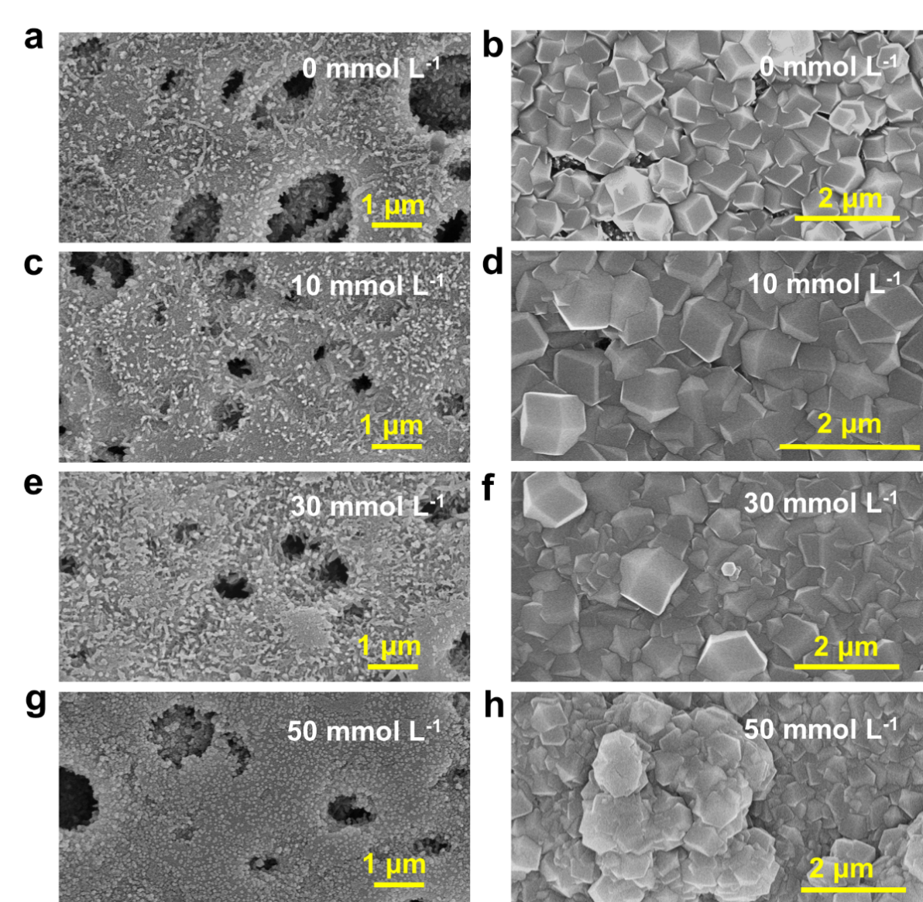
Supplementary Fig. 17. SEM images of the PANI/PES composite membranes before (a, c, e, g) and after (b, d, f, h) treated with different concentrations of zinc nitrate to grow ZIF-8 membranes.

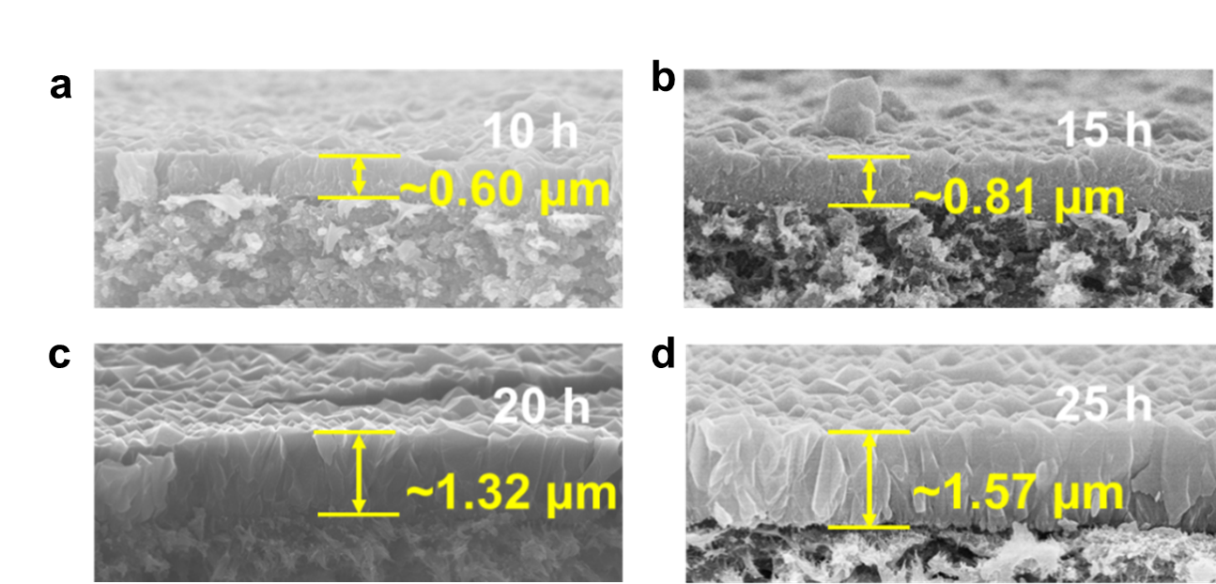
Supplementary Fig. 18. Cross-sectional SEM images of the ZIF-8 membranes with different reaction time.

Supplementary Fig. 19. Optical photos of Clbim_{x}/ZIF-8 membranes. a) ZIF-8, b) Clbim₃/ZIF-8, c) Clbim₁₁/ZIF-8, d) Clbim₁₇/ZIF-8, e) Clbim₂₃/ZIF-8, and f) Clbim₂₇/ZIF-8. The scale bar is 2 cm.
Supplementary Fig. 20. XRD patterns of ZIF-8 and Clbim_{x}/ZIF-8 membranes.

Supplementary Fig. 21. EDX analysis of ZIF-8 and Clbim_{x}/ZIF-8 membranes.

Supplementary Fig. 22. Summary of CO₂/CH₄ ideal selectivity versus CO₂ permeability of Clbim₂₃/ZIF-8 and previously reported membranes including 2008 Robeson upper bound of polymer membranes. The related CO₂ permeance and CO₂/CH₄ separation data are summarized in the following table.
Supplementary Fig. 23. Summary of H₂/CH₄ ideal selectivity versus H₂ permeability of Clbim₂₃/ZIF-8 and previously reported membranes including 2008 Robeson upper bound of Polymer membranes. The related H₂ permeance and H₂/CH₄ separation data are summarized in the following table.

Supplementary Fig. 24. Summary of H₂/C₃H₈ ideal selectivity versus H₂ permeability of Clbim₂₃/ZIF-8 and previously reported membranes⁴.

Supplementary Fig. 25. Schematic illustration of gas permeation across the aperture of ZIF-8, SW/ZIF-8 and DW/ZIF-8 membranes.

Supplementary Fig. 26. a) Schematic diagram of setup for mixed gas permeation; b) Membrane cell; c) Inside view photo of the upside of membrane cell; d) Inside view photo of the downside of membrane cell. e) Photo of membrane covered by aluminum tape for gas permeation testing.

Supplementary Table 1. Molar percentage (%) of Clbim accounting for all the ligands in the synthesis solution and the resulting Clbim_{x}/ZIF-8. The molar percentage in the resulting Clbim_{x}/ZIF-8 is determined by ¹H NMR data shown in Fig. 2b.
Clbim_{x}/ZIF-8 | Molar percentage in the synthesis solution (Clbim) | Molar percentage in the framework  (Clbim)
Clbim₃/ZIF-8 | 2% | 3%
Clbim₁₁/ZIF-8 | 7% | 11%
Clbim₁₇/ZIF-8 | 14% | 17%
Clbim₂₃/ZIF-8 | 20% | 23%
Clbim₂₇/ZIF-8 | 22% | 27%
Clbim₃₄/ZIF-8 | 30% | 34%

Supplementary Table 2. Molar percentage (%) of Mbim accounting for all the ligands in the synthesis solution and the resulting Mbim_{x}/ZIF-8. The molar percentage in the resulting Mbim_{x}/ZIF-8 is determined by ¹H NMR data shown in supplementary Fig. 5b.
Mbim_{x}/ZIF-8 | Molar percentage in the synthesis solution (Mbim) | Molar percentage in the framework (Mbim)
Mbim₄/ZIF-8 | 2% | 4%
Mbim₈/ZIF-8 | 5% | 8%
Mbim₁₆/ZIF-8 | 9% | 16%
Mbim₂₁/ZIF-8 | 15% | 21%
Mbim₂₆/ZIF-8 | 20% | 26%
Mbim₂₉/ZIF-8 | 25% | 29%
Mbim₃₁/ZIF-8 | 30% | 31%

Supplementary Table 3. Molar percentage (%) of Ebim accounting for all the ligands in the synthesis solution and the resulting Ebim_{x}/ZIF-8. The molar percentage in the resulting Ebim_{x}/ZIF-8 is determined by ¹H NMR data shown in supplementary Fig. 6b.
Ebim_{x}/ZIF-8 | Molar percentage in the synthesis solution (Ebim) | Molar percentage in the framework (Ebim)
Ebim₁₄/ZIF-8 | 20% | 14%
Ebim₁₇/ZIF-8 | 28% | 17%
Ebim₂₁/ZIF-8 | 36% | 21%
Ebim₂₅/ZIF-8 | 44% | 25%

Supplementary Table 4. Molar percentage (%) of Pbim accounting for all the ligands in the synthesis solution and the resulting Pbim_{x}/ZIF-8. The molar percentage in the resulting Pbim_{x}/ZIF-8 is determined by ¹H NMR data shown in supplementary Fig. 7b.
Pbimx/ZIF-8 | Molar percentage in the synthesis solution (Pbim) | Molar percentage in the framework (Pbim)
Pbim₂/ZIF-8 | 20% | 2%
Pbim₉/ZIF-8 | 50% | 9%

Supplementary Table 5. Molar percentage (%) of Bim accounting for all the ligand in the synthesis solution and the resulting Bim_{x}/ZIF-8. The molar percentage in the resulting Bim_{x}/ZIF-8 is determined by ¹H NMR data shown in supplementary Fig. 8b.
Bim_{x}/ZIF-8 | Molar percentage in the synthesis solution (Bim) | Molar percentage in the framework (Bim)
Bim₁₀/ZIF-8 | 2% | 10%
Bim₂₂/ZIF-8 | 5% | 22%
Bim₄₄/ZIF-8 | 7% | 44%
Bim₅₃/ZIF-8 | 10% | 53%

Supplementary Table 6. Thickness and corresponding CO₂/CH₄ selectivity of ZIF-8 membranes with different diffusion time.

Time/h | Thickness  /μm | Selectivity of  CO₂/CH₄
10 | ~ 0.60 | 2.6 ± 0.2
15 | ~ 0.81 | 4.2 ± 0.3
20 | ~ 1.32 | 6.6 ± 0.5
25 | ~ 1.57 | 7.0 ± 0.5

Supplementary Table 7. H₂/CH₄ selectivity of our membranes compared with the reported MOF membranes.
MOF | Support layer type | Method | Thickness  (μm) |  | Testing  temperature  /pressure  (°C/bar)ª | H₂ Permeance  (×10⁻⁷ mol m⁻² s⁻¹ pa⁻¹) | H₂/CH₄  Selectivity | Ref.
ZIF-8 | YSZ-fiber^{b} | seeding | 2 |  | 22/1 | 13.9 | 10 | 5
ZIF-8 | AAO^{c} | electrophoretic | 0.5 |  | 25/1 | 83 | 16.2 | 6
ZIF-8 | hollow-fiber PVDF | hydrothermal | 1 | RTª/1 |  | 33 | 9.1^{d} | 7
ZIF-8 | BPPO^{e} | contra-diffusion | 2 | RT/1 |  | 6.1 | 10.2^{d} | 8
ZIF-8 | Al₂O₃ | liquid-phase epitaxy | 1.6 | 35/1 |  | 0.19 | 4.63 | 9
ZIF-8 | α-Al₂O₃ hollow fiber | seeding | 2 | RT/1 |  | 4.324 | 12.13^{d} | 10
ZIF-8 | α-Al₂O₃ | seeding | 1.1 | 150/1 |  | 1.84 | 21.4 | 11
ZIF-8 | porous stainless steel | solvent-free growth | 3.4 | 25/1 |  | 1.47 | 39.1 | 12
ZIF-8 | P84® hollow fiber | microfluidics | 1.3 | 35/1 |  | 0.13 | 72.4 | 13
ZIF-8 | ceramic hollow fiber | hot-coating | 0.1 | RT/2 |  | 10.64 | 26.5 | 14
ZIF-8-ZnAl-NO₃-LDH | Al₂O₃ | solvothermal | 1.1 | 90/1 |  | 0.41 | 54.1 | 15
ZIF-7₂₂-8 | AAO^{c} | current-driven | 0.45 |  | RT/1 | 0.27 | 71 | 16
ZIF-7 | polysulfone hollow fiber | microfluidics | 2.4 |  | 35/1 | 0.0215 | 34.6 | 17
ZIF-62 | Al₂O₃ | solvothermal | 70 |  | RT/1 | 0.19 | 50 | 18
ZIF-90 | α-Al₂O₃ | solvothermal | 20 |  | 225/1 | 2.85 | 77^{d} | 19
ZIF-93 | P84® hollow fiber | microfluidics | — |  | 100/1.25 | 0.11 | 97.2 | 20
ZIF-94 | P84® hollow fiber | microfluidics | 7.1 |  | 35/1 | 0.042 | 136 | 21
ZIF-8 | PES | counter-diffusion | ~ 1.6 |  | 25/1 | 3.81 | 23.6 | This work
Clbim₃/ZIF-8 |  |  |  |  |  | 3.10 | 75.3 | This work
Clbim₁₁/ZIF-8 |  |  |  |  |  | 2.75 | 229.3 | This work
Clbim₁₇/ZIF-8 |  |  |  |  |  | 2.69 | 251.8 | This work
Clbim₂₃/ZIF-8 |  |  |  |  |  | 2.05 | 337.8 | This work
Clbim₂₇/ZIF-8 |  |  |  |  |  | 1.41 | 253.3 | This work
a: room temperature; b: hollow yttria-stabilized zirconia fiber; c: anodic aluminum oxide; d: ideal selectivity for pure gases; e: poly(2,6-dimethyl-1,4-phenylene oxide).

Supplementary Table 8. CO₂/CH₄ selectivity of our membranes compared with the reported MOF membranes.
MOF | Support layer type | Method | Thickness  (μm) | Testing  Temperature  /Pressure  (°C/bar)ª | CO₂ Permeance  (×10⁻⁹ mol m⁻² s⁻¹ pa⁻¹) | CO₂/CH₄  Selectivity | Ref.
ZIF-8-ZnAl-NO₃-LDH | Al₂O₃ | solvothermal | 1.1 | 90/1 | 9.8 | 12.9 | 15
ZIF-8 | P84@ hollow fiber | microfluidics | 1.3 | 35/1 | 2.8 | 18.4 | 13
ZIF-8 | alumina hollow fiber | microfluidics | 2 | 25/1 | 121.9 | 3.79^{c} | 10
ZIF-8 | polysulfone hollow fiber | microfluidics | 3.6 | 35/1 | 1.54 | 6.1 | 17
ZIF-7 | polysulfone hollow fiber | microfluidics | 2.4 | 35/1 | 0.78 | 13.5 | 17
ZIF-7₂₂-8 | AAO^{b} | current-driven | 0.45 | RTª/1 | 15 | 25 | 16
ZIF-62 | Al₂O₃ | solvothermal | 70 | RT/1 | 12 | 36 | 18
ZIF-69 | α-alumina | seeding | 40 | RT/1 | 100 | 4.6 | 22
ZIF-90 | α-Al₂O₃ | solvothermal | 20 | 225/1 | 13 | 4.7 | 19
ZIF-93 | P84@ hollow fiber | microfluidics | — | 35/1.25 | 0.77 | 16.9 | 20
ZIF-94 | P84@ hollow fiber | microfluidics | 7.1 | 35/1 | 1.2 | 38 | 21
ZIF-8 | PES | contra-diffusion | ~ 1.6 | 25/1 | 67.4 | 7.0 | This work
Clbim₃/ZIF-8 |  |  |  |  | 44.1 | 17.6 | This work
Clbim₁₁/ZIF-8 |  |  |  |  | 28.6 | 24.5 | This work
Clbim₁₇/ZIF-8 |  |  |  |  | 24.5 | 34.1 | This work
Clbim₂₃/ZIF-8 |  |  |  |  | 21.6 | 55.6 | This work
Clbim₂₇/ZIF-8 |  |  |  |  | 19.2 | 40.2 | This work
a: room temperature; b: anodic aluminum oxide; c: ideal selectivity for pure gases.

Supplementary References
1. Zhang, S., Wang, Z., Ren, H., Zhang, F. & Jin, J. Nanoporous film-mediated growth of ultrathin and continuous metal-organic framework membranes for high-performance hydrogen separation. J. Mater. Chem. A. 5, 1962-1966 (2017).
2. Wang, Z., Wang, D., Zhang, S., Hu, L. & Jin, J. Interfacial Design of Mixed Matrix Membranes for Improved Gas Separation Performance. Adv. Mater. 28, 3399-3405 (2016).
3. Shi, Y. et al. Mixed matrix membranes with highly dispersed MOF nanoparticles for improved gas separation. Sep. Purif. Technol. 277, 119449 (2021).
4. Wang, Q., Yu, L., Nagasawa, H., Kanezashi, M. & Tsuru, T. Tuning the microstructure of polycarbosilane-derived SiC(O) separation membranes via thermal-oxidative cross-linking. Sep. Purif. Technol. 248, 117067 (2020).
5. Pan, Y. C., Wang, B. & Lai, Z. P. Synthesis of ceramic hollow fiber supported zeolitic imidazolate framework-8 (ZIF-8) membranes with high hydrogen permeability. J. Membr. Sci. 421, 292-298 (2012).
6. He, G. W., Dakhchoune, M., Zhao, J., Huang, S. Q. & Agrawal, K. V. Electrophoretic Nuclei Assembly for Crystallization of High-Performance Membranes on Unmodified Supports. Adv. Funct. Mater. 28, 1707427 (2018).
7. Hou, J. W., Sutrisna, P. D., Zhang, Y. T. & Chen, V. Formation of Ultrathin, Continuous Metal-Organic Framework Membranes on Flexible Polymer Substrates. Angew. Chem. Int. Ed. 55, 3947-3951 (2016).
8. Shamsaei, E. et al. Aqueous Phase Synthesis of ZIF-8 Membrane with Controllable Location on an Asymmetrically Porous Polymer Substrate. ACS Appl. Mater. Interfaces 8, 6236-6244 (2016).
9. Shekhah, O. et al. The liquid phase epitaxy approach for the successful construction of ultra-thin and defect-free ZIF-8 membranes: pure and mixed gas transport study. Chem. Commun. 50, 2089-2092 (2014).
10. Huang, K., Dong, Z. Y., Li, Q. Q. & Jin, W. Q. Growth of a ZIF-8 membrane on the inner-surface of a ceramic hollow fiber via cycling precursors. Chem. Commun. 49, 10326-10328 (2013).
11. Zhang, C. H. et al. Fabrication of highly (110)-Oriented ZIF-8 membrane at low temperature using nanosheet seed layer. J. Membr. Sci. 641 (2022).
12. Hou, J. M., Hong, X. L., Zhou, S., Wei, Y. Y. & Wang, H. H. Solvent-free route for metal-organic framework membranes growth aiming for efficient gas separation. AIChE J 65, 712-722 (2019).
13. Cacho-Bailo, F. et al. MOF-polymer enhanced compatibility: post-annealed zeolite imidazolate framework membranes inside polyimide hollow fibers. RSC Adv. 6, 5881-5889 (2016).
14. Kong, C. L., Du, H. B., Chen, L. & Chen, B. L. Nanoscale MOF/organosilica membranes on tubular ceramic substrates for highly selective gas separation. Energ. Environ. Sci. 10, 1812-1819 (2017).
15. Liu, Y. et al. Remarkably Enhanced Gas Separation by Partial Self-Conversion of a Laminated Membrane to Metal-Organic Frameworks. Angew. Chem. Int. Ed. 54, 3028-3032 (2015).
16. Hou, Q. Q. et al. Ultra-Tuning of the Aperture Size in Stiffened ZIF-8_Cm Frameworks with Mixed-Linker Strategy for Enhanced CO₂/CH₄ Separation. Angew. Chem. Int. Ed. 58, 327-331 (2019).
17. Cacho-Bailo, F. et al. Metal-organic framework membranes on the inner-side of a polymeric hollow fiber by microfluidic synthesis. J. Membr. Sci. 476, 277-285 (2015).
18. Wang, Y. H. et al. A MOF Glass Membrane for Gas Separation. Angew. Chem. Int. Ed. 59, 4365-4369 (2020).
19. Huang, A. S., Liu, Q., Wang, N. Y. & Caro, J. Organosilica functionalized zeolitic imidazolate framework ZIF-90 membrane for CO₂/CH₄ separation. Micropor. Mesopor. Mat. 192, 18-22 (2014).
20. Cacho-Bailo, F. et al. High selectivity ZIF-93 hollow fiber membranes for gas separation. Chem. Commun. 51, 11283-11285 (2015).
21. Cacho-Bailo, F., Etxeberria-Benavides, M., Karvan, O., Tellez, C. & Coronas, J. Sequential amine functionalization inducing structural transition in an aldehyde-containing zeolitic imidazolate framework: application to gas separation membranes. CrystEngComm 19, 1545-1554 (2017).
22. Liu, Y. Y., Zeng, G. F., Pan, Y. C. & Lai, Z. P. Synthesis of highly c-oriented ZIF-69 membranes by secondary growth and their gas permeation properties. J. Membr. Sci. 379, 46-51 (2011).

