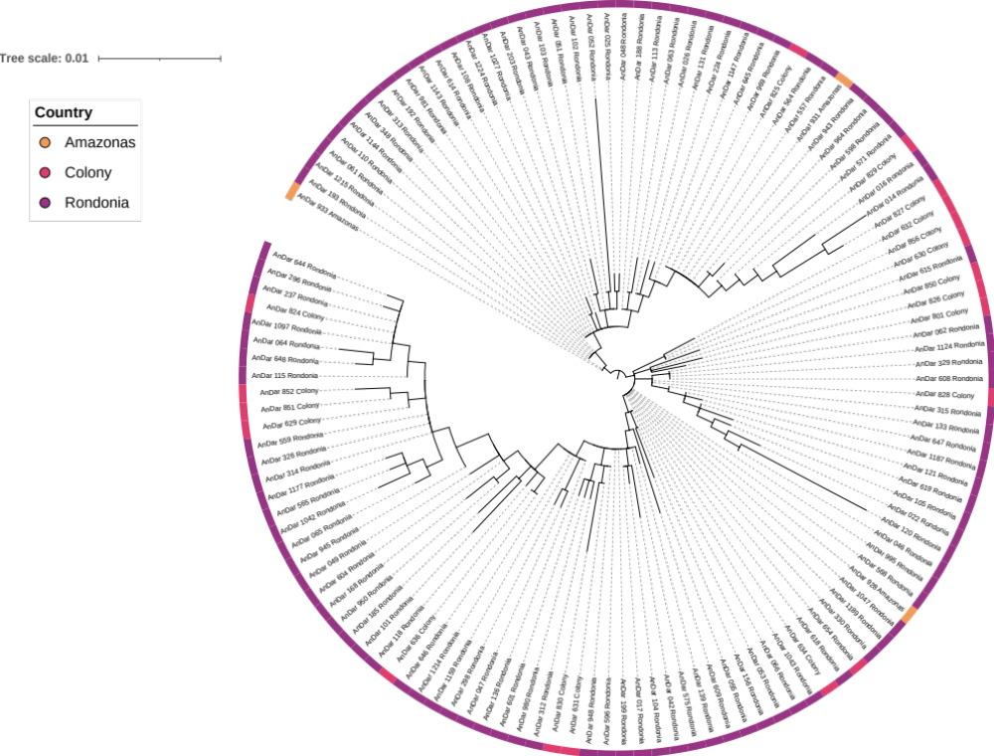

Supplementary figure 1. Maximum-likelihood tree constructed using concatenated ITS2 and cox-1 gene sequences generated in this study (n=127). This included samples from Rondonia (n = 106), Colony (n=18), Amazonas (n=3). The tree was built using the maximum-likelihood method assuming GTR model of nucleotide substitution, with the gamma model of heterogeneity rate.

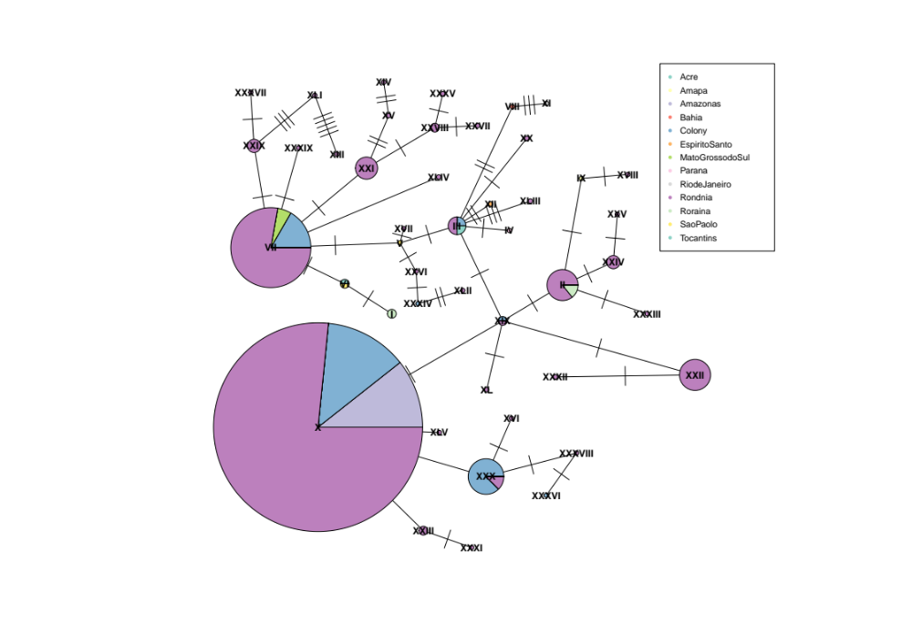

Supplementary Figure 2. Haplotype or minimal-spanning network constructed using cox-1 sequences generated in this study. Each node represents a haplotype, each segment within the node represents a region, and is proportionally sized to the number of sequences present in the segment and node. The number of number of ticks between nodes represents the number of genetic differences between nodes.

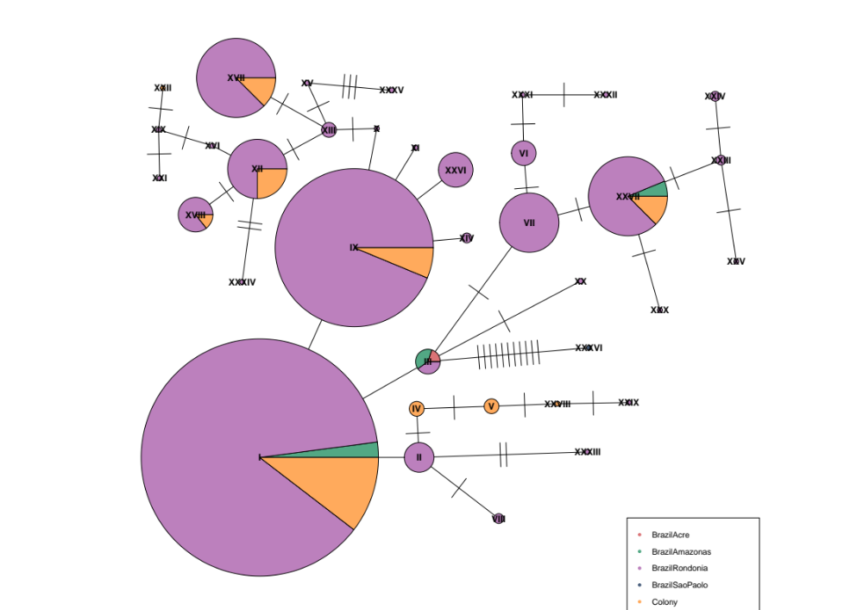
Supplementary Figure 3. Haplotype or minimal-spanning network constructed using ITS2 sequences generated in this study. Each node represents a haplotype, each segment within the node represents a region, and is proportionally sized to the number of sequences present in the segment and node. The number of number of ticks between nodes represents the number of genetic differences between nodes.

Supplementary Table 1. Number of genetic variants identified per population

Population | Sample Number | Number of SNPs | Number of Non-synonymous SNPs | Number of INDELs | Number of Non-synonymous INDELS
All | 200 | 246 | 10 | 20 | 1
Amazonas State | 4 | 91 | 7 | 14 | 0
Rondônia State | 171 | 241 | 10 | 19 | 1
Colony | 25 | 133 | 6 | 16 | 1

