Supplementary data
Fabrication of 8-nitroquinoline coated pencil graphite electrode for rutin determination by differential pulse voltammetry in orange juice
Farah En-Nakra, Demet Uzun*, Erdoğan Hasdemir
Gazi University, Faculty of Science, Department of Chemistry, 06500, Ankara/Turkey

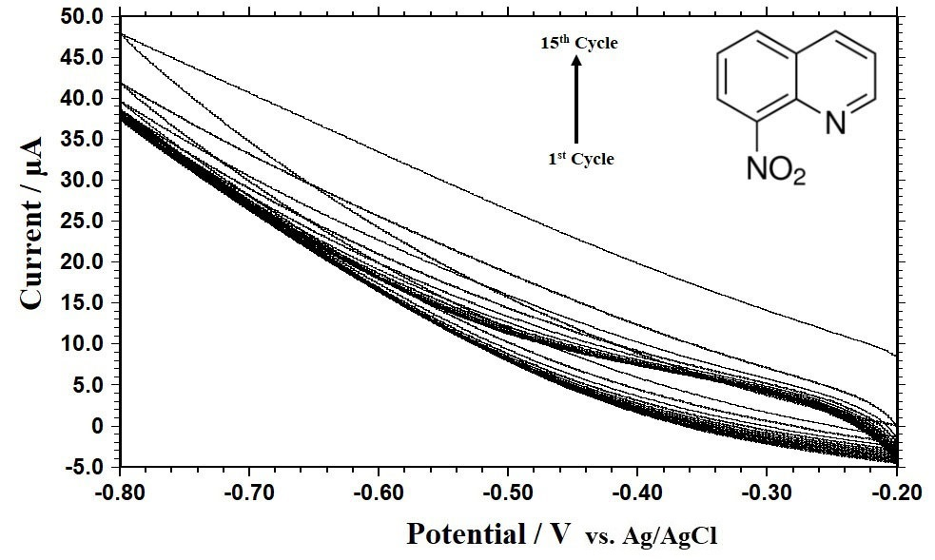
Figure S1. The CVs of 1 mM 8-NQ solution prepared in ethanol on the PGE surface (reference electrode: Ag/AgCl, scan rate: 100 mV s⁻¹).
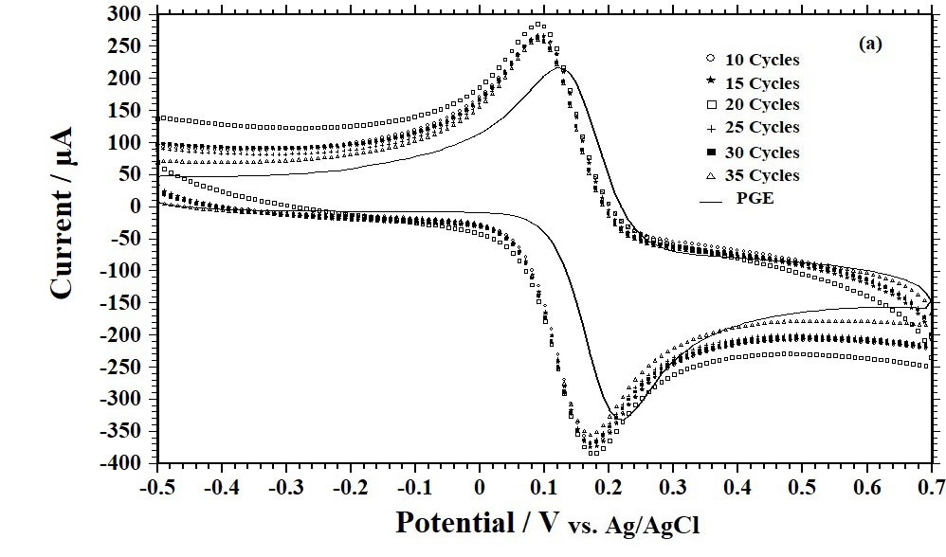
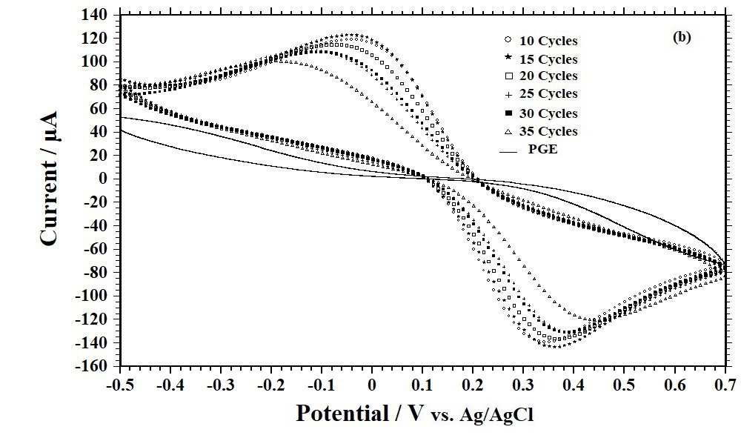
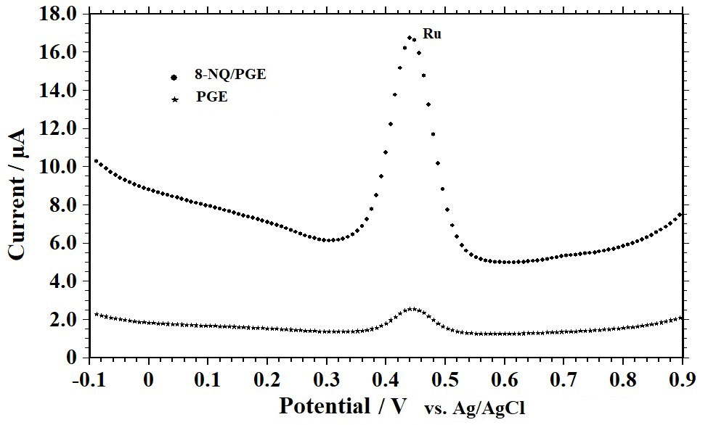
Figure S2. (A) CVs of 1 mM ferrocene redox molecule prepared in 0.1 M TBATFB, (B) CVs of 1 mM Fe(CN)₆ ^{3−/4−} redox molecules prepared in 0.1 M KCl, and (C) DPVs of 30 μM Ru at pH 3.0 in BR buffer at PGE and 8-NQ/PGE covered with 15 cycles (versus Ag/AgCl/KCl (sat.), the scan rate is 100 mVs⁻¹, pulse amplitude: 0.05 V, pulse period:0.2 s, and pulse width: 0.1 s).
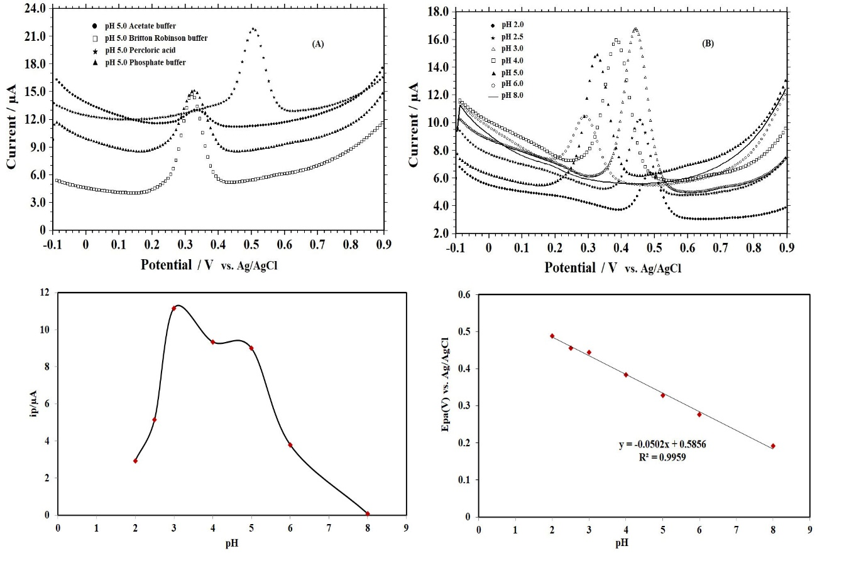
Figure S3. DPVs of Ru (30 μM) (A) in different supporting electrolytes of 0.1 M pH 5 Ac, BR and PBS buffers and pH 2 HClO₄, (B) in 0.1 M BR buffer solution with pH values of 2.0, 2.5, 3.0, 4.0, 5.0, 6.0, 8.0, (C) Graph of peak current Ip vs. pH, and (D) The relationship between peak potential Ep and pH for Ru (30 μM).
Scheme S1. The possible redox reaction mechanism of Ru on the 8-NQ/PGE.

Table S1. Influence of possible interfering species (inorganic ions and organic molecules) on the anodic peak current signals of Ru (10 μM) at pH 3.0 in BR buffer at the 8-NQ/PGE (n = 3).
Possible Coexisting Species | Concentration | Change of the peak current of Ru  %
NaCl | 1000µM (100 fold) | -1.94
KCl | 1000µM (100fold) | -2.75
Ca(CH₃COO)₂ | 1000µM (100fold) | -3.14
Mg(NO₃)₂ | 1000µM (100fold) | -2.56
Zn(CH₃COO)₂ | 300µM (30fold) | 3.35
Pb(CH₃COO)₂ | 300µM (30fold) | 4.4
Luteolin | 100µM (10fold) | 1.97
Quercetin | 100µM (10fold) | 3.5
Morin | 100µM (10fold) | -1.61
DA | 500µM (50fold) | 1.87
AA | 500µM (50fold) | -1.5
UA | 500µM (50fold) | 3.24
Phenol | 500µM (50fold) | 2.89
p-nitrophenol | 500µM (50fold) | 4.65
Glucose | 500µM (50fold) | 1.74

