

Supplementary Materials for

LncRNA CARMN m6A Demethylation by ALKBH5 Inhibits Mutant p53-Driven Tumor Progression through miR-5683/FGF2

Nannan Liu et al.

* Yingjie Zhang. Email: yingjiezhang@hnu.edu.cn

This PDF file includes:

Figs. S1 to S7

Fig. S1.
(A) The secondary structure of LncRNA CARMN was predicted by the online tool (http://rna.tbi.univie.ac.at/). (B) LncRNA CARMN was a non-coding RNA in CPAT online tool. (C) Immunofluorescent analysis of m6A (green) accumulation in sw480 cells with p53 antibody (red). (D, E) The box plots made in R revealed the expression of FTO and METTL3 without Significant differences between mutants and wildtypes. (F) A comparison of ALKBH5, FTO, METTL3, METTL14, METTL16, WTAP, and Ki67 expression levels between tissues with mutant p53 colorectal cancer and adjacent normal tissues.

Fig. S2.
(A-B) Motif analysis was made by the online tool JASPAR to identify the ALKBH5 binding motif of mutant p53.

Fig. S3.
(A) Proteins obtained from the RNA pull-down experiment were used to calculate the quantification of ALKBK5 by EMSA in sw480 cells transfected with OE-ALKBH5 or si-ALKBH5. (B) The secondary structure of m6A sites was predicted by the online tool SRAMP. (C) ALKBH5, YTHDF2, and YTHDF3 were located by western blotting using the protein extracted from nucleocytoplasmic separation experiment in HCT116, SW480 and SW620 cells.

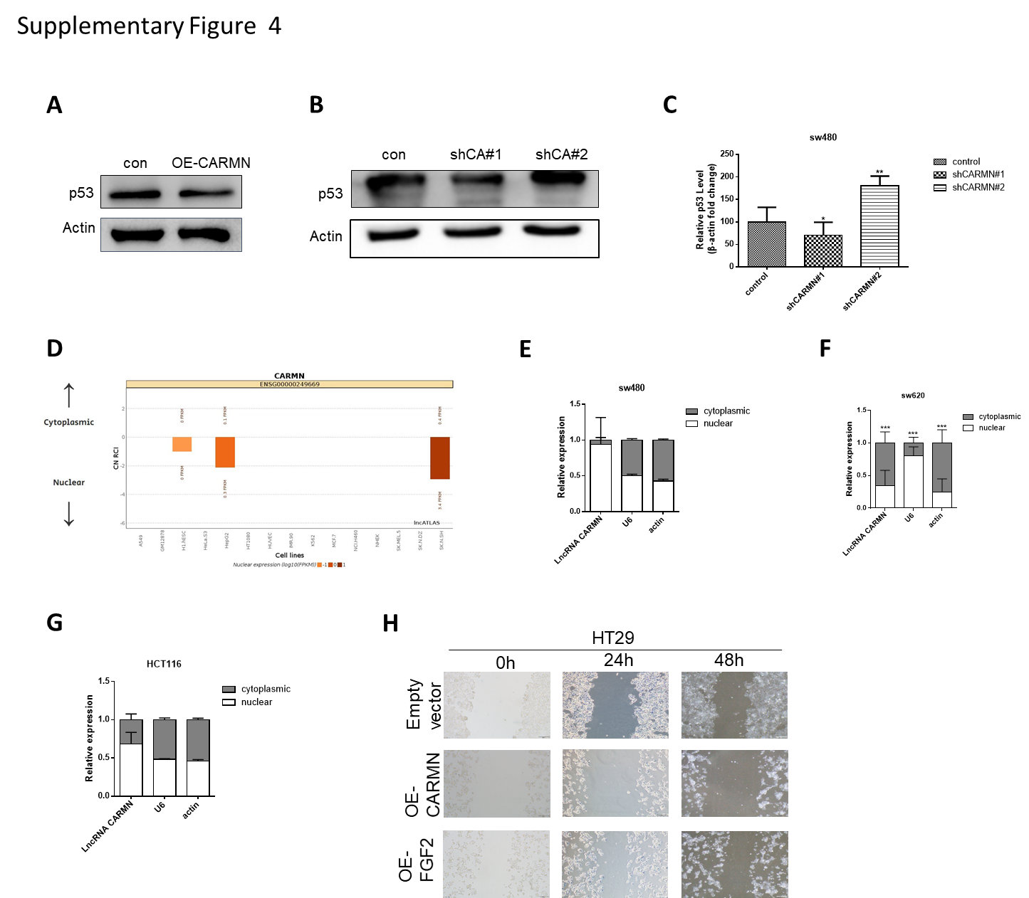

Fig. S4.
(A-C) Expression of P53 was tested by western blotting and RT-PCR in sw480 cells transfected with shRNA-CARMN or OE-CARMN. (D) The online tool lncATLAS predicted the location of CARMN mainly in the nucleus. (E-G) RT-PCR assays were used to measure the expression of subcellular CARMN in the nucleus and cytoplasm of sw480 cells. β-actin and U6 were worked as endogenous controls. (H) Wound-healing assays were used to observe the cell migration ability in sw480 cells transfected with OE-CARMN or Sh-CARMN in HT29 cells.

Fig. S5.
(A) The predicted miR-5683 binding sites in the CARMN transcript. (B, C) RT-PCR assays revealed the change of p53 in sw480 cells transfected with miR-5683 mimics or miR-5683 inhibitor. (D-F) Expression of miR-5683 was obtained by RT-PCR in HT29 or sw480 transfected with miR-5683 mimics or miR-5683 inhibitor. (G) EdU assays were applied to compare the cell proliferation ability in sw480 transfected with miR-5683 mimics or miR-5683 inhibitor. (H, I) It was used to identify the apoptosis and autophagy related proteins in sw480 cells.

Fig. S6.
(A) The degree value of sixteen core genes. (B) The predicted binding sites of miR-5683 in the 3’UTR of FGF2.

Fig. S7.
(A-C) Expression of FGF2 was obtained by RT-PCR in sw480 transfected with miR-5683 mimics, miR-5683 inhibitor or OE-CARMN. (D) The protein level of FGF2, Bcl-xl, Bcl-2, Caspase 3, P53, ULK1, P62 and LC3 were detected by western blotting in SW480 cells transfected with OE-CARMN, miR-5683 mimics, OE-FGF2 or shFGF2.

