Supplementary Figures

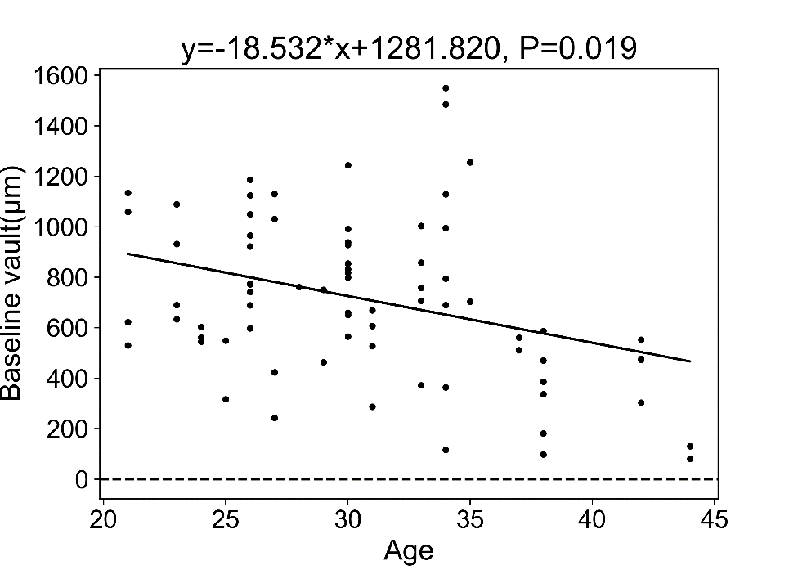
Figure A. Scatter plots show the correlations between baseline vault and Age. With Age increase, baseline vault become small.
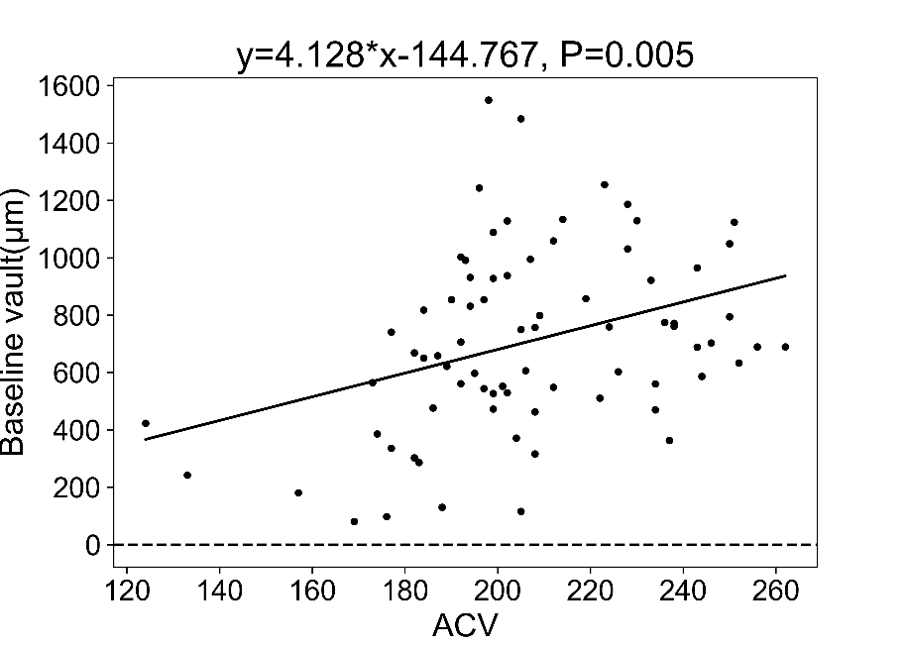
Figure B. Scatter plot shows the correlations between baseline vault and ACV. As ACV increase, baseline vault becomes large.

