Supplementary Information for
Changing the Game: The Role of Women in Experiential Learning
Authors: Thomas Falk^{1, 2}, Lara Bartels³, Ivo Steimanis¹, Vishwambhar Duche⁴, Björn Vollan¹
Affiliations: ¹ University of Marburg, Chair for Sustainable Use of Natural Resources, School of Business and Economics, Am Plan 2, 35032 Marburg, Germany; ² International Food Policy Research Institute, Natural Resources and Resilience Unit, 1201 Eye St., NW, Washington, DC 20005-3915 USA, ³ ZEW – Leibniz Centre for European Economic Research, L7, 1, 68161 Mannheim, Germany; ⁴ International Crops Research Institute for the Semi-Arid Tropics, Research Program on Innovation Systems for the Drylands, Patancheru 502324, Telangana/India
The supplementary materials are organized as follows: Section S1 provides further details on how the study was implemented: sampling, games intervention, outcomes measurements, summary statistics, and treatment balancing. Section S2 provides additional analysis referenced in the main manuscript and robustness checks. Section S3 provides the game protocol.
Table of Contents
S1 Study implementation 10
1.1. Economic game 10
1.2. Sampling, implementation, and ethical considerations 13
1.2.1. Survey data 13
1.2.2. Economic game 14
S2 Additional analysis and robustness checks 16
2.1. Calculation of return on investment 16
2.2. Summary Statistics 17
2.3. Main regression model 20
S3 Game protocol 24

Supplementary Tables:
Table S1. Crop income and water requirements 11
Table S2. Estimation of return on investment of main effect of game intervention 17
Table S3. Estimation of return on investment of gender effect of game intervention 18
Table S4. Game participants’ characteristics 18
Table S5. Balancing: First half versus second half villages 19
Table S6. Village characteristics 20
Table S7. Direct, indirect, and total effects from SEM 21
Table S8. Robustness check: Generalized SEM 23
Table S9. Maintenance treatment effect 24
Table S10. Cards to assign group composition and player positions randomly 26
Table S11. Relationships between choices 29
Table S12. Crops’ income and water requirement 30
Table S13. Record poster 35
Table S14. Communication record sheet 36

Supplementary Figures:
Figure S1. Relationship between investment and available water 11
Figure S2. Relationship between available water and irrigable fields by crop choice 12
Figure S3. Relationship between group investment and earnings 13
Figure S4. The structure of the dam 27
Figure S5. Decision card for crop choices 31
Figure S6. Players’ balance sheet 32

Study implementation

Economic game
The game was designed along the lines of other irrigation games, with a provision decision and an appropriation decision under asymmetric resource access. ¹⁴ The game was played simultaneously with two groups of seven players each in 56 randomly selected villages in the Mandla district in Madhya Pradesh, India. Each group played a maximum of 10 rounds. The rounds were divided in two phases, with five rounds in each phase.
In the first phase, players kept their group assignments, positions along the feeder channel, and their decisions secret. To maintain anonymity but allow players to keep track of the consequences of their investment and crop decisions, they were given a personal sheet with their round earnings after each round. Before the second phase, the groups and player positions were reshuffled to maintain the anonymity of phase one. In phase two, players knew who the group members were and their positions. They could communicate between game rounds and individual decisions were disclosed. Contributions, crop choices, and earnings of all players were written on a poster visible for all players. All these changes were announced before the second phase started. Each session closed with a debriefing that allowed all players and other community members to discuss the experience of the game for approximately 15 minutes. The facilitators asked open-ended questions intended to relate the game experience to the community’s real-life water challenges.
In each game round, players received an initial endowment of 3,000 play rupees and made two interlinked decisions. First, they had to decide how much of their endowment to invest in collective dam maintenance (and how much to keep). The accumulated individual contributions determined the total amount of water available as a function of diminishing returns (Figure S1).
Second, players had to choose between a water-intensive crop that yields more income and a water-efficient crop that yields less income. Their decisions affect the distribution of water among the group members, and thus players’ earnings.
In both phases, to ensure that participants took their investment decisions independently, two envelopes were given to them: an orange one containing the initial endowment of 3,000 play rupees; and an empty red envelope. If the players wanted to invest money in dam maintenance, they transferred their chosen amount to the red envelope. The envelopes were then handed back to the field assistants, who calculated the total group investment for this round. For the crop decision, decision cards were also given to the players in a (white) envelope to assure anonymity.
Relationship between investment and available water
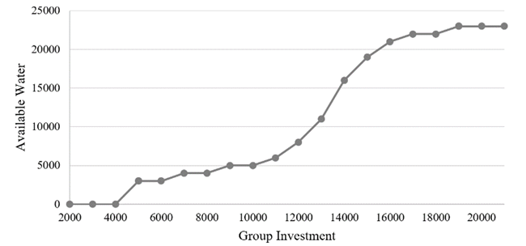
- Crop income and water requirements
 | Net return per ha in INR | Water requirement per ha in m³
Water-consumptive crop | 15,000 | 5,000
Water-efficient crop | 13,000 | 3,000

By design, there is never enough water in the dam such that all players can grow the water-consumptive crop (Figure S2). If players choose the water-consumptive crop, the water is depleted quickly, and overall group earnings are less than if everybody in the group chose the water-efficient crop. If all players invest approximately three-fourths of their endowment in dam maintenance in the first decision, there is enough water such that all players can grow the water-efficient crop.
Relationship between available water and irrigable fields by crop choice
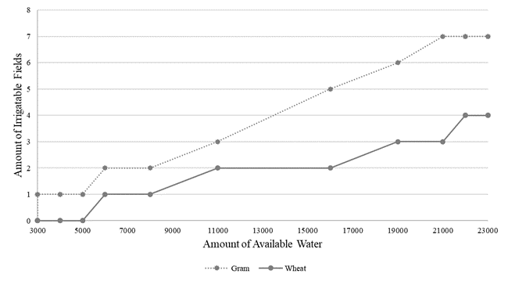
In addition, players are placed successively downstream from the dam along the feeder channels; players closest to the dam have preferential access to the water. For example, player 2 only takes water for irrigation after player 1; player 3 after player 2; and so on to player 7. How much each player can take depends on how much water was provided in step 1 and how much water was left by the upstream players.
A group of seven players would maximize their income if every player invested approximately three-fourths of the endowment and opted for the water-efficient crop. Figure S3 shows the relationship between the total group investment and the total group earnings, assuming homogeneous crop choices in the group. Any heterogeneous crop choice would result in a group income between the two functions. In fact, the game is set up so that if just one player chooses the water-intensive crop, the last player will not have enough water for either crop, regardless of how much he or she invested and how much the group contributed in total. Therefore, the maximum group income can be reached by jointly investing INR 14,000 and all choosing the water-efficient crop. However, players have incentive to deviate from this tactic and choose the water-intensive crop with the higher net returns. Additionally, the randomly allocated asymmetric positions may influence their decisions. Thus, the particularity of this game lies in the relationship of the investments collected for maintenance, the crop choice, and the sequential access to the water, simulating the fundamental dilemma of common property resource management. Interlinking these factors creates a complex impact chain that closely replicates the collective action problems around surface water management in the study region.
The exact wording and all materials that were used to explain the game are reported in Supplementary Section 3.
Relationship between group investment and earnings
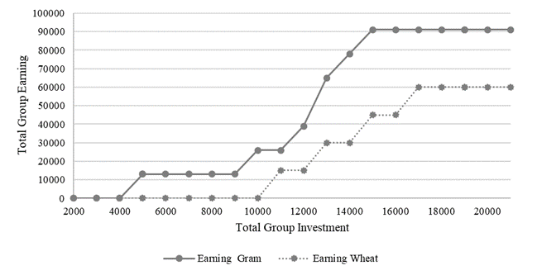

Sampling, implementation, and ethical considerations
Research partners and their contributions: The study was carried out by a team from the University of Marburg (UoM), the International Crops Research Institute for the Semi-Arid Tropics (ICRISAT), and the Foundation for Ecological Security (FES). The team coordinated with respective panchayats and the watershed committees of the sites. The partners jointly developed the intervention tool. FES identified local field assistants for data collection. Data management and analysis were carried out jointly by the UoM and ICRISAT.
Village sample selection: The Bhichiya block of Mandla district of Madhya Pradesh, India, was selected for this study. The project initially covered 90 villages, which were randomly selected, without any stratification, from a list of the 194 villages in the Mandla district reported by the official 2011 census. Of these 90 sample villages, 60 were assigned to the treatment group and 30 were assigned to the control group. Our final sample included only 84 villages: 56 treated and 28 control sites. Three sites (ID 34, 218, and 243) were dropped because there was no water infrastructure, and two sites (ID 254 and 378) were dropped because baseline survey data were not complete. Another village (ID 252) was dropped because too few people showed up for the game session.

Survey data
Baseline: A key informant baseline survey was conducted at the community level. The survey collected information about local water use and local water governance.
Local community members were identified as enumerators in coordination with FES. They received a two-day training on the questionnaire and the data collection process. Data collection was conducted in February and March 2017. First, enumerators visited the sample communities to explain the purpose and background of the research to community leaders. They then invited knowledgeable people, such as village presidents, ward members, village committee members, members of the water users association, teachers, and self-help group members, for the interview.
A few days later, between two and six key informants participated in the interviews, which were conducted at the village panchayat office, a temple, or a community hall. The enumerators first gave a brief introduction of the project, the project partners, and themselves. Oral consent was obtained from the key informants before the interviews started.
Follow-up: A key informant follow-up survey was conducted at the community level. The survey again collected information about local water use and governance. The follow-up survey was conducted by ICRISAT staff only. Otherwise, the same process was followed as for the baseline survey.

Economic game
Invitation: After the baseline survey interview, the enumerators provided a brief explanation of the nature of the intervention. They then gave a letter of invitation to the village leaders in the treatment communities, requesting the community’s participation in the experimental game. The invitation contained some background information about the project and requested that the leaders should contact a FES project manager if the community wanted to participate in the intervention. All communities who were randomly selected as treatment sites confirmed their interest in participating in the project.
Facilitation team: The facilitation team consisted of a student from the University of Marburg, a research fellow and a research assistant from ICRISAT, and 9 community members who were trained in facilitating the game. Community facilitators were identified with the support of FES. Three of the 12 facilitators were women.
Training of community facilitators: Over multiple days, we developed the capacity of community facilitators to lead the community participants through the games. The game protocol and material were translated into Hindi. The game was explained step by step, and the role of each facilitation team member was worked out. The game was then played repeatedly, first within the facilitation team and then with college students who were invited to participate in test runs. After the classroom training, two game sessions were arranged in communities that were not part of the sample. Once the facilitation team was trained, they started conducting game sessions in the sample communities.
Selection of participants: One member of the facilitation team was appointed to visit the treatment communities to fix a convenient time and day for playing the game with community leaders. During this visit, he reminded the village leaders about the background and purpose of the study. He informed them that we invite 14 community members who own or manage land near common water infrastructure. In addition, community members who benefit from the rainwater harvesting structure and village members who play an important role in management of common resources were invited. He emphasized that women who actively participate in village-level committees, self-help groups, the panchayat, or work as teachers should be encouraged to join the session.
Implementation process: One day before the game, one member of the facilitation team revisited the community and informed all invited players about their participation and how long the session would take. He also identified a venue, typically a temple, community meeting place, school, or town hall, in consultation with community members.
The facilitation team always arrived in the community one hour before the game session to set up banners and posters before the players gathered at the venue.
Once all players had gathered, the lead facilitator provided information about the project, the project partners, and the game, and introduced the facilitation team. S/he then explained the type of data to be collected, and the way the data would be stored and used. Expectations regarding the project outcomes were clarified. The facilitator informed the players again about the time required to run a session. After all these explanations, oral consent was obtained.
After this introduction, the lead facilitator explained the game narrative and rules. Test rounds were conducted before the facilitators led the players through the actual game.
Debriefing: At the end of the whole process, we asked players to give us anonymous feedback about their satisfaction with the experiential learning experience. We used two boxes that were placed where they could not be observed. The boxes had the following meanings:
Box: 1 Yes, the game is good and I would like to participate in such types of games in the future.
Box: 2 No, the game is not useful and I am not interested to participate in such kinds of games in the future.
Each player received a token and then voted, one at a time, by placing the token in the box of their choice.
Payments: After completing the game and the debriefing, the facilitators paid the players. To test whether individual payments affected players’ choices and learning, we randomly allocated half the sites to have individual payments based on players’ “earnings” in the game, and half the sites to receive a single lump sum paid to the community. Individual payments where made in a discrete manner. For more details on this aspect of our study, please see Bartels, et al. ⁶

Ethical considerations
The ethics committee of the School of Business and Economics of the University of Marburg has reviewed the research and approves the practices of the research.

Additional analysis and robustness checks

Calculation of return on investment
Acknowledging great variations between specific dams, the NGO Action for Social Advancement estimated in 2008 that the increase in irrigation water availability from a fully functional dam results on average in annual additional agricultural income of INR 91,080. A partially functional dam would increase income on average by INR 33,120. We converted these values to US dollars (exchange rate 1:75) and 2022 prices (inflation rate 156%). Thus, in 2022 prices, a fully functional dam would provide benefits of US$1,895 and a partially functional dam US$689. Based on expert advice, we added annual fish-farming income of US$70 (if the dam is fully functional). The average annual costs of regular dam maintenance have been estimated by FES to be approximately US$450.
We assume that a recently constructed or rehabilitated dam would be at least partially functional even without maintenance. The annual loss from not maintaining the dam would therefore be US$ 1,895 + $70 – $689 – $450 = $826. After three years, not maintaining the dam would lead to its complete breakdown. The annual loss due to not maintaining the dam would then be $1,895 + $70 – $450 = $1,516.
Our analysis of the main treatment effect indicates that the intervention increased the probability that a dam is properly maintained by 20 pp compared with control sites where the game was not played (Supplementary Appendix 2.3, Table S9). We make the conservative assumption that the effect of the intervention on collective maintenance activities declines by 10 pp over a period of five years, although it is also possible that a positive experience of successful dam maintenance increases its effect.
- Estimation of return on investment of main effect of game intervention
Year | Treatment cost | Benefit compared to no maintenance | Additional probability that intervention leads to maintenance in pp | Expected value of benefit | Cumulated present value assuming 10 percent annual discount rate | Return  on  Investment  in percent
1 | $72.44 | $826.26 | 0.20 | $165.25 | $92.81 | 28
2 |  | $826.26 | 0.19 | $156.99 | $235.53 | 225
3 |  | $826.26 | 0.17 | $140.46 | $351.62 | 385
4 |  | $1.515.56 | 0.13 | $197.02 | $499.64 | 590
5 |  | $1.515.56 | 0.10 | $151.56 | $603.16 | 733
Notes: ASA (2008) Study on Workings of Check Dams in M.P. Study Commissioned by the State Planning Commission, Madhya Pradesh/India. Bhopal/India.
We can see that the investment of the game interventions is recouped in the first year. After five years, the return on investment under our assumptions is 733 percent.
Focusing on the treatment sites only, the results of our structural equation model (Supplementary Table S7) indicate that increasing the participation of women in the game session by 10 pp increases the probability that maintenance will take place by 6 pp. If no women participate in a session, the model finds a 58 percent probability that maintenance takes place. This probability rises to 88 percent if an equal number of men and women participate, that is, a 30 pp increase in maintenance probability. Based on these numbers, we calculated the return on investment of equal gender participation compared to men only sessions (Supplementary Table S3).
- Estimation of return on investment of gender effect of game intervention
Year | Treatment cost | Benefit compared to no maintenance | Additional maintenance probability (in pp) of 50% vs. 0% female participants | Expected value of benefit | Cumulated present value assuming 10 percent annual discount rate | Return  on  Investment  in percent
1 | $72.44 | $826.26 | 0.30 | $247.88 | $175.44 | 142
2 |  | $826.26 | 0.30 | $247.88 | $400.78 | 453
3 |  | $826.26 | 0.25 | $206.57 | $571.0 | 689
4 |  | $1.515.56 | 0.20 | $303.11 | $799.23 | 1003
5 |  | $1.515.56 | 0.10 | $151.56 | $902.74 | 1146
Notes: ASA (2008) Study on Workings of Check Dams in M.P. Study Commissioned by the State Planning Commission, Madhya Pradesh/India. Bhopal/India.
The results indicate that including equal numbers of women and men in game sessions pays back more than twofold in the first year – assuming no additional costs of women’s participation. After five years, the return on investment is 1146 percent.

Summary Statistics
- Game participants’ characteristics
 | Leader |  | T-Test: | Not-leader villager |  | T-Test:
 | Male | Female | Difference | Male | Female | Difference
Variable | (1) | (2) | (1)-(2) | (3) | (4) | (3)-(4)
Age (in years) | 40 | 31 | 9.23*** | 34 | 30 | 3.5***
Literate (%) | 0.95 | 0.96 | -0.00 | 0.96 | 0.95 | 0.0
Primary education (%) | 0.56 | 0.74 | -0.18 | 0.58 | 0.63 | -0.1
Secondary education (%) | 0.36 | 0.22 | 0.15 | 0.32 | 0.31 | 0.0
University degree (%) | 0.03 | 0.00 | 0.03 | 0.06 | 0.01 | 0.0***
How often player would be asked for help by fellow players (1-14) | 1.39 | 1.74 | -0.35 | 1.21 | 1.00 | 0.21**
Labor contribution to dam (%) | 0.45 | 0.22 | 0.24** | 0.27 | 0.23 | 0.04
N | 66 | 23 | 89 | 503 | 192 | 695
Joint significance: F-Stat |  |  | 4.01*** |  |  | 4.43***
F-Test, N |  |  | 89 |  |  | 691
Notes: The value displayed for t-tests are the differences in the means across the groups. The value displayed for F-tests are the F-statistics. ***, **, and * indicate significance at the 1, 5, and 10 percent critical level.

- Balancing: First half versus second half villages
 | First 28 villages | Second 28 villages | t-test
 | (1) | (2) | Difference
Variable | Mean  (SD) | Mean  (SD) | (1)-(2)
Endline: Maintenance (=1) | 0.607 | 0.821 | -0.214*
 | (0.497) | (0.390)
Baseline: Maintenance (=1) | 0.464 | 0.607 | -0.143
 | (0.508) | (0.497)
Village size (households) | 157.929 | 170.464 | -12.536
 | (92.526) | (105.852)
NGO active in village (=1) | 0.607 | 0.786 | -0.179
 | (0.497) | (0.418)
Share literacy in % | 52.015 | 50.542 | 1.473
 | (7.983) | (8.943)
Share caste/tribal in % | 79.313 | 77.468 | 1.845
 | (17.875) | (17.285)
Dam used for irrigation (=1) | 0.500 | 0.357 | 0.143
 | (0.509) | (0.488)
N | 28 | 28
F-test of joint significance (F-stat) |  |  | 1.167
F-test, number of observations |  |  | 56
Notes: The value displayed for t-tests are the differences in the means across the groups. The value displayed for F-tests are the F-statistics. Standard deviations in parentheses. * indicates significance at the 10 percent critical level.

- Village characteristics
Variable | Definition | Survey source | Range | N | mean | SD | median
Dam maintenance | Dam has been maintained by anyone (e.g., development agency or village) during last year | Baseline | [0, 1] | 56 | 0.54 | 0.50 | 1
Dam maintenance |  | Follow-up | [0, 1] | 56 | 0.71 | 0.46 | 1
Rule existence | Rules on dam maintenance are in place | Baseline | [0, 1] | 56 | 0.32 | 0.47 | 0
Rule existence | Rules on dam maintenance are in place | Follow-up | [0, 1] | 56 | 0.14 | 0.35 | 0
Dam for farming | Village dam is used for farming /irrigation | Baseline | [0, 1] | 56 | 0.44 | 0.50 | 0
Dam for farming | Village dam is used for farming /irrigation | Follow-up | [0, 1] | 56 | 0.43 | 0.50 | 0
Village size (households) | No. of households living in village | Census | [24, 418] | 56 | 164.2 | 98.71 | 150
Share literacy in (in %) | Share of literate population in village | Census | [36, 69] | 56 | 51.28 | 8.43 | 52
Share caste/tribal in (in %) | Share of scheduled caste and tribal population in village | Census | [35, 100] | 56 | 78.39 | 17.45 | 81
FES presence | Village has worked with FES in the past | FES | [0, 1] | 56 | 0.70 | 0.46 | 1
Share of non-leader women (in %) | Indicates the share of women on the game participants in village in 10% | Game | [0, 93] | 56 | 24.49 | 17.54 | 21
Only male leader present | Indicates that male leaders were among the game participants | Game | [0, 1] | 56 | 0.30 | 0.46 | 0
Female leader present | Indicates that female and male leaders were among the game participants | Game | [0, 1] | 56 | 0.23 | 0.43 | 0

Main regression model
- Direct, indirect, and total effects from SEM
 | (1) | (2) | (3)
 | direct | indirect | total
Non-leader women participants (in 10%)
Female leader participated (=1) | 1.48*** | . | 1.48***
 | (0.44) | . | (0.44)
Sequence of game interventions (1 to 56) | 0.04*** | . | 0.04***
 | (0.01) | . | (0.01)
Village size (households) | -0.00 | . | -0.00
 | (0.00) | . | (0.00)
NGO active in village (=1) | -0.36 | . | -0.36
 | (0.45) | . | (0.45)
Share literacy in % | 0.05* | . | 0.05*
 | (0.03) | . | (0.03)
Share caste/tribal in % | 0.01 | . | 0.01
 | (0.02) | . | (0.02)
Dam used for irrigation (=1) | -0.26 | . | -0.26
 | (0.36) | . | (0.36)
Endline: Maintenance rule (=1)
Non-leader women participants (in 10%) | 0.10*** | . | 0.10***
 | (0.03) | . | (0.03)
Female leader participated (=1) | -0.05 | 0.15** | 0.10
 | (0.16) | (0.07) | (0.16)
Sequence of game interventions (1 to 56) | . | 0.00** | 0.00**
 | . | (0.00) | (0.00)
Village size (households) | -0.00 | -0.00 | -0.00
 | (0.00) | (0.00) | (0.00)
NGO active in village (=1) | 0.16 | -0.04 | 0.13
 | (0.12) | (0.05) | (0.12)
Share literacy in % | -0.01 | 0.00 | -0.00
 | (0.01) | (0.00) | (0.01)
Share caste/tribal in % | -0.00 | 0.00 | -0.00
 | (0.00) | (0.00) | (0.00)
Dam used for irrigation (=1) | -0.11 | -0.03 | -0.14
 | (0.12) | (0.04) | (0.13)
Baseline: Maintenance rule (=1) | -0.00 | . | -0.00
 | (0.17) | . | (0.17)
Endline: Maintenance (=1)
Non-leader women participants (in 10%) | 0.04 | 0.02* | 0.06**
 | (0.03) | (0.01) | (0.03)
Endline: Maintenance rule (=1) | 0.25** | . | 0.25**
 | (0.12) | . | (0.12)
Female leader participated (=1) | -0.10 | 0.08 | -0.02
 | (0.13) | (0.05) | (0.13)
Sequence of game interventions (1 to 56) | . | 0.00 | 0.00
 | . | (0.00) | (0.00)
Village size (households) | 0.00 | -0.00 | 0.00
 | (0.00) | (0.00) | (0.00)
NGO active in village (=1) | 0.17 | 0.02 | 0.19
 | (0.15) | (0.04) | (0.15)
Share literacy in % | 0.01 | 0.00 | 0.01
 | (0.01) | (0.00) | (0.01)
Share caste/tribal in % | -0.00 | -0.00 | -0.00
 | (0.00) | (0.00) | (0.00)
Dam used for irrigation (=1) | 0.17 | -0.04 | 0.13
 | (0.11) | (0.04) | (0.11)
Baseline: Maintenance (=1) | 0.03 | . | 0.03
 | (0.12) | . | (0.12)
Baseline: Maintenance rule (=1) | . | -0.00 | -0.00
 | . | (0.04) | (0.04)
N | 56 | 56 | 56
Notes: Estimates are from SEM model with robust standard errors in parentheses. * p<0.10, ** p<0.05, *** p<0.0

- Robustness check: Generalized SEM
 | Non-leader female participants (in 10%) | Endline: Maintenance (=1) | Endline: Maintenance rule (=1)
Female leader participated (=1) | 1.48*** | -0.28 | -0.09
 | (0.44) | (0.48) | (0.48)
Sequence of game interventions (1 | 0.04***
to 56) | (0.01)
Village size (households) | -0.00 | 0.00 | -0.00
 | (0.00) | (0.00) | (0.00)
NGO active in village (=1) | -0.36 | 0.46 | 0.52
 | (0.45) | (0.44) | (0.43)
Share literacy in % | 0.05* | 0.04 | -0.02
 | (0.03) | (0.03) | (0.02)
Share caste/tribal in % | 0.01 | -0.01 | -0.01
 | (0.02) | (0.01) | (0.01)
Dam used for irrigation (=1) | -0.26 | 0.58 | -0.36
 | (0.36) | (0.38) | (0.41)
Non-leader female participants |  | 0.17 | 0.31***
(in 10%) |  | (0.15) | (0.11)
Baseline: Maintenance (=1) |  | 0.11
 |  | (0.40)
Endline: Maintenance rule (=1) |  | 0.96**
 |  | (0.46)
Baseline: Maintenance rule (=1) |  |  | 0.01
 |  |  | (0.53)
Constant | -1.51 | -1.98 | 0.83
 | (2.33) | (2.20) | (1.85)
N | 56 | 56 | 56
Notes: Estimates are from generalized SEM model using probit link functions for binary outcomes with robust standard errors in parentheses. * p<0.10, ** p<0.05, *** p<0.01

- Maintenance treatment effect
 | Dam Maintenance (=1)
 | (1) | (2)
Games intervention | 0.19** | 0.20**
 | (0.01, 0.38) | (0.01, 0.39)
Baseline: DV | 0.21** | 0.19**
 | (0.03, 0.39) | (0.01, 0.38)
Village characteristics
Village size (households) |  | -0.00
 |  | (-0.00, 0.00)
FES presence (=1) |  | 0.02
 |  | (-0.20, 0.24)
Share literacy in % |  | 0.01
 |  | (-0.01, 0.02)
Share caste/tribal in % |  | -0.01*
 |  | (-0.01, 0.00)
Dam used for farming (=1) |  | 0.04
 |  | (-0.17, 0.24)
N | 84 | 83
Pseudo R2 | 0.07 | 0.12
Notes: The dependent variable in models (1) to (2) is dam maintenance in the past 12 months (=1). Reported are the average marginal effects obtained after Probit regressions. The 95% confidence intervals with robust standard errors are reported in brackets: *** p<0.01, ** p<0.05, * p<0.1.

Game protocol
Text written in italics is instructions given directly to the players. Normal text is instructions for the facilitators only. In the manuscript we refer to water-intensive and water-efficient crop. In the original game, we talk about wheat as the water-intensive crop and gram as the water-efficient crop.

Materials needed:
Before you begin, make sure that the following materials are at hand:
- A computer device with Excel
- USB stick
- 1 laminated pay-off table as a poster
- 2 laminated results tables
- 15 laminated player’s balance sheets
- 15 laminated Crop Choice Cards
- 15 laminated NREGA decision cards
- A set of 14 cards to assign the group composition and the player positions randomly
- Print outs of 25 record sheets
- 25.000 play Rupees in 1000 bills
- 7000 play Rupees in 500 bills
- 7000 play Rupees in 100 bills
- 3 dice
- 20 pens
- 20 non-permanent markers
- 3 cloths to clean the cards
- 10.000 real Rupees in small bills
- Receipt book or printouts
- 20 white envelopes
- 20 brown envelopes
- 15 name tags

Registration of Players
Please note the names of all players and assign them player numbers in the order they register.
Use the Excel-Form tab “initial information” provided to the facilitator for this documentation. Please ask all players to draw one of the cards that assigns the group affiliation and the player position (Table S10).
- Cards to assign group composition and player positions randomly
Group 1, Position 1 | Group 2, Position 1
Group 1, Position 2 | Group 2, Position 2
Group 1, Position 3 | Group 2, Position 3
Group 1, Position 4 | Group 2, Position 4
Group 1, Position 5 | Group 2, Position 5
Group 1, Position 6 | Group 2, Position 6
Group 1, Position 7 | Group 2, Position 7
Enter the group affiliation and player position in the Excel form. Make each player aware that under no circumstances should anyone in the group know her/his group affiliation and player position. Please also ask all players the question in the Excel form! Save the file repeatedly on the computer and a USB stick.
Please write the players’ names on the nametags and distribute them. Please do not write the players’ numbers on the nametag!
General Instructions to the Players
Is has come to our attention that the maintenance of stop-dams in the Mandla district is an issue. In our meetings thus far, people have mentioned that the dams can help the community a lot and that farmers experience a wide range of benefits because of them. At the same time, it was mentioned that some of the benefits are decreasing. Dams are filled with silt and overgrown with grass and bushes. Sluices are damaged. As a result, you experience fewer and fewer benefits in terms of groundwater recharge, surface irrigation water availability, and flood and soil erosion control. This is the main topic of this game!
The question is how to deal with this situation? We are aware that this is a difficult situation and we want to play a little game with you to explore this challenge jointly and develop ideas to ensure the continuous function of the watershed infrastructure.
In which villages the players receive actual payments will be determined randomly. In the villages that receive actual payments, you add the following explanation! Make sure that you do not read this statement at the sites where the players are not paid real money: [In this game, you can win real money of up to INR 400. We guarantee that you will receive at least 100 real Rupees. How much you win depends upon how you play, as well as how the other Ps play in the game. In the game, we play with play Rupees. At the end of the game, we will exchange 1000 play Rupees for one real Indian Rupee. The money we give you is not our private money, but comes from the International community via (identity information removed for review process).]
The team represented here is working for (identity information removed for review process) and (identity information removed for review process). (Identity information removed for review process) is an international institute that is conducting agricultural research that will help farmers all over the world improve their living conditions. (Identity information removed for review process) is a NGO working all over India on different aspects of rural development in cooperation with many international partners.
We have gathered 14 people today to play our game. You will play in two groups of seven players each, but at the beginning of the game, you will not know who plays with whom in one group. We will tell you only later during the game.
All of the information we collect during this game is treated confidentially. Only summary results are made available to different stakeholders at a later stage. We will return to share our scientific results with you. However, the main purpose of the exercise is to encourage discussion within the community and we hope that in this way it will be beneficial for you immediately. We will not bring any grants and will not start a project here. The benefits we hope that you will receive from us are the new ideas. At the same time, our study is likely to help the watershed department implement and manage watershed projects better.
We will explain the game step by step. You should listen to the instructions very carefully and ask questions at any point. We will conduct short quizzes to see if you understand the game. You can only participate in the game when you understand it fully. The game will be played in different rounds and we will have discussions in between in clearly dedicated time slots. The entire workshop will take approximately two hours.
We will introduce different rules during our explanations. Please ask us if you do not understand any of the rules fully. If we observe that someone is not following the rules, we will explain the rules again first. If anyone breaks the rules repeatedly, we have to exclude her/him from the game and no payments will be made to that person.
A Stop Dam as a Common Pool Resource
General Explanation
The game is all about maintaining stop dams in your village. The dams support the recharge of open wells downstream of them. This affects an area of up to four kilometers downstream, although the benefits decrease the farther away from the dam people have their wells and fields.
In our game, we assume a stop-dam of approximately 8,000 m³. A dam with this capacity can store approximately 40.000 m³ water over the year. Many communities agree that a certain amount of water needs to be made available for domestic use, watering livestock, fish production, and other non-irrigation uses. Considering this, we assume that communities allow farmers to take a maximum of 25.000 m³ water for irrigation in the Rabi season. The farmers below the dam can use this water to irrigate their fields. The number of fields that can be irrigated depends, amongst other reasons, on the crops the farmers grow.
As you know, even if the stop dam is in good condition, it requires regular maintenance in terms of materials, labor, and hiring machinery. The water available for irrigation depends upon the amount invested in maintenance. We assume that every year at least 50 person-days of labor are required and materials need to be bought. We estimate that the annual maintenance costs to maintain the dam at full capacity are in the range of INR 20.000.
The Investment Decision
Now that you learned about the main idea of the game, we want to explain how investments for the maintenance of the dam are made and how you can earn money.
Figure S4 shows a typical dam and seven fields downstream of the dam. Every field belongs to a farmer; player 1 is closest to the dam, and player 7 is the farthest away. Each of the farmers needs water to grow crops.
Point at the dam and the different field positions to illustrate this structure:
The structure of the dam
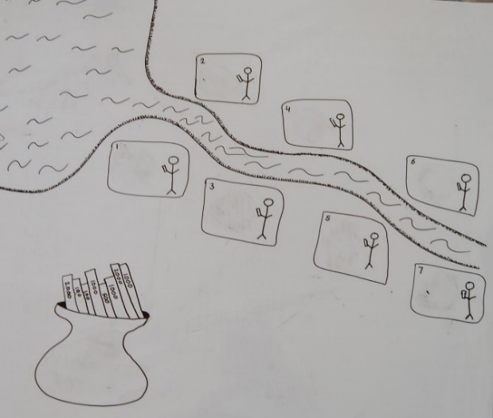
The water can be received from the dam. How much water is available depends upon how well the dam is maintained—in any case, the water available is limited. Money is needed to maintain the dam. This money comes from the investments you as a group can make voluntarily.
In every game round, we will give each of you 3,000 play Rupees. Consider that this money is money you have left at the end of every month. You can decide freely how to use it. You have the opportunity to invest money in the dam’s maintenance, or you can keep the money for yourself and use it for household expenditures. Any amount you do not invest remains in your personal account and no one can touch it. The money you invest will be put into the group account.
Draw some arrows from the players to the pot on Figure S4 to symbolize the investment.
The relation between the water available for irrigation and the investment in the dam’s maintenance can be seen in Table S11. Depending upon how much the group invested, the dam will have water available for irrigation. The water stored increases greatly with average investments. These calculations are made on the basis of experiences of (identity information removed for review process) in your area.
Point at the first and second columns of the table and show how the amount of water increases with the amount of money invested.
Now, for example, imagine your group made an overall investment of INR 16,000.
Circle the 16,000 on Table S11 and write 16,000 in the pot on Figure S4.
This will yield 21,000m³ of water to irrigate your fields.
Circle the 21,000 on Table S11 and write 21,000 in the dam on Figure S4.
- Relationships between choices
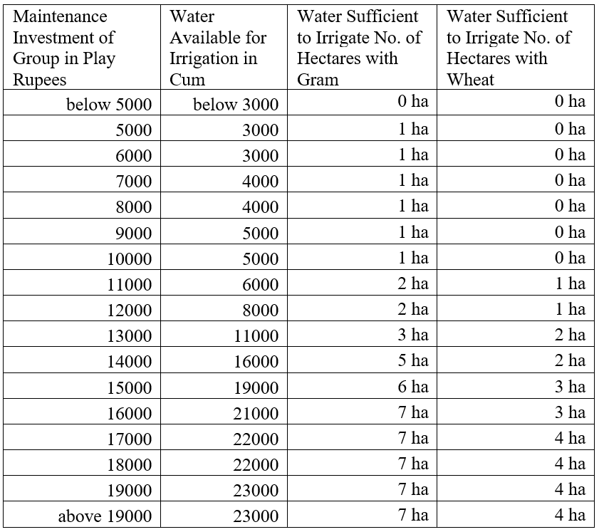
You can use this water to irrigate your fields and grow a Rabi crop. Each of you can choose between two crops, wheat or gram. You can see in Table S12 the differences between growing gram or wheat.
- Crops’ income and water requirement
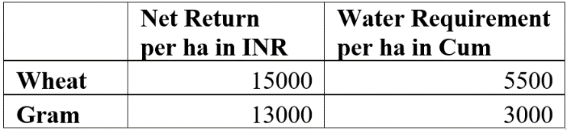
Taking all costs and labor inputs into account, wheat gives you a better return per acre than gram, but gram requires substantially less water: Wheat requires 5500 m³ and gram 3000 m³ of water.
Point at the different returns and water requirements (use Table S12).
The amount of crops that can be grown with any investment is calculated in the third and fourth column of Table S12.
Point to the third and fourth respective columns of Table S12 and show the relation between investment, amount of water available, and the amounts of wheat and gram the farmers can grow.
In this example, your group made an overall investment of 16,000. With the 21,000m³ available, each of you seven can either grow 1 ha of gram, or four of you can grow 1 ha of wheat each.
Point to the third and fourth respective columns of Table S12 to show the numbers.
In the first case, all of you receive returns and make a profit. However, in the latter case, there is not enough water left for the remaining three players to grow any crops. Thus, only four receive some return, while the other three farmers make no return despite their investment in the dam.
Use Table S12 to illustrate this case.
However, the investments are not high enough in every case for every farmer to potentially grow crops and make profits. Consider the case in which your group made an overall investment of INR 11,000.
Circle the 11,000 on Table S11 and write 11,000 in the pot on Figure S4.
This will yield 6000m³ of water to irrigate your fields.
Circle the 6000 on Table S11 and write 6000 in the dam on Figure S4.
Again, you can use this water to irrigate your fields and grow wheat or gram. However, with the 6000m³ available, only two of you can each grow 1 ha of gram, or one of you can grow 1 ha of wheat.
Point to the third and fourth respective columns of Table S11 to show the numbers.
In both cases, there is not enough water for all farmers to grow crops. Again, these earn no return despite their investment in the dam.
Use Table S11 to illustrate this case.
------
To make your investment decision, we will give you two envelopes, an orange one and a red one. In the orange one, you will find 3,000 play Rupees; the red envelope is empty. If you want to invest money in the dam’s maintenance, please transfer the amount you would like to invest to the red envelope.
At the time when the decisions are made, each player acts independently without consulting anyone else. You are not allowed to talk to each other or say anything. To ensure that you can make decisions independently, everyone will be seated in such a way that no one is able to see other players’ decisions.
We will now practice this with seven of you.
Select seven players and place them in the front. Please hand over the two envelopes prepared.
Now you can decide freely how much of your 3,000 play Rupees you want to invest in the maintenance of the stop dam. Please move as much play money from the orange to the red envelope as you want to invest in maintaining the dam. Please do it in a discreet way. Once you have made your decision, please hand both envelopes to the facilitators. All individuals make their decisions at the same time and without talking or consulting with anyone. We will then calculate how much your group has invested in the dam’s maintenance.
Once you get all of the envelopes, type the individual amounts invested into the Excel-table. In addition, circle the amount the group invested and the amount of water available in Table S11 and write both numbers in the pot and the dam in Figure S4.
Your group made an investment of X play Rupees, which yields Y m³ of water available for irrigation.
The Crop Choice Decision
Now, we come to the second decision of each round, which concerns the distribution of the dam water and the choice of crops.
We will distribute one card to each of you. In the upper part, you see a drawing, as here on the wall. There is a dam, a channel, and seven fields. You can find your field position on this card: it is the circled field. Keep this position in mind, as the water flows from the top to the bottom. The farmers farther up can take the water first and the next farmer can take only from what is left. This continues until there is no water left.
In the lower part of the card, you can mark which crop you want to grow: tick the left box if you want to grow gram, and the right box if you want to grow wheat. Whether you will indeed get the income from this crop will depend upon whether there was enough water available to grow it. This depends upon 1) how much the group has invested in the dam, and 2) on how much water the players above you have taken. We will give you the following decision cards in every round.
Show the empty crop choice decision cards (Figure S5) and hand them out to the players.
Decision card for crop choices
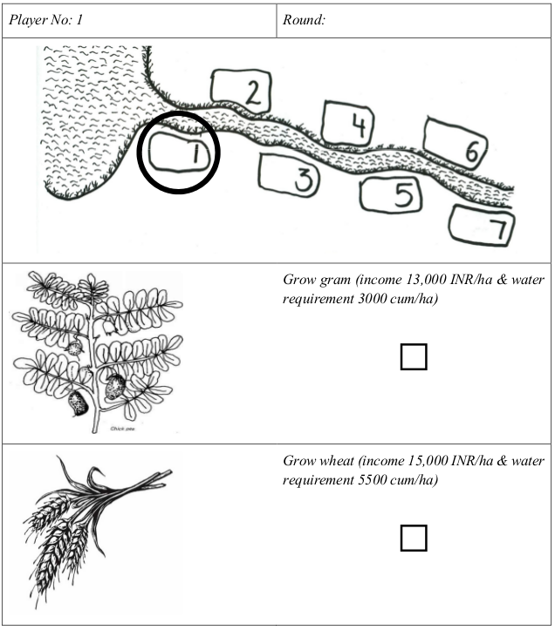
Please tick the box next to the crop you want to grow! Please do it so that no one can see your decision! Whether you can indeed grow this crop depends upon how much water is left to you at the end. Nevertheless, you will not face any costs if you selected a crop, but it could not be grown. If you chose to grow wheat, but there is only enough water for gram, we will change your crop choice to gram automatically.
Collect the Crop Choice Cards. Enter the data in the Excel sheet. Finally, write each player’s return and crop choice in each player’s field on the picture. Read the numbers aloud. Explain the result.
We will now practice this with the other seven players.
Repeat the procedure with the other seven players.
Once all players have made their decisions, we will inform you about your income in this round using the balance sheet. You will be given a balance sheet that tells you how much you have earned in the last round.
Show empty balance sheet (Figure S6):
Players’ balance sheet
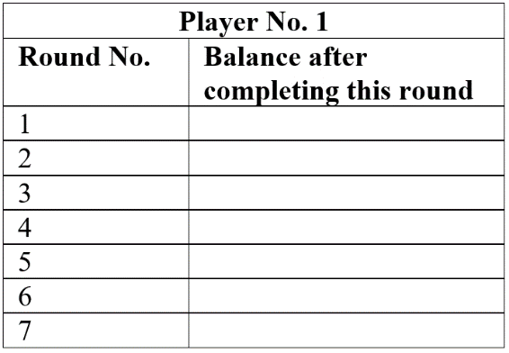
Once you have all Crop Choice Cards, type the decisions into the Excel-table. The table will calculate the individual earnings; write the player’s earnings on her/his balance sheet. Put the filled balance sheet into the brown envelope, move all play money from the brown back to the white envelopes, and hand back the envelopes.
This is how the game is played, but before we start the real game, please answer the following question!
Hypothetical Question
The following question will give us an idea about the player’s more general attitude.
We will now give you the Crop Choice Cards for the first time. Imagine that there are 21,000m³ of water available in the dam. Which crop would you choose? Please tick on the decision card and give it back to us.
Please record the players’ choice in the Excel file in the “Initial Information” tab.
The Actual Game
After all players understand the game well, we play one test round. If it becomes apparent during the test round that additional information is needed, than we will explain these aspects again. Otherwise, we play the game with them and record all decisions.
Before every round, prepare the brown and white envelopes by always putting 3,000 play Rupees into the white envelopes.
Now, please turn around and sit in a way that no one is able to see each other’s decisions. Now we start the game.
Please hand out the white and brown envelopes.
All of you please decide how much you want to invest in the dam’s maintenance. Place this amount secretly into the brown envelope.
After all group members have made their decision, collect all envelopes. Record every player’s contribution in the Excel table, which will help you calculate the water available to the group in this round. Mark the amount of water on Table S11 in front and hand out the crop decision cards.
Now you can see the water available to all of you in this round marked here in front. Please tick on your crop choice decision card which crop you want to grow in this round. Do not talk to anyone.
After all group members have made their decision, collect the crop choice decision cards, and record every player’s choice in the Excel table. This will help you calculate each player’s income in this round. Write each player’s earnings on the balance sheet and give the cards back in such a way that other players cannot see them.
Now that you have had this experience, we want to see what you decide now. Let us play the game for five rounds to see whether anything changes.
Repeat the procedure 5 times!
Discussion
Allow players to discuss after every game round. Avoid interfering into these discussions! Record the discussion content as summary!
As a variation of the game, village members who are observers can participate in the discussion. If this is the case, please note this down in your discussion report.
Communication and Social Information Treatment
As a first treatment, we introduce communication and social information. This is important, as our game is supposed to initiate a learning effect within the group. This effect is strongest if people can discuss their experiences in the game.
We mix the position of the players to ensure that their anonymity in treatment one is protected. Excel does this automatically. The new allocation of positions can be found in the Excel file in the “Initial Information” tab. Thus, make sure that you change the crop choice cards before you start to explain the treatment. Write all of the players’ names on the two Record posters too.
Now you play the same game for another five rounds, but from now on, at the end of each round, we will tell you how much each player contributed and earned. We use this poster for this purpose. You will also naturally find out with whom you are playing.
Show the empty Record Poster (Table S13)!
- Record poster
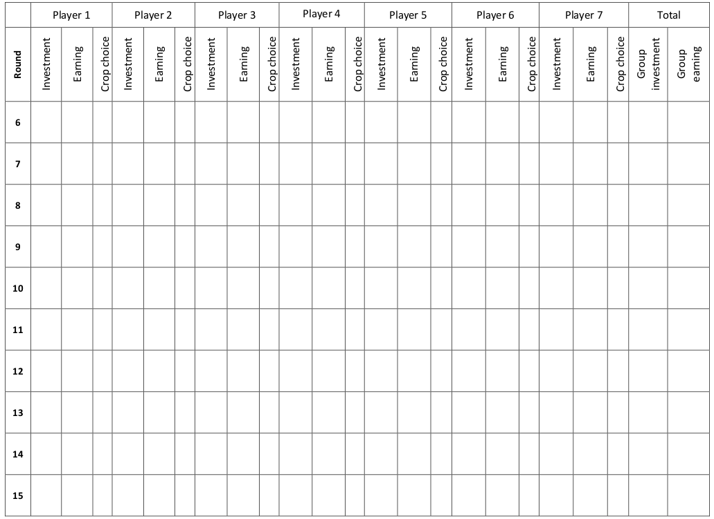
In addition, you can now discuss amongst yourselves as soon as you have given back the envelopes and decision cards and once we have written all of the players’ contributions and earnings on the Record Poster. To keep the exercise short, you have a maximum of five minutes of discussion for every round. In case you finish earlier, you can just give us your envelopes.
It is very important to note down the content of the discussion. You can summarize the content, but please include all arguments, agreements, complaints, and praises.
In addition, please use the communication record sheet (Table S14Table S13) to tick how often every player made statements of the following kinds:
- Proposing rule
- Agreeing with rule
- Rejecting rule
- Praise
- Blame/complaint
- Proposing punishment
- Proposing reward
- Statement unrelated to the game

From now on, you do not have to write the earnings of each round on the balance sheet because it is written on the poster below. Before every round, prepare the envelopes by always putting 3000 play Rupees into the white envelopes! Please also clean the crop choice decision cards. Please hand over the white and brown envelopes.
- Communication record sheet
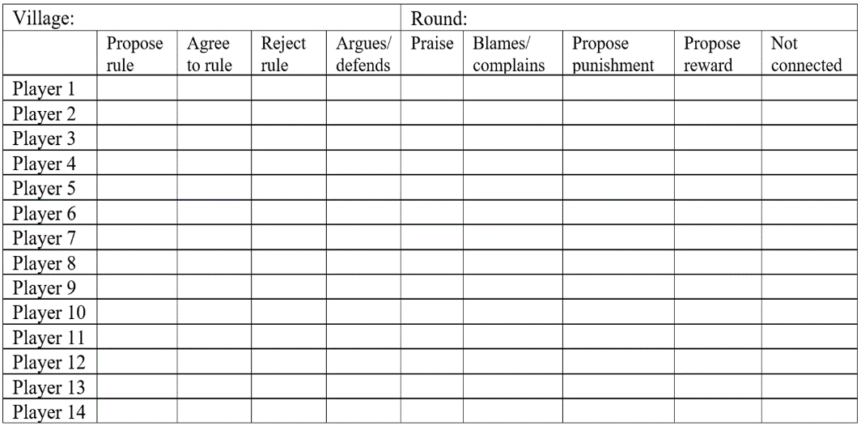
All of you please make your investment decisions.
After all group members have made their decision, we will calculate the water available to the group in the round and mark it on Table S11 in front. Please hand out the crop decision cards.
Now you can see the water available to all of you in this round marked here in front. Please tick on your crop choice decision card which crop you want to grow in this round.
After all group members have made their decision, collect the crop choice decision cards. Record every player’s crop choice in the Excel table. The table will help you calculate each player’s income in this round. Write the individual earnings on the Record Poster (Table S13) in front.
You now have 5 minutes time to discuss amongst yourselves.
Please watch the time and record the discussion both on the Communication record sheet (Table S14) as well as by taking summary notes.
Now that you have had this experience, we want to see what you decide now. Let us play the game for five rounds to see whether anything changes.
Repeat the procedure 5 times!

