SUPPLEMENTARY INFORMATION

Pulsed Laser Welding of Graphene Materials
Wenjie Yu^{1,2}, Weiwei Zhao¹ & Xiaoqing Liu^{1*}
1 Key Laboratory of Marine Materials and Related Technologies, Zhejiang Key Laboratory of Marine Materials and Protective Technologies, Ningbo Institute of Materials Technology and Engineering, Chinese Academy of Sciences, Ningbo, 315201, China
2 University of Chinese Academy of Sciences, Beijing, 100049, China

*Corresponding author:
Xiaoqing Liu, E-mail address: liuxq@nimte.ac.cn

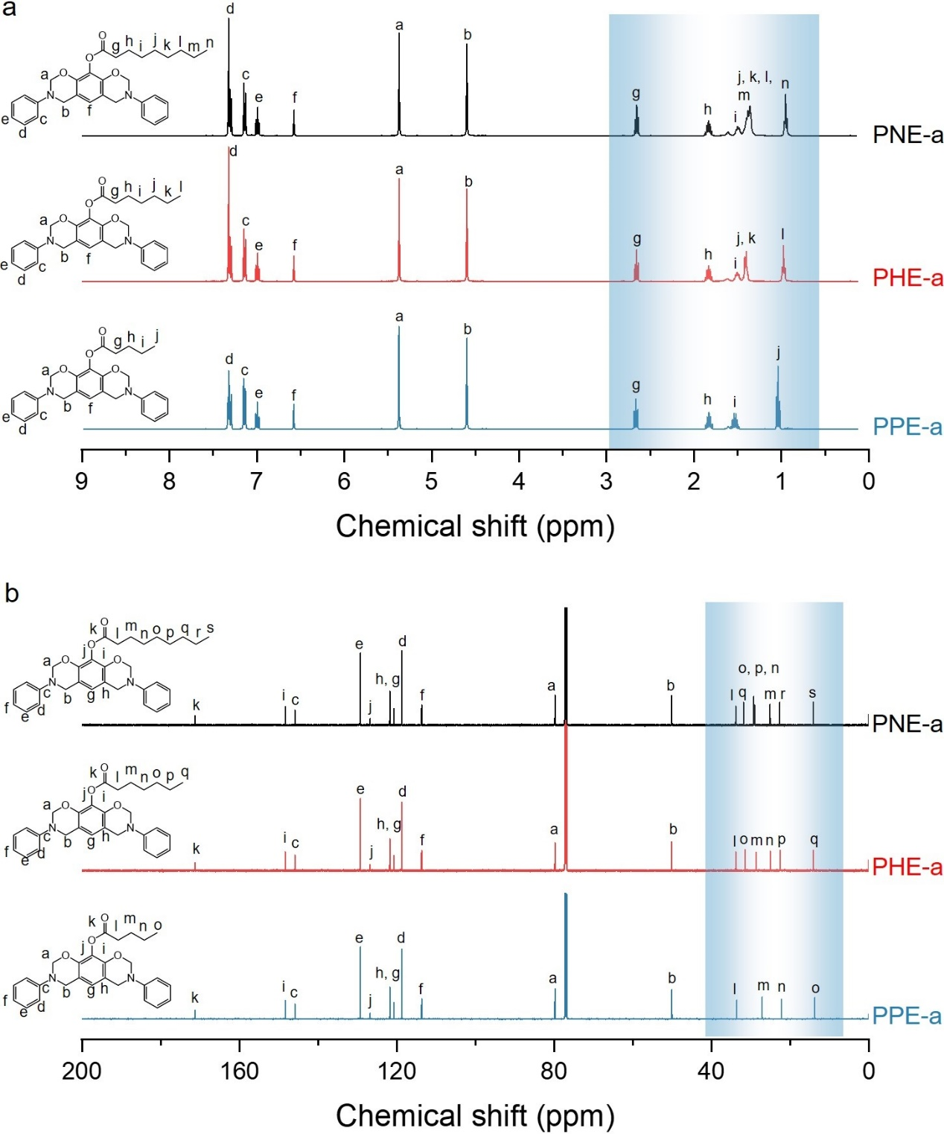
Supplementary Fig. 1: Chemical structure characterization of synthesized PNE-a, PHE-a, and PPE-a. a) ¹H NMR spectra (CDCl₃, 400 MHz). (b) ¹³C NMR spectra (CDCl₃, 101 MHz). PPE-a: ¹H NMR (400 MHz, Chloroform-d) δ = 7.34 – 7.28 (m, 4H), 7.18 – 7.10 (m, 4H), 7.00 (td, J = 7.3, 1.1 Hz, 2H), 6.58 (s, 1H), 5.38 (s, 4H), 4.60 (s, 4H), 2.67 (t, J = 7.5 Hz, 2H), 1.83 (p, J = 7.5 Hz, 2H), 1.59 – 1.48 (m, 2H), 1.04 (t, J = 7.4 Hz, 3H). ¹³C NMR (151 MHz, Chloroform-d) δ = 171.21, 148.34, 145.88, 129.25, 126.76, 121.77, 120.71, 118.69, 113.69, 79.79, 50.07, 33.57, 27.10, 22.19, 13.75. PHE-a: ¹H NMR (400 MHz, Chloroform-d) δ = 7.36 – 7.26 (m, 4H), 7.18 – 7.10 (m, 4H), 7.04 – 6.95 (m, 2H), 6.58 (s, 1H), 5.37 (s, 4H), 4.60 (s, 4H), 2.66 (t, J = 7.5 Hz, 2H), 1.83 (p, J = 7.5 Hz, 2H), 1.55 – 1.47 (m, 2H), 1.44 – 1.34 (m, 4H), 1.02 – 0.94 (m, 3H). ¹³C NMR (151 MHz, Chloroform-d) δ = 171.22, 148.35, 145.88, 129.26, 126.76, 121.77, 120.71, 118.70, 113.69, 79.78, 50.09, 33.87, 31.47, 28.68, 25.05, 22.58, 14.06. PNE-a: ¹H NMR (400 MHz, Chloroform-d) δ = 7.35 – 7.26 (m, 4H), 7.18 – 7.10 (m, 4H), 7.04 – 6.95 (m, 2H), 6.58 (s, 1H), 5.37 (s, 4H), 4.60 (s, 4H), 2.66 (t, J = 7.5 Hz, 2H), 1.83 (p, J = 7.5 Hz, 2H), 1.50 (m, J = 7.6 Hz, 2H), 1.45 – 1.31 (m, 8H), 0.99 – 0.90 (m, 3H). ¹³C NMR (151 MHz, Chloroform-d) δ = 171.23, 148.35, 145.89, 129.26, 126.76, 121.77, 120.71, 118.69, 113.69, 79.78, 50.09, 33.87, 31.85, 29.26, 29.04, 25.11, 22.68, 14.12.
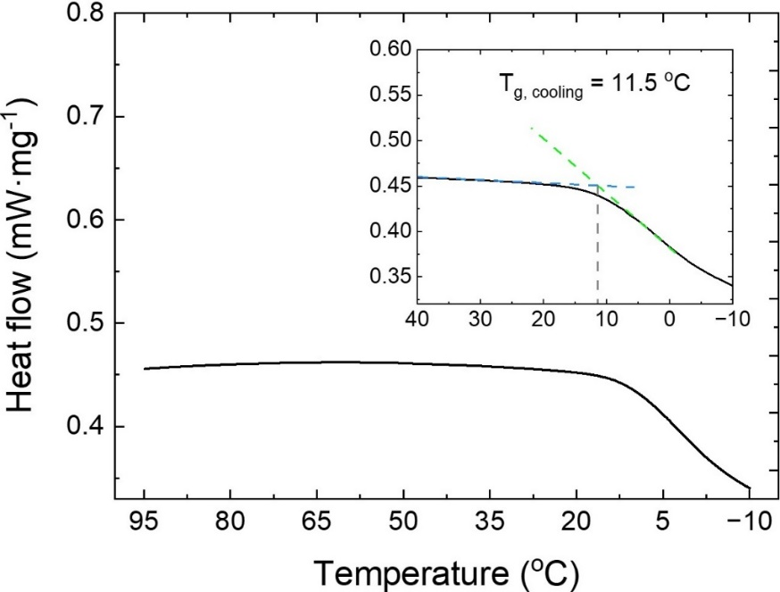
Supplementary Fig. 2: DSC curves of PHE-a. It can be seen that the glass transition appears when the temperature dropped below 11.5℃.

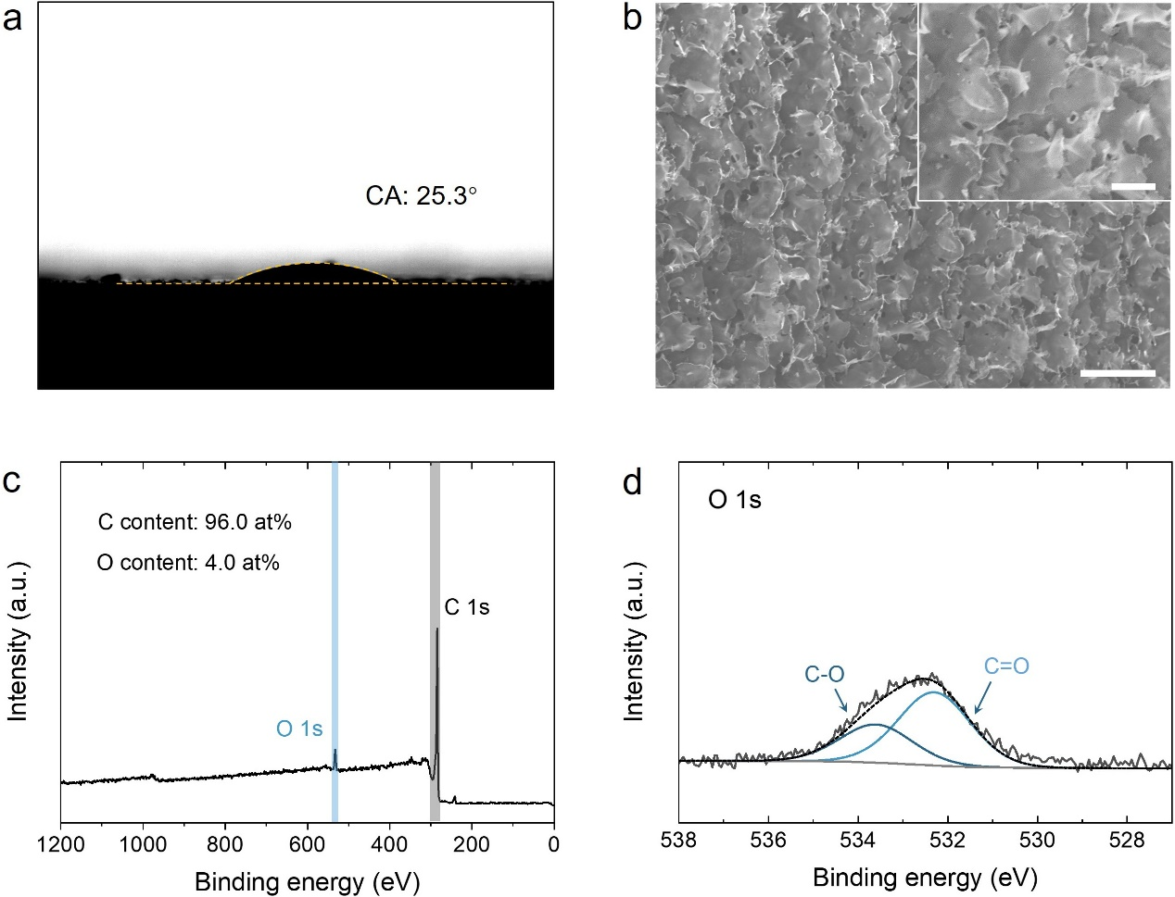
Supplementary Fig. 3: a) Contact angle between PHE-a and a base graphene film measured at ~90 ℃. b) Surface morphology of the base graphene film; the scale bar is 30 μm. Inset is an enlarged version; the scale bar is 10 μm. c) XPS spectra of the base graphene film, showing a dominant C 1s peak and extremely low oxygen content of ~4.0 at%. d) The XPS O 1s spectrum was deconvoluted into two peaks that were assigned to C-O (~533.5 eV) and C=O (~532.3 eV).
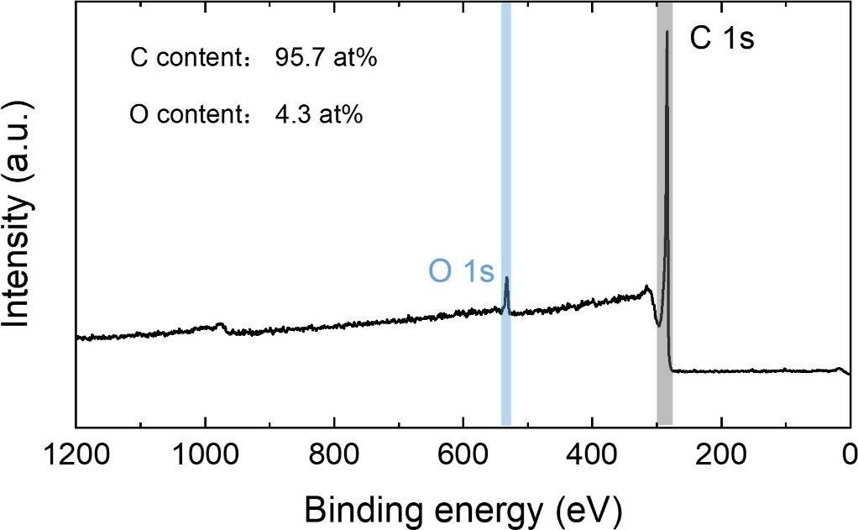
Supplementary Fig. 4: XPS spectrum of LIG solder.

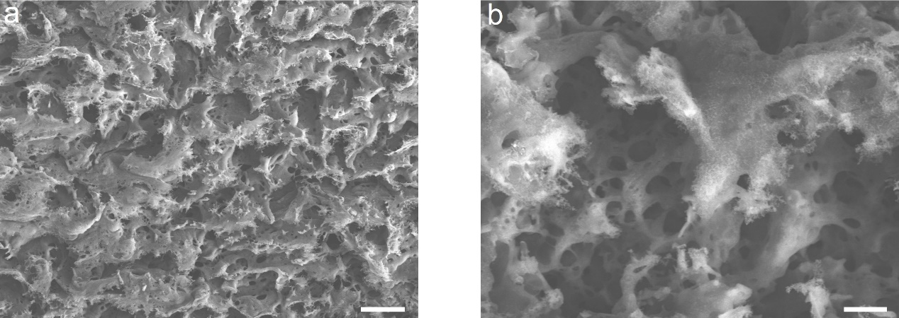
Supplementary Fig. 5: Porous morphology of LIG solder at a) low magnification and b) high magnification; the scale bars are 50 μm and 10 μm, respectively.

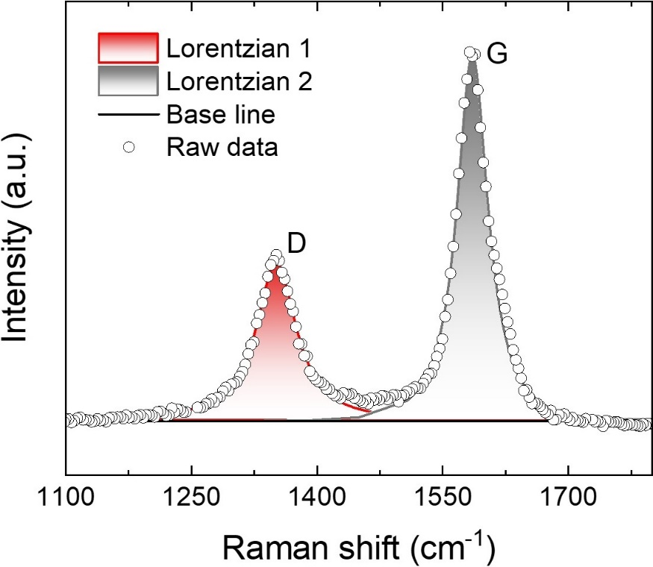
Supplementary Fig. 6: Curve fitting for the Raman D and G peak of the solder. The D peak at 1351 cm⁻¹ results from defects or bent sp²-carbon bonds. The G peak centered at 1585 cm⁻¹ possesses an FWHM of 44 cm⁻¹, suggesting a high graphitization level of LIG solder.¹

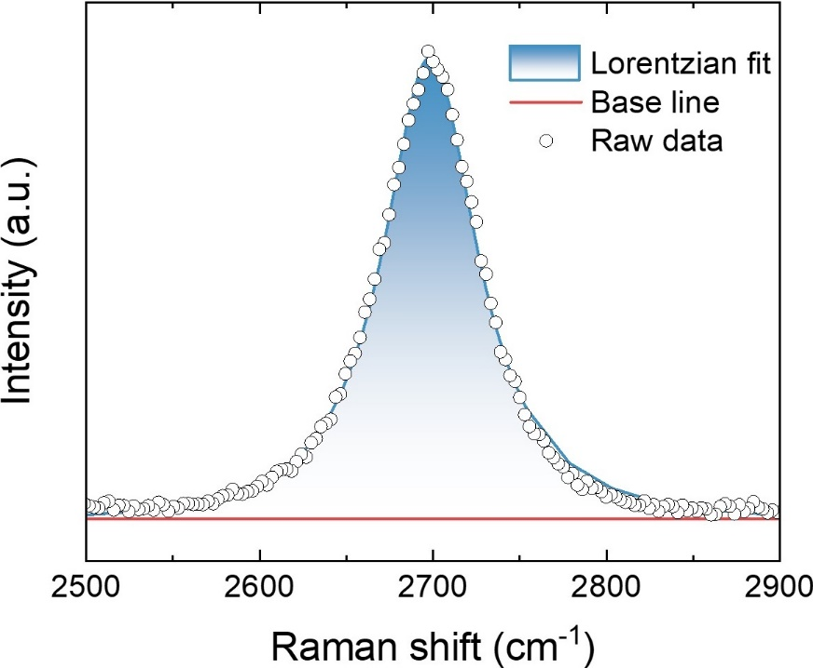
Supplementary Fig. 7: Curve fitting for the Raman 2D peak of the solder. The 2D peak at 2698 cm⁻¹ possesses a single Lorentzian shape with an FWHM of ~ 64 cm⁻¹.

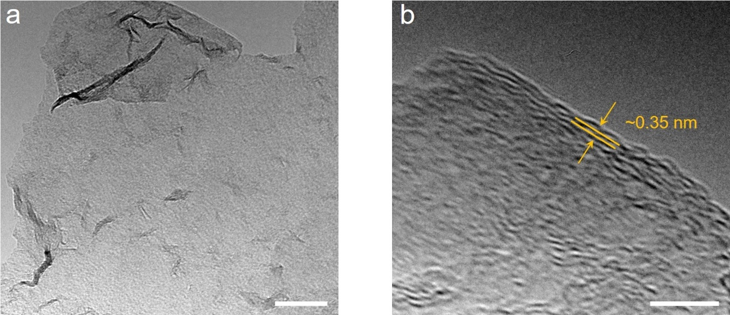
Supplementary Fig. 8: a) TEM image and b) HRTEM image of the edge of the solder flake; the scale bars are 50 nm and 5 nm.

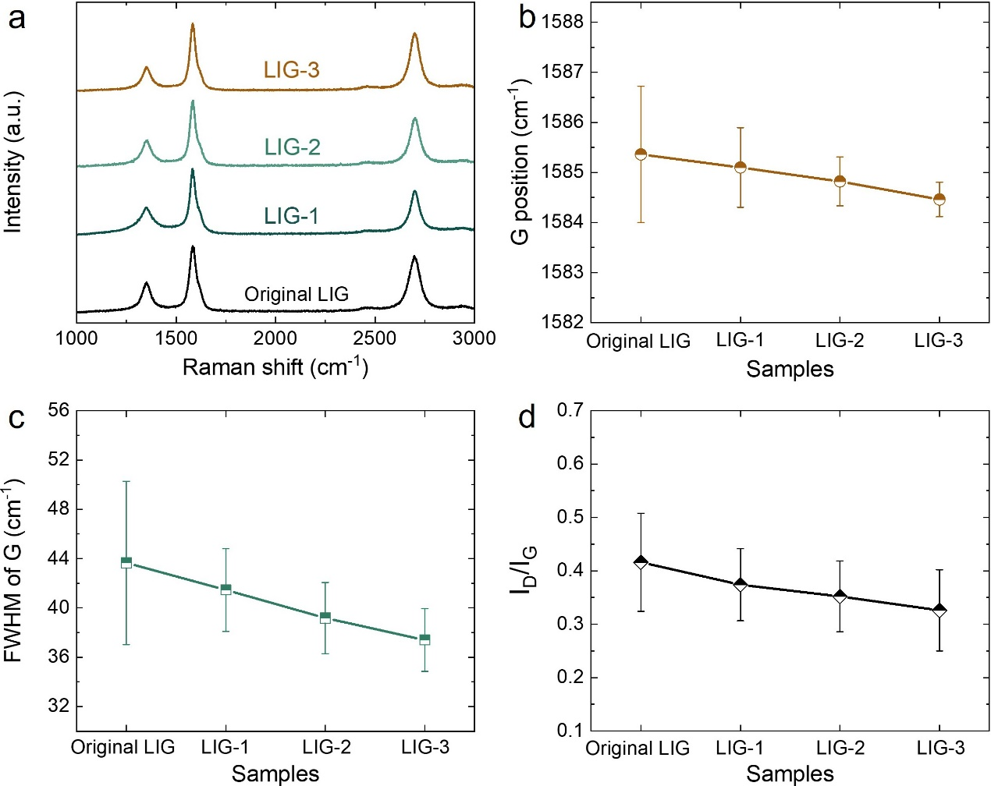
Supplementary Fig. 9: a) Representative Raman spectra of LIG solders that underwent different precursor infiltration and pyrolysis times. Statistical analysis of b) G position, c) FWHM of G peak, and d) I_{D}/I_{G} of samples. The standard deviation was calculated based on five repeated experiments.

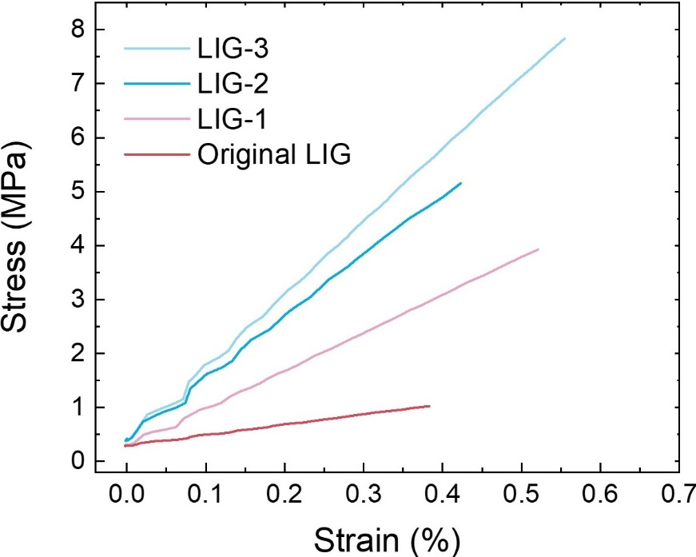
Supplementary Fig. 10: Representative tensile stress-strain curves of the different LIG solder.

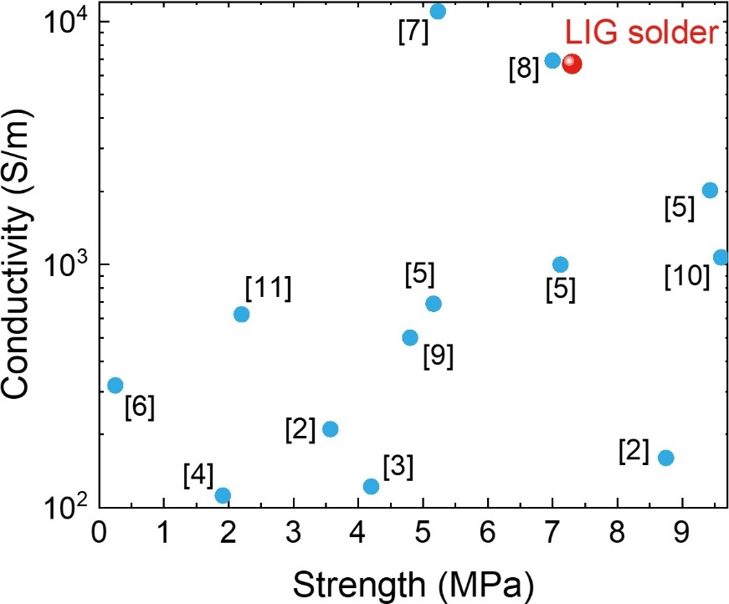
Supplementary Fig. 11: Comparison of the LIG solder with 3D graphene materials previously reported in terms of conductivity and strength.²⁻¹¹

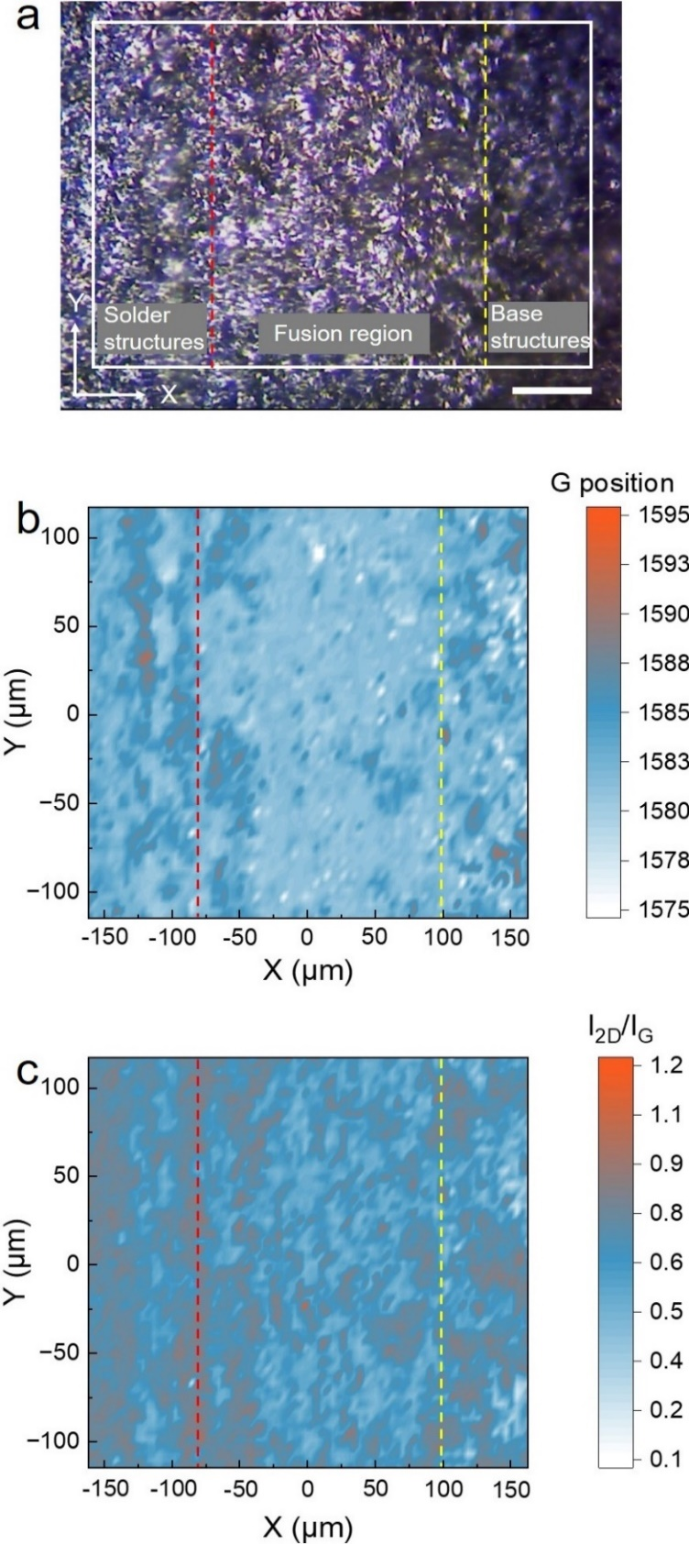
Supplementary Fig. 12: a) Optical image of the junction part of solder and base graphene structures; the scale bar is 50 μm. Corresponding Raman b) G position and c) I_{2D}/I_{G} mapping images. The red dashed lines are used to distinguish the solder structures and fusion structures, and the yellow dashed lines are used to distinguish the base structures and fusion structures.

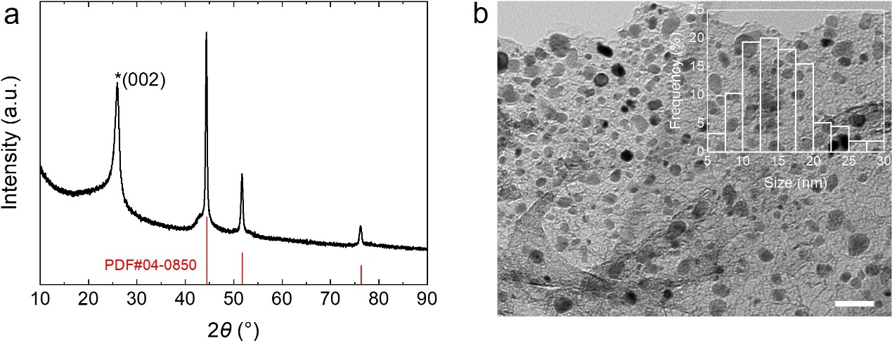
Supplementary Fig. 13: a) XRD pattern of the Ni-solder. The PDF reference card is Ni, 04-0850. The peak at ~26° (star) is attributed to the multi-layer graphene structure. b) TEM image shows that Ni nanoparticles evenly distribute on the solder flake with roughly a normal distribution size; the scale bar is 50 nm. Inset is the particle size distribution calculated based on the statistical analysis of the projected area diameter of Ni nanoparticles.

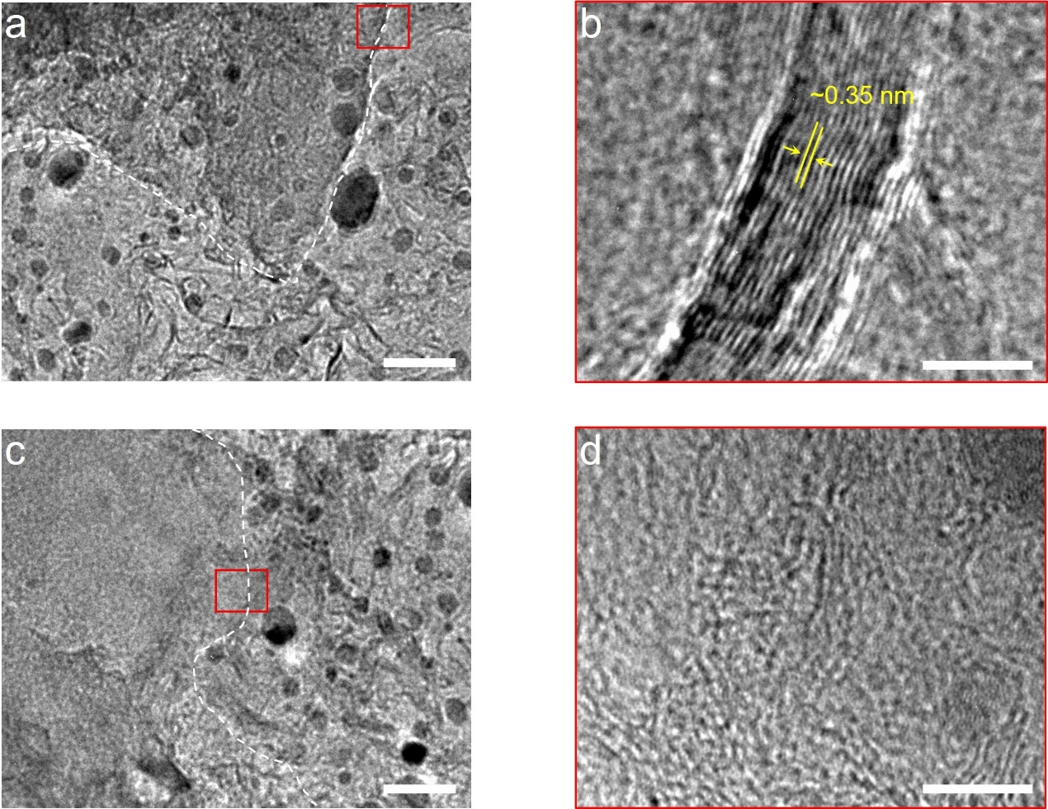
Supplementary Fig. 14: a) A TEM image of the layer-to-layer welding structure; the scale bar is 30 nm. The multi-layer stacking structural feature is further detailed by b) an HRTEM image; the scale bar is 5 nm. c) TEM image and d) HRTEM image of the integrated welding structure show a roughly continuous graphene flake with Ni-solder and base structures; the scale bars are 30 nm and 5 nm, respectively. The white dashed lines are used to roughly outline base graphene structures. Presumably, the formation mechanism of the integrated welding structure was conceptually similar to the repair of graphene holes and edge defects by carbon sources at high temperatures, which have been well demonstrated in the research relevant to graphene nanomanufacturing.^{12, 13}

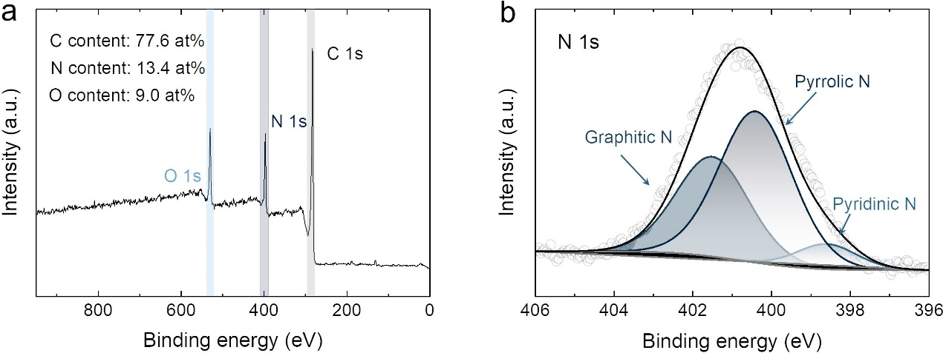
Supplementary Fig. 15: a) XPS spectrum of N-solder. The N-doping level is calculated to be 13.4 at%. b) High-resolution XPS N 1s spectra of N-solder. The N 1s peak can be deconvoluted into three sub-peaks located at ~398.5 eV, 400.4 eV, and 401.5 eV, which may be respectively attributed to pyridinic N, pyrrolic N, and graphitic N.¹⁴

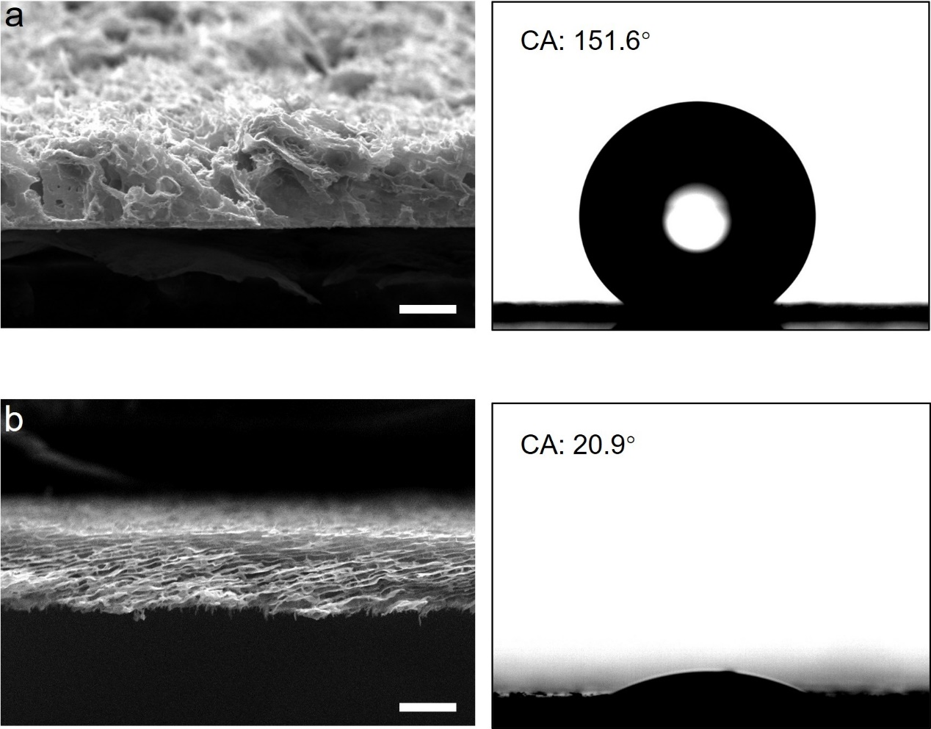
Supplementary Fig. 16: The characterization of two base graphene films used to fabricate the Janus structure. a) SEM image of the upper film (right) and its water contact angle (left); the scale bar is 30 μm. b) SEM image of the underlying one (right) and its water contact angle (left); the scale bar is 30 μm.

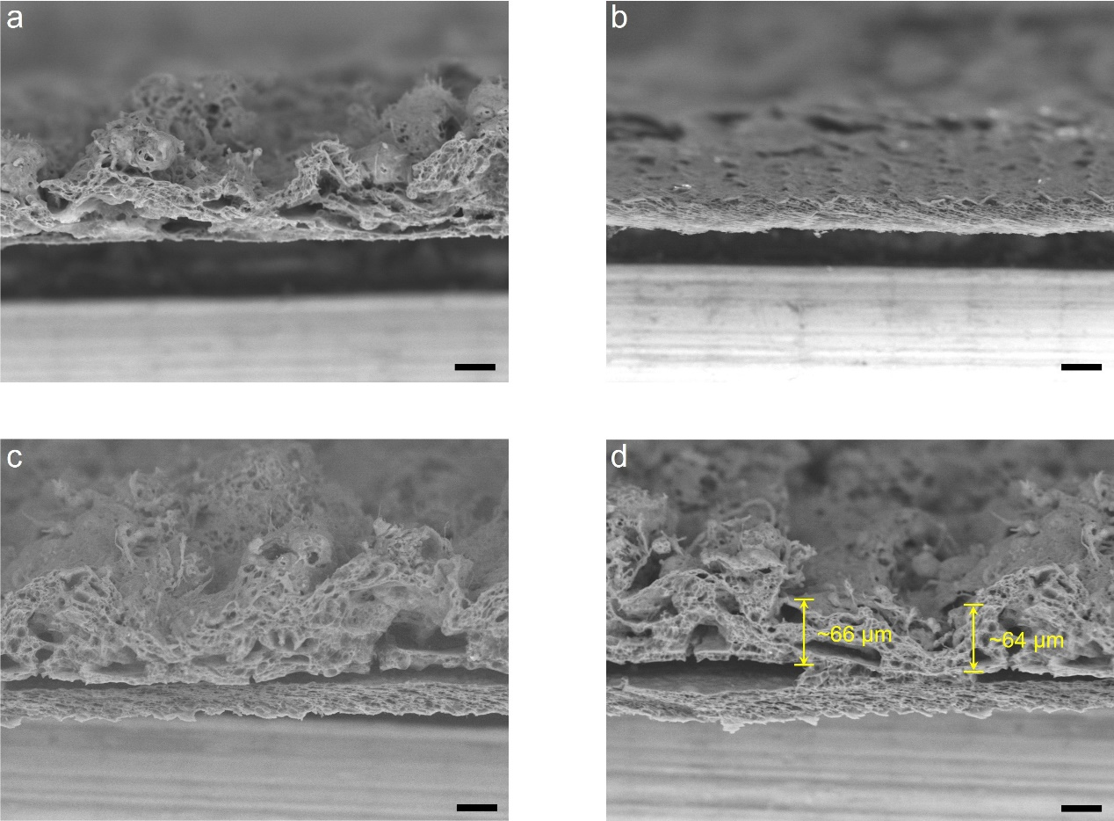
Supplementary Fig. 17: The investigation of the critical thickness of the upper layer for face-to-face welding. a) a graphene film with a non-uniform thickness and b) a graphene film with a uniform thickness of ~40 μm are respectively employed as the upper layer and underlying one for the welding. c) The SEM image shows that face-to-face welding is completely unfeasible if the thickness of the upper layer is too large. d) The SEM image shows that the critical thickness of the upper layer structure is roughly 65 μm. The scale bars are 40 μm.

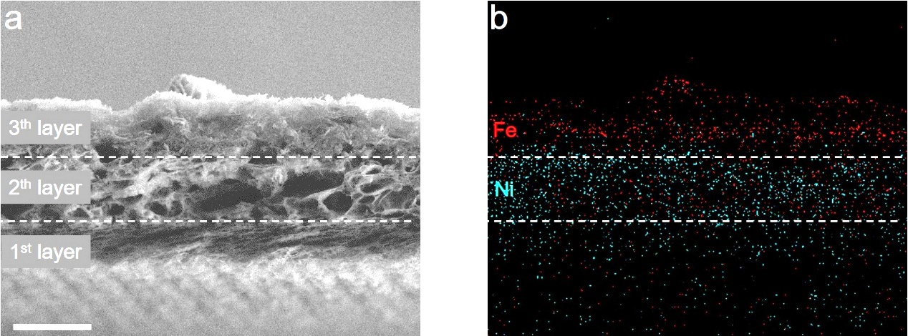
Supplementary Fig. 18: a) SEM image of a three-layer graphene film fabricated by forming Ni-solder and Fe-solder on a base film in sequence; the scale bar is 20 μm. b) EDS elemental mapping derived from a).

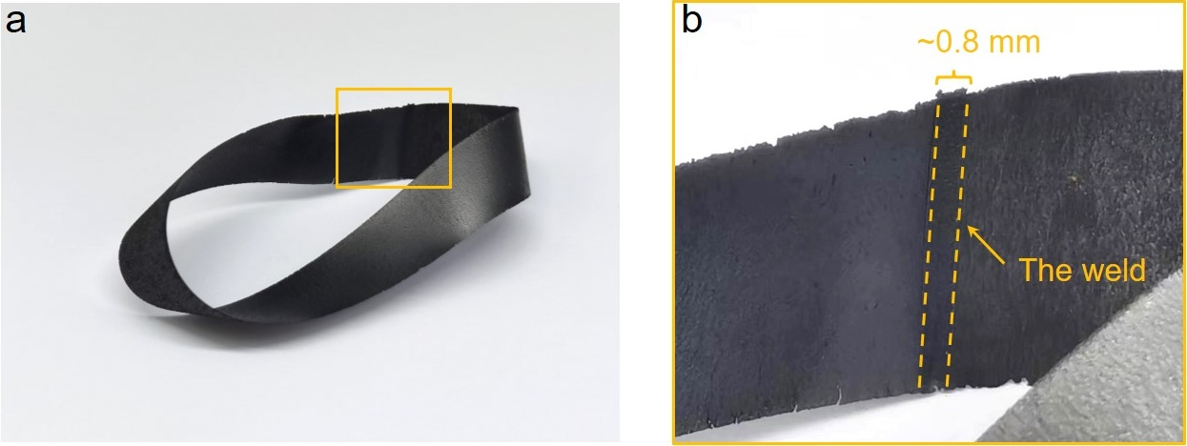
Supplementary Fig. 19: A graphene Möbius strip fabricated from a free-standing graphene film with the dimension of 160 mm × 14 mm × 40 μm. a) Digital image of as-made Möbius strip. b) A magnification of the weld.

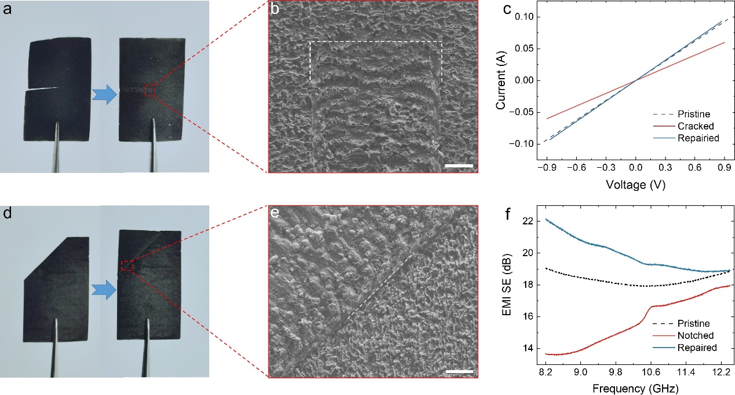
Supplementary Fig. 20: a) A cracked graphene film repaired via PLW. b) SEM image of the repaired part; the scale bar is 200 μm. c) I-V curves of the pristine, cracked, and repaired graphene films. d) A notched graphene film repaired via PLW. e) SEM image of the junction part of base structures and solder structures; the scale bar is 200 μm. f) EMI SE of the pristine, the notched, and the repaired graphene films at the frequency of 8.2~12.8 GHz.

Supplementary References
1. X. Zang, C.J., S. Ingersoll, Huashan Li, J. J. Adams, Z. Lu, N. Ferralis, J. C. Grossman Laser-engineered heavy hydrocarbons: Old materials with new opportunities. Sci. Adv. 6, 5231 (2020).
2. Wang, Y., Wang, Y., Zhang, P., Liu, F. & Luo, S. Laser-Induced Freestanding Graphene Papers: A New Route of Scalable Fabrication with Tunable Morphologies and Properties for Multifunctional Devices and Structures. Small 14, 1802350 (2018).
3. Gao, Y. et al. 3D-Laminated Graphene with Combined Laser Irradiation and Resin Infiltration toward Designable Macrostructure and Multifunction. Adv. Sci. 9, 2200362 (2022).
4. Xiong, Z., Liao, C., Han, W. & Wang, X. Mechanically Tough Large-Area Hierarchical Porous Graphene Films for High-Performance Flexible Supercapacitor Applications. Adv. Mater. 27, 4469-4475 (2015).
5. Lai, D., Chen, X., Wang, G., Xu, X. & Wang, Y. Highly conductive porous graphene film with excellent folding resilience for exceptional electromagnetic interference shielding. J. Mater. Chem. C 8, 8904-8916 (2020).
6. Bi, H. et al. Three-dimensional porous graphene-like carbon cloth from cotton as a free-standing lithium-ion battery anode. J. Mater. Chem. A 4, 11762-11767 (2016).
7. Zhang, M. et al. From wood to thin porous carbon membrane: Ancient materials for modern ultrafast electrochemical capacitors in alternating current line filtering. Energy Storage Mater. 35, 327-333 (2021).
8. Zhang, L. et al. Ultrathin flexible electrospun carbon nanofibers reinforced graphene microgasbags films with three-dimensional conductive network toward synergetic enhanced electromagnetic interference shielding. J. Mater. Sci. Technol. 111, 57-65 (2022).
9. Song, Z. et al. Space-Confined Graphene Films for Pressure-Sensing Applications. ACS Appl. Nano Mater. 3, 1731-1740 (2020).
10. Zhang, Y. et al. Strong and conductive reduced graphene oxide-MXene porous films for efficient electromagnetic interference shielding. Nano Research 15, 4916-4924 (2022).
11. Huang, M. et al. CVD Growth of Porous Graphene Foam in Film Form. Matter 3, 487-497 (2020).
12. Huang, H. et al. Polyacrylonitrile-derived thermally conductive graphite film via graphene template effect. Carbon 180, 197-203 (2021).
13. Chen, Y. et al. Nanomanufacturing of graphene nanosheets through nano-hole opening and closing. Mater. Today 24, 26-32 (2019).
14. Zhang, F., Alhajji, E., Lei, Y., Kurra, N. & Alshareef, H.N. Highly Doped 3D Graphene Na-Ion Battery Anode by Laser Scribing Polyimide Films in Nitrogen Ambient. Adv. Energy Mater. 8, 1800353 (2018).

