Tab. 1. Review of research samples
 | Name of the building | Total property area (total land) | Area and percentage of occupancy level | Area and percentage of outside mobility | Area and percentage of green space | Area and percentage of fountain space | Closed space density | The amount of internal mobility space | The amount of internal stillness space | The amount of internal physical space | Floor plan
1 | House of Tehran Imam of Friday Prayer | 879 | 369 | 431 | 746 | 404 | 656.7 | 265.3 | 243.7 | 147.7 | 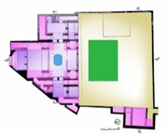  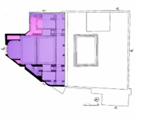
1 | House of Tehran Imam of Friday Prayer | 879 | 42.0% | 49.0% | 8.5% | 0.5% | 74.7% | 40.4% | 37.1% | 22.5%
2 | Reza Khan House, Tehran | 360 | 209.0 | 107.9 | 35.2 | 7.9 | 209.0 | 104.5 | 60.4 | 44.1 | 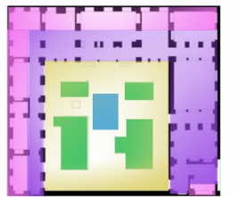
2 | Reza Khan House, Tehran | 360 | 58.0% | 30.0% | 9.8% | 2.2% | 58.0% | 50.0% | 28.9% | 21.1%
3 | Jalal Al Ahmad House, Tehran | 354 | 333.6 | 95.7 | 8.5 | 16.2 | 578.5 | 208.2 | 176.6 | 193.7 | 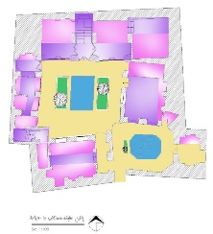  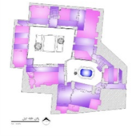  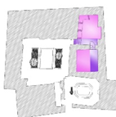
3 | Jalal Al Ahmad House, Tehran | 354 | 66.0% | 27.0% | 2.4% | 4.6% | 163.7% | 36.0% | 30.5% | 33.5%
4 | Ghavam Al-Dawlah House | 3000 | 990.13 | 1210.40 | 653.20 | 146.27 | 1929.37 | 802.79 | 804.74 | 321.84 | 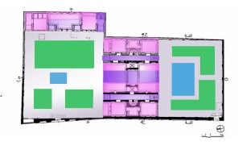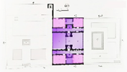
4 | Ghavam Al-Dawlah House | 3000 | 33.00% | 40.35% | 21.77% | 4.88% | 63.97% | 41.60% | 41.70% | 16.70%
5 | Amir Bahador House | 3000 | 1150.20 | 1543.05 | 245.10 | 61.65 | 2053.08 | 1033.82 | 694.65 | 323.61 | 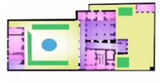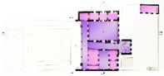
5 | Amir Bahador House | 3000 | 38.35% | 51.43% | 8.17% | 2.05% | 76.3% | 50.40% | 33.85% | 15.75%
6 | Mostowfi al-Mamalek House | 50000 | 10770 | 28110 | 8654 | 2466 | 22063.85 | 15148.63 | 6446.53 | 468.69 | 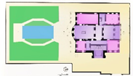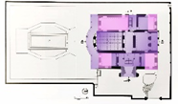
6 | Mostowfi al-Mamalek House | 50000 | 21.55% | 56.22% | 17.30% | 4.93% | 44.12% | 68.65% | 29.20% | 2.15%
7 | Qawam Al-Saltanah House | 1040 | 134.72 | 360.08 | 500 | 45.20 | 250.62 | 141.60 | 65.40 | 43.62 | 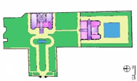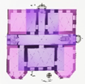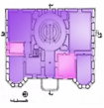
7 | Qawam Al-Saltanah House | 1040 | 12.95% | 34.62% | 48.08% | 4.35% | 497.65% | 56.50% | 26.10% | 17.40%
8 | Mushir al-Dawlah House | 1882 | 325.30 | 1320.10 | 223.10 | 13.50 | 947.50 | 520.30 | 270.40 | 156.80 | 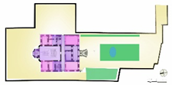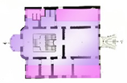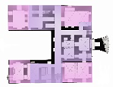
8 | Mushir al-Dawlah House | 1882 | 17.30% | 70.15% | 11.85% | 0.70% | 2747.9% | 54.90% | 28.55% | 16.55%
9 | Moghaddam House | 2117 | 1095.40 | 900.80 | 100.70 | 20.10 | 1095.40 | 560.80 | 350.60 | 184 | 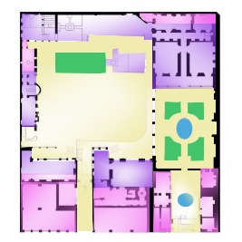
9 | Moghaddam House | 2117 | 51.75% | 42.55% | 4.75% | 0.95% | 51.75% | 51.20% | 32.00% | 16.80%
10 | Vesal House | 2300 | 275.40 | 1134.40 | 870.20 | 20 | 480.80 | 270.90 | 125.95 | 83.95 | 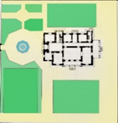  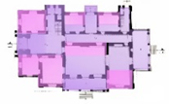  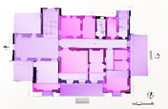
10 | Vesal House | 2300 | 12.00% | 49.30% | 37.83% | 0.87% | 20.90% | 56.35% | 26.20% | 17.45%
Average specifications of the studied buildings |  | Average area of land | % of average occupancy level | % of average outside mobility | % of average green space | % of average fountain space | % of closed space density | % of internal space mobility | % of internal space stillness | % of internal physical space | Floor status
Results of the values examined |  | 6493 m² | 23.95% | 54.25% | 17.50% | 4.30% | 466.10% | 62.95% | 30.55% | 6.50% | 1 to 3 floors of historic building

