Supplementary Information

Single fiber ghost imaging for extreme minimally invasive medicine

Toshitaka Wakayama*, Yudai Higuchi, Rikuto Kondo, Yasuhiro Mizutani, Takeshi Higashiguchi

¹Faculty of Health and Medical Care, Saitama Medical University, 1397-1 Yamane, Hidaka, Saitama, 350-1241, Japan
²Graduate school of Medicine, Saitama Medical University, 1397-1 Yamane, Hidaka, Saitama, 350-1241, Japan
³ Department of Mechanical Engineering, Faculty of Engineering, Osaka University, 2-1 Yamada-oka, Suita, Osaka, 565-0871, Japan
⁴Department of Electrical and Electronic Engineering, Faculty of Engineering, Utsunomiya University, 7-1-2 Yoto, Utsunomiya, Tochigi, 321-8585, Japan

*Corresponding author. : Toshitaka Wakayama (Email: wakayama@saitama-med.ac.jp)

This file includes:

Figures. S1 to S10

Other Supplementary Materials for this manuscript include the following:

Movies S1

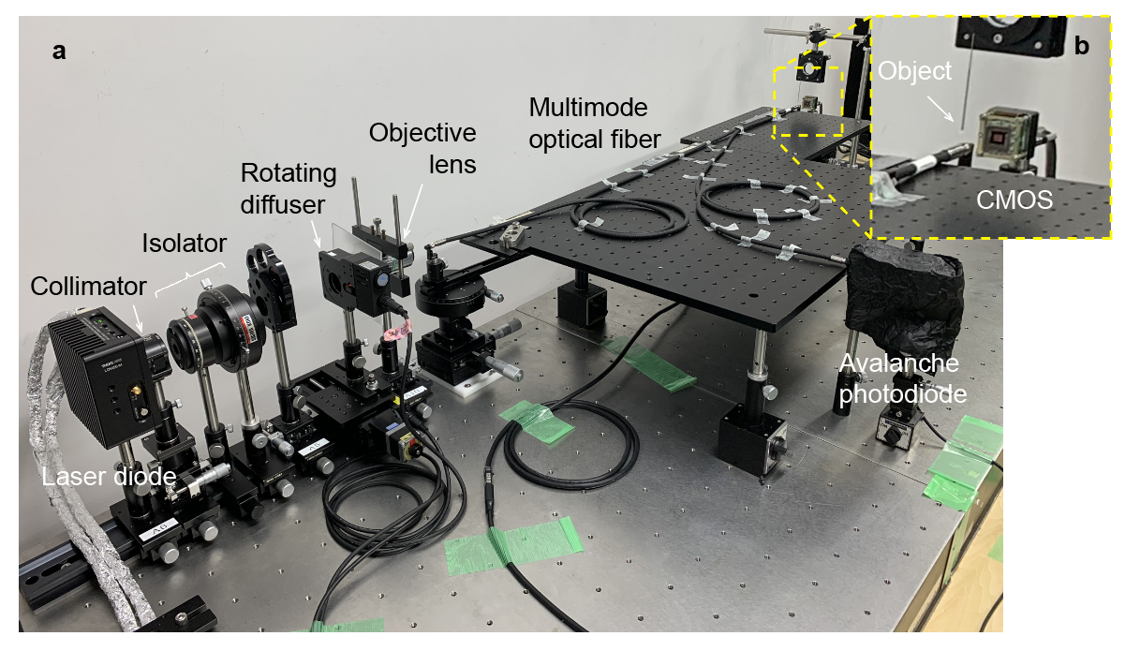

Figure S1. Experimental setup
a. Experimental setup of single fiber ghost imaging. Laser beam from a laser diode is collimated by a lens. After passing through an isolator, laser beam is incident into a rotating diffuser with precise control. The laser beam is scattered by the diffuser. An objective lens is collected the scattering light beam, and condensed into the end of a multimode optical fiber. Another end of the optical fiber is enlarged in b. b. Enlarged figure of the end of the optical fiber. The laser beam generated with speckle pattern is recorded by a CMOS camera. After registration, we removed the CMOS camera and placed an object as a sample. Illuminated speckle patterns on the object, we detected a bucket signal by an avalanche photodiode. The recorded speckle patterns and bucket signals were calculated by our differential ghost imaging improved for the single fiber imaging.

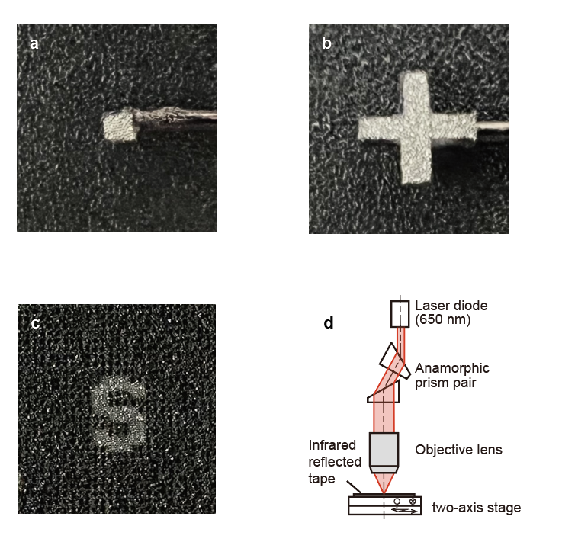

Figure S2. Sample preparation and laser drawing system
Test targets as samples of (a) a square, (b) a cross, and (c) a letter of “S”, respectively. We fabricated (A) the 0.5 mm square and (b) the cross of 2 mm by manual cutting. Infrared reflected tape (Hansha, Custom) is used for their test target’s substrates. The square and the cross are connected by a stainless-steel beam. As shown in Fig. S1, their sample was placed in the front of the optical fiber. On contrary, the “S” was fabricated by our laser drawing system shown in (d). The black area in (c) is scorch marks after the infrared reflected tape is burned by our laser processing.

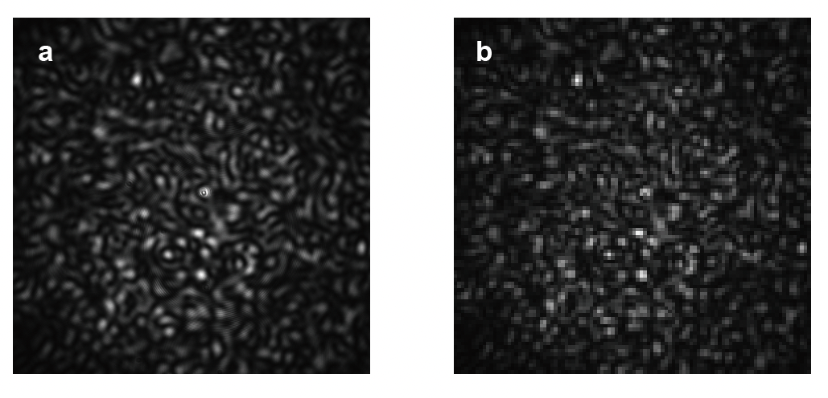
Figure S3. Decimation of a captured image
a. This image was resized with 540 x 540 pixels after capturing by a CMOS camera. b. Image after decimation. This image resolution was reduced to be 100 x 100 pixels by pixel skipping. Though the decimation, the speckle pattern was not changed as compared between a and b.

Figure S4. Images reconstructed for resolution test
These images are generated from our single fiber ghost imaging. We placed adjacent to two squares and gradually moved the right square to right at every 0.05 mm. We imaged two objects shifted from 0.00 mm to 1.00 mm, respectively.

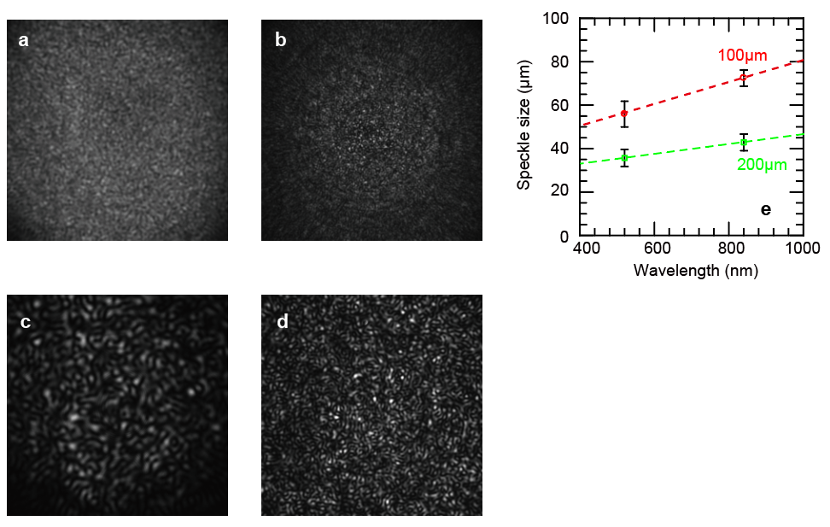
Figure S5. Relationship between optical fiber diameter and speckle size
Speckle patterns are captured by CMOS camera illuminating by laser diodes with wavelengths of 520 nm (a, b) and of 840 nm (c, d). We evaluated the speckle size depend on optical fiber diameter. We herein used two optical fibers with diameters of 100 μm (a, c) and 200 μm (b, d). (e)The speckle size was 72 μm by use of the optical fiber of 100 μm and laser diode with wavelength of 840 nm. Used an optical fiber with diameter of 200 μm with use of a laser diode at wavelength of 520 nm, we estimated the spatial resolution of single fiber imaging is 25 μm.

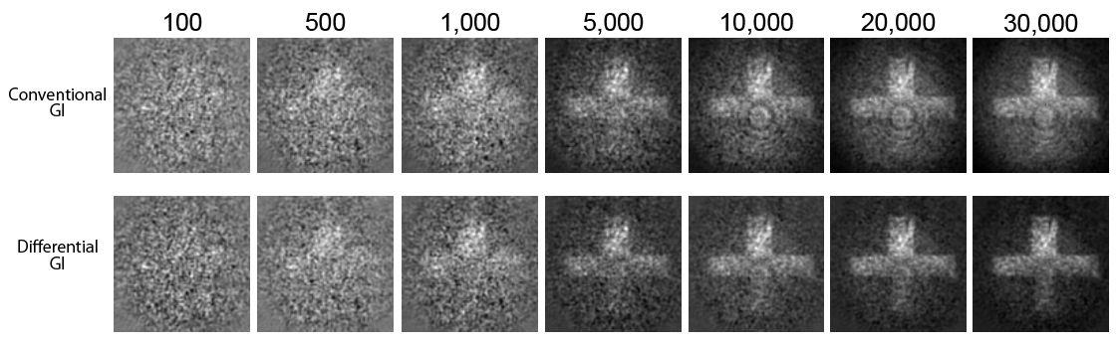
Figure S6. Comparison between conventional and differential ghost imaging (Sample is a cross)
Comparison between a conventional ghost imaging (upper column) and a differential ghost imaging (lower column). A maximum of 30,000 speckle patterns are used to reconstruct their images. Two methods are reconstructed the object of cross. The conventional ghost imaging has concentric ripples. The differential ghost imaging is clearly suppressed their concentric ripples. Their images reconstructed by the differential ghost imaging were captured their edges more clearly than that of the conventional ghost imaging.

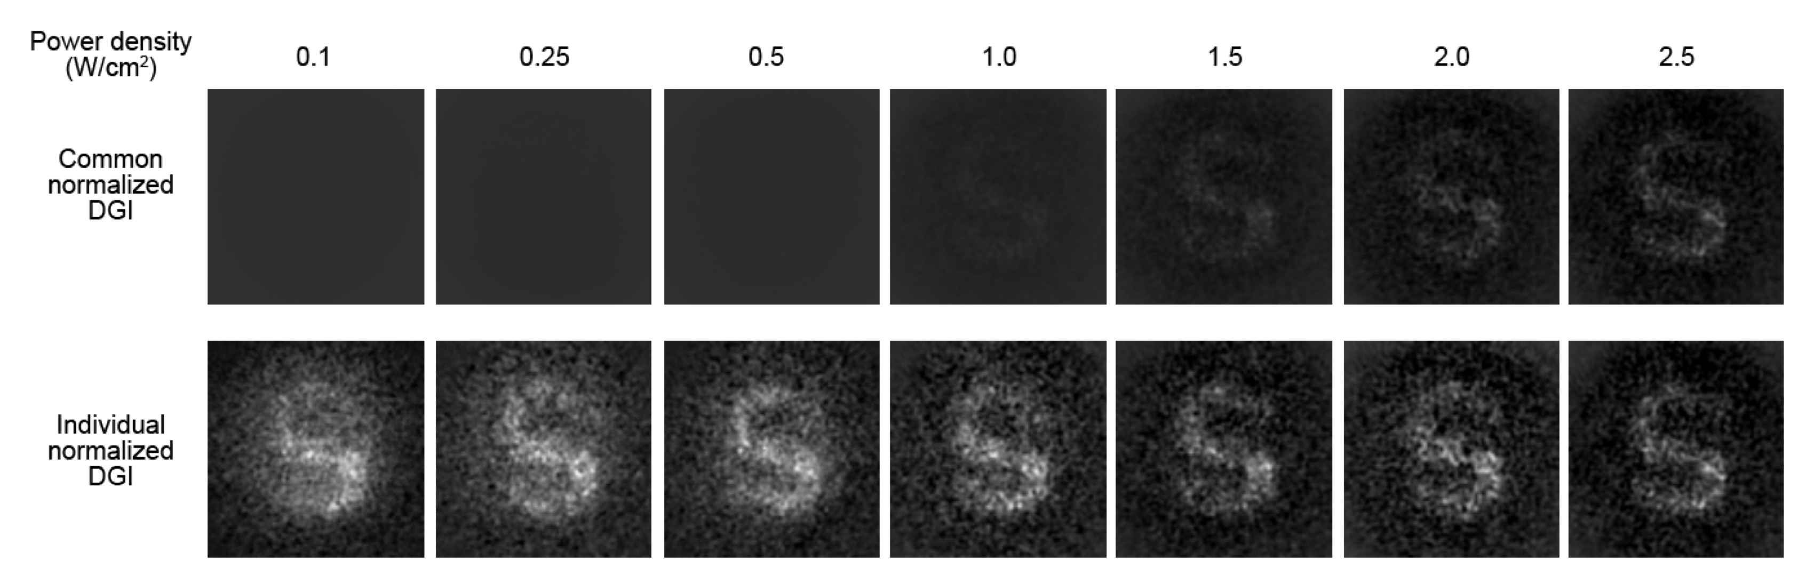
Figure S7. Comparison by normalization method between common and individual normalization on single fiber ghost imaging (Sample is a letter of “S”)
The images reconstructed with common and individual normalization are investigated power density dependence from 0.1 to 2.5 W/cm². Common normalization, which is normalized by common maximum and minimum intensity in seven images, (upper column) affects with their contrast of the reconstructed image. On contrary, individual normalization, which is normalized by individual maximum and minimum intensity in every image, (lower column) also created an image of the object at weak illumination with 0.1 W/cm². 0.1 W/cm² is power density of 1/940 as compared with the conventional endoscope.

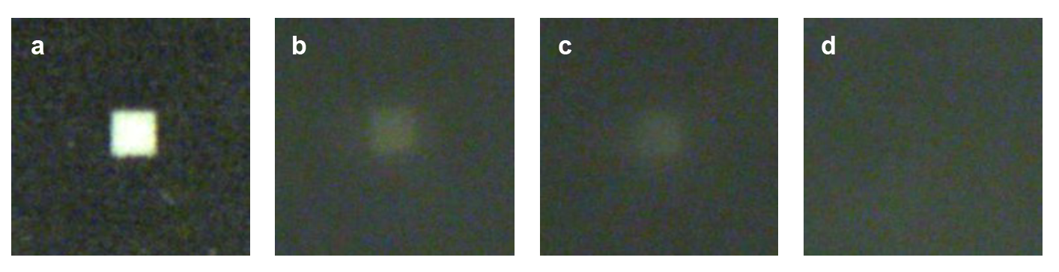
Figure S8. Conventional camera image by different scattering condition (Sample is a square)
a. We captured object’s images using conventional CMOS camera. In this experiment, we set the CMOS camera at distance of 20 mm. b-d. We also captured same object’s images through diffuser with different diffusivity of I, II, and III. We can sight the object through two diffusers of I and II in (b) and (c). However, it is impossible for the CMOS camera to sight the object through the diffuser with strong diffusivity of III in (d).

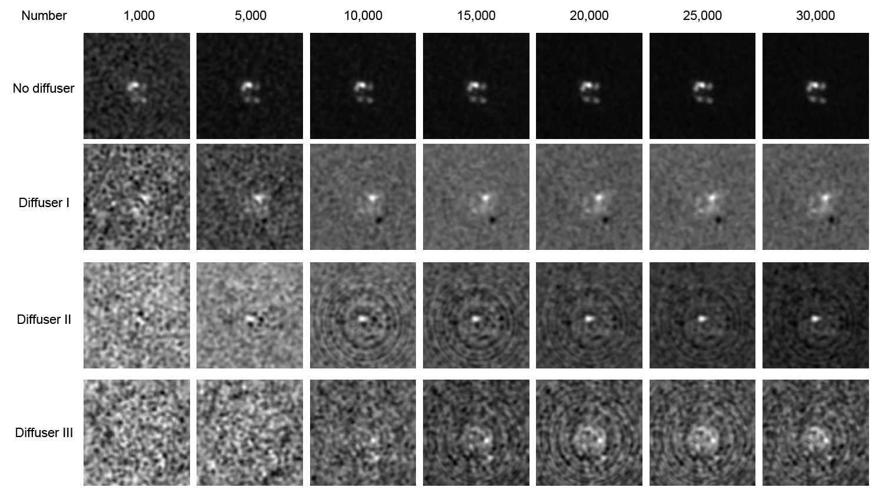
Figure S9. Reconstructed images through different scattering condition (Sample is a square)
Employed no diffuser and different diffusers with weak, middle, and strong scattering of I, II, and III, respectively, we conducted our single fiber ghost imaging through different condition. Using different numbers of speckle patterns, the image of object was reconstructed. Note that the centers of their squares are dark. This result is corresponded with the microscopic image in Fig. 6f. Enlarged figures are shown in Fig. S10.

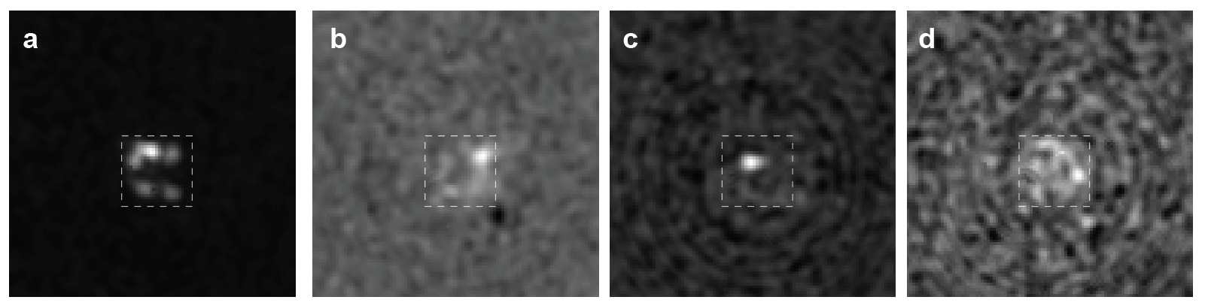
Figure S10. Enlarged images, which are reconstructed using 30,000 speckle patterns, through diffusers (Sample is a square)
For (a) no diffuser and diffusers with different diffusivity of (b) I, (c) II, and (d) III, squares were imaged as an object. White broken squares are shown at same position in their images. The center of images in (b), (c), and (d) was darker than their surroundings. The coincidence degree between (a) and (d) was 0.39. Note that the coincidence degrees between (d) and Fig. 6b was 0.45.

