Supplementary figures
S Figure 1: Identification and selection of articles for bibliometric analysis
S Figure 2: Most relevant authors, affiliations, sources, and locally cited sources
S Figure 3: Tree map on most used words in EHR research in Australia
S Figure 4: Thematic evolution across four time periods

S Figure 1: Identification and selection of articles for bibliometric analysis

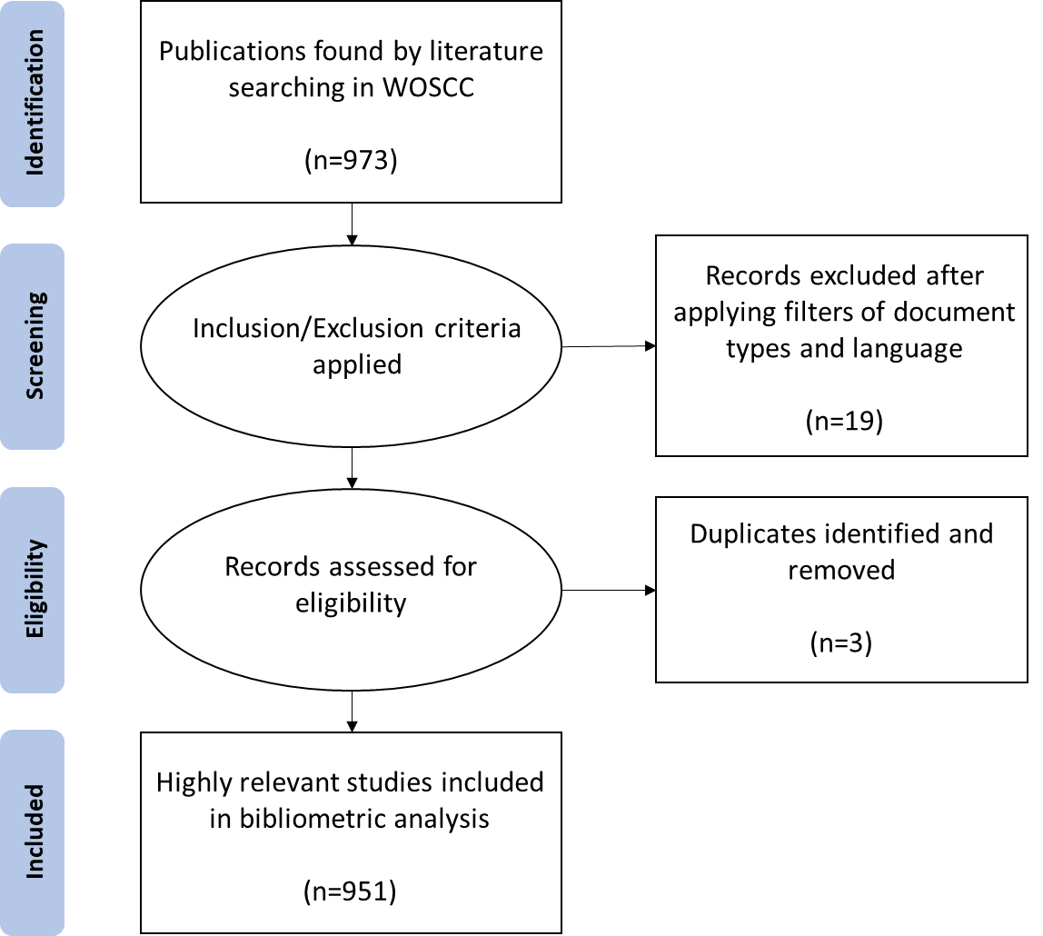

S Figure 2: Most relevant authors, affiliations, sources and locally cited sources

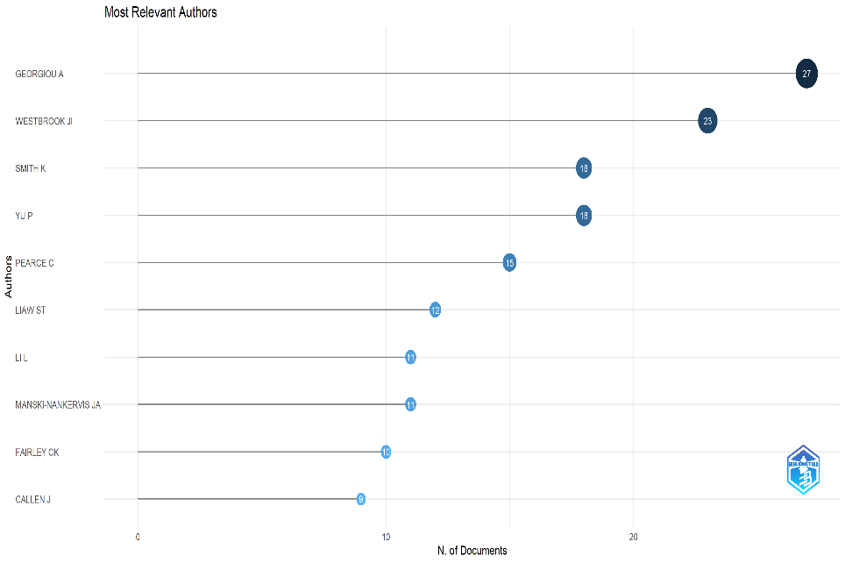
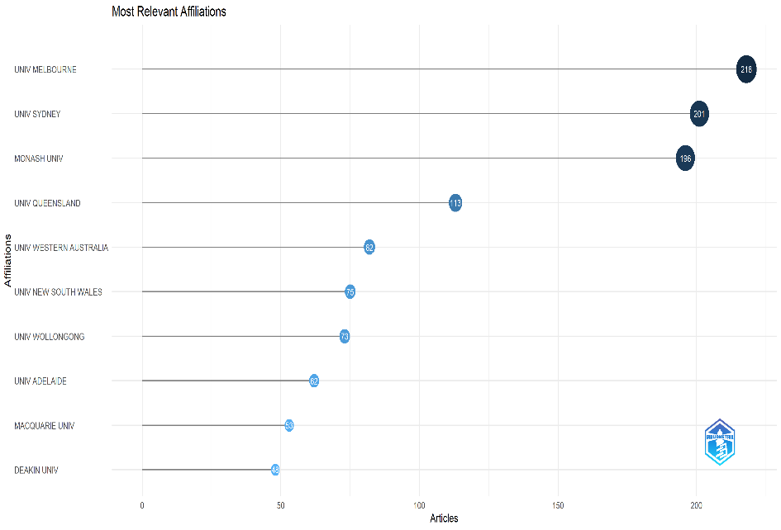

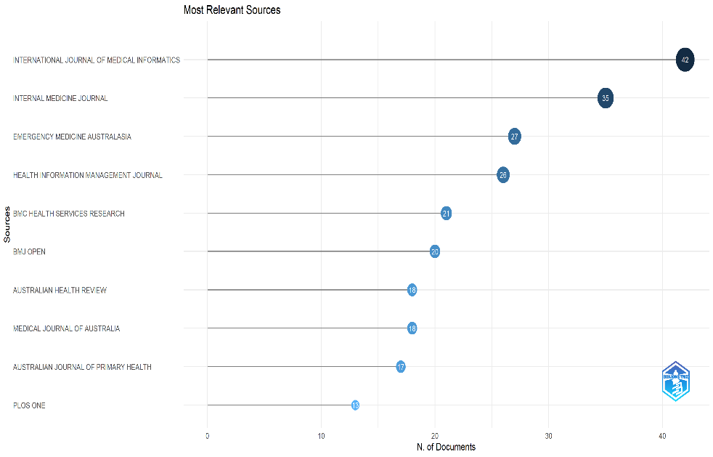
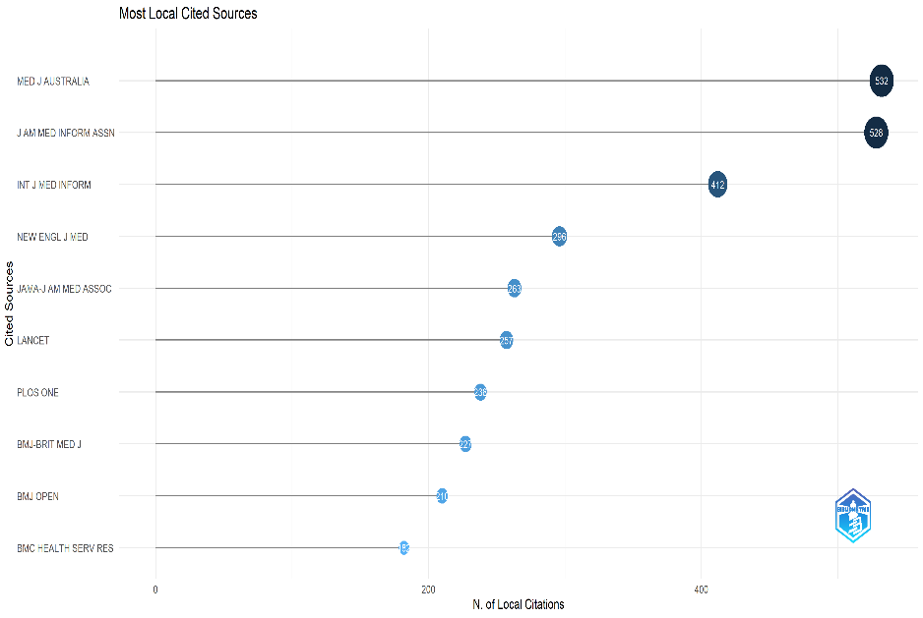

S Figure 3: Tree map on most used words on EHR research in Australia

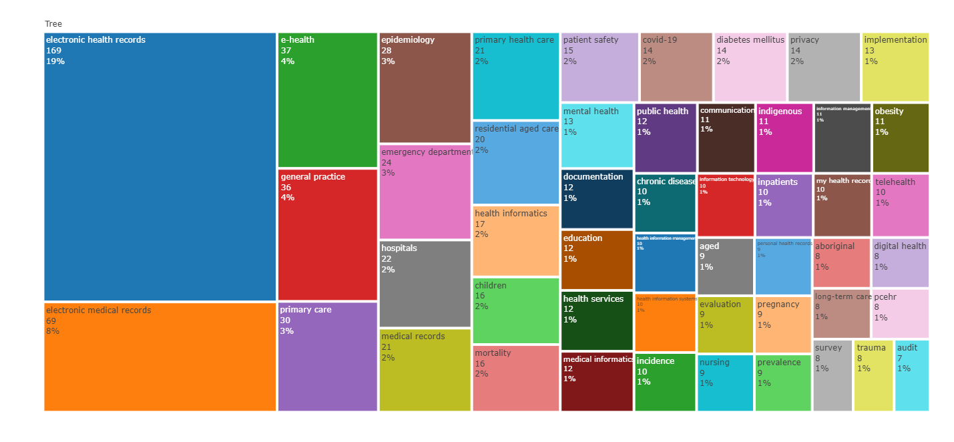

S Figure 4: Thematic evolution of EHR Research in Australia across four time periods

