Sensitization of hepatocellular carcinoma cells to HDACi is regulated through hsa-miR-342-5p/CFL1

Parvathi Nakka¹, Chikondi Jassi², Ming-Cheng Chen^{3,4}, Yi-Sheng Liu^{5,6}, Jer-Yuh Liu^{1, 7}, Chung-Min Yeh⁸, Chi-Cheng Li^{9,10}, Yu-Chun Chang¹¹, Wei-Wen Kuo^{2,12}*, Chih-Yang Huang^{1,11,13,14,15,}*

1. Graduate Institute of Biomedical Sciences, China Medical University, Taichung 404, Taiwan
2. Department of Biological Science and Technology, China Medical University, Taichung 406, Taiwan
3. Division of Colorectal Surgery, Department of Surgery, Taichung Veterans General Hospital, Taichung 40705, Taiwan
4. Faculty of Medicine, National Yang-Ming University, Taipei, Taiwan
5. Division of Hematology and Oncology, Department of Medicine, Kaohsiung Armed Forces General Hospital, Kaohsiung, Taiwan
6. School of Medicine, National Defense Medical Center, Taipei, Taiwan
7. Center for Molecular Medicine, China Medical University Hospital, Taichung, Taiwan
8. Department of Pathology, Changhua Christian Hospital, Changhua 500, Taiwan
9. School of Medicine Tzu Chi University, 701, Section 3, Chung-Yang Road, Hualien 97004, Taiwan
10.Department of Hematology and Oncology, Hualien Tzu Chi Hospital, Buddhist Tzu Chi Medical Foundation, Hualien, Taiwan
11. Cardiovascular and Mitochondrial Related Disease Research Center, Hualien Tzu Chi Hospital, Buddhist Tzu Chi Medical Foundation, Hualien, Taiwan
12. Ph.D. Program for Biotechnology Industry, China Medical University, Taichung 406, Taiwan
13. Center of General Education, Buddhist Tzu Chi Medical Foundation, Tzu Chi University of Science and Technology, Hualien 970, Taiwan
14. Department of Medical Research, China Medical University Hospital, China Medical University, Taichung 404, Taiwan
15. Department of Biotechnology, Asia University, Taichung 413, Taiwan

*These authors contributed equally to this paper.
Corresponding author: Chih-Yang Huang Ph.D., Chair Professor, Cardiovascular and Mitochondrial Related Disease Research Center, Hualien Tzu Chi
Hospital, Buddhist Tzu Chi Medical Foundation, Tzu Chi University of Science and Technology, Hualien, Taiwan Tel: +886-3-8561825 ext. 15930. Fax:
+886-4-22032295. E-mail address: cyhuang@mail.cmu.edu.tw

Submitted to Cancer Cell International

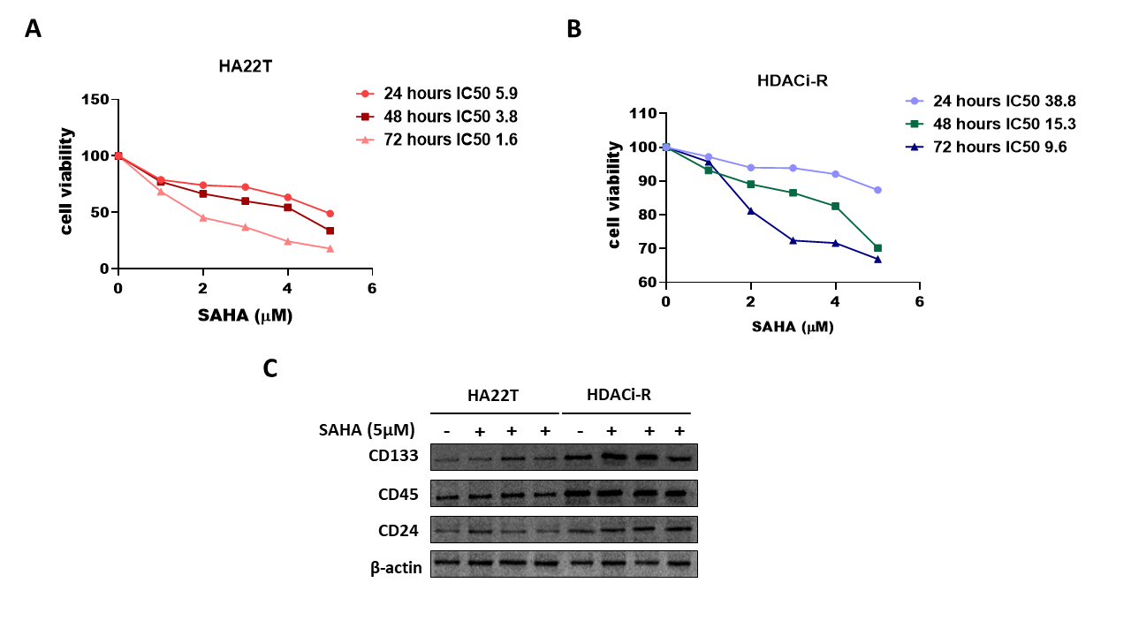
Fig. S.1 (A-B) MTT assay was used to evaluate cell viability in HA22T and HDACi-R cells after they were treated with the appropriate amounts of SAHA for 24 hours, 48 hours, and 72 hours. (C) Expression of stem cell markers are higher in HDAC inhibitor-resistant cells than HA22T cells.

