Supplementary material

Strongly coupled C@MoSe₂@OMWCNT heterostructure as an anode for sodium ion batteries
Yincai Yang,^{‡1} Feng Wang^{‡1}, Mengru Biang¹, Youwen Chen,^{1,2*} Shiguo Zhang,¹ Zhen-Qiang Yu,^{3*} Chak-Tong Au, ¹ Shuang-Feng Yin^{1*} and Renhua Qiu^{1*}

¹State Key Laboratory of Chemo/Biosensing and Chemometrics, Advanced Catalytic Engineering Research Centre of the Ministry of Education, College of Chemistry and Chemical Engineering, School of Physics & Electronics, College of Material Science and Chemical Engineering, Hunan University, Changsha 410082, China.
²College of Information and Mechatronic Engineering, Hunan International Economics University, Changsha 410082, China.
³College of Chemistry and Environmental Engineering, Shenzhen University, Shenzhen, China.
‡ These authors contributed equally to this work
*Corresponding authors
Dr. Y-W Chen, Prof. Z-Q Yu, Prof. S-F Yin and Prof. R. Qiu
Email: youwenchen1@hnu.edu.cn (Y-W Chen), zqyu@szu.edu.cn (Z-Q Yu), sf_yin@hnu.edu.cn (S-F Yin), renhuaqiu1@hnu.edu.cn (R. Qiu)

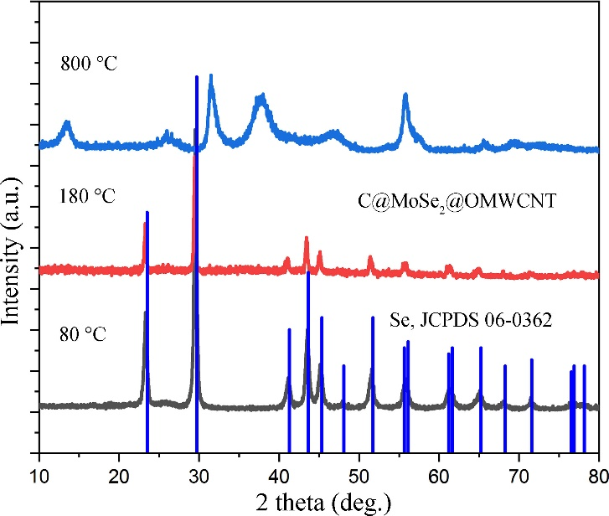
Fig. S1. XRD of Samples taken at different temperatures.

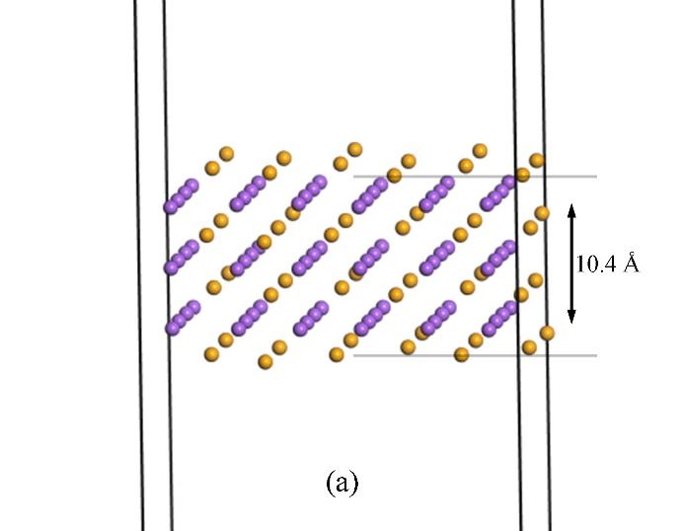
Fig. S2. Structures of Na₂Se (a) after geometry optimization

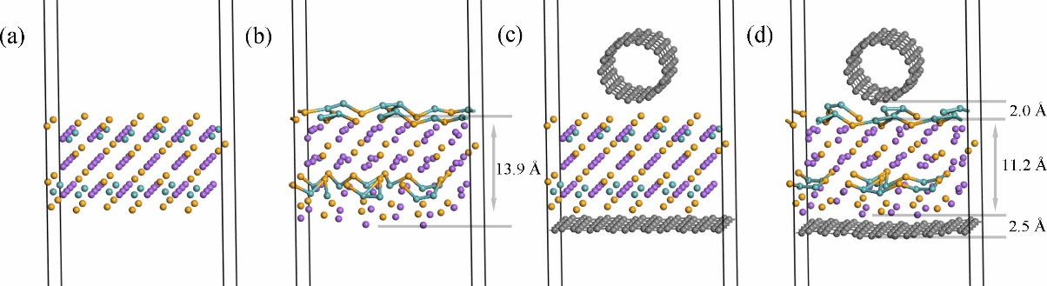
Fig. S3 Na₄MoSe₂ and GR@Na₄MoSe₂@SWCNT: initial (a, c) and final structures (b, d) of geometry optimization, respectively.
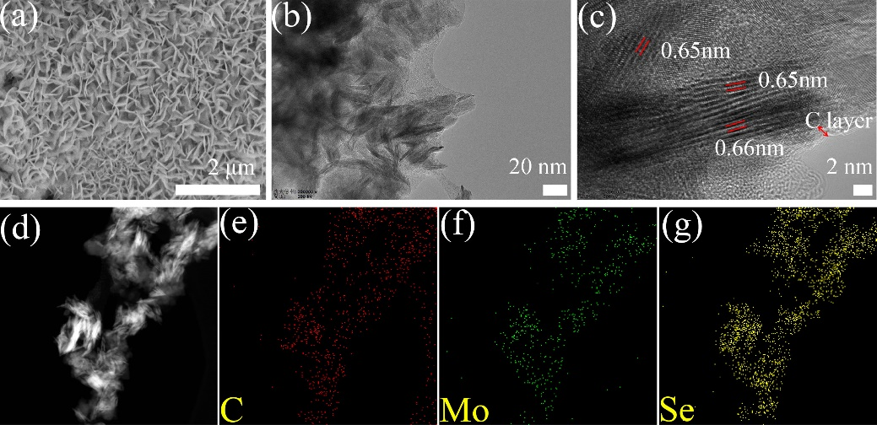
Fig. S4. SEM (a), TEM (b) and HRTEM (c), STEM (d) image and the corresponding (e), (f) and (g) EDS elemental mappings of C@MoSe₂.
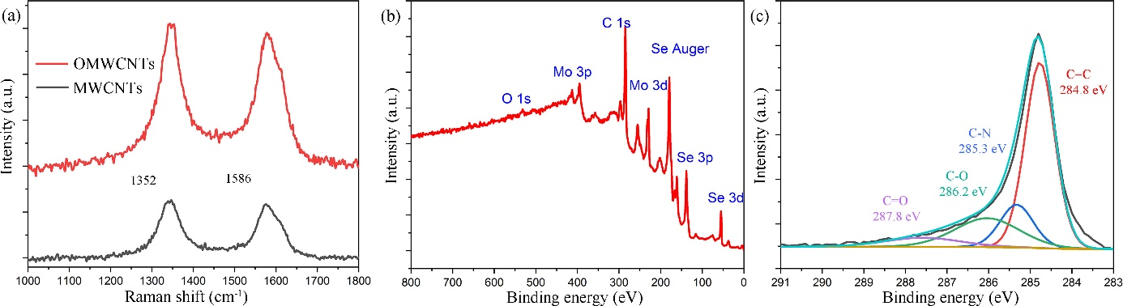
Fig. S5. (a) Raman shift of MWCNTs and OMWCNTs, (b) XPS analyses of PEG-200-2-C@MoSe₂@OMWCNT anode materials, and (c) the high-resolution spectrum of C 1s.
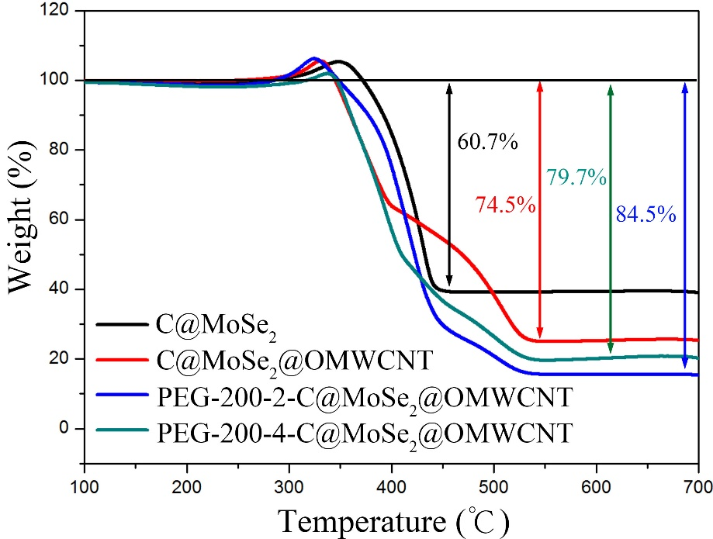
Fig. S6. (a) The TG analysis of C@MoSe₂, C@MoSe₂@OMWCNT, PEG-200-2-C@MoSe₂@OMWCNT and PEG-200-4-C@MoSe₂@OMWCNT. According to Mo element conservation, the following equation (Eq. S1) is obtained,
$m_{{MoSe}_{2}}\%=\frac{M_{{MoSe}_{2}}}{M_{{MoO}_{3}}}*m_{{MoO}_{3}}\%$ Eq. S1
which $M_{{MoSe}_{2}}$ and $M_{{MoO}_{3}}$ stand for the average molecular weight of MoSe₂ and MoO₃, respectively,$m_{{MoSe}_{2}}\%$ and $m_{{MoO}_{3}}\%$ represents the percentage containing of MoSe₂ and MoO₃ in the system, respectively. $M_{{MoSe}_{2}}=253.86$ and $M_{{MoO}_{3}}=143.94$, $m_{{MoO}_{3}}\%$ equals 39.3%, 25.5%, 20.3%, and 15.5% for C@MoSe₂, C@MoSe₂@OMWCNT, PEG-200-2-C@MoSe₂@OMWCNT and PEG-200-4-C@MoSe₂@OMWCNT, respectively. Therefore, the corresponding mass loading of MoSe₂ are estimated to be 69.3%, 45.0%, 35.8% and 27.3%, respectively.

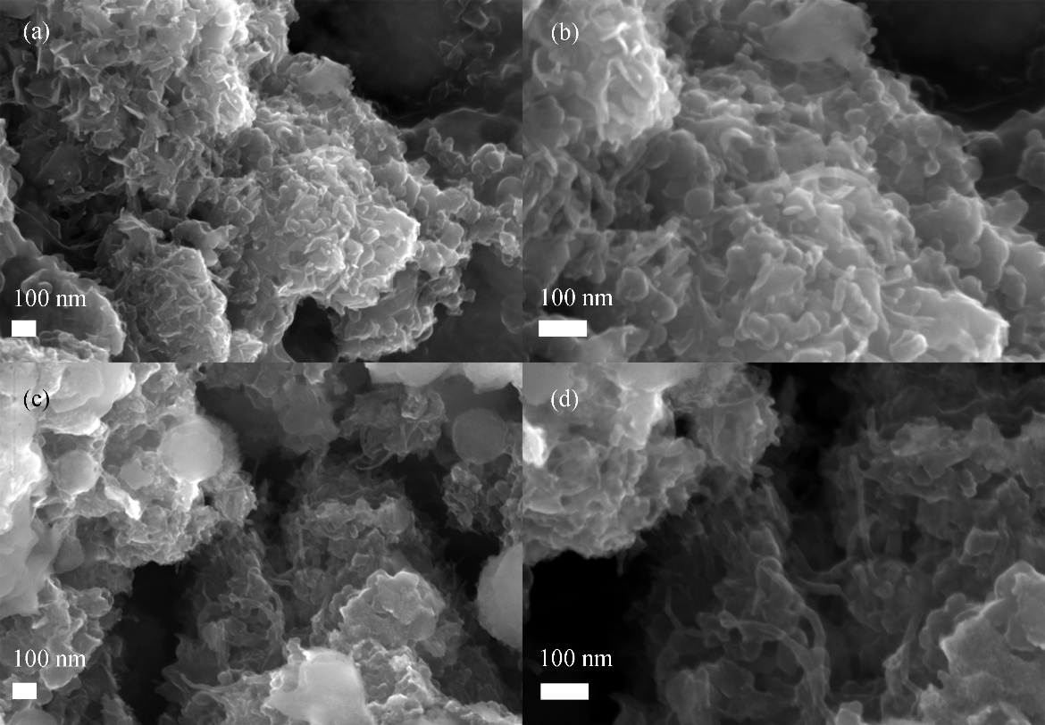
Fig. S7. SEM of C@MoSe₂@OMWCNT electrode after smeared (a, b) and (c, d) decomposed after 200 cycles.

