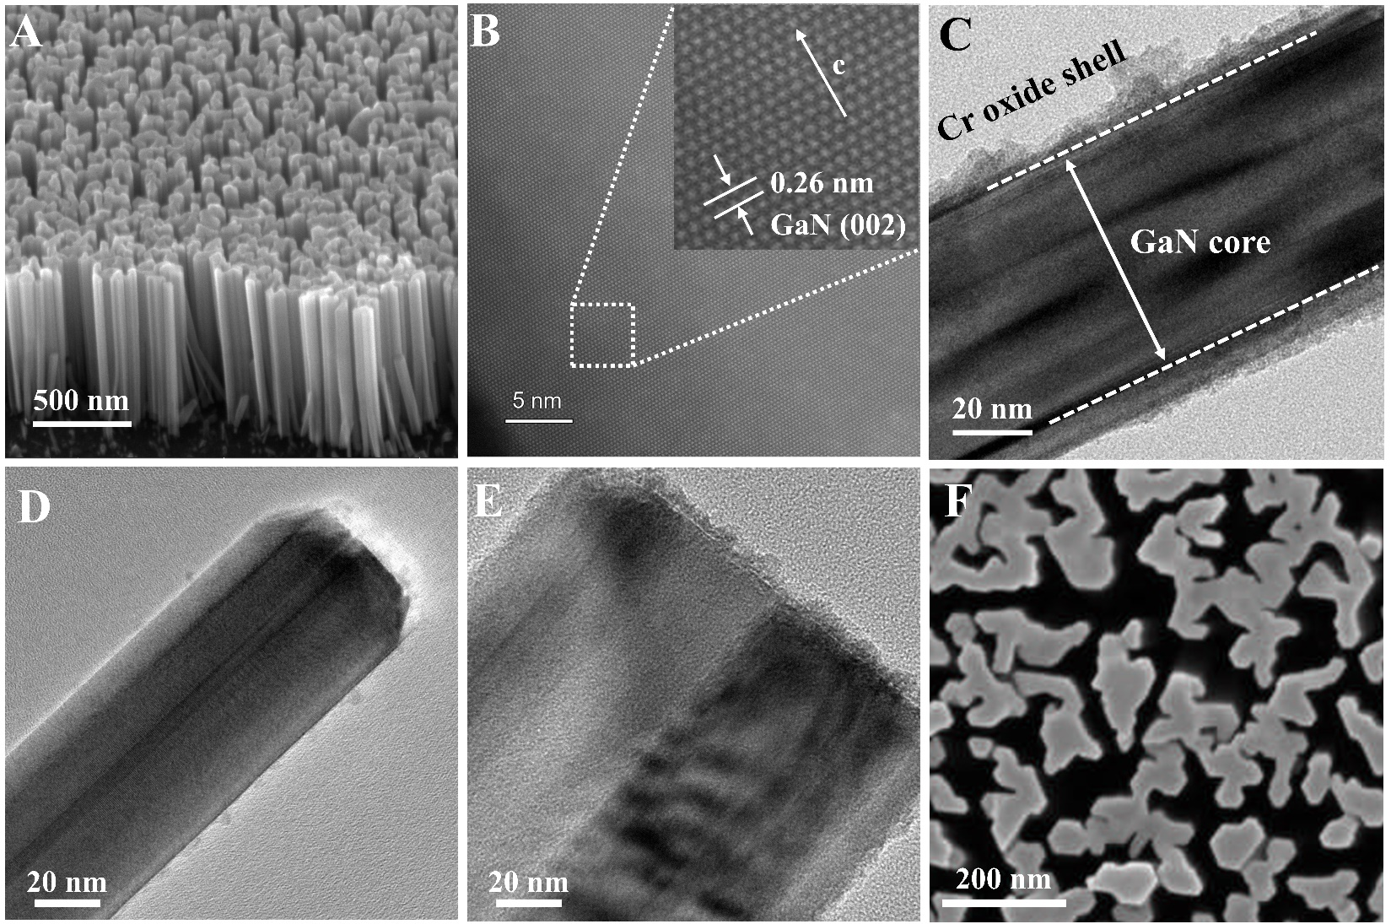

Extended Data Fig. 1 | Morphology characterizations of the coupled architecture. (A) The 45° tilted-view SEM and (B) STEM images of pure GaN NWs. (C) TEM image of the core-shell structure of Cr₂O₃@GaN NWs. TEM images of (D) Cr₂O₃-0.1@GaN and (E) Cr₂O₃-80@GaN, respectively. (F) The top view SEM image of pure GaN NWs. From this top view of the SEM image, the fill factor of GaN NWs on Si wafer is estimated to be about 53% by a photoshop software. Moreover, taking the length (L) of GaN NWs (~750 nm) and the mass density (ρ) of gallium nitride (6.1 g‧cm⁻²) into consideration, the weight of GaN NWs deposited on Si substrate (W) is evaluated to be ~0.24 mg‧cm⁻² by the following equation: W = L * ρ * Fill factor.

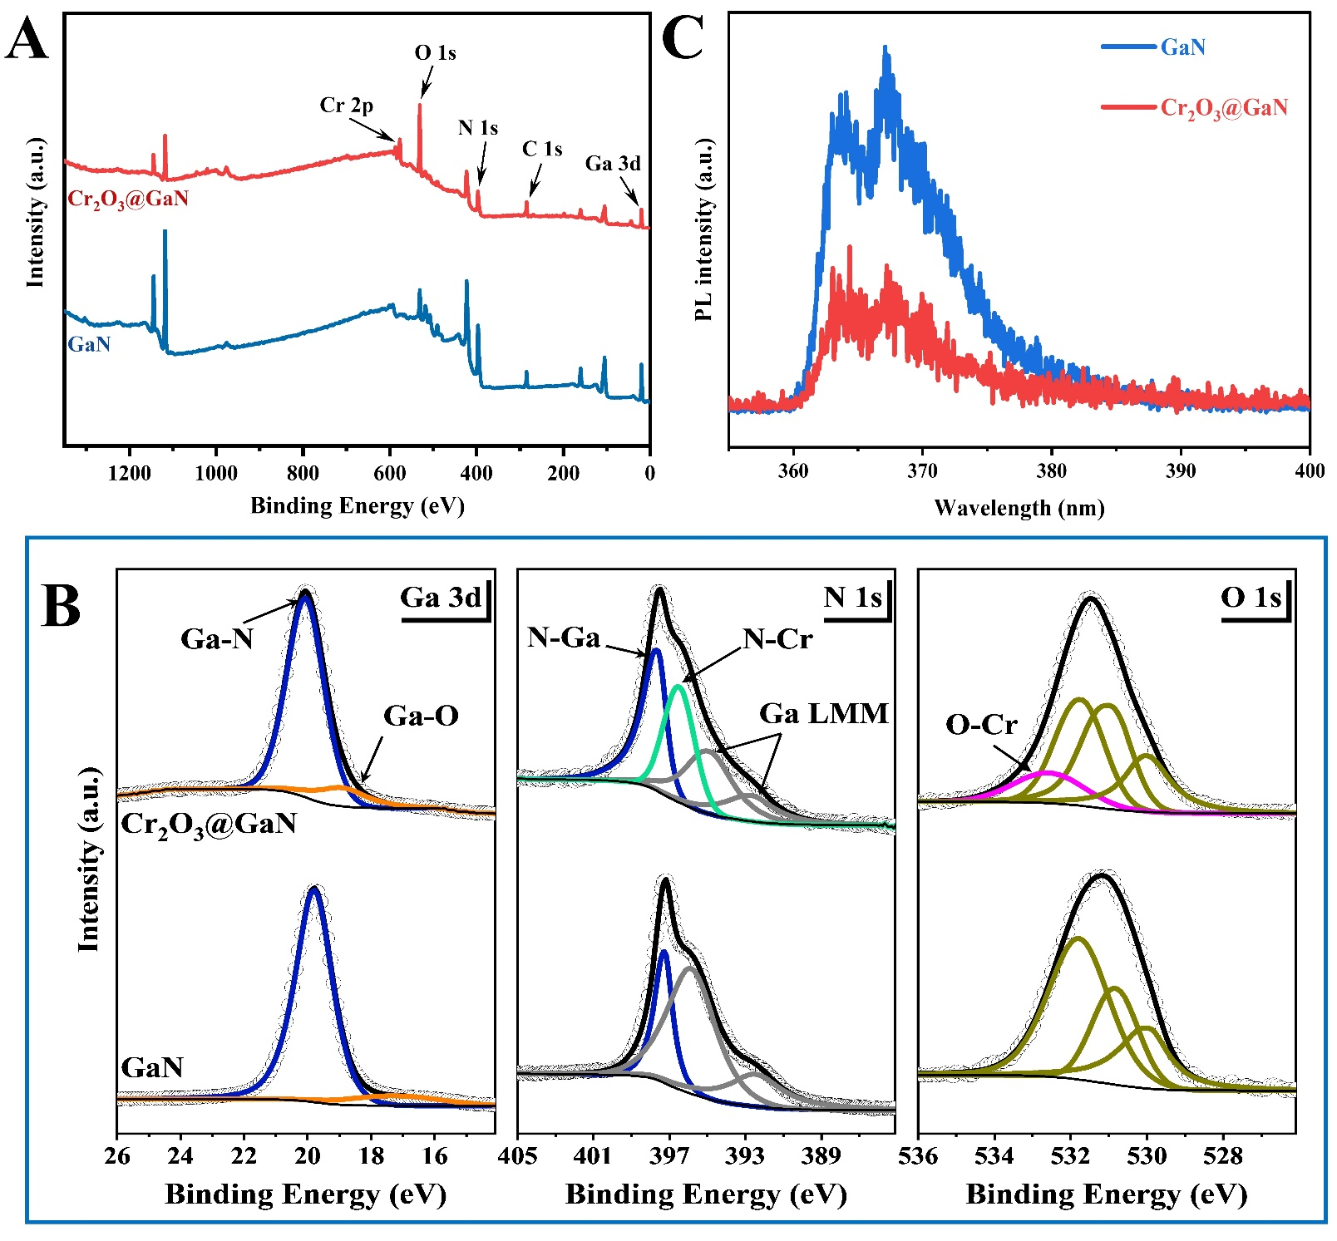

Extended Data Fig. 2 | Spectroscopy characterizations of the coupled architecture. (A) XPS survey spectrum of Cr₂O₃@GaN and bare GaN. (B) The XPS of Ga 3d, N 1s, and O 1s for Cr₂O₃@GaN and bare GaN, respectively. (C) Photoluminescence spectra of GaN NWs and Cr₂O₃@GaN.

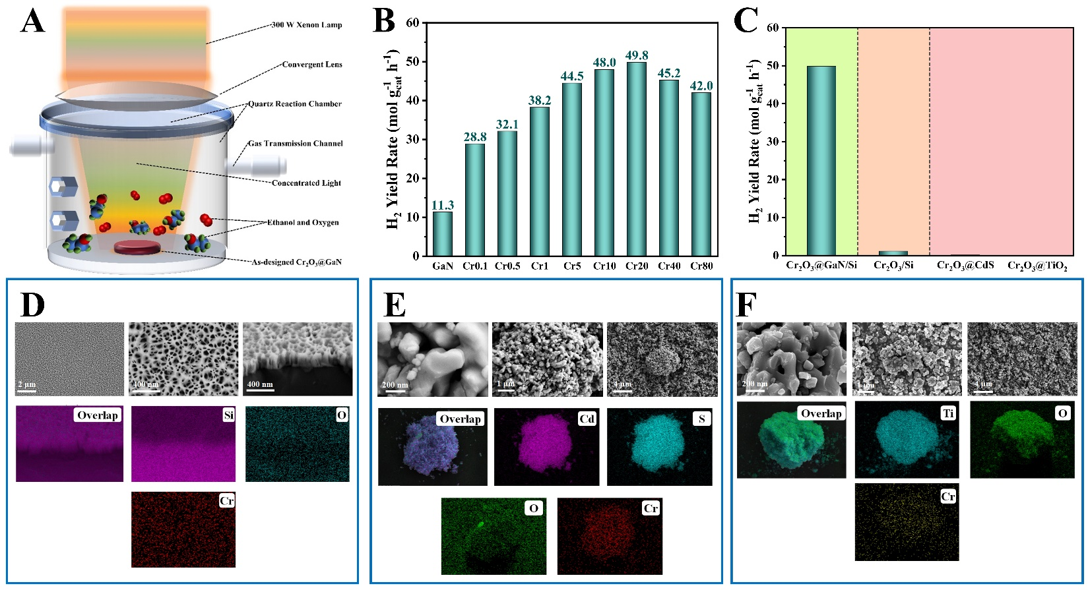

Extended Data Fig. 3 | Ethanol dehydrogenation experiment. (A) Schematic illumination of light-driven hydrogen production from bioethanol over Cr₂O₃@GaN nanoarchitecture supported by silicon wafer in a custom-built chamber. (B) Optimizing the decoration of Cr oxide onto GaN NWs for hydrogen evolution from ethanol. (C) The performance of various semiconducting platforms decorated with Cr₂O₃. Experiments conditions: 300 W Xenon lamp; light intensity, 5 W‧cm⁻²; bioethanol dosage, 1 mL; atmosphere, 1 atm air. SEM and elemental mapping images of (D) Cr₂O₃/Si, (E) Cr₂O₃@CdS, and (F) Cr₂O₃@TiO₂.

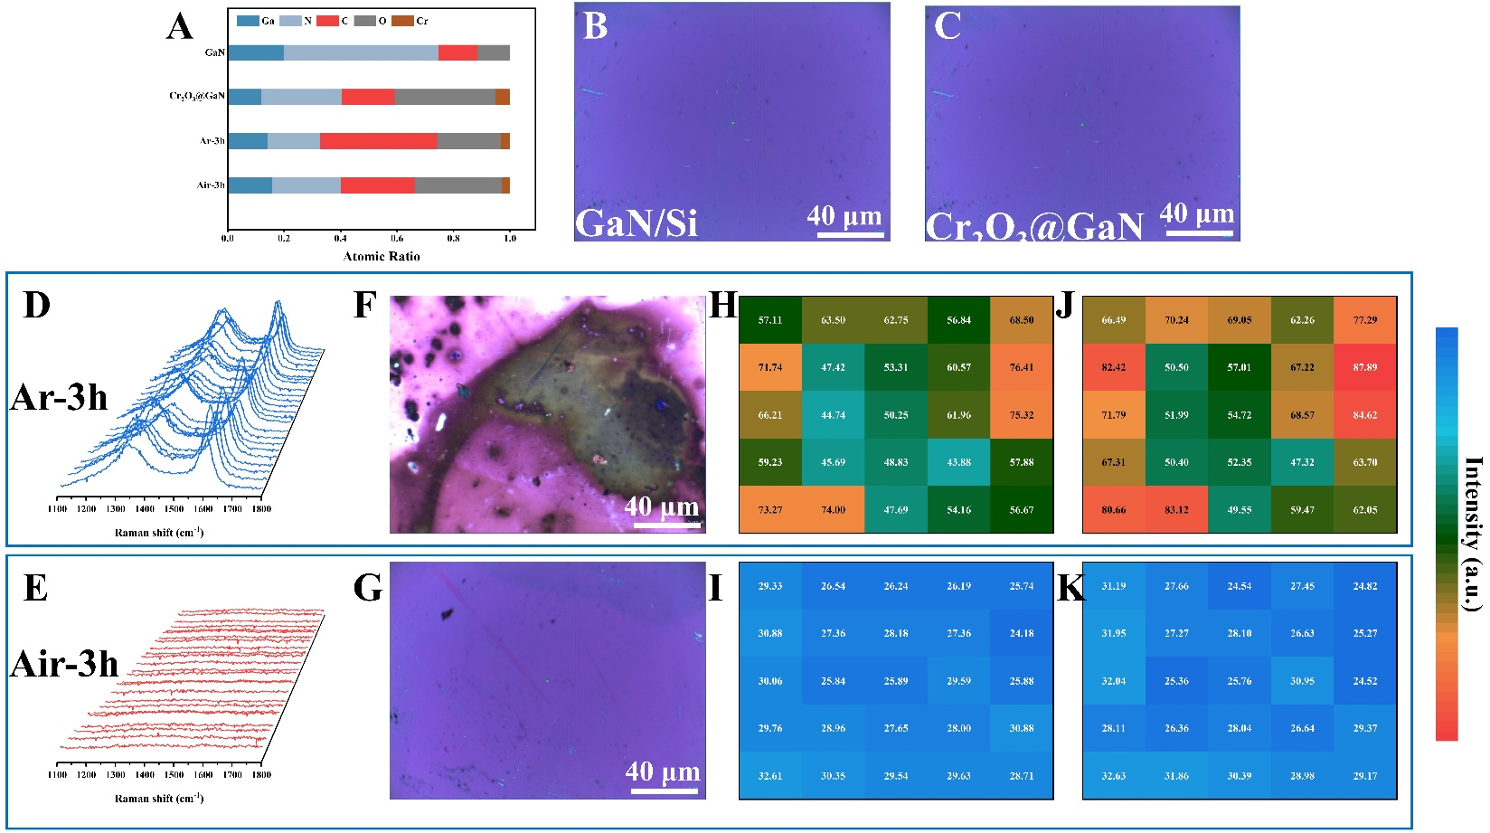

Extended Data Fig. 4 | Surface coke characterization. (A) The atomic ratio of various elements based on XPS analysis for GaN, Cr₂O₃@GaN, Cr₂O₃@GaN after 3 hours of reaction under Ar and Air atmosphere, respectively. Raman optical images for (B) fresh GaN/Si and (C) fresh Cr₂O₃@GaN, respectively. Raman spectrum, Raman optical image, and the corresponding Raman signal intensity of defective carbon peak and graphite carbon peak for Cr₂O₃@GaN after reaction under (D, F, H, J) Ar and (E, G, I, K) Air, respectively.

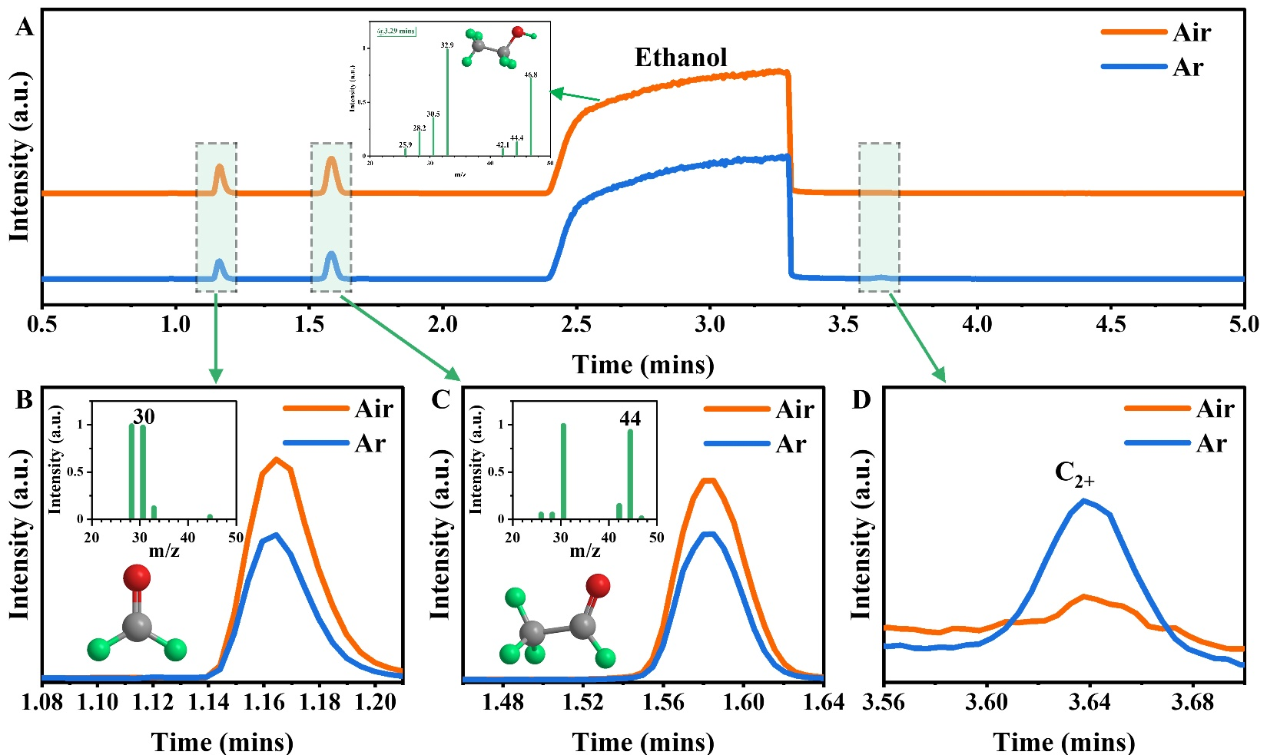

Extended Data Fig. 5 | GC-MS signals of liquid products. (A) The gas chromatography-mass spectrograph (GC-MS) characterization of the liquid phase products of light-driven bioethanol reforming over Cr₂O₃@GaN nanoarchitecture under Air and Ar atmosphere, respectively. Typically, the largest peak around 3.29 mins was attributed to the signal of ethanol reactant. The insert was the signal of MS corresponding to the peak at 3.29 mins. (B-D) Fine chromatographic signal and mass spectrum signal (insert) at various time. Each signal corresponds to a production.

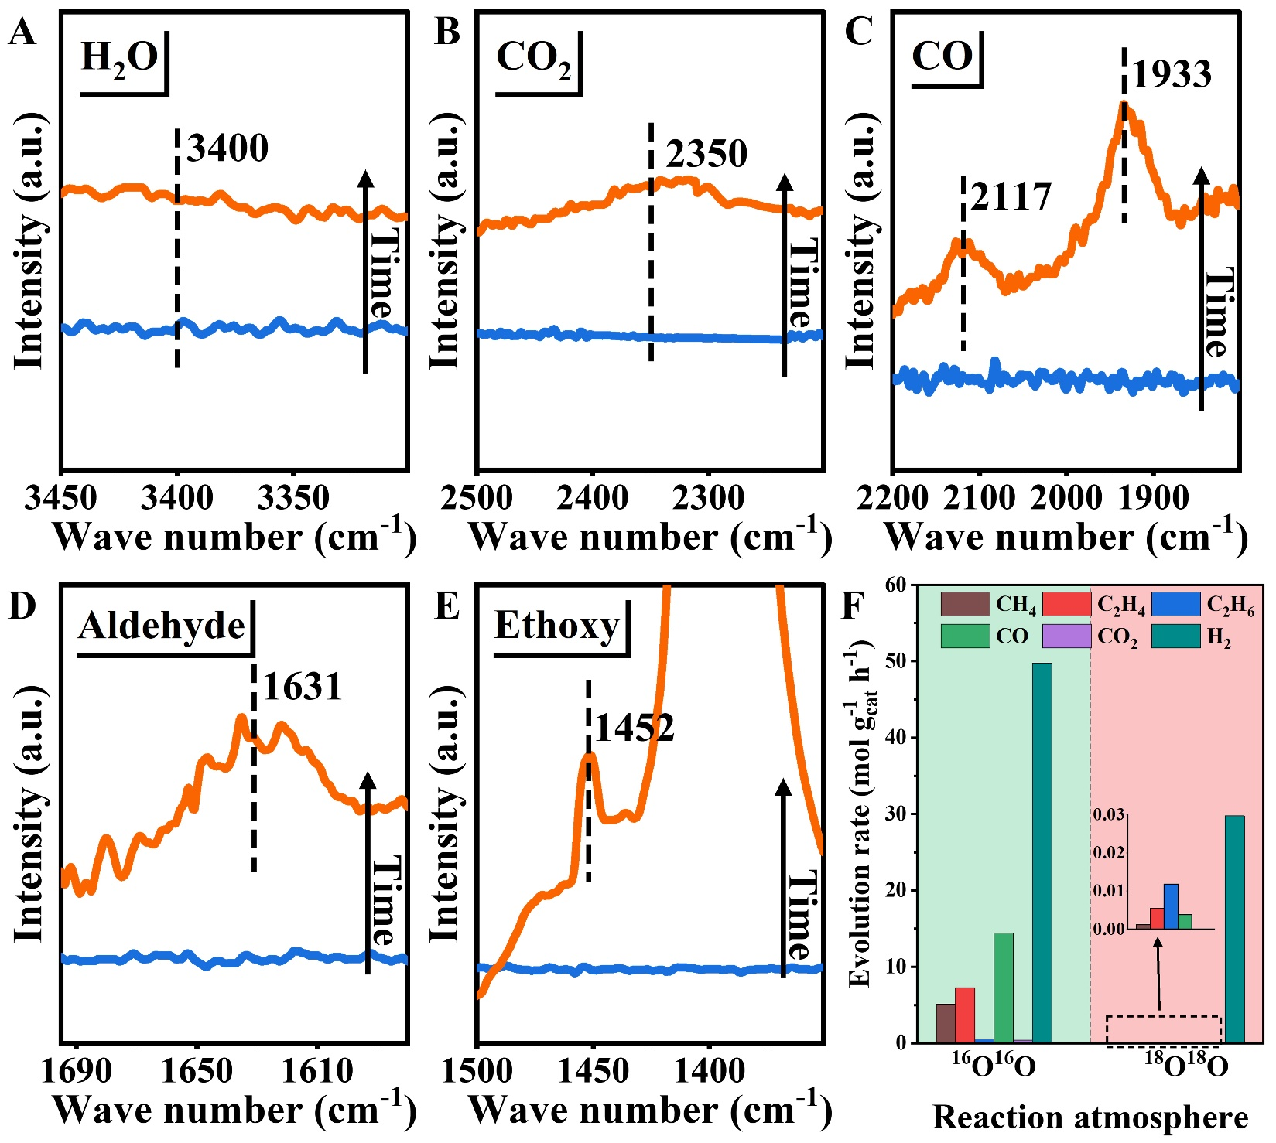

Extended Data Fig. 6 | Mechanism study. (A-E) Infrared spectroscopy of different regions. Typically, (A) no signal of the region corresponding to H₂O; (B) almost negligible signal of the region corresponding to CO₂; (C) the peak at 2117 cm⁻¹ and 1933 cm⁻¹ were ascribed to the CO formation; (D) the peaks at 1631 cm⁻¹ was ascribed to the C=O bond corresponding to the aldehyde; and (E) the peaks at 1452 cm⁻¹ were attributed to the CH₂ bond corresponding to the surface ethoxy species. (F) Activity of various gaseous products from light-driven hydrogen production from bioethanol over Cr₂O₃@GaN nanoarchitecture under ¹⁶O₂/Ar and ¹⁸O₂/Ar atmosphere with a molar ratio of 2/8, respectively.

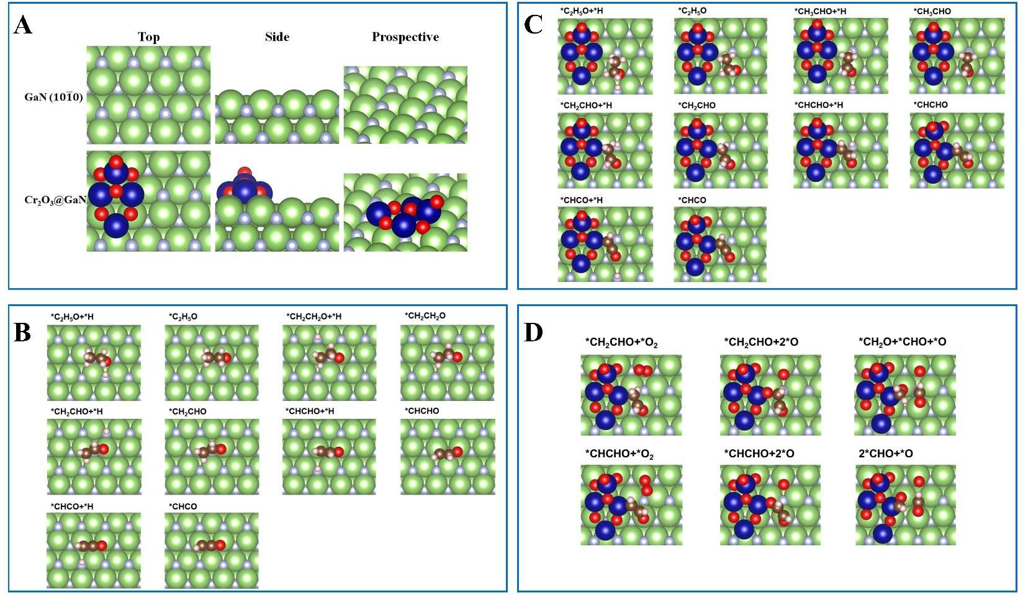

Extended Data Fig. 7 | Theoretical simulation. (A) Top, side, and prospective views of optimized geometries of GaN ($10\overline{1}0$) and Cr₂O₃@GaN surfaces. (B) Adsorption configurations for each reaction intermediates of ethanol decomposition on GaN ($10\overline{1}0$). (C) Adsorption configurations for each reaction intermediates of ethanol decomposition on Cr₂O₃@GaN. (D) Adsorption configurations for each reaction intermediates of C-C bond cleavage on Cr₂O₃@GaN in the presence of O₂. Ga, green; N, purple; Cr, blue; C, brown; O, red; and H, pink.

Extended Data Table 1 | A brief overview of photocatalysts for hydrogen production published in the last five years (2018-2022).
Photocatalysts | Substrate (Solvent) | H₂ evolution  (mmol g_{cat}⁻¹ h⁻¹) | Durability  (hours) | Light source | Reference
Cr₂O₃@GaN | Ethanol | 76,903.05 | 180 | 300W Xe-lamp | This work
Pt/FAPbBr_{3-x}I_{x} | HBr/HI (H₂O) | 6.83 | 30 | 300W Xe-lamp | Energy Environ. Sci. 2022, 15, 1271
Pt_{SS}-ZIS | TEOA  (H₂O) | 17.50 | 50 | 300W Xe-lamp | Nat. Commun. 2022, 13, 1287
Pt/PY-DHBD-COF | Ascorbic acid (H₂O) | 42.43 | 60 | Xe-lamp (>420 nm) | Nat. Commun. 2022, 13, 1355
Cu/TiO₂ | Methanol  (H₂O) | 101.70 | 30 | Xe-lamp | Nat. Commun. 2022, 13, 58
Pt-CN/CuS | Methanol  (H₂O) | 7.25 | 15 | Xe-lamp | Angew. Chem. Int. Ed. 2021, 60, 2541
Pt/CN | NaOH (Methanol) | 3.30 | 38 | 450W Xe-lamp | Angew. Chem. Int. Ed. 2021, 60, 26694
Zn-Cu alloy | Methanol  (H₂O) | 328.00 | 4 | LA-251 Xe-lamp | J. Am. Chem. Soc. 2021, 143, 12145
S_{v}-ZnIn₂S₄/MoSe₂ | Ascorbic acid (H₂O) | 63.21 | 20 | 300W Xe-lamp (>420 nm) | Nat. Commun. 2021, 12, 4112
Pt/CsSnI | HI/H₃PO₂  (H₂O) | 0.43 | 24 | 300W Xe-lamp (>420 nm) | Nat. Commun. 2021, 12, 4412
ZnPor-DETH-COF | TEOA  (PBS) | 0.41 | 120 | 300W Xe-lamp | Nat. Commun. 2021, 12, 1354
V_{s}-ZnIn₂S₄ | CO₂  (H₂O) | 13.48 | 16 | 300W Xe-lamp | Nat. Commun. 2021, 12, 5923
Cu/TCN | Methanol  (H₂O) | 10.60 | 20 | 300W Xe-lamp (>420 nm) | Adv. Mater. 2020, 32, 2003082
Ni-a/TiO₂ | Methanol  (H₂O) | 1.89 | 20 | 300W Xe-lamp | Angew. Chem. Int. Ed. 2020, 59, 7230
Pt/ZnIn₂S₄/Ti₃C₂T_{x} | TEOA  (H₂O) | 3.48 | 24 | 300W Xe-lamp (>420 nm) | Angew. Chem. Int. Ed. 2020, 59, 11287
Ag/g-C₃N₄ | TEOA  (H₂O) | 7.25 | 60 | 300W Xe-lamp (>420 nm) | Angew. Chem. Int. Ed. 2020, 59, 23112
Ni/PCN | TEOA  (H₂O) | 0.08 | 36 | 300W Xe-lamp | Angew. Chem. Int. Ed. 2020, 59, 6827
ML-MoS₂  /MAPbI₃-MCs | HI/H₃PO₂  (H₂O) | 13.60 | 200 | 300W Xe-lamp (>420 nm) | Matter 2020, 3, 935
PTB7-Th:EH-IDTBR | Ascorbic acid  (H₂O) | 64.45 | 16 | 300W Xe-lamp (350-800 nm) | Nat. Mater. 2020, 19, 559
Rh/Cr₂O₃/CoOOH  /SrTiO₃: Al | H₂O | 35.40 | 12.5 | 300W Xe-lamp | Nature 2020, 581, 411
Ni/ZCS QDs | TEOA  (H₂O) | 18.90 | 28 | 300W Xe-lamp (>420 nm) | Sci. Adv. 2020, 6, eaaz8447
Co/NGC/ZIS | TEOA  (H₂O) | 11.27 | 30 | 300W Xe-lamp (>400 nm) | Adv. Mater. 2019, 31, 1903404
Pt/MNSs | Ascorbic acid  (H₂O) | 11.32 | 20 | 300W Xe-lamp (>420 nm) | Angew. Chem. Int. Ed. 2019, 58, 10198
CTF-BT/Th | TEOA  (H₂O) | 6.60 | 25 | 300W Xe-lamp (>420 nm) | Angew. Chem. Int. Ed. 2019, 58, 8676
TpDTz COF | TEOA  (H₂O) | 0.94 | 70 | 300W Xe-lamp | J. Am. Chem. Soc. 2019, 141, 11082
Ru/ZnIn₂S₄ | DMF/MF  (CH₃CN) | 6.00 | 100 | 9W blue LEDs | Nat. Energy. 2019, 4, 575
Pt/Al-TCPP | TEOA  (CH₃CN, H₂O) | 0.13 | 16 | 300W Xe-lamp (>380 nm) | Adv. Mater. 2018, 30, 1705112
Phosphorene/g-C₃N₄ | Lactic acid  (H₂O) | 0.57 | 14 | 300W Xe-lamp (>400 nm) | Adv. Mater. 2018, 30, 1800128
Pt-Ir/MOF HNTM | TEOA  (CH₃CN, H₂O) | 0.20 | 15 | 300W Xe-lamp (>400 nm) | Angew. Chem. Int. Ed. 2018, 57, 3493
Pt/PCN-777 | Dibenzylamine  (DMF, H₂O) | 0.33 | 6 | Xe-lamp | Angew. Chem. Int. Ed. 2018, 57, 5379
Pt/CTF-1-100W | TEOA/methanol (H₂O) | 5.50 | 18 | 300W Xe-lamp | Energy Environ. Sci. 2018, 11, 1617
Ni/CNPS-NH₂ | TEOA  (H₂O) | 8.13 | 12 | 300W Xe-lamp (>420 nm) | Energy Environ. Sci. 2018, 11, 566
Co₉S₈/ZnIn₂S₄ | TEOA  (H₂O) | 6.25 | 30 | 300W Xe-lamp (>400 nm) | J. Am. Chem. Soc. 2018, 140, 15145
MoS₂/CdS | Methanol  (H₂O) | 12.00 | 100 | 300W Xe-lamp (420-780 nm) | Nat. Commun. 2018, 9, 1181
MG/hm-C(CN)₃ | TEOA  (H₂O) | 1.01 | 44 | 300W Xe-lamp | Nat. Commun. 2018, 9, 3366
P10 | TEA/Methanol  (H₂O) | 3.26 | 40 | 300W Xe-lamp | Nat. Commun. 2018, 9, 4968

Extended Data Table 2 | ICP-OES analysis of chromium element for Cr₂O₃@GaN. After digestion, the constant volume was 50 mL.
Co-catalysts | Amount of precursor  (μL) | Area  (cm²) | Detected mass concentration  (μg L⁻¹) | Loading molar density  (μmol cm⁻²)
Cr0.1 | 0.1 | 0.5 | 1.09 | 0.002
Cr20 | 20 | 0.5 | 29.44 | 0.057

Extended Data Table 3 | The abundance of ¹⁸O in the specific oxygen-containing gas products.
Gas production | Abundance of ¹⁸O  (At. %)
C¹⁸O | 38.18
C¹⁸O₂ | 20.22

