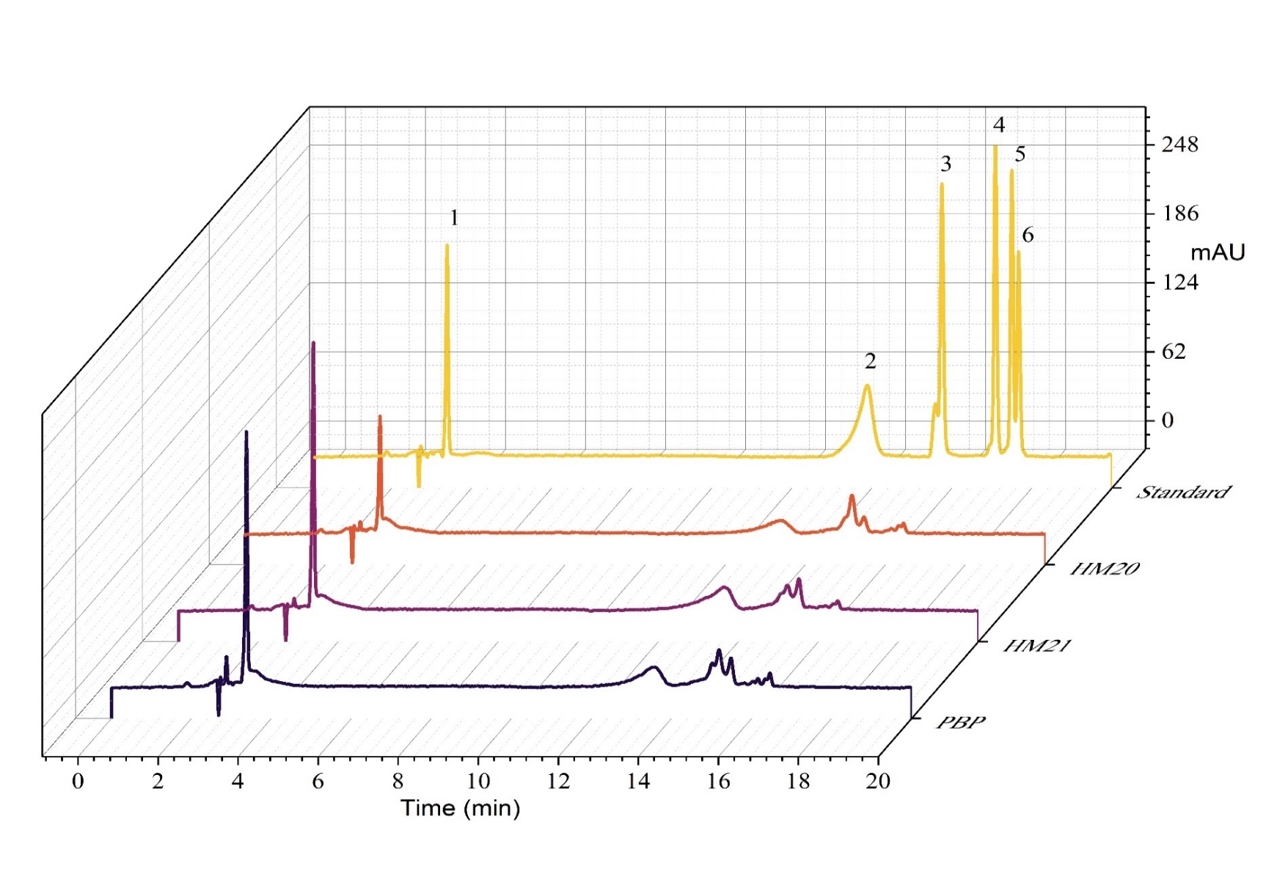
Supplementary Fig. S1. Anthocyanins profile of selected corn varieties identified through HPLC analyses
Note: (1) cyanidin-3-glucoside, (2) delphinidin, (3) cyanidin chloride, (4) peonidin, (5) malvidin, and (6) pelargonidin chloride
HM20: Hopi/Cherry pericarp x Maiz morado 2020, HM21: Hopi/Cherry pericarp x Maiz morado 2021, PBP: Purple butcher purple
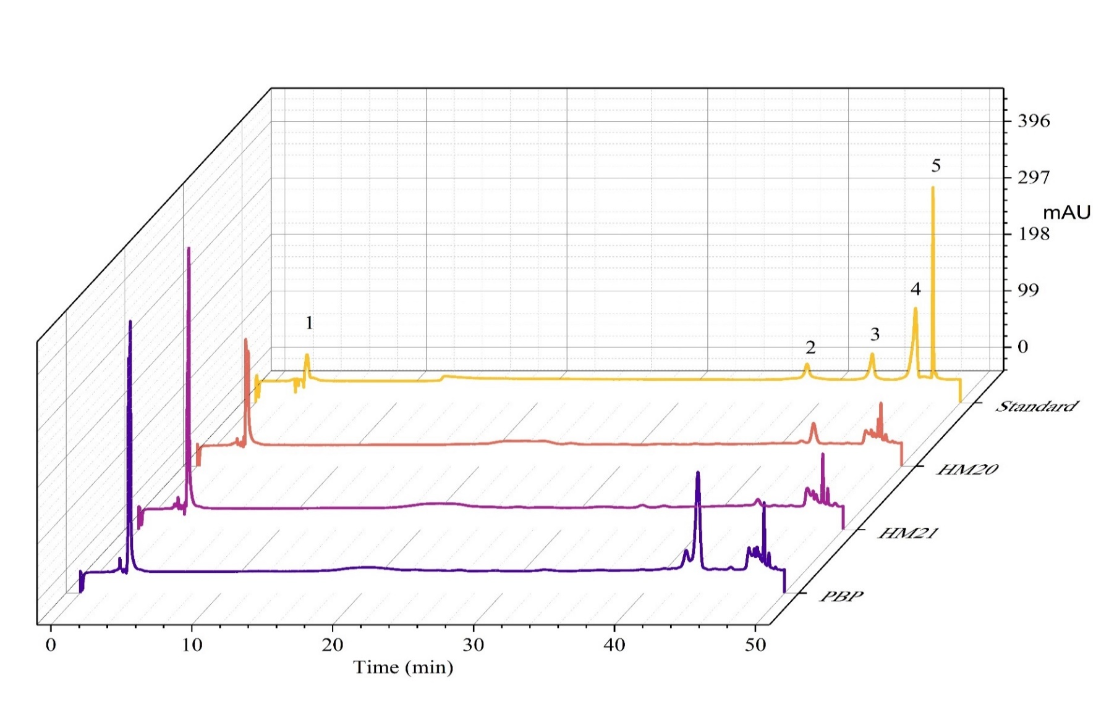
Supplementary Fig. S2. Flavonoids profile of selected corn varieties identified through HPLC analyses
Note: (1) epicatechin, (2) morin, (3) naringin, (4) quercetin, and (5) kaempferol
HM20: Hopi/Cherry pericarp x Maiz morado 2020, HM21: Hopi/Cherry pericarp x Maiz morado 2021, PBP: Purple butcher purple

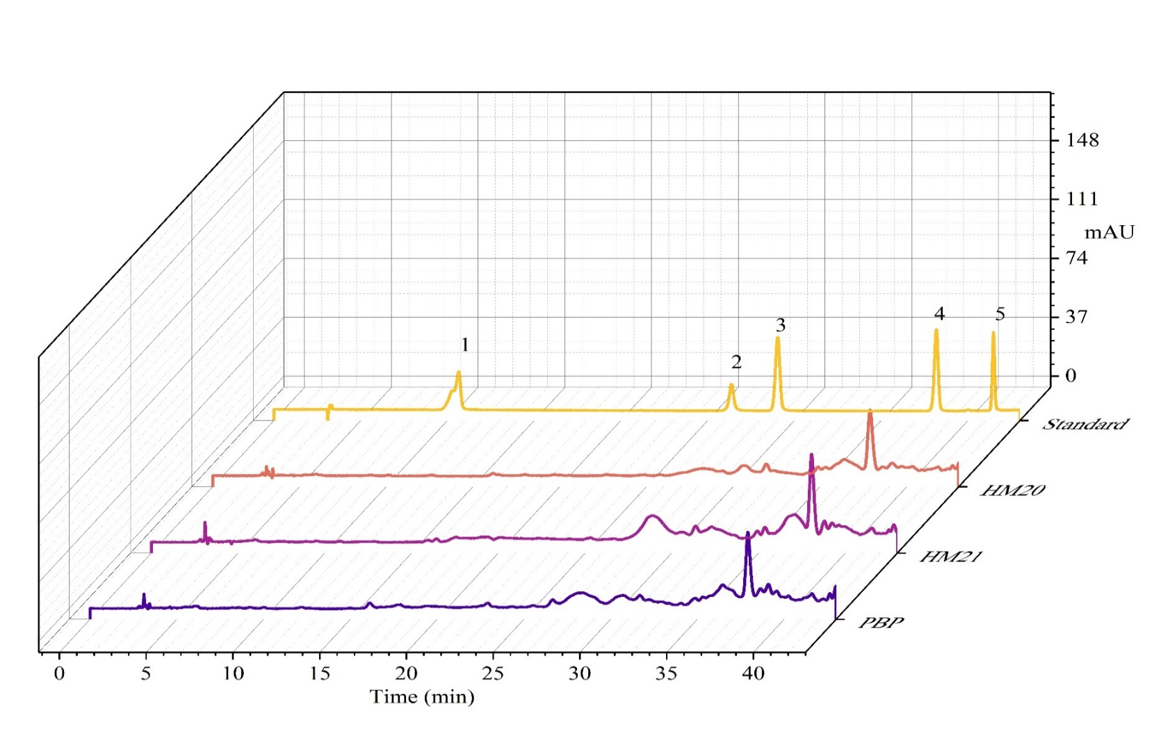
Supplementary Fig. S3. Phenolics profile of selected corn varieties identified through HPLC analyses
Note: (1) gallic acid, (2) chlorogenic acid, (3) caffeic acid, (4) ferulic acid, and (5) hesperidin
HM20: Hopi/Cherry pericarp x Maiz morado 2020, HM21: Hopi/Cherry pericarp x Maiz morado 2021, PBP: Purple butcher purple

Supplementary Fig. S4. Illustration of four regions (B1, S1, S2, and E) where the pericarp and aleurone thicknesses of kernels from six selected colored corn varieties were evaluated

