Supplementary Information
for
Global Heliospheric Termination Shock Strength from the Solar-Interstellar Interaction

E. J. Zirnstein¹, R. Kumar^{1,2}, P. Swaczyna^{1,3}, M. A. Dayeh^{4,5}, J. Heerikhuisen⁶, B. L. Shrestha¹, J. R. Szalay¹

¹Department of Astrophysical Sciences, Princeton University, Princeton, NJ 08544, USA (ejz@princeton.edu)
²Tau Systems, Austin, TX 78701, USA
³Space Research Centre PAS (CBK PAN), Bartycka 18a, 00-716, Warsaw, Poland
⁴Southwest Research Institute, San Antonio, TX 78238, USA
⁵Department of Physics and Astronomy, University of Texas at San Antonio, San Antonio, TX 78249, USA
⁶Department of Mathematics and Statistics, University of Waikato, Hamilton, New Zealand

Here we provide supplemental figures referenced in the main text and Methods section of the paper.

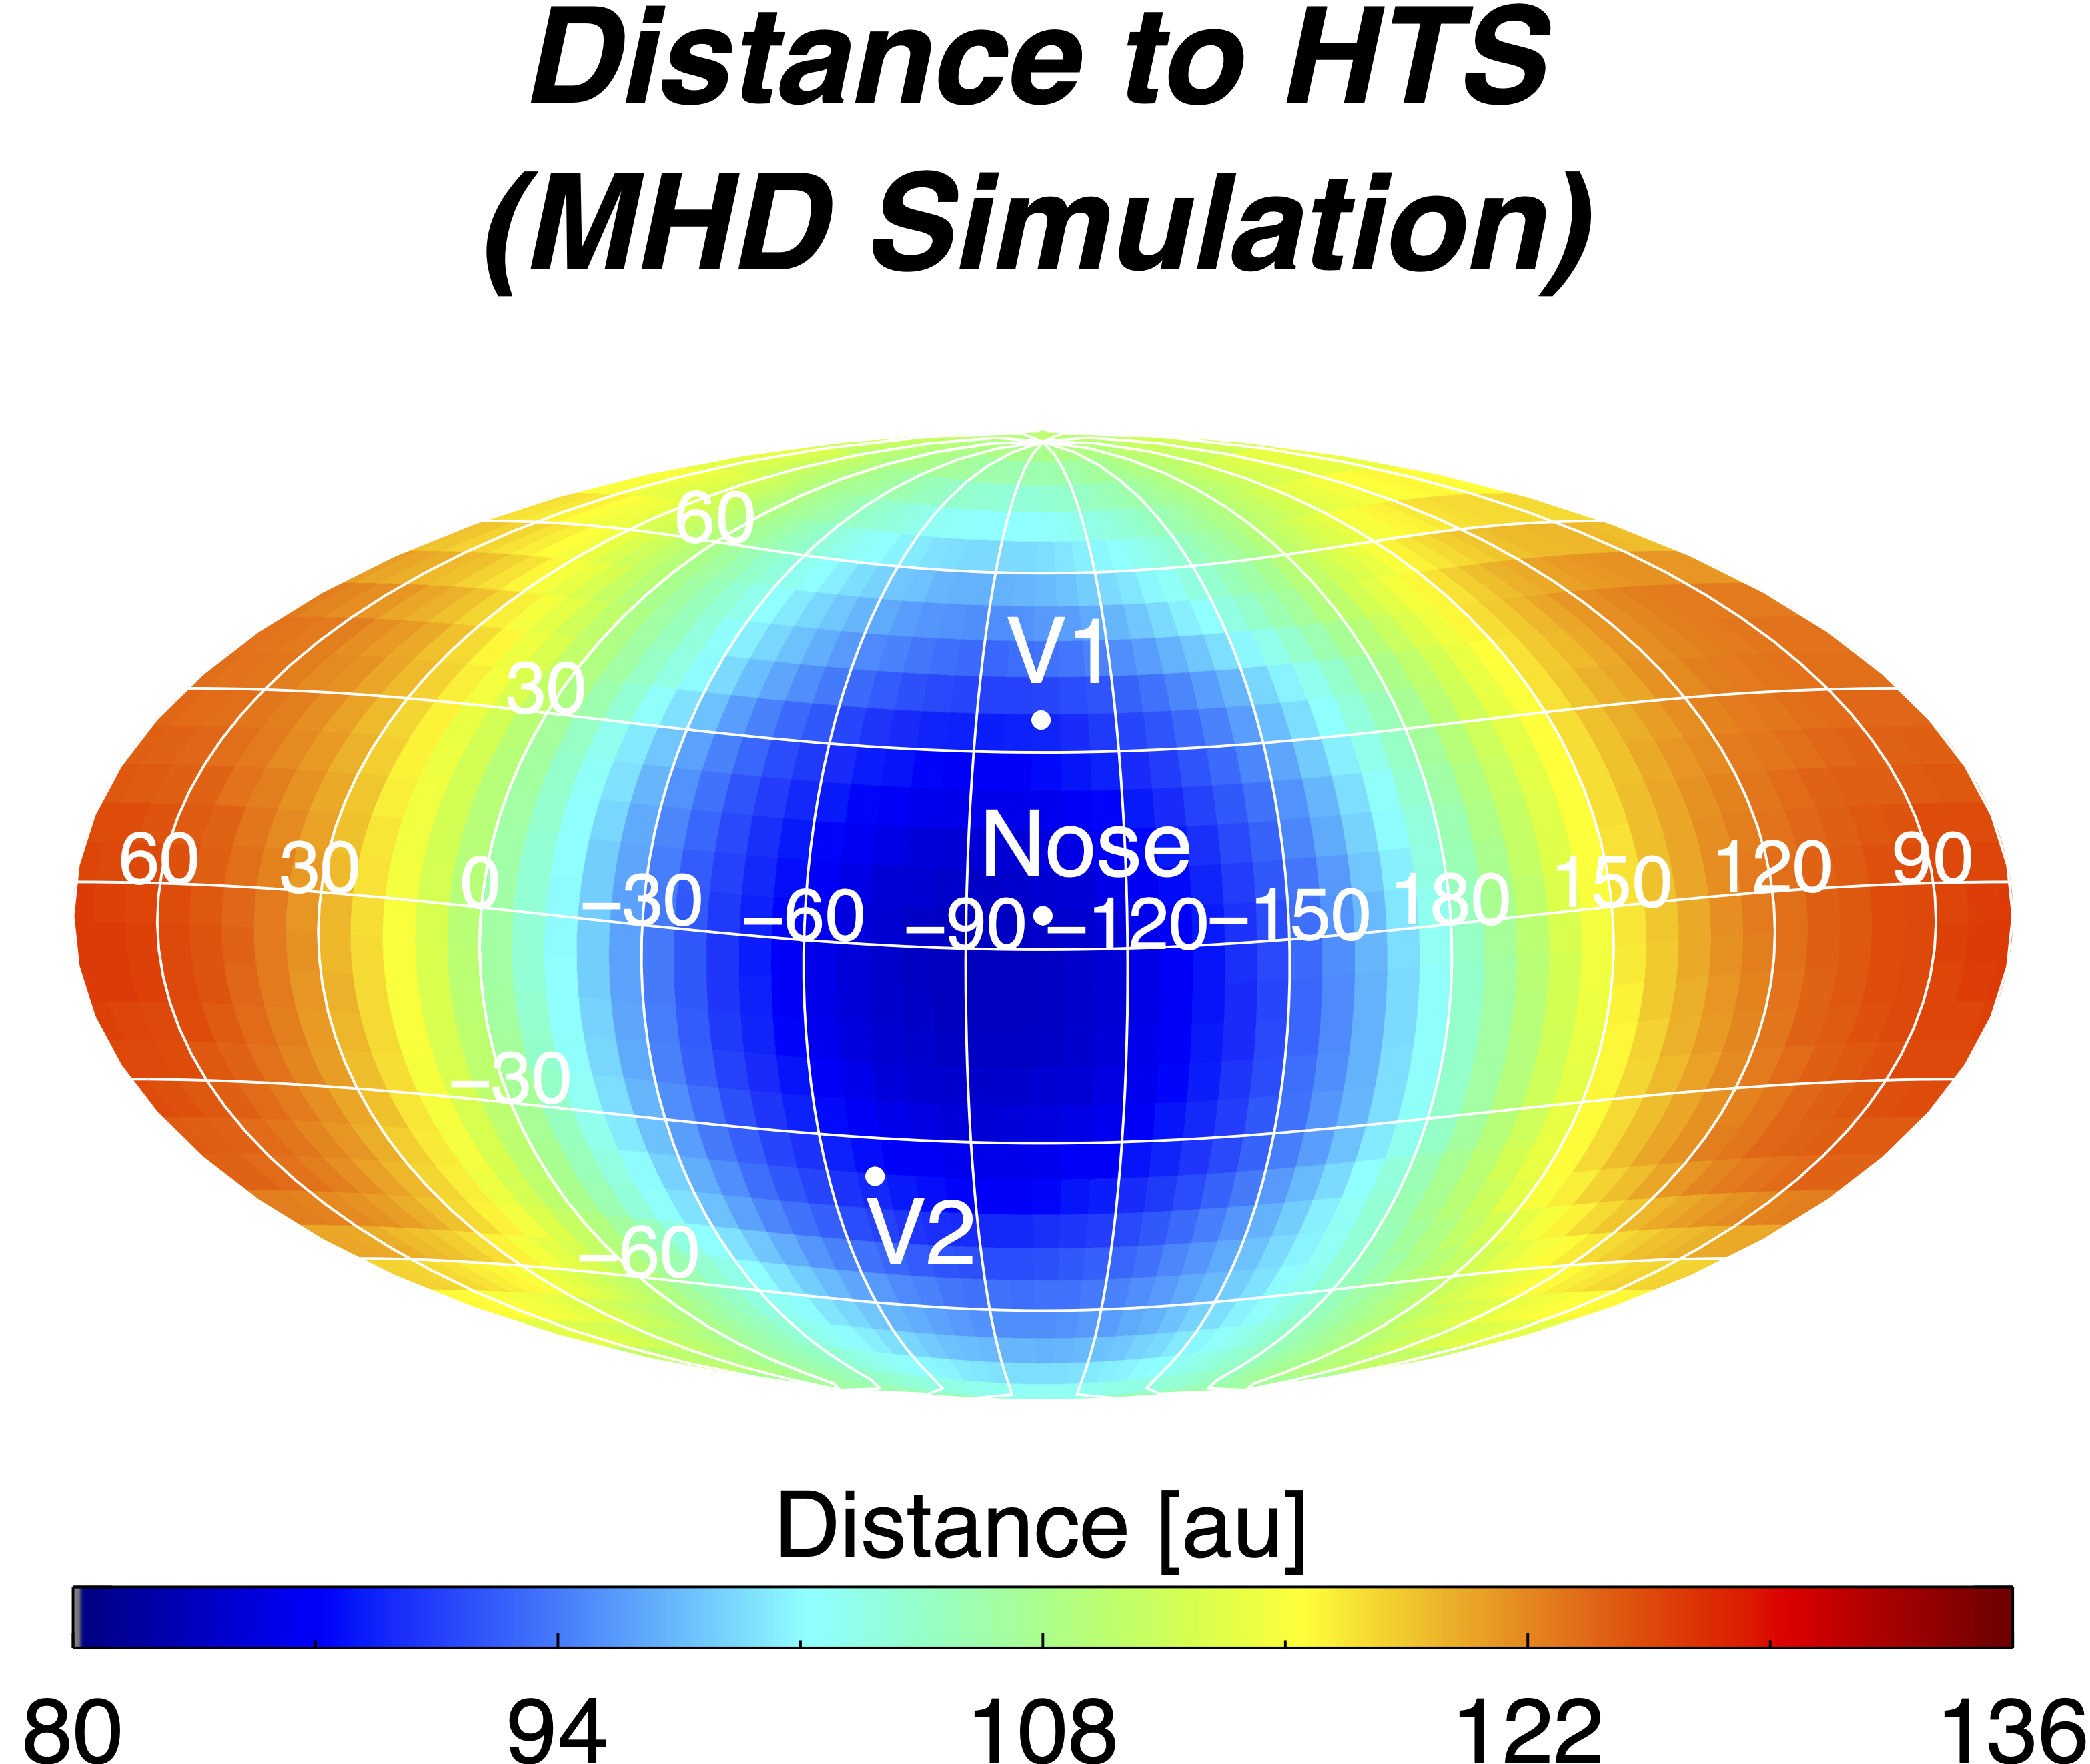
Figure S1. Distance to the HTS from the MHD simulation used in this study¹. Distances were scaled such that the average distance to the HTS from the simulation in the V1 and V2 directions is the same as the average of the observed crossings from the Voyager spacecraft^{2,3}.

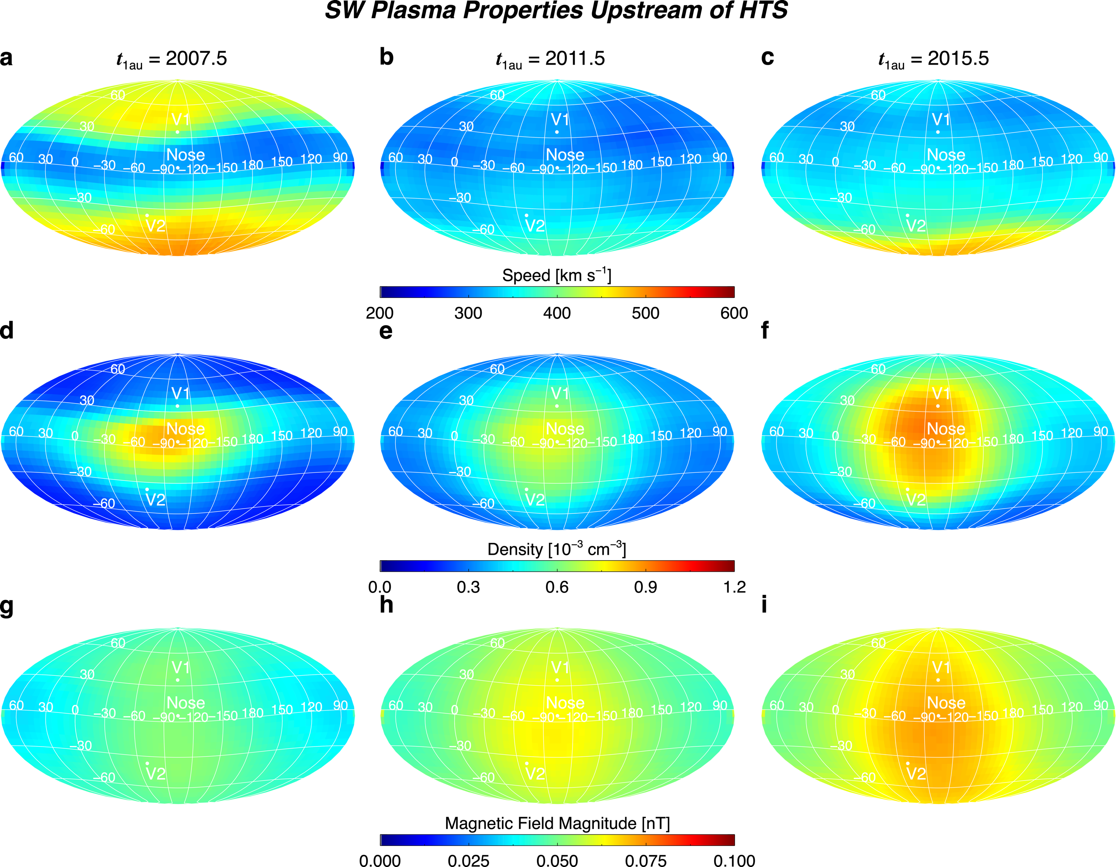
Figure S2. Example sky maps of SW speed, density, and magnetic field magnitude upstream of the HTS derived from IPS/OMNI data taken at 1 au in (a) 2007.5, (b) 2011.5, and (c) 2015.5 and propagated to the HTS using Eq. (1)-(5). Note that the results for t_{1au} = 2015.5 reflect the enhancement in SW pressure beginning at the Sun in late 2014, but we do not use this data in our analysis. We restrict our analysis to times before IBEX first observed an increase in ENA fluxes associated with the SW pressure increase.

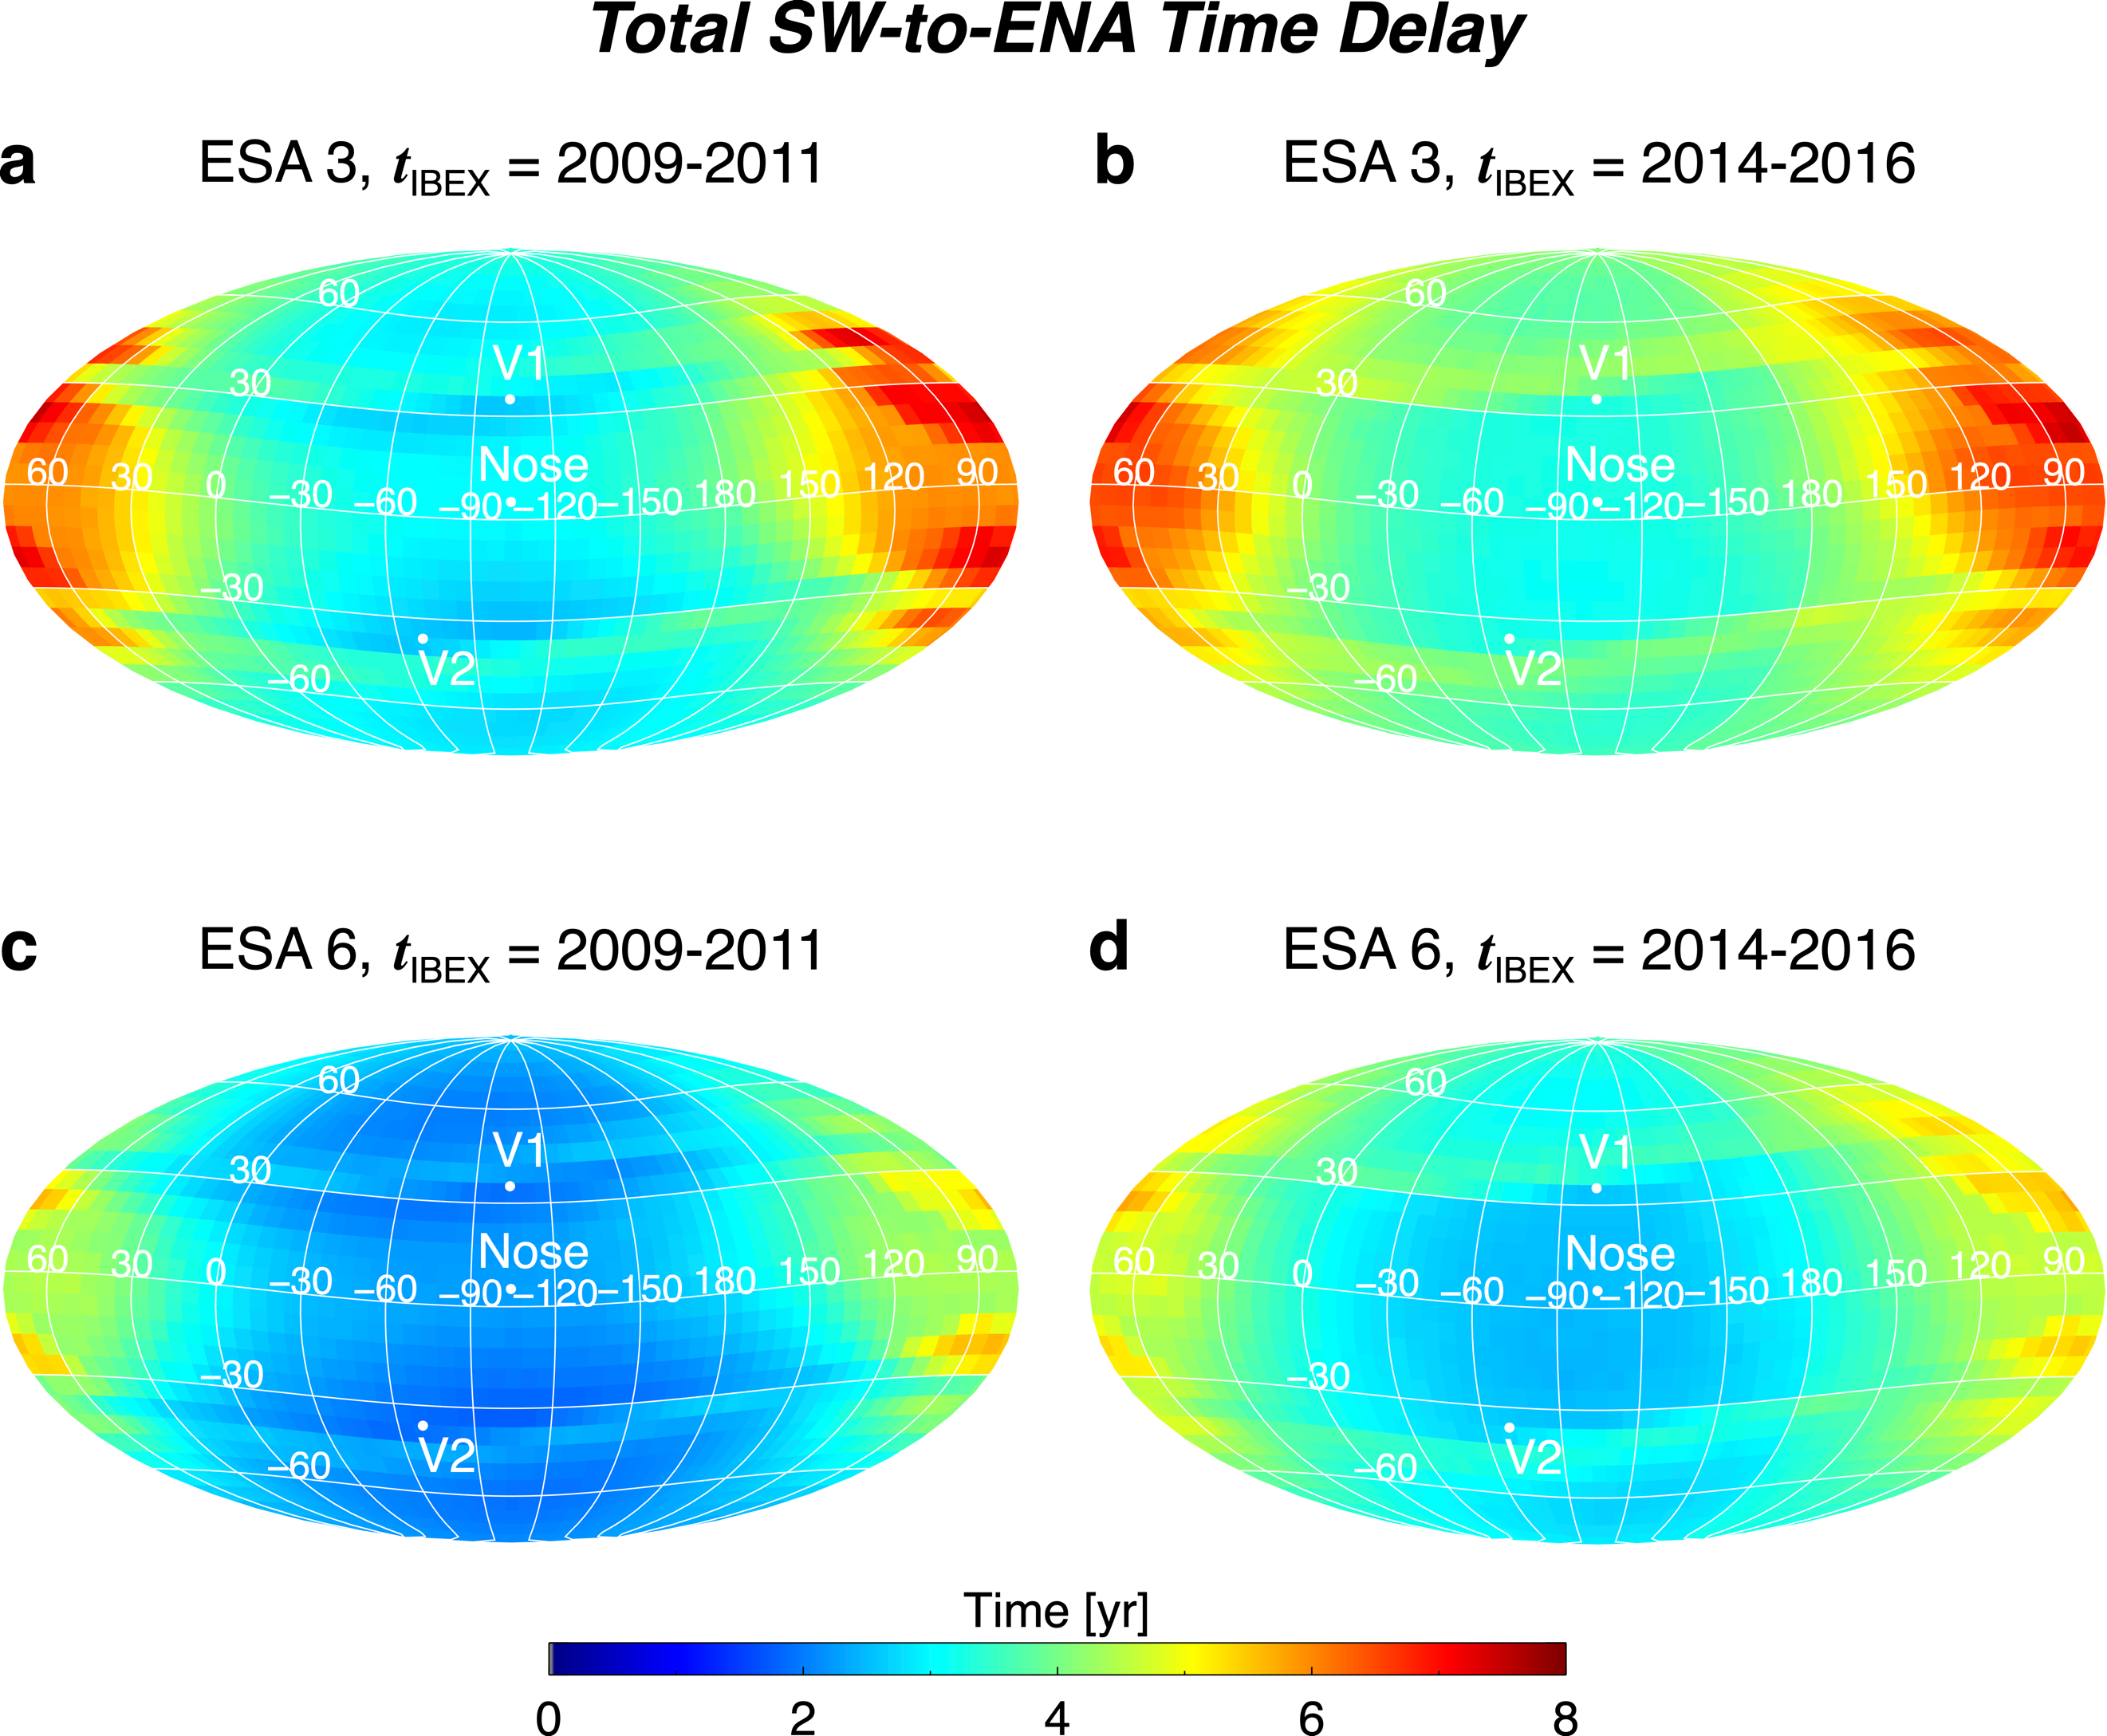
Figure S3. Example sky maps of the total time delay between SW outward propagation at 1 au and IBEX ENA observation, for ESA 3 (a, b) and ESA 6 (c, d). These results are based on flow streamlines from a steady-state simulation of the heliosphere¹, but speeds based on the IPS/OMNI model⁴. See text for details.

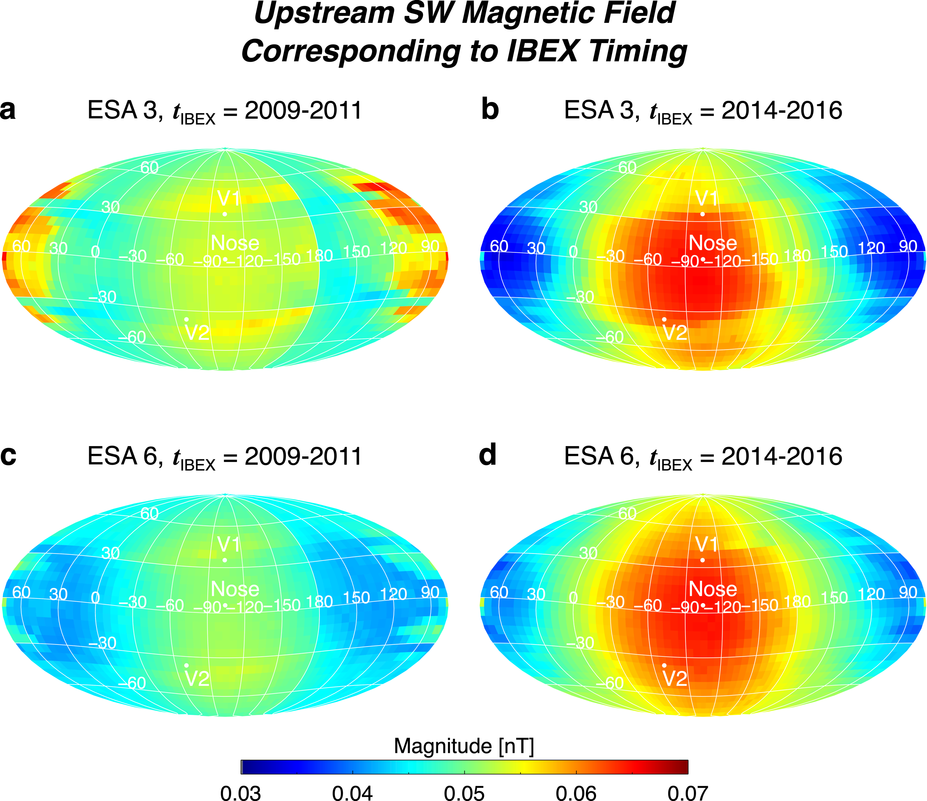
Figure S4. Similar to Figure 2, except we show magnetic field magnitude.

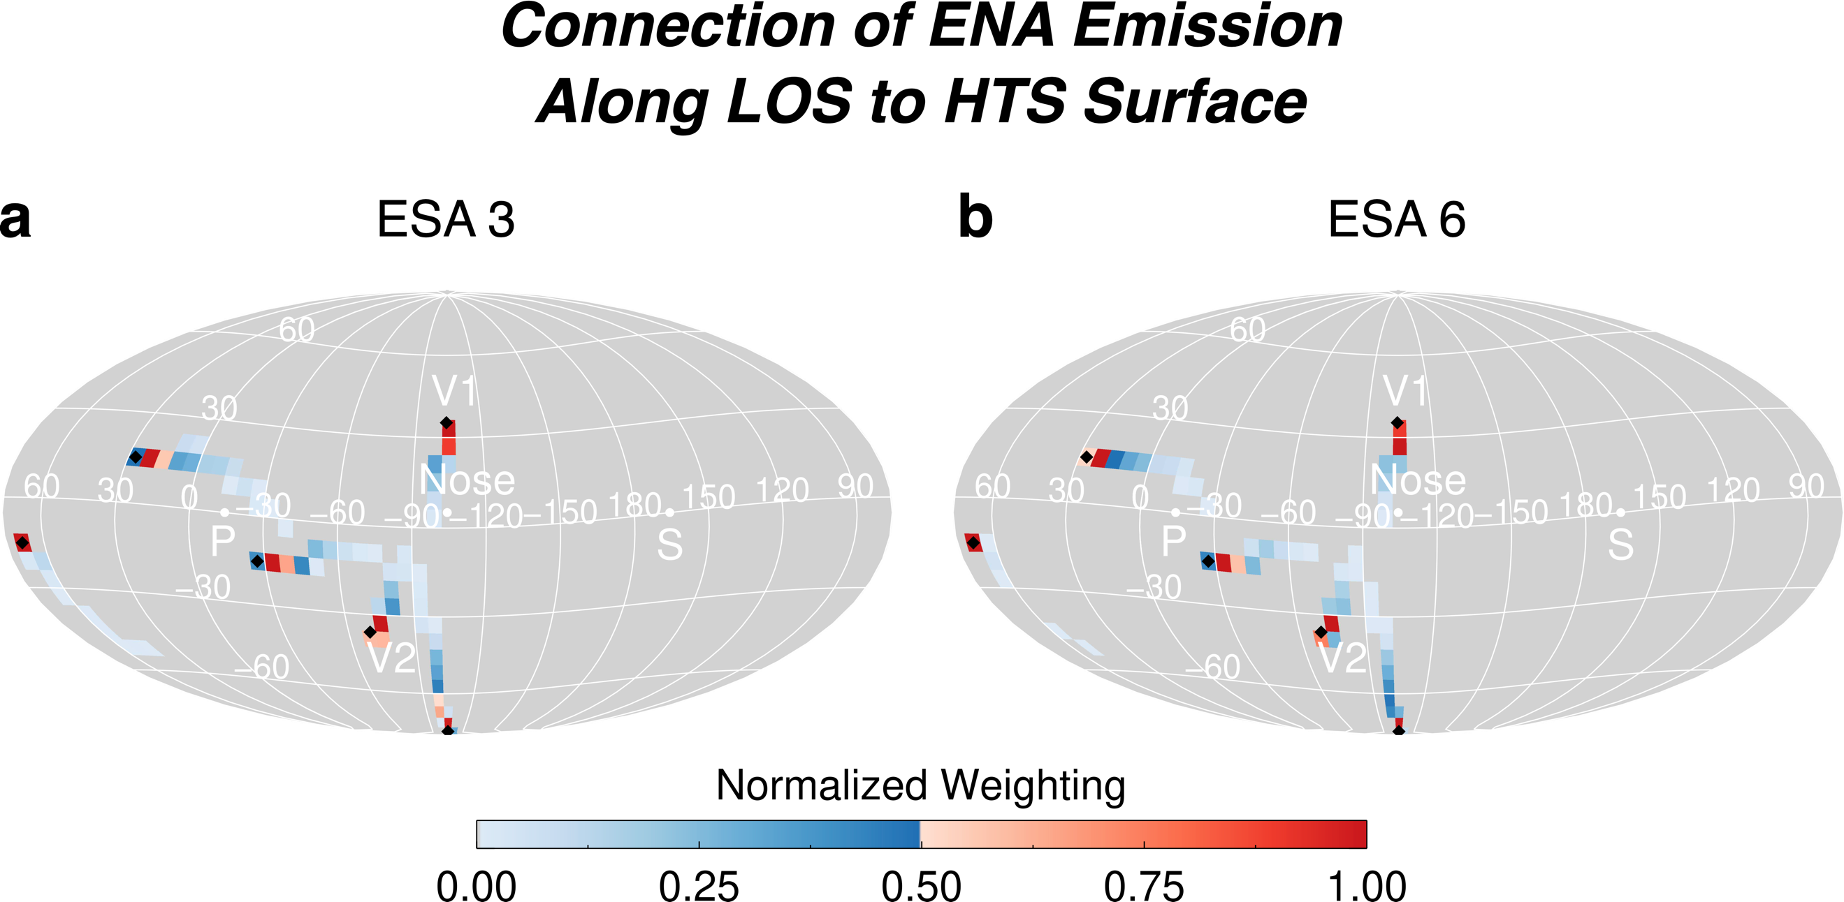
Figure S5. Examples of IBEX lines of sight (LOS) and where they map back to the HTS depending on the IHS plasma flow streamlines. Examples are shown for ENAs at energies for ESA 3 (a) and ESA 6 (b) are shown. The colored pixels are positions on the HTS that are connected to the IBEX LOS (black diamond symbols) via bulk plasma flow streamlines in the global MHD simulation. Note that the weights for ESA 3 vs. 6 are different due to the energy-dependent source regions of the ENAs. Because of this, several pixels with weights close to zero appear different in panels a and b, but the flow streamlines themselves are the same.
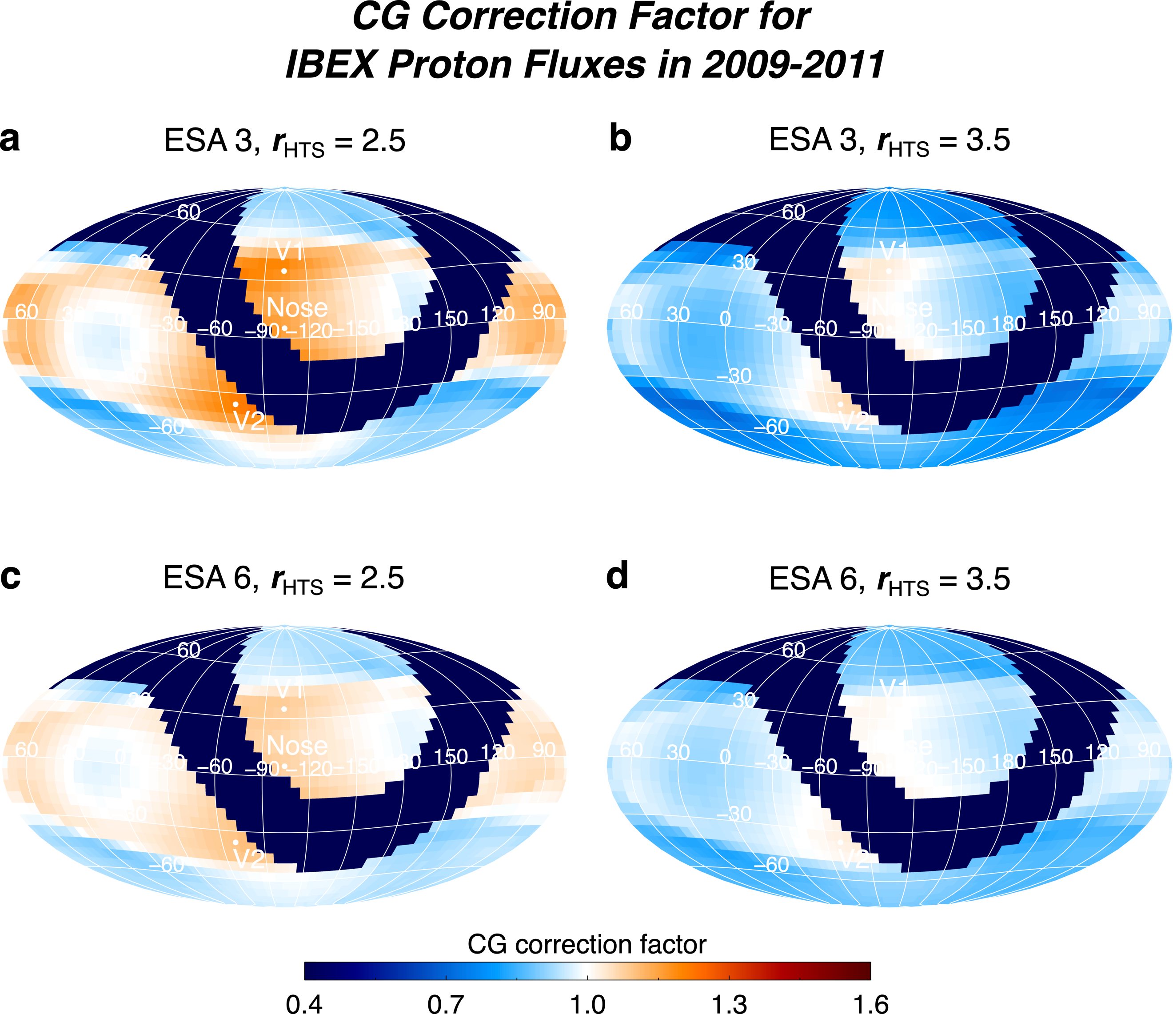
Figure S6. Examples of the CG correction factor as a function of ESA and compression ratio for 2009-2011.

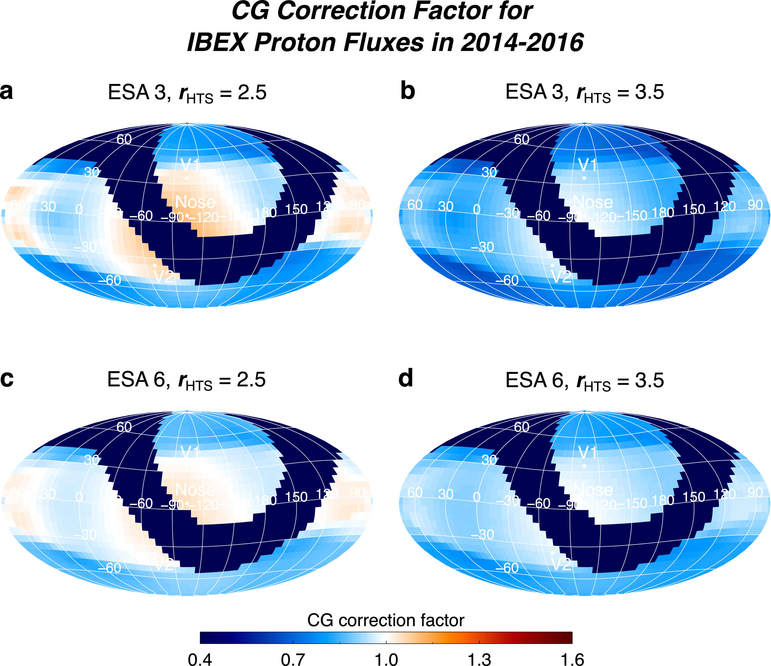
Figure S7. Similar to Figure 9, except for 2014-2016.

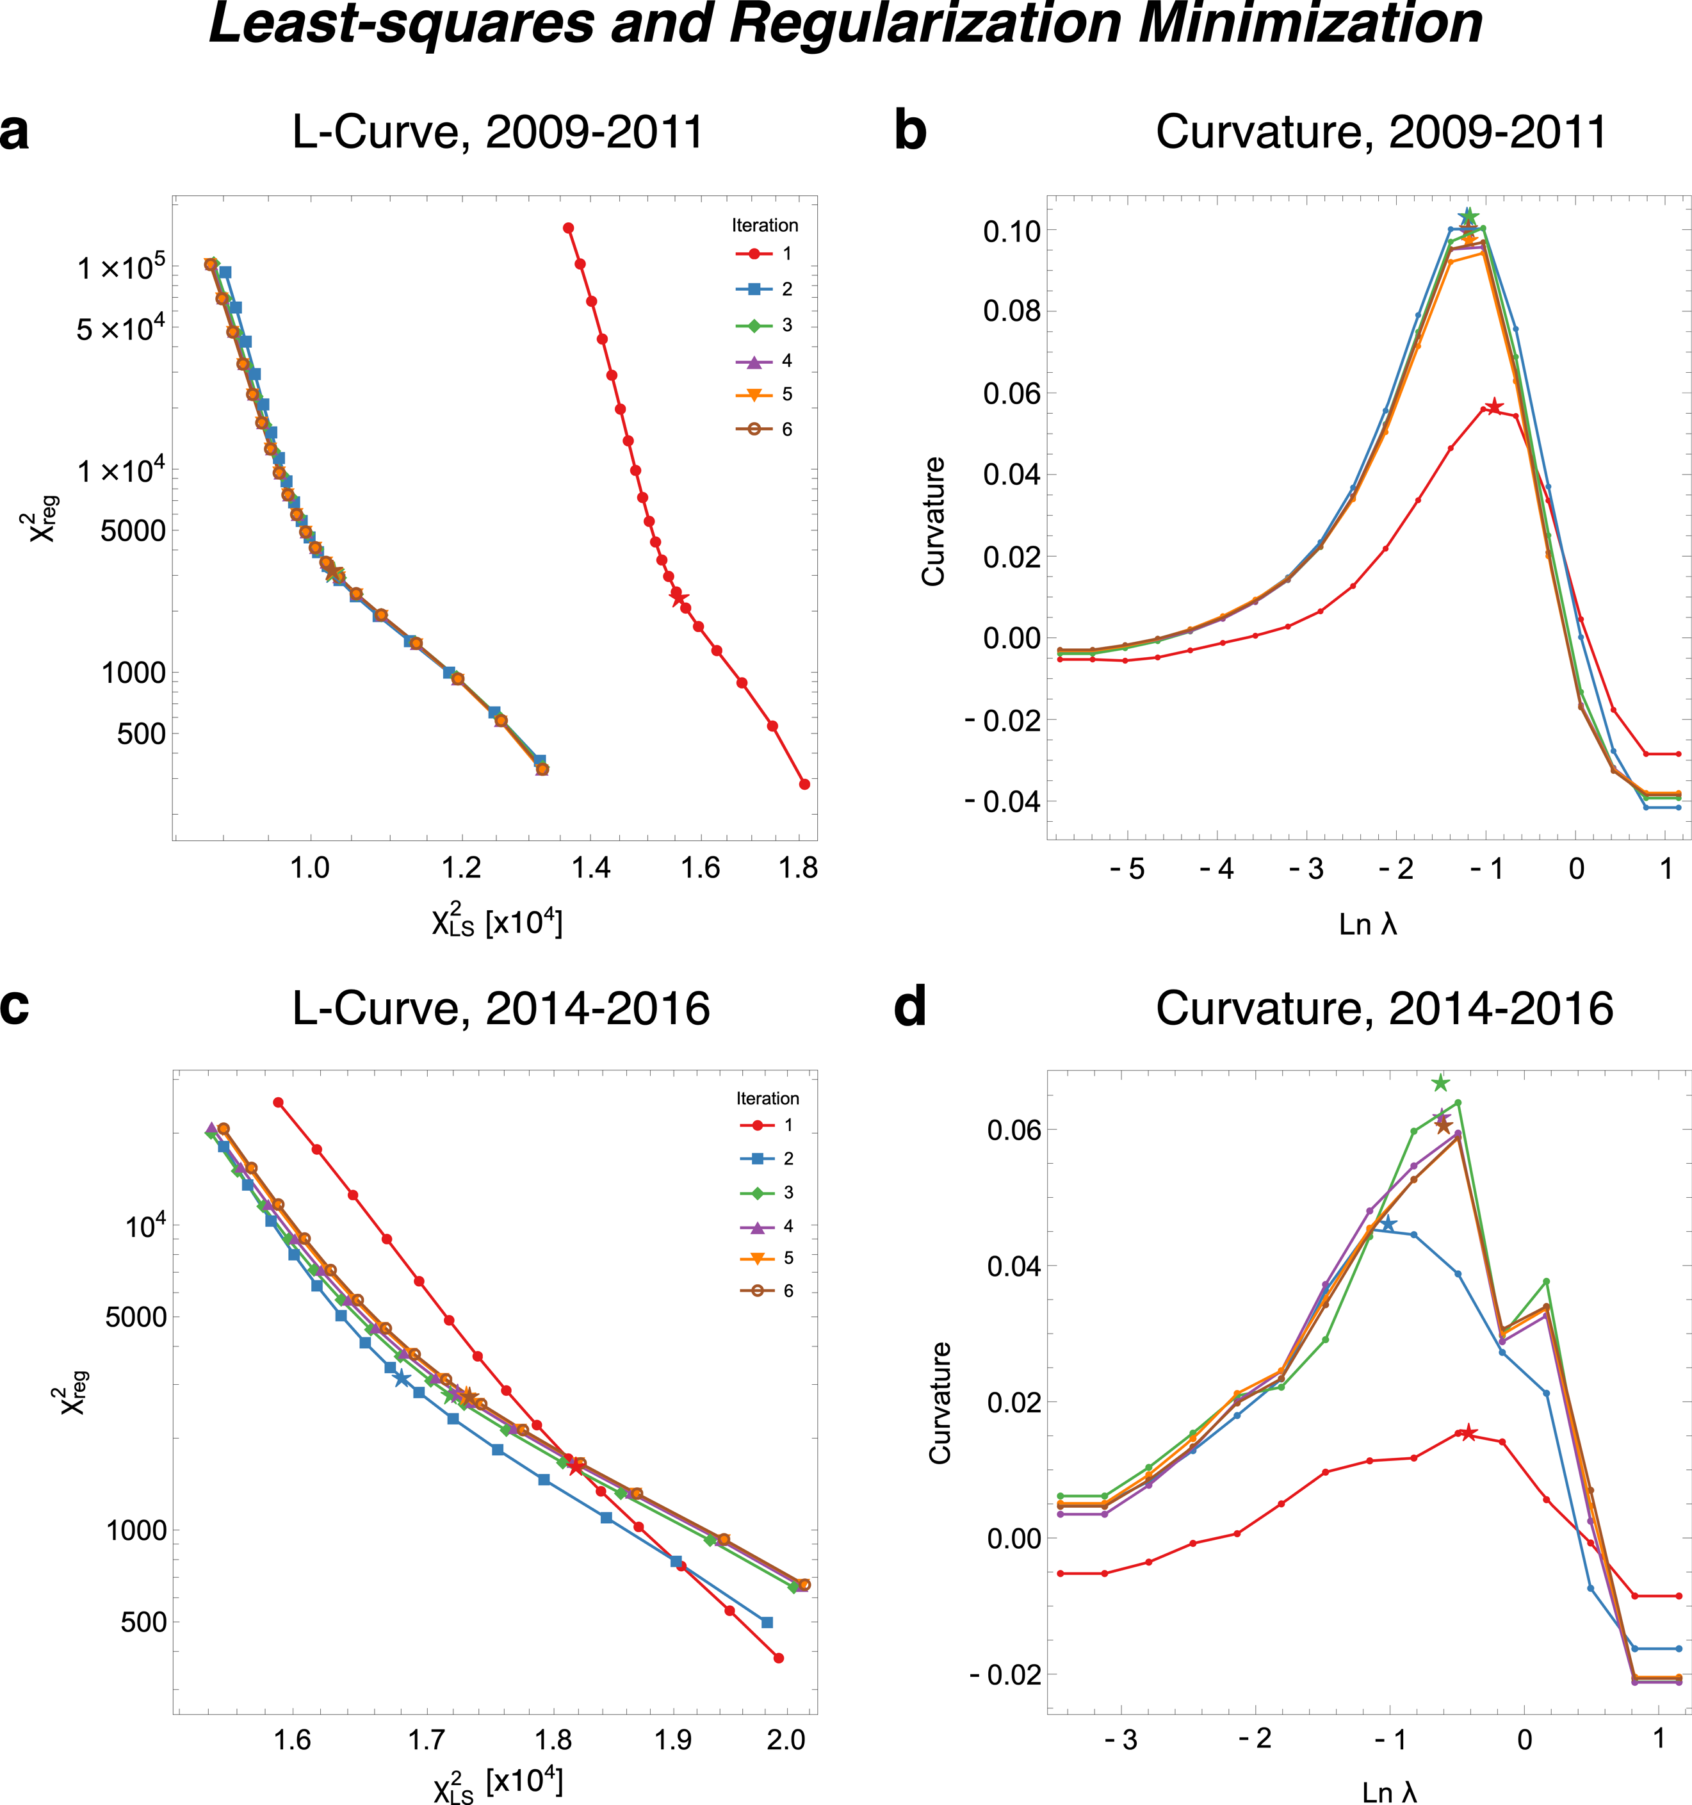
Figure S8. Example of the L-curve (a,c) and its curvature (b,d) used to determine the best-fit compression ratio simultaneously for all pixels in a map. These results are from case L1, shown for time periods 2009-2011 (a,b) and 2014-2016 (c,d). The point of maximum curvature is shown as the star in both panels. Note that the stars in panels b and d do not necessarily lie on the curve because the point of maximum curvature is found by fitting a Gaussian function to the 5 points nearest to the peak.

References
1. Zirnstein, E. J., Dayeh, M. A., Heerikhuisen, J., McComas, D. J. & Swaczyna, P. Heliosheath Proton Distribution in the Plasma Reference Frame. ApJS 252, 26 (2021).
2. Stone, E. C. et al. Voyager 1 Explores the Termination Shock Region and the Heliosheath Beyond. Sci 309, 2017–2020 (2005).
3. Stone, E. C. et al. An asymmetric solar wind termination shock. Natur 454, 71–74 (2008).
4. Porowski, C., Bzowski, M. & Tokumaru, M. A New 3D Solar Wind Speed and Density Model Based on Interplanetary Scintillation. ApJS 259, 2 (2022).

