Online Resource 1 Water level fluctuations during field study

Water level hour⁻¹.day⁻¹ in the Boven Slinge during the research period at a distance of 100 m from the site where diaspore-deposition was sampled. Sampling dates (triangles) and elevations (low, middle, high) of the mats are indicated. N.A.P. = Normaal Amsterdam Peil (Normal Amsterdam Ordnance Level).

Online Resource 2 Sampling method of water transported diaspores
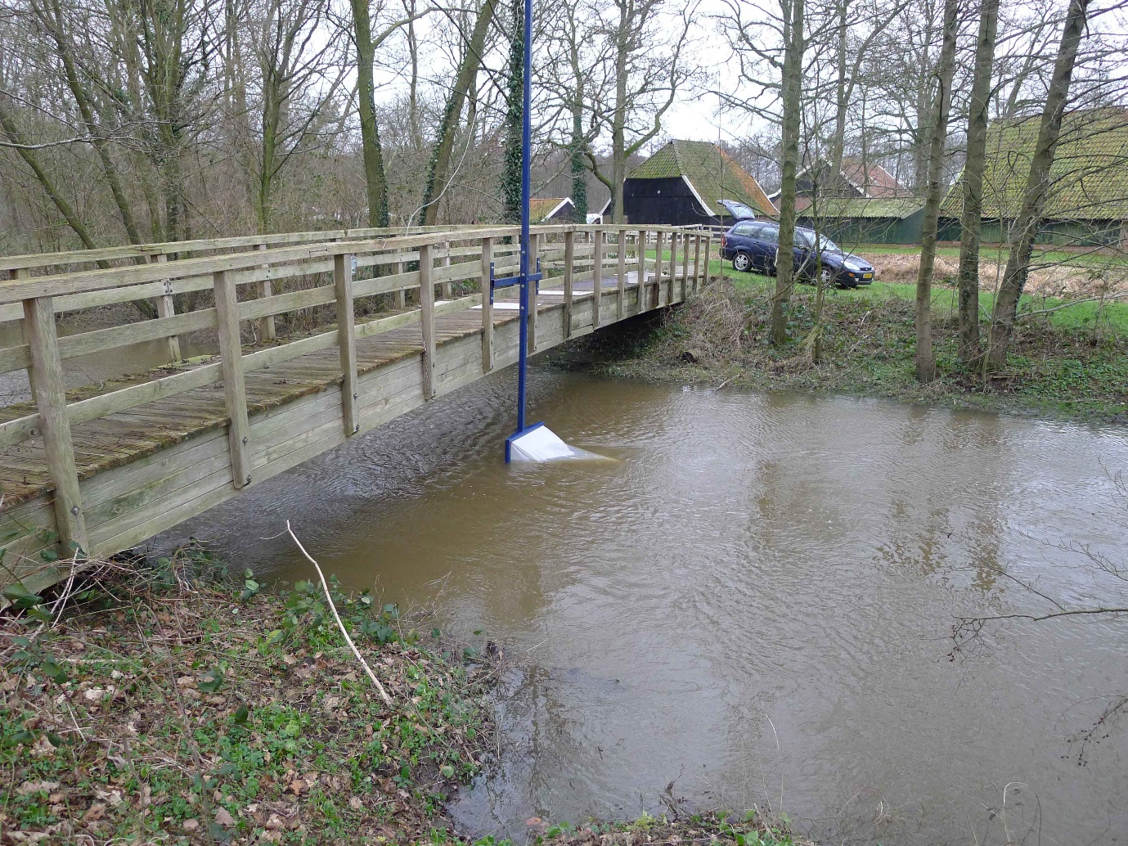
Sampling of water transported diaspores during high discharges with net attached to bridge over the BovenSlinge.

Online Resource 3 Sampling of water deposited diaspores.

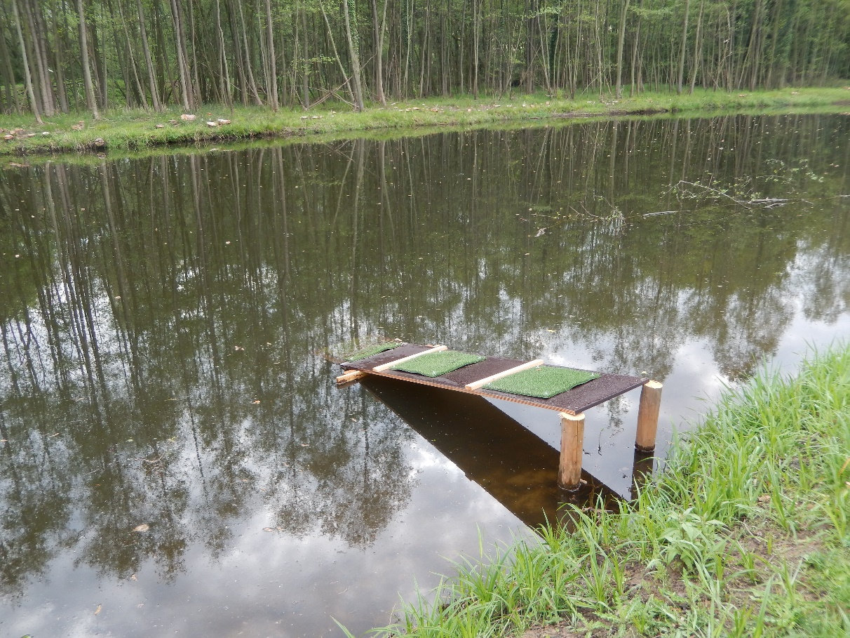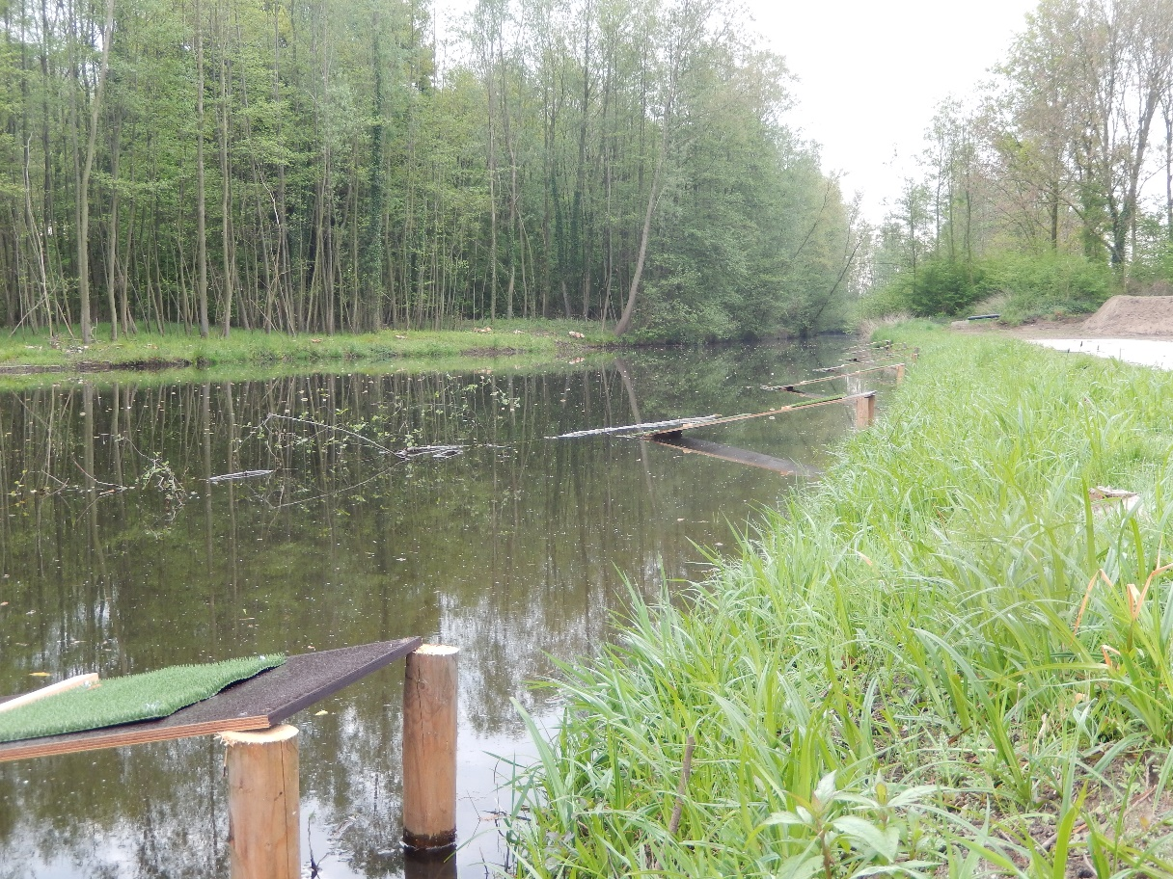

Upper pictures shows a plank with mats at three elevations, with the lowest elevation being submerged. Lower picture shows replicated planks at the sampling point in the BovenSlinge.
The placement of mats on planks at an angle of 30° allowed us to exactly position a mat at the desired elevation and to guarantee that mats with, for instance ‘low elevation’ were fixed at the same elevation, regardless of which plank they were on. The slope of the streambank itself was too steep and narrow to place the three mats above each other, i.e. the shoreline between the minimal water level and yearly maximum water level was about 50 cm wide.
The stretch where deposition was sampled was in a 150 m long anthropogenic sediment trap (roughly at 51⁰, 56’49.6” N, 6⁰,40’06.8” E, about 1.5 kilometer downstream from the point where water transport was sampled) between the more or less natural forested stream trajectory and the downstream trajectory where the stream was fully canalized, widened and deepened to meet agricultural demands. Placement of the mats within the sediment trap implied that stream velocity here was generally low, i.e. below 0.1 m.s⁻¹ even at yearly peak discharge, both within the main stream and around the mats. Sampling within this sediment trap may thus have overestimated deposition of propagules in a natural stream, but avoided disturbing whirls around the planks.

Online Resource 4 Main effects of traits in a GLMM on site by species abundance data

CATs regression (Shipley 2010; Warton, Shipley & Hastie 2015) is a method to study the effect of traits on community assembly, in particular (relative) species abundance data. In a multisite CATs regression the trait-effects can be made site dependent. This gives also the possibility of main effects of trait effects (i.e. the average trait effects across sites). Such data (trait data and site by species abundance data) can also be analysed by generalized linear mixed models (GLMMs). GLMMs have been advocated for use in studies of trait-environment relationships (Jamil et al. 2013; ter Braak 2019). In such models the focus is on the interaction effects: how the environment changes the effect of the trait on species abundance. On our study also the trait main effect is of importance, what is the average effect and how variable is this effects across sites (days or planks in our study).
The investigation of a trait main effect in a multi-site study finds an analogy in a meta analysis, which is the investigation of the treatment effect across multiple studies resulting in the overall effect and its variability across studies. In this analogy a site is a study, the treatment is the trait, the species are the participants in the studies. A difference is that the sites have species in common whereas studies in a meta analysis normally do not share participants. The standard model for a meta analysis has mixed model formula: y~ treatment + (1+treatment|study). By the analogy, the model for trait analysis becomes: y~ trait + (1+trait|site). Note that the random term (trait|site) is precisely the term that was singled out in ter Braak 2019 that was needed (together with the random term (environment|species)) for robust analysis of trait-environment relationships. To conclude, a (trait|site) is useful also in the analysis for trait main effects. Analyses with such terms result in a value for each trait main effect and an estimate of the variability of the trait effect across sites (measured, for example, by the standard deviation of the random term).

Jamil, T., Ozinga, W.A., Kleyer, M. & ter Braak, C.J.F. (2013) Selecting traits that explain species–environment relationships: a generalized linear mixed model approach. Journal of Vegetation Science, 24, 988-1000. http://dx.doi.org/10.1111/j.1654-1103.2012.12036.x
Shipley, B. (2010) From plant traits to vegetation structure : chance and selection in the assembly of ecological communities. Cambridge University Press, Cambridge ;. 9780521117470 052111747X 9780521133555 0521133556
ter Braak, C.J.F. (2019) New robust weighted averaging- and model-based methods for assessing trait–environment relationships. Methods in Ecology and Evolution, 10, 1962-1971. https://doi.org/10.1111/2041-210X.13278
Warton, D.I., Shipley, B. & Hastie, T. (2015) CATS regression – a model-based approach to studying trait-based community assembly. Methods in Ecology and Evolution, 6, 389-398. http://dx.doi.org/10.1111/2041-210X.12280

Online Resource 5 20 Most abundant species in water and deposition samples

Table S5.1 List of 20 most abundant species in water transport samples. Table indicates full species name and abbreviations as used in Fig. 1. Totals refer to number of vegetative and generative diaspores summed over all water transport samples collected in the field study divided by the total volume of water that was sampled.
Full species name | Abbreviation Fig. 1 | Number per m3
Alnus glutinosa | Alnglu | 225,5
Urtica dioica | Urtdio | 53,0
Lycopus europaeus | Lyceur | 50,1
Carex remota | Carrem | 14,0
Ranunculus sceleratus | Ransce | 10,7
Juncus effusus | Juneff | 5,7
Callitriche obtusangula | Calspe | 3,8
Rorippa palustris | Rorpal | 2,9
Cardamine pratensis | Cardpr | 2,2
Salix fragilis | Salfra | 2,0
Rumex obtusifolius | Rumobt | 1,9
Bidens frondosa | Bidfro | 1,6
Betula sp. | Betspe | 1,5
Poa trivialis | Poatri | 1,2
Epilobium tetragonum | Epitet | 1,1
Iris pseudacorus | Iripse | 1,0
Hedera helix | Hedhel | 1,0
Juncus tenuis | Junten | 0,9
Lysimachia vulgaris | Lysvul | 0,7
Galium aparine | Galapa | 0,7

Table S5.2 List of 20 most abundant species in water deposition samples at low, middle and high elevations. Table indicates full species name and abbreviations as used in Fig. 1. Totals refer to sum of vegetative and generative diaspores per mat (0.25 m²) and sampling event.

Full species name | Abbreviation Fig.1 | Low | Middle | High
Alnus glutinosa | Alnglu | 1,7 | 26,0 | 2,8
Urtica dioica | Urtdio | 9,5 | 13,6 | 5,3
Juncus effusus | Juneff | 0,5 | 8,2 | 2,9
Callitriche spec | Calspe | 7,0 | 3,1 | 0,0
Phalaris arundinacea | Phaaru | 6,9 | 0,2 | 0,0
Poa trivialis | Poatri | 2,2 | 0,4 | 0,2
Persicaria maculata | Permac | 0,0 | 2,5 | 0,0
Lycopus europaeus | Lyceur | 0,8 | 1,0 | 0,6
Veronica beccabunga | Verbec | 0,1 | 1,6 | 0,3
Juncus tenuis | Junten | 0,1 | 0,9 | 0,7
Persicaria mitis | Permit | 0,0 | 1,6 | 0,0
Plantago major | Plamaj | 0,1 | 0,8 | 0,5
Epilobium tertragonum | Epitet | 0,2 | 0,9 | 0,2
Carex remota | Carrem | 0,5 | 0,3 | 0,2
Agrostis stolonifera | Agrsto | 0,4 | 0,4 | 0,0
Scirpus sylvaticus | Scisyl | 0,0 | 0,4 | 0,3
Taraxacum officinale | Taroff | 0,7 | 0,0 | 0,0
Lipandra polyspermum | Chepol | 0,0 | 0,7 | 0,0
Mentha aquatica | Menaqu | 0,2 | 0,4 | 0,0
Eupatorium cannabinum | Eupcan | 0,2 | 0,4 | 0,0

Online Resource 6 Detailed data on abundance of ancient and general forest species

Ancient (sensu Hermy et al., 1999) and general forest species which occurred in the 4.5 km upstream from the sampling sites. Upstream frequency (proportion of upstream 100m stretches in which a species occurred) is indicated. Since water transported diaspores were sampled 1,5 km upstream from the point where water deposited diaspores were sampled, upstream frequencies for species were also determined on a partly different trajectory of the stream. As a consequence, values for upstream frequency may differ for the same species. Highlighted species were found as viable diaspores in either water or deposition samples. Numbers refer to total diaspores per species and diaspore type, summed over sampling dates, replicates and, in case of water deposition, elevation.
 |  |  |  | Water-transported diaspores |  |  | Water deposited diaspores
Ancient forest species |  |  |  | Frequency | Seeds | Vegetative |  | Frequency | Seeds | Vegetative
Acer campestre |  |  |  | 0.03 | 0 | 0 |  | 0.02 | 0 | 0
Adoxa moschatellina |  |  |  | 0.52 | 3 | 1 |  | 0.64 | 0 | 1
Anemone nemorosa |  |  |  | 0.68 | 2 | 0 |  | 0.56 | 0 | 0
Arum maculatum |  |  |  | 0.02 | 0 | 0 |  | 0.01 | 0 | 0
Brachypodium sylvaticum |  |  |  | 0.02 | 0 | 0 |  | 0.02 | 0 | 0
Carpinus betulus |  |  |  | 0.19 | 1 | 0 |  | 0.18 | 0 | 0
Carex remota |  |  |  | 0.86 | 597 | 0 |  | 0.82 | 57 | 0
Circaea lutetiana |  |  |  | 0.31 | 0 | 0 |  | 0.26 | 0 | 0
Convallaria majalis |  |  |  | 0.07 | 0 | 0 |  | 0.05 | 0 | 0
Corylus avellana |  |  |  | 0.82 | 15 | 0 |  | 0.82 | 0 | 0
Cornus sanguinea |  |  |  | 0.05 | 0 | 0 |  | 0.08 | 0 | 0
Crataegus laevigata |  |  |  | 0.44 | 0 | 0 |  | 0.4 | 0 | 0
Euonymus europaeus |  |  |  | 0.34 | 0 | 0 |  | 0.46 | 0 | 0
Festuca gigantea |  |  |  | 0.60 | 4 | 1 |  | 0.71 | 3 | 0
Gagea lutea |  |  |  | 0.23 | 0 | 0 |  | 0.27 | 0 | 0
Hieracium sabaudum |  |  |  | 0.02 | 0 | 0 |  | 0.01 | 0 | 0
Ilex aquifolium |  |  |  | 0.44 | 0 | 0 |  | 0.44 | 0 | 0
Lamiastrum galeobdolon |  |  |  | 0.66 | 0 | 0 |  | 0.71 | 0 | 0
Lonicera periclymenum |  |  |  | 0.37 | 0 | 0 |  | 0.32 | 0 | 0
Maianthemum bifolium |  |  |  | 0.13 | 0 | 0 |  | 0.11 | 0 | 0
Mespilus germanica |  |  |  | 0.07 | 0 | 0 |  | 0.06 | 0 | 0
Milium effusum |  |  |  | 0.08 | 0 | 0 |  | 0.06 | 0 | 0
Oxalis acetosella |  |  |  | 0.21 | 0 | 0 |  | 0.15 | 0 | 0
Poa nemoralis |  |  |  | 0.86 | 23 | 4 |  | 0.88 | 14 | 1
Primula elatior |  |  |  | 0.27 | 1 | 0 |  | 0.21 | 0 | 0
Ranunculus auricomus |  |  |  | 0.18 | 0 | 0 |  | 0.13 | 0 | 0
Scrophularia nodosa |  |  |  | 0.57 | 2 | 0 |  | 0.58 | 2 | 0
Stachys sylvatica |  |  |  | 0.58 | 1 | 0 |  | 0.54 | 0 | 0
Stellaria holostea |  |  |  | 0.31 | 0 | 0 |  | 0.28 | 0 | 0
Tilia cordata |  |  |  | 0.05 | 0 | 0 |  | 0.04 | 0 | 0
Tilia platyphyllos |  |  |  | 0.07 | 2 | 0 |  | 0.05 | 1 | 0
Ulmus glabra |  |  |  | 0.18 | 9 | 0 |  | 0.13 | 0 | 0
Ulmus laevis |  |  |  | 0.00 | 0 | 0 |  | 0.01 | 0 | 0
Ulmus minor |  |  |  | 0.13 | 0 | 0 |  | 0.11 | 0 | 0
Veronica montana |  |  |  | 0.16 | 0 | 0 |  | 0.12 | 0 | 0
Viburnum opulus |  |  |  | 0.23 | 0 | 0 |  | 0.18 | 0 | 0
Vinca minor |  |  |  | 0.02 | 0 | 0 |  | 0.04 | 0 | 0
Viola reichenbachiana |  |  |  | 0.03 | 0 | 0 |  | 0.02 | 0 | 0
Viola riviniana |  |  |  | 0.16 | 0 | 0 |  | 0.12 | 0 | 0

General forest species | Frequency |  | Seeds |  | Vegetative |  |  | Frequency |  | Seeds |  | Vegetative
Acer platanoides | 0.32 |  | 0 |  |  | 0 |  | 0.27 |  | 0 |  | 0
Acer pseudoplatanus | 0.29 |  | 0 |  |  | 0 |  | 0.26 |  | 0 |  | 0
Aesculus hippocastanum | 0.07 |  | 0 |  |  | 0 |  | 0.05 |  | 0 |  | 0
Amelanchier lamarckii | 0.03 |  | 0 |  |  | 0 |  | 0.02 |  | 0 |  | 0
Avenella flexuosa | 0.03 |  | 0 |  |  | 0 |  | 0.02 |  | 0 |  | 0
Betula spec. | 0.18 |  | 64 |  |  | 0 |  | 0.18 |  | 21 |  | 0
Calluna vulgaris | 0.02 |  | 3 |  |  | 0 |  | 0.01 |  | 2 |  | 0
Carex pilulifera | 0.13 |  | 0 |  |  | 0 |  | 0.11 |  | 0 |  | 0
Castanea sativa | 0.02 |  | 0 |  |  | 0 |  | 0.01 |  | 0 |  | 0
Chamaenerion angustifolium | 0.00 |  | 2 |  |  | 0 |  | 0 |  | 1 |  | 0
Cicerbita muralis | 0.07 |  | 0 |  |  | 0 |  | 0.05 |  | 0 |  | 0
Crataegus monogyna | 0.44 |  | 0 |  |  | 0 |  | 0.4 |  | 0 |  | 0
Cuscuta europaea | 0.07 |  | 0 |  |  | 0 |  | 0.06 |  | 0 |  | 0
Cytisus scoparius | 0.13 |  | 0 |  |  | 0 |  | 0.18 |  | 0 |  | 0
Digitalis purpurea | 0.02 |  | 1 |  |  | 0 |  | 0.01 |  | 1 |  | 0
Fagus sylvatica | 0.81 |  | 0 |  |  | 0 |  | 0.64 |  | 0 |  | 0
Ficaria verna | 0.84 |  | 0 |  |  | 10 |  | 0.87 |  | 0 |  | 2
Frangula alnus | 0.03 |  | 0 |  |  | 0 |  | 0.04 |  | 0 |  | 0
Fraxinus excelsior | 0.71 |  | 0 |  |  | 0 |  | 0.72 |  | 0 |  | 0
Galanthus nivalis | 0.37 |  | 0 |  |  | 0 |  | 0.35 |  | 0 |  | 0
Geranium robertianum | 0.45 |  | 0 |  |  | 0 |  | 0.53 |  | 0 |  | 0
Geum urbanum | 0.66 |  | 3 |  |  | 0 |  | 0.74 |  | 4 |  | 0
Hedera helix | 1.00 |  | 14 |  |  | 29 |  | 0.98 |  | 2 |  | 10
Hieracium laevigatum | 0.02 |  | 0 |  |  | 0 |  | 0.01 |  | 0 |  | 0
Holcus mollis | 0.11 |  | 0 |  |  | 0 |  | 0.14 |  | 4 |  | 0
Humulus lupulus | 0.40 |  | 5 |  |  | 0 |  | 0.49 |  | 3 |  | 0
Larix decidua | 0.26 |  | 7 |  |  | 0 |  | 0.2 |  | 0 |  | 0
Moehringia trinervia | 0.40 |  | 0 |  |  | 0 |  | 0.39 |  | 0 |  | 0
Narcissus pseudonarcissus | 0.11 |  | 0 |  |  | 0 |  | 0.12 |  | 0 |  | 0
Ornithogalum umbellatum | 0.53 |  | 0 |  |  | 0 |  | 0.59 |  | 0 |  | 0
Picea abies | 0.27 |  | 1 |  |  | 0 |  | 0.2 |  | 1 |  | 0
Pinus sylvestris | 0.13 |  | 0 |  |  | 0 |  | 0.09 |  | 0 |  | 0
Populus tremula | 0.10 |  | 0 |  |  | 0 |  | 0.12 |  | 0 |  | 0
Prunus avium | 0.63 |  | 3 |  |  | 0 |  | 0.6 |  | 1 |  | 0
Prunus padus | 0.29 |  | 2 |  |  | 0 |  | 0.36 |  | 0 |  | 0
Prunus serotina | 0.13 |  | 0 |  |  | 0 |  | 0.12 |  | 0 |  | 0
Prunus spinosa | 0.03 |  | 0 |  |  | 0 |  | 0.12 |  | 0 |  | 0
Pseudotsuga menziesii | 0.13 |  | 0 |  |  | 0 |  | 0.09 |  | 0 |  | 0
Quercus petraea | 0.03 |  | 0 |  |  | 0 |  | 0.02 |  | 0 |  | 0
Quercus robur | 0.87 |  | 0 |  |  | 0 |  | 0.85 |  | 0 |  | 0
Quercus rubra | 0.21 |  | 0 |  |  | 0 |  | 0.24 |  | 0 |  | 0
Ribes rubrum | 0.34 |  | 0 |  |  | 0 |  | 0.36 |  | 0 |  | 0
Ribes uva-crispa | 0.05 |  | 0 |  |  | 0 |  | 0.04 |  | 0 |  | 0
Rosa canina | 0.08 |  | 0 |  |  | 0 |  | 0.14 |  | 0 |  | 0
Sambucus nigra | 0.90 |  | 1 |  |  | 0 |  | 0.87 |  | 6 |  | 0
Silene dioica | 0.86 |  | 1 |  |  | 0 |  | 0.89 |  | 0 |  | 0
Sorbus aucuparia | 0.31 |  | 1 |  |  | 0 |  | 0.27 |  | 0 |  | 0
Taxus baccata | 0.19 |  | 0 |  |  | 0 |  | 0.15 |  | 0 |  | 0
Veronica hederifolia | 0.60 |  | 1 |  |  | 0 |  | 0.64 |  | 0 |  | 0
Veronica officinalis | 0.05 |  | 0 |  |  | 0 |  | 0.05 |  | 0 |  | 0

