Supplementary Material
Table of Contents

- Figure A1. Dates Associated with Activity Windows and Study Periods
- Table A1. Analytic Sample Exclusions
- Table A2. Characteristics of the Ten Health Systems
- Figure A2. Covariates Balance Using Stabilized Inverse Propensity Treatment Weighting Among Adults with Diabetes (Limited Covariates)
- Figure A3. Covariates Balance Using Stabilized Inverse Propensity Treatment Weighting Among Adults with Hypertension Only (Limited Covariates)
- Figure A4. Covariates Balance Using Stabilized Inverse Propensity Treatment Weighting Among Adults with Diabetes (Full Set of Covariates)
- Figure A5. Covariates Balance Using Stabilized Inverse Propensity Treatment Weighting Among Adults with Hypertension Only (Full Set of Covariates)
- Table A3. Prescriptions Categories
- Table A4. Sensitivity Analysis 1: Association Between Telemedicine Encounter Categories and Outcome Measures using Generalized Linear Models with Stabilized Inverse Propensity Treatment Weighting
- Table A5. Sensitivity Analysis 2: Association Between Telemedicine Video Exposure and Outcome Measures using Generalized Linear Models with Stabilized Inverse Propensity Treatment Weighting
- Table A6. Sensitivity Analysis 3: Telemedicine Effects on Outcome Measures, estimated using Differences-in-Differences Regression (XTLOGIT)

Figure A1. Dates Associated with Activity Windows and Study Periods
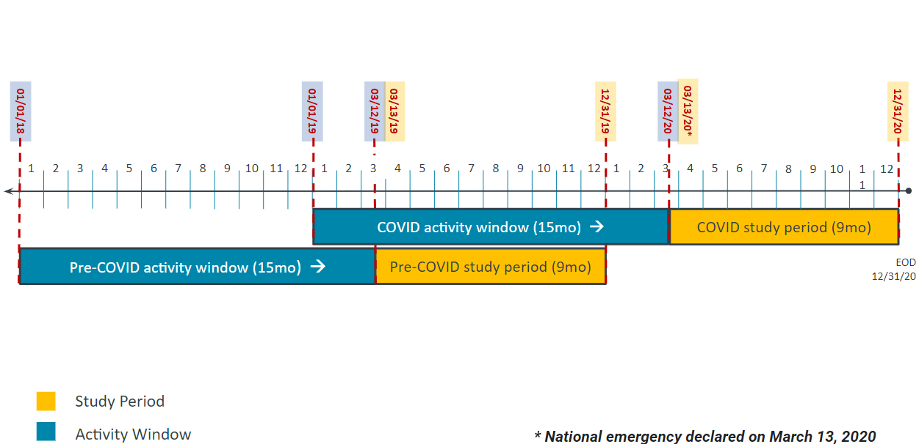

Table A1. Patient Analytic Sample Exclusions

 | Overall | Percent of Original Sample | Number of patients |  | % of Overall (row %)
 | Overall | Percent of Original Sample | Pre-  COVID-19 | COVID-19 | Pre-  COVID-19 | COVID-19
Number of adults with diabetes and/or hypertension | 2,858,026
Exclusion #1: Gestational or steroid-induced diabetes (type 1, type 2 or unknown, unknown) | 68,584 | 2.4% | 34,137 | 34,447 | 49.8% | 50.2%
Exclusion #2: Type 1 diabetes | 19,664 | 0.7% | 9,955 | 9,709 | 50.6% | 49.4%
Exclusion #3: Died during activity windows and study periods* | 28,701 | 1.0% | - | 28,701 | 0.0% | 100.0%
Exclusion #4: Polycystic ovary syndrome | 11,832 | 0.4% | 5,667 | 6,165 | 47.9% | 52.1%
Exclusion #5: End-stage renal disease | 36,636 | 1.3% | 18,246 | 18,390 | 49.8% | 50.2%
Exclusion #6: Hospice or palliative care | 14,791 | 0.5% | 6,459 | 8,332 | 43.7% | 56.3%
Exclusion #7: Patients with anemia | 13,732 | 0.5% | 6,617 | 7,115 | 48.2% | 51.8%
Exclusion #8: Patients who are pregnant | 15,043 | 0.5% | 7,435 | 7,608 | 49.4% | 50.6%
Exclusion #9: Patients without ambulatory care encounters during the activity windows. | 685,480 | 24.0% | 329,902 | 355,578 | 48.1% | 51.9%
Final Analytic Sample | 1,963,563 | 68.7% | 946,209 | 1,017,354 | 48.2% | 51.8%

Note: *We excluded 28,701 patients who died during the COVID-19 period activity window and study period. The initial dataset already excluded patients who died during the pre-COVID period activity window and study period.

Table A2. Characteristics of the Ten Health Systems

Health System | Practice Count | Physician full-time Equivalents | Physicians per practice | Clinician employment relationships represented in data
A | 638 | 2100 | 3.29 | system-employed
B | 50 | 100 | 2.00 | medical group
C | 14 | 76 | 5.43 | medical group
D | 77 | 156 | 2.03 | medical group
E | 226 | 1014 | 4.49 | system-employed
F | 43 | 550 | 12.79 | system-employed (academic)
G | 63 | 235 | 3.73 | medical group
H | 55 | 115 | 2.09 | medical group
I | 42 | 70 | 1.67 | medical group
J | 40 | 240 | 6.00 | medical group

Figure A2. Covariates Balance Using Stabilized Inverse Propensity Treatment Weighting Among Adults with Type 2 Diabetes 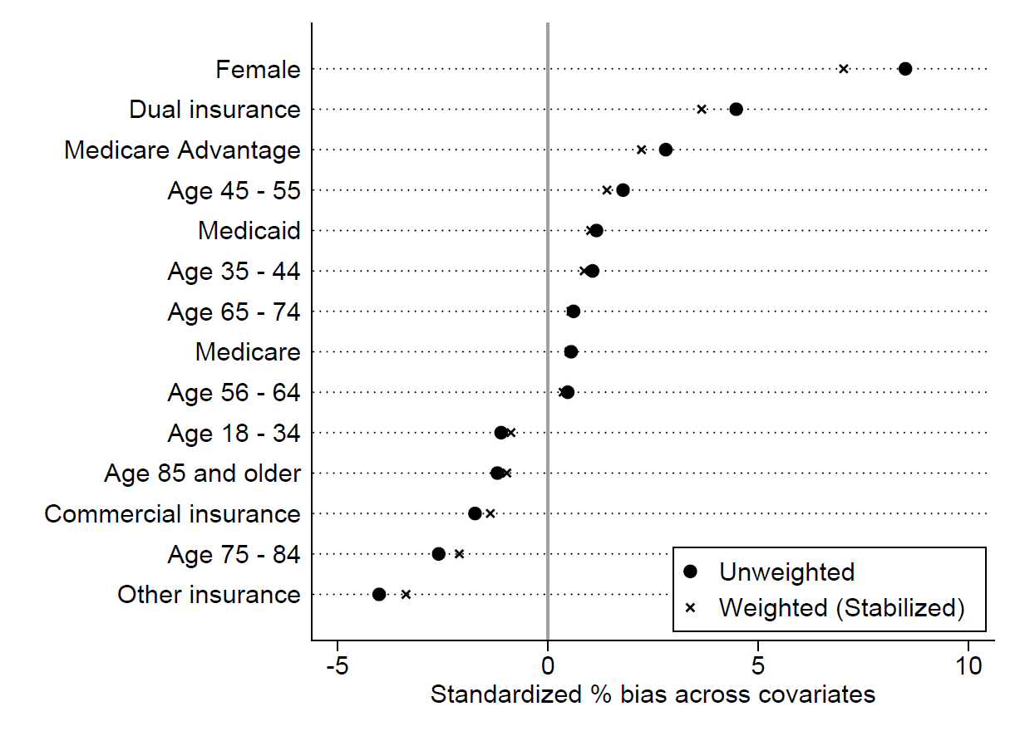

Figure A3. Covariates Balance Using Stabilized Inverse Propensity Treatment Weighting Among Adults with Hypertension Only
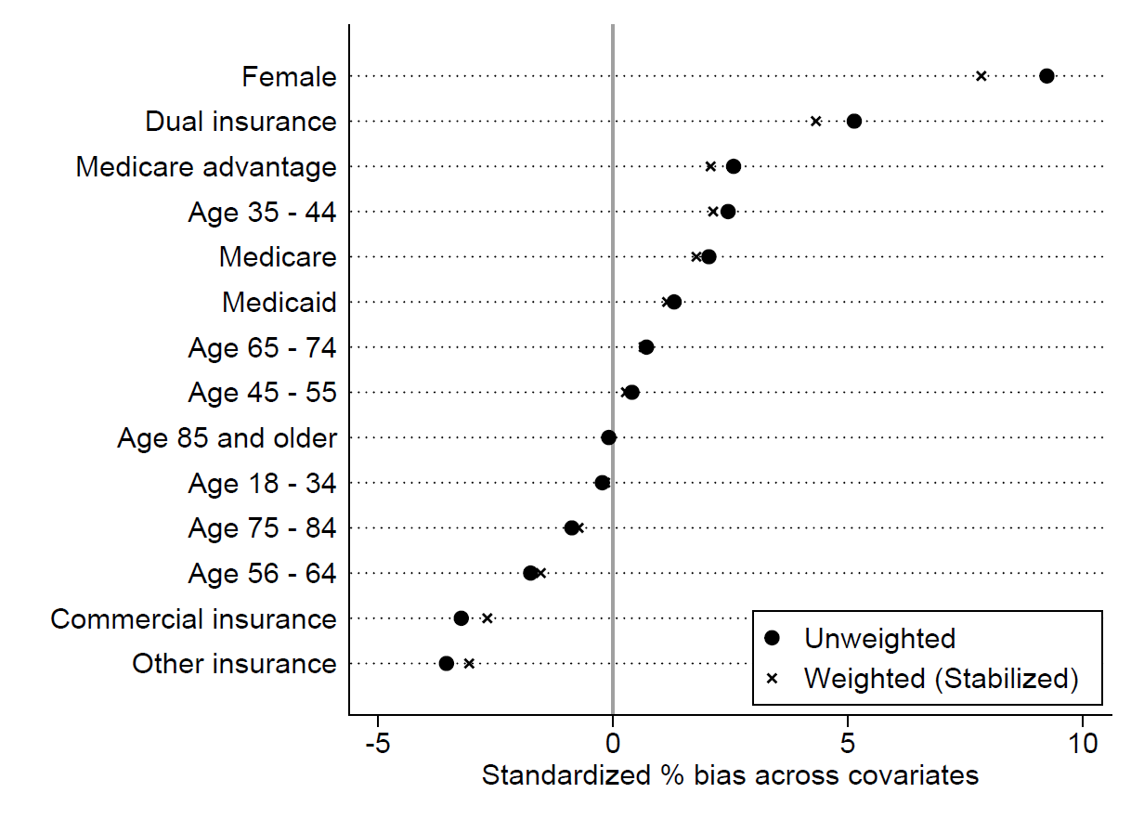

Figure A4. Covariates Balance Using Stabilized Inverse Propensity Treatment Weighting Among Adults with Diabetes (Full Set of Covariates)

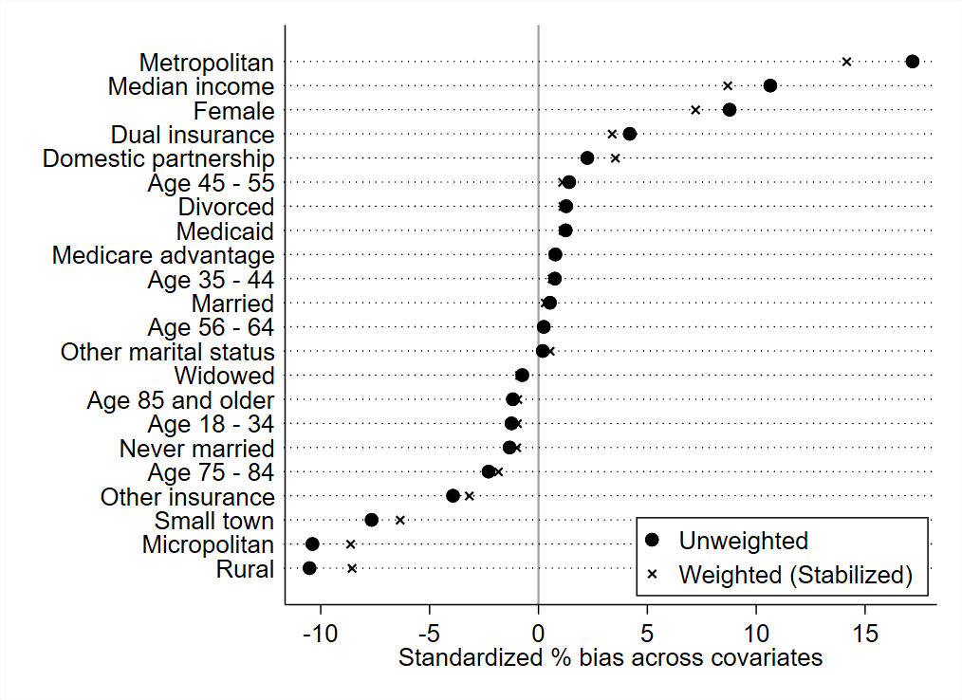

Figure A5. Covariates Balance Using Stabilized Inverse Propensity Treatment Weighting Among Adults with Hypertension Only (Full Set of Covariates)

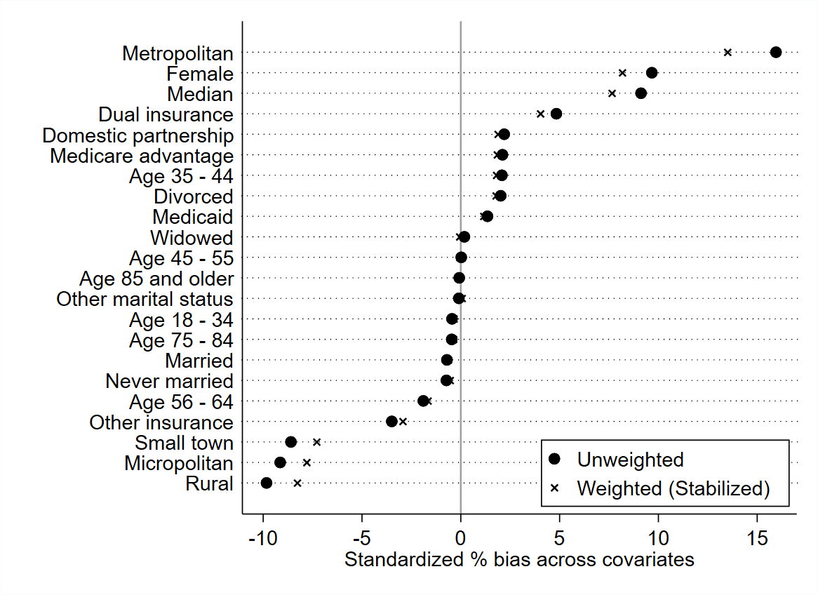

Table A3. Prescriptions Categories

Diabetes Treatment, Insulin Prescriptions | Diabetes Treatment, Non-Insulin Prescriptions | Hypertension Prescriptions
Basal Insulin | Alpha-glucosidase Inhibitors (AGI) | Alpha Blockers
Bolus Insulin | Biguanides (metformin) | Angiotensin-converting Enzyme (ACE) Inhibitors
Insulin Combo | Dipeptidyl Peptidase-4 (DPP4) Inhibitors | Angiotensin Receptor Blockers (ARB)
 | Glucagon-like Peptide 1 (GLP-1) Receptor Agonists | Anti-Adrenergic
 | Meglitinides | Beta Blockers
 | Sodium-Glucose Transporter- 2 (SGLT2) Inhibitors | Calcium Channel Blockers
 | Sulfonylureas | Dopamine Reuptake Inhibitor
 | Thiazolidinediones (TZDs) | Potassium Sparing Diuretics
 |  | Thiazide Diuretics
 |  | Vasodilators

Note: Diabetes treatment was categorized among adults with diagnosed type 2 diabetes as: (1) no diabetes prescriptions, (2) treated with non-insulin prescriptions only, and (2) treated with insulin prescription (with or without other non-insulin diabetes prescriptions). Hypertension treatment was categorized as: (1) no hypertension (only applicable to the diabetes sample), (2) treated with one or more hypertension prescriptions, and (3) not treated with any hypertension prescriptions.

Table A4. Sensitivity Analysis 1: Association Between Telemedicine Encounter Categories and Outcome Measures
 | Diabetes Subsample |  |  |  | Hypertension-only Subsample
 | HbA1c testing | HbA1c control¹ | Blood pressure testing | Blood pressure control² | Blood pressure testing | Blood pressure control²
Patient n | 512,344 | 391,269 | 642,224 | 506,254 | 1,321,339 | 1,012,980
Main Independent Variables
Post period | 0.92*** | 0.96*** | 0.61*** | 0.93*** | 0.60*** | 0.92***
Telemedicine Encounter
0 (reference) | - | - | - | - | - | -
1 | 0.68** | 0.94 | 0.39* | 1.12 | 0.09*** | 0.95
2 | 1.56 | 0.69 | 0.21* | 0.61* | 0.06*** | 1.09
Post period * 0 telemedicine encounters (reference) | - | - | - | - | - | -
Post period * 1 telemedicine encounter | 0.89 | 1.13 | 0.20*** | 0.90 | 0.74* | 1.08
Post period * 2 or more telemedicine encounters | 0.34* | 1.52 | 0.10** | 1.59* | 0.41** | 0.92
Control Variables
Total Encounters
0 | 0.01*** | 0.75*** | 0.00*** | 0.76*** | 0.00*** | 0.91***
1-2 | 0.27*** | 0.89*** | 0.04*** | 0.97** | 0.04*** | 1.03***
3+ (reference) | - | - | - | - | - | -
Age Categories
Age 18-34 | 0.43*** | 0.61*** | 0.66*** | 1.02 | 0.71*** | 0.91***
Age 35-44 | 0.55*** | 0.61*** | 0.63*** | 0.97 | 0.77*** | 0.89***
Age 45-55 | 0.68*** | 0.66*** | 0.73*** | 1.00 | 0.82*** | 0.95***
Age 56-64 | 0.85*** | 0.78*** | 0.81*** | 1.00 | 0.87*** | 1.00
Age 65-74 (reference) | - | - | - | - | - | -
Age 75-84 | 0.96** | 1.14*** | 1.02 | 0.98 | 1.04* | 0.94***
Age 85 and over | 0.91*** | 1.19*** | 0.98 | 0.94*** | 1.02 | 0.88***
Female | 0.93*** | 1.03** | 0.96* | 1.06*** | 1.11*** | 1.09***
Race/Ethnicity
White (reference) | - | - | - | - | - | -
Hispanic | 0.97 | 0.91*** | 1.00 | 0.99 | 0.94* | 0.94***
Black | 0.89*** | 1.02 | 0.99 | 0.82*** | 0.97 | 0.85***
Asian | 1.28*** | 1.06 | 1.06 | 1.03 | 1.00 | 1.01
Other race | 0.94*** | 0.95* | 0.94* | 0.92*** | 0.97 | 0.93***
Marital Status
Married (reference) | - | - | - | - | - | -
Divorced | 0.88*** | 0.97 | 0.89*** | 0.94*** | 0.85*** | 0.94***
Never married | 0.91*** | 0.94*** | 0.89*** | 0.97** | 0.87*** | 0.95***
Widowed | 0.95*** | 0.95** | 0.94* | 0.92*** | 0.90*** | 0.91***
Other marital status | 0.76*** | 0.95* | 0.70*** | 0.89*** | 0.70*** | 0.86***
Annual median household income (standardized) | 1.06*** | 1.07*** | 1.00 | 1.08*** | 1.02** | 1.07***
Urbanicity of Residence
Metropolitan (reference) | - | - | - | - | - | -
Micropolitan | 0.79*** | 0.97 | 1.12*** | 0.89*** | 1.04* | 0.90***
Small town | 0.82*** | 0.93*** | 0.94* | 0.90*** | 0.91*** | 0.92***
Rural | 0.76*** | 0.93** | 1.01 | 0.95*** | 0.98 | 0.93***
Insurance Class
Commercial insurance | 1.10*** | 1.07*** | 1.25*** | 1.03 | 1.12*** | 1.01
Medicare/Medicare Advantage (reference) | - | - | - | - | - | -
Medicaid | 0.74*** | 0.98 | 0.98 | 0.95* | 0.82*** | 0.88***
Dual Medicare/Medicaid | 1.22*** | 0.95 | 0.93 | 0.91** | 0.98 | 0.99
Other insurance | 0.94* | 0.99 | 1.09* | 0.94** | 0.99 | 0.92***
Comorbidities
Charlson comorbidity index | 0.95*** | 0.99* | 1.01* | 1.00 | 1.01** | 1.00
Atherosclerotic cardiovascular disease | 0.84*** | 0.98 | 1.29*** | 1.05*** | 1.40*** | 1.06***
Heart failure | 0.85*** | 0.99 | 1.16*** | 1.07*** | 1.20*** | 1.08***
Chronic kidney disease | 1.31*** | 0.95*** | 1.23*** | 0.98* | 1.22*** | 1.06***
Mental health illness | 0.94*** | 0.99 | 1.08*** | 1.05*** | 1.03** | 1.04***
Obesity | 1.14*** | 0.93*** | 1.19*** | 0.97*** | 1.12*** | 0.99*
Opioid use disorder | 0.86*** | 1.02 | 0.88* | 0.92*** | 0.95 | 0.90***
Diabetes Treatment
No diabetes prescriptions | 0.47*** | 1.50*** | 0.83*** | 0.87*** | N/A | N/A
Diabetes treated, non-insulin only (reference) | - | - | - | - | N/A | N/A
Diabetes treated, insulin +/- other Rx | 0.72*** | 0.57*** | 0.84*** | 0.89*** | N/A | N/A
Hypertension Treatment
No hypertension | 1.04* | 1.18*** | 1.31*** | 1.30*** | N/A | N/A
Hypertension-treated | 1.21*** | 1.15*** | 1.79*** | 0.92*** | 1.81*** | 1.02***
No hypertension prescriptions (reference) | - | - | - | - | - | -
A1c value, last value in pre-pandemic period | 1.05*** | 0.41*** | N/A | N/A | N/A | N/A
Systolic BP, last value in pre-pandemic | N/A | N/A | 1.00*** | 0.96*** | 1.00*** | 0.96***
Constant | 14.85*** | 3,833.36*** | 2,123.23*** | 603.73*** | 1,095.12*** | 367.58***
Note: ***, **, and * indicate p<0.001, p<0.01, and p<0.05, respectively. Coefficients are reported in odds ratios.

¹HbA1c is considered under control if the patient’s HbA1c test result is less than 8.0%.

²Blood pressure is considered under control if the patient’s last recorded systolic and diastolic blood pressure values are below 140 mmHg and 90 mmHg, respectively.

Table A5. Sensitivity Analysis 2: Association Between Telemedicine Video Exposure and Outcome Measures using Generalized Linear Models with Stabilized Inverse Propensity Treatment Weighting

 | Diabetes Subsample |  |  |  | Hypertension only Subsample
 | HbA1c testing | HbA1c control¹ | Blood pressure testing | Blood pressure control² | Blood pressure testing | Blood pressure control²
Patient n | 512,344 | 391,269 | 642,224 | 506,254 | 1,321,339 | 1,012,980
Main Independent Variables
Post period | 0.84*** | 0.96*** | 0.41*** | 0.92*** | 0.42*** | 0.92***
Telemedicine video encounter | 0.80 | 0.97 | 0.64 | 0.87 | 0.19*** | 0.83
Post period * telemedicine video encounter | 0.80 | 1.11 | 0.16** | 1.16 | 0.48** | 1.24*
Control Variables
Total Encounters
0 | 0.01*** | 0.75*** | 0.00*** | 0.76*** | 0.00*** | 0.91***
1-2 | 0.28*** | 0.89*** | 0.07*** | 0.98** | 0.08*** | 1.03***
3+ (reference) | - | - | - | - | - | -
Age Categories
Age 18-34 | 0.43*** | 0.61*** | 0.68*** | 1.02 | 0.73*** | 0.91***
Age 35-44 | 0.55*** | 0.61*** | 0.64*** | 0.97 | 0.79*** | 0.88***
Age 45-55 | 0.68*** | 0.66*** | 0.75*** | 1.00 | 0.84*** | 0.95***
Age 56-64 | 0.85*** | 0.78*** | 0.82*** | 1.00 | 0.88*** | 1.00
Age 65-74 (reference) | - | - | - | - | - | -
Age 75-84 | 0.96** | 1.14*** | 0.98 | 0.98 | 0.98 | 0.94***
Age 85 and over | 0.90*** | 1.20*** | 0.91* | 0.94*** | 0.91** | 0.88***
Female | 0.93*** | 1.03** | 0.96* | 1.06*** | 1.11*** | 1.09***
Race/Ethnicity
White (reference) | - | - | - | - | - | -
Hispanic | 0.96* | 0.91*** | 0.98 | 0.99 | 0.94* | 0.94***
Black | 0.89*** | 1.02 | 0.95 | 0.82*** | 0.95** | 0.85***
Asian | 1.28*** | 1.06 | 1.10* | 1.03 | 1.05 | 1.01
Other race | 0.94*** | 0.95* | 0.94* | 0.92*** | 0.96 | 0.93***
Marital Status
Married (reference) | - | - | - | - | - | -
Divorced | 0.88*** | 0.97 | 0.88*** | 0.94*** | 0.84*** | 0.94***
Never married | 0.91*** | 0.94*** | 0.88*** | 0.97** | 0.86*** | 0.95***
Widowed | 0.94*** | 0.95** | 0.92** | 0.92*** | 0.90*** | 0.91***
Other marital status | 0.76*** | 0.95* | 0.69*** | 0.89*** | 0.68*** | 0.86***
Annual median household income (standardized) | 1.06*** | 1.07*** | 1.01 | 1.08*** | 1.03*** | 1..07***
Urbanicity of Residence
Metropolitan (reference) | - | - | - | - | - | -
Micropolitan | 0.80*** | 0.97 | 1.15*** | 0.89*** | 1.07*** | 0.90***
Small town | 0.83*** | 0.93*** | 0.97 | 0.91*** | 0.95** | 0.92***
Rural | 0.77*** | 0.93** | 1.03 | 0.95*** | 1.01 | 0.93***
Insurance Class
Commercial insurance | 1.10*** | 1.07*** | 1.31*** | 1.03 | 1.17*** | 1.01
Medicare/Medicare Advantage (reference) | - | - | - | - | - | -
Medicaid | 0.74*** | 0.98 | 1.01 | 0.95** | 0.85*** | 0.88***
Dual Medicare/Medicaid | 1.24*** | 0.95 | 0.98 | 0.91** | 1.07 | 0.99
Other insurance | 0.93** | 0.99 | 1.04 | 0.94** | 0.96 | 0.92***
Comorbidities
Charlson comorbidity index | 0.95*** | 0.99* | 1.00 | 1.00 | 1.00 | 1.00
Atherosclerotic cardiovascular disease | 0.84*** | 0.98 | 1.26*** | 1.05*** | 1.35*** | 1.05***
Heart failure | 0.85*** | 0.99 | 1.13*** | 1.07*** | 1.15*** | 1.08***
Chronic kidney disease | 1.30*** | 0.95*** | 1.19*** | 0.98* | 1.20*** | 1.06***
Mental health illness | 0.93*** | 0.99 | 1.04* | 1.05*** | 0.99 | 1.04***
Obesity | 1.14*** | 0.93*** | 1.17*** | 0.97*** | 1.12*** | 0.99*
Opioid use disorder | 0.85*** | 1.02 | 0.82*** | 0.92*** | 0.90** | 0.90***
Diabetes Treatment
No diabetes prescriptions | 0.478*** | 1.50*** | 0.84*** | 0.87*** | N/A | N/A
Diabetes treated, non-insulin only (reference) | - | - | - | - | N/A | N/A
Diabetes treated, insulin +/- other Rx | 0.72*** | 0.57*** | 0.81*** | 0.89*** | N/A | N/A
Hypertension Treatment
No hypertension | 1.04* | 1.18*** | 1.33*** | 1.30*** | N/A | N/A
Hypertension-treated | 1.21*** | 1.15*** | 1.76*** | 0.92*** | 1.74*** | 1.02***
No hypertension prescriptions (reference) | - | - | - | - | - | -
A1c, last value in pre-pandemic period | 1.05*** | 0.41*** | N/A | N/A | N/A | N/A
Systolic BP, last value in pre-pandemic period | N/A | N/A | 1.00*** | 0.96*** | 1.00*** | 0.96***
Constant | 14.72*** | 3,840.20*** | 1,015.85*** | 603.84*** | 587.68*** | 367.24***
Note: ***, **, and * indicate p<0.001, p<0.01, and p<0.05, respectively. Coefficients are reported in odds ratios.¹HbA1c is considered under control if the patient’s HbA1c test result is less than 8.0%. ²Blood pressure is considered under control if the patient’s last recorded systolic and diastolic blood pressure values are below 140 mmHg and 90 mmHg, respectively.
Table A6. Sensitivity Analysis 3: Telemedicine Effects on Outcome Measures, estimated using Differences-in-Differences Regression (XTLOGIT)

 | Diabetes Subsample |  |  |  | Hypertension only Subsample
 | HbA1c testing | HbA1c control¹ | Blood pressure testing | Blood pressure control² | Blood pressure testing | Blood pressure control²
Patient n | 82,786 | 49,290 | 89,866 | 107,082 | 209,528 | 224,206
Main Independent Variables
Post period | 0.42*** | 0.81*** | 0.20*** | 0.89*** | 0.24*** | 0.91***
Telemedicine encounter | 0.81 | 1.03 | 0.21* | 1.01 | 0.06*** | 0.81
Post period * telemedicine encounter | 0.77 | 1.11 | 0.26 | 1.01 | 1.04 | 1.26*
Control Variables
Total Encounters
0 | 0.01*** | 0.90 | 0.00*** | 1.02 | 0.00*** | 1.05
1-2 | 0.32*** | 0.96 | 0.13*** | 1.06*** | 0.10*** | 1.14***
3+ (reference) | - | - | - | - | -
A1c, last value in pre-pandemic period | 1.22*** | 1.28*** | N/A | N/A | N/A | N/A
Systolic BP, last value in pre-pandemic period | N/A | N/A | 1.00 | 1.02*** | 1.00* | 1.02***

Note: Sample sizes decline compared to the main results due to perfect predictions for binary differences-in-differences regression models (XTLOGIT). As a result, the blood pressure control models have more observations than the blood pressure testing models.

***, **, and * indicate p<0.001, p<0.01, and p<0.05, respectively. Patient fixed effects are included. Coefficients are reported in odds ratios.¹HbA1c is considered under control if the patient’s HbA1c test result is less than 8.0%. ²Blood pressure is considered under control if the patient’s last recorded systolic and diastolic blood pressure values are below 140 mmHg and 90 mmHg, respectively.

