Novel Iboga-derivatives Modulate Nociception and Inflammation in Acute Mouse Pain Model

Tuhin Bhattacharya¹, Abhishek Gupta², Shalini Gupta², Samrat Saha¹, Shatabdi Ghosh¹, Zofa Shireen¹, Surajit Sinha^{2*} and Sanjit Dey^{1,3,4*}

¹Department of Physiology, ³Centre for Nanoscience and Nanotechnology (CRNN) and ⁴Centre with Potential for Excellence in Particular Area (CPEPA), University of Calcutta, 92 APC Road, Kolkata 70009, West Bengal, India

²School of Applied and Interdisciplinary Sciences, Indian Association for the Cultivation of Sciences, Kolkata 700032, West Bengal, India

Corresponding author: Prof. Sanjit Dey, Dept. of Physiology, University of Calcutta, 92 APC Road, Kolkata 700009, India. Contact No. 9830211512

Corresponding email: sdeyphys@caluniv.ac.in

Supplementary Fig1: Chemical structure of various iboga-analogs
Supplementary Scheme 1: Synthesis of dehydroisoquinuclidine and its iboga-analogs

((1R,4R,7R)-2-(benzofuran-2-ylmethyl)-2-azabicyclo[2.2.2]oct-5-en-7-yl)methanol (1): To a stirred solution of compound 2 (50mg, 0.186 mmol) in 5 ml dry THF at 0°C was added LiAlH₄ (8.5 mg, 0.223 mmol). The reaction mixture was stirred for 10 min and TLC was checked. When the starting material was consumed, the THF was evaporated to dryness and immediately acidified with 0.1(N) HCl. The aqueous layer was extracted with EtOAc, dried with anhydrous Na₂SO₄ and evaporated under reduced pressure to yield the crude compound1 as pale-yellow oil. The crude product was purified by flash column chromatography (60-120 mesh) eluting with 45% EA-hexane solvent to afford the pure product 2 in good yield (35 mg, 77%). Rf (1:1 EA-PE): 0.5
¹H NMR (300 MHz, CDCl₃): δ 7.62 – 7.40 (m, 2H), 7.33 – 7.15 (m, 2H), 6.86 (s, 1H), 6.51 (ddd, J = 8.0, 6.5, 1.3 Hz, 1H), 6.22 (ddd, J = 8.2, 5.4, 1.3 Hz, 1H), 4.75 (s, 1H), 4.11 – 3.92 (m, 2H), 3.83 (d, J = 14.1 Hz, 1H), 3.35 – 3.21 (m, 2H), 3.07 (dd, J = 11.0, 9.8 Hz, 1H), 2.79 – 2.53 (m, 2H), 2.32 (dt, J = 10.7, 2.7 Hz, 1H), 1.76 (ddd, J = 12.4, 9.3, 2.8 Hz, 1H), 0.64 (ddd, J = 12.6, 5.2, 2.7 Hz, 1H).¹³C NMR (75 MHz, CDCl₃): δ 155.12, 151.89, 135.92, 128.23, 127.94, 124.59, 122.98, 121.30, 111.37, 107.91, 77.37, 65.12, 54.47, 53.43, 53.02, 39.79, 30.36, 25.51.
IR (CHCl₃, cm⁻¹): 3344, 2934, 2863, 1453, 1254, 1053, 751, 706.
HRMS (ESI, Positive ion mode) for C₁₇H₁₉NO₂: [M+H⁺]: Calculated: 270.1489. Found: 270.1488.

(1R,4R,7R)-benzyl 7-(methylcarbamoyl)-2-azabicyclo [2.2.2] oct-5-ene-2-carboxylate (7):To a stirred solution of compound 3 (0.45mmol, 1 equiv.) was added ethyl chloroformate (0.52mmol, 1.4equiv.) and triethylamine (2.29mmol, 5equiv.) in dry THF at 0ºC. The reaction was stirred for one hour and the formation of mixed anhydride was monitored through TLC. Then methyl amine (1M in THF, 0.68mmol, 1.5equiv.) was added dropwise at 0ºC and the reaction was stirred for 4 hours. TLC was checked. Then THF was removed in vacuo and the crude was dissolved in ethyl acetate. It was then washed with saturated NaHCO₃ solution thrice and finally with brine. The organic layer was dried over Na₂SO₄ and concentrated. It was then purified by column chromatography (60-120 silica, eluted with 1% MeOH-DCM) to give a white solid (112 mg) in 81% yield. R_{f} (1:19 MeOH-DCM): 0.5

¹H NMR (300 MHz, CDCl₃): δ 7.41 – 7.21 (m, 5H), 6.46 (ddt, J = 10.0, 4.8, 2.3 Hz, 1H), 6.34 (dddd, J = 14.1, 7.8, 5.9, 1.6 Hz, 1H), 6.02 (d, J = 5.0 Hz, 1H), 5.21 – 5.08 (m, 2H), 4.94 (ddd, J = 6.1, 3.2, 1.4 Hz, 1H), 3.27 (td, J = 9.7, 2.1 Hz, 1H), 3.03 – 2.80 (m, 3H), 2.73 (t, J = 5.2 Hz, 3H), 2.38 (s, 1H), 1.90 (ddq, J = 12.6, 4.8, 2.4, 1.9 Hz, 1H), 1.73 (ddd, J = 12.7, 9.5, 2.7 Hz, 1H).
¹³C NMR (75 MHz, CDCl₃): δ 173.07, 172.49, 155.37, 154.77, 136.77, 135.26, 134.84, 130.60, 129.79, 128.60, 128.56, 128.13, 128.06, 127.79, 67.07, 66.99, 48.10, 47.84, 47.14, 46.94, 45.44, 44.79, 30.81, 30.66, 27.61, 26.50, 26.43, 25.93.
IR(CHCl₃, cm⁻¹): 3317, 2931, 1658, 1542, 1412, 1282, 1110, 751, 697.
HRMS (ESI, Positive ion mode) for C₁₇H₂₀N₂O₃: [M+H⁺]: Calculated: 301.1547. Found: 301.1545.

(1R,4R,7R)-2-(benzofuran-2-ylmethyl)-N-methyl-2-azabicyclo[2.2.2]oct-5-ene-7-carboxamide (2):The Cbz deprotection of compound 4 (0.37mmol, 1equiv.) was carried out following the usual method. The crude HBr salt obtained was washed with hexane till devoid of benzyl bromide and then dried. Then benzofuran chloride (0.41mmol, 1.1 equiv.) and freshly fused K₂CO₃ (0.93mmol, 2.5 equiv.) were added to the HBr salt in dry DMF (5ml). The reaction was stirred at room temperature for 12 h. TLC was checked and the reaction mixture was diluted with EtOAc. The organic layer was washed with water multiple times to remove the DMF. It was finally washed with brine and dried over anhydrous Na₂SO₄. It was then concentrated and purified by column chromatography (60-120 silica, eluting with 2% MeOH-DCM) to give the product was a white fluffy solid (75mg, 68%). R_{f} (1:1 EtOAc-hexane): 0.3

¹H NMR (300 MHz, CDCl₃): δ 7.57 – 7.39 (m, 2H), 7.29 – 7.13 (m, 2H), 6.63 – 6.46 (m, 2H), 6.25 (ddd, J = 8.1, 5.3, 1.3 Hz, 1H), 5.46 (s, 1H), 3.83 – 3.66 (m, 2H), 3.55 (dd, J = 14.1, 0.8 Hz, 1H), 3.12 – 2.97 (m, 2H), 2.72 (d, J = 4.8 Hz, 3H), 2.70 – 2.60 (m, 1H), 2.09 (dt, J = 10.0, 2.7 Hz, 1H), 1.82 (ddd, J = 12.5, 9.8, 2.7 Hz, 1H), 1.65 – 1.53 (m, 1H).
¹³C NMR (75 MHz, CDCl₃): δ 174.19, 155.54, 155.16, 134.69, 129.48, 128.44, 123.98, 122.74, 120.80, 111.34, 105.24, 54.47, 54.15, 53.68, 45.59, 31.05, 27.42, 26.45.
IR(CHCl₃, cm⁻¹): 3318, 2938, 1647, 1541, 1454, 1256, 751, 701.
HRMS (ESI, Positive ion mode) for C₁₈H₂₀N₂O₂: [M+H⁺]: Calculated: 297.1598. Found: 297.1597.

(1R,4R,7R)-benzyl 7-carbamoyl-2-azabicyclo[2.2.2]oct-5-ene-2-carboxylate (8):To a stirred solution of compound 3 (0.65mmol, 1 equiv.) was added ethyl chloroformate (0.91mmol, 1.4equiv.) and triethylamine (3.26mmol, 5equiv.) in dry THF at 0ºC. The reaction was stirred for one hour and the formation of mixed anhydride was monitored through TLC. Then ammonium chloride(0.97mol, 1.5equiv.) was added at 0ºC and the reaction was stirred for 4 hours. TLC was checked. Then THF was removed in vacuo and the crude was dissolved in ethyl acetate. It was then washed with saturated NaHCO₃ solution thrice and finally with brine. The organic layer was dried over Na₂SO₄ and concentrated. It was then purified by column chromatography (60-120 silica, eluted with 4% MeOH-DCM) to give a white solid (130 mg) in 70% yield. R_{f} (1:9 MeOH-DCM): 0.6

¹H NMR (300 MHz, CDCl₃): δ 7.36 (d, J = 6.8 Hz, 5H), 6.49 (q, J = 7.8 Hz, 1H), 6.40 – 6.25 (m, 1H), 5.13 (s, 2H), 4.92 (dd, J = 6.2, 3.3 Hz, 1H), 3.54 (s, 2H), 3.29 (ddd, J = 15.4, 10.3, 2.3 Hz, 1H), 2.99 (dt, J = 8.2, 3.2 Hz, 2H), 2.85 (dt, J = 9.7, 3.4 Hz, 1H), 2.05 – 1.86 (m, 1H), 1.70 (ddd, J = 12.6, 9.2, 2.6 Hz, 1H).
¹³C NMR (75 MHz, CDCl₃): δ 174.64, 155.72, 136.36, 135.80, 134.95, 130.16, 128.85, 128.53, 128.46, 128.14, 128.05, 127.96, 127.69, 77.36, 67.17, 49.60, 49.32, 49.03, 48.75, 48.46, 48.24, 47.63, 46.95, 44.66, 43.84, 30.56, 30.45, 27.04, 24.73.
IR(CHCl₃, cm⁻¹): 3344, 3198, 2935, 1682, 1420, 1339, 1117, 697.
HRMS (ESI, Positive ion mode) for C₁₆H₁₈N₂O₃: [M+Na⁺]: Calculated: 309.1210. Found: 309.1217.

(1R,4R,7R)-2-(benzofuran-2-ylmethyl)-2-azabicyclo[2.2.2]oct-5-ene-7-carboxamide (3): Synthesized in the same manner as the methyl amide derivative i.e. compound C3 was synthesized. Purified by column chromatography (60-120 silica, eluting with 2.5% MeOH-DCM) to give the product was a white fluffy solid (76mg, 59%). R_{f} (1:19 MeOH-DCM): 0.4

¹H NMR (300 MHz, CDCl₃): δ 7.54 – 7.40 (m, 1H), 7.33 – 7.15 (m, 1H), 6.62 – 6.45 (m, 1H), 6.26 (ddd, J = 8.2, 5.3, 1.3 Hz, 1H), 5.60 (d, J = 44.6 Hz, 1H), 3.85 – 3.72 (m, 1H), 3.56 (d, J = 14.1 Hz, 1H), 3.15 – 2.99 (m, 1H), 2.10 (dt, J = 10.0, 2.7 Hz, 1H), 1.83 (ddd, J = 12.5, 9.7, 2.8 Hz, 1H), 1.66 – 1.54 (m, 1H).
¹³C NMR (75 MHz, CDCl₃): δ 176.01, 155.42, 155.19, 134.97, 129.29, 128.42, 124.06, 122.79, 120.85, 111.34, 105.32, 54.60, 54.19, 53.60, 45.16, 31.01, 27.15.
IR(CHCl₃, cm⁻¹): 3341, 3210, 1671, 1602, 1378, 1254, 753.
HRMS (ESI, Positive ion mode) for C₁₇H₁₈N₂O₂: [M+H⁺]: Calculated: 283.1441. Found: 283.1446.

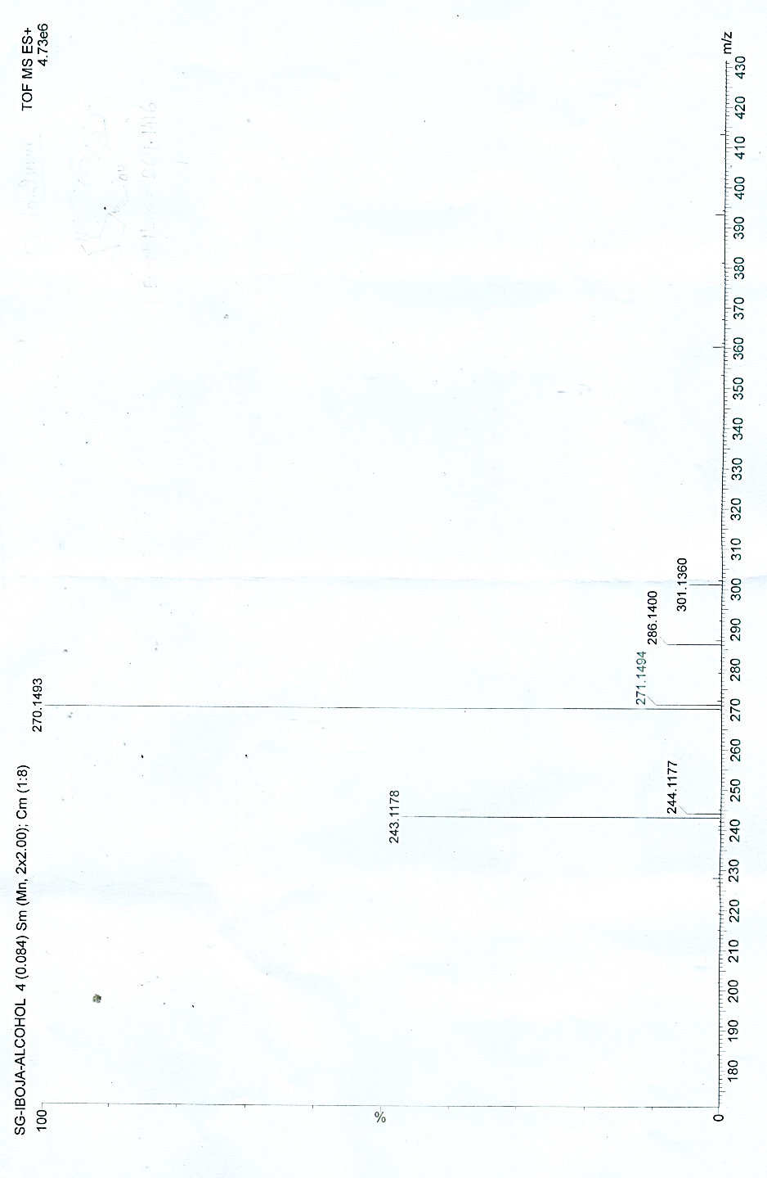
Mice Brain Extract
Exact Mass = 269.1416
[M+H⁺]
[Grab your reader’s attention with a great quote from the document or use this space to emphasize a key point. To place this text box anywhere on the page, just drag it.]
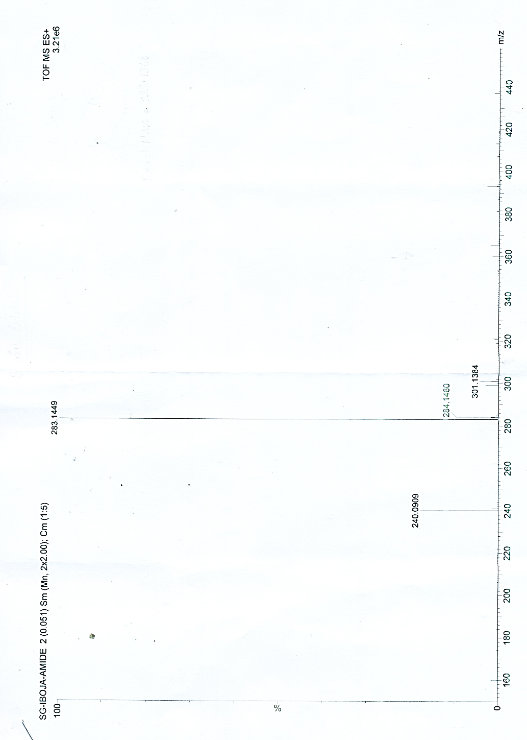
Mice Brain Extract
Exact Mass = 282.1368
[M+H⁺]
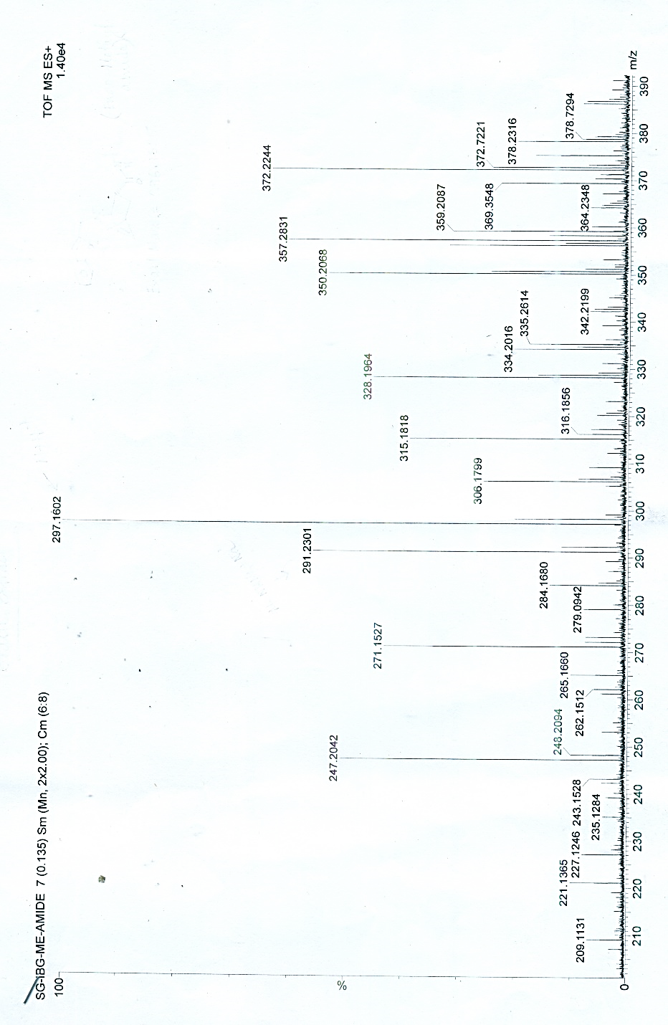
Mice Brain Extract
[M+H⁺]
Exact Mass = 296.1525

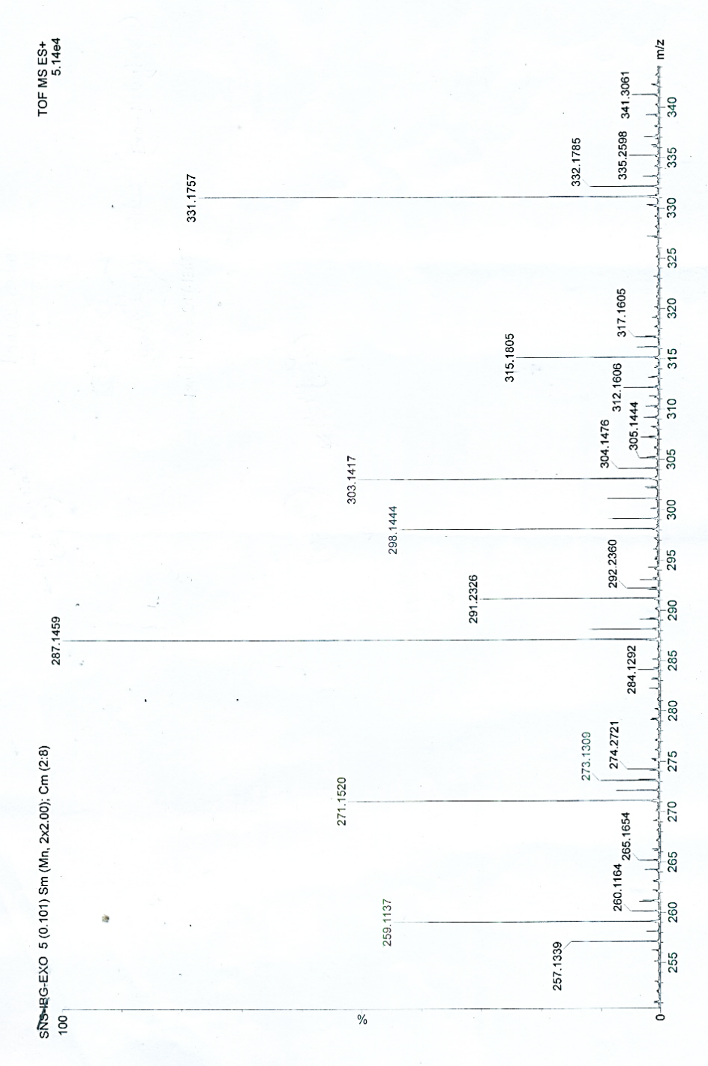
Mice Brain Extract
[M+H⁺]
Exact Mass = 297.1365
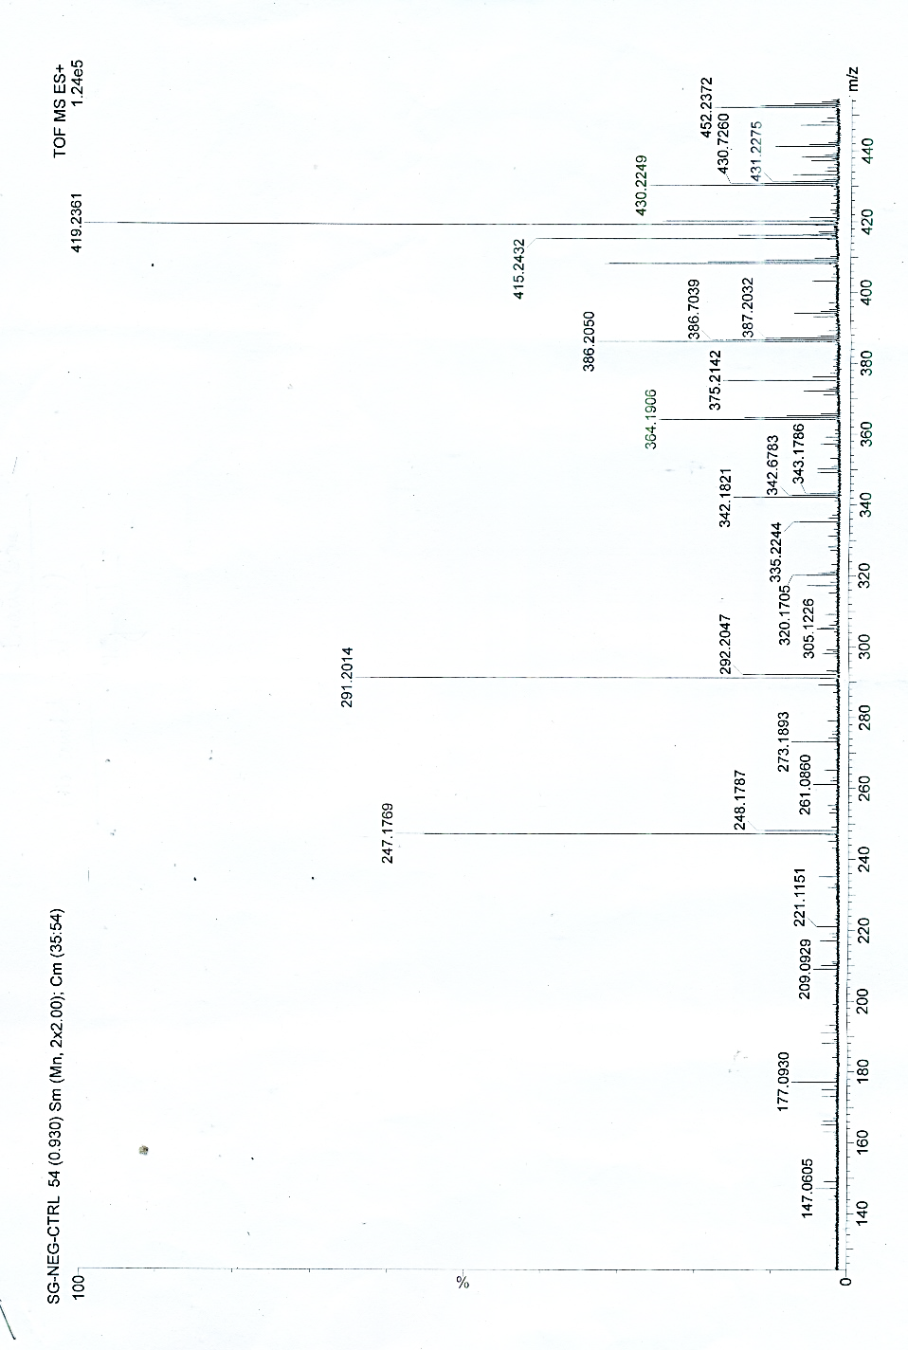
Negative Control / No compound treatment
Supplementary Fig 2: HRMS analysis of the iboga-analogs after extraction from Mice Brain.
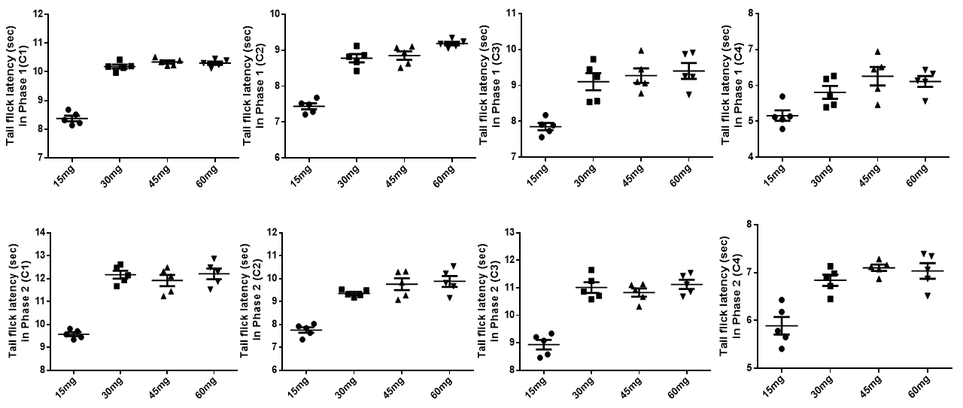
Supplementary Fig 3: Analgesic efficacies of iboga-analogs iboga-alcohol (C1), iboga-amide (C2), iboga-methyl amide (C3) and exo-iboga ester (C4) were evaluated at four different doses like 15, 30, 45 and 60 mg/kg body weight. Tail flick latency was measured at both the phases after formalin induction. Increased doses of analogues improved the tail flick latency. 30 mg/kg BW dose proved to be the best effective dose within the range of human dose equivalence. (All data are represented as Mean±SEM, n=5).
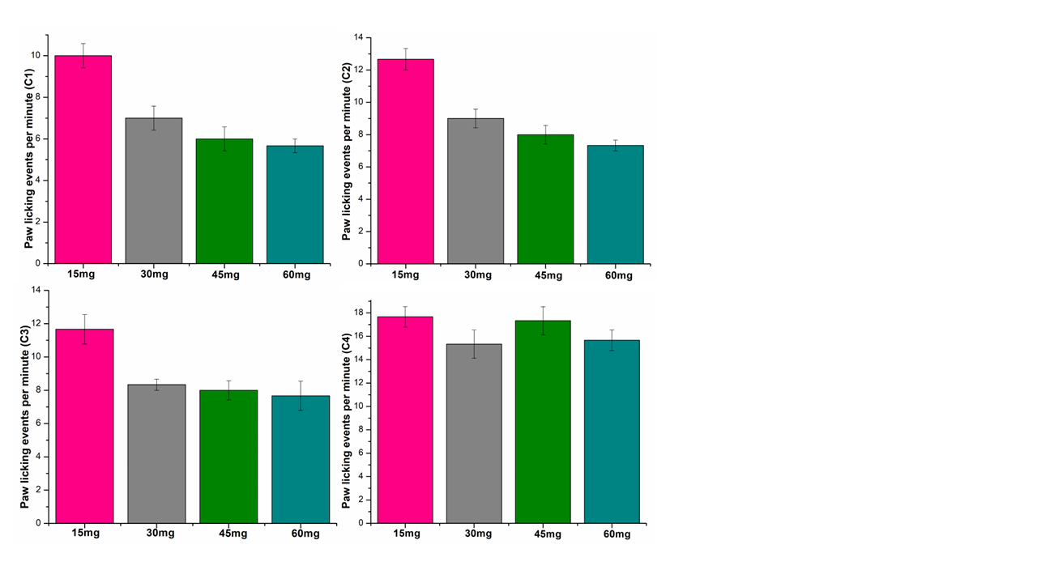
Supplementary Fig 4: Effect of graded doses of iboga-analogs on pain related behaviors. Inhibition of formalin-induced immediate nociceptive behaviour by paw licking event showed a gradual decrease in pain like behaviour with increasing dose of iboga-analogs (All data are represented as Mean±SEM, n=5).
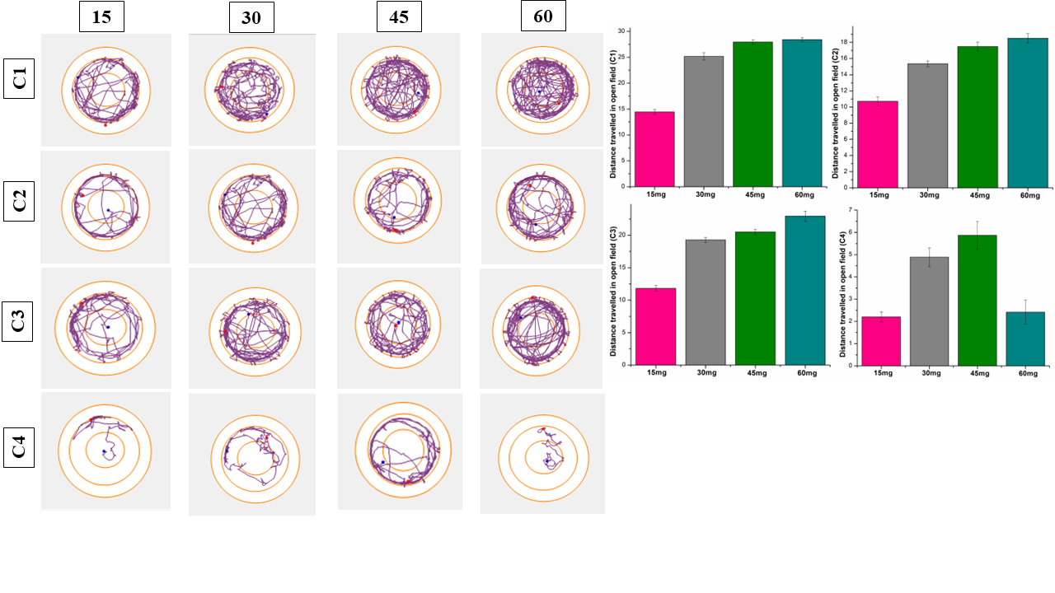
Supplementary Fig 5: Inhibition of pain related locomotor activity 24 hours after administration of novel iboga analogues at an increasing dose successfully mitigated the restricted locomotion. 30 mg/kg BW dose proved to be the optimal dose to alleviate the formalin induced locomotor activity. (All data are represented as Mean±SEM, n=5).
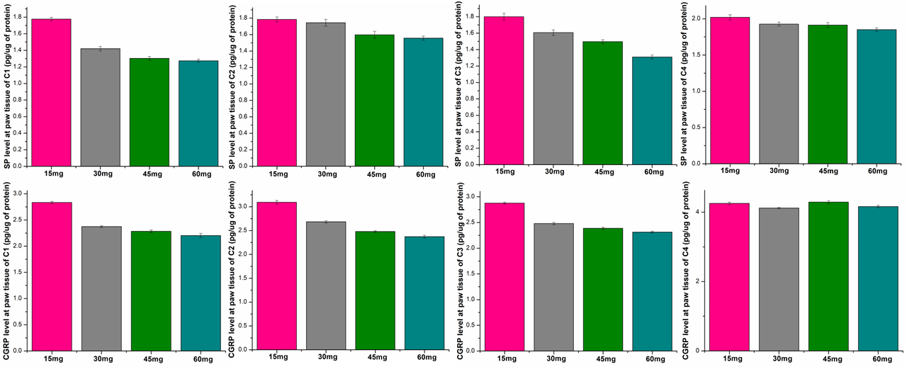
Supplementary Fig 6: Effect of graded doses of iboga-analogs on key acute pain markers. Early onset key markers of acute pain, Substance P (SP) and CGRP were effectively downregulated by increasing doses of iboga-analogs 24 hours after formalin administration. 30 mg/kg BW dose proved to be the optimal dose to ameliorate the inflammatory markers of pain. (All data are represented as Mean±SEM, n=5).
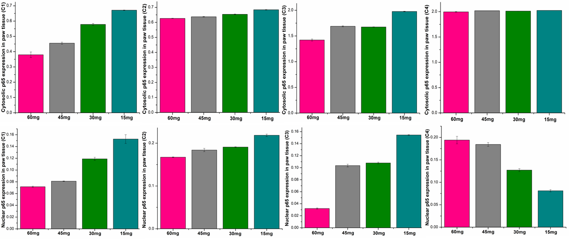

Supplementary Fig 7: Dose dependent inhibition of p65 nuclear translocation confirmed the efficacy of novel iboga-analogs to stop the onset of neurogenic inflammation 24 hours after formalin administration. 30 mg/kg BW dose proved to be the optimal dose to inhibit inflammation as human equivalent. (All data are represented as Mean±SEM, n=5).
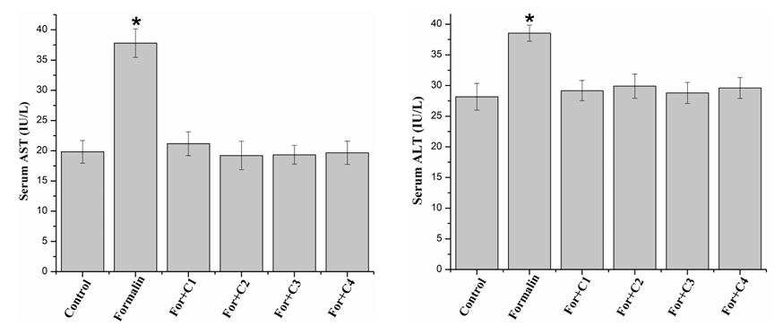
Supplementary Fig 8: Evaluation of hepatotoxicity by serum AST and ALT after administration of novel iboga-analogs at optimized dose. These shows no significant elevation after formalin infusion in comparison to control proves least toxic effects of iboga-alcohol (C1), iboga-amide (C2), iboga-methyl amide (C3) and exo-iboga ester (C4) in liver at a dose of 30 mg/kg body weight. (n=5, p<0.05, * indicates significant difference).

Supplementary Fig 9: Whole blot images of all the represented western blots. Samples from left to right direction are arranged as follows: Con, For, F+C1, F+C2, F+C3 and F+C4.

