Synthesis, molecular docking studies and cytotoxicity evaluation of new tetrazolic substituted para toluene sulfonamid on HT29 cancerous cell line
Zahra Sadeghiª, Hoda Abolhasani^{*b,c}, Zohreh Mirjafary^{*a}, Gholamreza Najafi^{d}, Fatameh Heidari^{b,e},
ªDepartment of Chemistry, Science and Research Branch, Islamic Azad University, Tehran, Iran
^{b}Cellular and molecular earch center, Qom University of Medical Sciences, Qom, Iran
^{c} Department of physiology & Pharmacology, Faculty of Medicine, Qom University of Medical Sciences, Qom, Iran
^{d}Department of Chemistry, Qom Branch, Islamic Azad University, Qom, Iran
^{e}Department of Anatomy, Faculty of Medicine, Qom University of Medical Sciences, Qom, Iran
Supporting Information

Contents

S. N Contents Page Number
1 ¹H and ¹³C spectra of aryl tetrazloes S2 – S11
2 ¹H and ¹³C spectra of aryl Sulfonamid and nitrile (3a, 4a)[10] S12_S14

S1

Fig. S1 ¹H NMR spectrum of (5a)

S2
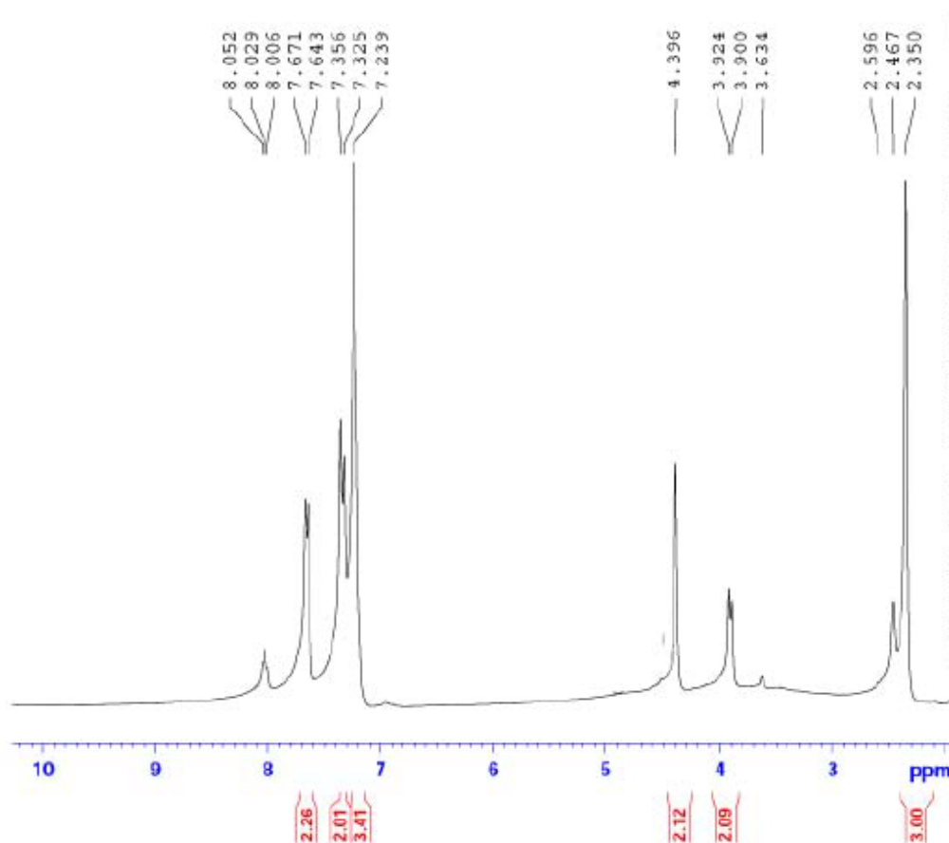
Fig. S1expand ¹H NMR spectrum of (5a)

S3
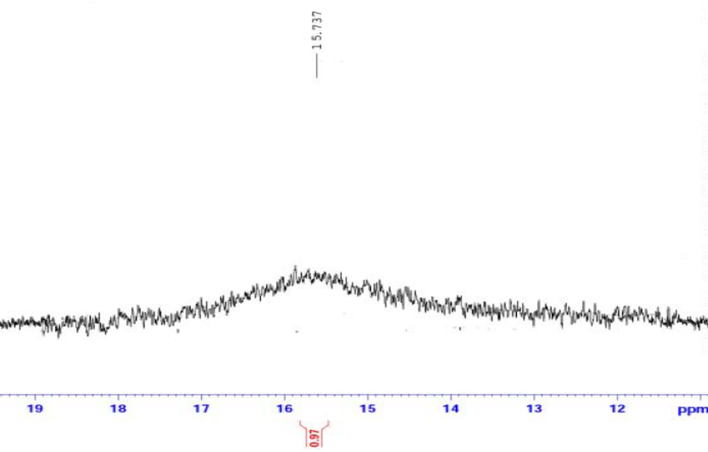

Fig. S1expand ¹H NMR spectrum of (5a)

S4
Fig. S2 ¹³C NMR spectrum of (5a)

S5
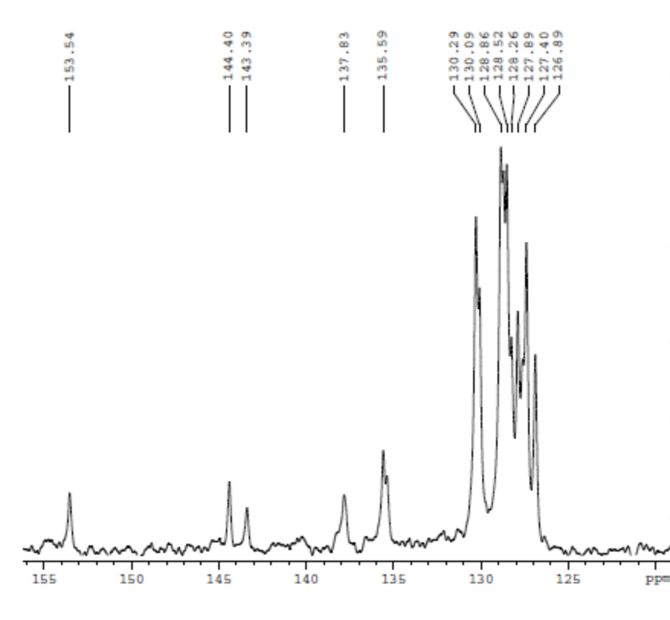
Fig. S₂ expand ¹³C NMR spectrum of (5a)

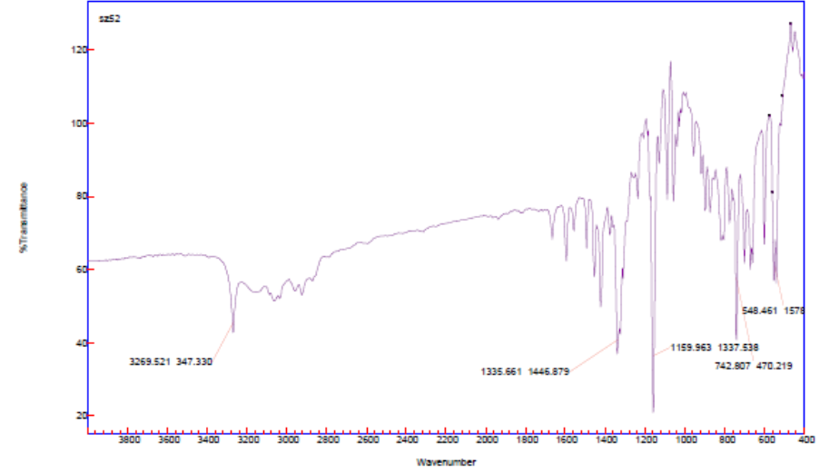
Fig. S3 FT-IR spectrum of (5a)
S6

Fig. S4 ¹H NMR spectrum of (5b)

S7
Fig. S4 expand ¹H NMR spectrum of (5b)

S8
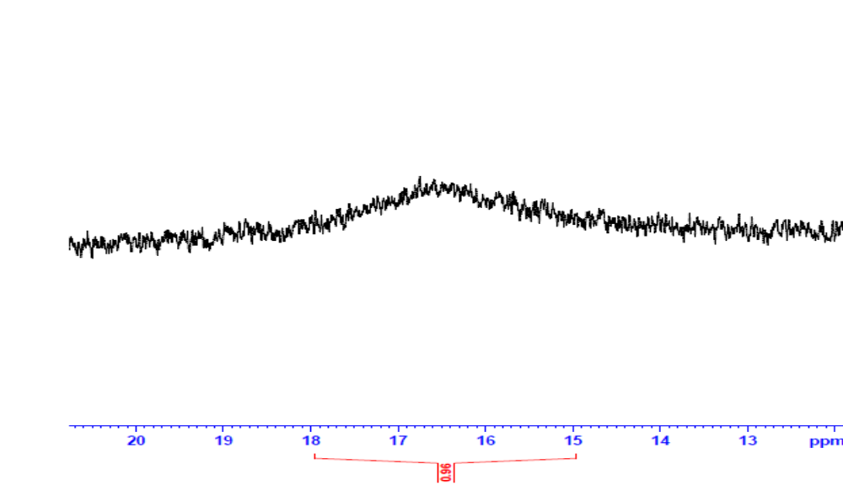
Fig. S4 expand ¹H NMR spectrum of (5b)

S9
Fig. S5 ¹³C NMR spectrum of (5b)

S10
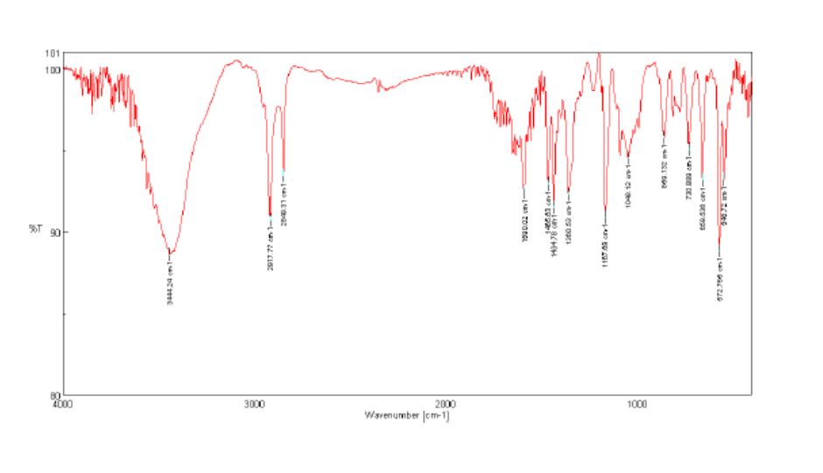

Fig. S6 FT-IR spectrum of (5b)

S11

Fig. S7¹H NMR spectrum of (3a)
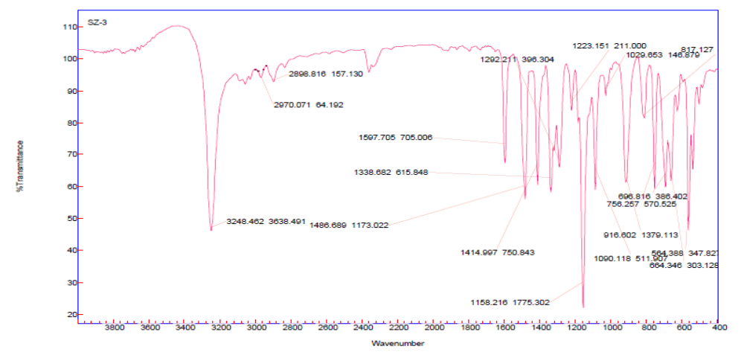
Fig. S8 FT-IR spectrum of (3a)

S12

Fig. S9 ¹H NMR spectrum of (4a)
Fig. S10 ¹³C NMR spectrum of (4a)
S13
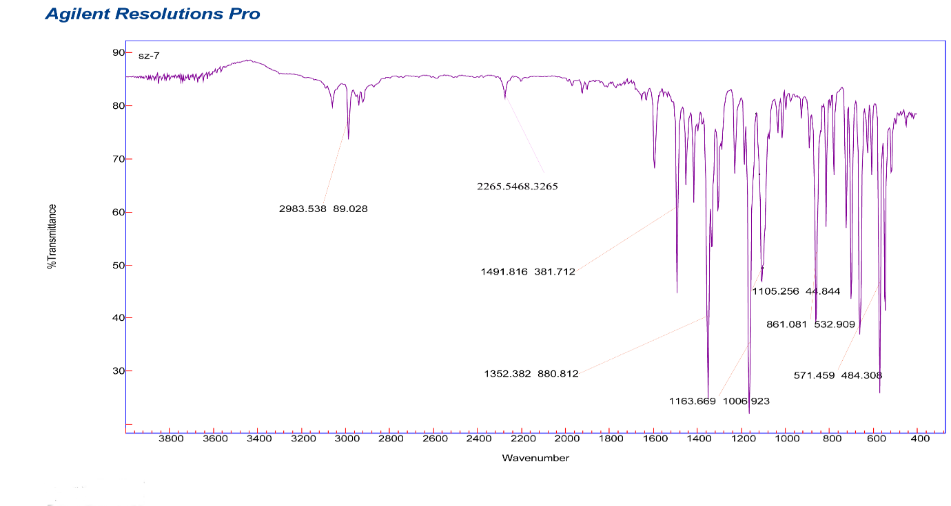

Fig. S11 FT-IR spectrum of (4a)

S14

