Supporting Information
Syntheses of MnW₁₂/TiO₂ Microflowers and Nanorods for Photocatalytic H₂ Evolution
Ningning Guo¹, Shixian Liu¹, Niuniu Zhang¹, Xia Wu¹, Guan Wang¹*, Yuan Zhao^{2*}
¹Henan Key Laboratory of Polyoxometalate Chemistry,Institute of Molecular and Crystal Engineering, College of Chemistry and Chemical Engineering, Henan University, Kaifeng, Henan, China E-mail: wangguan@henu.edu.cn
²The Key Laboratory of Natural Medicine and Immuno-Engineering, Henan University, Kaifeng, Henan, China. E-mail: zhaoyuan@henu.edu.cn
ORCID iDs: Guan Wang (https://orcid.org/0000-0002-0082-1875)
Yuan Zhao (https://orcid.org/0000-0001-6586-4350)

Related Control Synthetic and discussion
MnW₁₂ changes from microflowers to different morphologies when calcined under different temperatures and atmospheres (Figure S1). While calcined at 750℃ in air, microrods replaced microflowers (Figure S1b). When MnW₁₂ calcined with nitrogen, microflowers and microrods were still obtained at the corresponding temperature (Figure S1c and S1d). When MnW₁₂ calcined at 550℃ in air, each piece of the flowers changed from tortuous to flat although the shape of the flowers was still maintained (Figure S1a, inset). In contrast to this, after calcination at 550℃ under nitrogen, the microflowers consisted of small rods instead of flat pieces (Figure S1c). From the above discussion, it is not difficult to conclude that the calcination temperature and atmosphere have a vital influence on the morphology of MnW₁₂.
In addition, considering the influence of the nature of the counter cations on the morphology of the product [1-2], we replaced the Mn²⁺ by NH₄⁺, K⁺, N(C₄H₉)₄⁺, Cs⁺ under the same synthetic conditions, and isopolyoxometallate materials with different morphologies were obtained (Figure S2). When NH₄⁺, or K⁺, or Cs⁺ replaced the Mn²⁺, respectively, microplates of different sizes were obtained (Figure S2 a, b and d). However, when N(C₄H₉)₄⁺ was combined with W₁₂, nanoparticles were obtained (Figure S2 c). Hence, we have taken into account that Mn²⁺ plays a key role in the formation of the flower-like morphology.
The influence of different manganese salts on the morphology of MnW₁₂ has been also explored. When different manganese salts (Mn(Ac)₂, Mn(ClO₄)₂, MnSO₄, Mn(NO₃)₂) replaced MnCl₂, respectively, although microflowers were formed, these microflowers were destroyed to a certain extent (Figure S3). Therefore, the influence of the acid radical anion of these manganese salts on the morphology was discussed. The average open space between the leaves of a MnW₁₂ microflower is 96.55 nm and that of isopolyoxometallate materials in Figure S3 are 200 nm, 180 nm, 170 nm, and 140 nm, respectively. The difference in open space is attributed to the steric hindrance of Cl‒ is smaller than that of Ac‒, ClO₄‒, SO₄^{2‒}, and NO₃‒ [3-5]. Likewise, as the steric hindrance of Ac‒, ClO₄‒, and NO₃‒ decreases in sequence (Figure S4a, b, and d), the corresponding open space decreases in sequence, which is consistent with the above-mentioned open space. Since the spatial structure of ClO₄‒ and SO₄^{2‒} are similar (Figure S4b and c), the corresponding open space are almost the same. Hence, the strategy is proposed to be a general method to endow POM based nano/micro materials with new structures and new functions.
Besides, the influence of adding different amounts of PEG4000 on the MnW₁₂ microflowers have been also tested (Figure S5). When small amount of PEG4000 (0.025 g) is added, the morphology of the microflowers is still maintained; with the increase of PEG4000 (0.05 g), the microflowers are somewhat damaged; but when too much PEG4000 is added (1 g), the microflowers are damaged more seriously. From the above results, it can be concluded that the chain-like PEG4000 has a negative impact on the structure of MnW₁₂ microflowers. In other words, MnW₁₂ microflowers would not be changed to one dimensional structure by means of PEG4000.
In addition, the effect of different stirring times on the appearance of MnW₁₂ microflowers has been also measured (Figure S6). It is not difficult to see that the microflowers are destroyed with the extension of the stirring time. Beyond that, the influence of different amounts of MnCl₂ on the morphology of MnW₁₂ microflowers has been also explored (Figure S7). When the amount of MnCl₂ is too little or too much, it is not conducive to the formation of microflowers. Only when the stirring time and the amount of MnCl₂ are appropriate, can it contribute to the formation of unbroken microflowers.

Reference
[1] Guo, N.N.; Liu, N.; Meng, R.R.; Song, T.T.; Lu, Y.H.; Wang, G. (2020). Syntheses and multi-emissive properties of CeF₃:Tb³⁺-doped phosphotungstate solid nanospheres. Inorganic and Nano-Metal Chemistry 50: 444-452.
[2] Meng, R.R.; He, X.M.; Chen, J.J.; Yang, J.; Wang, G. (2019). Silver and sodium fluorescein co-doped phosphomolybdate microspindle: synthesis and spectroscopic properties. Journal of Cluster Science 30: 141–149.
[3] Thuijs, A.E.; Christou, G.; Abboud, K.A. (2015). [Mn₁₂O₁₂(O₂CMe)₁₂(NO₃)₄(H₂O)₄]: facile synthesis of a new type of Mn₁₂ complex. Acta Cryst. C 71: 185–187.
[4] Netzsch, P.; Höppe, H.A. (2020). Synthesis and characterisation of the chain borosulfates (NH₄)₃[B(SO₄)₃] and Sr[B₂(SO₄)₄]. Zeitschrift für anorganische und allgemeine Chemie 18: 1563-1569.
[5] Nelyubina, Y.V.; Lyssenko, K.A.; Golovanov, D.G.; Antipin, M.Y. (2007). NO₃–…NO₃– and NO₃–…π interactions in the crystal of urea nitrate. CrystEngComm 9: 991–996.

Figure captions:
Scheme S1 The synthetic strategy of MnW₁₂ microflower.
Scheme S2 The summary of morphology changes based on [H₂W₁₂O₄₀]^{6–} in this work.
Figure S1 (a–d) SEM images of MnW₁₂ calcined under different temperatures and atmospheres for 2 hrs: (a): air-550 ℃; (b): air-750 ℃; (c): nitrogen-550 ℃; (d): nitrogen-750℃.
Figure S2 (a–d) SEM images of isopolyoxometallate materials with different morphologies when MnCl₂·4H₂O was replaced by NH₄Cl, KCl, N(C₄H₉)₄Br, CsCl, respectively.
Figure S3 (a–d) SEM images of isopolyoxometallate materials with different morphologies when MnCl₂ was replaced by Mn(Ac)₂, Mn(ClO₄)₂, MnSO₄, Mn(NO₃)₂, respectively.
Figure S4 (a–d) The ball-and-stick models of Ac–, ClO₄–, SO₄^{2–}, NO₃–.
Figure S5 (a–c) SEM images of isopolyoxometallate materials with different morphologies when different amounts of PEG4000 were added: a) 0.025 g; b) 0.05 g; c) 1 g.
Figure S6 (a–c) SEM images of isopolyoxometallate materials with different morphologies with different stirring times: a) 10 min; b) 1 hr; c) 2 hrs.
Figure S7 (a and b) SEM images of isopolyoxometallate materials with different morphologies with different amount of MnCl₂: a) 1 mmol; b) 4 mmol.
Figure S8 The EDX spectrum and element mapping of MnW₁₂/TiO₂ microflowers.
Figure S9 The EDX spectrum and element mapping of MnW₁₂/TiO₂ nanorods.
Figure S10 (a-c) The XPS spectra of MnW₁₂/TiO₂ microflowers:(a) Mn_{2p} (b) W_{4f} (c) Ti_{2p}; (d-f) The XPS spectra of MnW₁₂/TiO₂ nanorods: (d) Mn_{2p} (e) W_{4f} (f) Ti_{2p}.
Figure S11 The XRD pattern of MnW₁₂/TiO₂ nanorods before and after three cycles of photocatalytic hydrogen generation.

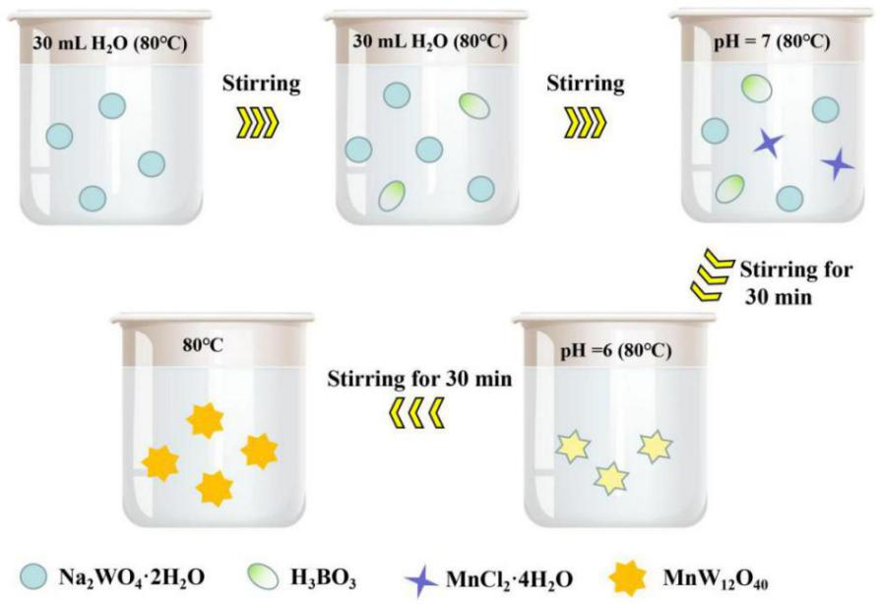
Scheme S1 The synthetic strategy of MnW₁₂ microflower.

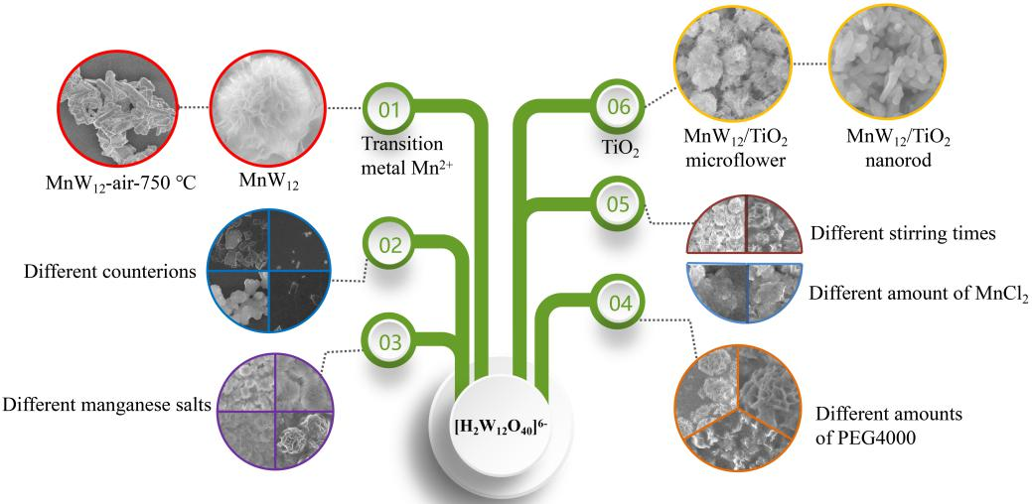
Scheme S2 The summary of morphology changes based on [H₂W₁₂O₄₀]^{6–} in this work.
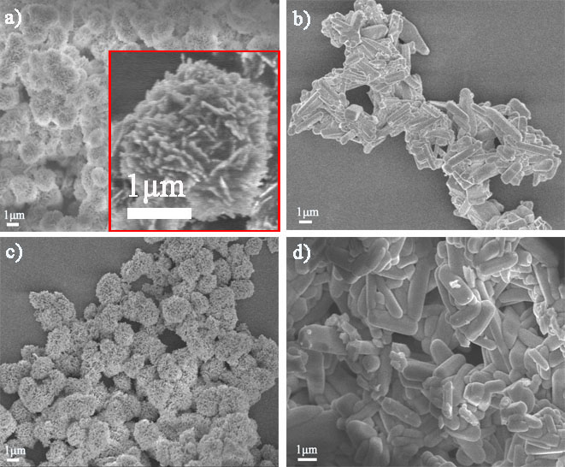
Figure S1 (a–d) SEM images of MnW₁₂ calcined under different temperatures and atmospheres for 2 hrs: (a): air-550 ℃; (b): air-750 ℃; (c): nitrogen-550 ℃; (d): nitrogen-750℃.
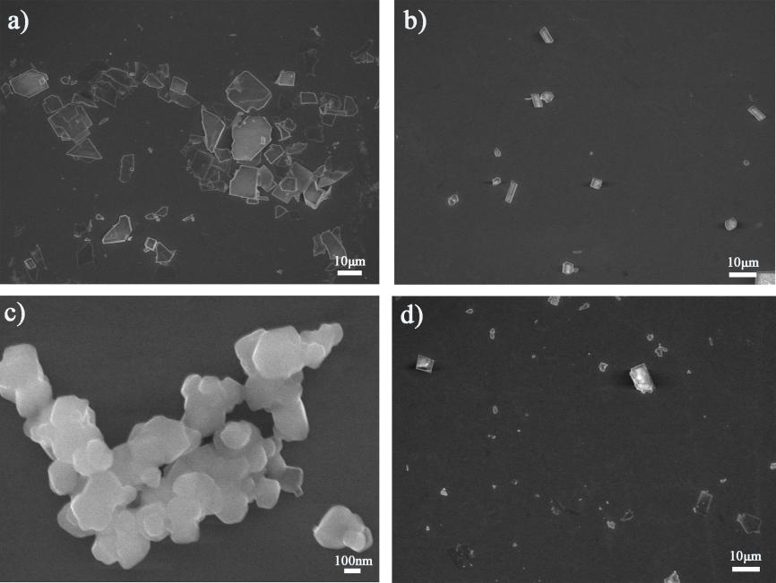
Figure S2 (a–d) SEM images of isopolyoxometallate materials with different morphologies when MnCl₂·4H₂O was replaced by NH₄Cl, KCl, N(C₄H₉)₄Br, CsCl, respectively.

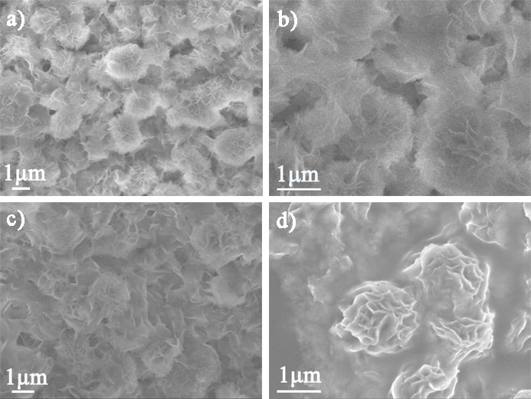
Figure S3 (a–d) SEM images of isopolyoxometallate materials with different morphologies when MnCl₂ was replaced by Mn(Ac)₂, Mn(ClO₄)₂, MnSO₄, Mn(NO₃)₂, respectively.
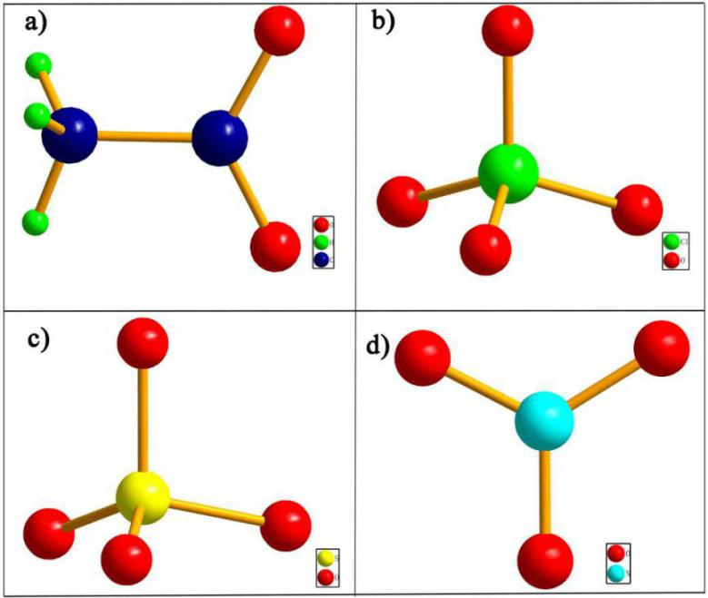
Figure S4 (a–d) The ball-and-stick models of Ac–, ClO₄–, SO₄^{2–}, NO₃–.

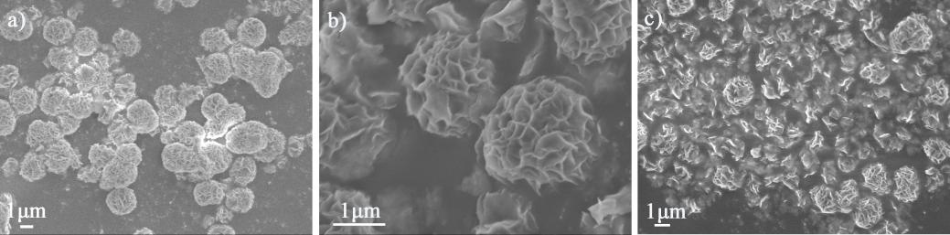
Figure S5 (a–c) SEM images of isopolyoxometallate materials with different morphologies when different amounts of PEG4000 were added: a) 0.025 g; b) 0.05 g; c) 1 g.

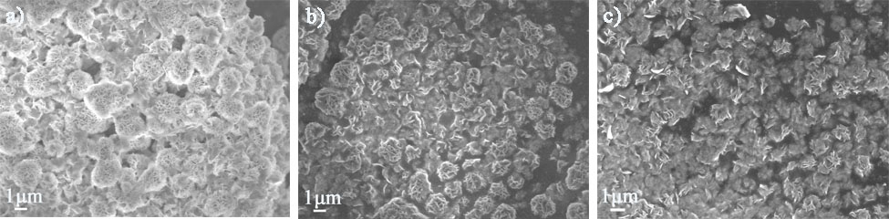
Figure S6 (a–c) SEM images of isopolyoxometallate materials with different morphologies with different stirring times: a) 10 min; b) 1 hr; c) 2 hrs.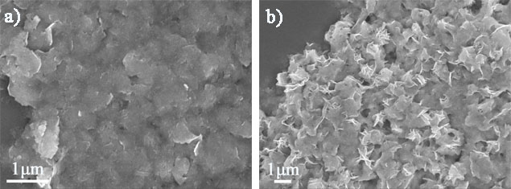
Figure S7 (a and b) SEM images of isopolyoxometallate materials with different morphologies with different amount of MnCl₂: a) 1 mmol; b) 4 mmol.

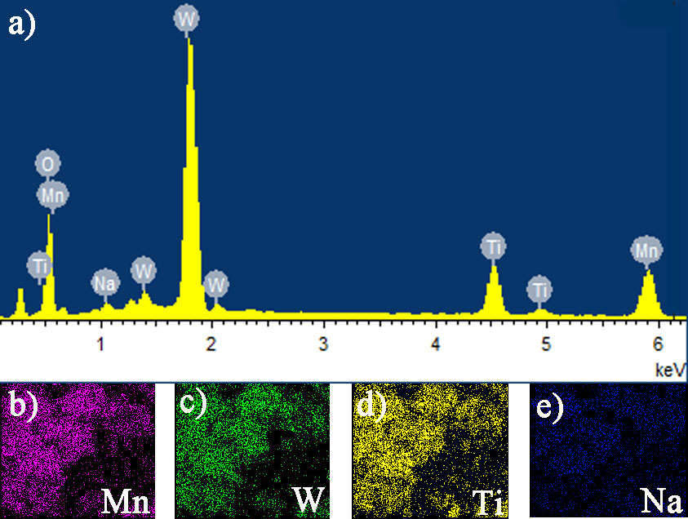
Figure S8 The EDX spectrum and element mapping of MnW₁₂/TiO₂ microflowers.

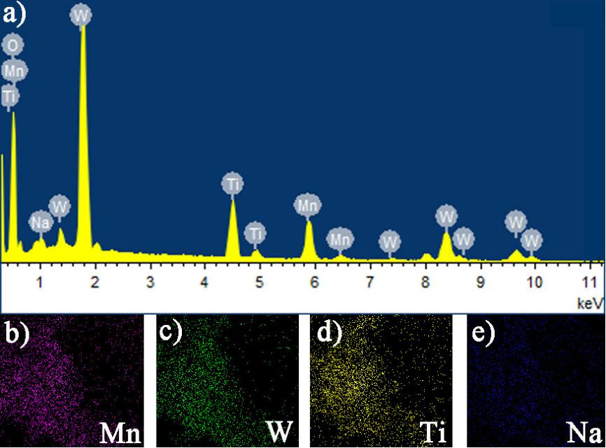
Figure S9 The EDX spectrum and element mapping of MnW₁₂/TiO₂ nanorods.
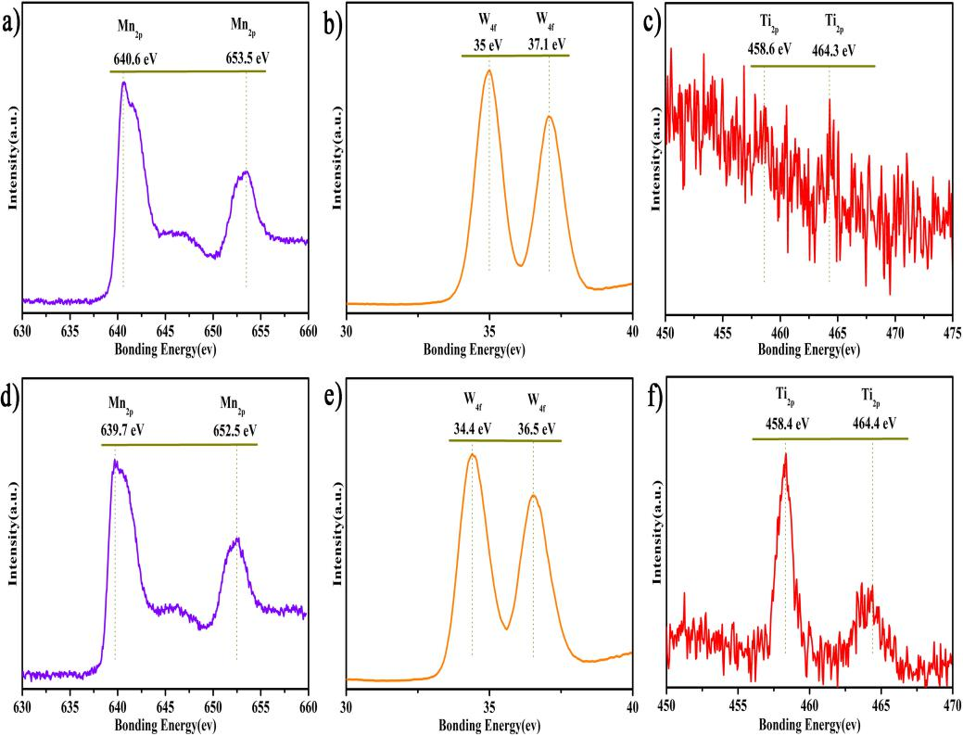
Figure S10 (a-c) The XPS spectra of MnW₁₂/TiO₂ microflowers:(a) Mn_{2p} (b) W_{4f} (c) Ti_{2p}; (d-f) The XPS spectra of MnW₁₂/TiO₂ nanorods: (d) Mn_{2p} (e) W_{4f} (f) Ti_{2p}.

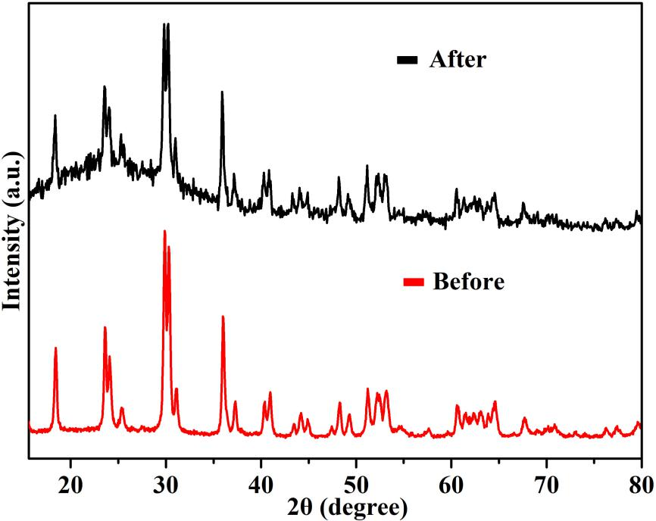
Figure S11 The XRD pattern of MnW₁₂/TiO₂ nanorods before and after three cycles of photocatalytic hydrogen generation.

