Supporting information
Metal-alkali catalytic valorization of lignocellulose towards aromatics and small molecular alcohols in a holistic approach
Wei Lv ^{a, c}, Yuting Zhu ª, Weiqi Mai ^{b}, Changhui Zhu ª, Qifeng Pi ª, Chenguang Wang ^{a*}, Ying Xu ª, Qi Zhang ª, Longlong Ma ^{a*}
ª Guangzhou Institute of Energy Conversion, Chinese Academy of Sciences; CAS Key Laboratory of Renewable Energy; Guangdong Provincial Key Laboratory of New and Renewable Energy Research and Development. No.2 nengyuan Rd, Tianhe District, Guangzhou 510640 (China)
^{b} College of Engineering, South China Agricultural University. No.4 nengyuan Rd, Tianhe District, Guangzhou 510640 (China)
^{c} Key Lab. of Biomass Energy and Material, Jiangsu Province. No. 16 5th Suojin village, Xuanwu District, Nanjing 210018 (China)
*Corresponding author: Tel.: +86-20-37029721; Fax: +86-20-87057673
Corresponding author: mall@ms.giec.ac.cn

Contents
Supporting information 1
Experimental procedures 3
Tables 8
Table S1. Composition of eucalyptus wood powder. 8
Table S2 Analysis of gaseous products after depolymerization reaction, indicating the main solvent degradation products. 9
Table S3 Band assignment for cornstalk hydrolysis residue (CHR) and depolymerization residual solid (DRS) FT-IR analysis 10
Table S4 Assignment of main lignin ¹H - ¹³C correlation signals in HSQC spectra of liquid fraction according to the literature ^{[2, 6-8]} 11
Figures 12
Fig. S1 GPC of the non-volatile lignin oil (n-butanol phase) for different solvent system.. 14
Fig. S2 FT-IR of eucalyptus and reaction residues with Ru/C and/or Mg(OH)₂. 15
Fig.S3 The HPLC analysis of aqueous products derived eucalyptus powder valorization in different solvents over Ru/C or MgO or Ru/C-MgO catalysts. 17
Fig. S4 The XRD analysis of feedstock and residue (with catalyst) derived eucalyptus powder valorization in different solvents over Ru/C-MgO catalysts.. 18
Fig. S5 GPC of the non-volatile lignin oil (n-butanol phase) for different reaction temperature over Ru/C-MgO.. 19
Fig.S6 The HPLC analysis of aqueous products derived eucalyptus powder valorization under different temperature over Ru/C-MgO catalysts. 20
Fig. S7 The XRD analysis of residue (with catalyst) derived eucalyptus powder valorization under different reaction temperature over Ru/C-MgO catalysts. 21
Fig. S8 GPC of the non-volatile lignin oil (n-butanol phase) for different reaction time over Ru/C-MgO. 22
Fig.S9 The HPLC analysis of aqueous products derived eucalyptus powder valorization under different reaction time over Ru/C-MgO catalysts. 23
Fig. S10 The XRD analysis of the aqueous phase products obtained from catalytic depolymerization euscalyptus over Ru/C-MgO catalysts. 24
Reference 25

Experimental procedures
Chemicals and materials
All commercial chemicals were analytic reagents and were used without further treament or purification. Acetophenone (≥99.5%), 4-n-Propanolguaiacol (3-(4-hydroxy-3-methoxyphenyl)-1-propanol, >98%), meso-erythritol (>99%), Guaiacol (2-methoxyphenol, 98%), 4-n-propylguaiacol (>99%), syringol (2,6-dimethoxyphenol, 99%), 4-methylsyringol (>97%), 4-Ethylguaiacol (98%) , n-butanol (>99%), 5 wt % Ru/C and MgO were purchased provided from Aladdin (Shanghai, China) and employed as received. Ethanol (>99%), methanol(≥99%) , arabinose (>99%), sorbitol (>99%) and mannose (>99%) were obtained from Shanghai Macklin Biochemical Technology Co., Ltd. Glucose (>99%), xylitol (≥99%), mannitol (>98%), xylose (≥99%), tetrahydrofuran (>99%) were purchased from Sigma Aldrich. Cellobiose (>98%), sorbitol(≥99.5%), lactic acid (≥88%), acetic acid (≥99%), valerolactone (≥98%), 1,2-propylene glycol(≥99%), propyl alcohol (≥99.5%), ethylene glycol (≥99.9%), glycerine (≥99.8%), 5-hydroxymethylfurfural (≥99%), Levulinic acid (>98%), γ-Valerolactone (>98%), 1-hydroxy-2-butanone (95%) were obtained from J&K Scientific Ltd..

Eucalyptus wood powder pretreatment
The bits of eucalyptus wood was smashed and sieved to the wood powder (40~60 mesh). Then the extractives (fats, waxes, resins and terpenoids /steroids) were removed by a Soxhlet extractor. 3.0 g of powder was put into the extraction flash and was completely submersed in 70 mL of a boiling solvent mixture comprising toluene and ethanol in a 2/1 (v/v) ratio. Then, a standard Soxhlet extraction step was carried out for 8 h. After extraction, the cooling samples were washed with ethanol and dried overnight at 80°C. This wood powder, hereafter marked as ‘pre-extracted powder’, was used for compositional analysis. The composition of eucalyptus powder was analyzed by NREL according to NREL Laboratory Analytical Procedures ^{[1]}. The composition is summarized in Table S1.

Typical Process for non-extracted Eucalyptus Wood Powder Depolymerization
Depolymerization experiments were conducted in a 100 ml autoclave (Hastelloy alloy, made by Anhui Kemi Machinery Technology Co., Ltd.) equipped with a mechanical stirring. In a typical depolymerization reaction, 2.0 g non-extracted powder was putted into the reactor with the catalyst (0.2 g Ru/C or/ and 0.4g MgO) and the n-butanol/water solvent mixture (40 mL, v/v=1:1). The reactor was sealed, replaced the air in the reactor by N₂ four times and then by H₂ three times. A total of 30 bar of H₂ was pressurized at room temperature. The reaction mixture was heated to 200 °C (∼10 °C min⁻¹) and then kept for 2h with continuous stirring at 700 rpm. After that, the reactor was cooled and collected the gaseous products at room temperature.

Product separation
The liquid and solid mixtures were taken out and the reactor was washed with 15 mL water and 15 mL n-butanol. The obtained mixture was filtered to separate solid and liquid mixture. The mixture of solid (Ru/C, Mg(OH)₂ (MgO converts to Mg(OH)₂ in hydrothermal condition) and depolymerization residue) were separated and collected through liquid-liquid extraction method with n-butanol and H₂O. Ru/C primarily resides (due to its relatively polar) in n-butanol phase, while Mg(OH)₂ and powder residue (if any) were located at aqueous phase. After liquid-liquid extraction, portion of Ru/C was extracted in the n-butanol phase and then retrieved, the reminder Ru/C blended with Mg(OH)₂ and powder residue (if any) in H₂O phase was extracted again with fresh n-butanol. This was repeated until the n-butanol phase remained relatively clear. All of the collected Ru/C was washed with ethanol to remove n-butanol and other adsorbents until alcoholic filtrate relative clear. MgO was retrieved by clacining the mixed solid (Mg(OH)₂ and powder residue) in air under 550℃for 4h. The retrieved catalysts were used to investigate reusability under the given conditions (see Fig. 10 in the main article). On the other hand, the liquid products transferred to a separating funnel and automatically separated into n-butanol phase (upper phase) and aqueous phase (bottom phase), as depicted in Fig.1. After phase separation, a 20mL fresh n-butanol was added to aqueous phase for extraction lignin-derived fragments, repeating this step three times. In this way, the total n-butanol fraction measured about 80 mL and the total aqueous fraction was about 43 mL.

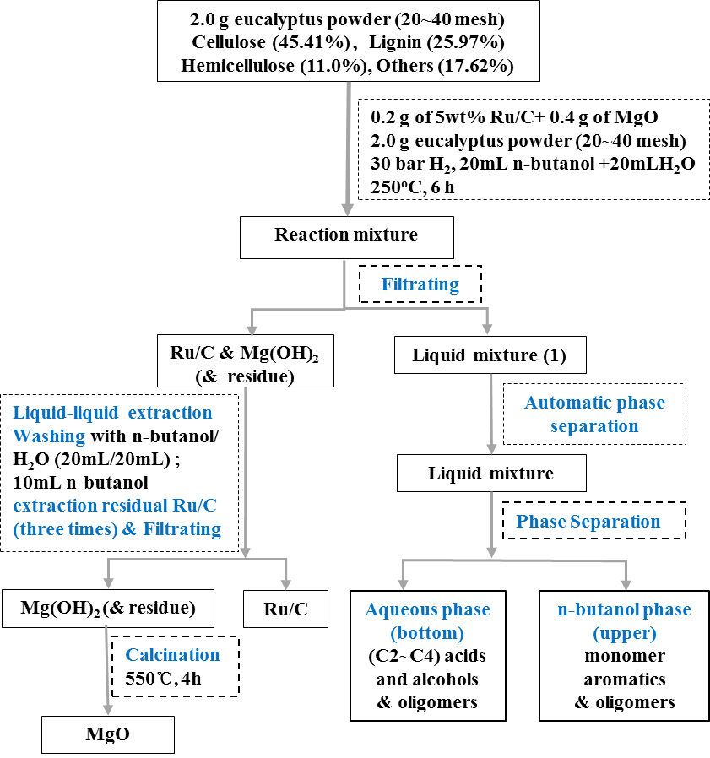
Scheme S1. Procedure for products separation

Analysis of gaseous products
The gas chromatography mass spectrometer (GC-MS) analysis of the gaseous was conducted on Agilent 7890A-5975C equipped with a Pxi-17Sil MS Cap. column (30 m × 0.25 mm × 0.25 μm) and was identified according to the NIST MS library. The oven temperature was programmed as 40 °C hold 5 min and, then, ramped up to 300 °C at 5.2 °C/min and held for another 4 min. The quantitative analysis of these chemicals was carried out on an Agilent 7890 GC with a flame ionization detector (FID) using acetophenone as the internal standard at the same capillary column and temperature program as the GC-MS analysis.

Analysis of the n-butanol phase products
To analyze the lignin monomers, a weighed amount of internal standard (acetophenone, ~20 mg) was added to n-butanol phase products, about 1.5mL n-butanol phase products was filtered with a 0.22 µm PTFE membrane to remove any particulate matter to prevent plugging of the columns and then analyzed on Agilent 7890A-5975C equipped with an INNOWAX column (30 m × 0.32 mm; film thickness, 1.0 μm) and a flame ionization detector (FID). The injection port and the detector were held at 240℃ and 260℃, respectively. The column flow rate was 40 mL min⁻¹ with a He carrier gas. The GC oven temperature was initially held at 60 °C for 2 min, ramped to 240 °C at 10 °C min⁻¹, and kept at 240 °C for 10 min. The quantitative analysis of these chemicals was carried out on an Agilent 7890 GC with a flame ionization detector (FID) at the same capillary column and temperature program as the GC-MS analysis.
To get more insight in the degree of lignin depolymerisation, the distribution of the molar mass of the lignin products was investigated using gel permeation chromatography (GPC).Therefore the n-butanol phase (5.0mL) was evaporated using a rotary evaporator (in order to remove n-butanol more easily and as much as possible, 2.5mL ethanol and 2.5mL water were added in n-butanol phase products to form an azeotropic solvent), yielding a viscous brown lignin oil and determining the mass of the lignin oil from 5.0 mL n-butanol phase products. The lignin oil after which the content was completely resolubilized in 2.0 mL tetrahydrofuran and filtered with a 0.22 µm PTFE membrane to remove any particulate matter to prevent plugging of the columns. GPC analyses were performed at 40 °C on a Waters E2695 equipped with a M-Gel column 3 μm (mixed), using THF as the solvent (1 mL min⁻¹) and a UV detection at 280 nm with a Waters 2988 Photodiode array detector.
NMR spectra were recorded on a Bruker Avanace 400 MHz spectrometer. A sample of the lignin oil (from 5.0mL n-butanol phase products evaporation) was dissolved in dimethylsulfoxide-d6 ([D6] DMSO) (0.7 mL). For the HSQC analysis, the collecting and processing parameters were listed as follows: number of scans, 84; receiver gain, 203; acquisition time, 0.2129/0.0636s; relaxation delay, 2.0 s; pulse width, 10s; spectrometer frequency, 400.15/100.61 MHz; and spectral width, 4807.8/20124.9 Hz (Huang et al. 2014; Zhang et al. 2015). The data was processed with MestReNova software.
The aqueous phase products (circa 2.0 mL) were filtered through 0.22 μm-pore-size filters (Jin Teng, China) to analysis. The samples were analyzed using a high performance liquid chromatography (HPLC, Waters e 2695, Shodex Sugar SH1011 column, differential refractive index detector) system. Separation was achieved at 50 °C with 5 mM H₂SO₄ as the mobile phase, flowing at a rate of 0.5 mL min⁻¹. For each analysis, the injection volume was 1 μL.

Analysis of pre-extracted eucalyptus wood powder
Eucalyptus powder and residue were measured by an X-ray diffractometer (X’Pert Pro MPD, Philip) with Cu Kα radiation (λ = 0.0167 nm) operated at 40 kV and 100 mA. The 2θ angles were scanned from 5° to 80°.
The components of eucalyptus powder and residue were measured according to NREL K-lignin analysis (A. Sluiter 2008; Lv et al. 2017). Eucalyptus powder and residue were characterized by Fourier Translation Infrared Spectroscopy (FT-IR). They were analyzed on a TENSOR27 FT-IR spectrometer in the range of 4000-400 cm⁻¹, scan times is 32. Before the analysis, Eucalyptus powder and residue were dried at 105℃ overnight, then ground with KBr and pressed into a wafer.

Catalyst recuperation & reuse
In this work, reused Ru/C and MgO were retrieved as descripted as Product separation section.

Feedstock conversion, monomer quantification and yield calculations
The liquefaction rate eucalyptus powder is determined via the weight comparison of feedstock and recovered residue as displayed in Eq.(1). The conversion of lignin, cellulose and hemicellulose were calculated by the weight comparison between the recovered and the feedstock as shown in Eq. (2), (3) and (4), respectively. As the Scheme S1 shown, the liquid products were separated into n-butanol phase and aqueous phase. The n-butanol phase mainly comprises of aromatics and lignin-derived oligomers, the aqueous phase mainly comprises of small molecular alcohols and acids. The yield of aromatics and oligomers were measured according to Eqs. (5) and (7). The weight of aqueous phase monomer products was measured by the external standard method with each component standard substance according to Eqs. (8). The weight of oligomers in aqueous phase is obtained via the weight of converted semi-cellulose minus the mass of monomers) (Eq. (9).
$liquefaction rate (\%)=\frac{M_{0}-M_{u}}{M_{0}}∙100\%$ (1)
$lignin conversion \left(\%\right)=\frac{M_{0}×L_{0}-M_{u}×L_{1}}{M_{0}×L_{0}}∙100\%$(2)
$Cellulose conversion (\%)=\frac{M_{0}×C_{0}-M_{u}×C_{1}}{M_{0}×C_{0}}∙100\%$ (3)
$Hemicellulsoe conversion (\%)=\frac{M_{0}×H_{0}-M_{u}×H_{1}}{M_{0}×H_{0}}∙100\%$ (4)
${Yield }_{X monomer aromatic}\left(\%\right)=\frac{M_{x}/W_{x}}{M_{0}×L_{0}}∙100\%$ (5)
${Yield}_{total monomer aromatics}\left(\%\right)=\frac{M_{tma}}{M_{0}×L_{0}}∙100\%$ (6)
${Yield}_{lignin-derived oligomers}\left(\%\right)=\frac{M_{0}×L_{0}-M_{tma}}{M_{0}×L_{0}}∙100\%$ (7)
${Mass }_{Y monomer aqueous products}\left(\%\right)=\frac{M_{Y}}{M_{0}}∙100\%$ (8)
${Mass }_{aqueous phase oligomers}\left(\%\right)=\frac{M_{0}(C_{0}+H_{0})-M_{tmap}}{M_{0}}∙100\%$ (9)
${Mass }_{total monomer aqueous products}\left(\%\right)=\frac{M_{tmap}}{M_{0}}∙100\%$ (10)
In the equations, M₀: the weight of feedstock; Mu: the weight of unreacted feedstock; L₀, L₁, C₀, C₁, H₀ and H₁ , were determined following standard NREL procedures, are the content of lignin, cellulose and hemicellulose in feedstock (L₀, C₀, H₀) and residue (L₁, C₁, H₁ ),respectively. M_{x}: the weight of X component of monomer aromatic (the weight of monomer aromatics was calculated by internal standard method using acetophenone as standard compound); W_{x}: the molecular weight of X product; M_{tma}: the weight of total monomer aromatics. M_{Y}: the weight of Y component of aqueous phase monomer product; M_{tmap}: the weight of total monomer aqueous phase products.

Tables

Table S1. Composition of eucalyptus wood powder.
Constituent | Content/wt%
cellulose | 45.41
hemicellulose | 11.00
lignin | 25.97
Extraction ª | 3.70
Water ^{b} | 9.68
ash | 0.98
Total | 96.74
ª See the extraction procedure of powder preparation.
^{b} Measured gravimetrically by drying overnight at 120 °C.

Table S2 Analysis of gaseous products after depolymerization reaction, indicating the main solvent degradation products.
Compound | Vol %
Compound | Eucalyptus powder | Without feedstock
H₂ | 79.33 | 55.74
N₂ | 1.65 | 1.40
O₂ | 0.41 | 0.41
CO₂ | 6.96 | 0
CO | 0.91 | 0
CH₄ | 6.75 | 25.85
C₂H₆ | 0.29 | 1.30
C₃H₈ | 3.64 | 15.18
n-C₄H₁₀ | 0.04 | 0.08
Total | 99.98 | 99.96
Reaction conditions: 20 mL n-butanol, 20 mL water, without or 1.0 g non-extracted eucalyptus powder, 0.2 g Ru/C, 0.4g MgO, 30 bar H₂, 250 °C, 6 h.

Table S3 The effect of solvent or/and catalyst on eucalyptus powder valorization
solvents | catalyst | liquefaction rate (wt.%) ª | conversion (%) ^{b} |  |  | lignin fractions  (wt.%) ^{c} |  | cellulose and hemicellulose fractions (mg) ^{d}
solvents | catalyst | liquefaction rate (wt.%) ª | cellulose | hemi-cellulose | lignin | monomer aromatic yield | oligomer yield | monomers | oligomers
n-butanol/H₂O | Free cat. | 20.67 | 12.52 | 78.26 | 11.64 | 9.04 | 2.6 | 41.23 | 98.9
n-butanol/H₂O | MgO | 37.57 | 16.81 | 87.58 | 49.32 | 20.68 | 28.64 | 72.74 | 102.05
n-butanol/H₂O | Ru/C | 65.33 | 37.88 | 91.98 | 80.25 | 47.15 | 33.1 | 193.7 | 78.77
n-butanol/H₂O | Ru/C-MgO | 65.92 | 40.61 | 92.69 | 92.26 | 54.70 | 37.56 | 116.08 | 160.75
Pure n-butanol | MgO | 9.69 | 0.56 | 0.78 | 26.25 | 8.63 | 17.62 | 3.42 | 0.00
Pure n-butanol | Ru/C | 5.88 | 0.54 | 2.42 | 13.43 | 12.54 | 0.89 | 3.76 | 0.00
Pure n-butanol | Ru/C-MgO | 12.78 | 2.29 | 5.38 | 33.77 | 16.79 | 16.98 | 9.66 | 2.12
Pure H₂O | MgO | 25.23 | 21.72 | 97.64 | 4.38 | 0.52 | 3.86 | 177.36 | 10.86
Pure H₂O | Ru/C | 54.57 | 31.61 | 100.0 | 70.92 | 28.56 | 42.36 | 224.84 | 28.21
Pure H₂O | Ru/C-MgO | 50.95 | 29.45 | 100.0 | 64.57 | 26.05 | 38.52 | 162.56 | 81.20
Reaction conditions: 20 mL n-butanol/20 mL water or 40 mL pure n-butanol or 40 mL pure water, 2.0 g non-extracted eucalyptus powder, 0.2 g catalyst, 0.4g MgO, 30 bar H₂, 200 °C, 2 h.
ª liquefaction rate is determined via the weight comparison of feedstock and recovered residue (mass of catalysts were subtracted).
^{b} Cellulose, hemicellulose and lignin conversion based on the weight of cellulose, hemicellulose and lignin in feedstock, respectively.
^{c} The yield of monomer aromatics was measured via the weight comparison of monomer aromatics and total lignin (the weight of monomer aromatics was calculated by internal standard method using acetophenone as standard compound); the yield of oligomers was obtained via the weight comparison of oligomers and total lignin (the weight of the converted lignin minus the mass of monomer aromatic).
^{d} The weight of aqueous phase monomer products was measured by the external standard method with each component standard substance. The weight of oligomers in aqueous phase is obtained via the weight of converted cellulose and hemicellulose minus the mass of monomers).

Table S4 Band assignment for cornstalk hydrolysis residue (CHR) and depolymerization residual solid (DRS) FT-IR analysis
Band position  / cm⁻¹ | Functional groups | Typical structures
3590 | O-H stretching vibration | H₂O
3455-3410 | O-H stretching vibration | -OH and O(2)H-O(6)(intra)in cellulose
3375-3340 | O-H stretching vibration | O(3)H-O(5)(intra) in cellulose
3310-3230 | O-H stretching vibration | O(6)H-O(3’)(inter) in cellulose
3250-3000 | O-H stretching vibration | O(2)H-O(2’)(inter) or/ and O(6)H-O(2’)(inter) in cellulose
3570~3050 | O-H multiple strong stretching vibration | saccharides
3440~3245 | O-H strong and width stretching vibration | Alcohols, phenols
3087 | Olefinic =C-H stretching vibration | olefin
3010 | Aromatic =C-H stretching vibration | Aromatics with various types of substitution
2960~2850 | C-H stretching vibration | alkane
2935 | C-H stretching vibration of -OCH₃ | alkane
2820, 2720, 1713 | C=O typical stretching vibration of  aldehyde group | aldehydes
1740 | C=O stretching vibration | Unconjugated alkyl aldehydes and alkyl esters
1715 | C=O stretching vibration | Carboxylic acids(or fatty acids), aldehydes, ketones
1696,1654 | C=O stretching vibration | Unsaturated aldehydes, ketones, hydroxyl unsaturated ketones , aldehydes
1645 | C=C stretching vibration | Olefin, aromatic ring
1705, 1605, 1514, 1479 | Aromatic C=C ring breathing | Aromatics with various types of substitution
1372 | Aliphatic C-H stretching | Cellulose
1165 | C-O-C stretching at β-(1-4)-glycosidic | Cellulose
1112 | C＝O/C-O-C stretching glucose ring stretching vibration | Cellulose
1057 | C-O stretching vibrations | Cellulose
897 | C-O-C vibration at β-1,4-glycosidic | Cellulose
1268, 1237, 1037 | Ar-O stretching breathing | Ar-O-R、R-O-CH₃
835, 730.04, 688 | Aromatic C-H ring out-of-plane vibration breathing | Aromatics with various types of substitution
875 | C-O stretching vibration | Aromatics with various types of substitution
All spectra were assigned according to the reported literature.^{[2-5]}

Table S5 Assignment of main lignin ¹H - ¹³C correlation signals in HSQC spectra of liquid fraction according to the literature ^{[2, 6-8]}
Lables | (δ_{C}/δ_{H}) ppm | Assignment
-OCH₃ | 56.1/3.77 | C-H in methoxyls
A_{α} | 72.4/4.85 | C_{α}-H_{α} in β-O-4'substructures (A)
A_{β}(G) | 84.9/4.32 | C_{β}–H_{β} in β-O-4'structures linked to G (A)
A_{β}(S) | 86.2/4.12 | C_{β}–H_{β} in β-O-4' structures linked to G (A)
A_{β}(S) | 79.8/4.63 | C_{β}–H_{β} in β-O-4'linked to S (A)
A'_{β}(G) | 80.8/4.62 ND | C_{β}–H_{β} in β-O-4'structures linked to G (A)
A_{γ} | 59.8-60.2/3.23-3.71 | C_{γ}-H_{γ} in β-O-4' substructures (A)
A'_{γ} | 63.0/3.8-4.10 | C_{γ}-H_{γ} in γ-acylated β-O-4'substructures (A')
B_{α} | 84.8/4.66 | C_{α}-H_{α} in β-β' substructures (B)
B'_{α} | 83.2/4.94 | C_{α}–H_{α} in β-β' (B', tetrahydrofuran)
B_{β} | 53.8/3.07 | C_{β}-H_{β} in β-β' resinol substructures (B)
B'_{β} | 49.8/2.56 | C_{β}-H_{β} in β-β' tetrahydrofuran (B')
B_{γ} | 71.3/3.84-4.2; | C_{γ}-H_{γ} in β-β' resinol substructures (B)
C_{α} | 86.2/5.51 | C_{α}–H_{α} in β-5 structures (C)
C_{β} | 52.8/3.47 | C_{β}-H_{β} in β-5 structures (C)
C_{γ} | 62.8/3.74 | C_{γ}-H_{γ} in β-5 structures (C)
D_{α} | 81.0/5.10 | C_{α}–H_{α} in spirodienones (D)
D_{β} | 60.7/3.18 | C_{β}-H_{β} in spirodienone substructures (D)
E_{α} | 144.5/7.5 | C_{α}–H_{α} in α,β-diaryl ethers (E)
E_{β} | 113.7/6.30 | C_{α}–H_{α} in cinnamate structures (E)
T₆ | 98.9/6.23 | C_{2,6}–H_{2,6} in tricin (T)
S_{2,6} | 104.4/6.72 | C_{2,6}-H_{2,6} in etherified syringyl units (S)
S'_{2,6} | 106.4/7.34 | C_{2,6}-H_{2,6} in oxidized (C_{α}=O) syringyl units (S’)
G₂ | 110.0-110.9/6.97-7.00 | C₂-H₂ in guaiacyl units (G)
G₅ | 114.5-115.9/6.75 | C₅-H₅ in guaiacyl units (G)
G₆ | 119.5/6.83; | C₆-H₆ in guaiacyl units (G)
PB_{2,6} | 131.5/7.67 | C_{2,6}-H_{2,6} in p-hydroxybenzoate substructures (PB)
H_{2,6} | 128.2/7.19 | C_{2,6}–H_{2,6} in H units (H)
PCE_{3,5} | 115.6/6.77; 122.1/7.14 | C_{3,5}–H_{3,5} in p-coumarate (PCE)
PCE_{2,6} | 130.2/7.48; 129.3/7.68 | C_{2,6}–H_{2,6} in p-coumarate (PCE)
FA₂ | 110.7/7.32-7.35 | C₂–H₂ in ferulate (FA)
FA₆ | 123.1/7.20 | C₆–H₆ in ferulate (FA)
CH₂(3) | 7.4/124.2; 7.7/136.0 | CH₂(3) in pyridine
CH(3) | 6.87/127.97 | 2,6-dimethyl-4-tert-butylphenol
CH₂CH₃ | 2.07/29.26 | ethyl methyl ketone
CH₂ | 1.201/30.42 | aliphatic
Xyl | 102-110/4.0-5.5 | C-H in xylose derived from hemicellulose
X2 | 70.6/3.03 | C₂-H₂ in β-D-xylopyranoside
X3 | 74.2/3.24 | C₃-H₃ in β-D-xylopyranoside
X4 | 75.0/3.74 | C₄-H₄ in β-D-xylopyranoside
X3₁ | 101.4/4.20 | 3-O-acetyl-β-D-xylopyranoside

Figures

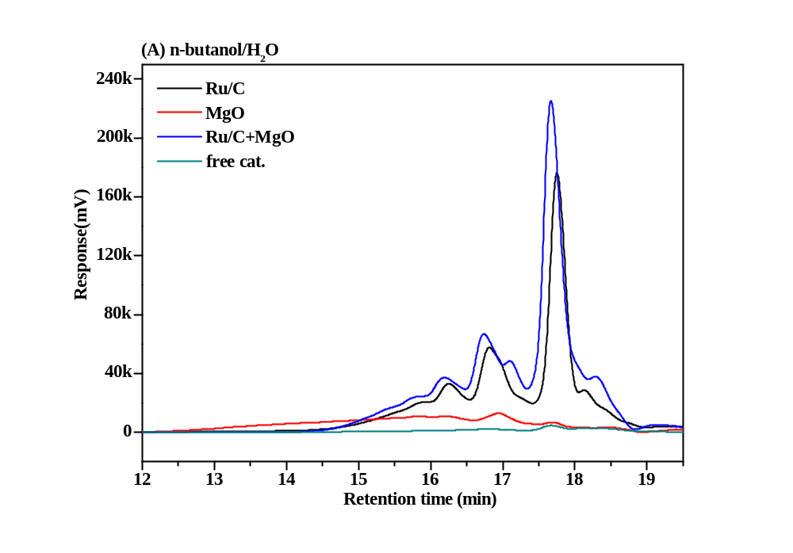
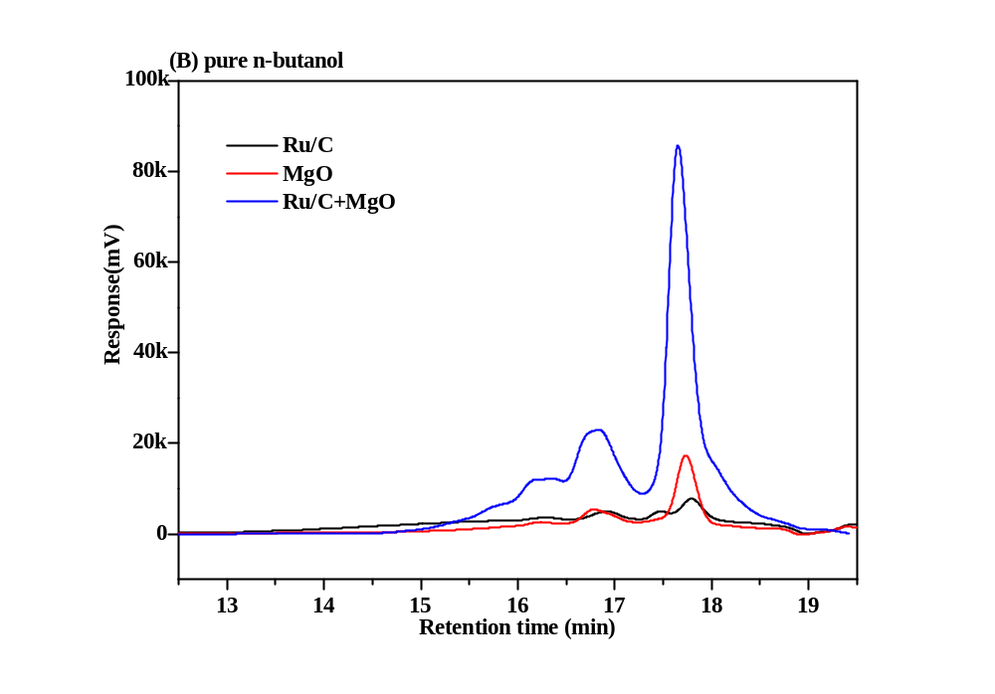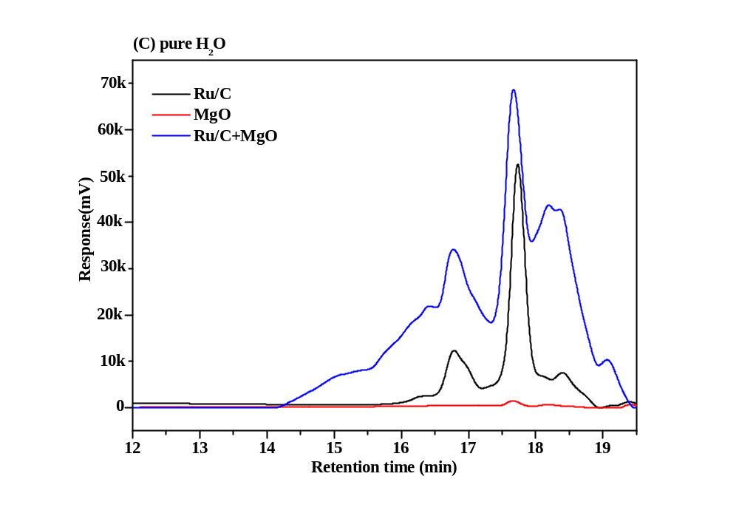
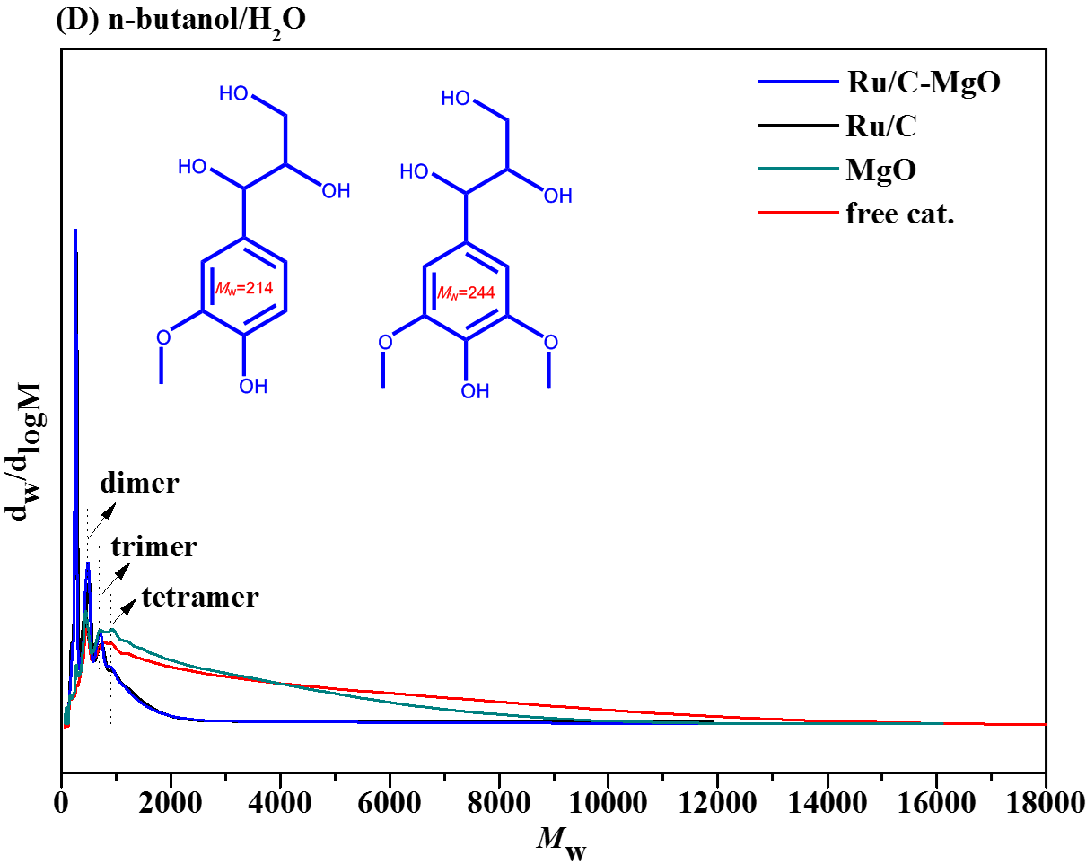

Fig. S1 GPC of the non-volatile lignin oil (n-butanol phase) for different solvent system. (A) n-butanol/H₂O, (B) pure n-butanol, (C) pure H₂O, (D) n-butanol/H₂O (M_{w} distribution). Reaction conditions: 2.0 g non-extracted eucalyptus powder, 0.2 g Ru/C, 0.4g MgO, 20 mL n-butanol, 20 mL water (or 40 mL n-butanol or 40 mL water), 30 bar H2, 200 °C, 2 h.

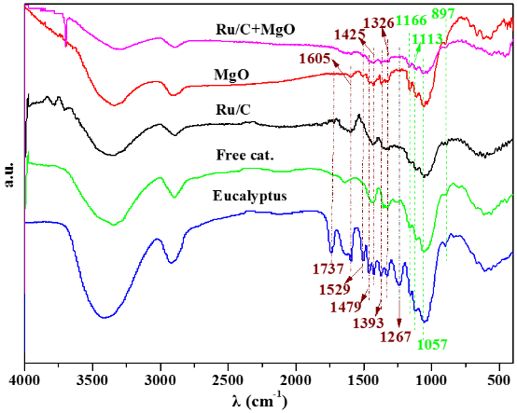

Fig. S2 FT-IR of eucalyptus and reaction residues. Reaction condition: 2.0 g of non-eucalyptus, 0.2 g of 5 wt% Ru/C, 0.4g of MgO, 40.0 mL of solvents (n-butanol /H₂O=1:1(v/v) 40mL), 200 ºC, 2 h

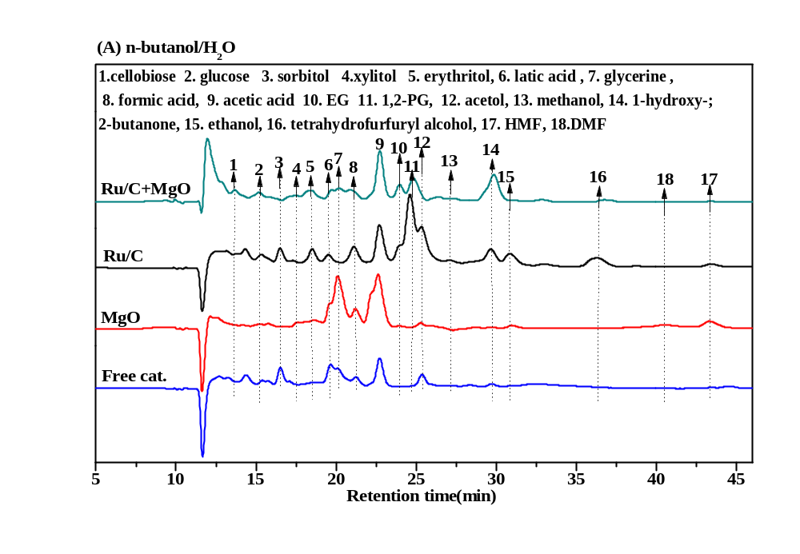
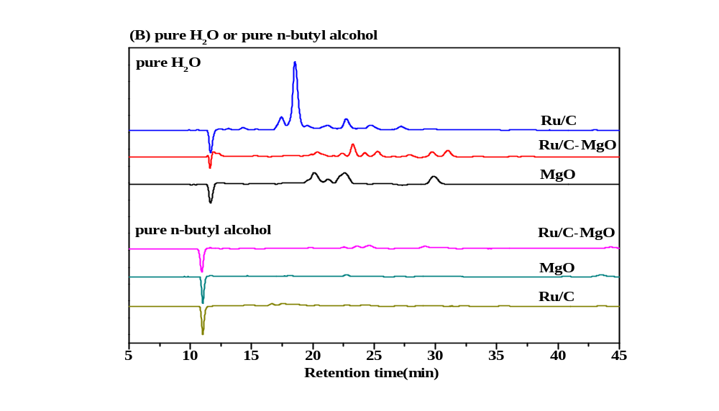
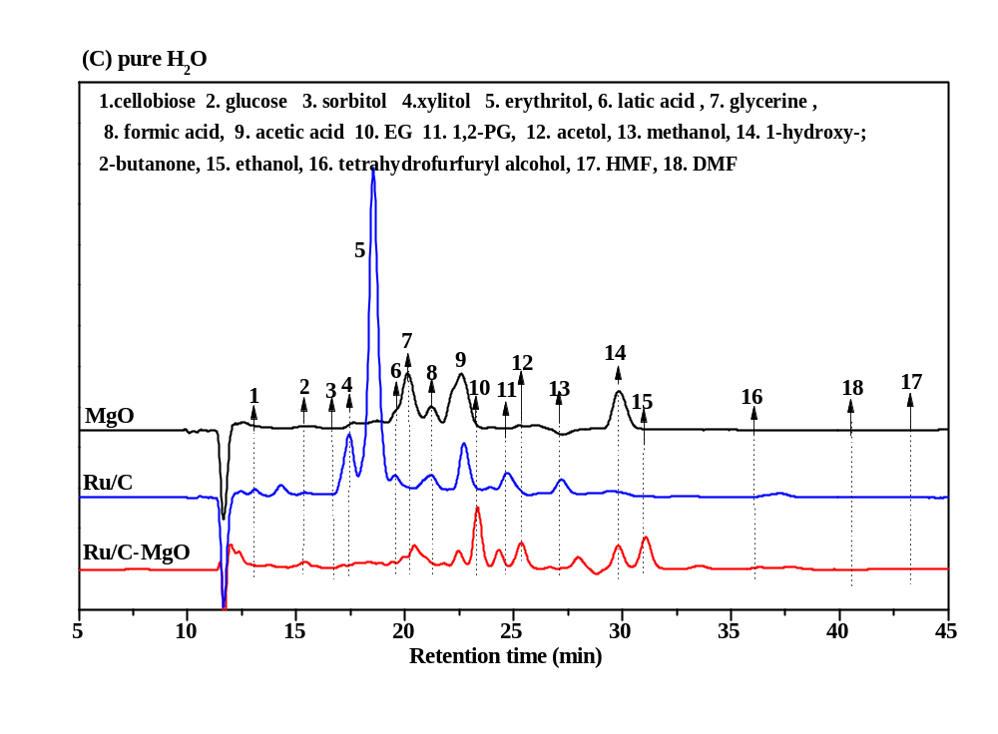

Fig.S3 The HPLC analysis of aqueous products derived eucalyptus powder valorization in different solvents over Ru/C or MgO or Ru/C-MgO catalysts. (A) catalytic valorization eucalyptus powder in n-butanol/H₂O, (B) catalytic valorization eucalyptus powder in pure n-butanol or pure H₂O solvent, (C) catalytic valorization eucalyptus powder in pure H₂O. Reaction conditions: 2.0 g non-extracted eucalyptus powder, 0.2 g Ru/C or/and 0.4g MgO, 40mL n-butanol or 40mL H₂O, or 20 mL n-butanol and 20 mL water, 30 bar H2, 200 °C, 2 h.

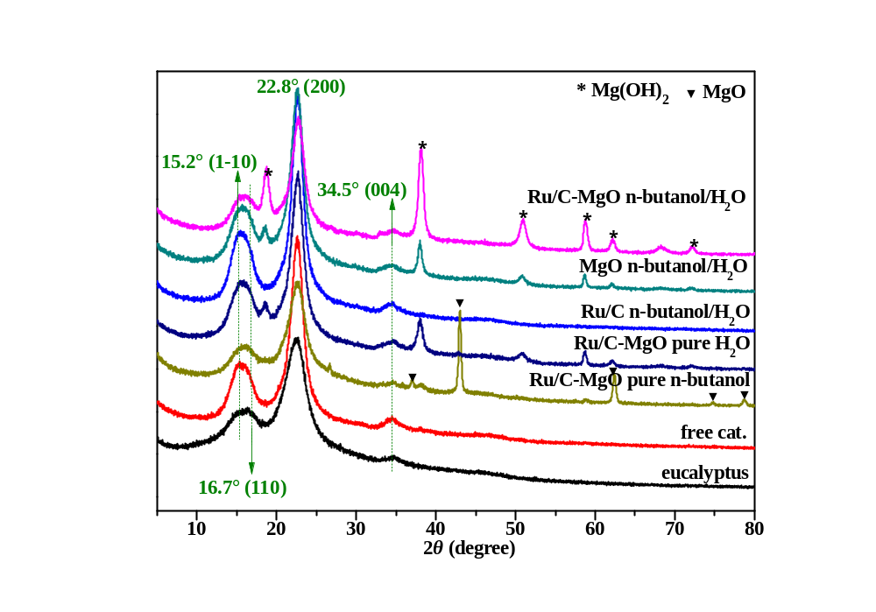

Fig. S4 The XRD analysis of feedstock and residue (with catalyst) derived eucalyptus powder valorization in different solvents over Ru/C-MgO catalysts. Reaction conditions: 2.0 g non-extracted eucalyptus powder, 0.2 g Ru/C or/and 0.4g MgO, 40mL n-butanol or 40mL H₂O, or 20 mL n-butanol and 20 mL water, 30 bar H2, 200 °C, 2 h.

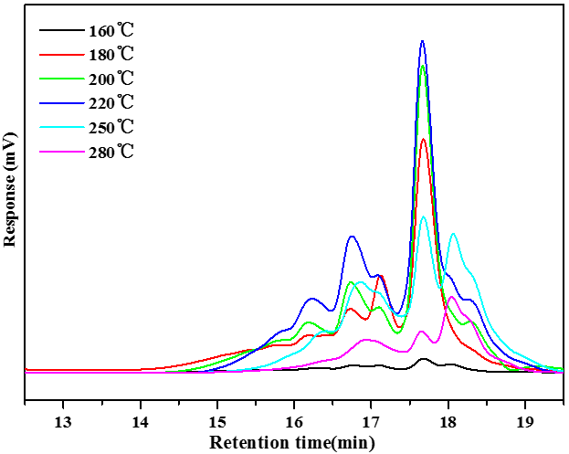

Fig. S5 GPC of the non-volatile lignin oil (n-butanol phase) for different reaction temperature over Ru/C-MgO. Reaction conditions: 2.0 g non-extracted eucalyptus powder, 0.2 g Ru/C, 0.4g MgO, 20 mL n-butanol, 20 mL water, 30 bar H2, 160~280 °C, 2 h.

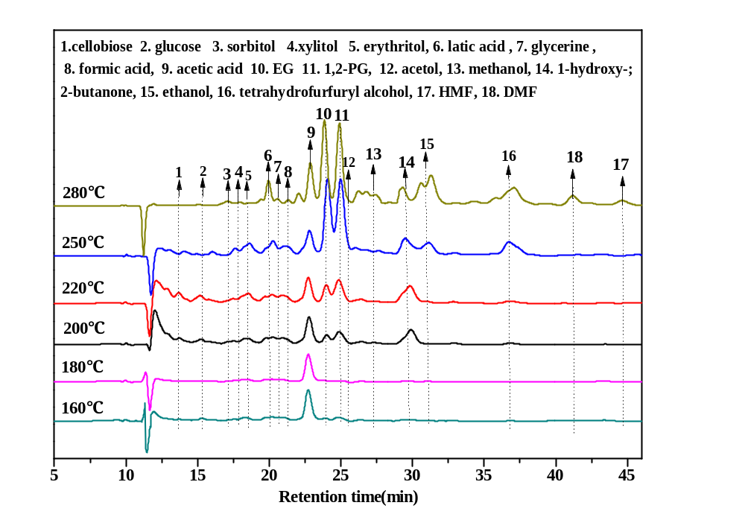

Fig.S6 The HPLC analysis of aqueous products derived eucalyptus powder valorization under different temperature over Ru/C-MgO catalysts. Reaction conditions: 2.0 g non-extracted eucalyptus powder, 0.2 g Ru/C or/and 0.4g MgO, 20 mL n-butanol and 20 mL water, 30 bar H2, 160~280 °C, 2 h.

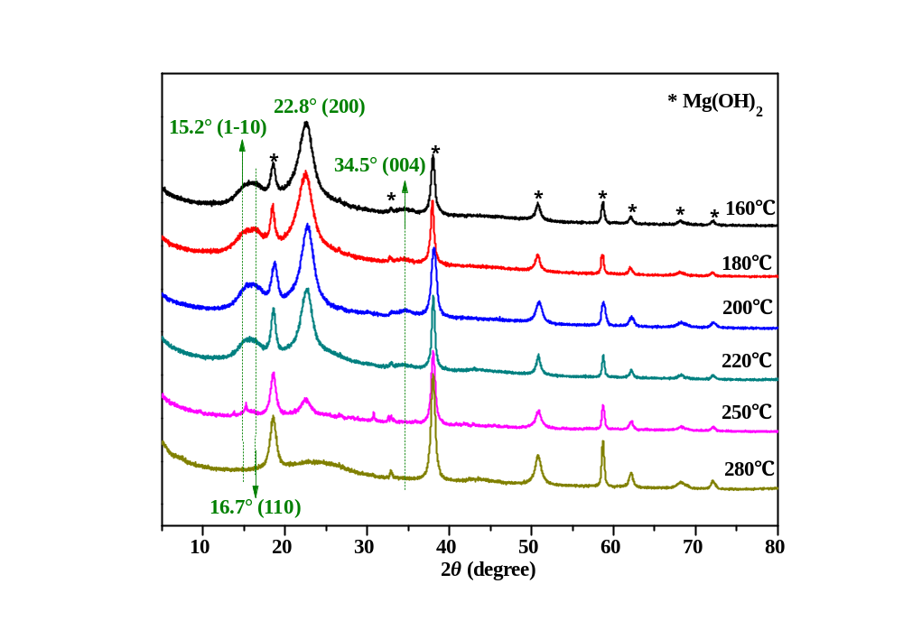

Fig. S7 The XRD analysis of residue (with catalyst) derived eucalyptus powder valorization under different reaction temperature over Ru/C-MgO catalysts. Reaction conditions: 2.0 g non-extracted eucalyptus powder, 0.2 g Ru/C or/and 0.4g MgO, 20 mL n-butanol and 20 mL water, 30 bar H2, 160~280 °C, 2 h.

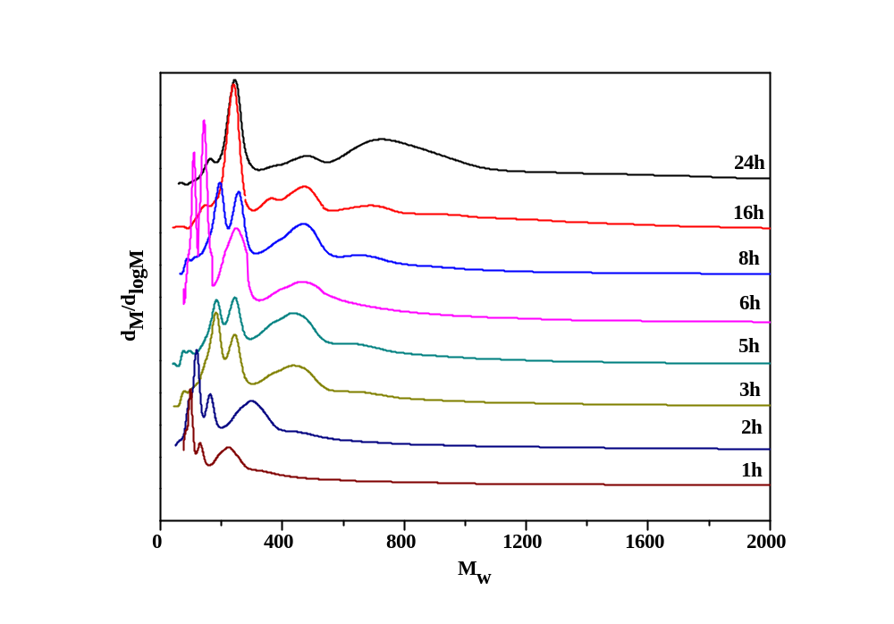

Fig. S8 GPC of the non-volatile lignin oil (n-butanol phase) for different reaction time over Ru/C-MgO. Reaction conditions: 2.0 g non-extracted eucalyptus powder, 0.2 g Ru/C, 0.4g MgO, 20 mL n-butanol, 20 mL water, 30 bar H2, 250 °C, 1~24 h.

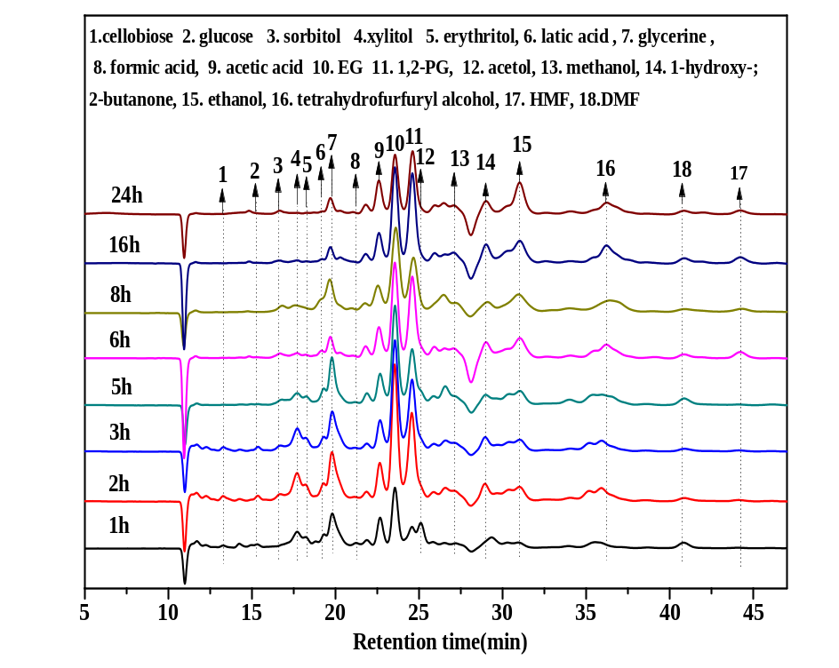

Fig.S9 The HPLC analysis of aqueous products derived eucalyptus powder valorization under different reaction time over Ru/C-MgO catalysts. Reaction conditions: 2.0 g non-extracted eucalyptus powder, 0.2 g Ru/C or/and 0.4g MgO, 20 mL n-butanol and 20 mL water, 30 bar H2, 250 °C, 1~24 h.

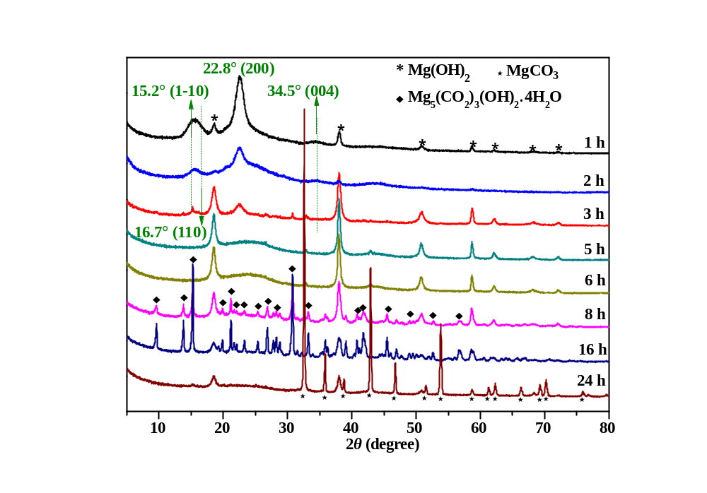

Fig. S10 The XRD analysis of the aqueous phase products obtained from catalytic depolymerization euscalyptus over Ru/C-MgO catalysts. Reaction conditions: 20.0 mL n-butanol, 20.0 mL water, 2.0 g eucalyptus powder (about 40 mesh), 0.2 g Ru/C and 0.4g MgO catalysts, 30 bar H₂, 250 °C, 1~24 h.

Reference
[1] A. Sluiter, B. H., R. Ruiz, C. Scarlata, J. Sluiter, D. Templeton, Crocker D, Determination of structural carbohydrates and lignin in biomass [J]. http://wwwnrelgov/biomass/analytical_procedureshtml 2008.
[2] Hu, L.; Luo, Y.; Cai, B., et al., The degradation of the lignin in Phyllostachys heterocycla cv. pubescens in an ethanol solvothermal system [J]. Green Chem 2014, 16 (6), 3107-3116.
[3] Long, J.; Xu, Y.; Wang, T., et al., Efficient base-catalyzed decomposition and in situ hydrogenolysis process for lignin depolymerization and char elimination [J]. Appl Energ 2015, 141, 70-79.
[4] Shu, R.; Long, J.; Yuan, Z., et al., Efficient and product-controlled depolymerization of lignin oriented by metal chloride cooperated with Pd/C [J]. Bioresour Technol 2015, 179, 84-90.
[5] Oh, S. Y.; Yoo, D. I.; Shin, Y., et al., Crystalline structure analysis of cellulose treated with sodium hydroxide and carbon dioxide by means of X-ray diffraction and FTIR spectroscopy [J]. Carbohyd Res 2005, 340 (15), 2376-2391.
[6] Yuan, T. Q.; Sun, S. N.; Xu, F., et al., Isolation and Physico-Chemical Characterization of Lignins from Ultrasound Irradiated Fast-Growing Poplar Wood [J]. Bioresources 2011, 6 (1), 414-433.
[7] Wen, J.-L.; Sun, S.-L.; Xue, B.-L., et al., Recent Advances in Characterization of Lignin Polymer by Solution-State Nuclear Magnetic Resonance (NMR) Methodology [J]. Materials 2013, 6 (1), 359-391.
[8] Joffres, B.; Lorentz, C.; Vidalie, M., et al., Catalytic hydroconversion of a wheat straw soda lignin: Characterization of the products and the lignin residue [J]. Applied Catalysis B: Environmental 2014, 145, 167-176.
[9] Jun-ichi Kadokawa, Y. K., Hideyuki Tagaya, Koji Chiba, Synthesis of an amylose–polymer inclusion complex by enzymatic
polymerization of glucose 1-phosphate catalyzed by phosphorylase enzyme in
the presence of polyTHF: a new method for synthesis of polymer–polymer
inclusion complexes [J]. Chem. Commun. 2001, 459–450.
[10] Soo-Jeong Shin, N.-S. C., Conversion factors for carbohydrate analysis by hydrolysis and 1H-NMR spectroscopy [J]. Cellulose 2008, 15, 255–260.
[11] Neiss, H. N. C. T. G., Solution NMR Spectroscopy of Food Polysaccharides [J]. Polymer Reviews 2012, 52, 81–114.

